1. When the user tries to log in getting an unknown alert.  
   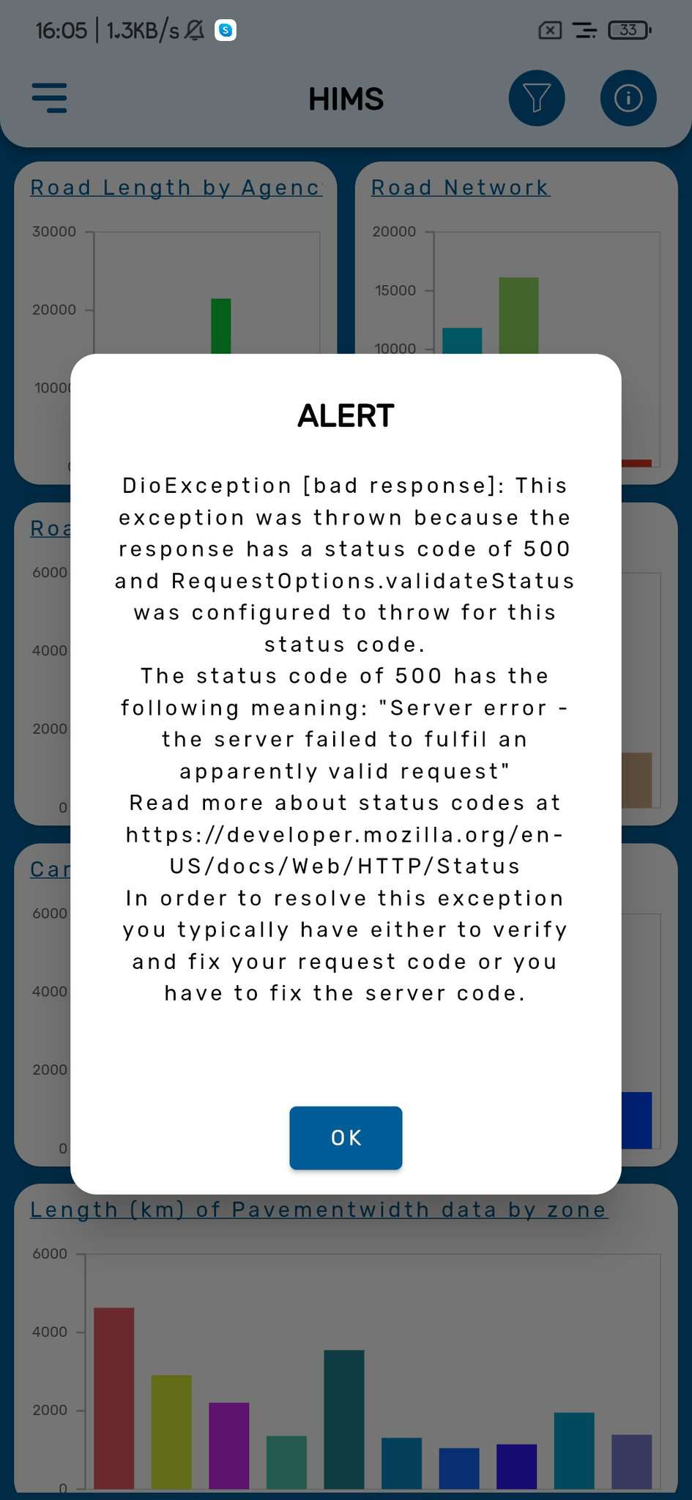
2. Survey inspection module -> unknown alert  
   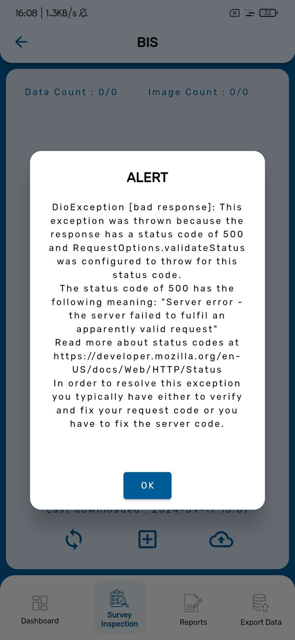  
   3.