1. The Submit button should be disabled after one click.   
   Multiple tickets have been raised when the user clicks on submit multiple times.  
   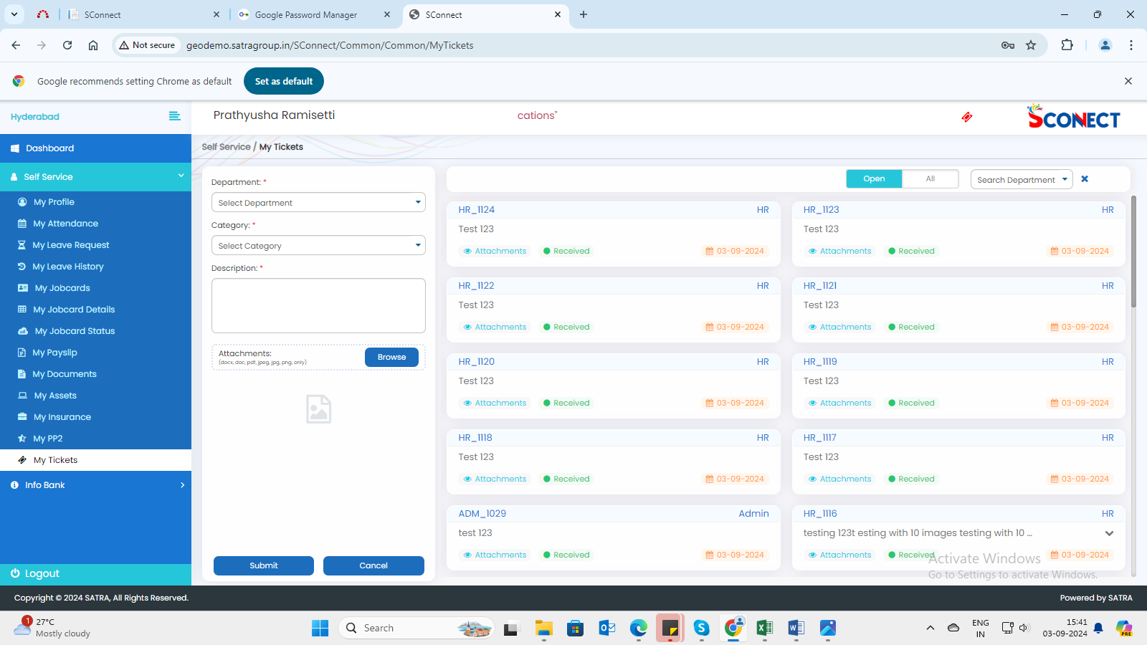

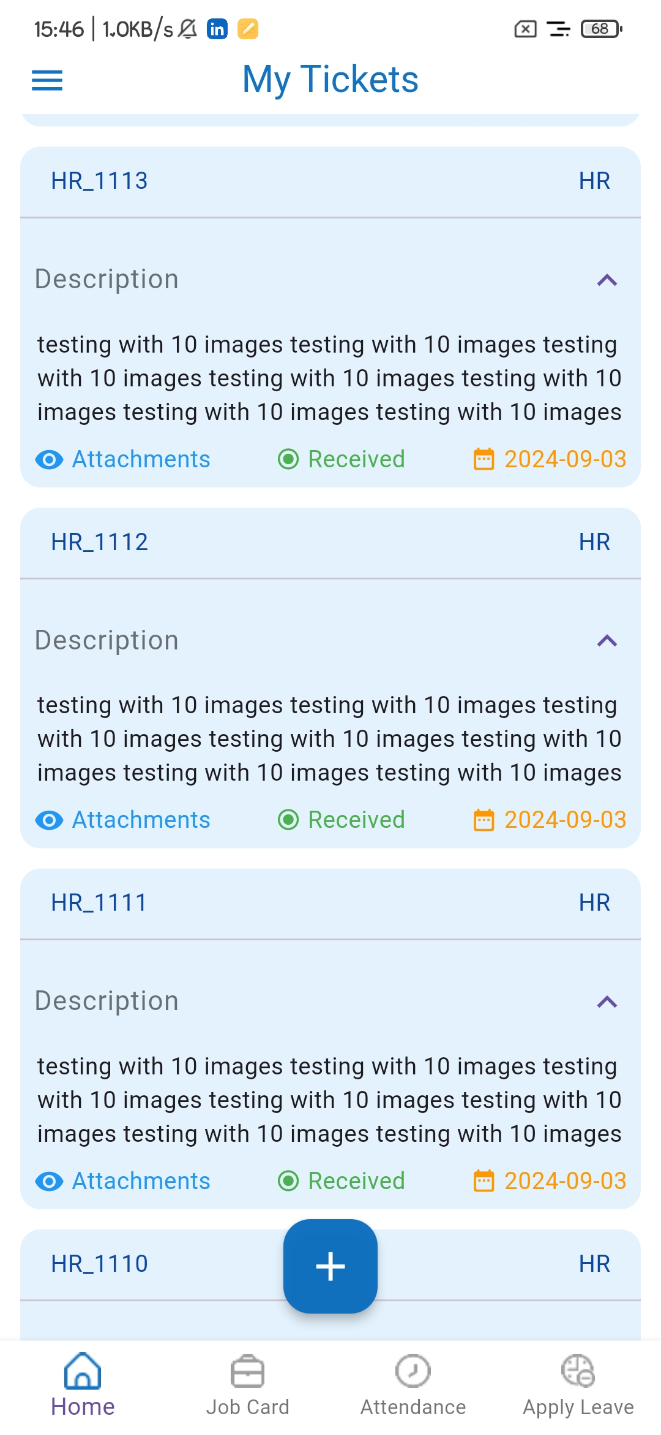  
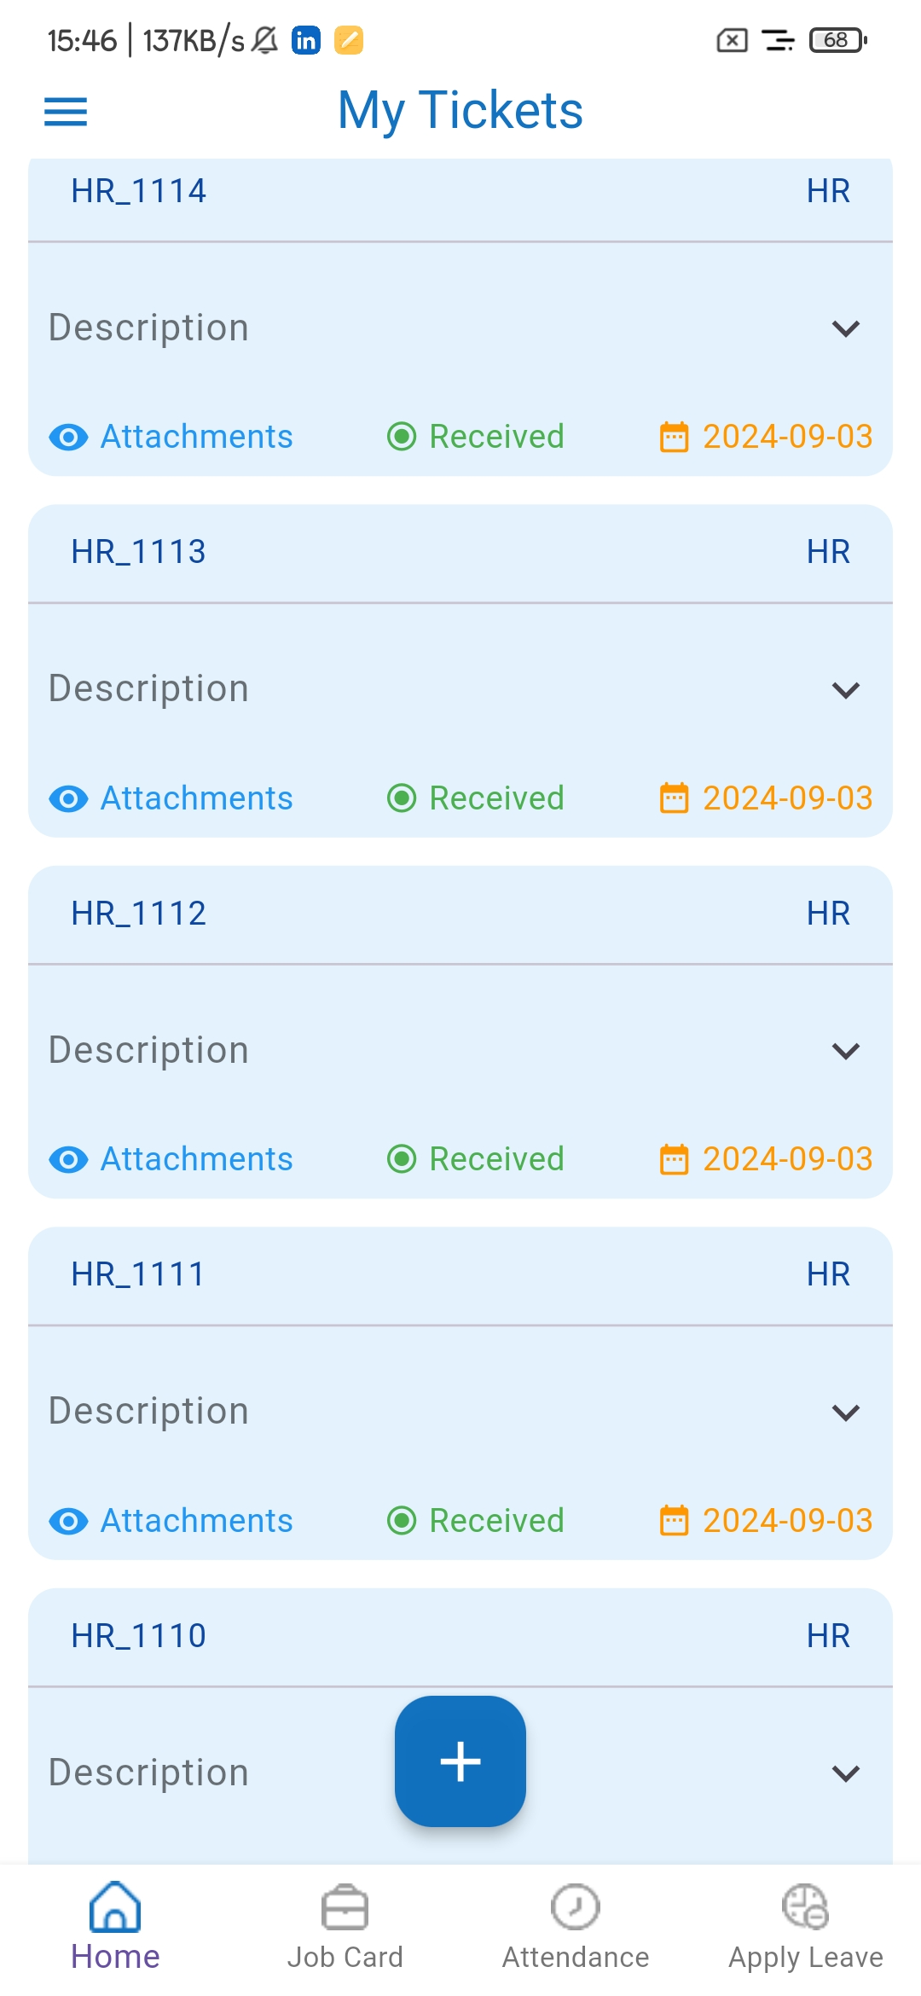  
  
2. Unable to view attached images in mobile application.  
