1. Traffic Management System (TMS) / Import-> Vehicle Classifications(L)

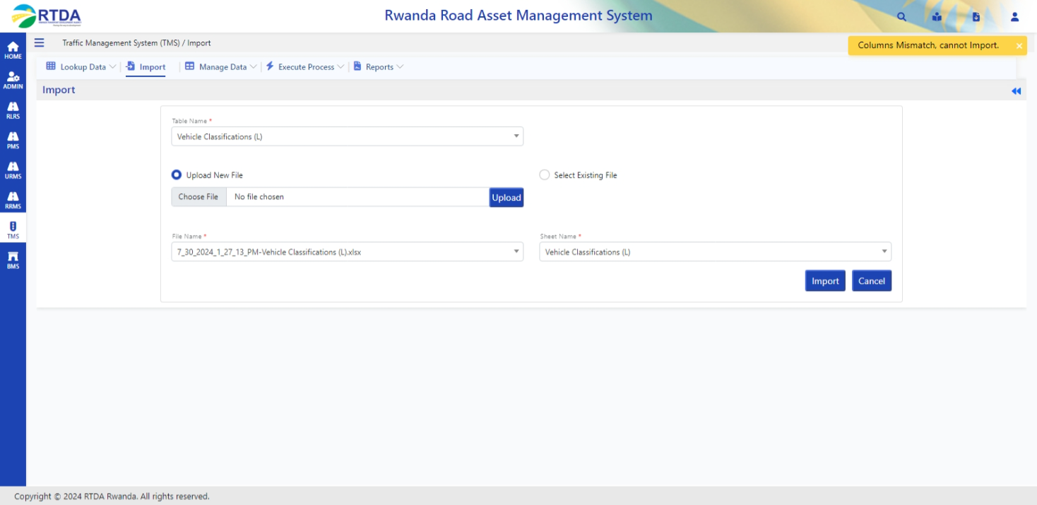

1. Traffic Management System (TMS) / Import-> Registration data (L)

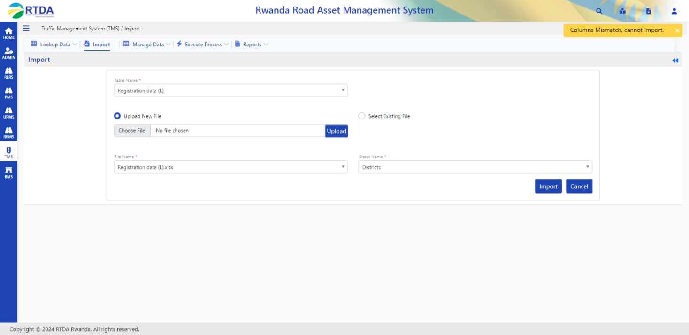

1. Traffic Management System (TMS) / Import->Time period -> Fail  
     
   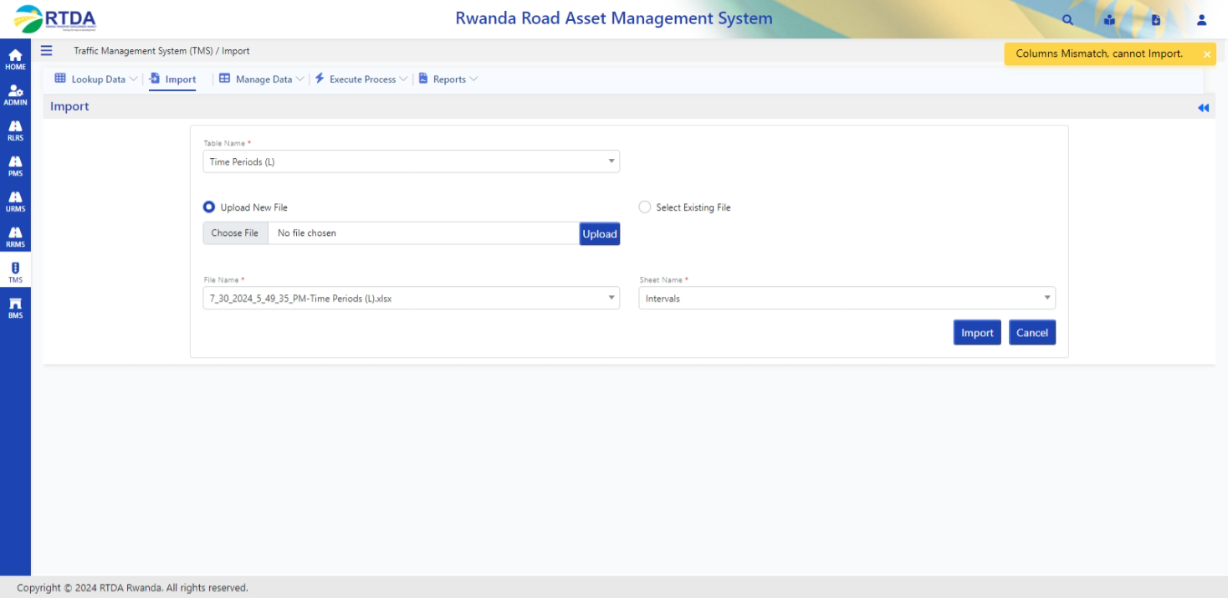
2. Traffic Management System (TMS) / Import-> manage data -> traffic stations. – fail.  
   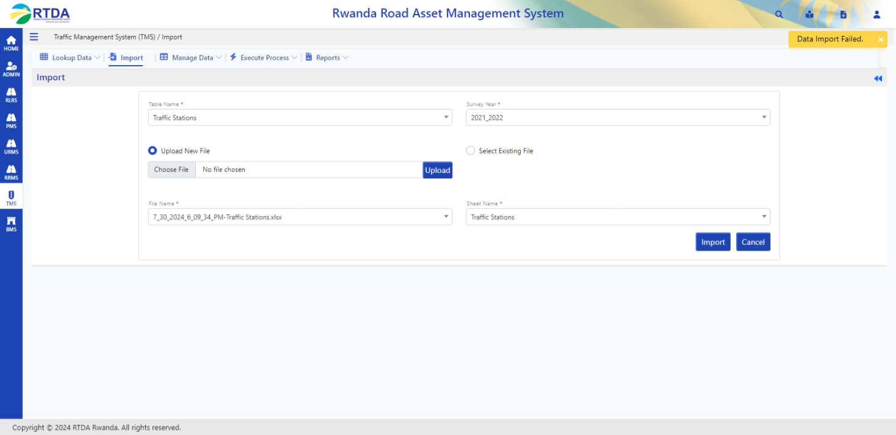  
     
   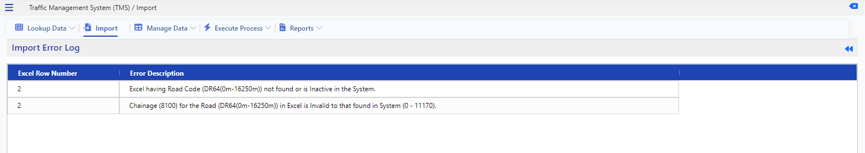
3. Traffic Management System (TMS) / Import-> manage data ->Traffic Distribution –>  
   If the survey year is 97-98 gets an error  
   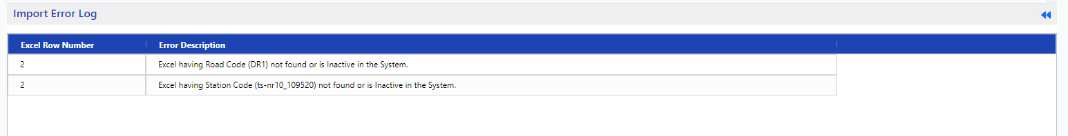  
    If the survey year is 2021-2022 page is not loading.

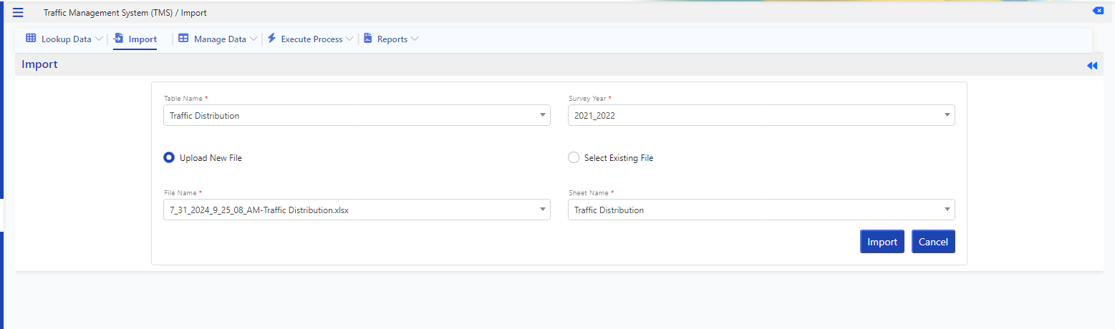

1. Traffic Management System (TMS) / Import -> axle load survey

