1. Texture Depth, Potholes Severity(L), Road Assets-Point, Road Type(L), Surface Type(L)

Error: -Columns Mismatch, cannot Import

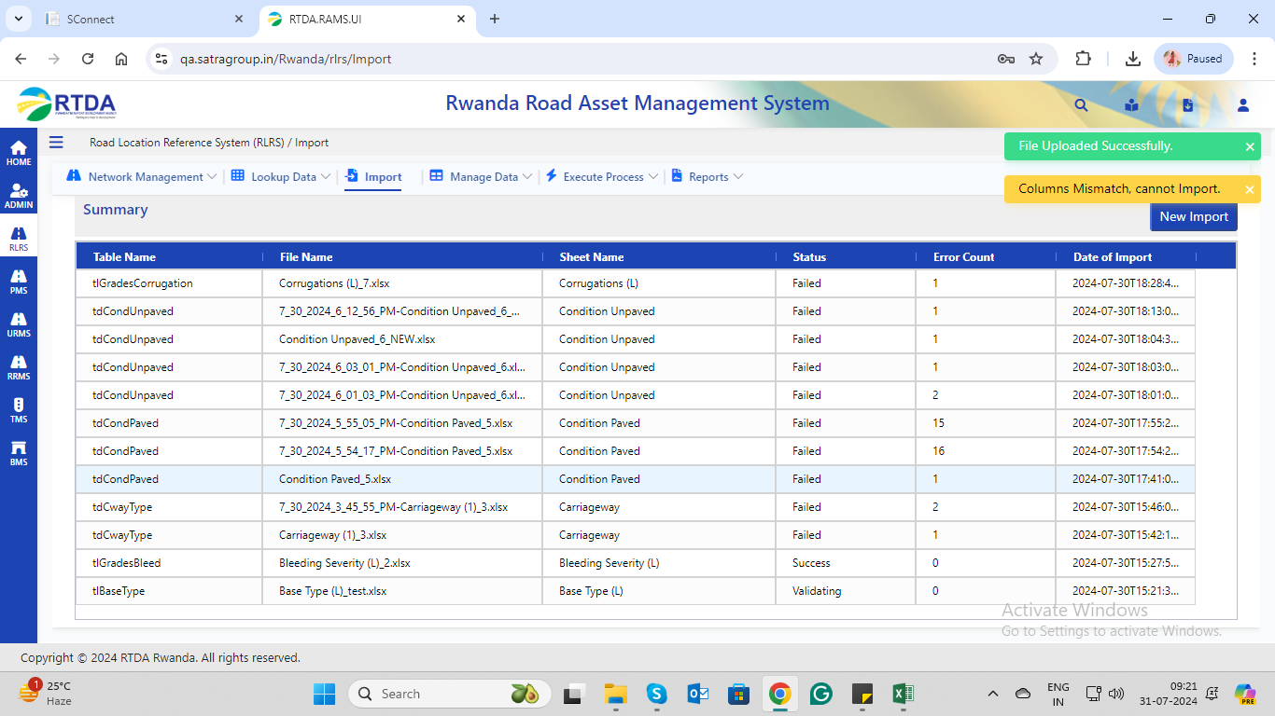

2. Terrain

Error: -No data found in excel to import

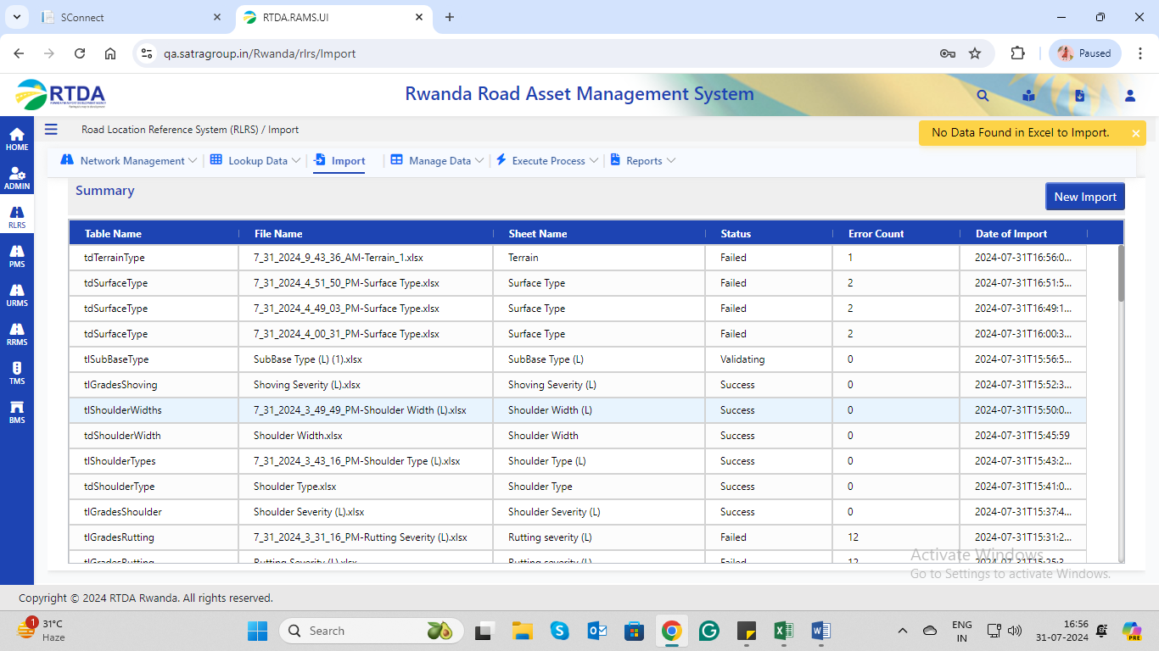

3. Corrugations, Erosion Gullies(L)

Error:-failed.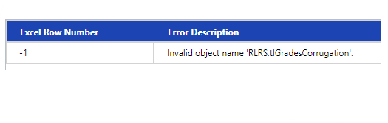

4. Condition Paved

Error: -failed

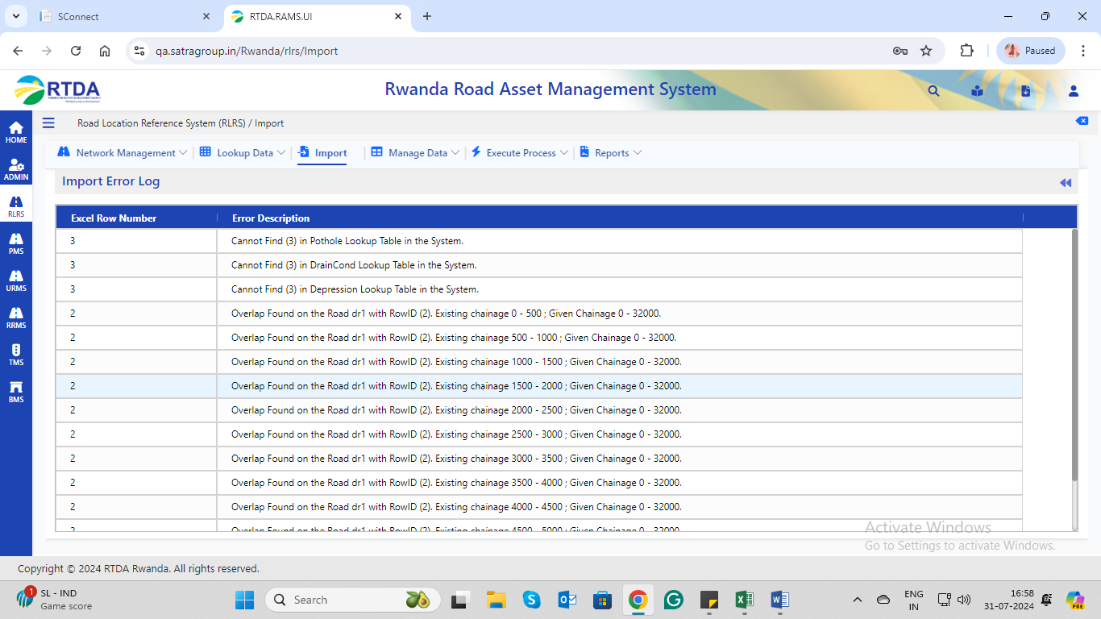

5. Condition Unpaved

Error: -Failed

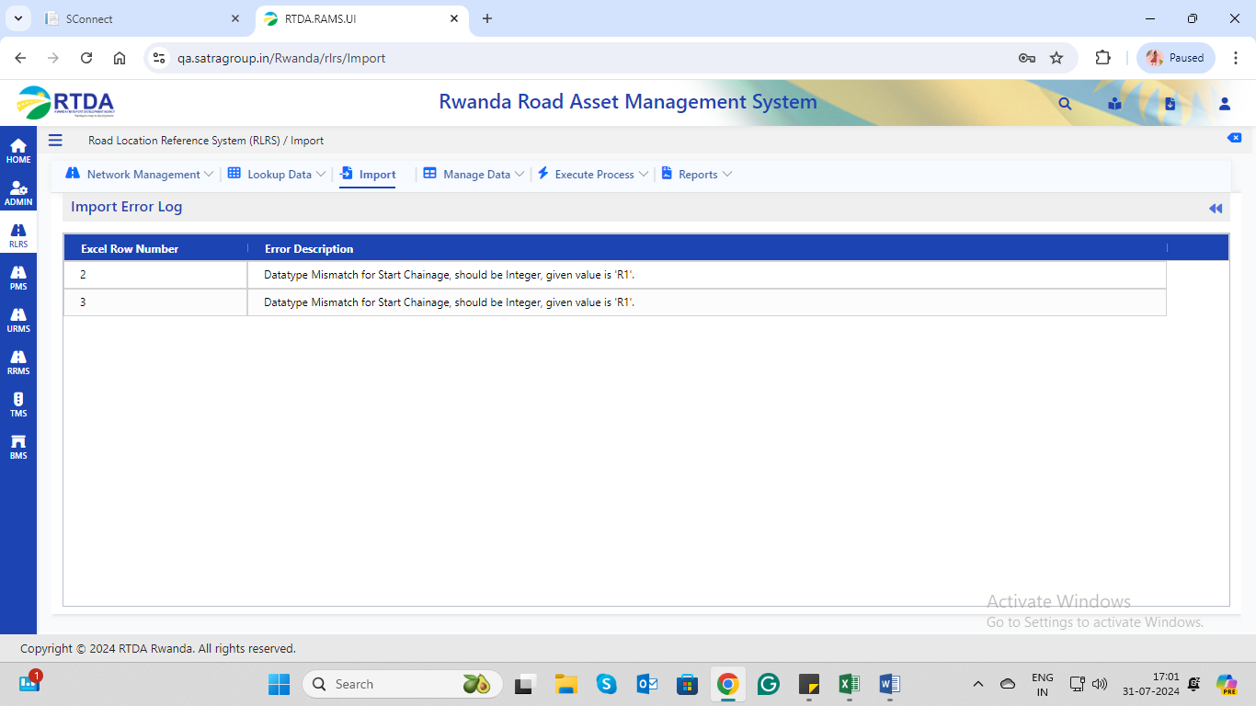

6. Cross-sections

Error:- Failed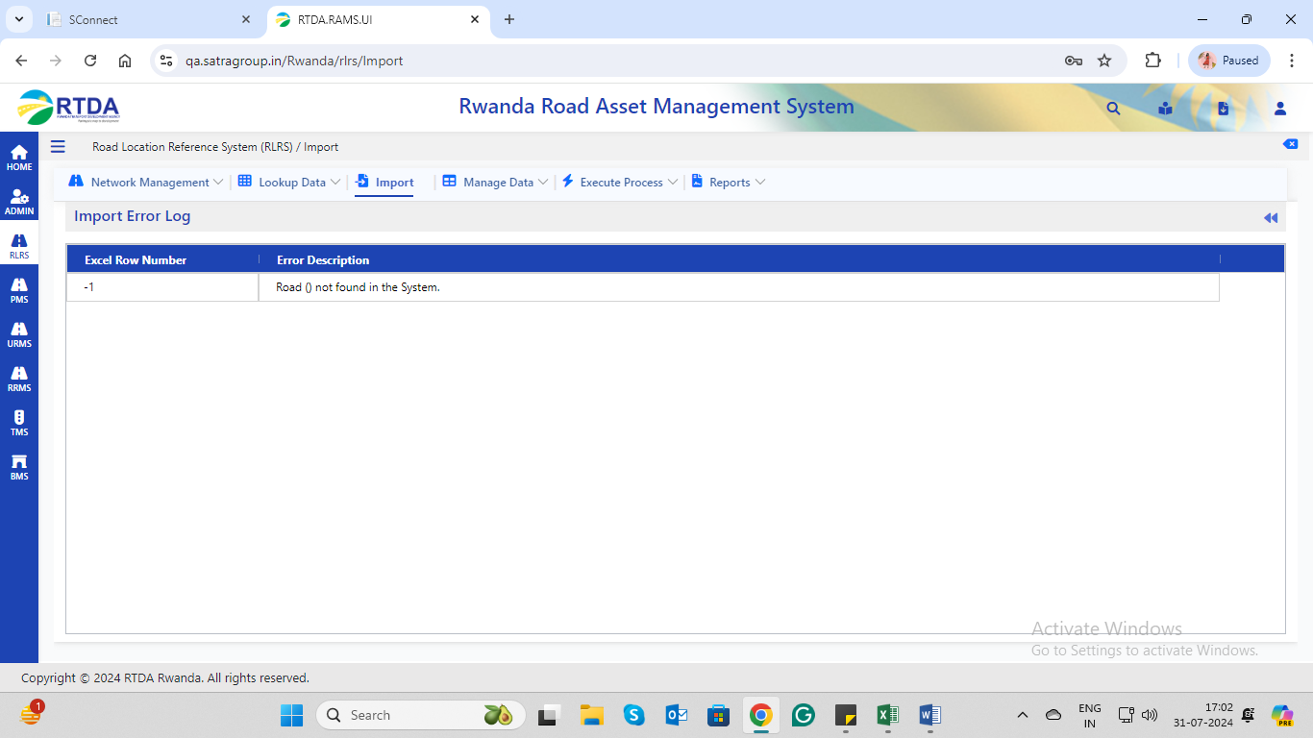

7. Drain Type

Error:-Failed

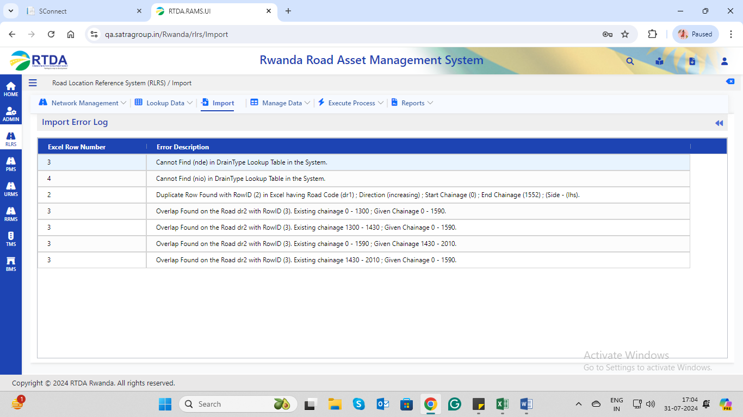

8.Payment Composition

Error: -Failed

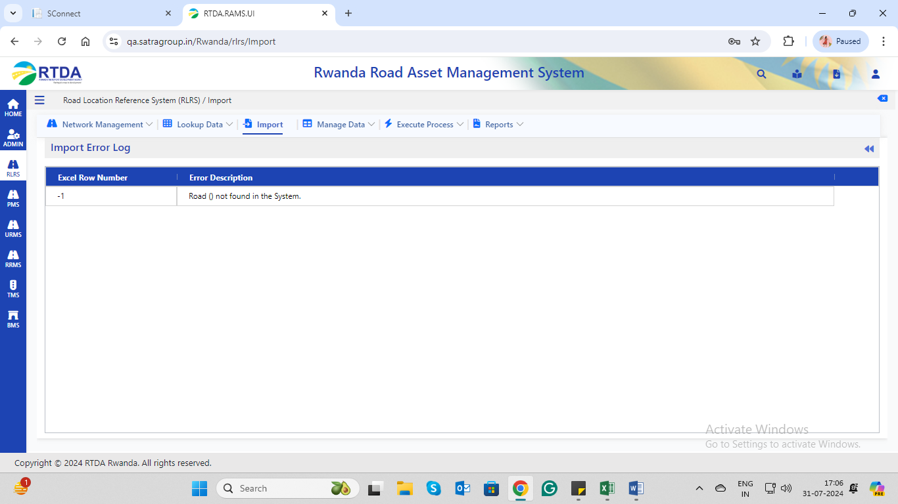

9. Pavement Type

Error:-Data Import Failed

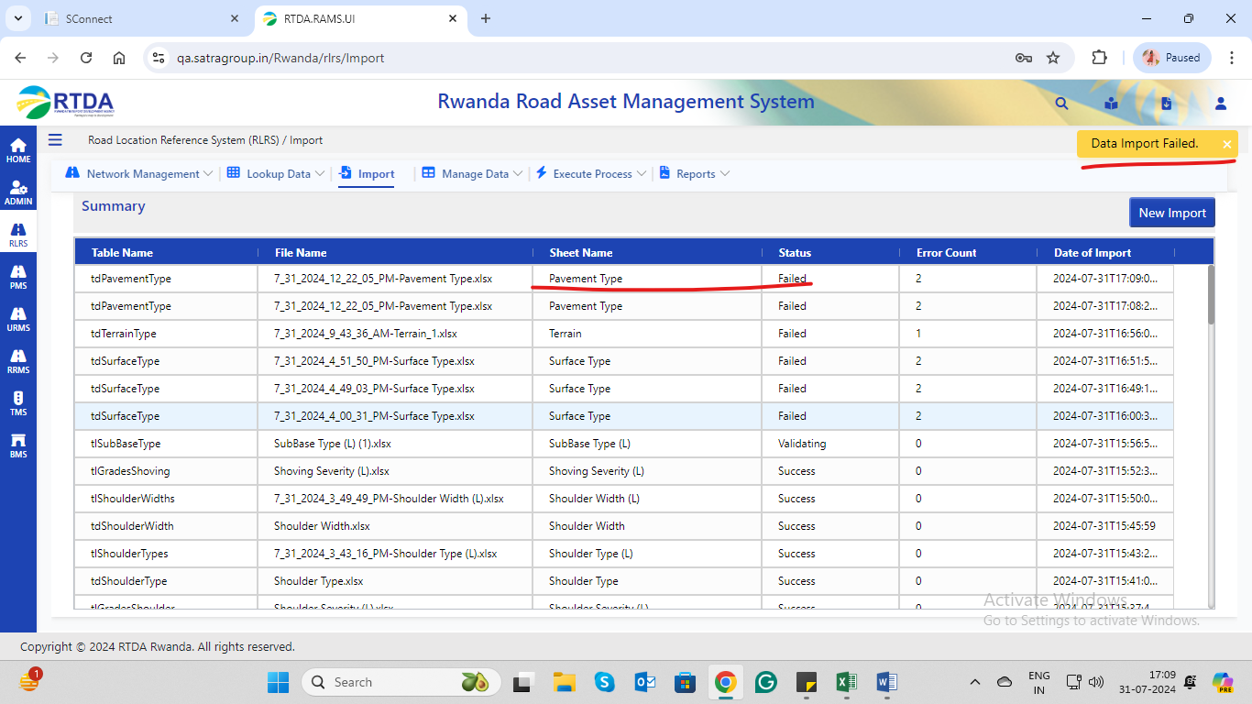

10. Road Assets-Point(L), Road Assets-Section(L)

ERROR-Duplicate data/Data Type mismatch

