1. . Road Location Reference System (RLRS) / Network Management / Jurisdiction Management / Province

RLRS-TEST CASE-SNO-20

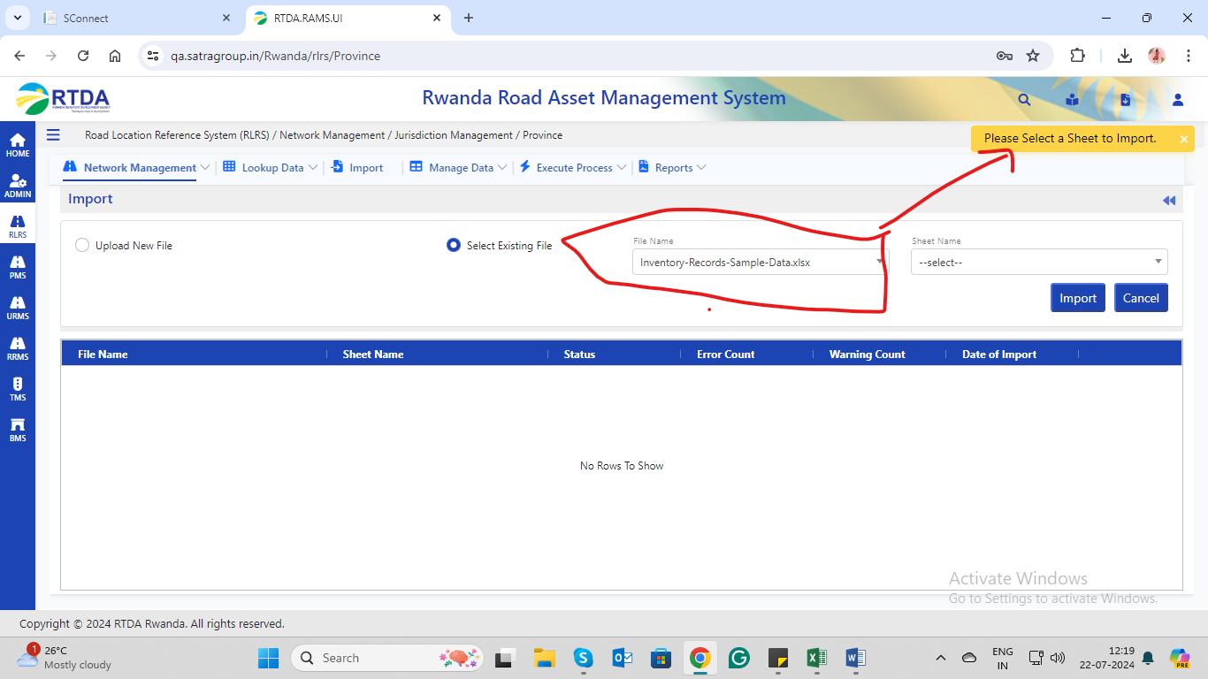

1. Road Location Reference System (RLRS)->KPI’S🡪ERROR No data is available/there is an unknown error, so please contact the administrator.

RLRS_OLD:-TESET CASE-SNO-2

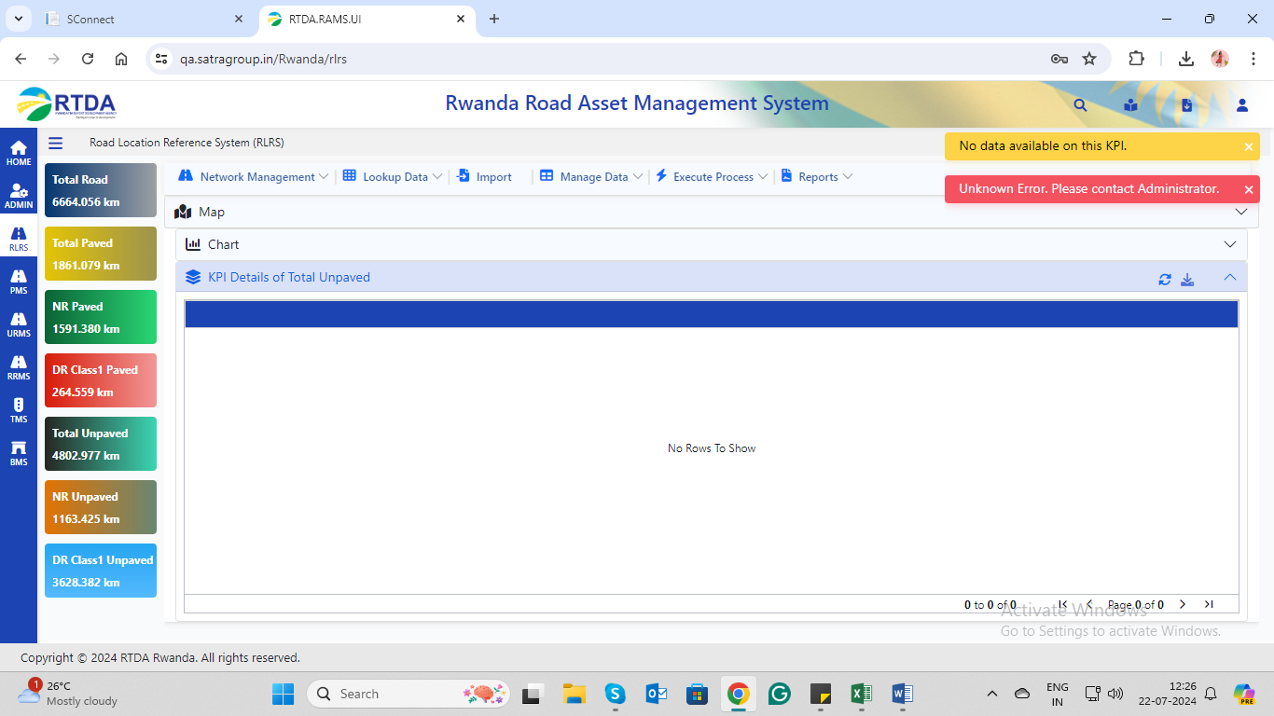

1. Road Location Reference System (RLRS)🡪charts-filters-reset function

The reset function is not working

RLRS_OLD: -TESET CASE-SNO-6

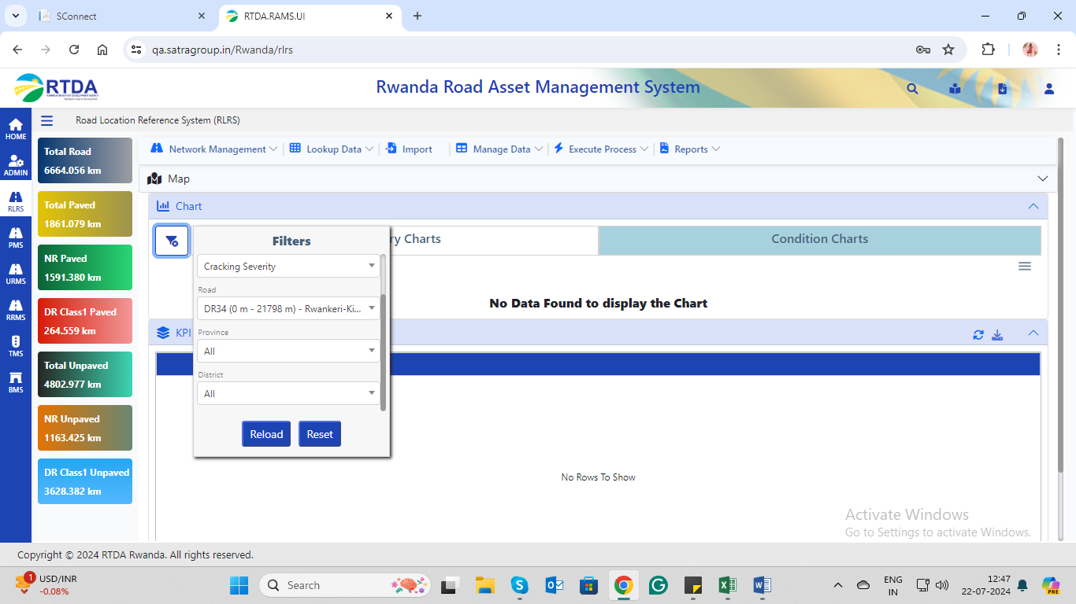

1. Road Location Reference System (RLRS) / Network Management / Lookup Data / Road Categories🡪There is no filter and search button.

RLRS: -TESET CASE-SNO-78,100,101.

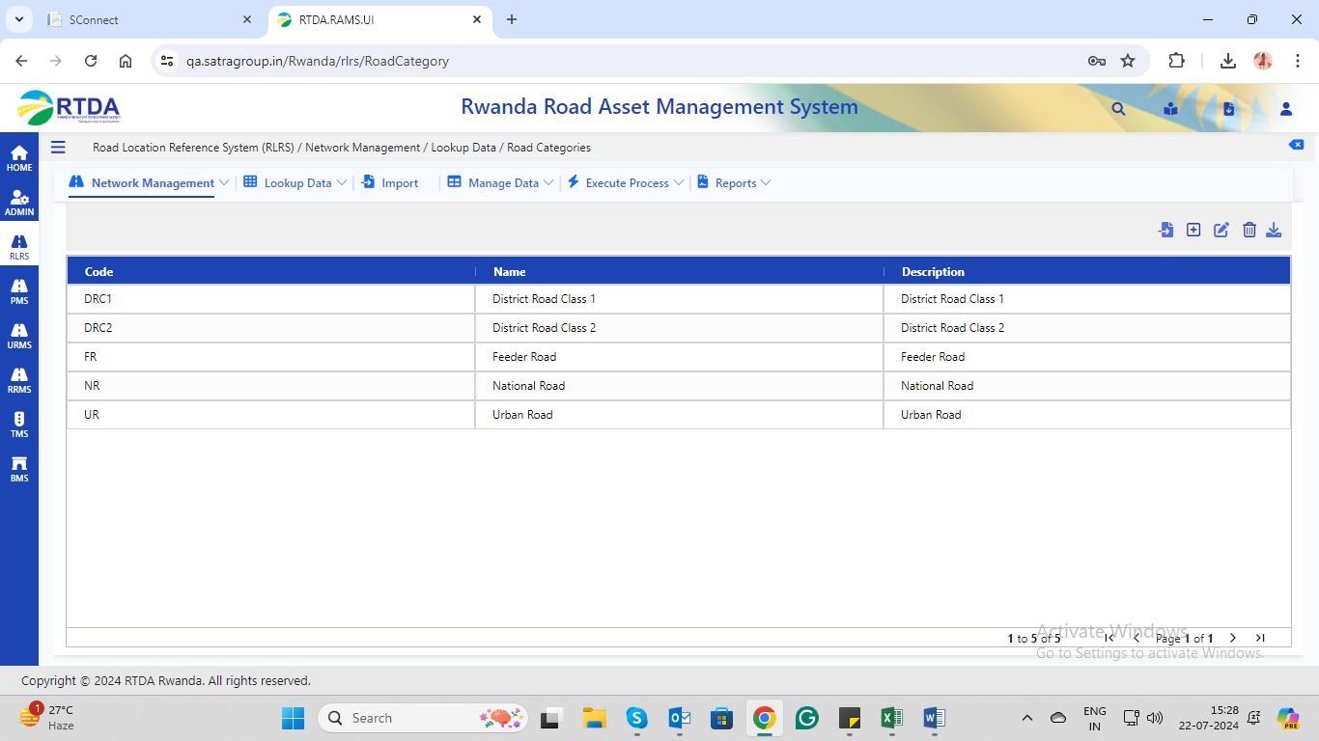

1. Road Location Reference System (RLRS) / Network Management / Network Data / Road Master

From gallery->image/document uploaded successfully but still, the screen rotating as shown in the attached screenshot.

RLRS-test case no:-189.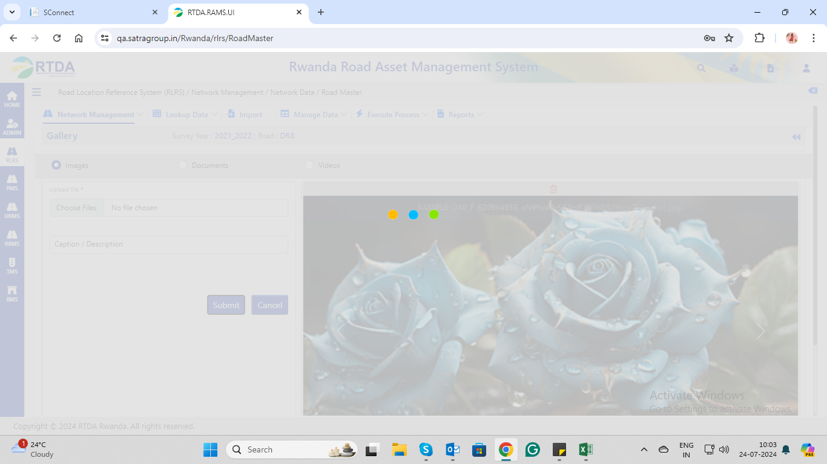

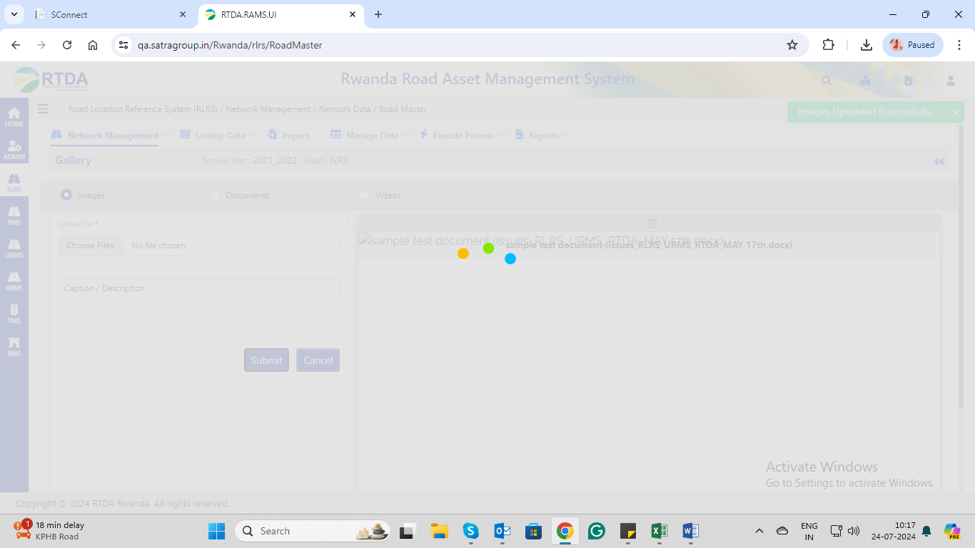

1. Road Location Reference System (RLRS) / Network Management / Network Data / GPS Master

The clear filter button is not working

RLRS-Test case no:-246.

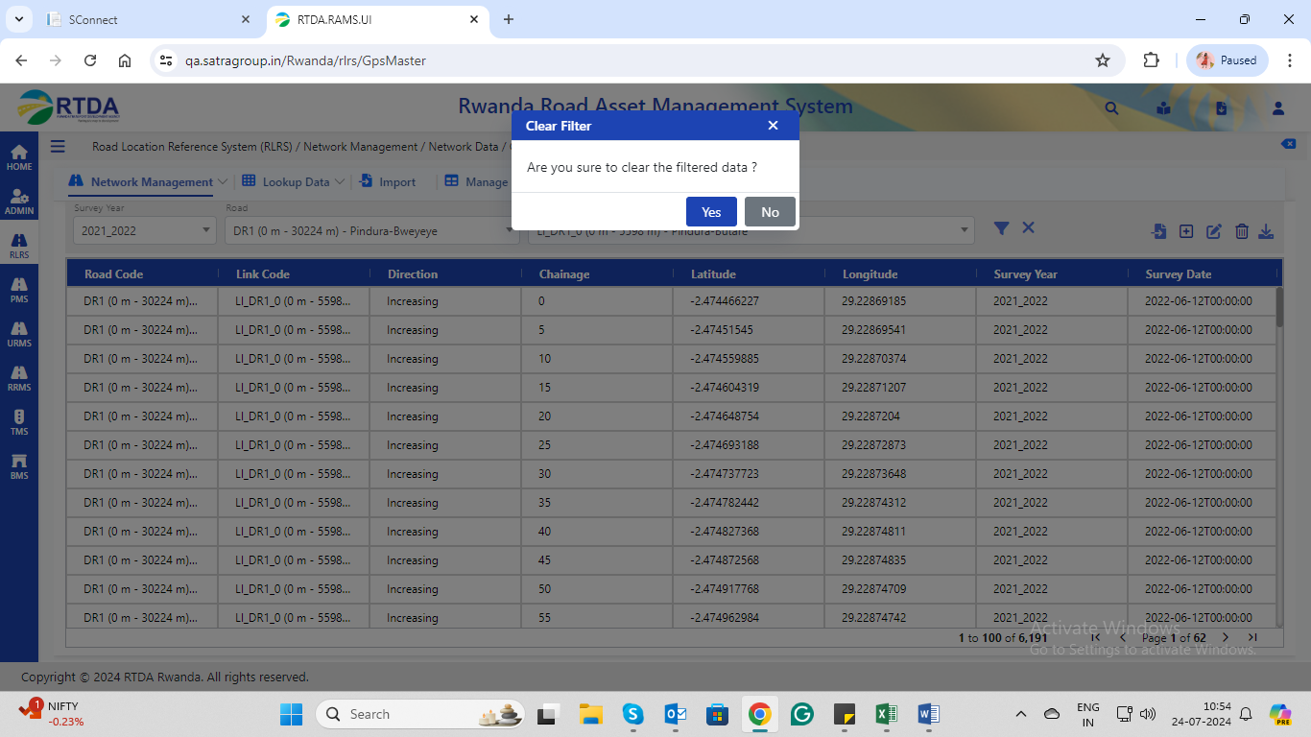

1. Road Location Reference System (RLRS) / Network Management / Network Data / Survey Videos->Add new data/edit selected data, values are not binding in the asset code drop-down list

RLRS Test case no:-271

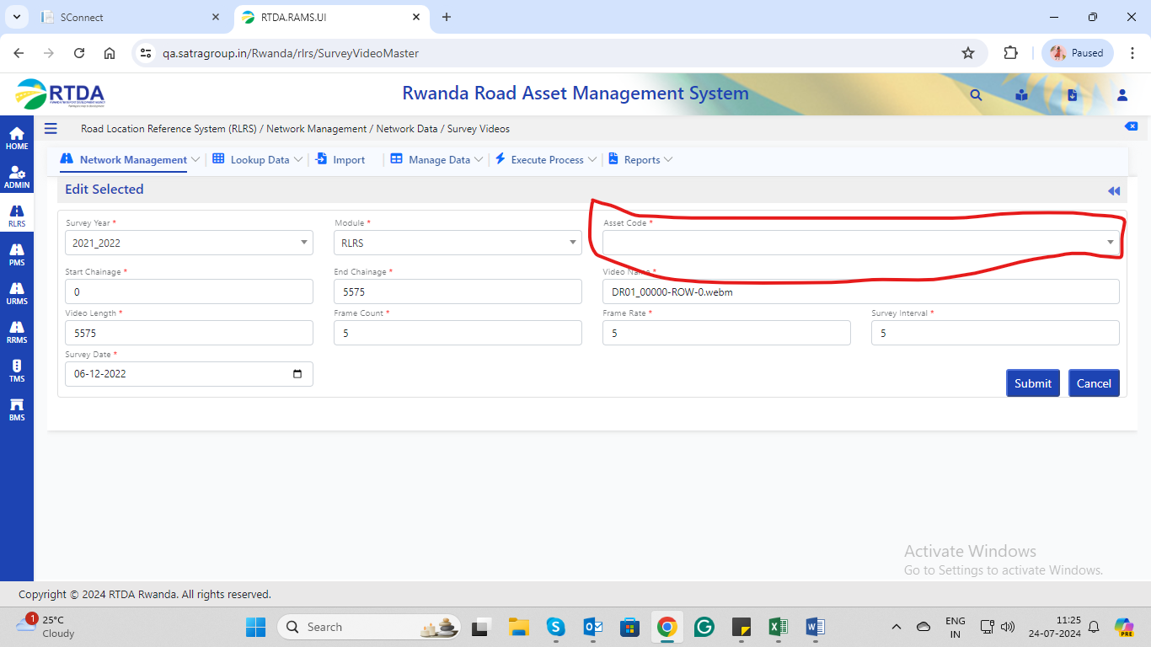

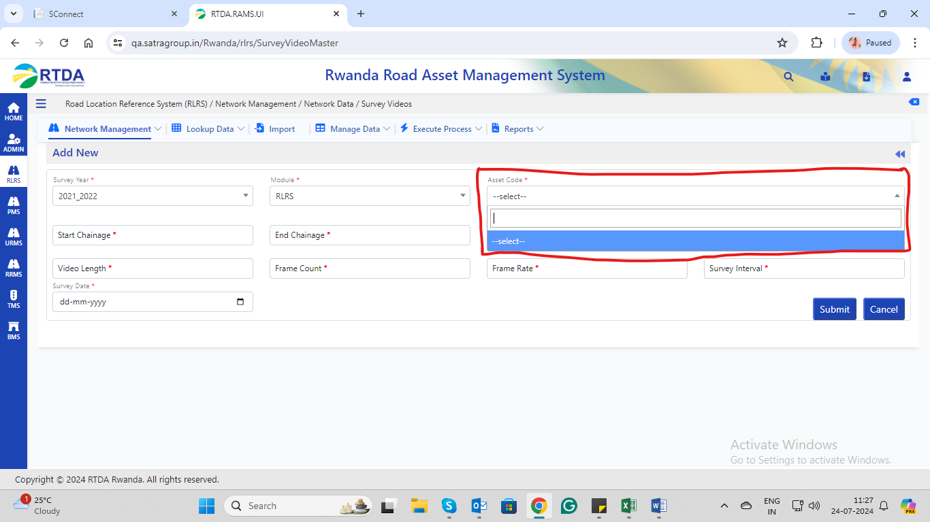

1. Road Location Reference System (RLRS) / Network Management / Network Data / Overlap While adding a new record unknown error occurs.

RLRS Test case No:-284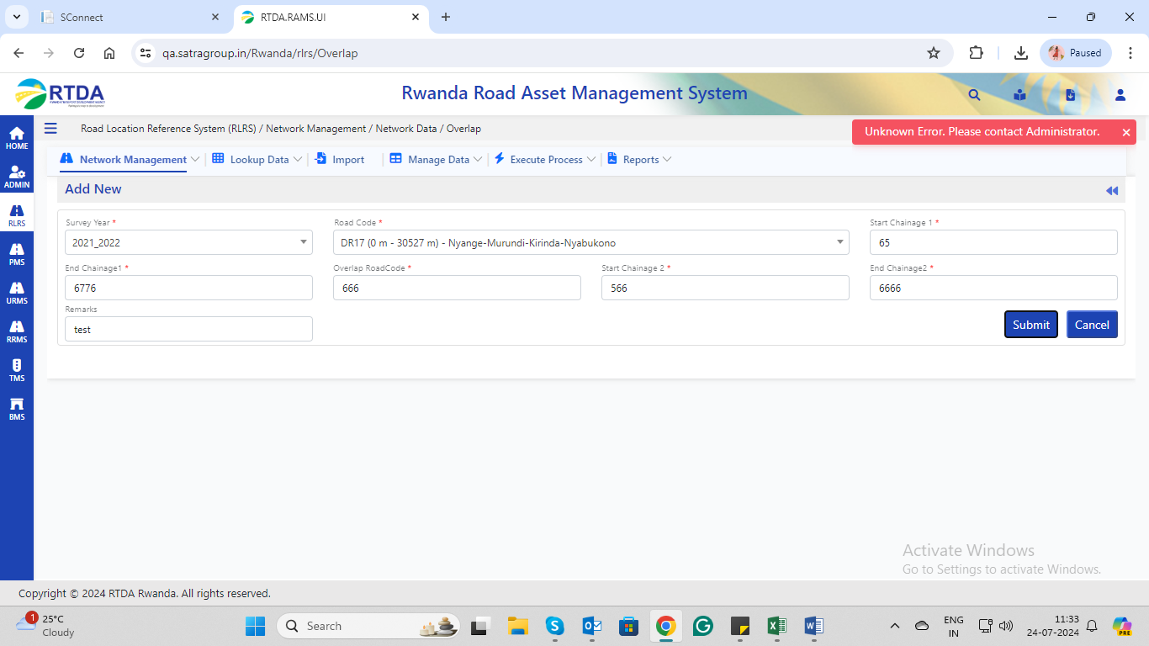

1. Road Location Reference System (RLRS) / Network Management / Network Data / Overlap🡪gallery to upload image but screen shown as below.

RLRS Test case No:-288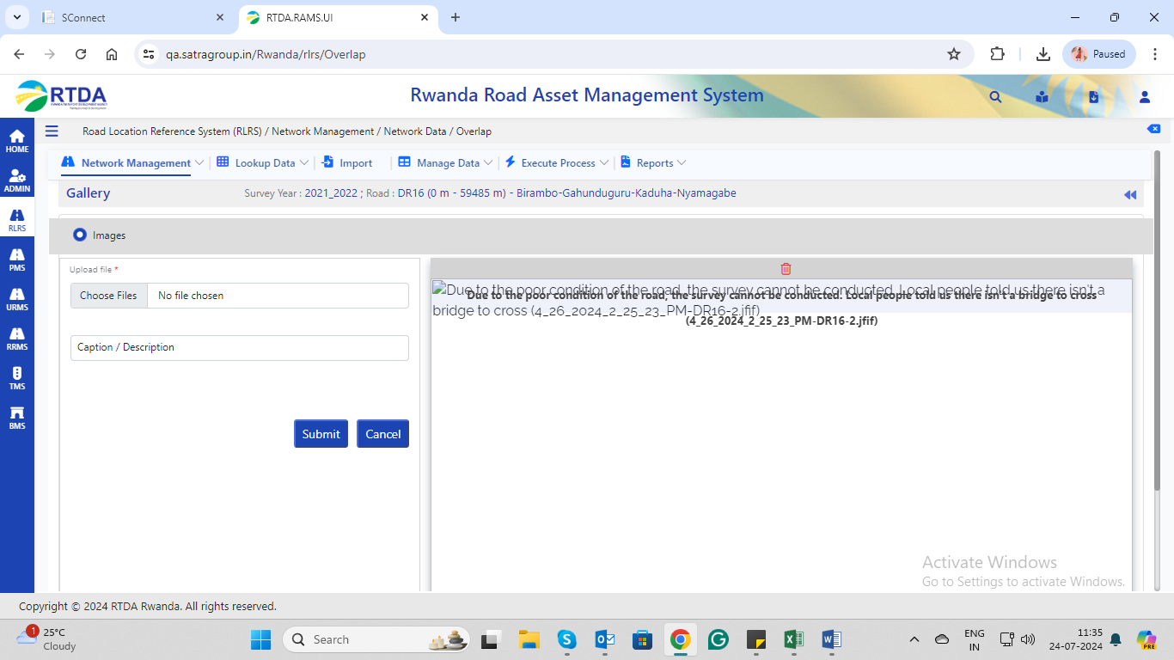

1. Road Location Reference System (RLRS) / Lookup Data / Road Inventory / Land use

RLRS Test case No:-442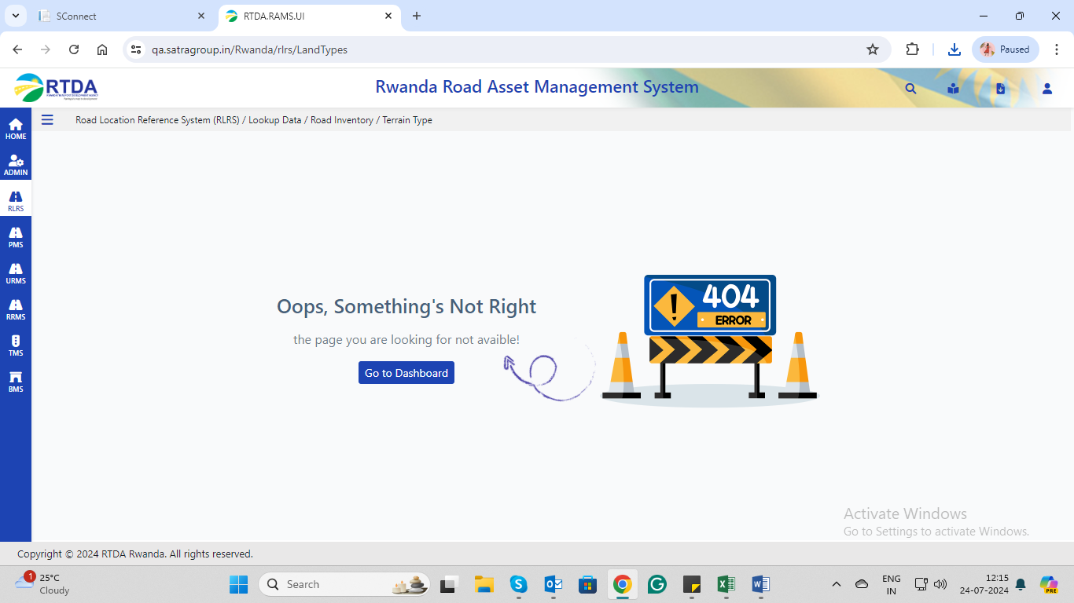

1. Road Location Reference System (RLRS) / Manage Data / Road Inventory / Landuse🡪add new

But some mandatory fields->values already bind up

RLRS;-TEST CASE-804

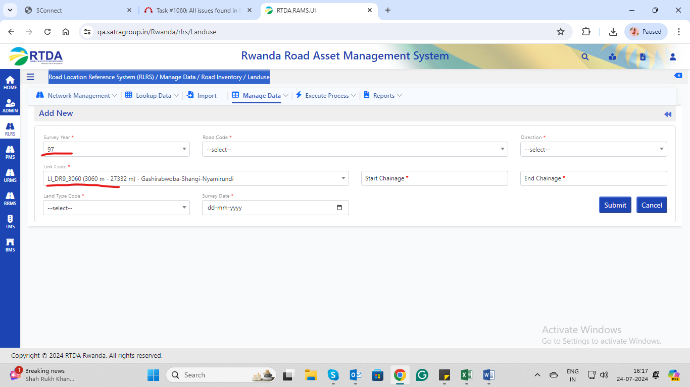

1. Road Location Reference System (RLRS) / Manage Data / Road Condition / Condition – Paved🡪edit selected 🡪but link code become empty field with doing any edit.

RLRS;-TEST CASE-844

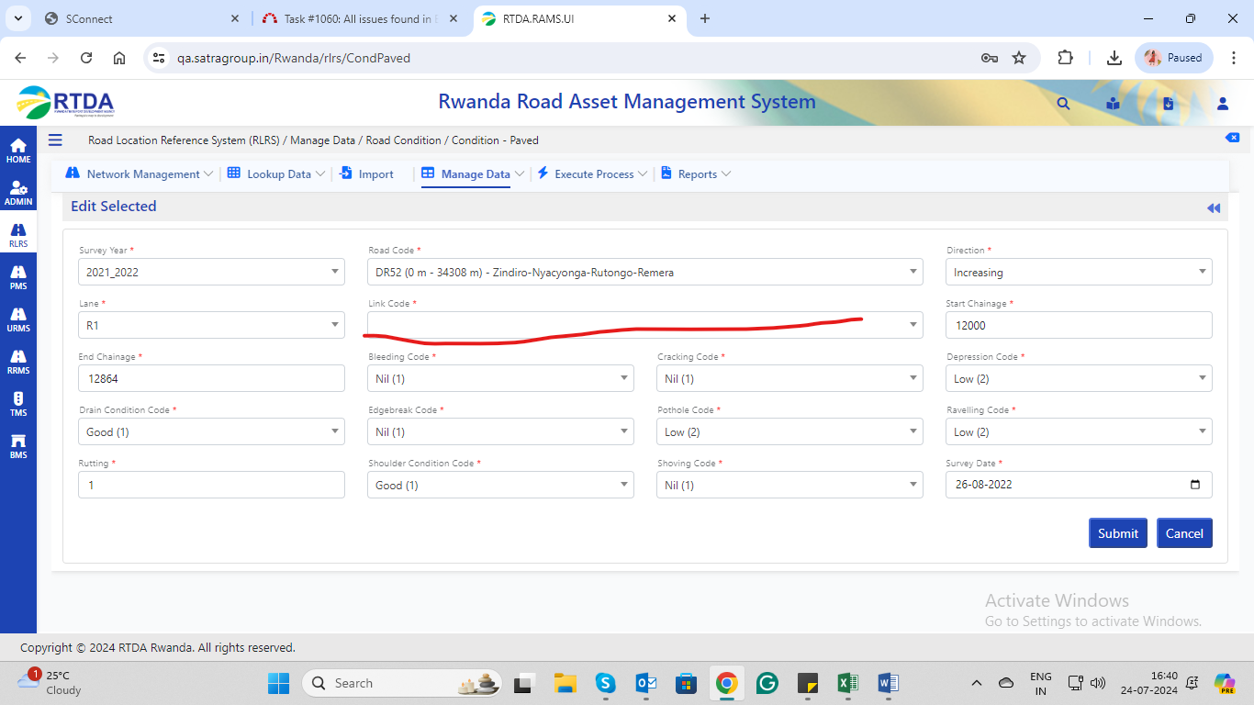

1. Road Location Reference System (RLRS) / Reports / Road Network / Link Summary AND Sector Level Link Summary🡪error occurs

RLRS TEST CASE NO-983

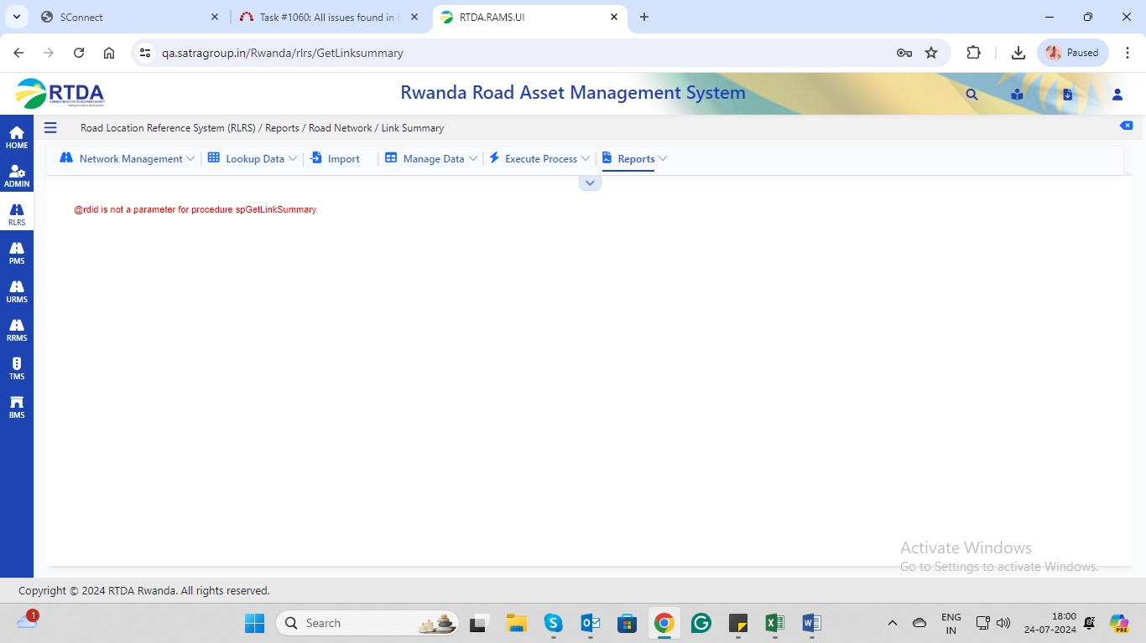

RLRS TEST CASE NO-987

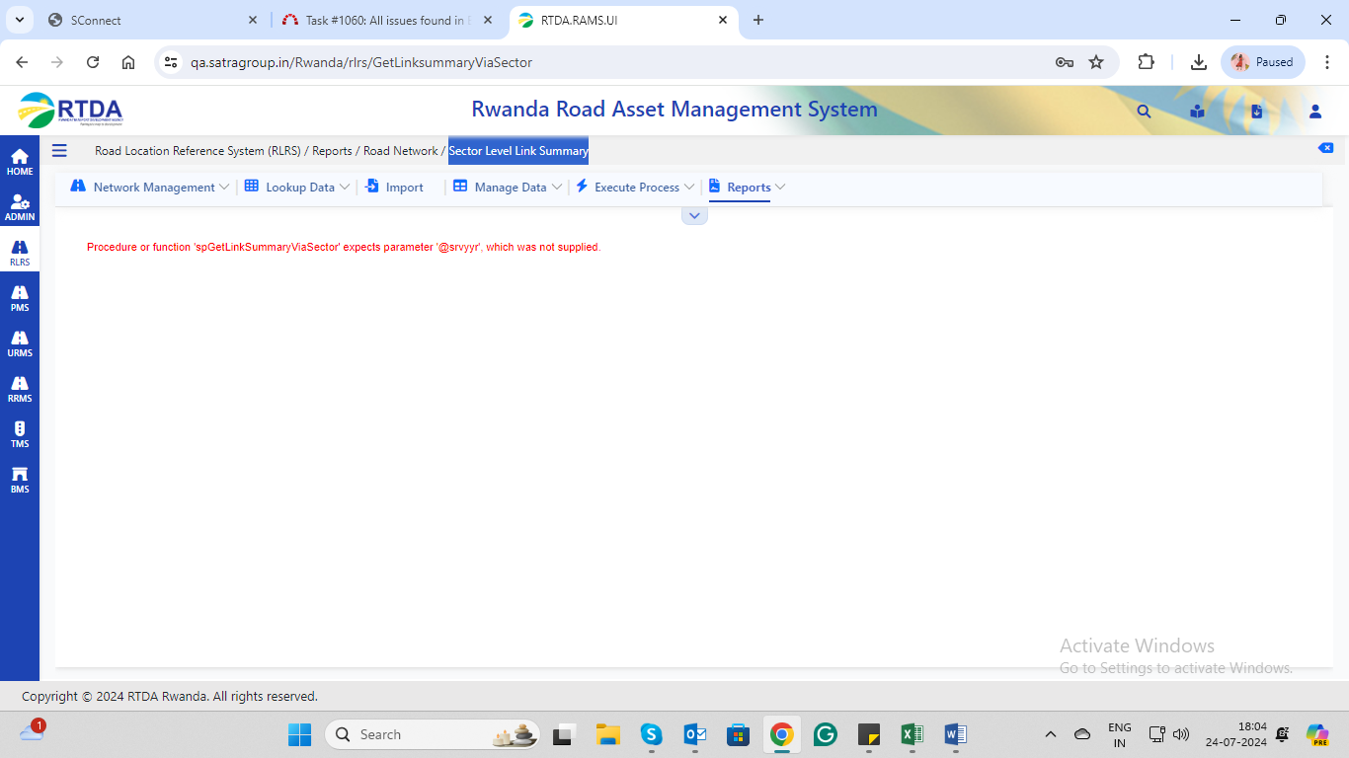

Road Location Reference System (RLRS) / Reports / Road Condition / Unpaved Roughness Summary

RLRS TEST CASE NO -1016

