1. Administrator (ADMIN) / Languages Management without selecting mandatory field subtype, data is displaying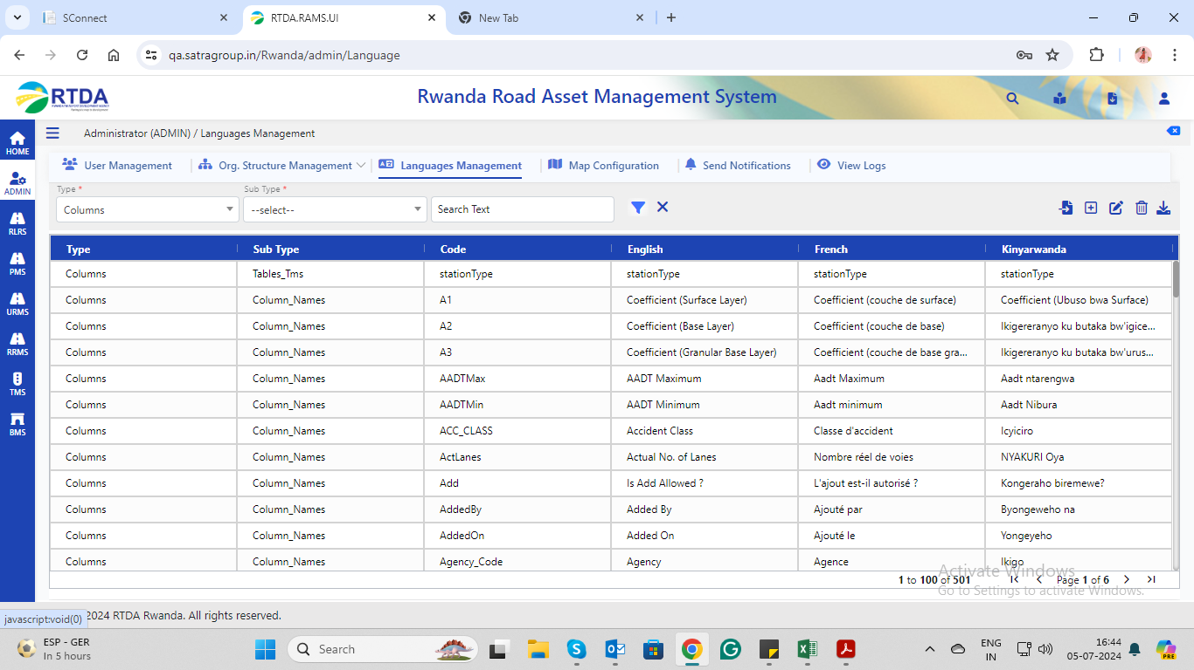
2. Administrator (ADMIN) / View Logs🡪trying to access logs file then an error occurs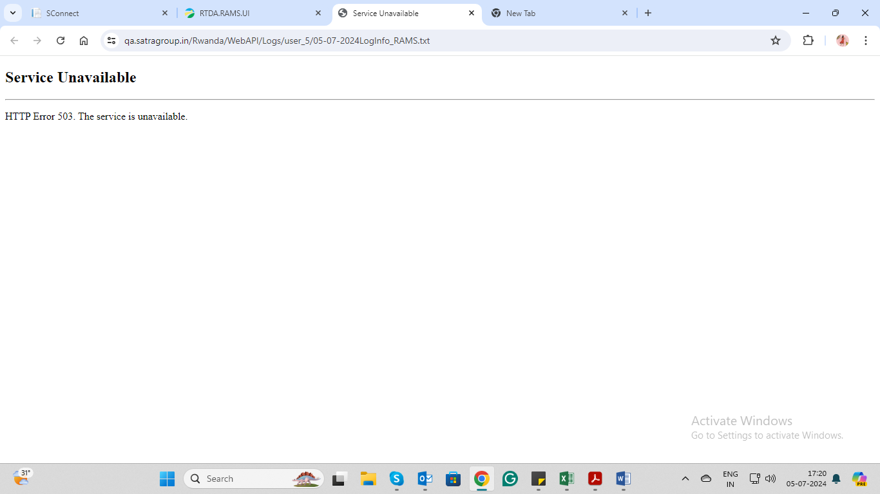
3. Road Location Reference System (RLRS) / Lookup Data / Road Inventory / Landuse->Error occurs as follows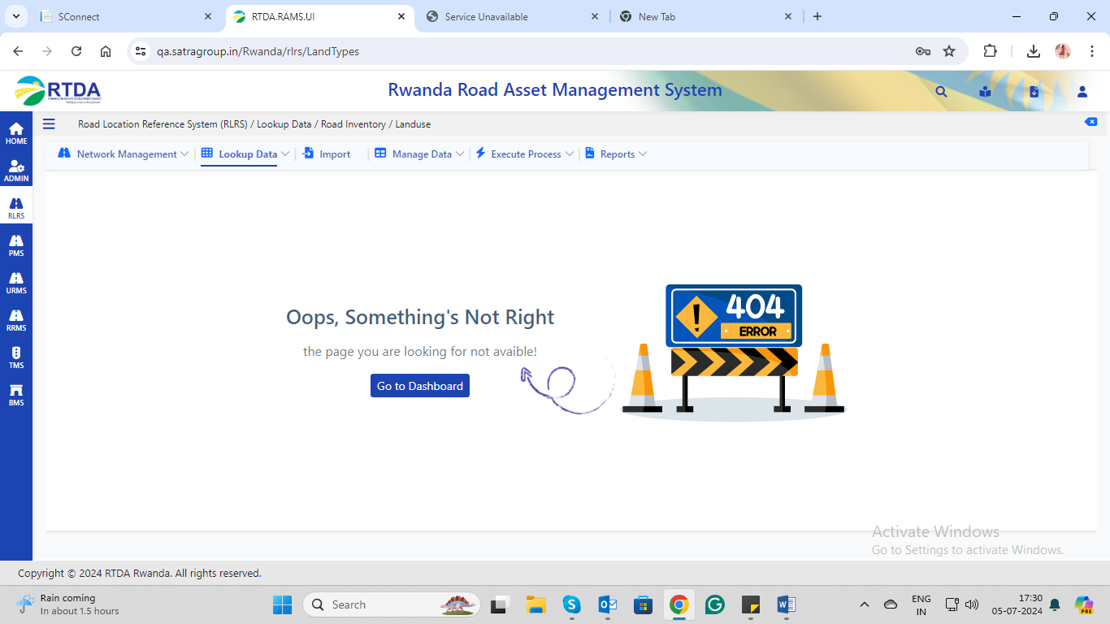

Road Location Reference System (RLRS) / Execute Process / Link Summary🡪execute processing🡪error occurs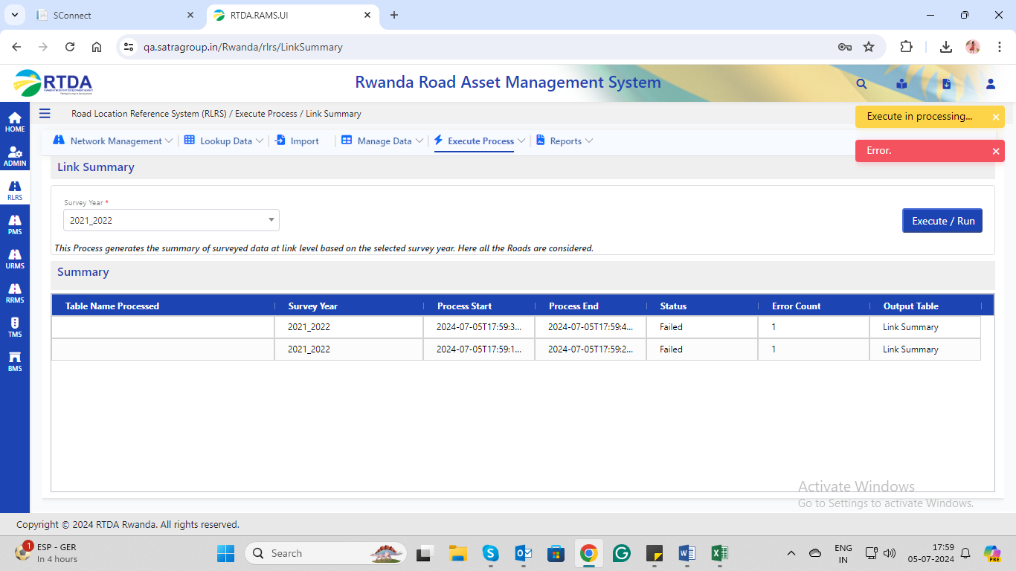5. Exported files are displayed as disabled pdf.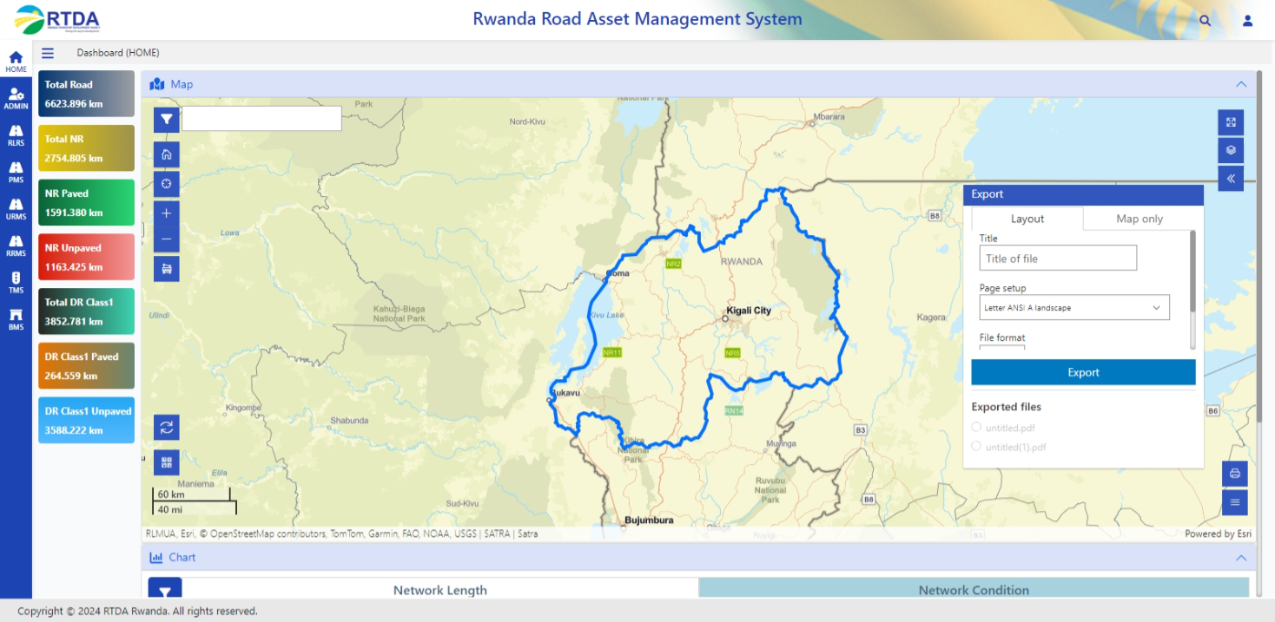6. Scroll down is required near exported files.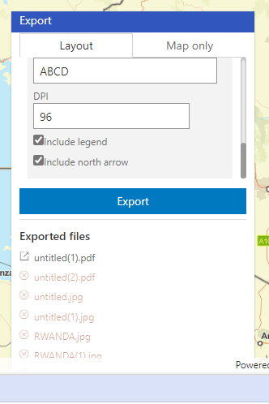

1. Unknown error near exported screen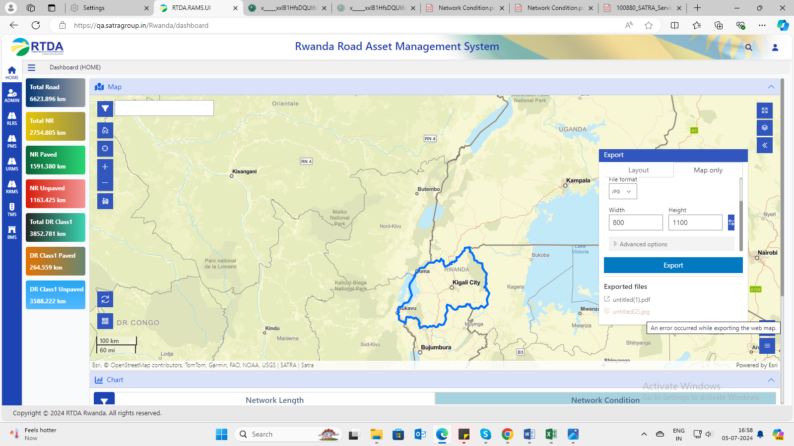
2. The Unwanted Icon is displayed below the national boundary.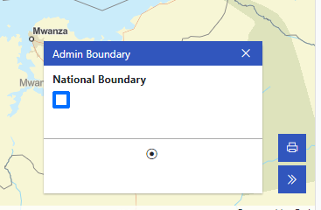
3. Colour different for this alert and layer also displayed in the map.