1. Add this in physician login

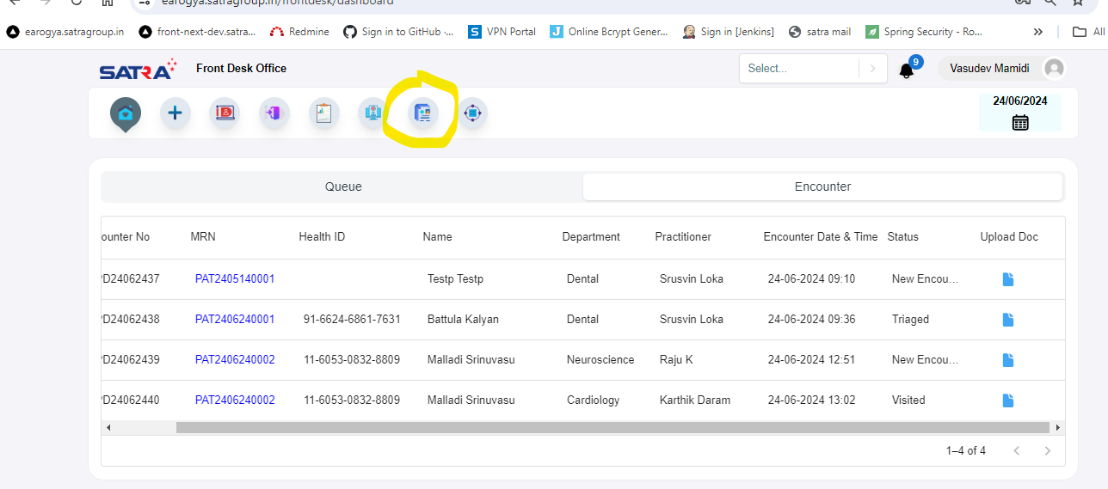

1. Made link for uploaded document (view)

And show patient details in patient and encounter details in banner

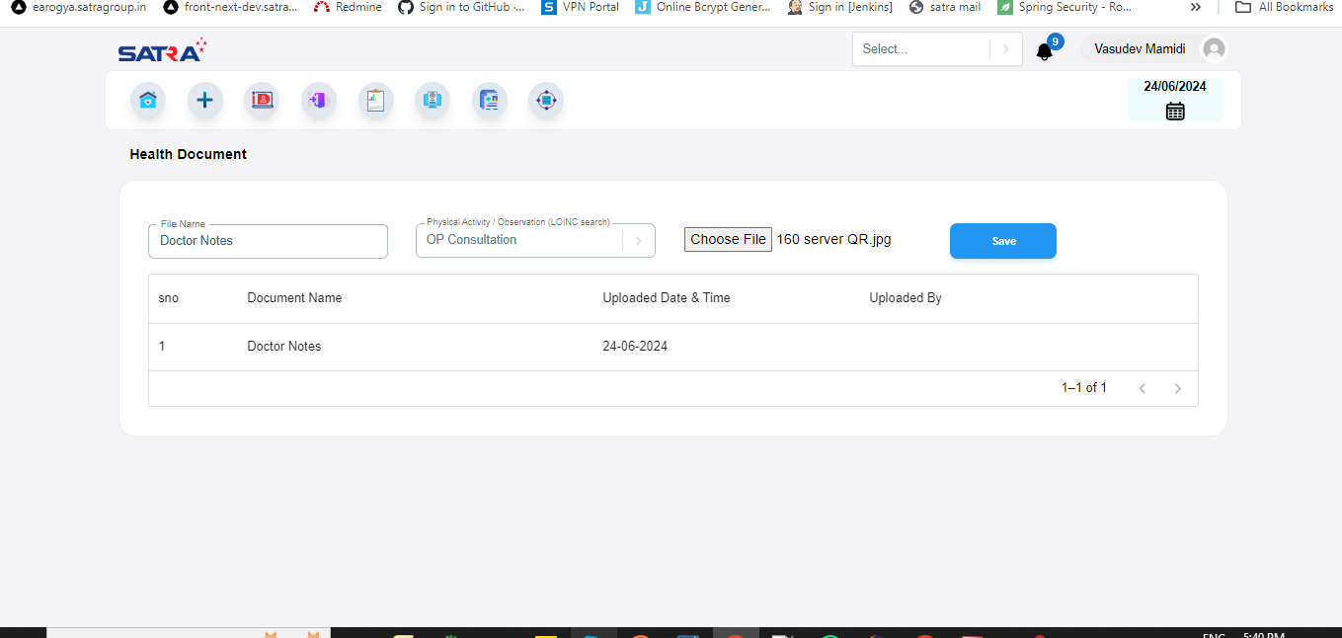

1. Add this in front desk

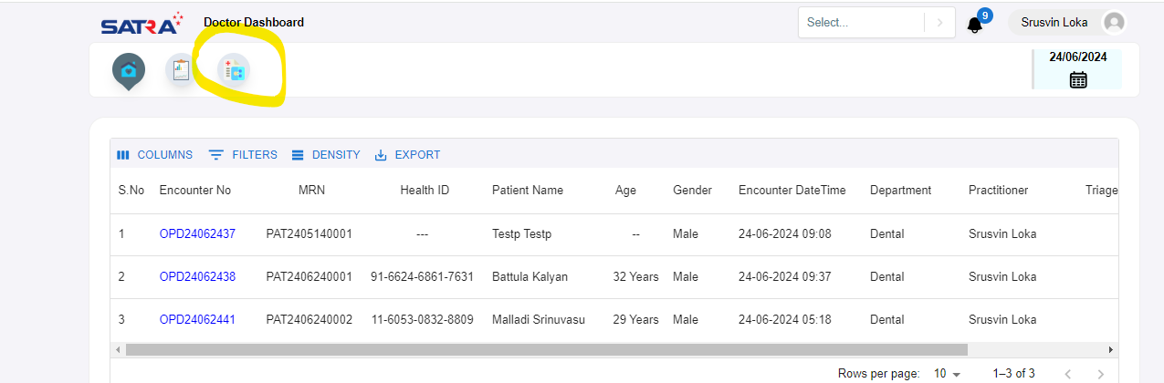

1. Allergy entry is not saving in EMR

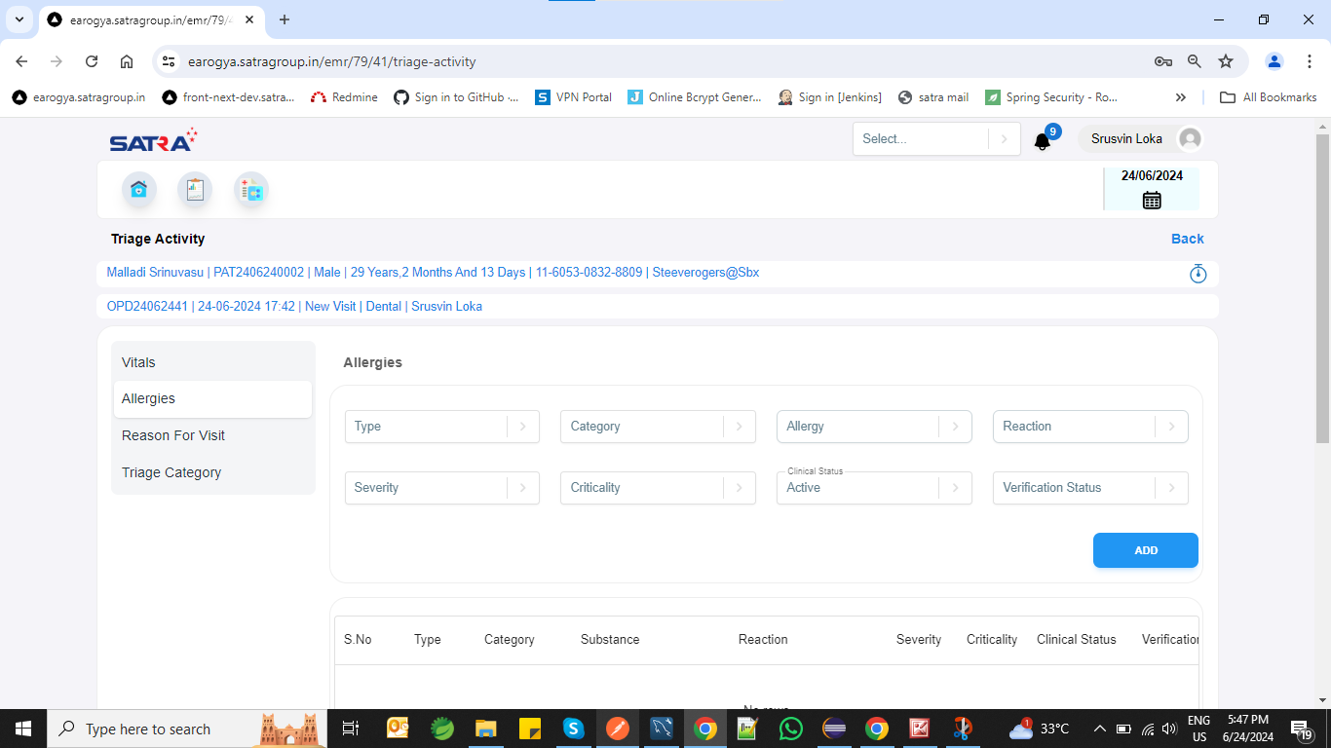

1. Encounter screen buttons not display (Need to check once)

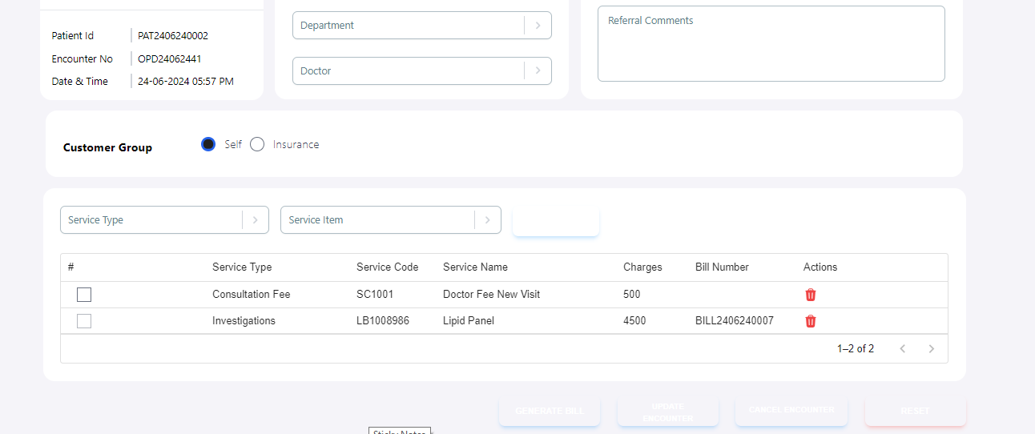

1. Not saving

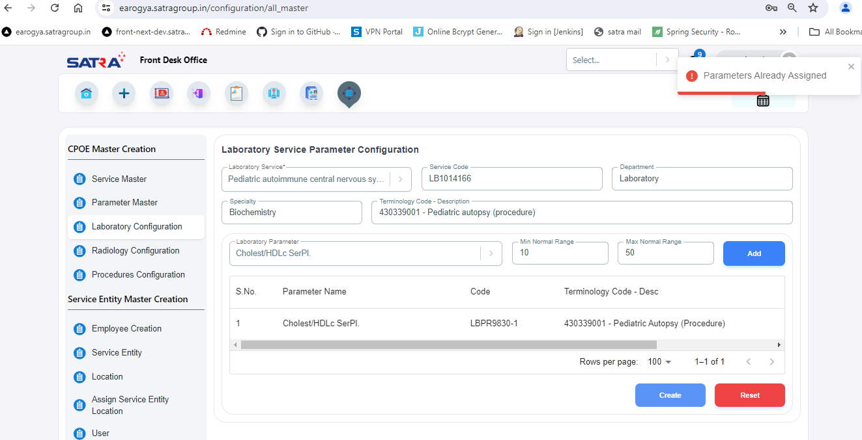

1. Request sends records not displaying before approving by patient

Columns grant date and exp date not display

1. Result entry for lab test, rad test
2. Diagnostic report bundle generation for the result

