1. Dashboard-> Unwanted space displayed between graphs  
   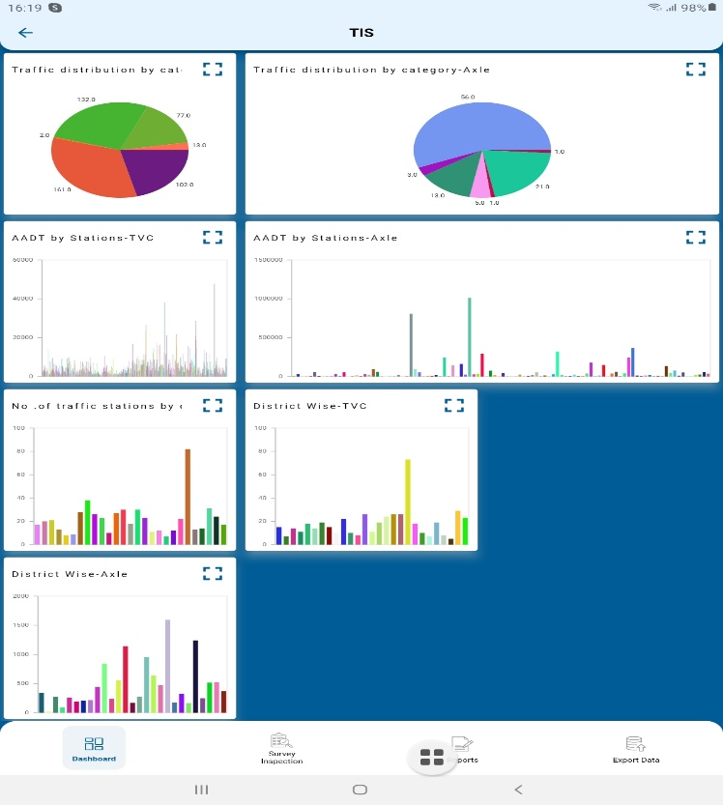  
     
     
   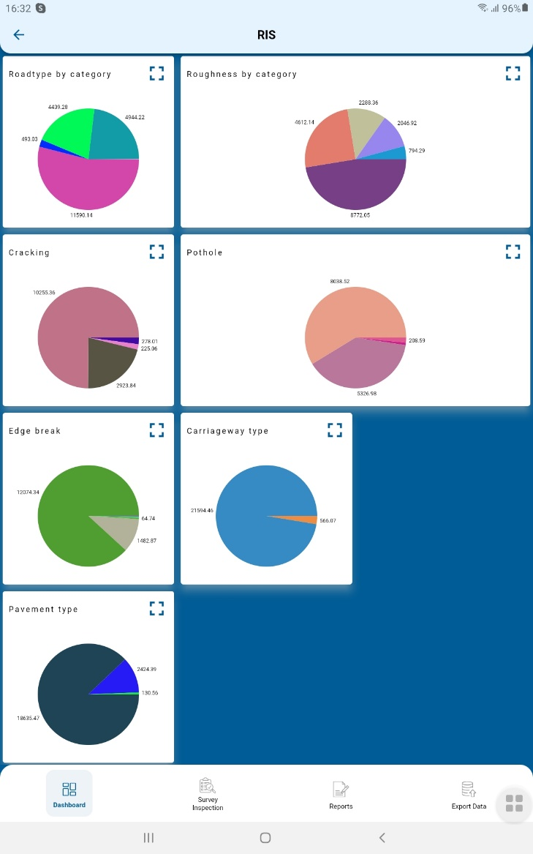

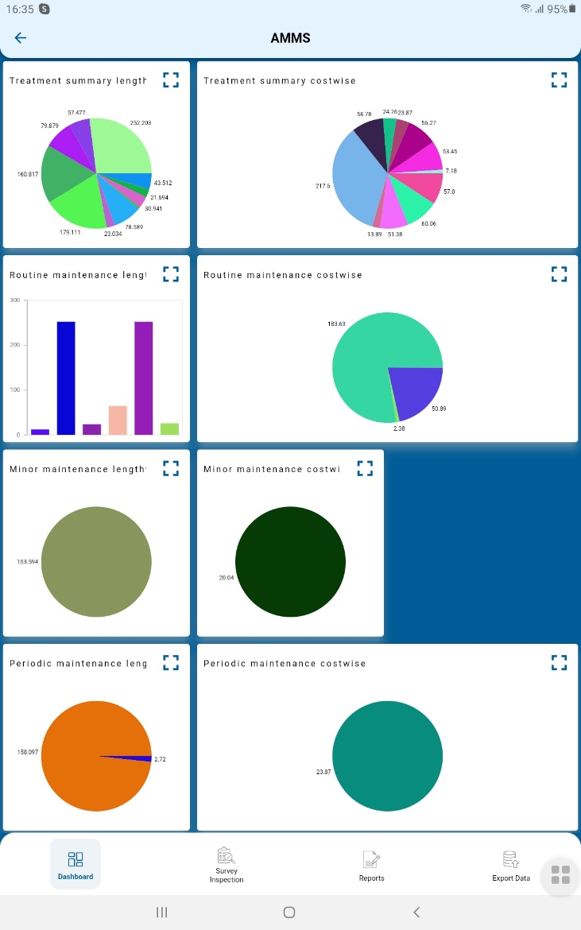

1. Charts need to be displayed in full screen.  
   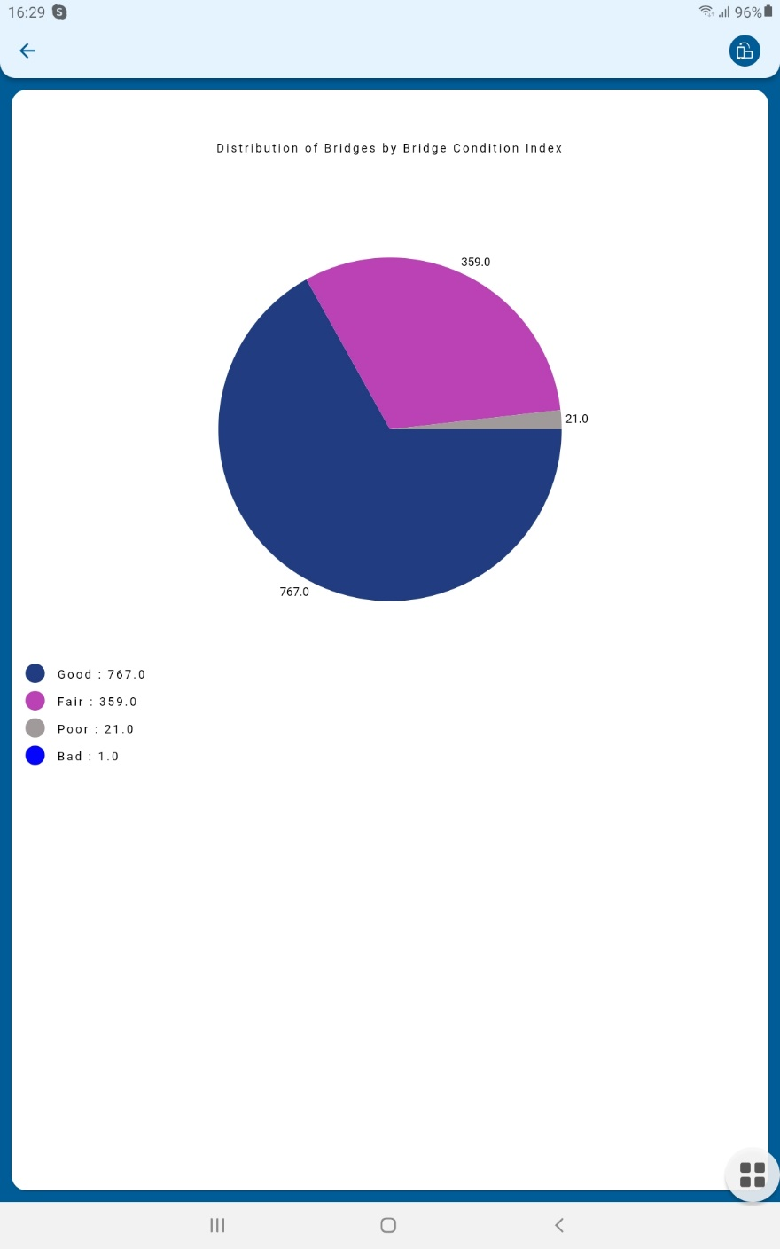
2. After clicking on the GIS module if we click the back button, the page gets struck.  
   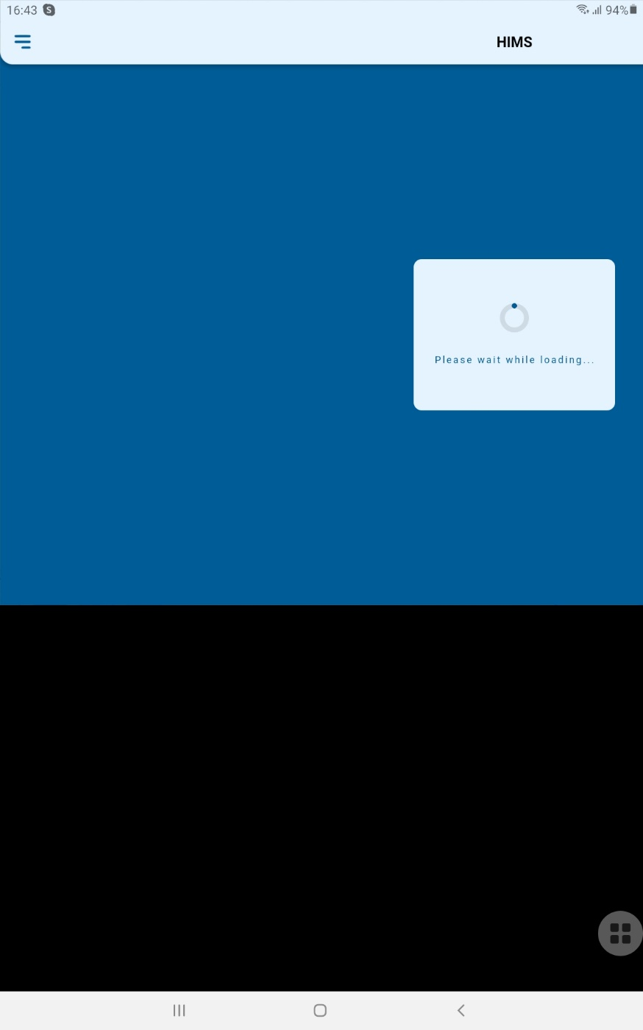
3. After clicking on **clear**-> all fields are not getting cleared.-> Road ID, Start Chainage, and end chainage.  
   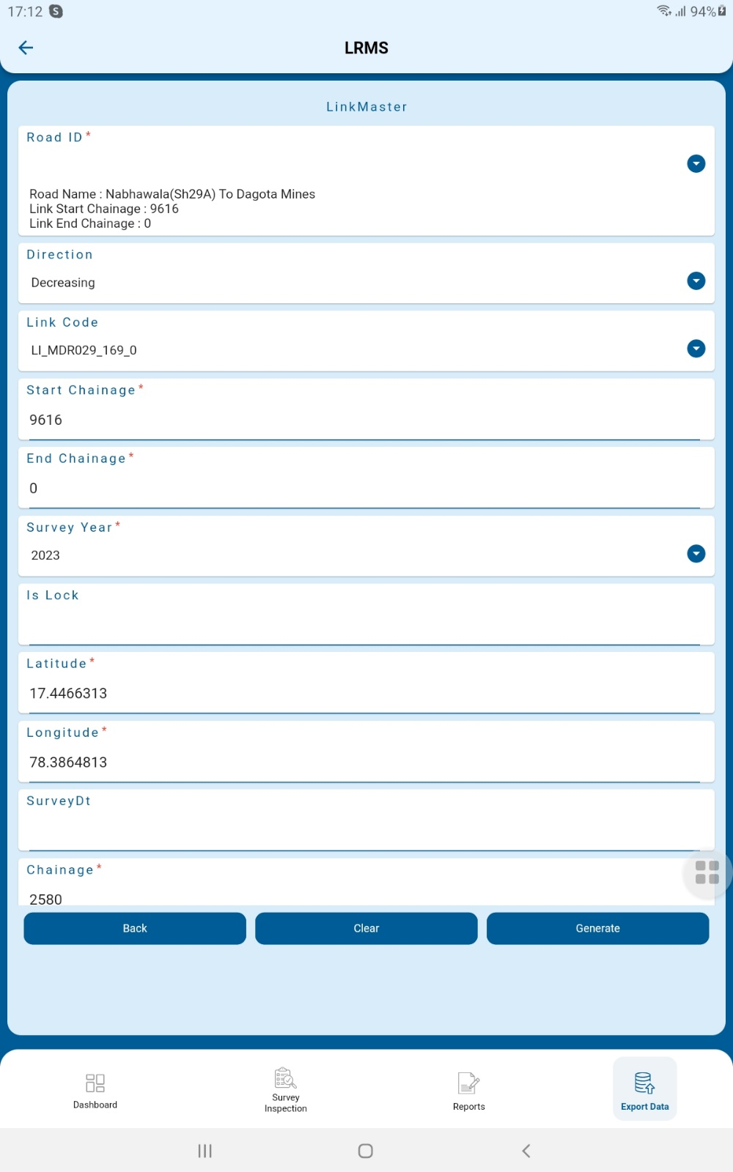  
   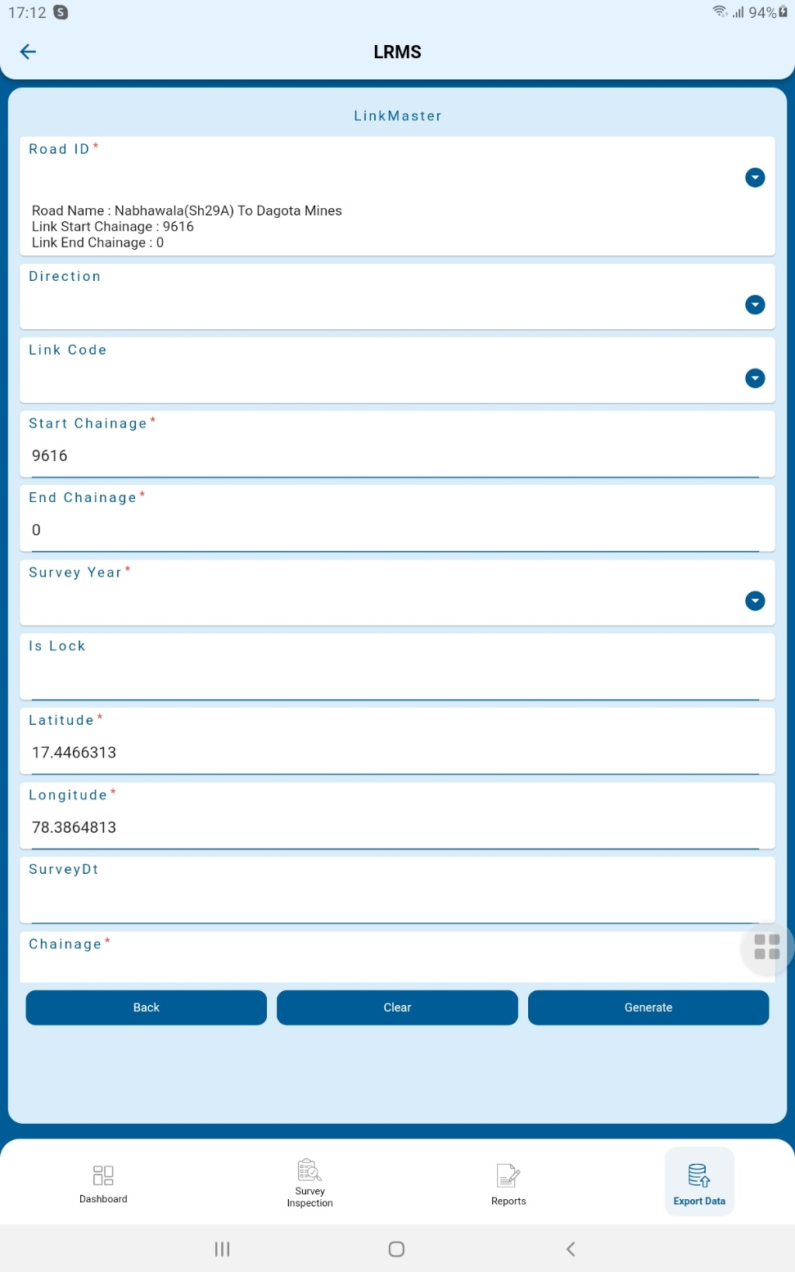
4. Uneven alignment in export data screen.  
   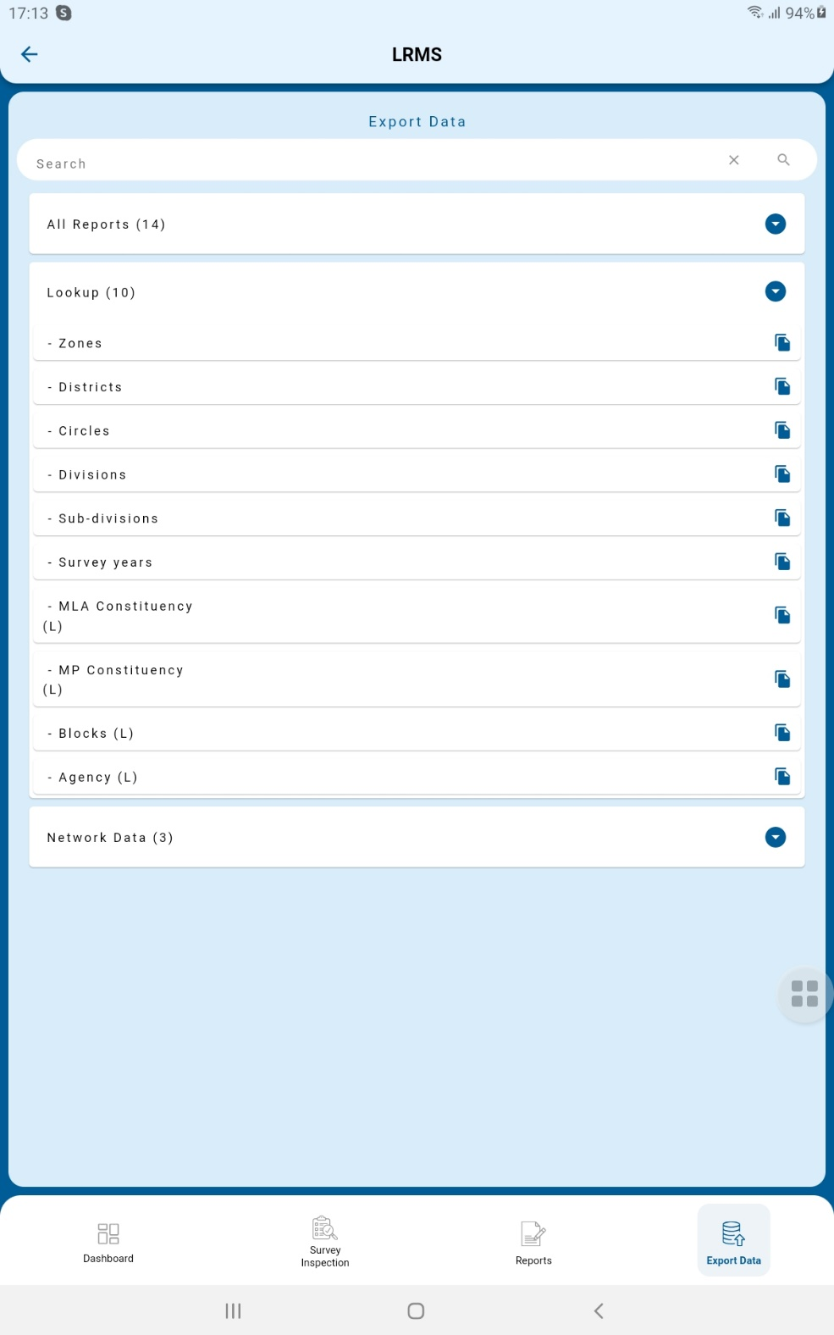
5. Without entering mandatory fields if we click on generate it is displaying the report.  
     
   