1)Employee Joined year is enough previous not needed and also month

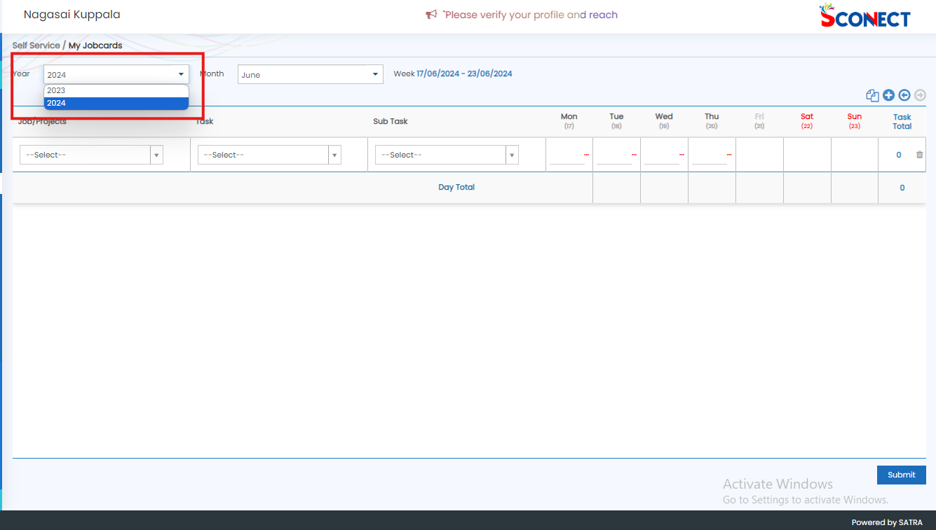

2)mostly checked all variables assigned to their respective Not Found any Unused Variables in jobcards

 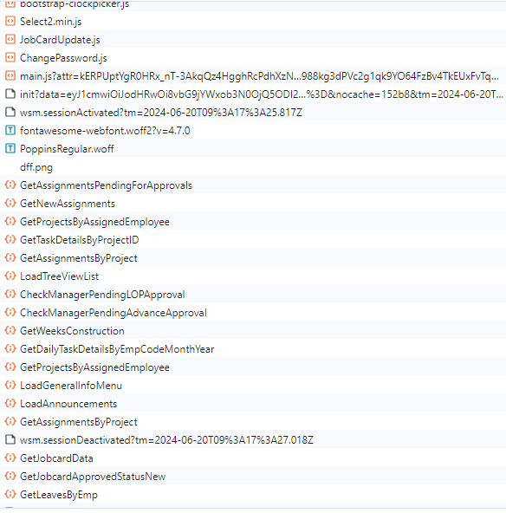

Hits

-----

JobCardUpdate.js-Normal

GetProjectsByAssignedEmployee-Normal

GetTaskDetailsByProjectID-Normal

GetAssignmentsByProject(2 times calling)

GetLeavesByEmp-Normal

GetJobCardData-Normal

GetDailyTaskDetailsByEmpcodeMonthYear-Normal

GetAssignmentsPendingForApproval-Normal

Commonly called

ChangePassword.js

GetNewAssignment

LoadTreeViewList

LoadGeneralInfoMenu

Loadannouncments