Sconnect Issues

1.Manage JobCards🡪Approved JobCards,Update Jobcards🡪 upto current month should show

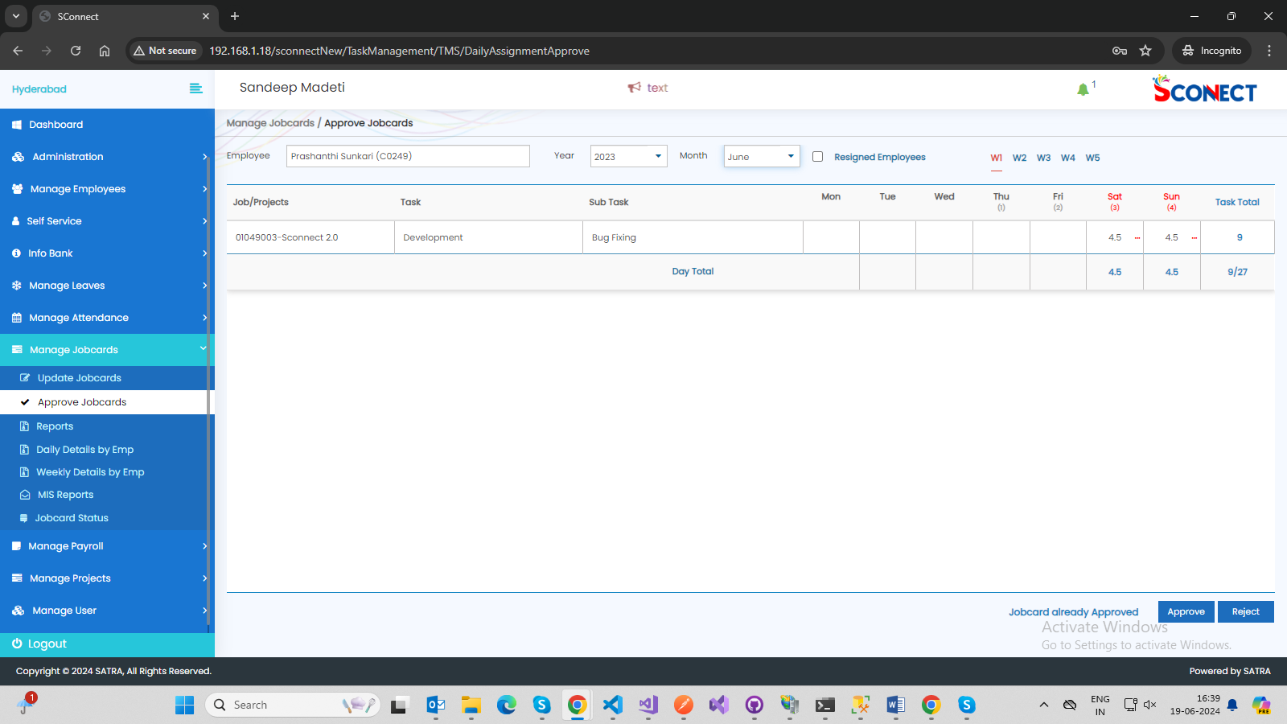

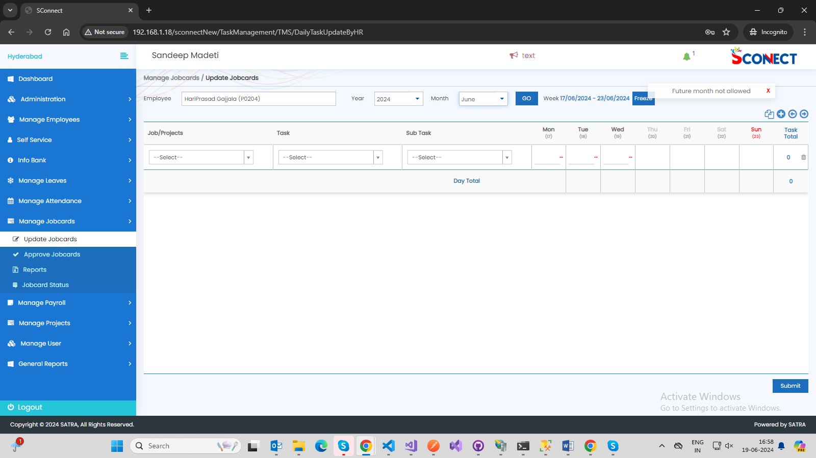

2.Manage Attendance🡪Lock Time Change 🡪while loading the lockin time is showing 10:00

Instead of hh:mm(Only when clicking reset its showing)

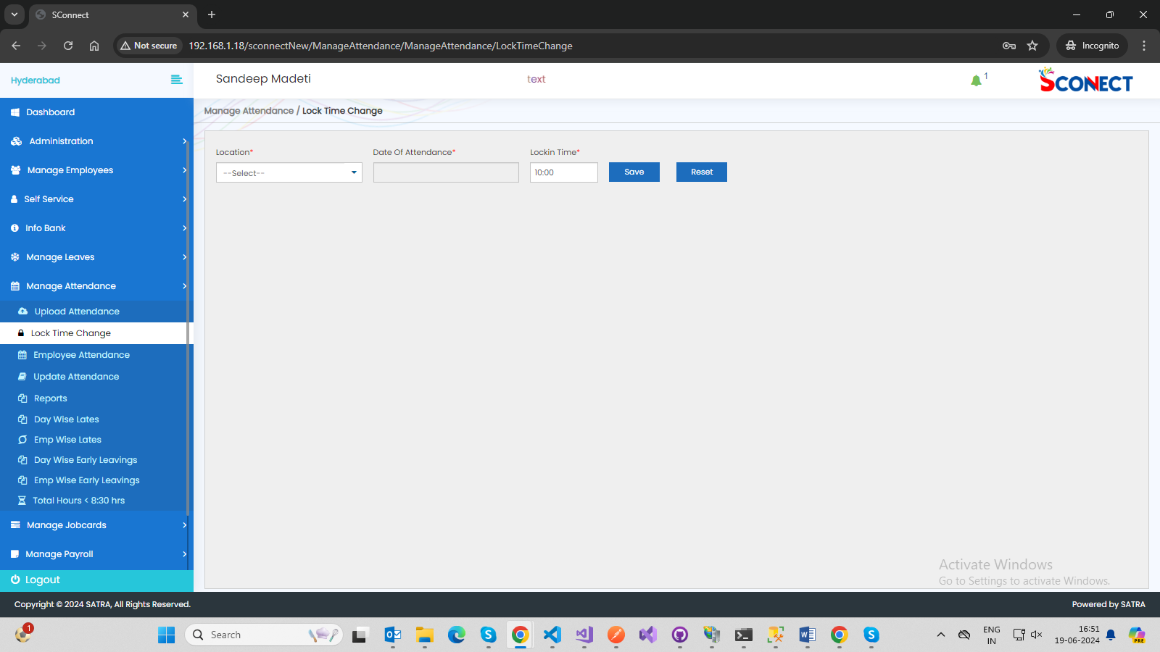

3.Manage Attendance🡪Upload Attendance🡪Lockin,LockOut Time is always fixed value showing

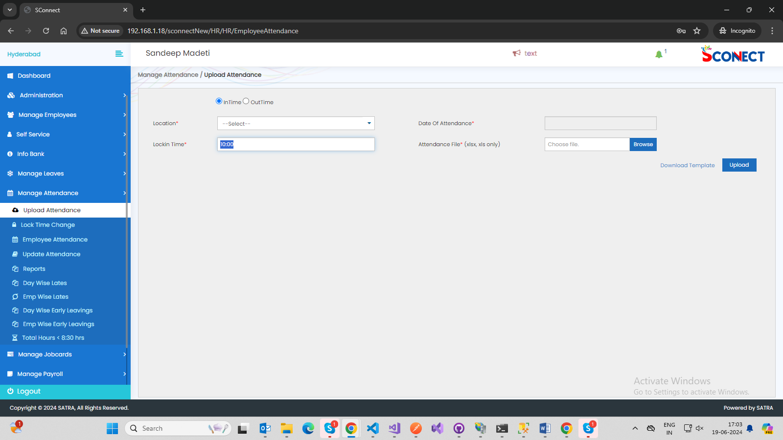

4.Manage Attendance🡪Update Attendance🡪Grid Header Missing

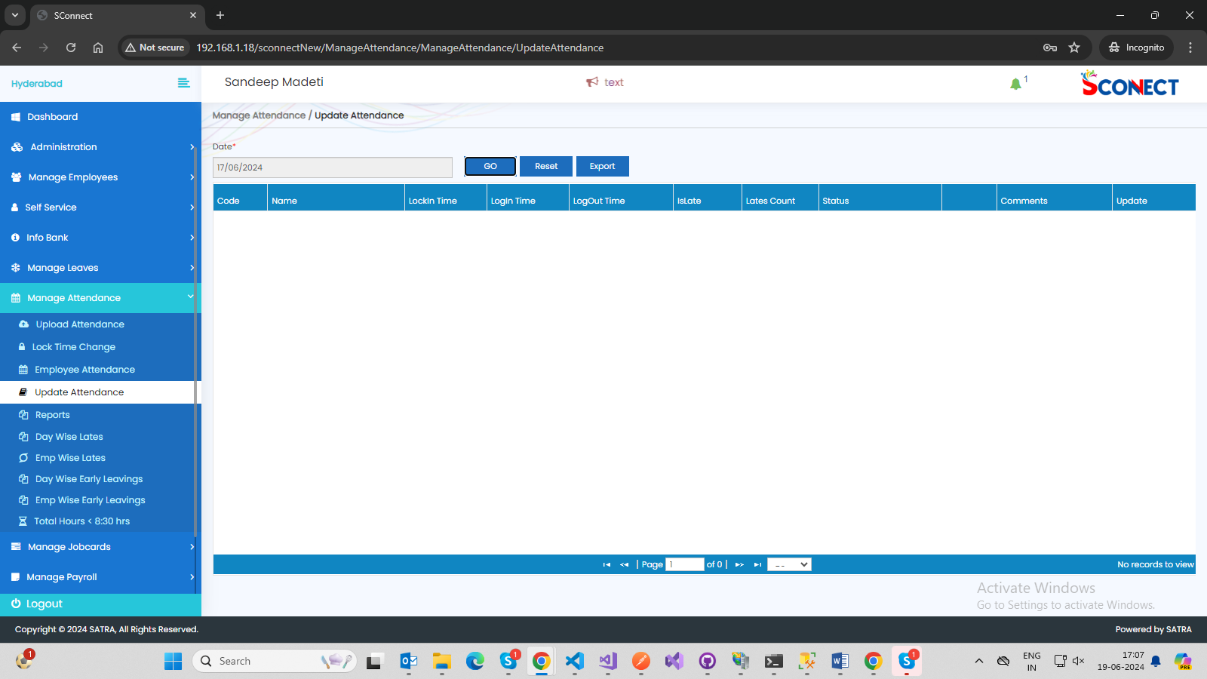

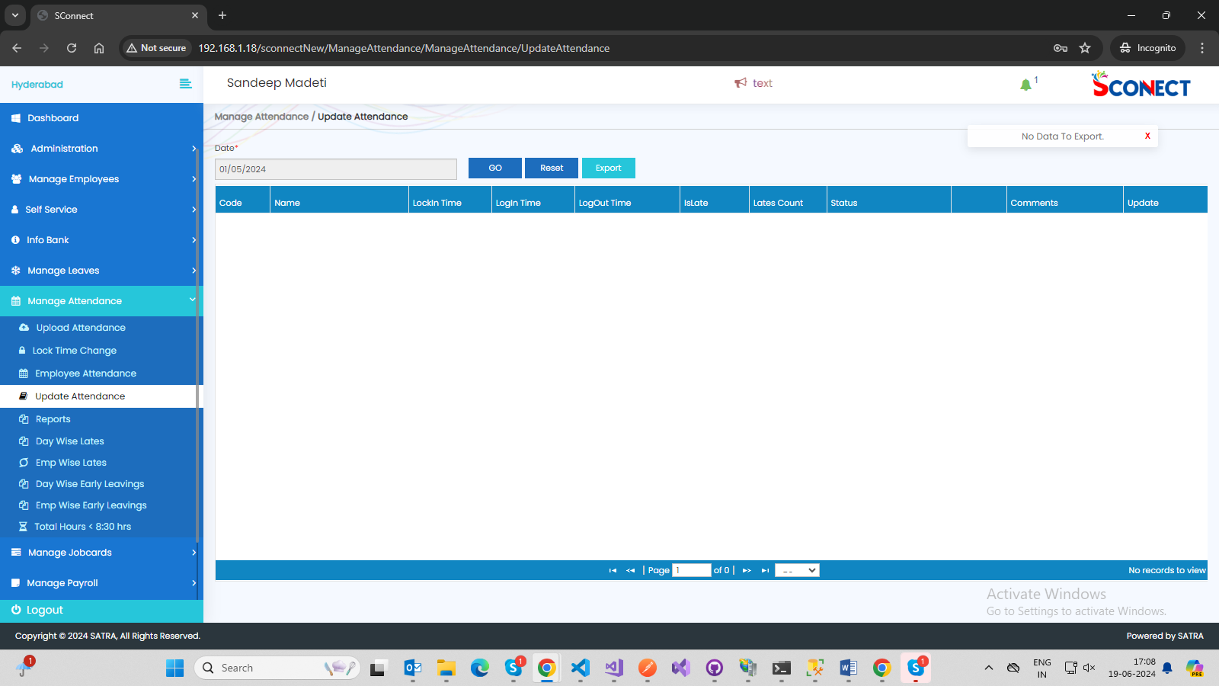

5.Manage attendance🡪Emp Wise Lates,Emp wise Early leavings🡪when employee name entered getting grid when clicking anywhere.(without click on GO)

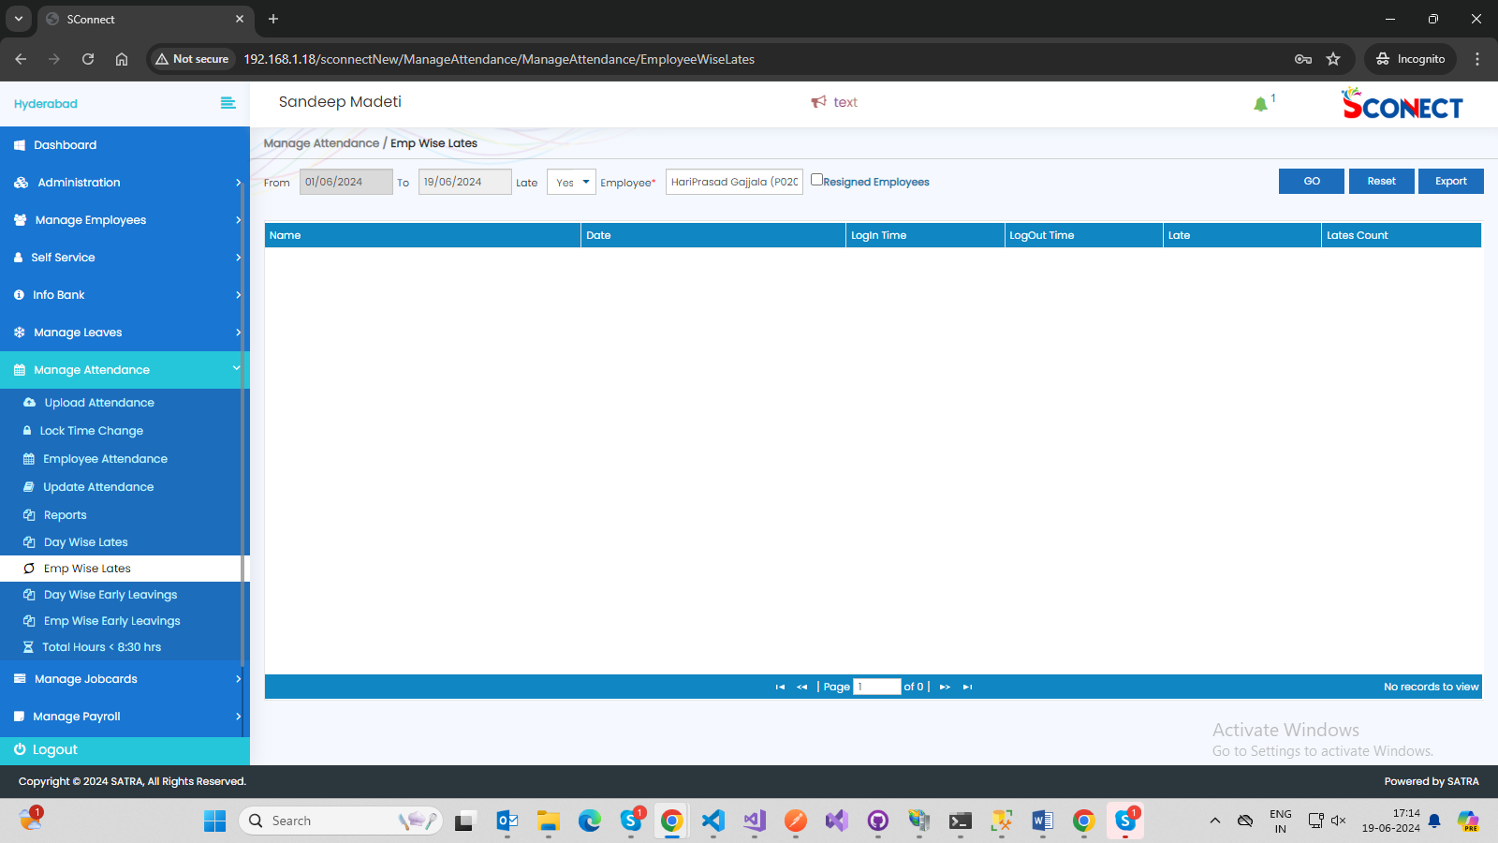

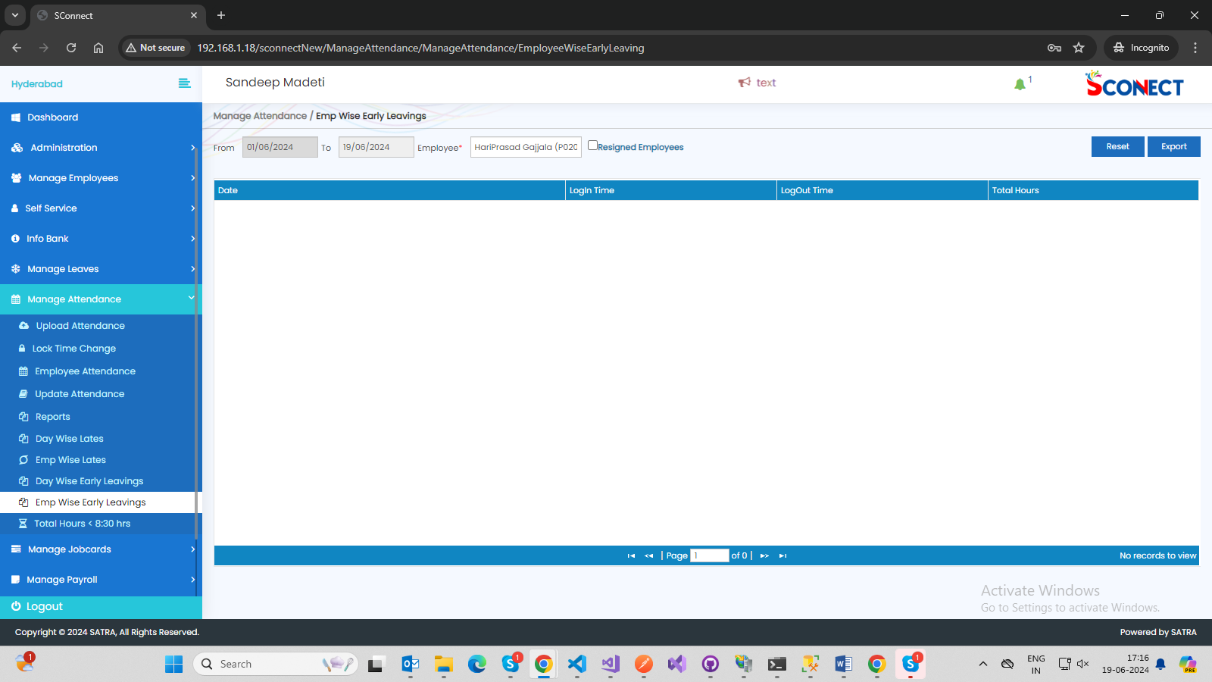

6.Manage Leaves🡪Pending Leaves🡪No Sorting in grid and page no issue

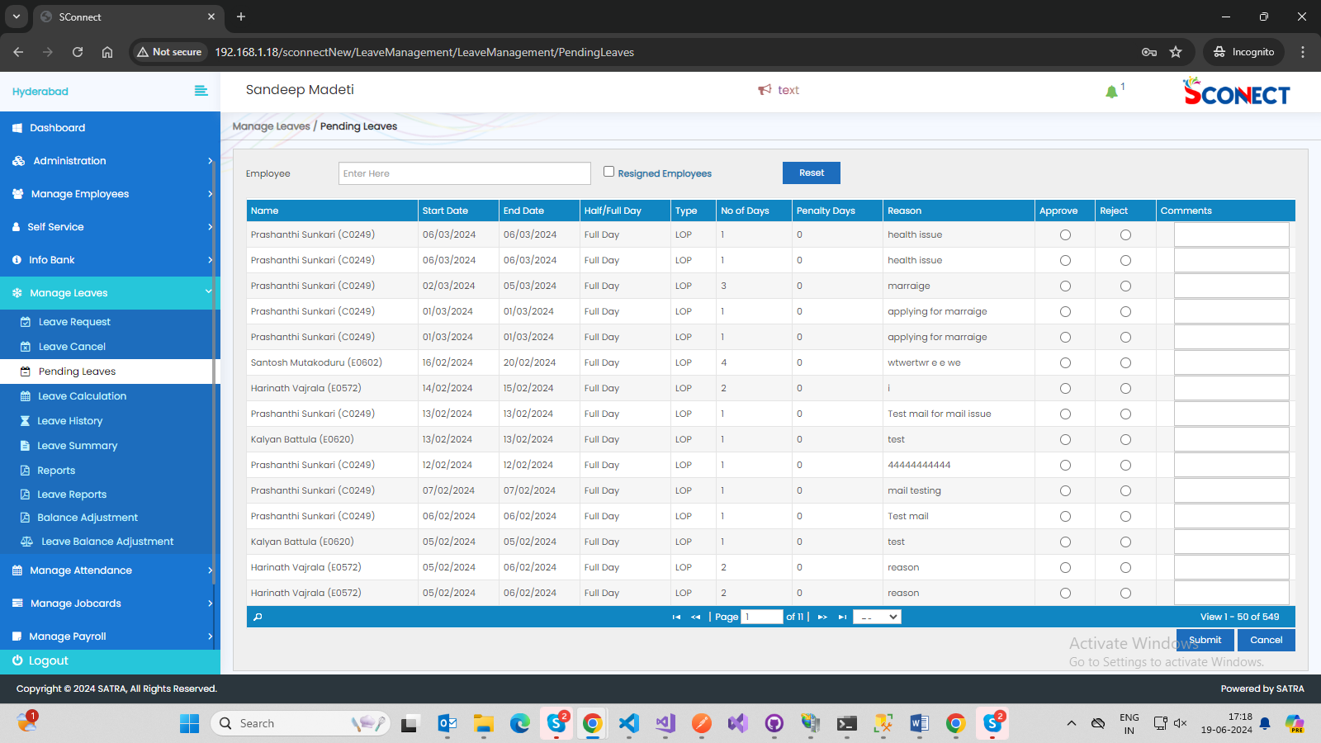

6. Manage Leaves🡪Manage Leaves🡪employee joining year is enough not needed Previous years

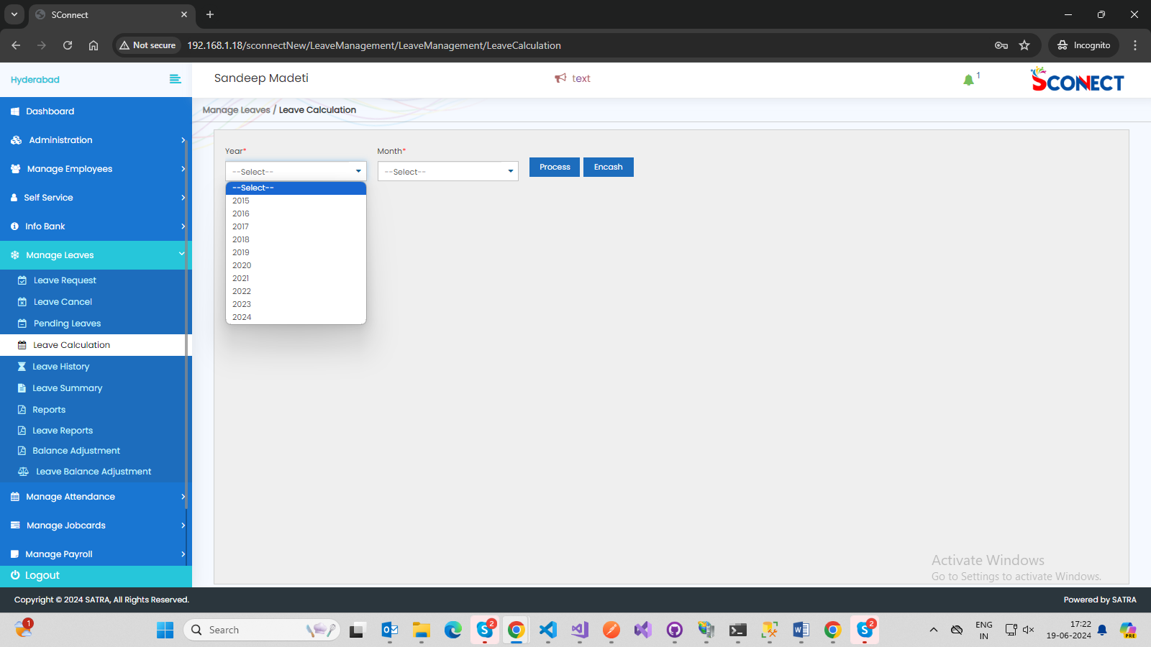

7.Manage Leaves,Manage Attendance,Manage JobCards🡪Page No issue In all of these Mentioned

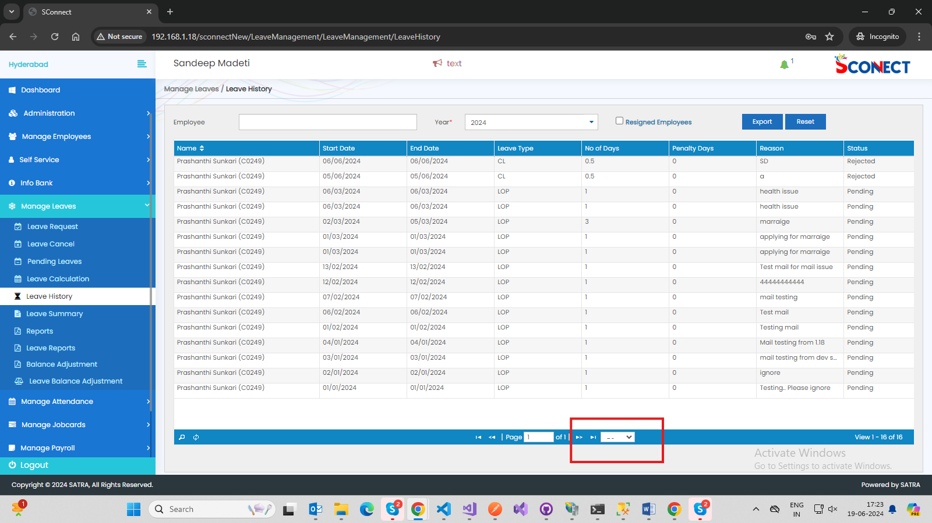

8.Manage Leaves🡪Leave Summary🡪Taking Time to load the grid

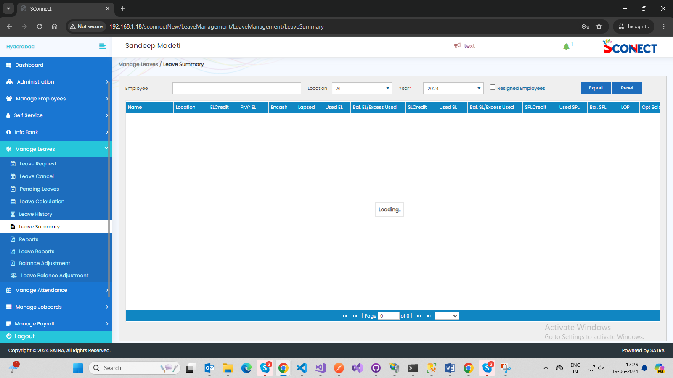

9.Manage JobCards🡪Daily Details By EMP🡪 no sorting in grid

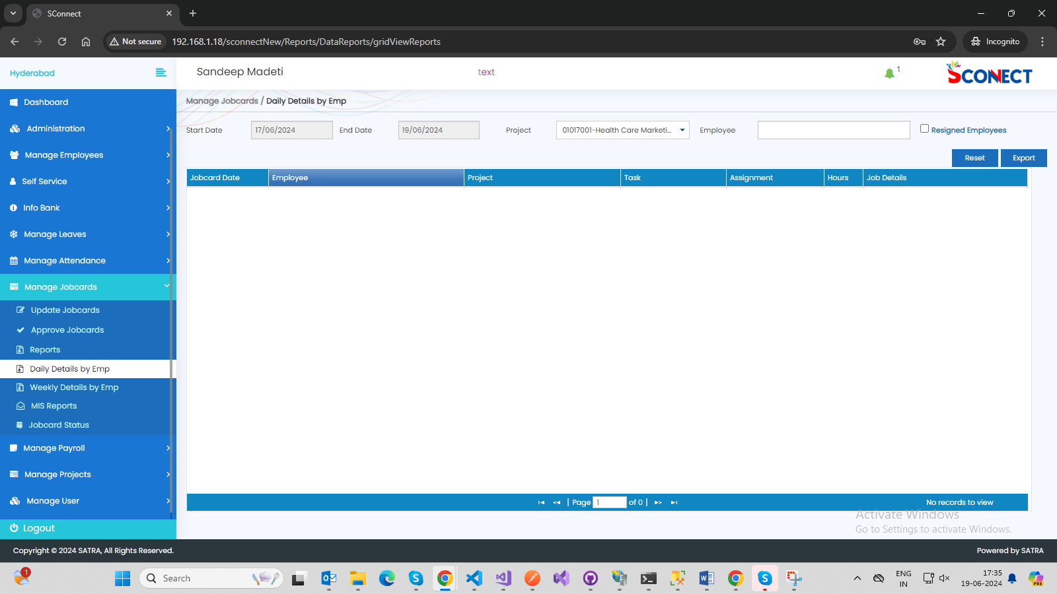

10. Manage JobCards🡪MIS Reports🡪Project Cost By Dept🡪Based on Departments not getting project list

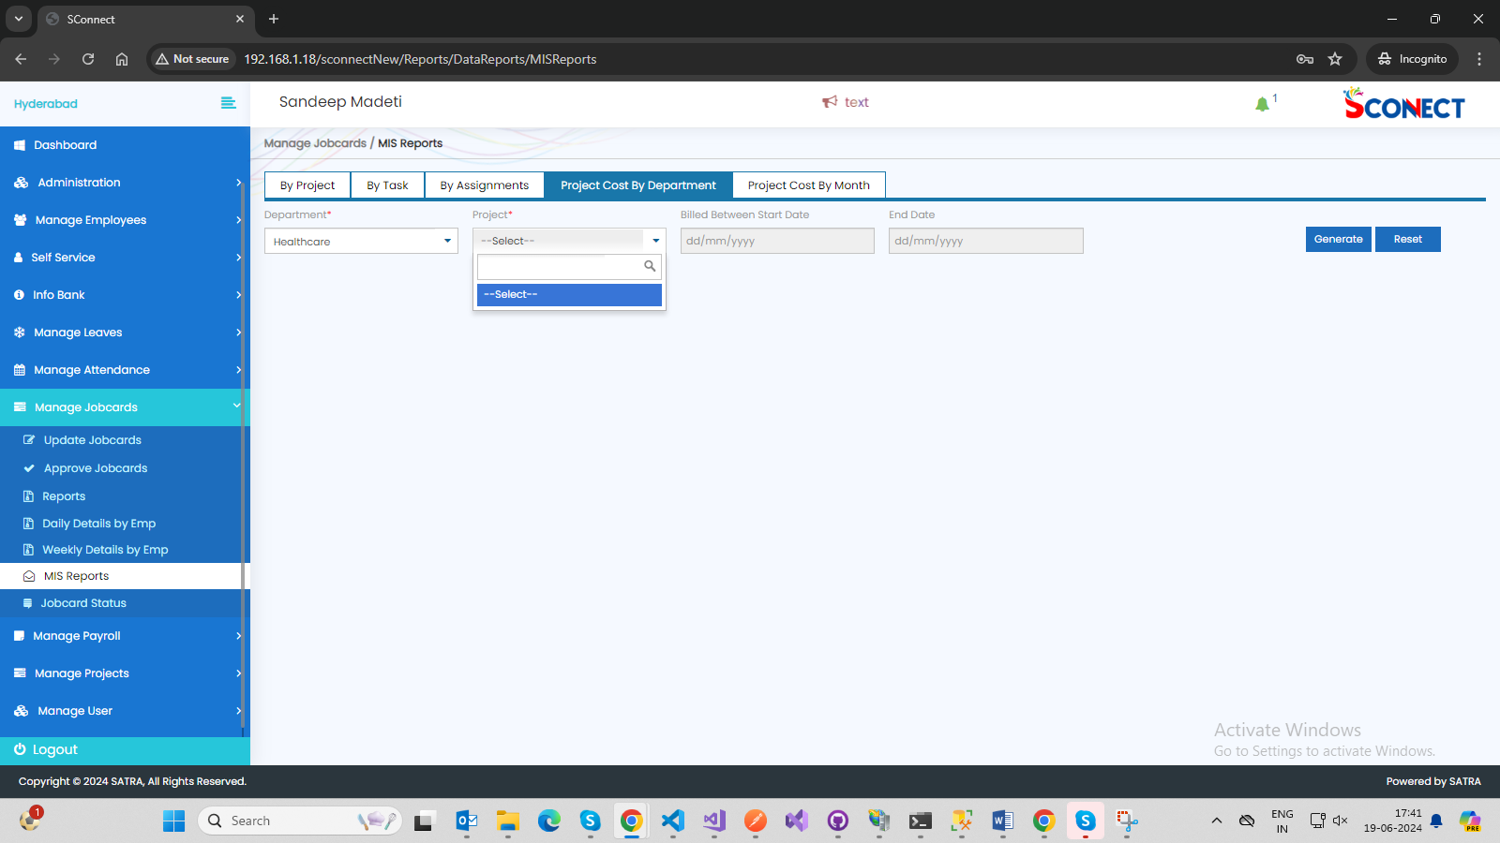

11.Manage Projects🡪Manage Team🡪Alignment issue

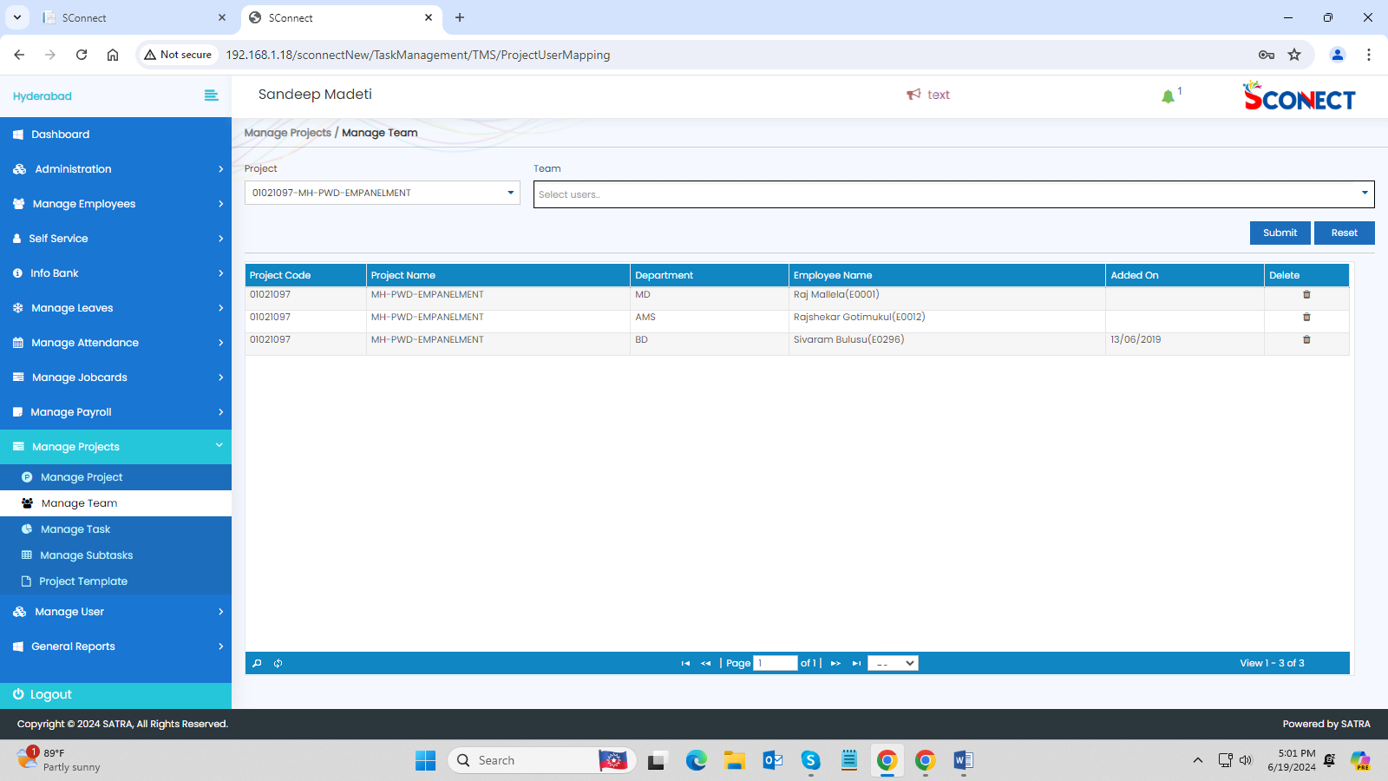

12.ManageUser🡪User Definition🡪Alignment issue

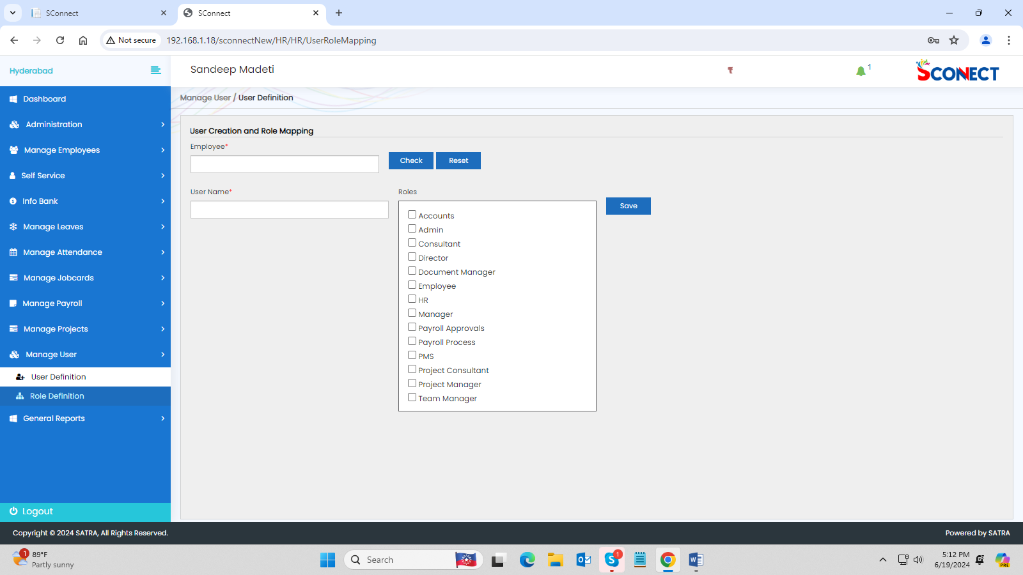

13.General Reports🡪Adhoc Reports🡪AlignMent Issue

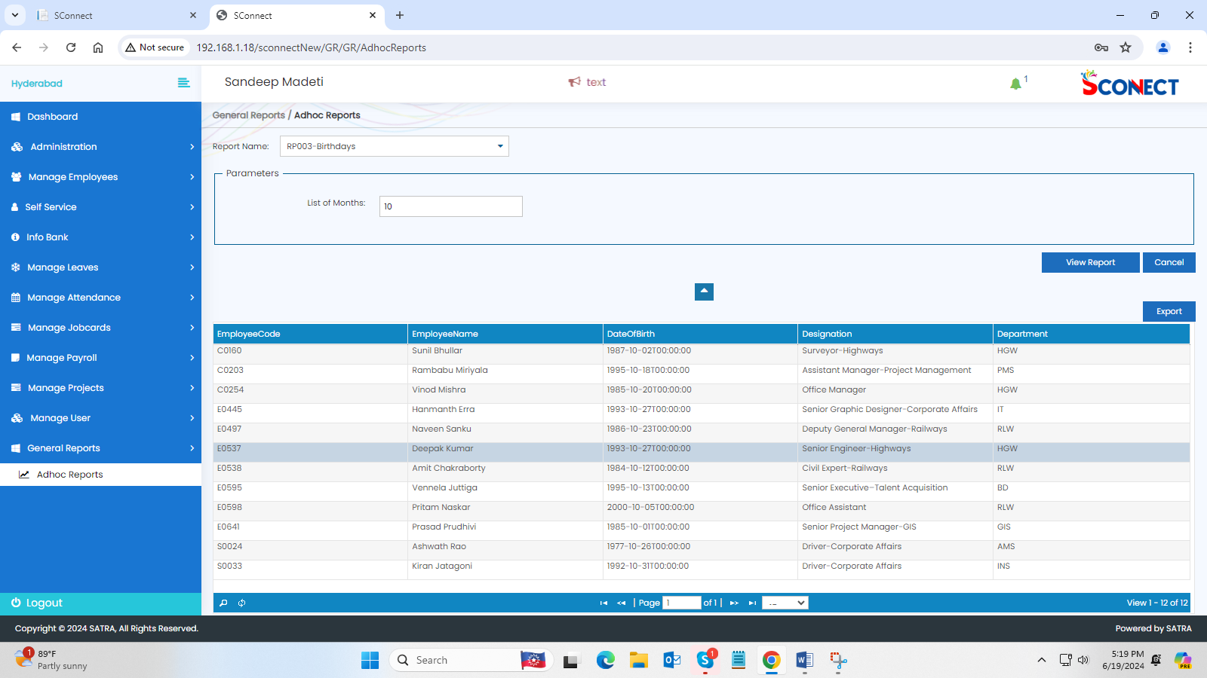

14.Manage leaves🡪Leave Calculation🡪For present year it should be displaying Current month but previous years every month Is not displaying

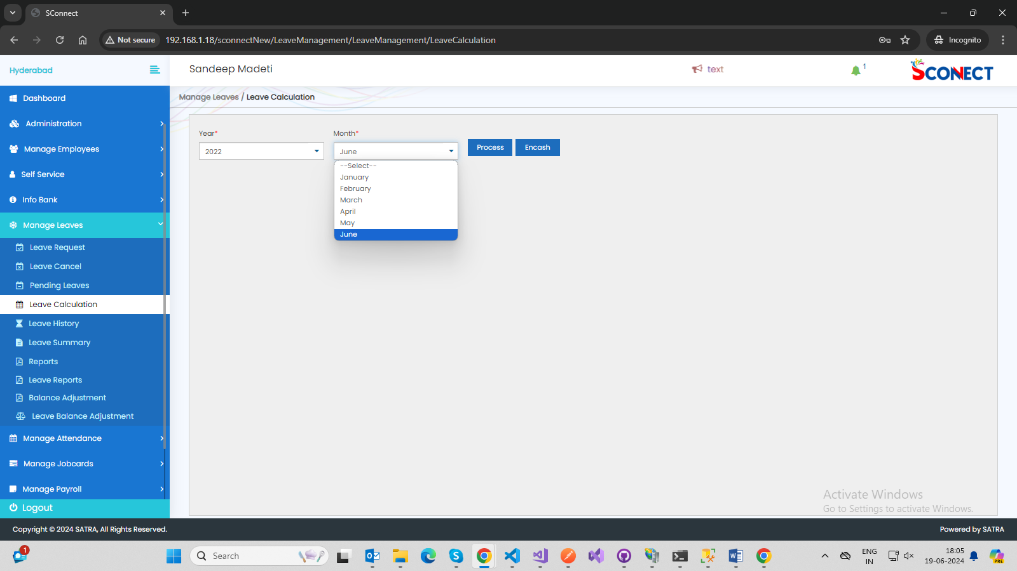

15. sconnectNew/HR/HR/DashboardImages->alignment issue

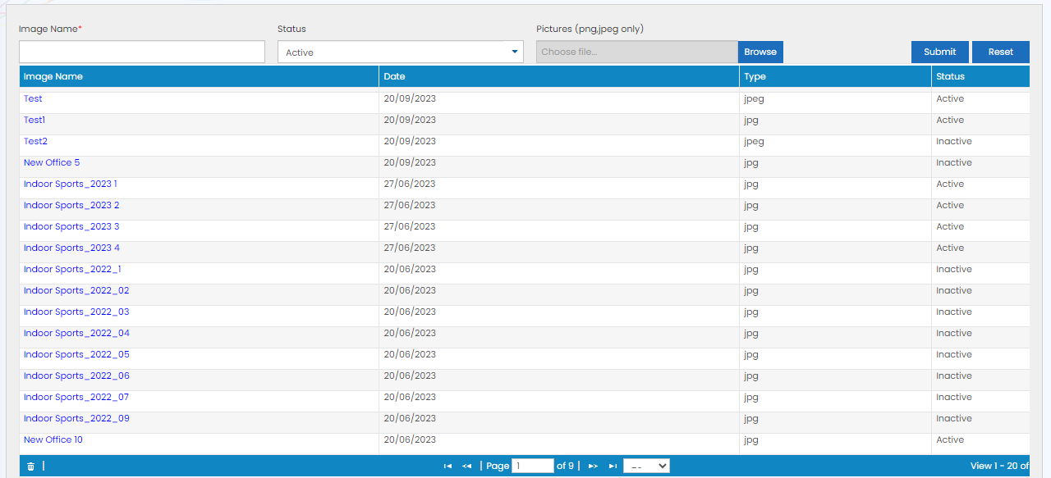

16. sconnectNew/Administration/Admin/Events->Requred to scrollbar

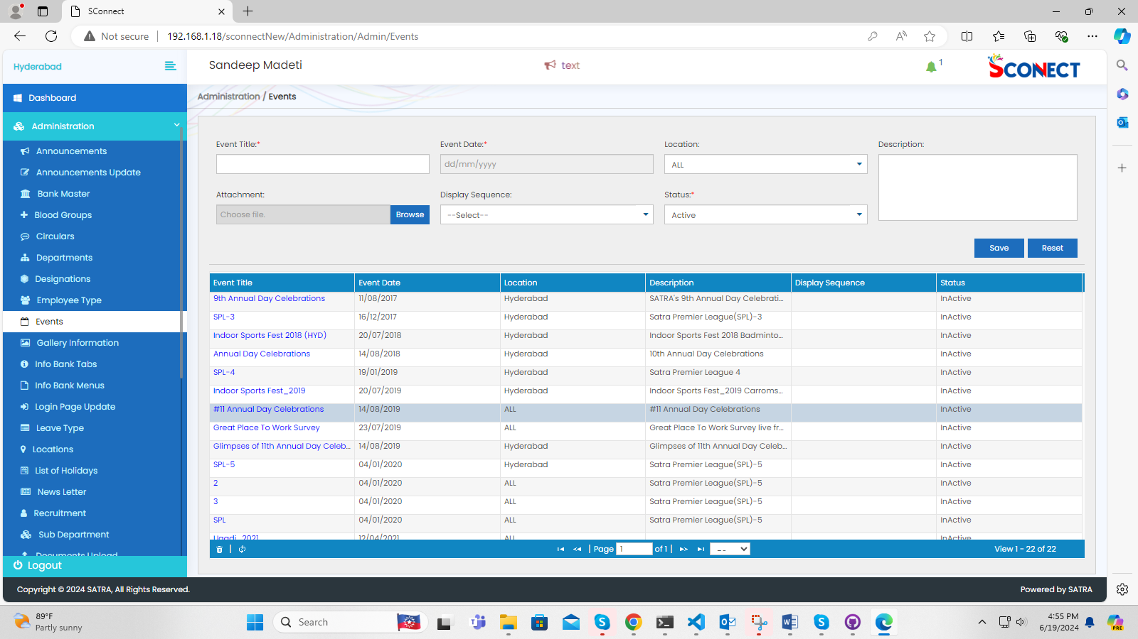

17. sconnectNew/Administration/Admin/EmployeeForms-> alignment issue

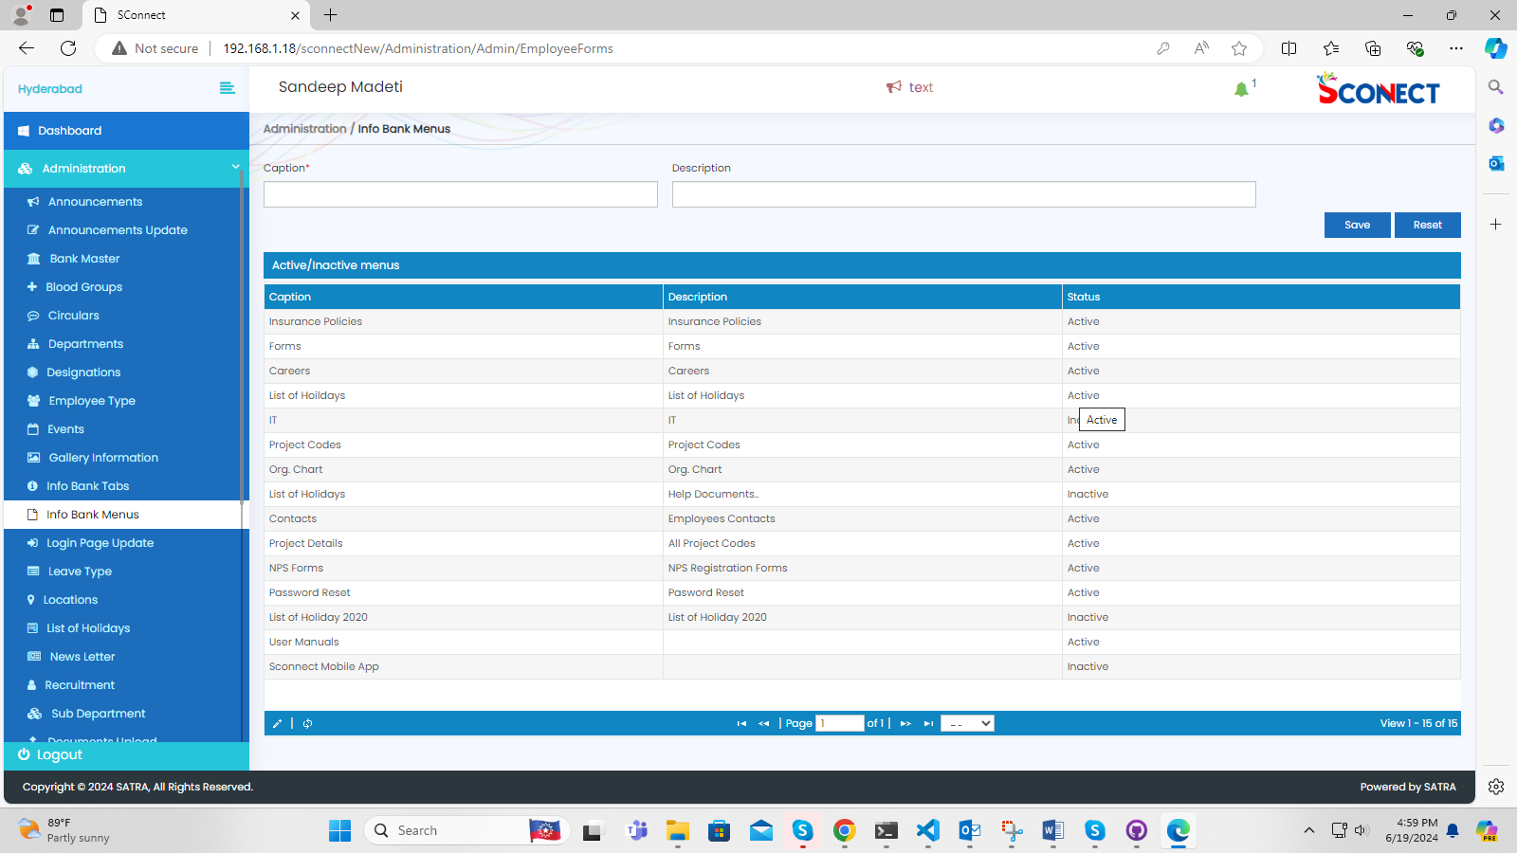

18. sconnectNew/HR/HR/LoginPage->alignmnet issue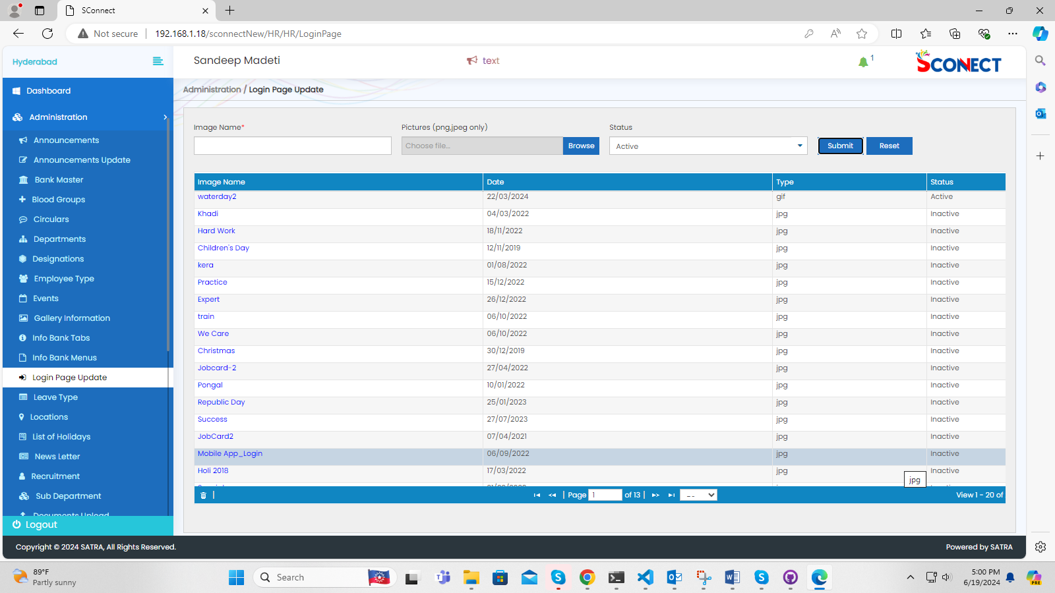

19. sconnectNew/Administration/Admin/NewsLetter->scrol bar issue

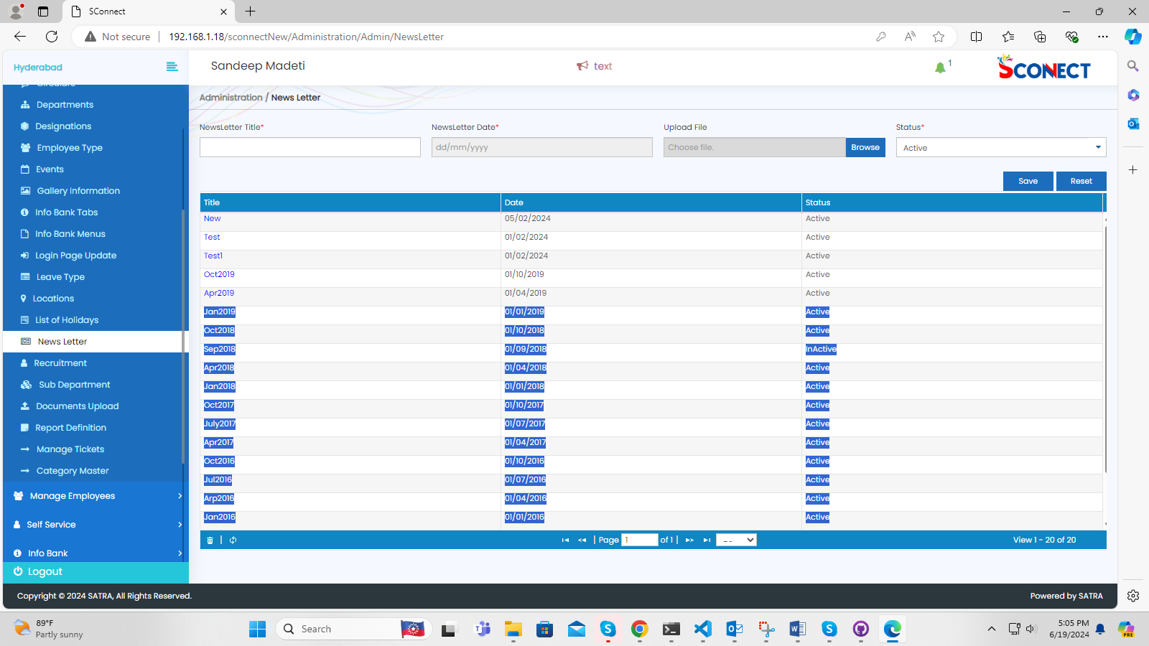

20. sconnectNew/HR/HR/MyReportsHR->alignment issue

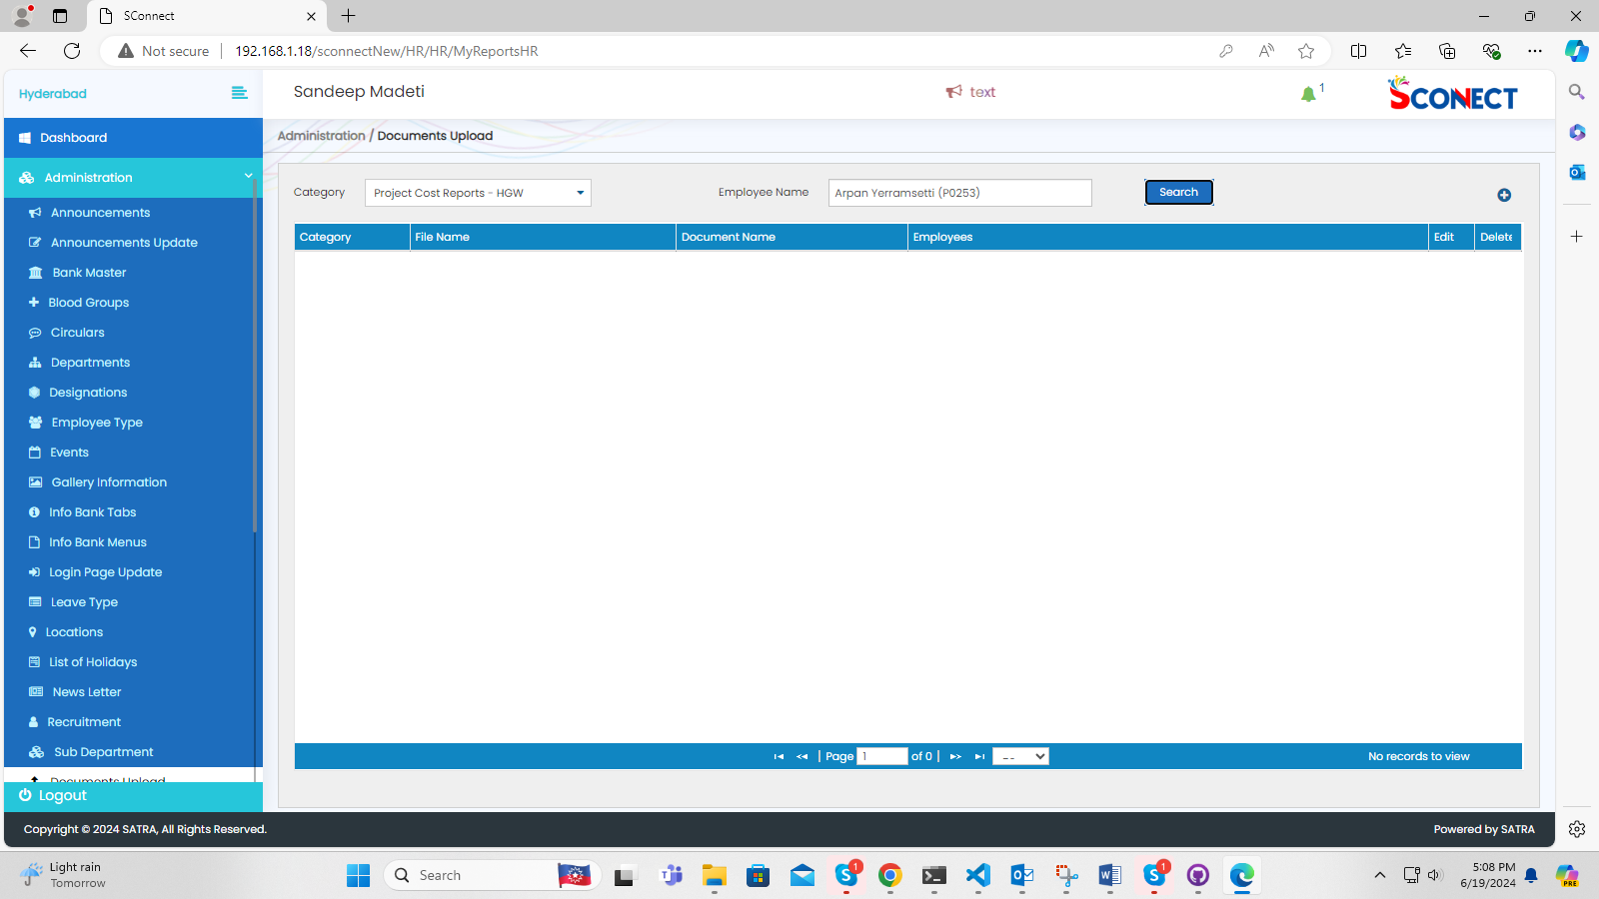  
21. sconnectNew/Common/Common/ManageTickets-> when click on manage tickets component its showing error page

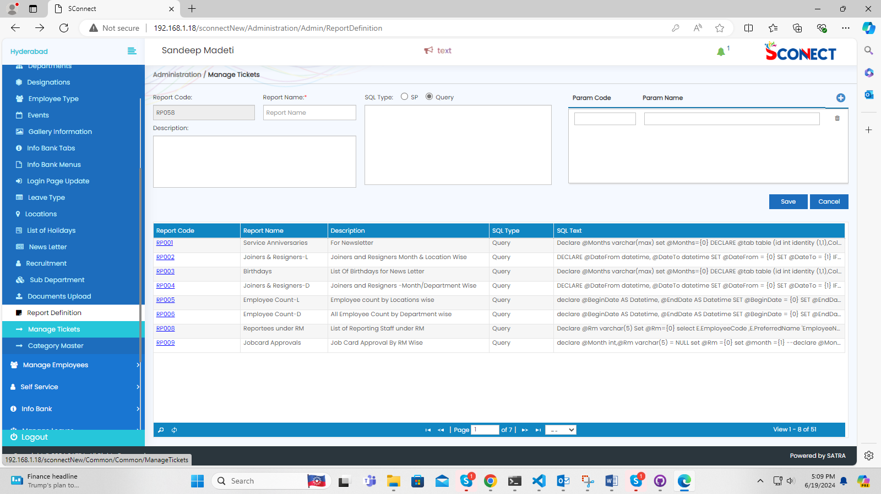

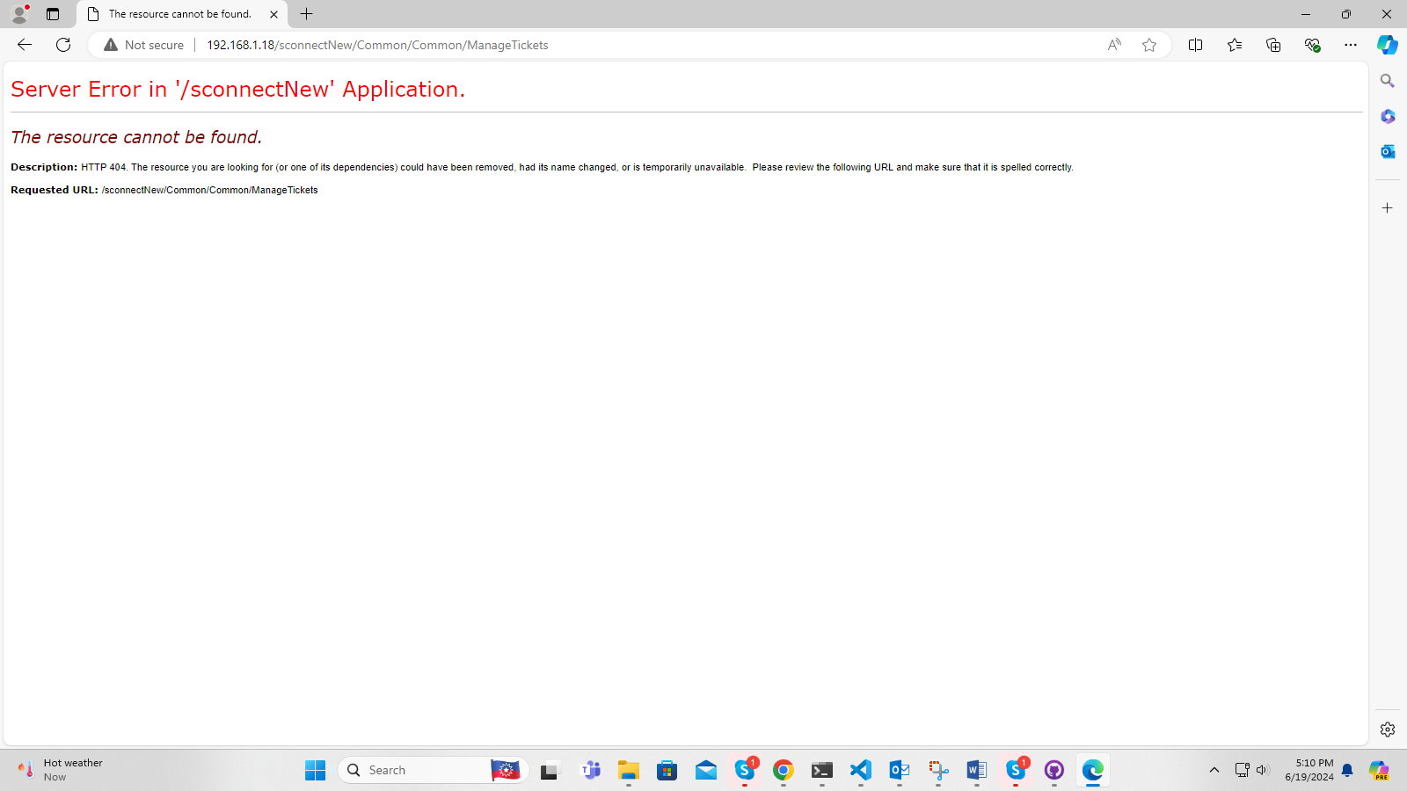

22. sconnectNew/HR/HR/EmployeeStatusUpdate-> scroll bar issue

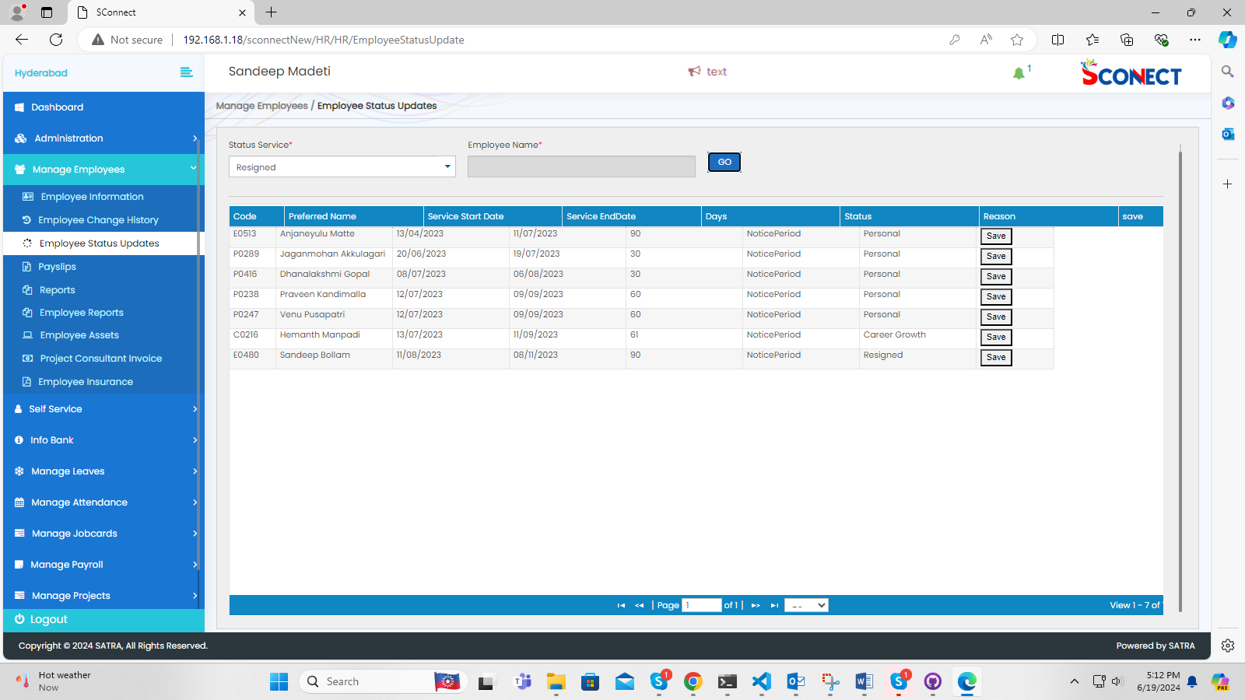

23. sconnectNew/HR/HR/HRReports->scroll bar issue

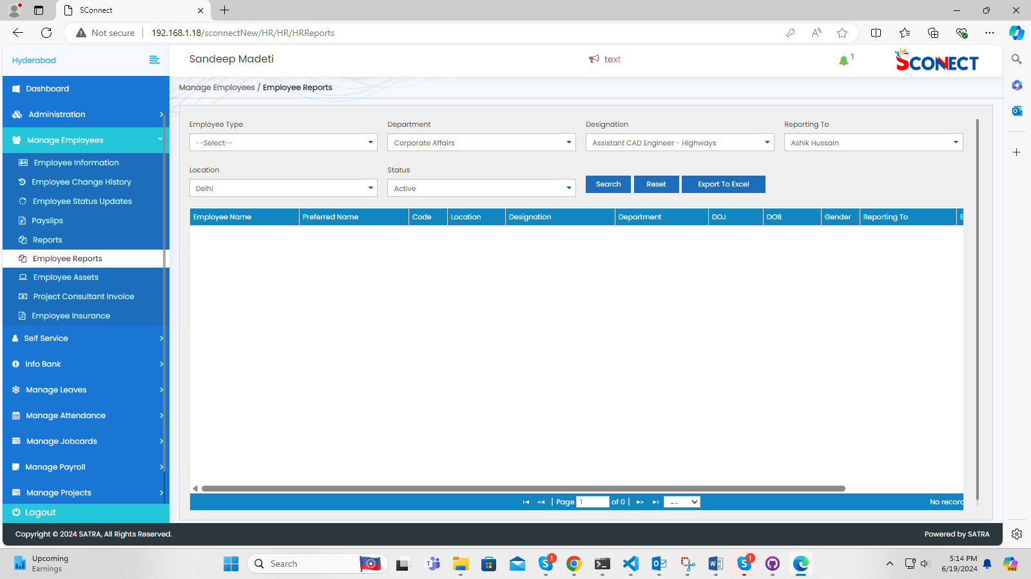

24. sconnectNew/HR/HR/ProjectConsultantInvoiceForHR-> when click on ProjectConsultantInvoice its showing error page

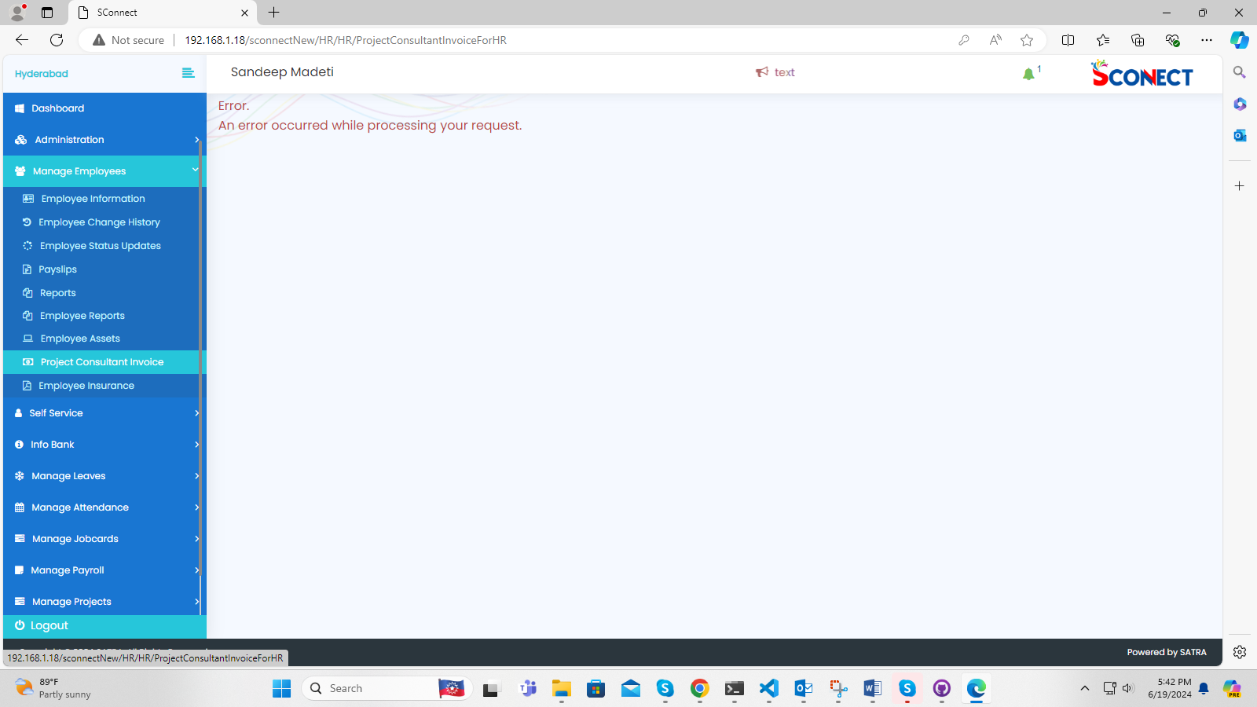

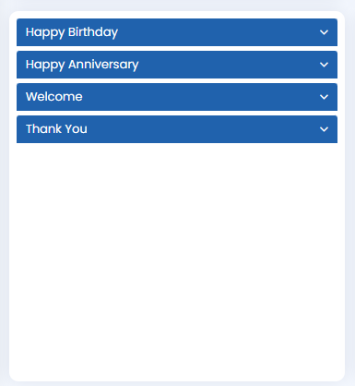 Birthday Card Height Issue

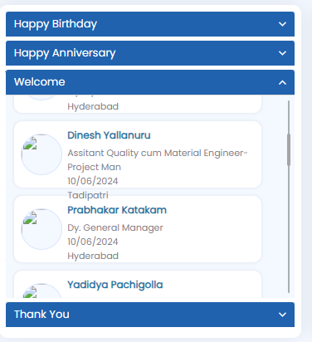 Text Align Issue

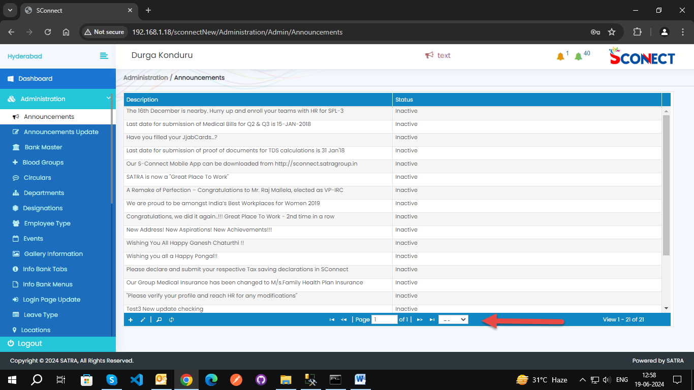 Pager Numbers Not Visible In All Pages.

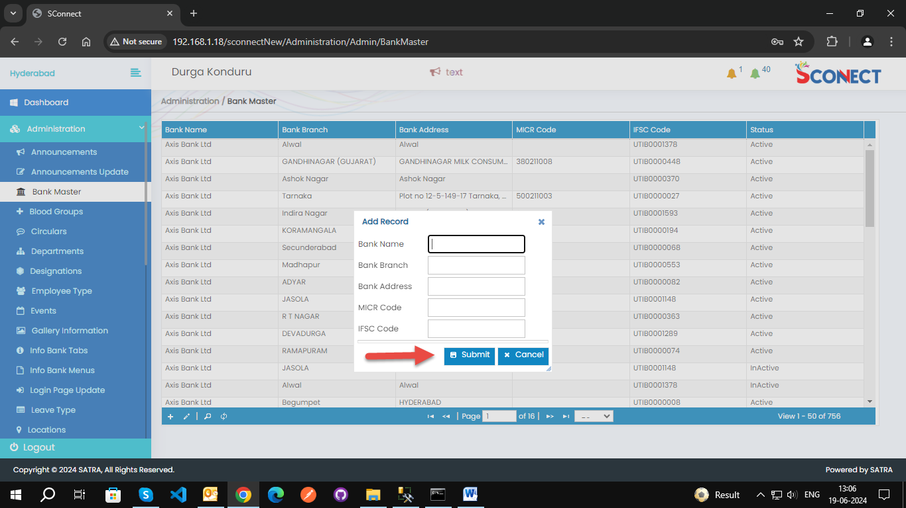 Alignment Issues in Button.

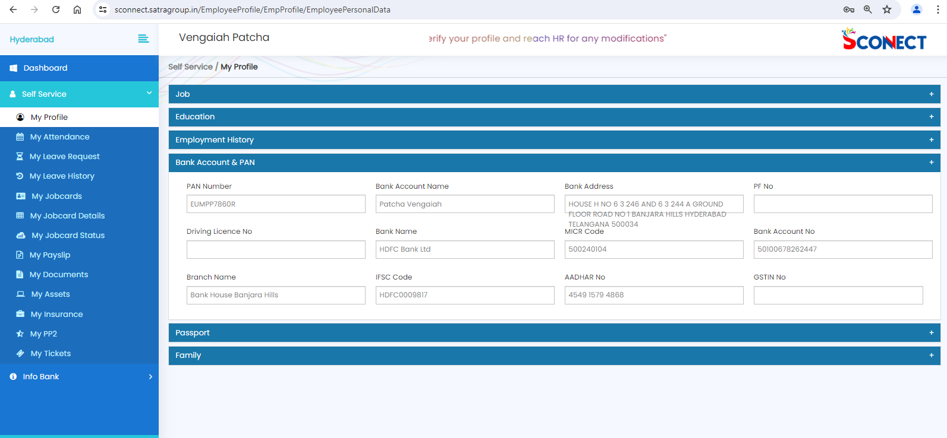

Bank Address text box issue

--- Service Issue--

1.When Clicking On jobCards the time taken to completely load it is exceeding 5sec

i.e; GetAssignmentByProject its taking long

