1. RIS->Reports-> All Reports->002- Roughness by road class-> After selecting required columns -> when we click on generate -> It is displaying an Alert.

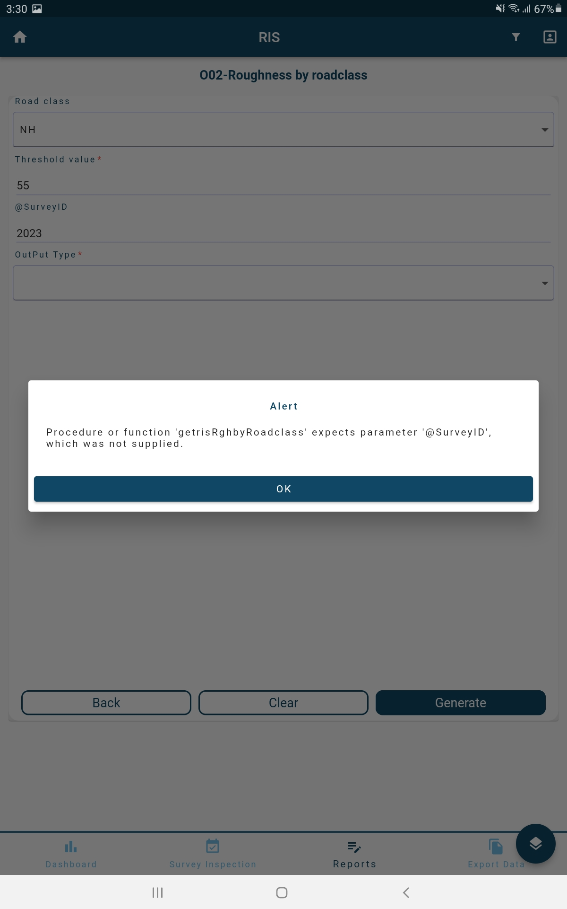

1. RIS->Reports-> All Reports->N 02-Link details-> After selecting required columns -> when we click on generate -> It is displaying an Alert.

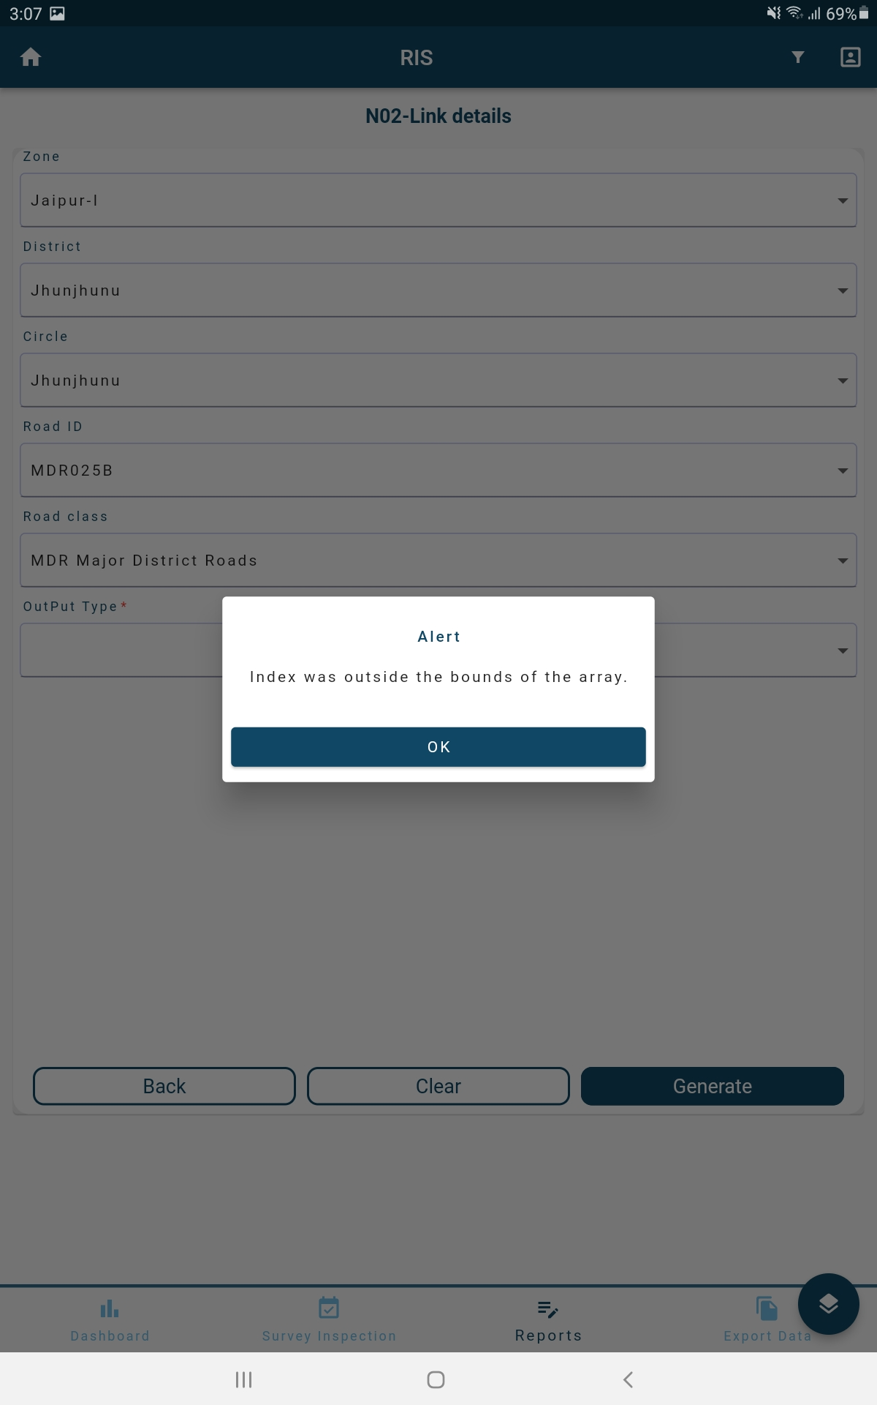

1. BIS->Reports-> All Reports->R2I03 –Span-wise bridges-> After selecting required columns -> when we click on generate -> It is displaying an Alert.

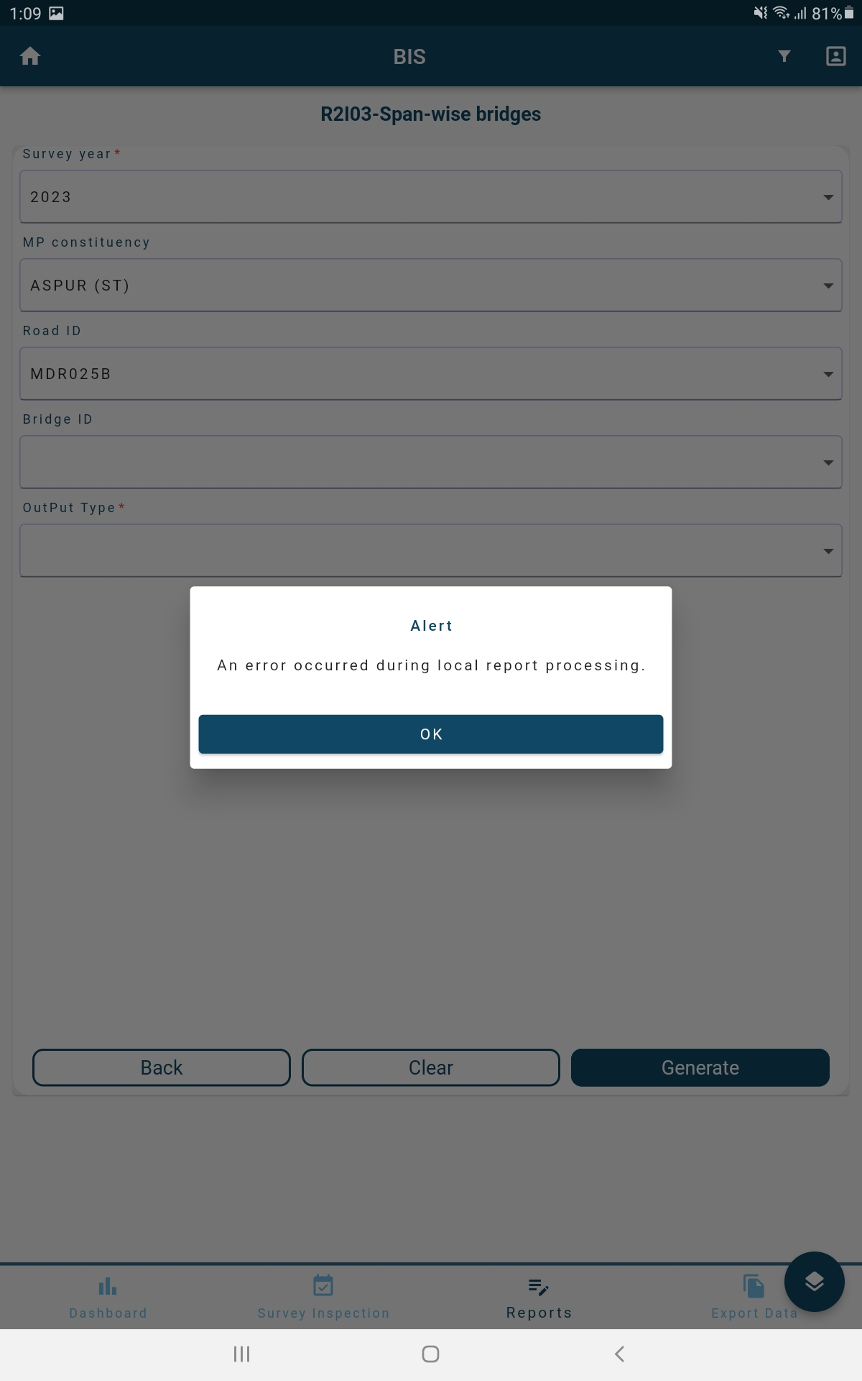

1. TIS->Reports-> All Reports->Projected traffic-> After selecting required columns -> when we click on generate -> It is displaying an Alert.

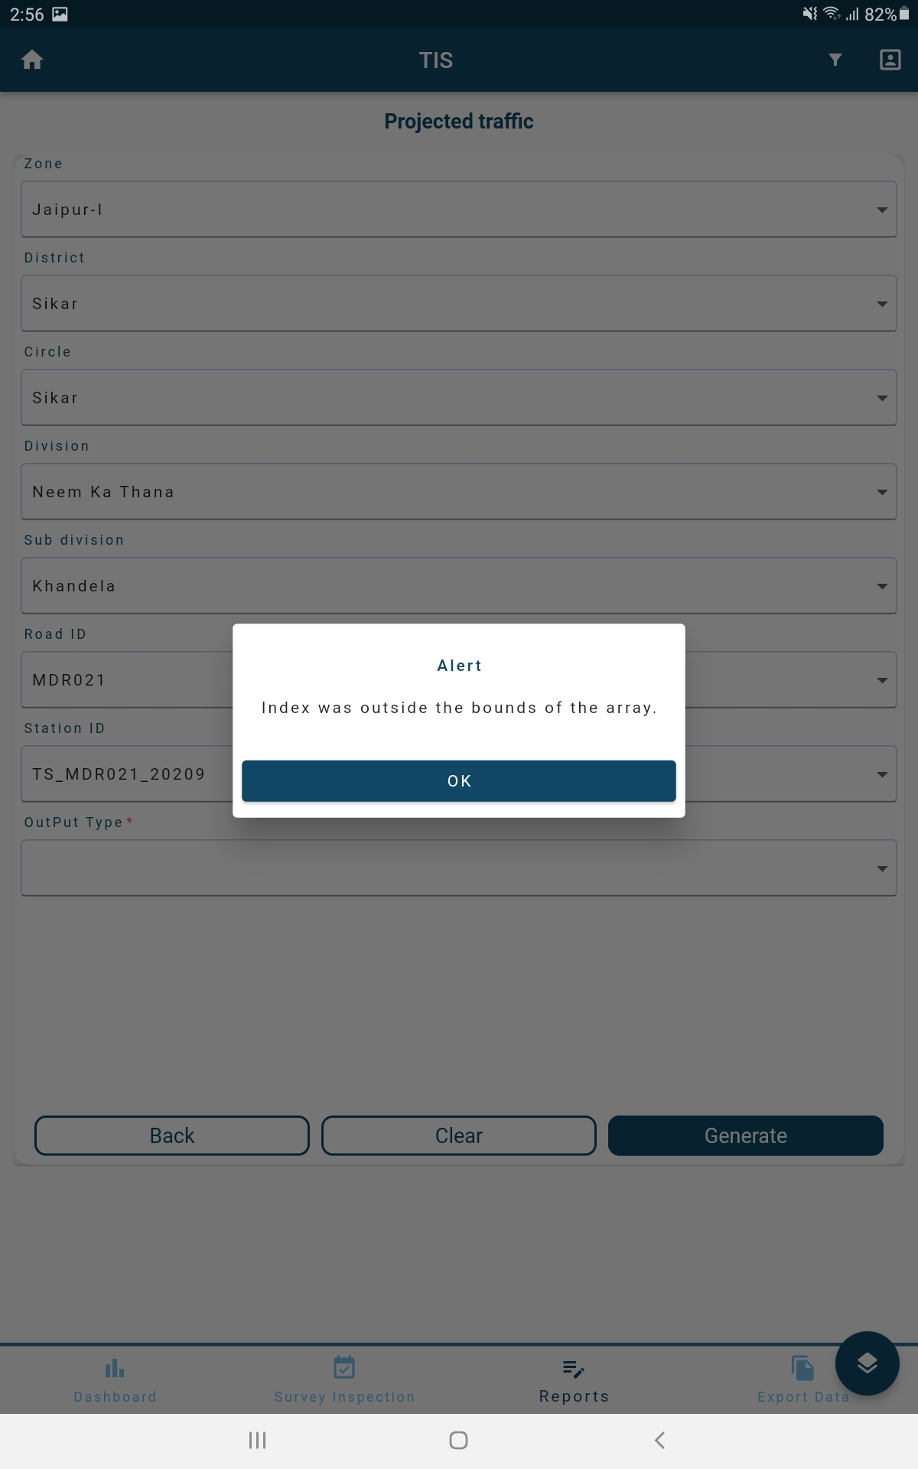

1. TIS->Reports-> All Reports->Projected traffic (NSDP)-> After selecting required columns -> when we click on generate -> It is displaying an Alert.  
   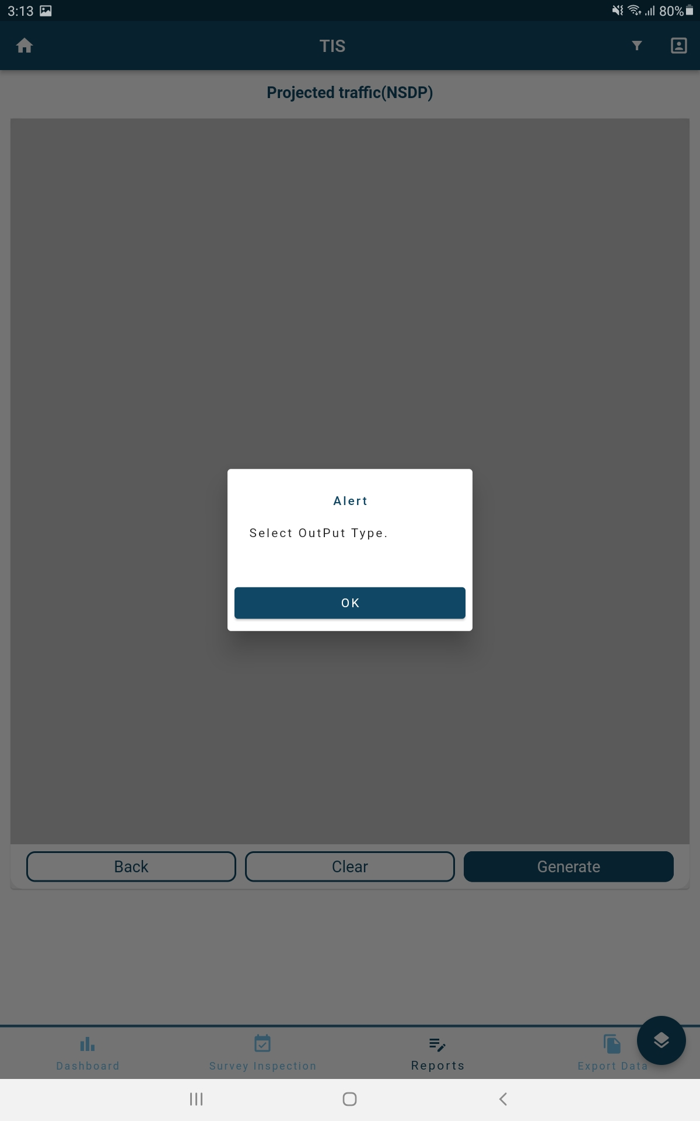
2. PMS->Reports-> All reports-> Structure cost-> After selecting required columns -> when we click on generate -> It is displaying an Alert.  
   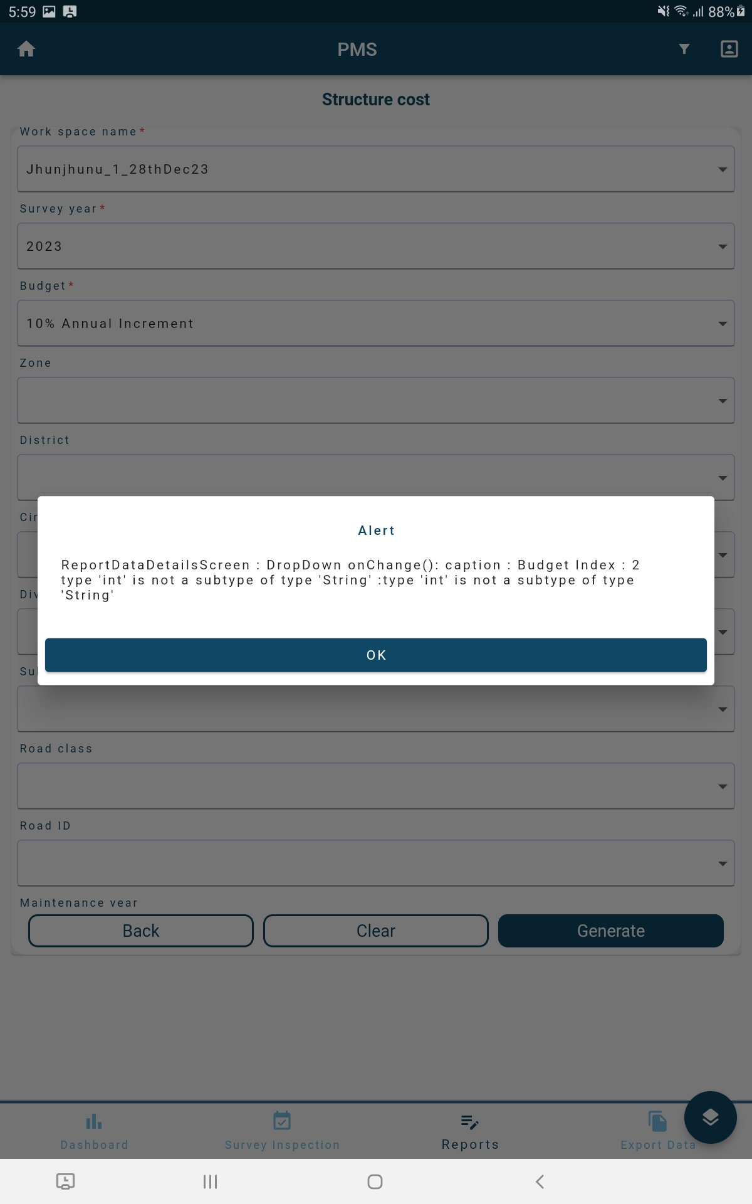
3. PMS-> Reports-> Homogeneous Sections-> After selecting required columns -> when we click on generate -> It is displaying an Alert.  
     
   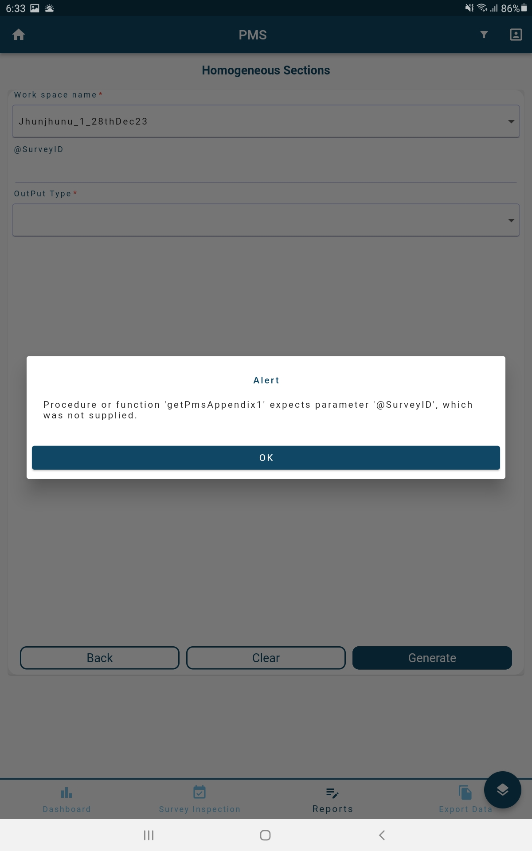
4. PMS->Full maintenance-> Homogeneous Section-> After selecting required columns -> when we click on generate -> It is displaying an Alert.



1. PMS->All reports->Structure cost-> After selecting required columns -> when we click on generate -> It is displaying an Alert.

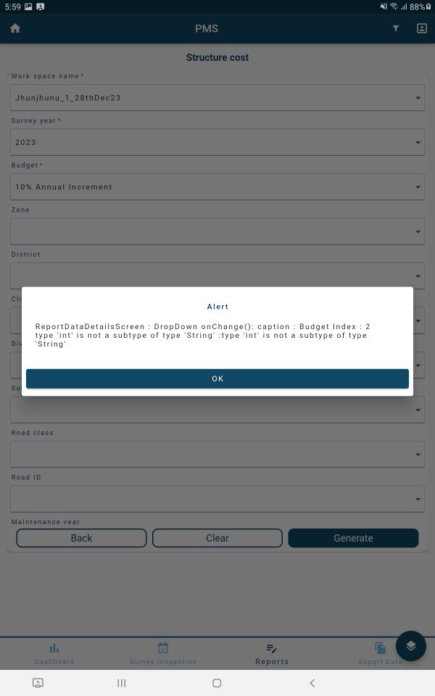

1. PMS->All reports->Homogenous sections-> After selecting required columns -> when we click on generate -> It is displaying an Alert  
   