1. RIS->Reports-> All Reports->002- Roughness by road class-> After selecting required columns -> when we click on generate -> It is displaying an Alert.

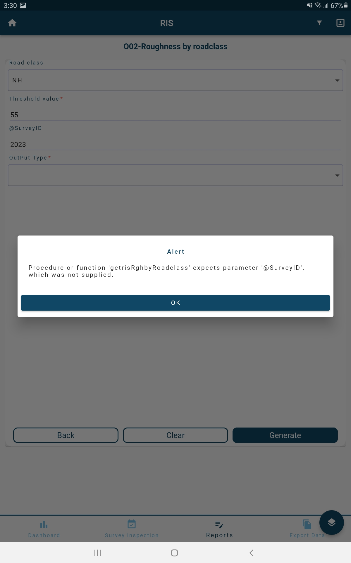

1. RIS->N02-Link Details->   
   