Session search

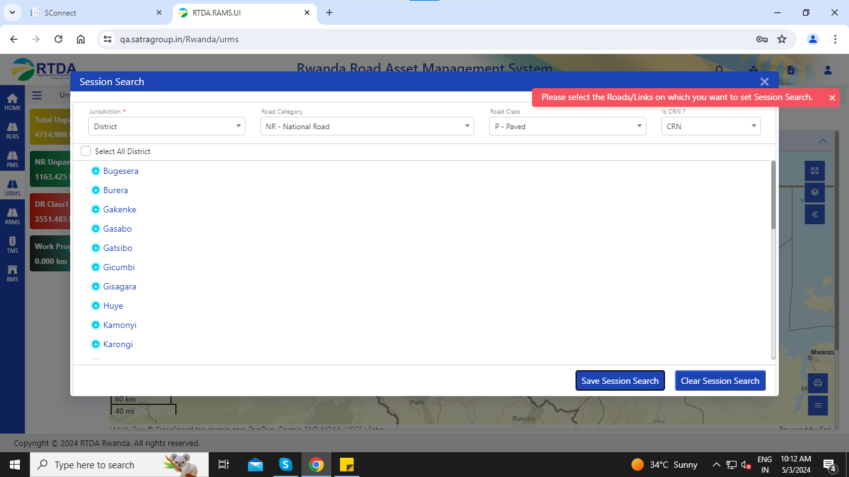

# 2. URMS Module

1. Unsealed Road Management System (URMS) / Lookup Data / Road Inventory / Pavement Type (L)/add new 🡪no drop down list in surface type.

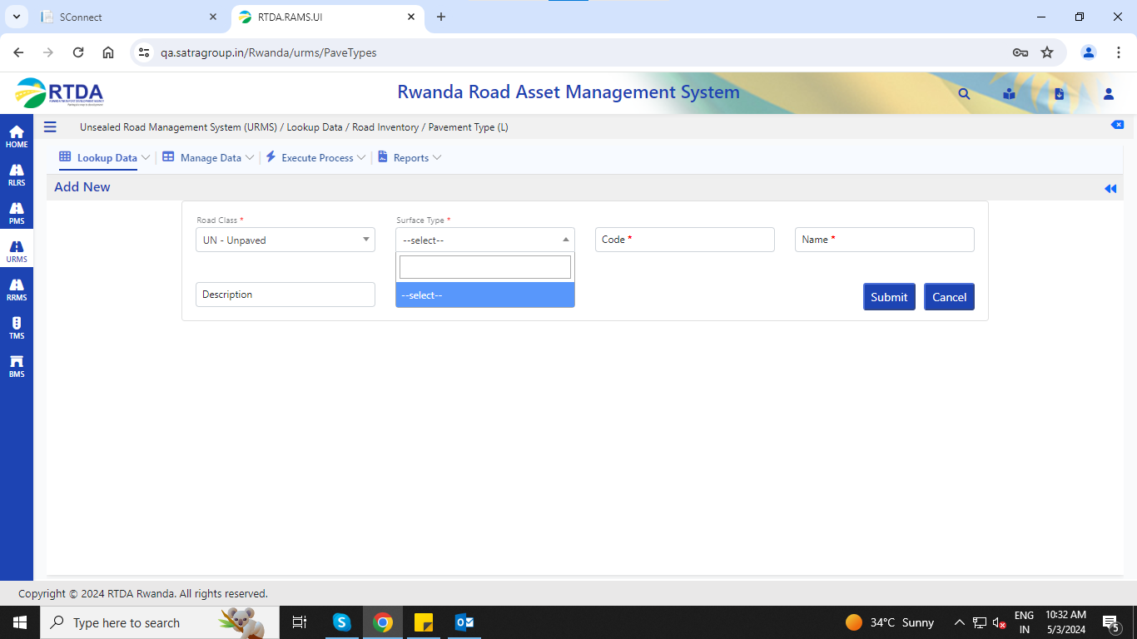

2. Unsealed Road Management System (URMS) / Lookup Data / HDM4 Master Details / HDM4 Factors/add new🡪any data given below error message occurs. – Service Issue

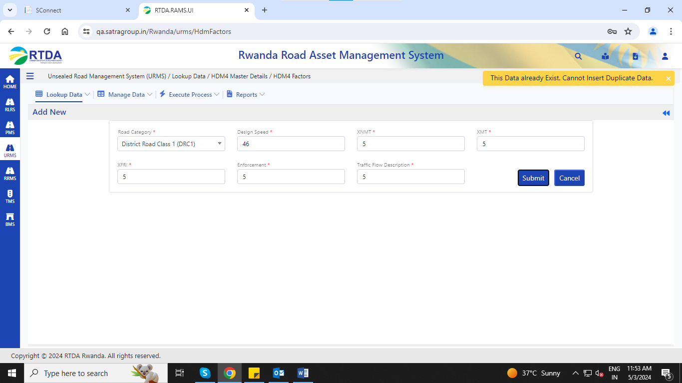

3. Unsealed Road Management System (URMS) / Lookup Data / HDM4 Master Details / Accident Class/Speed Flow/add new 🡪any data given below error message occurs. – Service Issue

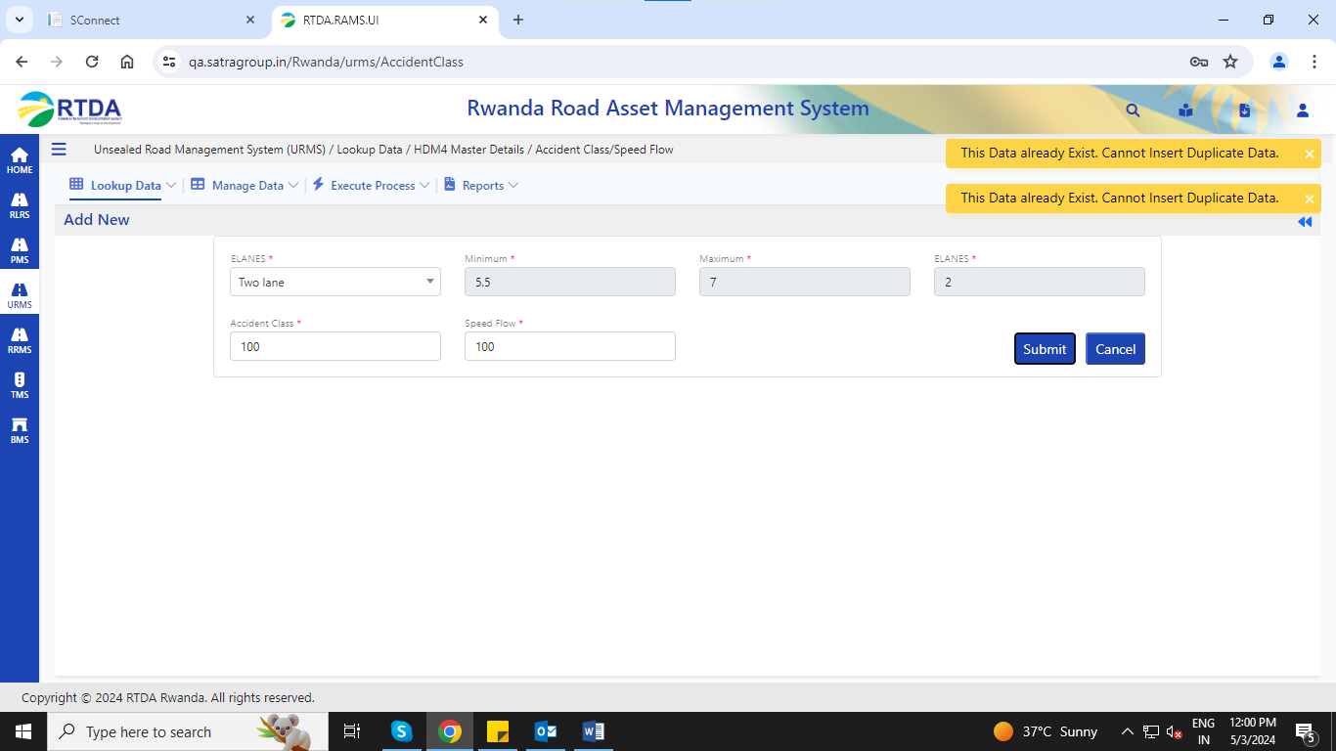

4. Unsealed Road Management System (URMS) / Lookup Data / Sectioning Definition / Define Sectioning Criteria/add new🡪 any data given below error message occurs. – Service Issue

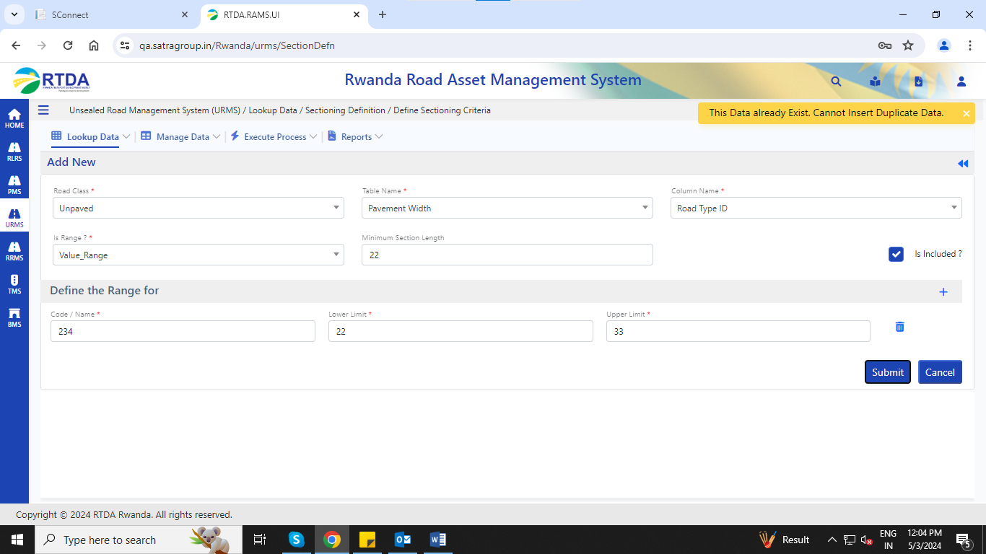

5. Unsealed Road Management System (URMS) / Manage Data / Road Inventory / Surface Type/add new🡪not entering pavement type data, wrong pop up appears as error

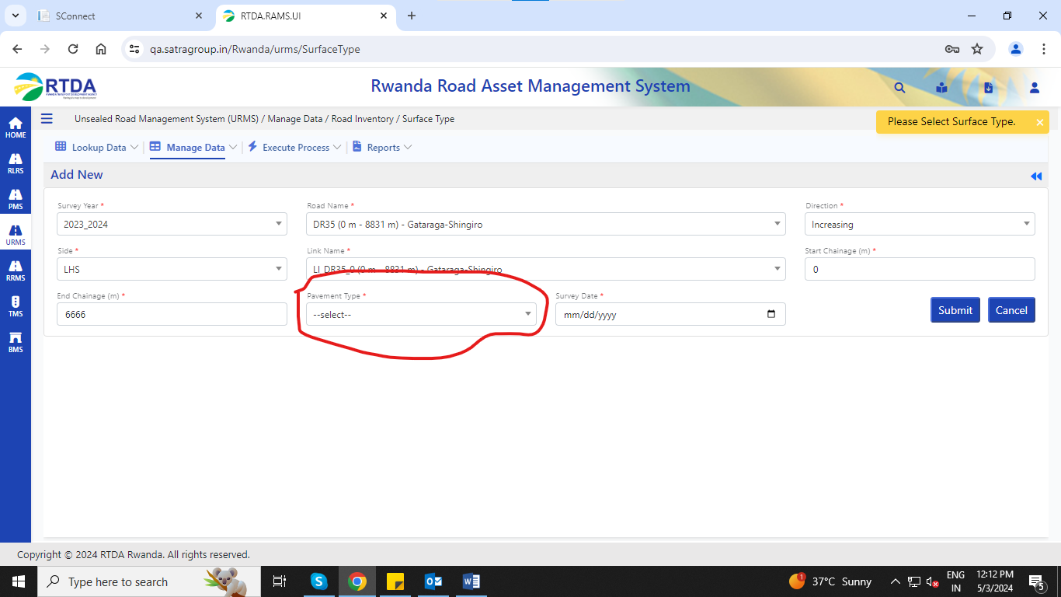

6. Unsealed Road Management System (URMS) / Manage Data / Road Inventory / Shoulder Type /add new all fields data entered and click on submit then Unknown error appears as follows. – Service Issue

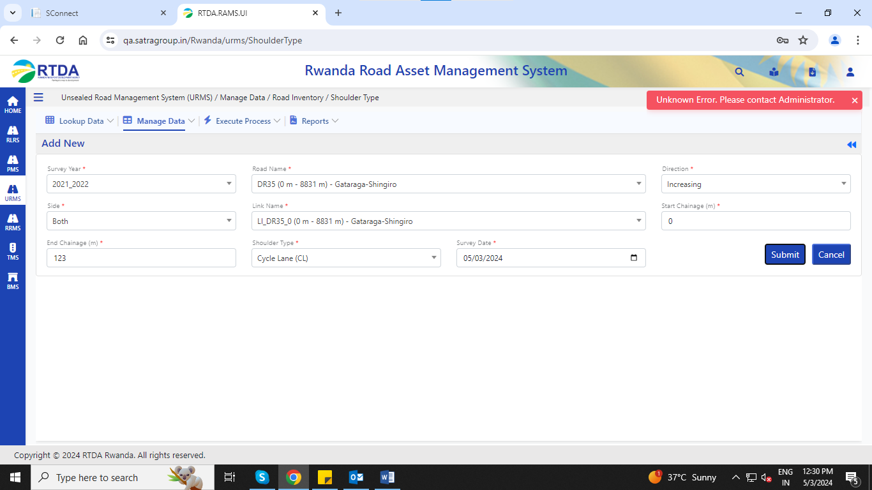

1. Unsealed Road Management System (URMS) / Manage Data / Road Inventory /

Carriage way type,

cross-section type,

Drain type

Surface type

add new , no drop down list for above mentioned fields.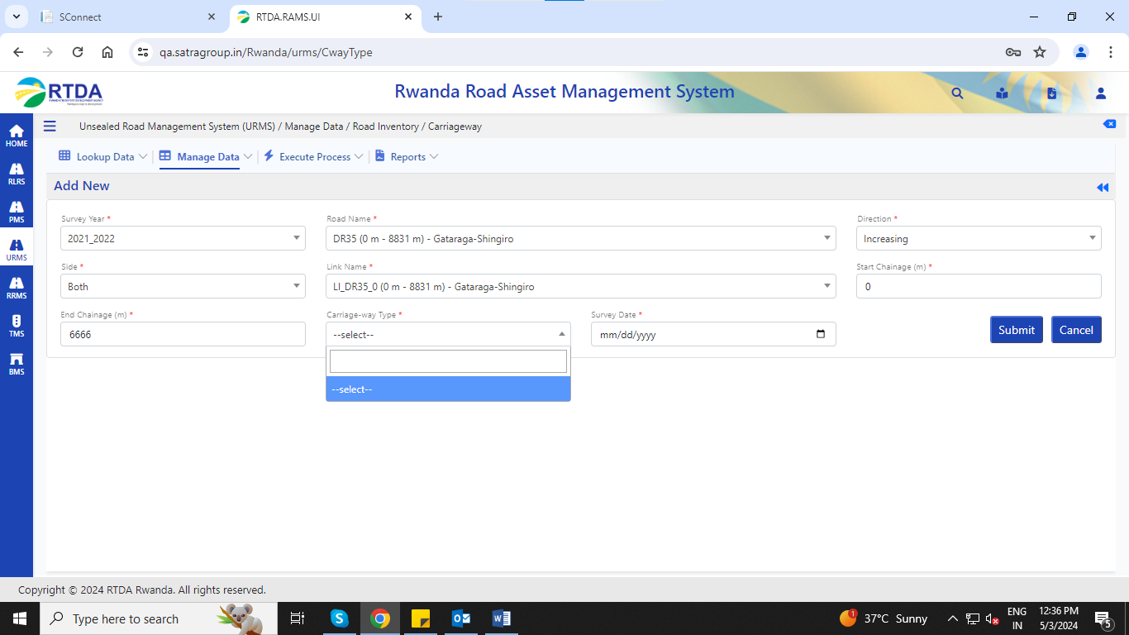

1. Unsealed Road Management System (URMS) / Manage Data / Road Inventory /

Pavement Width,

Pavement type,

Surface type,

Drain type,

Shoulder type,

Shoulder Width,

Carriageway,

Cross Sections,

Terrain,

 Geometry,

Road Assets – Point,

Road Assets – Section And

Unsealed Road Management System (URMS) / Manage Data / Road Condition / Roughness – Unpaved,

Unsealed Road Management System (URMS) / Manage Data / Pavement Details / Pavement History,

Unsealed Road Management System (URMS) / Manage Data / Pavement Details / Pavement Composition

Editing selected (existing) data and clicking on submit button then default value (previous given value) is not bind up for **Link Name field** and shows as below error.

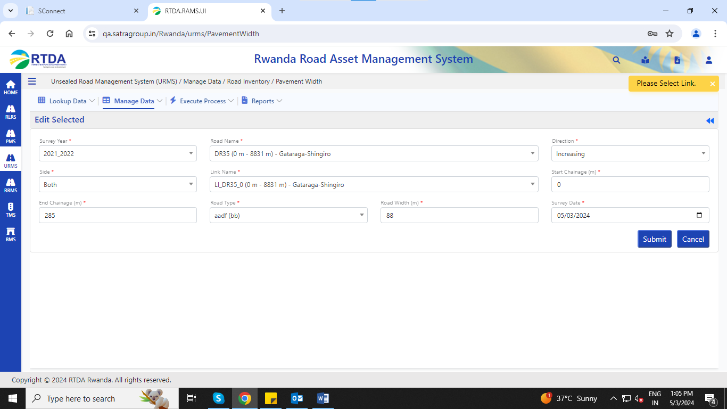

9. Unsealed Road Management System (URMS) / Manage Data / Road Condition / Condition – Unpaved/add new, all fields data entered and click on submit button then the below error appears.

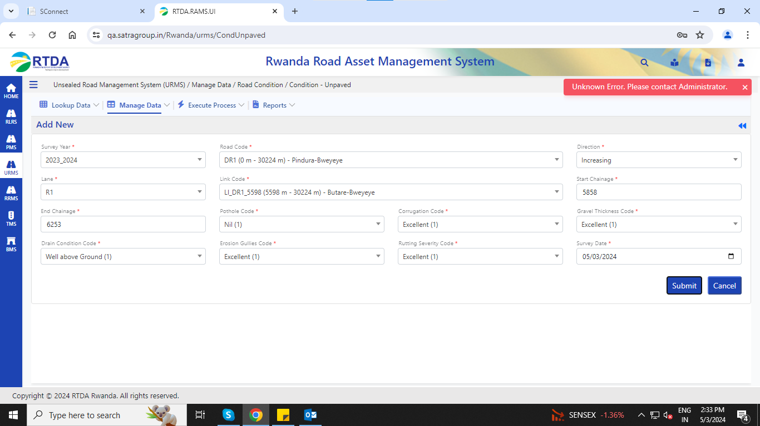

10. Unsealed Road Management System (URMS) / Manage Data / Pavement Details / Pavement Composition/add new, all fields data entered and click on submit button then the below error appears.