1. Road Location Reference System (RLRS) / Lookup Data / Road Condition / Edge break Severity-> Add new ->when clicking on submit getting wrong alert in pop-up. (UI – Resolved-Added mandatory fields)

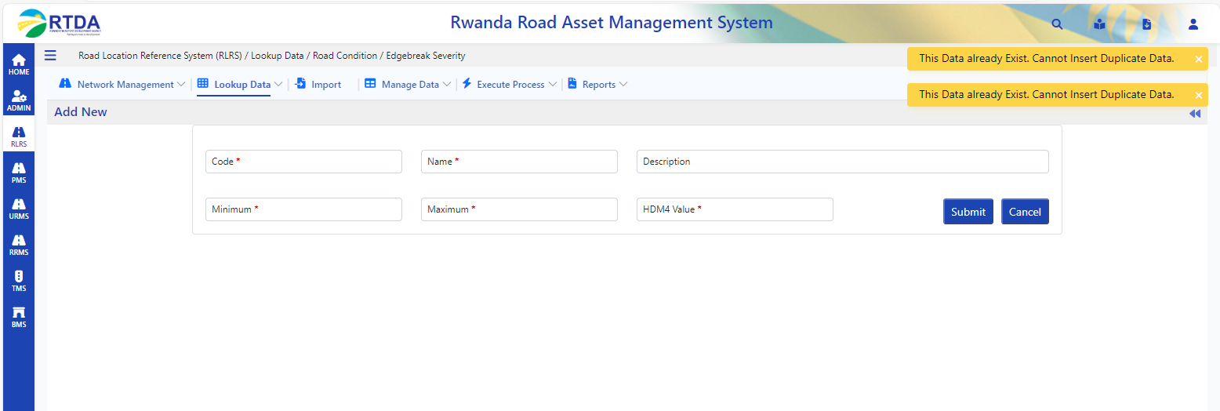

1. 2. Road Location Reference System (RLRS) / Lookup Data / Road Condition / Shoving Severity-> Add new ->when clicking on submit getting wrong alert in pop-up. (Resolved UI Changes)

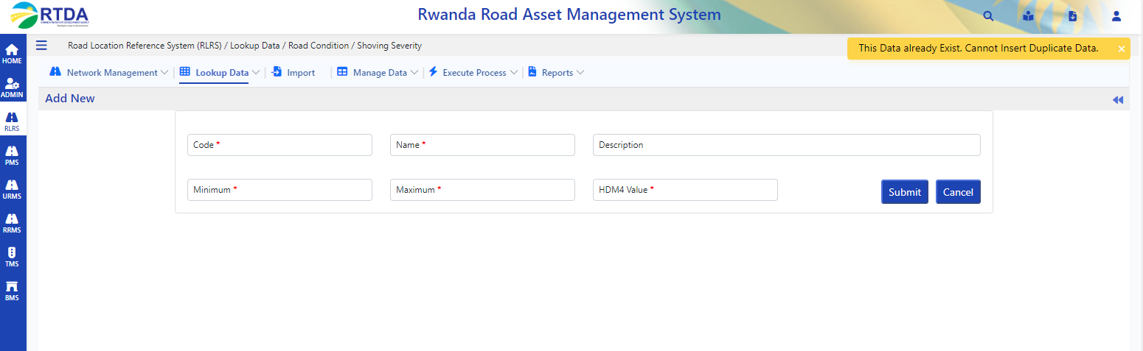

1. Road Location Reference System (RLRS) / Manage Data / Road Inventory / Pavement Width->Add new -> getting an error when clicking on submit. (Unable To Reproduce in Dev – Confirmed with QA team)

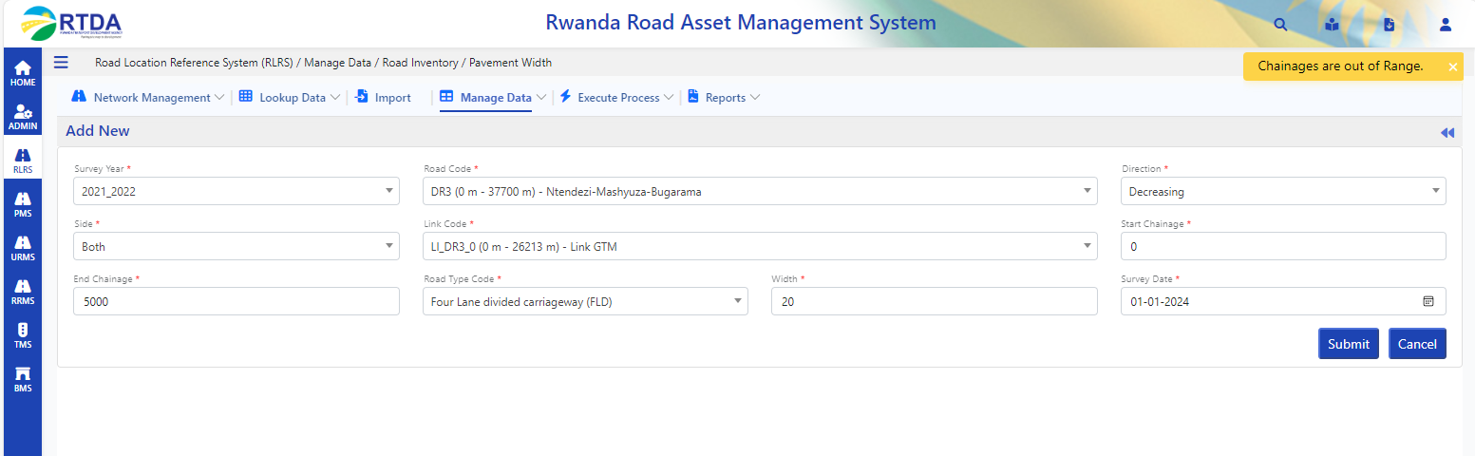

1. Road Location Reference System (RLRS) / Manage Data / Road Inventory / Pavement Type->Add new-> Unable to select Survey date-> If we enter manually it is saving the data. (Resolved UI changes)

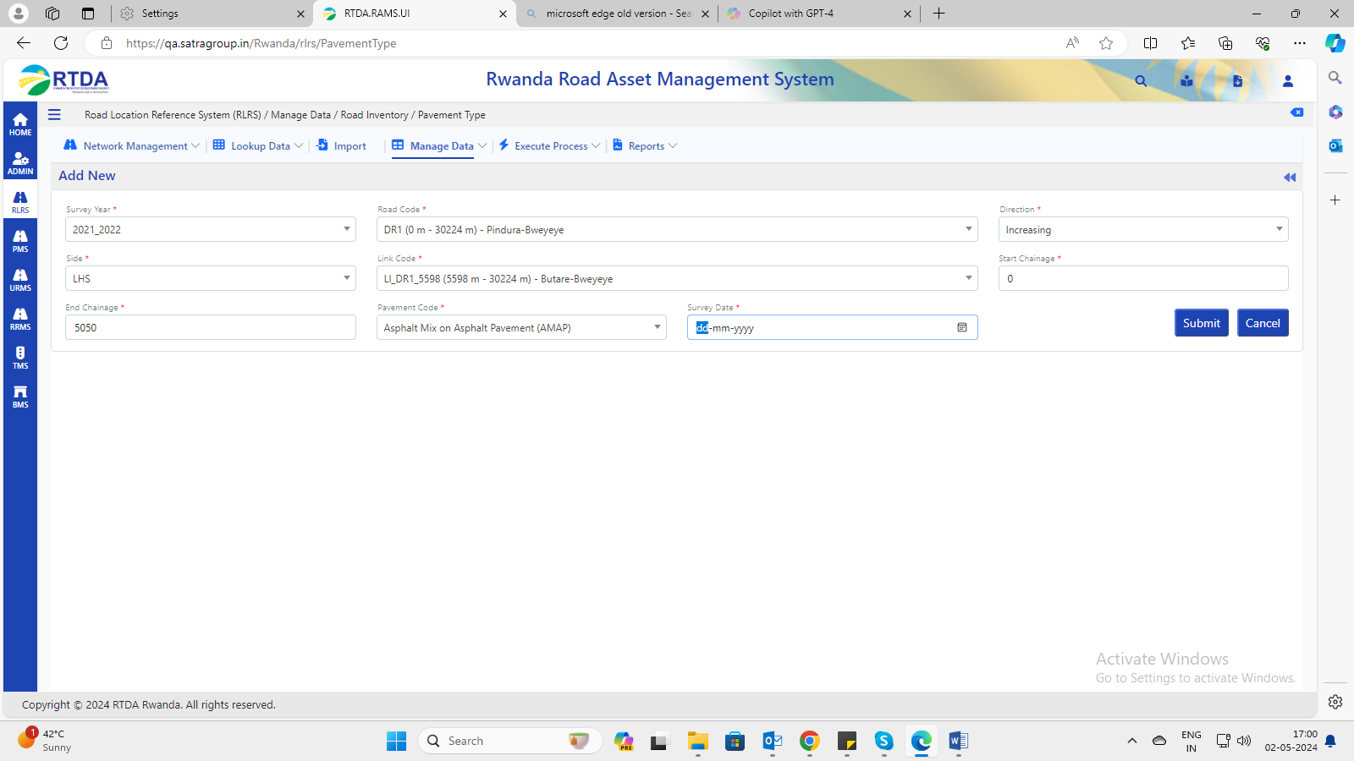

1. Road Location Reference System (RLRS) / Manage Data / (Resolved)  
   a. Road Inventory

1. Surface Type

2.Drain type  
3.Shoulder type  
4.Shoulder width  
5.Carriageway  
6.Cross sections  
7.Terrain  
8.Geometry  
9. Road Assets - Point

10. Road Assets – Section

b. Road Condition

Condition – Paved  
Texture Depth

Roughness – Unpaved

In Edit Selected data-> any field edited without editing Link code it is displaying an error as **Please Select link** when clicking on submit.

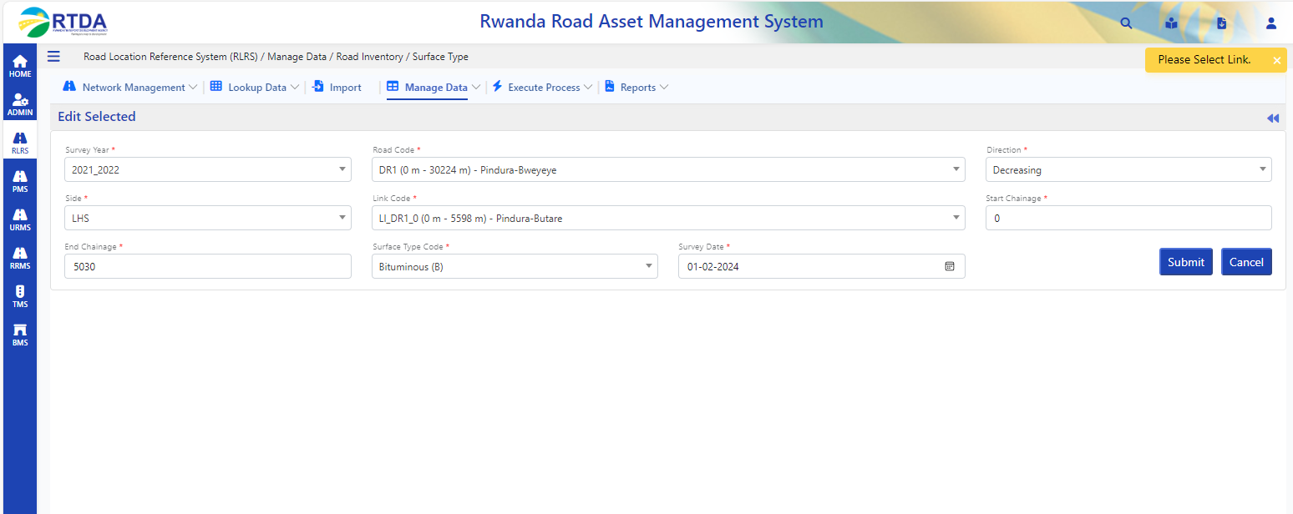

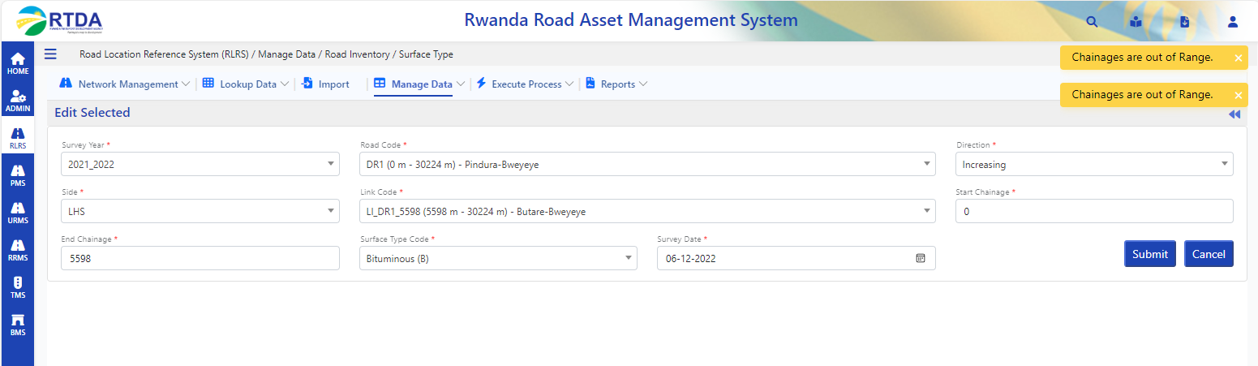

1. Road Location Reference System (RLRS) / Manage Data / Road Inventory / Shoulder Type

->when clicking on submit getting unknown error. (Unable To Reproduce in Dev)

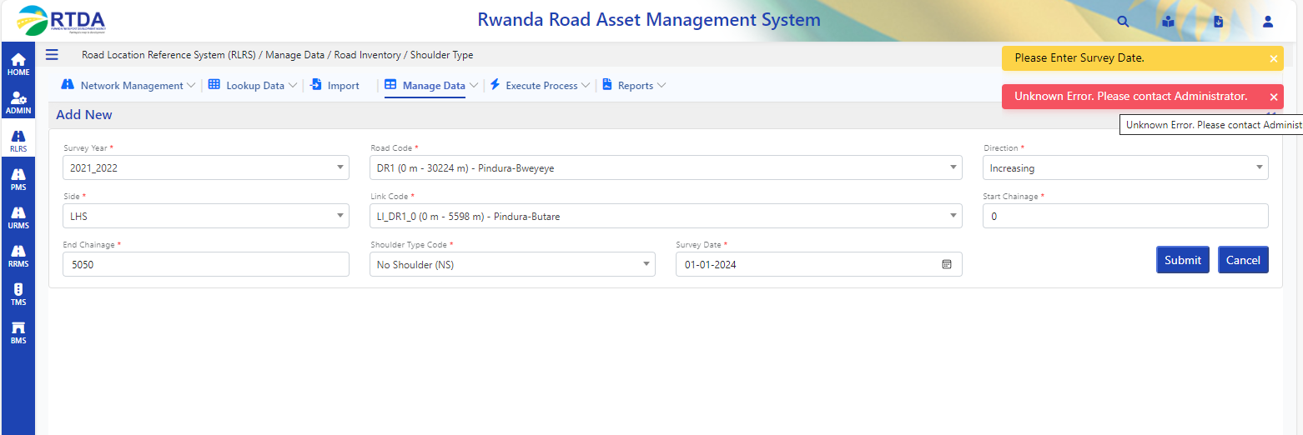

1. Road Location Reference System (RLRS) / Manage Data / Road Inventory / Geometry->when clicking on submit getting error. (Unable To Reproduce in Dev – Confirmed by QA)

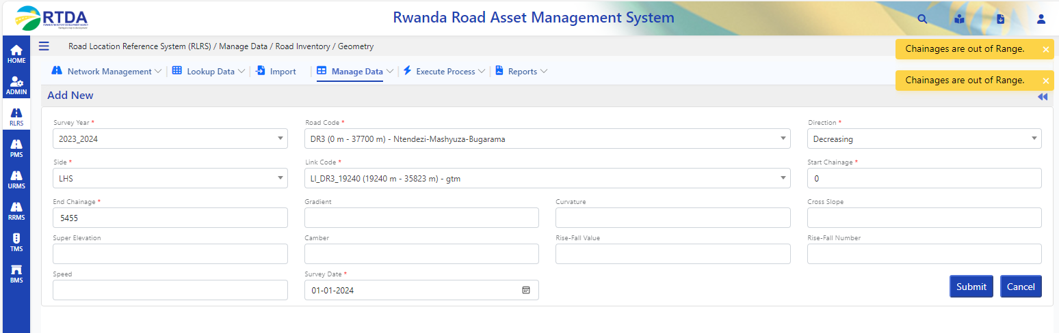

1. Road Location Reference Syste06050m (RLRS) / Manage Data / Road Condition / Condition – Paved->Add new -> Wrong alert/spelling in pop-up for all columns(UI Resolved)

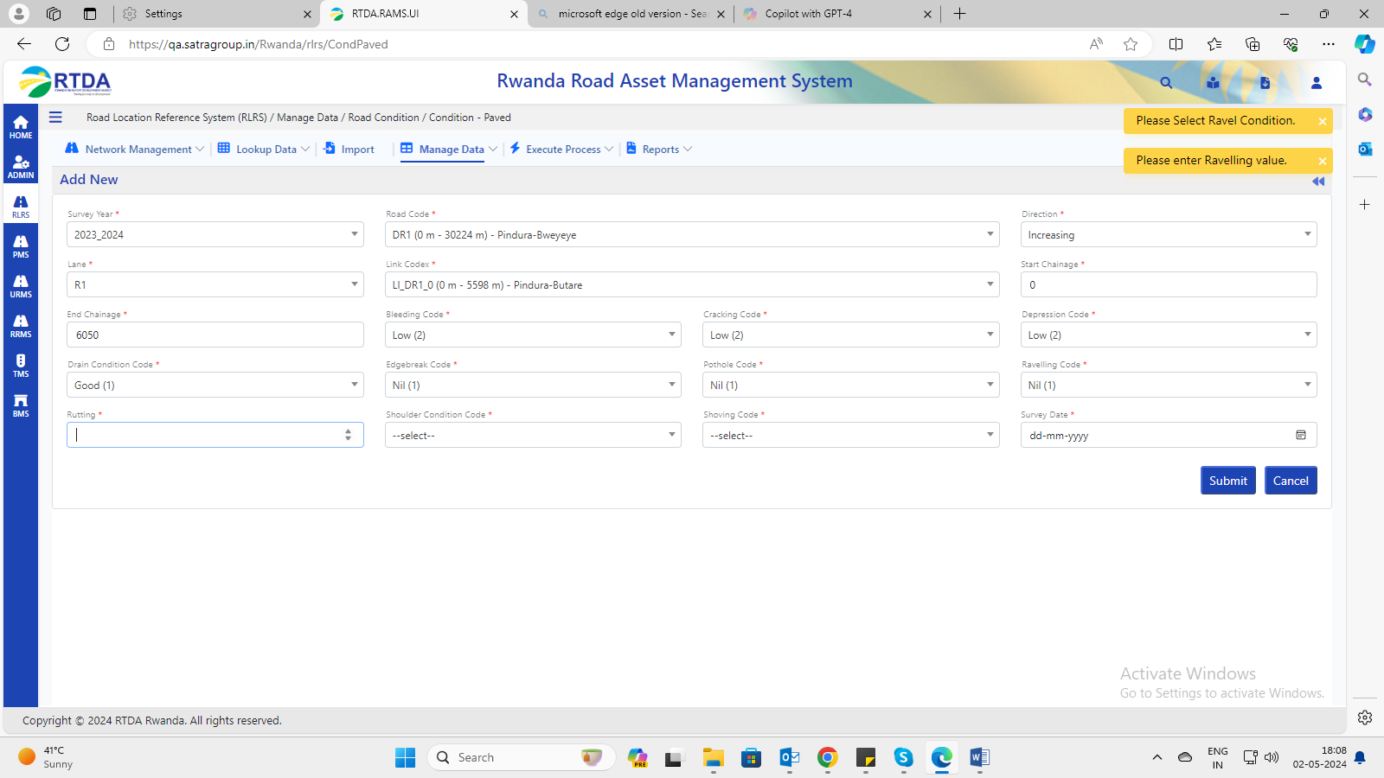

1. Road Location Reference System (RLRS) / Manage Data / Road Condition / Condition – Unpaved->Add new-> getting an error when clicking on submit(unable to produce in Dev – Confirmed by QA)

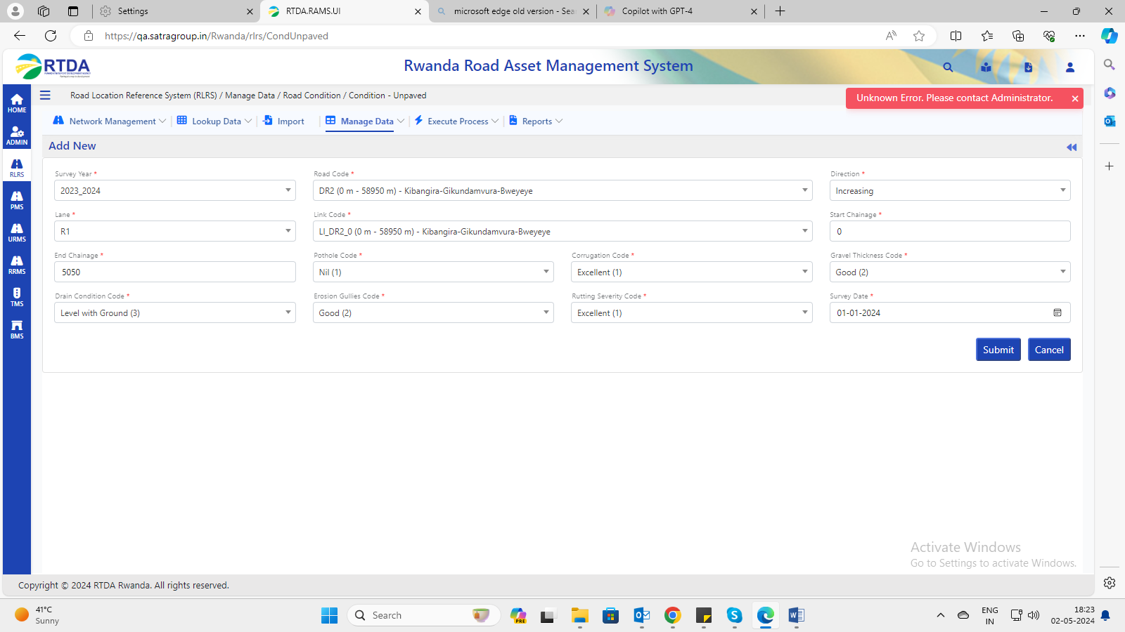

1. Road Location Reference System (RLRS) / Manage Data / Road Condition / Roughness – Unpaved-> when clicking on submit getting an error. (Unable To Reproduce in Dev – Confirmed by QA)

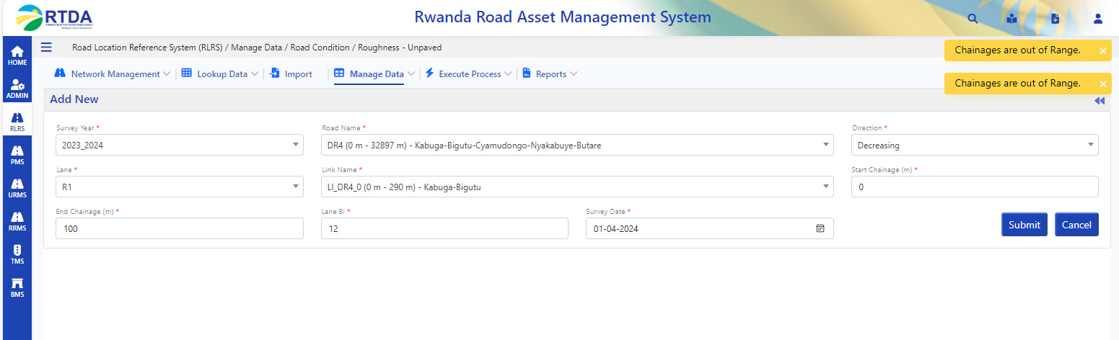

1. Road Location Reference System (RLRS) / Manage Data / Pavement Details / Pavement Composition->Add new -> getting error when clicking on submit.(Enter these fields(pavementID,SurfaceId,surfacethik,SubGradeTypeID,SubBaseTypeID,BaseTypeID) and try again its working) – Need to discuss – Red colour columns are mandatory or not ?

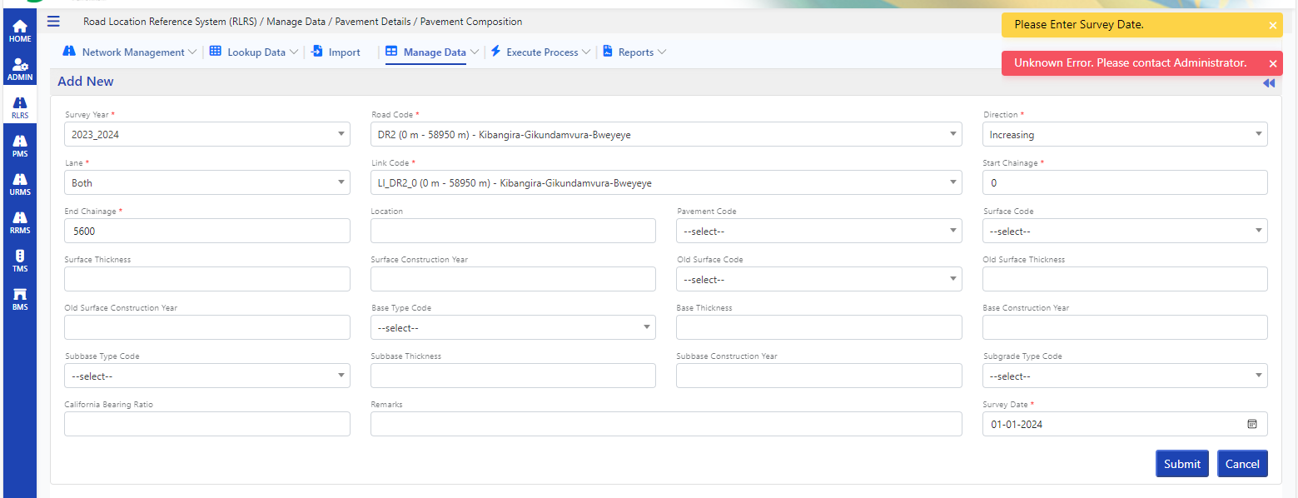

1. Road Location Reference System (RLRS) / Manage Data / Pavement Details / Pavement Composition->Wrong alert in pop-up (UI Resolved)

