1. Road Reserve Management System (RRMS) / Manage Data / Establishments->Add New screen-> Duplicate rows are allowed.(Not allowing Duplicates)

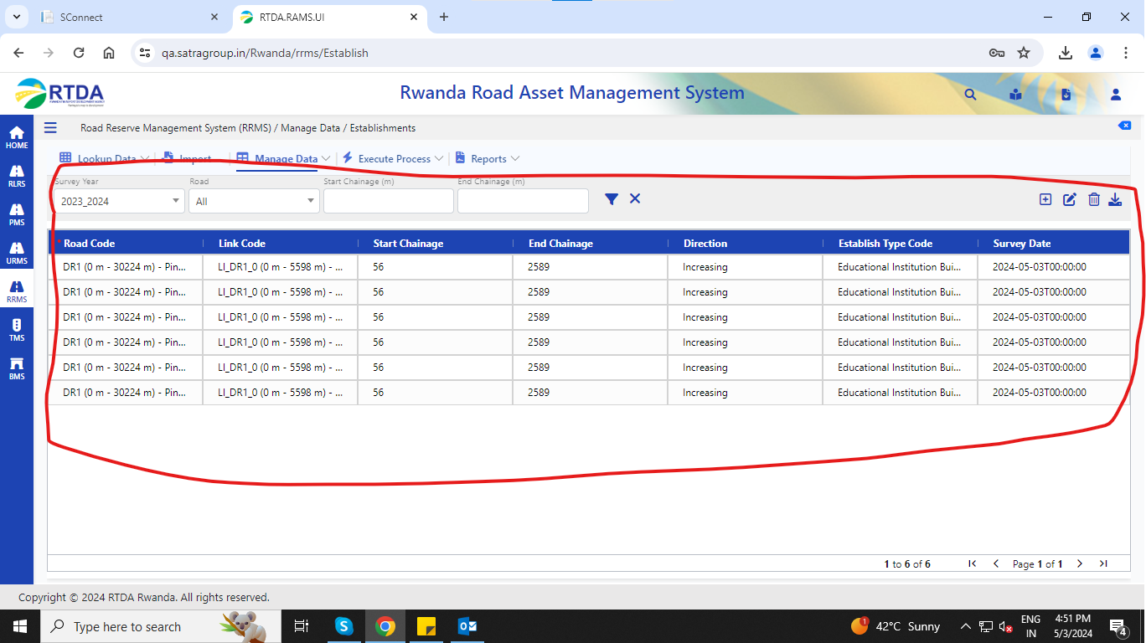

2. Road Reserve Management System (RRMS) / Manage Data / Establishments, Land use, ROW

In Edit Selected data screen -> any field edited without editing Link code it is displaying an error as **Please Select link** when clicking on submit. -> default value is not binding up for Link code(Checked all three data is binding and updating properly)

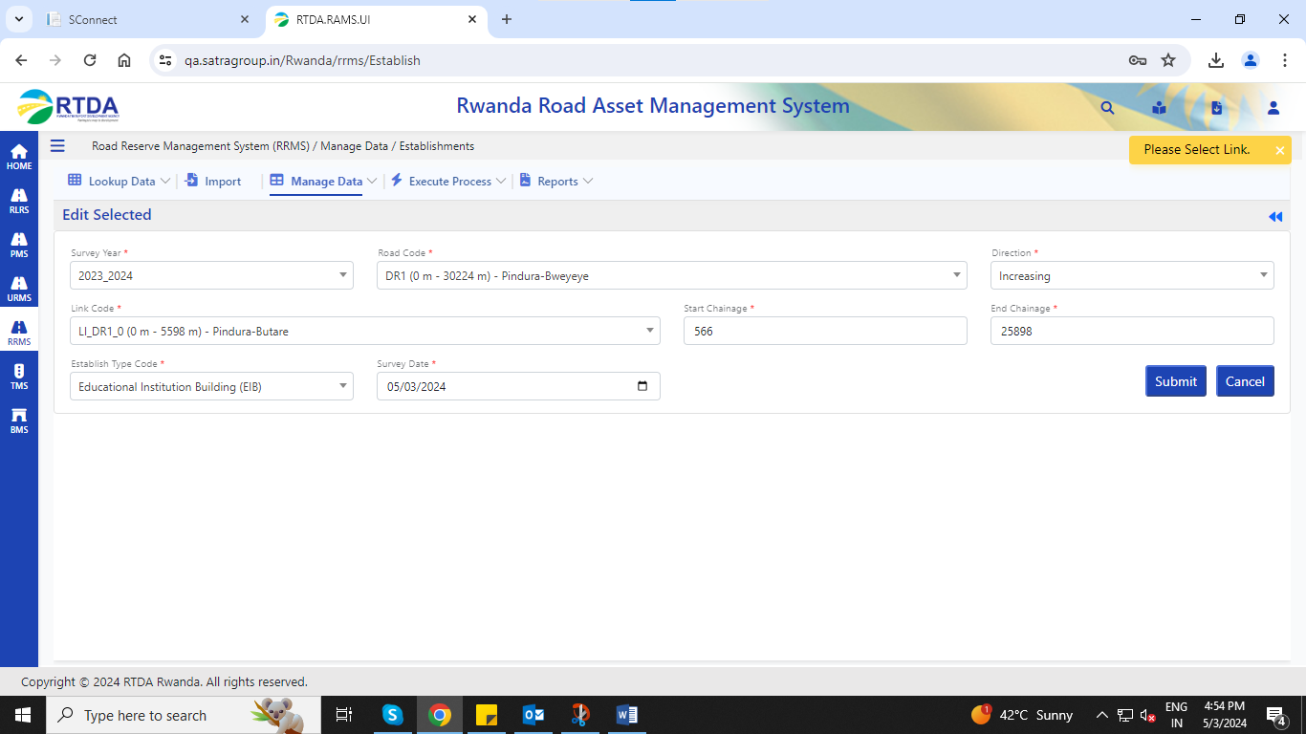

1. Road Reserve Management System (RRMS) / Manage Data / Proclamation->

Empty column in the grid after to chainage (Hold)

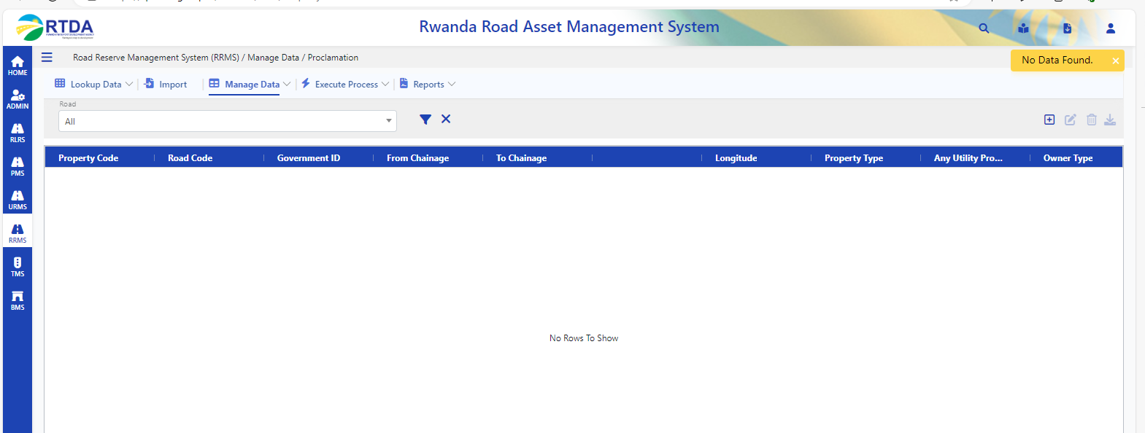

Road Reserve Management System (RRMS) / Manage Data / Proclamation->

Data not binding near ->Type of Property field, Owner type , payment method, Move status, property status

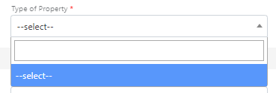

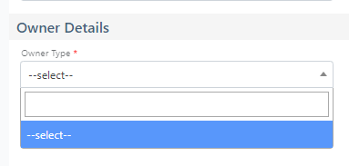

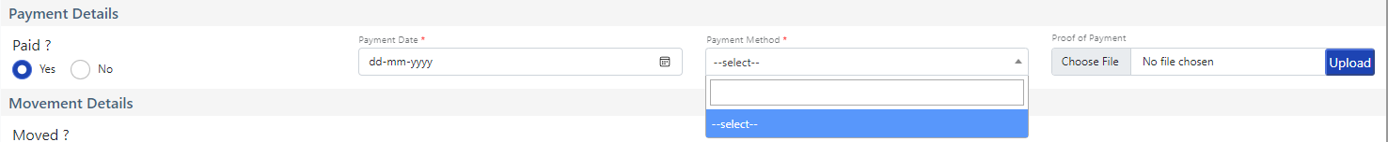

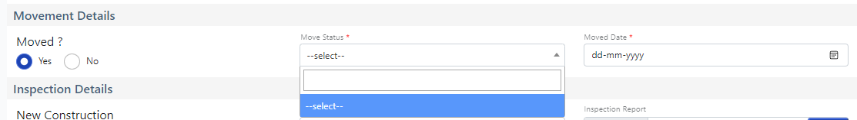

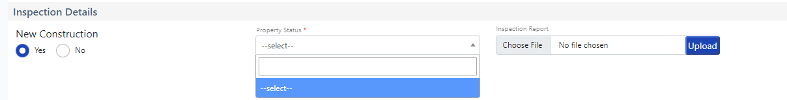

1. Road Reserve Management System (RRMS) / Manage Data / Utilities->when clicking on filter icon getting error.(In Dev Its Working Fine)

