RLRS

2.When click on clear filter Road field data not clear -- Done

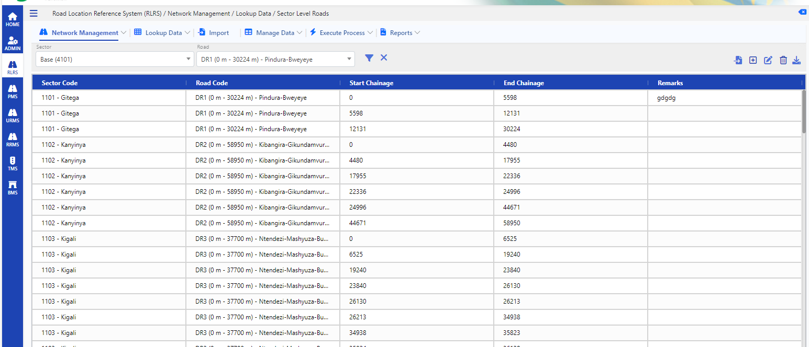

3. Road Location Reference System (RLRS) / Network Management / Network Data / Impassable-> upload new file alignement issue--Done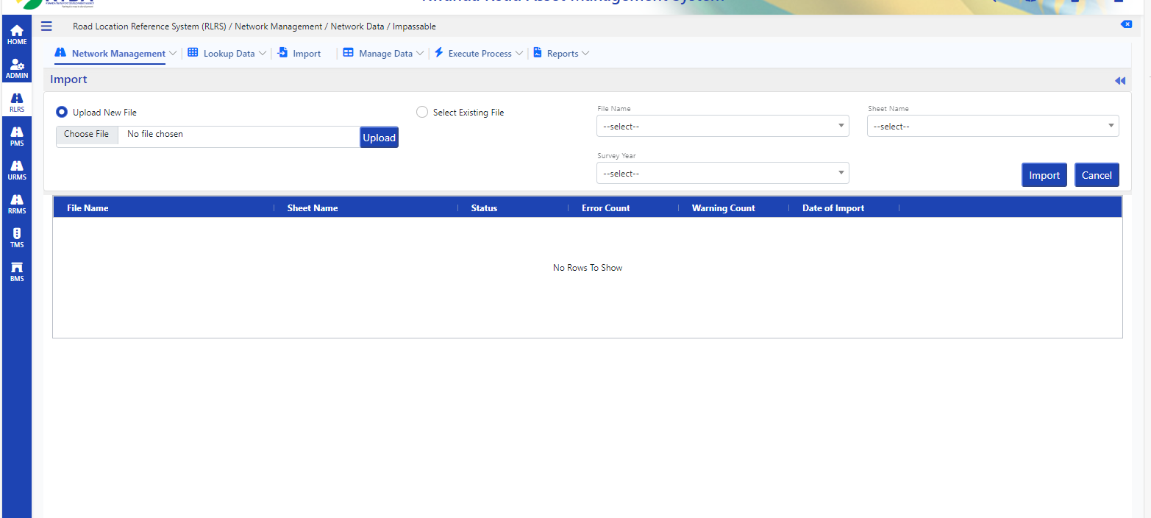

4Road Location Reference System (RLRS) / Network Management / Network Data / GPS Master-> upload new file alignement issue --- Done

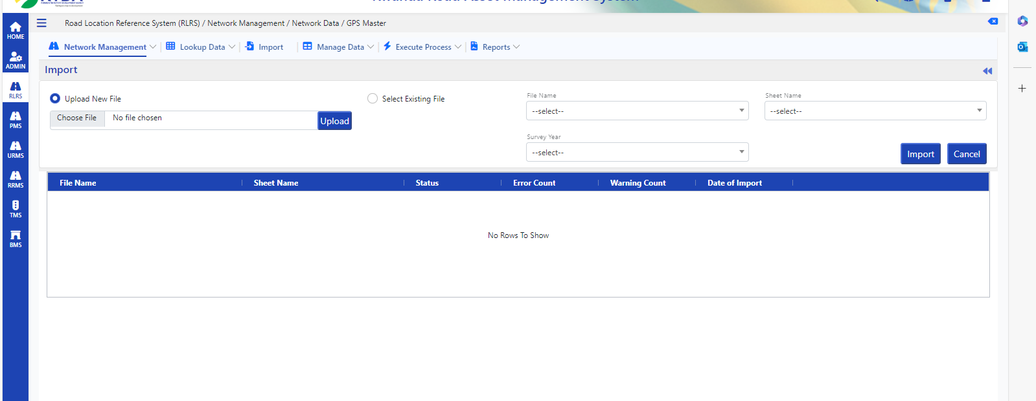

5Road Location Reference System (RLRS) / Network Management / Network Data / LRP Master-> upload new file alignement issue -- Done

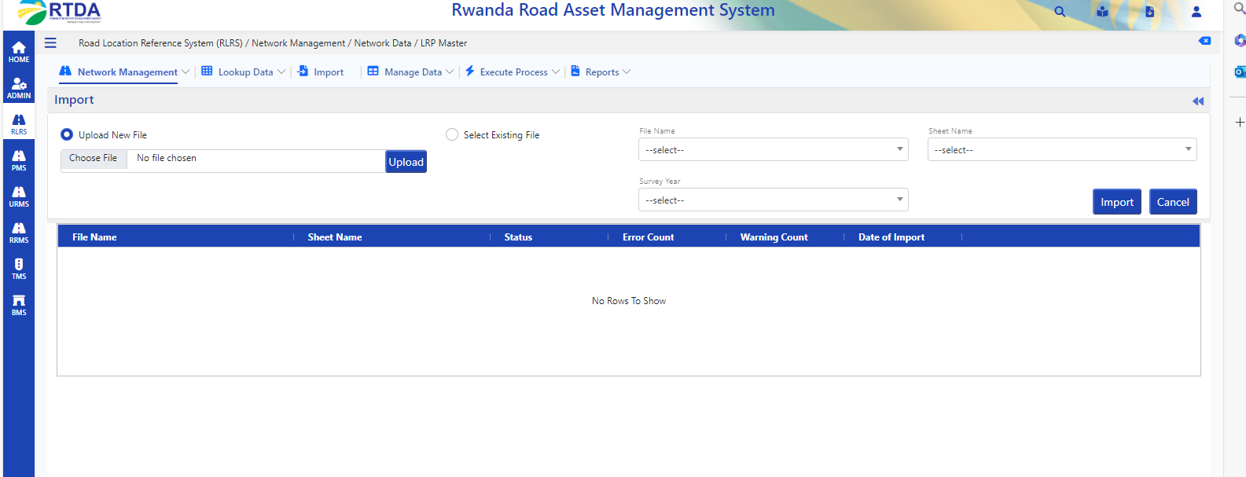

6 Road Location Reference System (RLRS) / Network Management / Network Data / Link Master-> upload new file alignement issue – Done

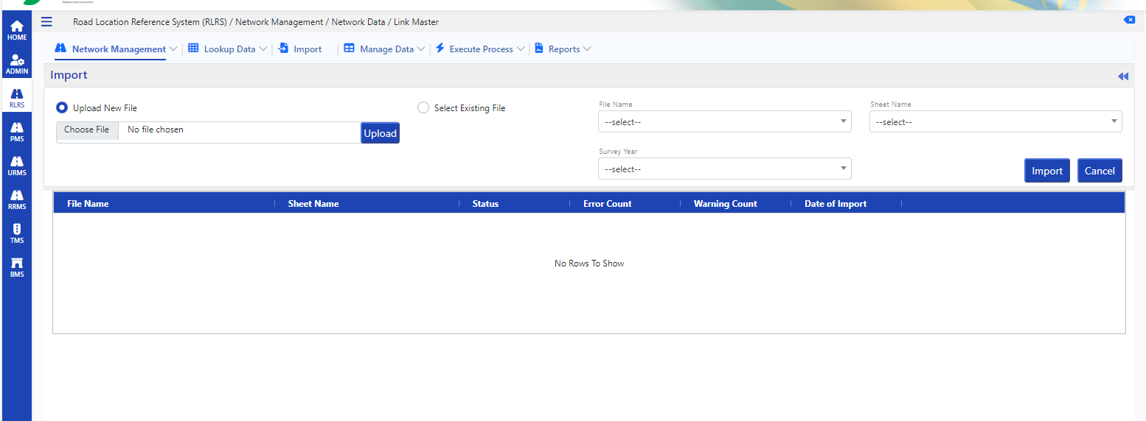

7 Road Location Reference System (RLRS) / Network Management / Network Data / Road Master-> upload new file alignement issue -- Done

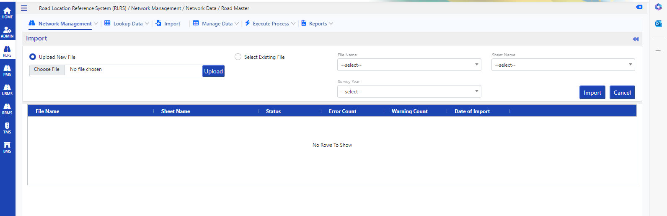

8. Road Location Reference System (RLRS) / Manage Data / Road Condition / Condition – Unpaved-> in edit page data not binding pothole code and drain condition code fields --- Service Issue

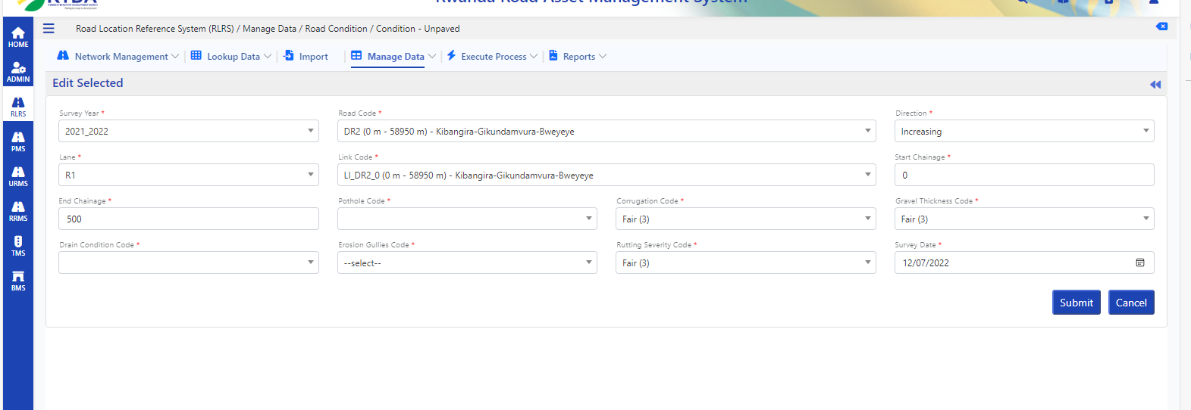

9 Road Location Reference System (RLRS) / Manage Data / Road Inventory / Road Assets – Section -> add upload file mandatary in choose file field -- Done

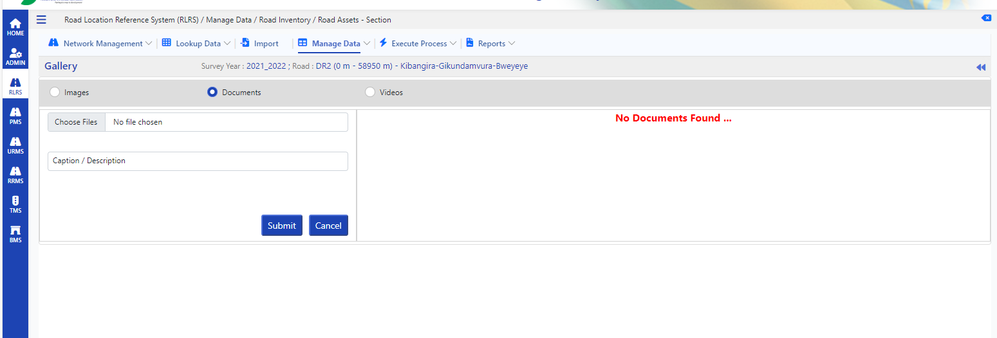

10 Road Location Reference System (RLRS) / Manage Data / Road Inventory / Road Assets - Point-> add upload file mandatary in choose file field -- Done

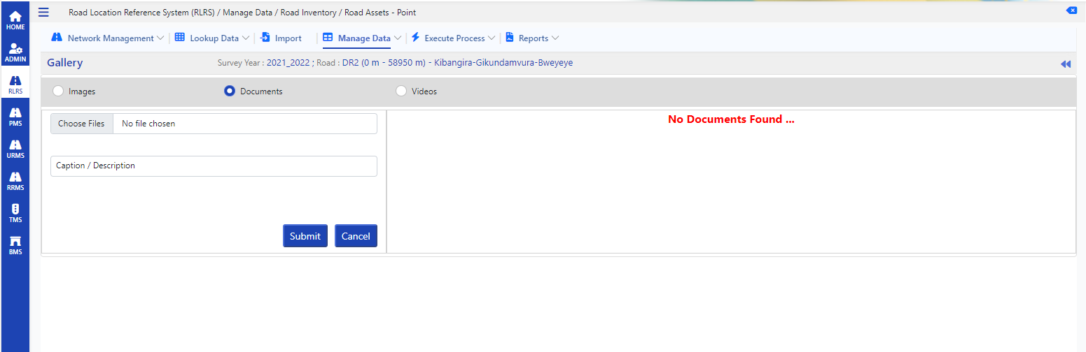

11 Road Location Reference System (RLRS) / Manage Data / Road Condition / Condition - Paved-> add upload file mandatary in choose file field -- Done

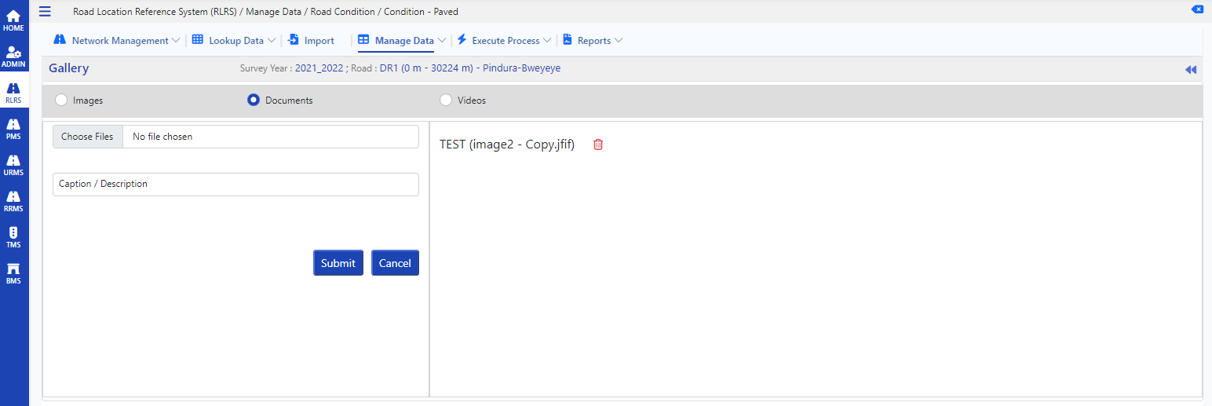

12 -> add upload file mandatary in choose file field --- Done

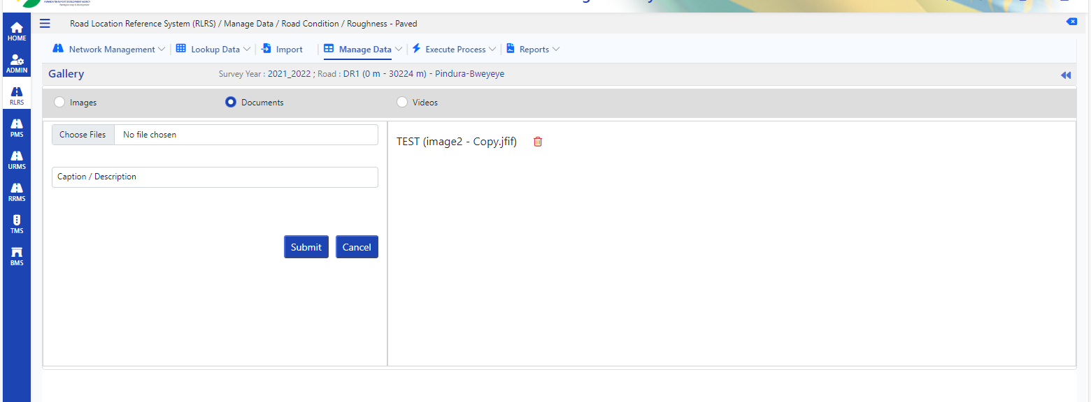

13. Road Location Reference System (RLRS) / Manage Data / Road Condition / Texture Depth-> add upload file mandatary in choose file field ---Done

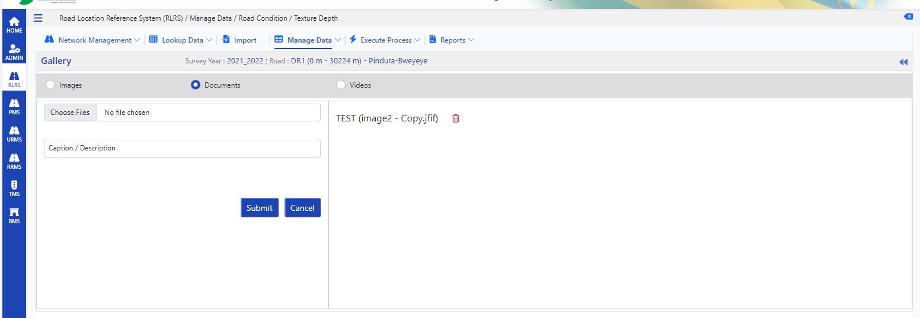

14 Road Location Reference System (RLRS) / Manage Data / Pavement Details / Pavement Strength (FWD) -> add upload file mandatary in choose file field --- Done

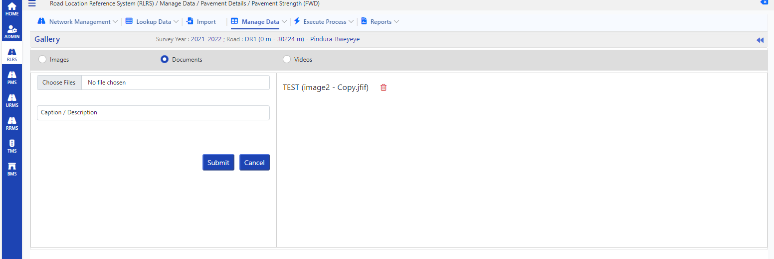

15 Road Location Reference System (RLRS) / Manage Data / Pavement Details / Pavement Composition-> add upload file mandatary in choose file field ---Done

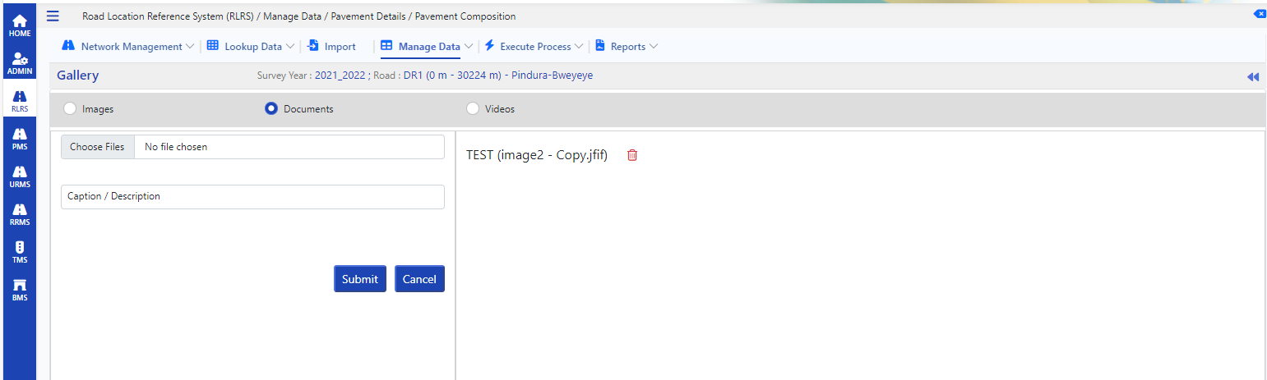

16 Road Location Reference System (RLRS) / Manage Data / Pavement Details / Pavement History-> add upload file mandatary in choose file field --- Done

