**Test Scenario:**

1. Fill in all bridge details: **Location Details**, **Top Deck**, **Span Details**, and **Protection Work**.
2. In **Span Details**, select **Non-pipe type**.
3. Enter data in **Superstructure**, **Abutment**, **Piers**, and **Bridge Condition** Tabs — each has **Inventory** and **Condition** screens.
4. Enter **Condition** data for the year **2023**.
5. Sync the data to the server along with ten images.
6. After sync, check on the web application whether the synced data is displayed correctly.
7. Download the same bridge by clicking **+Existing Bridge** in the **Condition** section.
8. Enter **Road Category** and **Road Number** — verify that bridges matching the selection are displayed.
9. Open the downloaded bridge — confirm that only **Superstructure**, **Abutment**, **Piers**, **Bridge Condition**, and **View Details** are visible initially.
10. Click **View Details** — verify that all bridge tabs are displayed.
11. Open **Condition** from **Superstructure Inventory**, then copy last year’s (**2023**) data to **2024** by clicking **Copy Data from Last Year**.
12. Verify that the data is successfully copied to **2024**.
13. After entering data for **2024**, sync the data to the server again and check on the web application by changing the **Survey Year** dropdown value — verify that the 2024 data is displayed correctly.

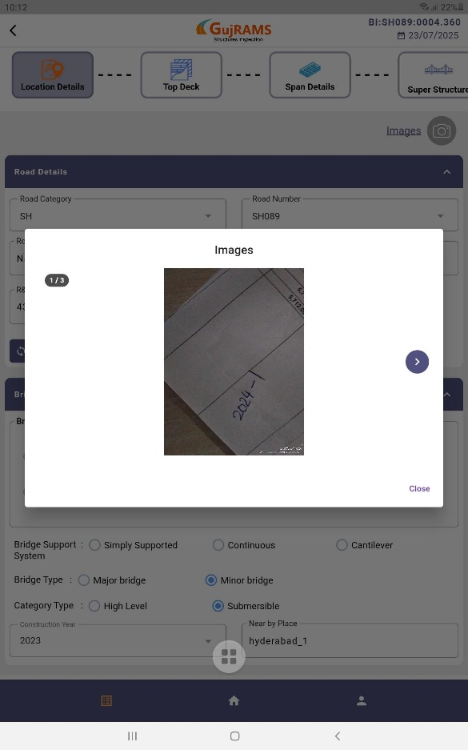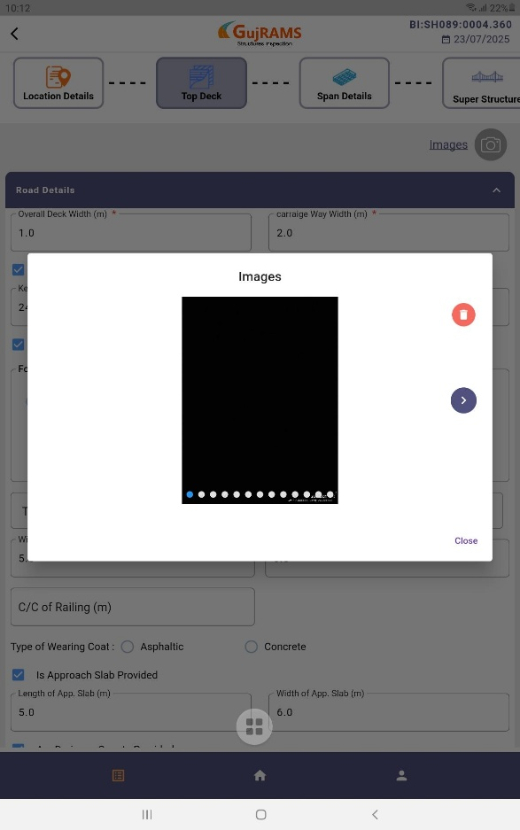**Issues:  
1.** After downloading the existing bridge ->In the location details tab, it is displaying three images that were uploaded in 2024. However, in the top deck tab, it is displaying ten images that were uploaded in 2023.

2. When entering Abutment data for a new bridge for the first time, the Condition screen should not display the “Copy data from last year” option.  
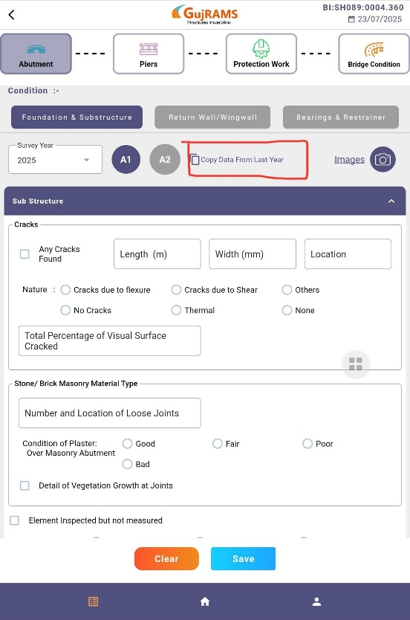

3. In the Bridge condition, it is displaying images of 2024 year but the survey year is selected as 2023.  
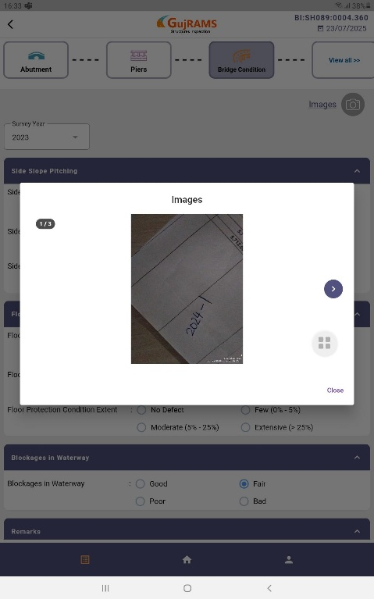  
  
4. Without entering data in 2025, it is displaying as a check box selected  
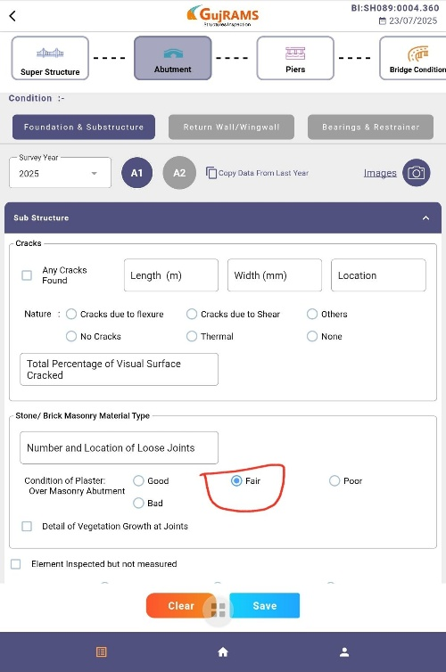

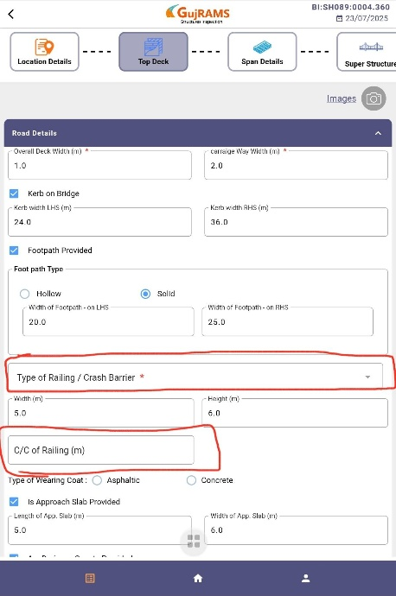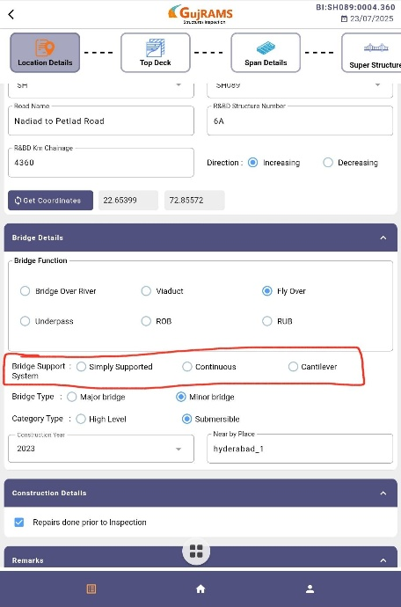5. After downloading existing bridge data, the below highlighted fields are not bound.

6.Web sync -> pier condition failed

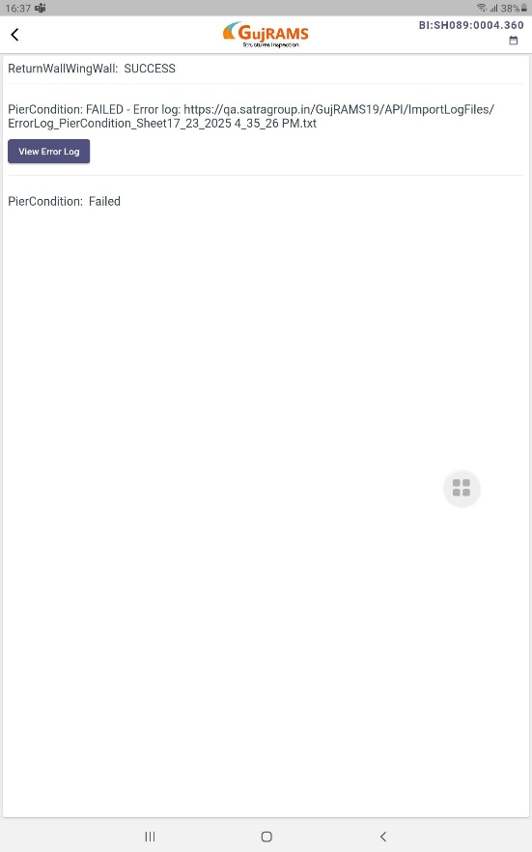 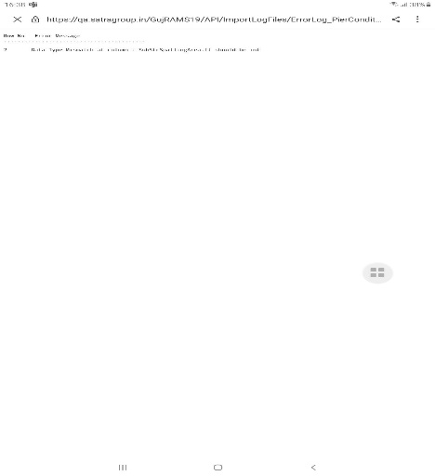

Web issues:

7. Survey Year is not binding on the web.

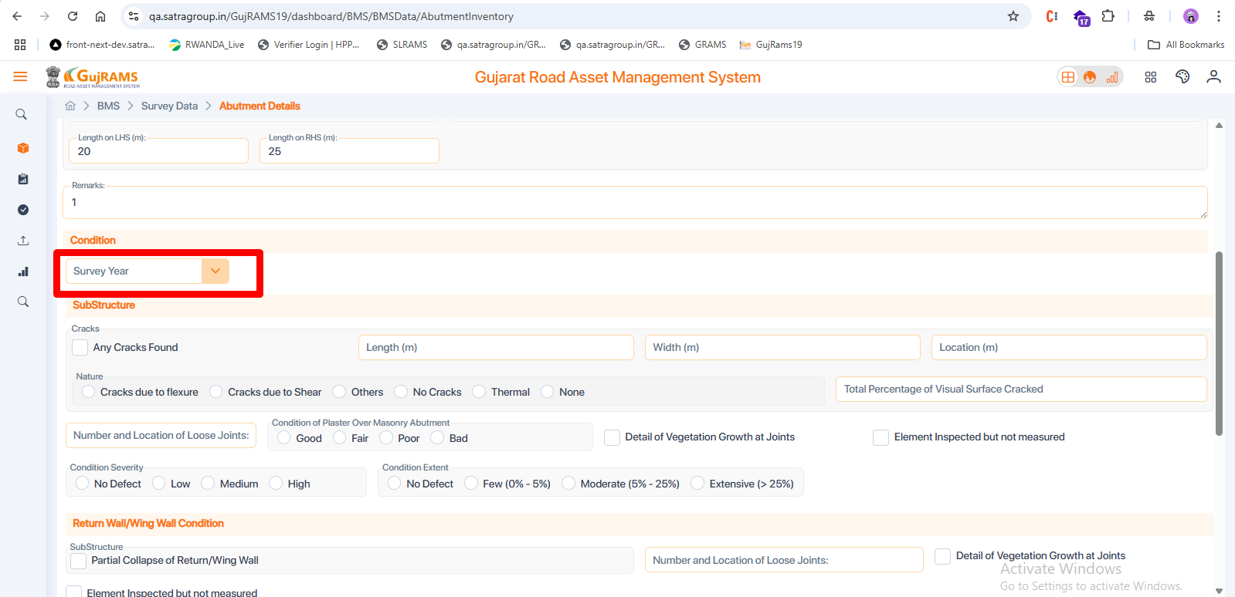  
  
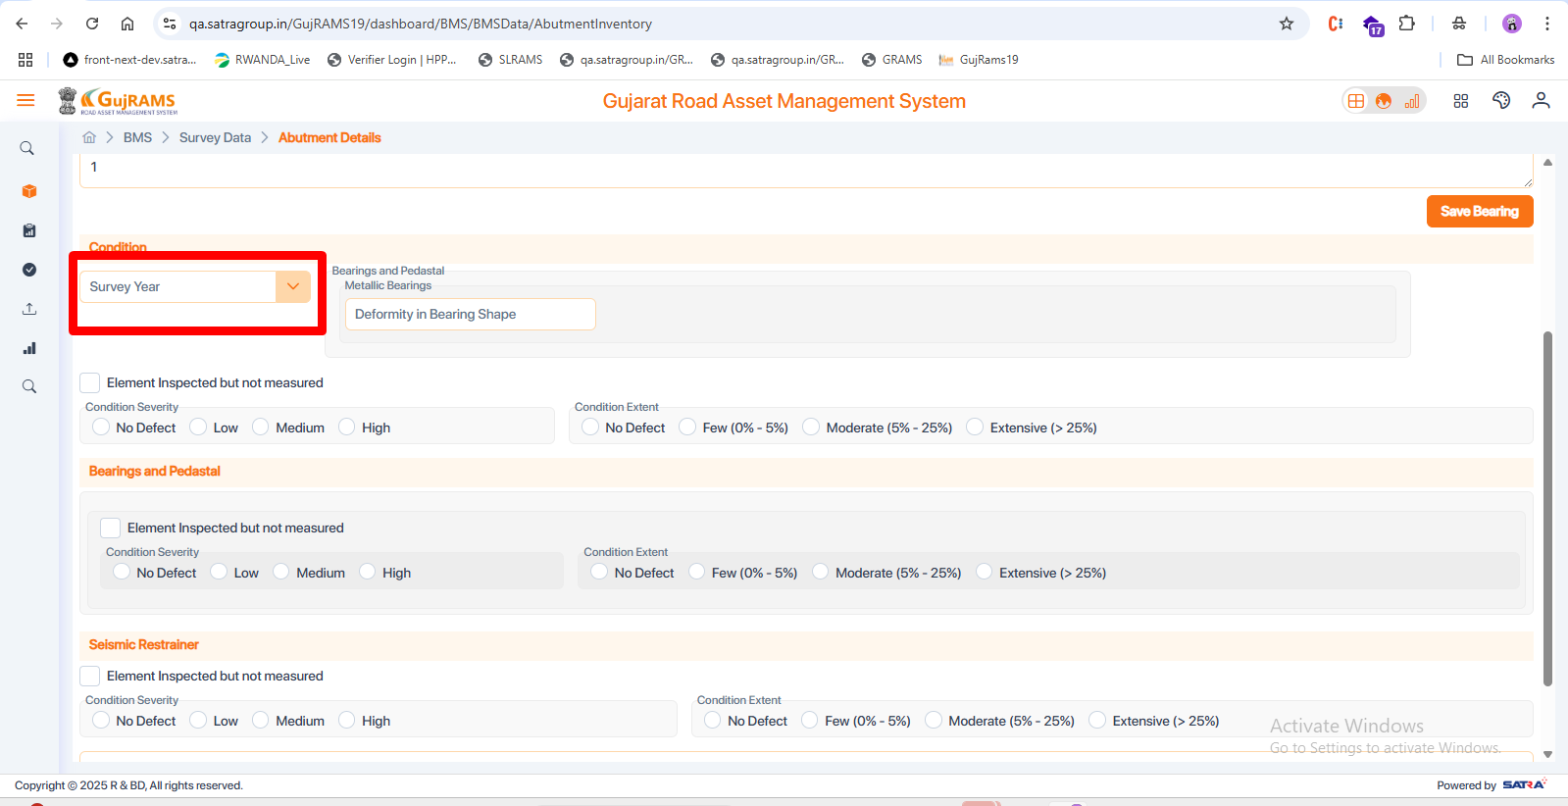  
  
8. Values are submitted in the year 2020, but images are displayed by default for the year 2025.  
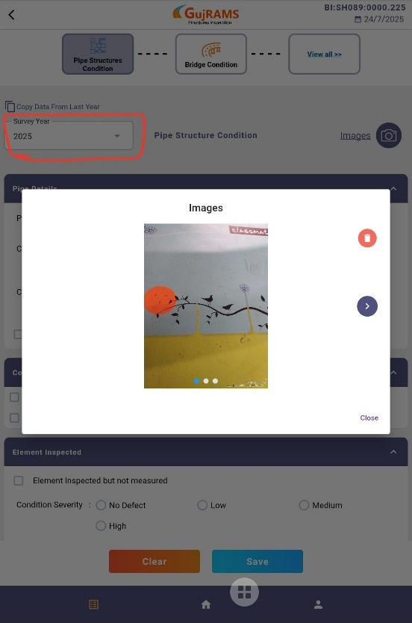

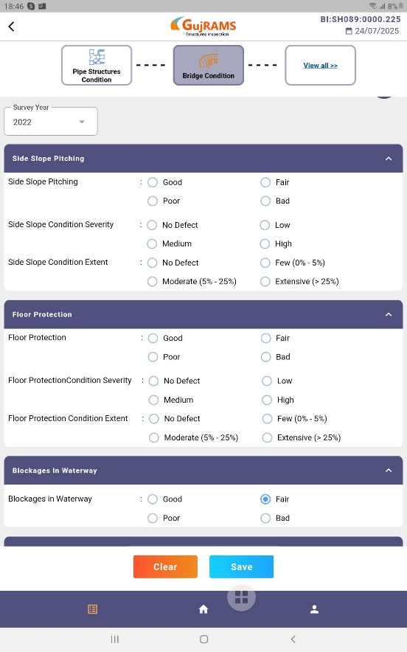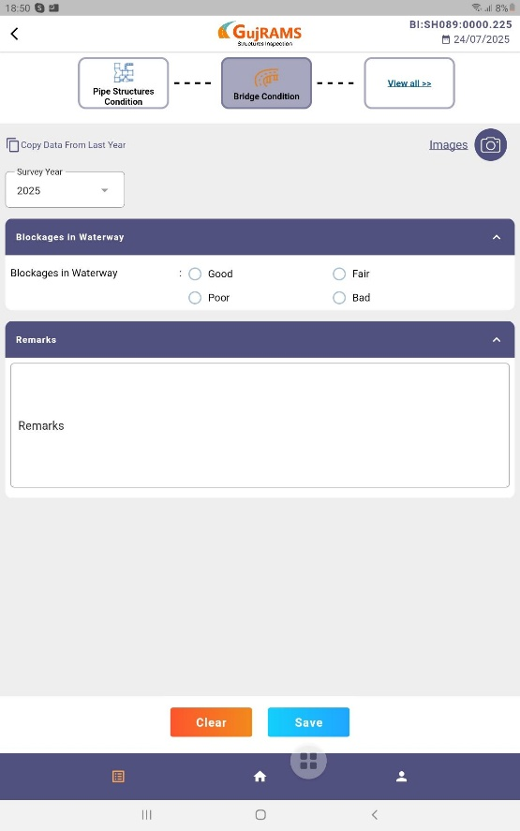9. When opening the Bridge Condition tab and clicking “Copy data from last year,” additional fields are displayed that were not shown when entering data for the first time in 2020.

10. values not binded in the tab when the existing bridge is downloaded  
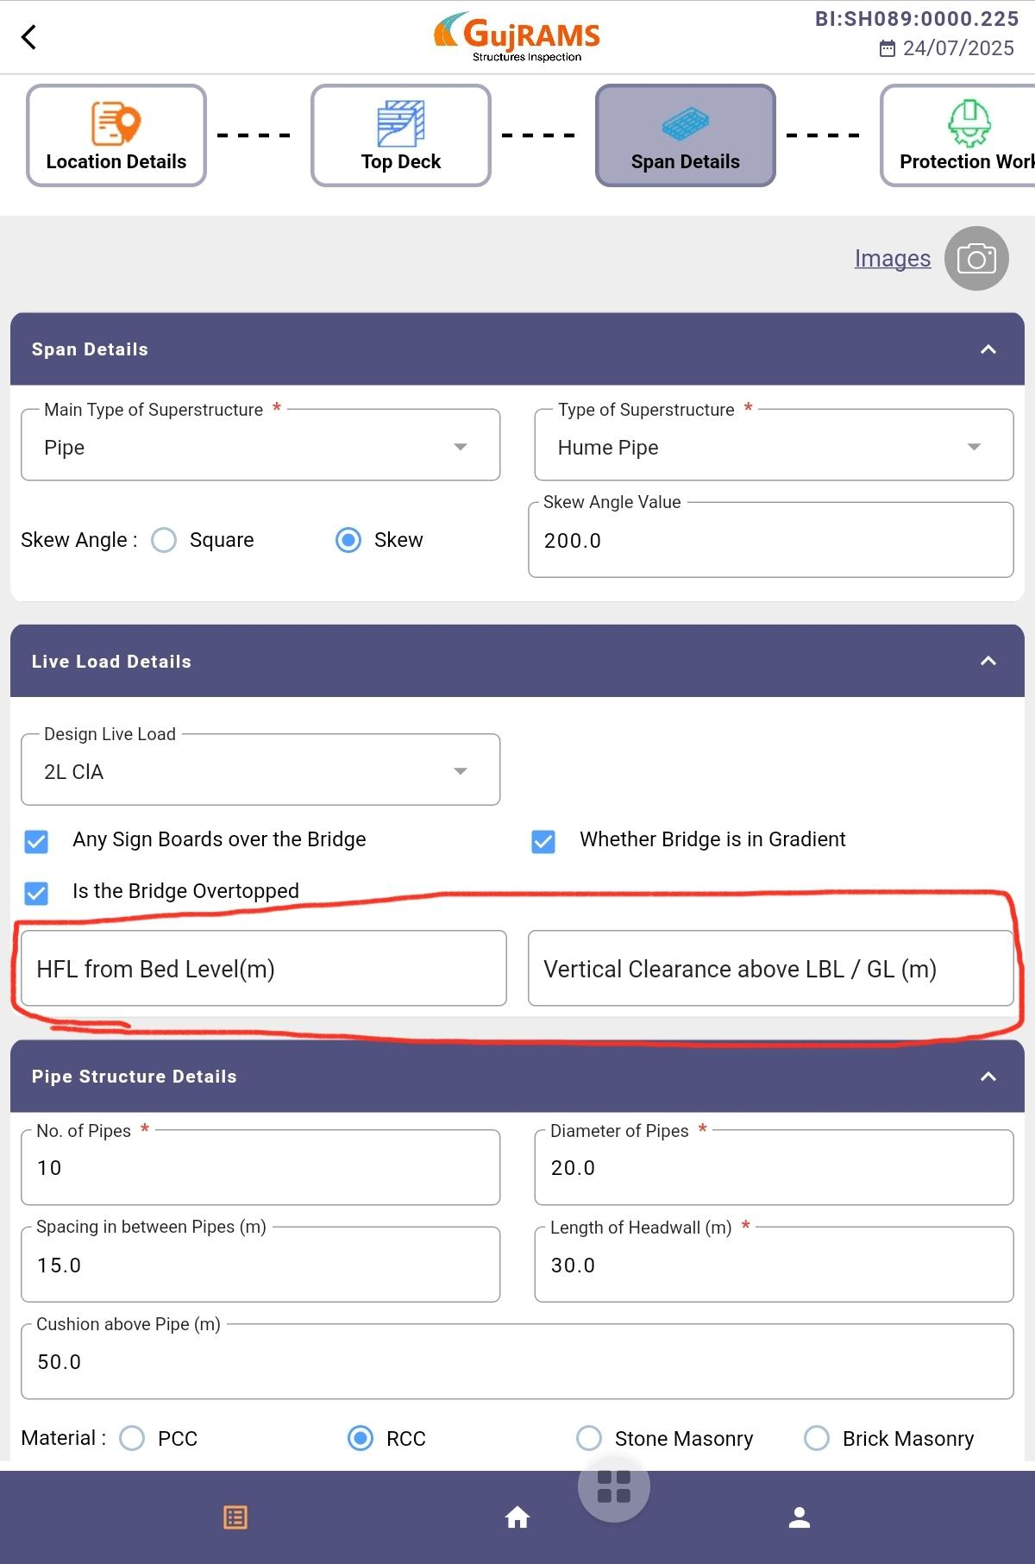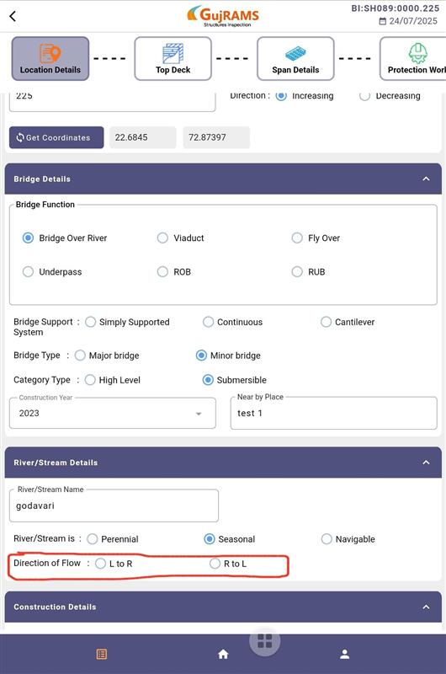

11. After syncing the bridge second time with another year in the condition tab -> image, which is uploaded in the first year, is not displayed.

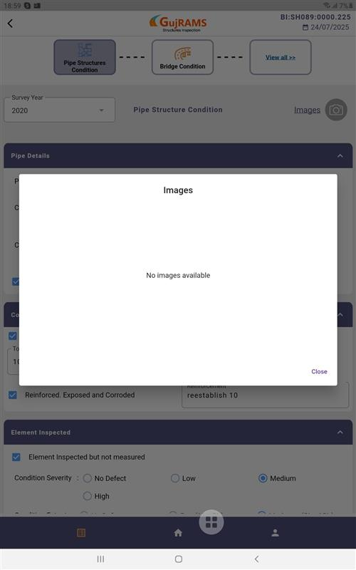 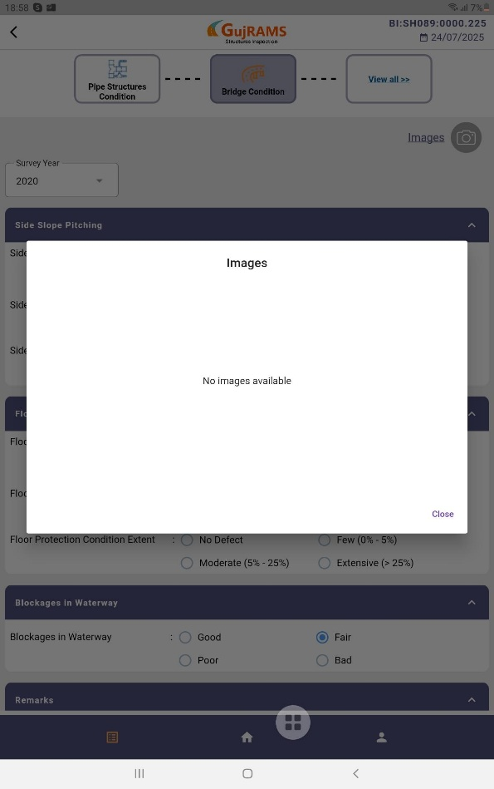

12.“Bridge has been displayed twice on the web.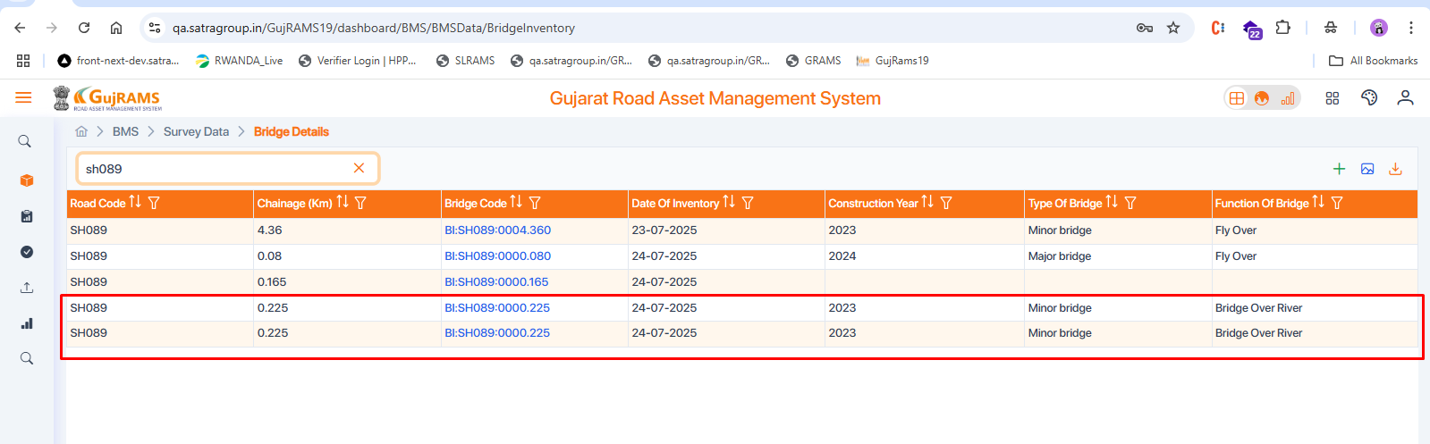

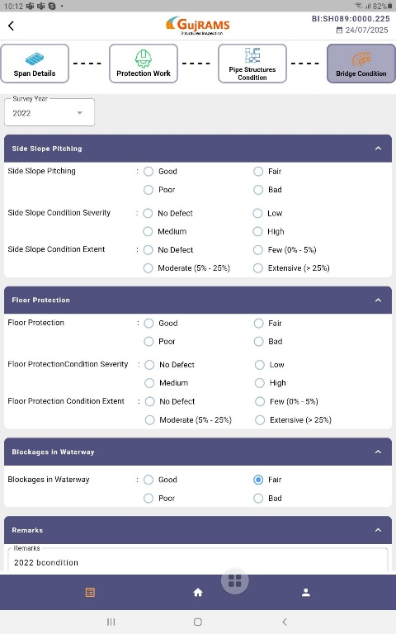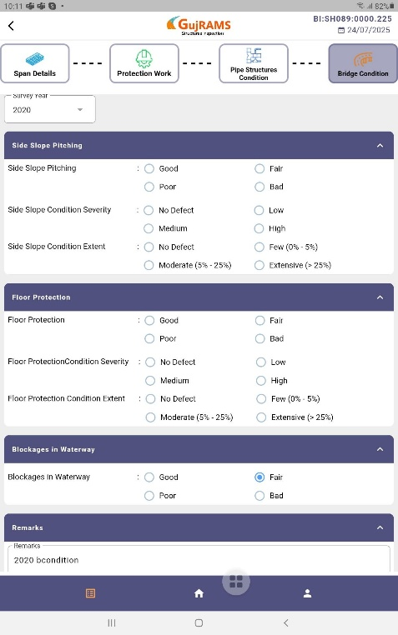13. Remarks field is missing in the Details of protection work tab in the web.  
 2. In the Condition of Protection Works screen, data is available for the years 2020 and 2022, but on the web, the radio button for the year 2025 is displayed as selected.  
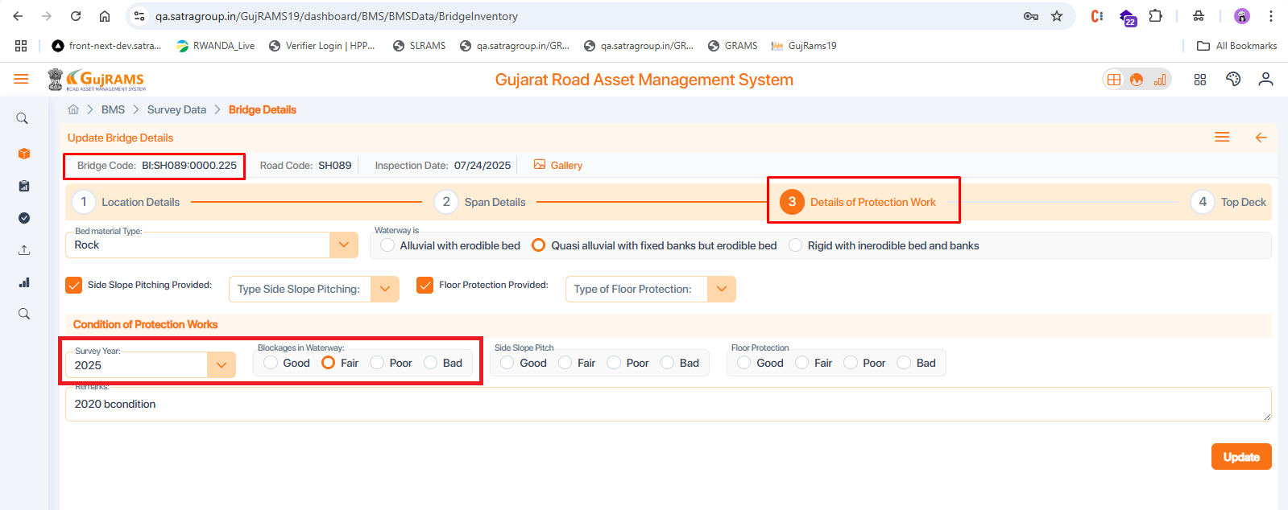  
  
   
  
  
  
  
  
  
  
  
  
  
  
  
  
  
  
  
  
  
  
  
  
  
  
  
  
  
  
  
  
  
  
  
  
  
  
14. After clicking on the gallery, images should be displayed in a separate pop-up screen, but currently, they are appearing below for all the tabs.  
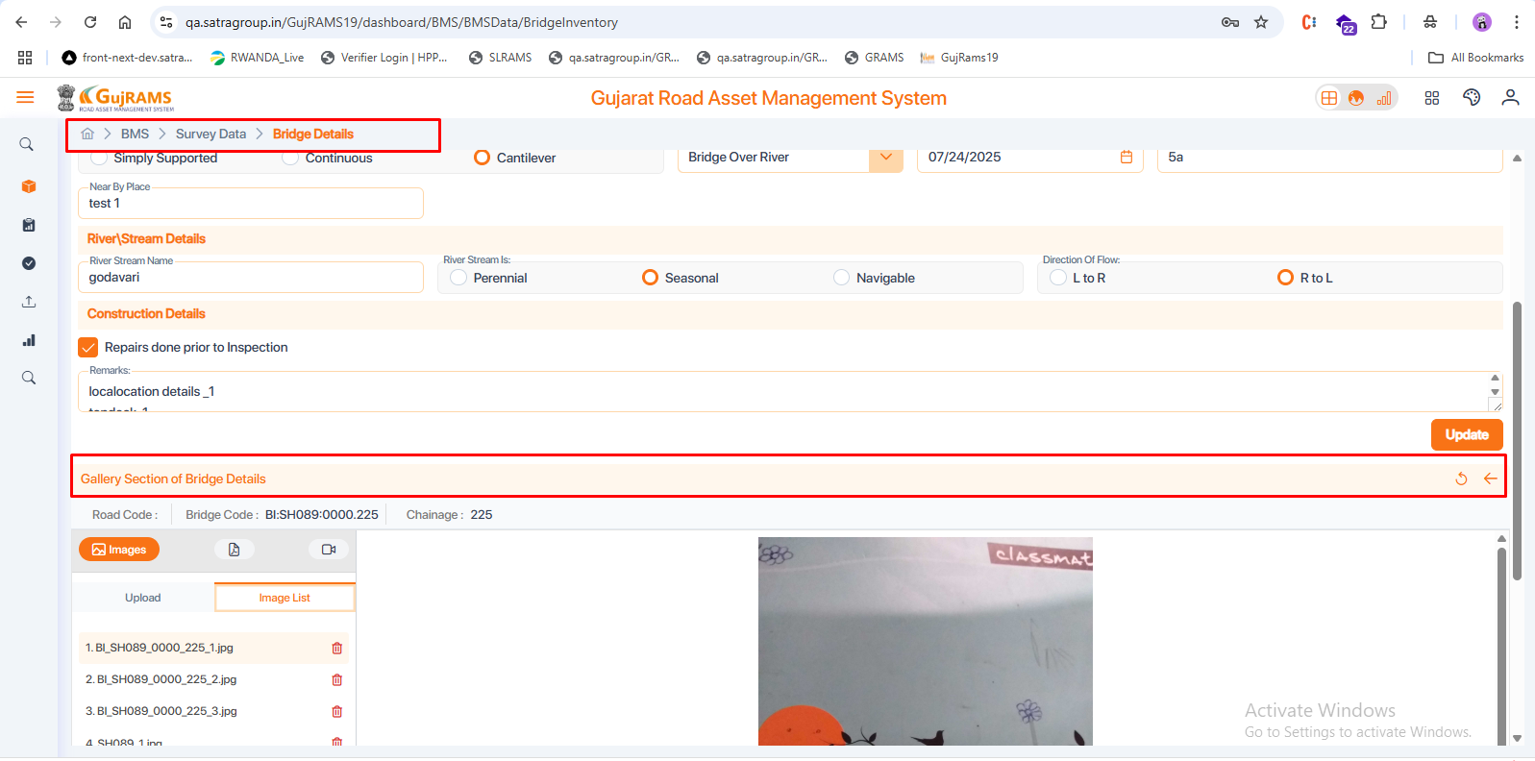

15. For the pipe type, when we click on ‘**Navigate to Other Modules**,’ it is displaying superstructure and piers details as well, but it should only display abutment details.  
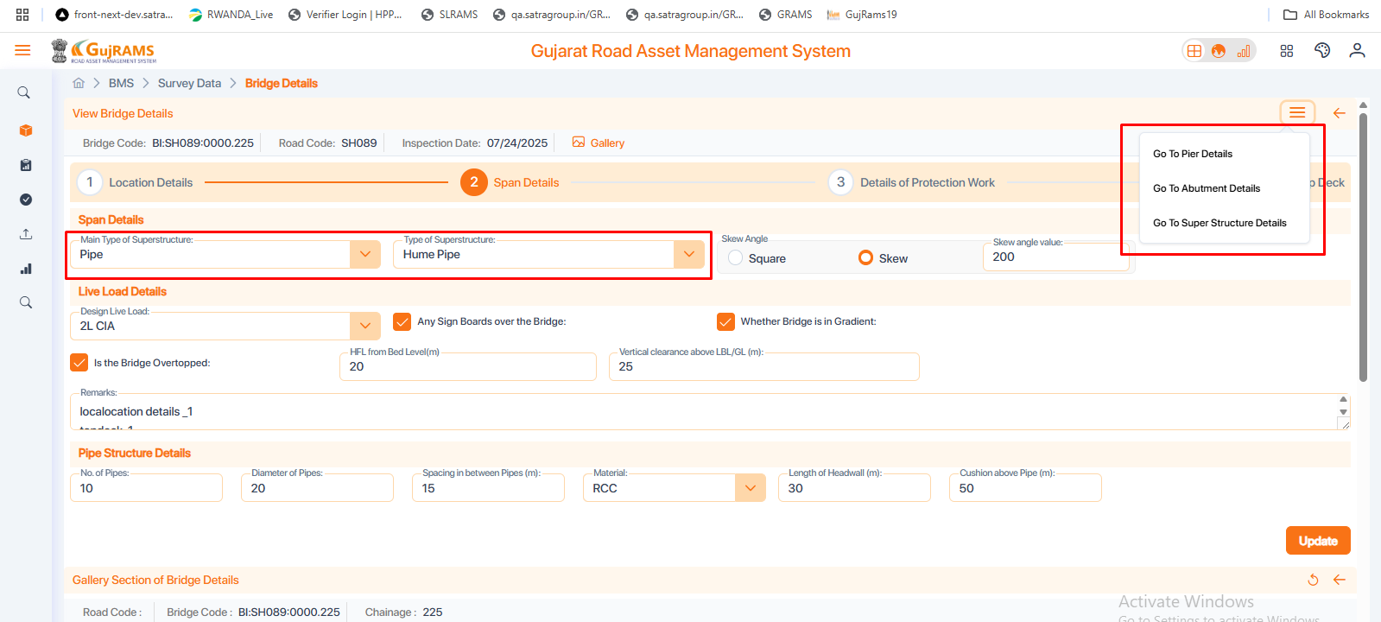

16. In the pipe structure condition screen, there is no survey year dropdown, so it is not possible to test whether the values are displaying correctly  
  
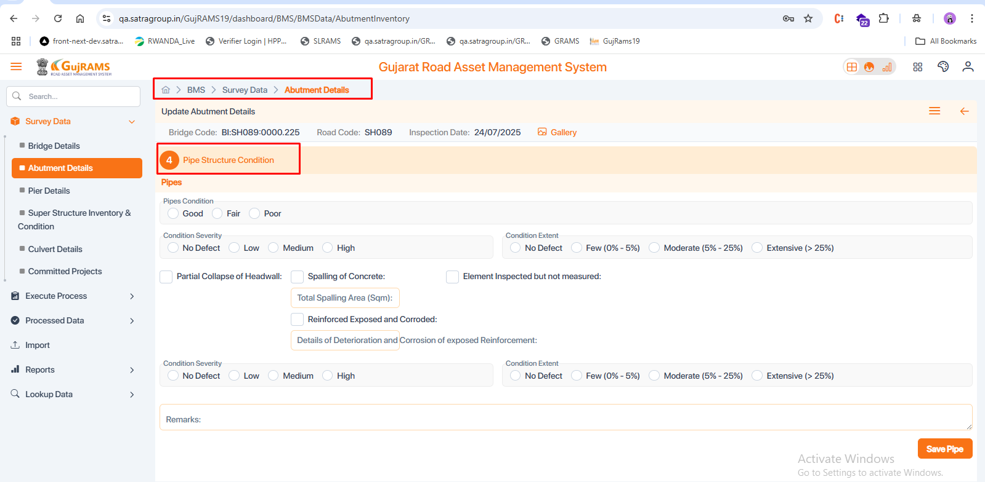

17. After changing the survey year, an error is displayed when attempting to sync to the web.”

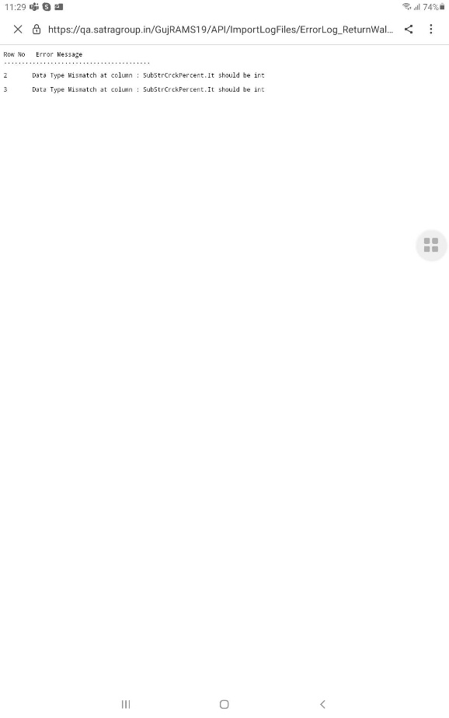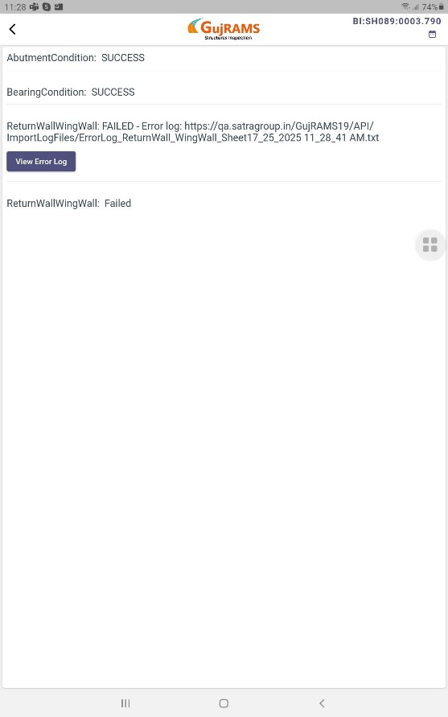

18.Below highlighted field is missing in tab  
  
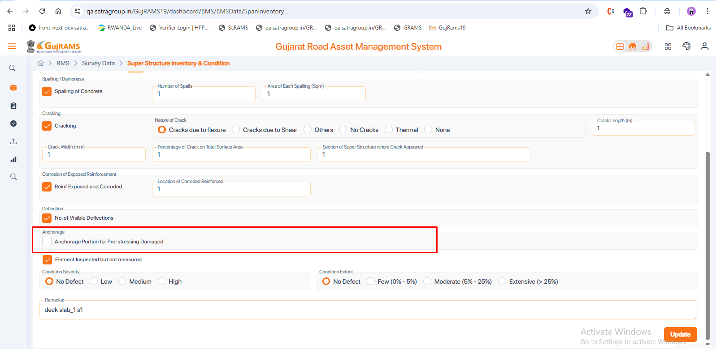

19. Abutment Substructure -> material value is not binded in web  
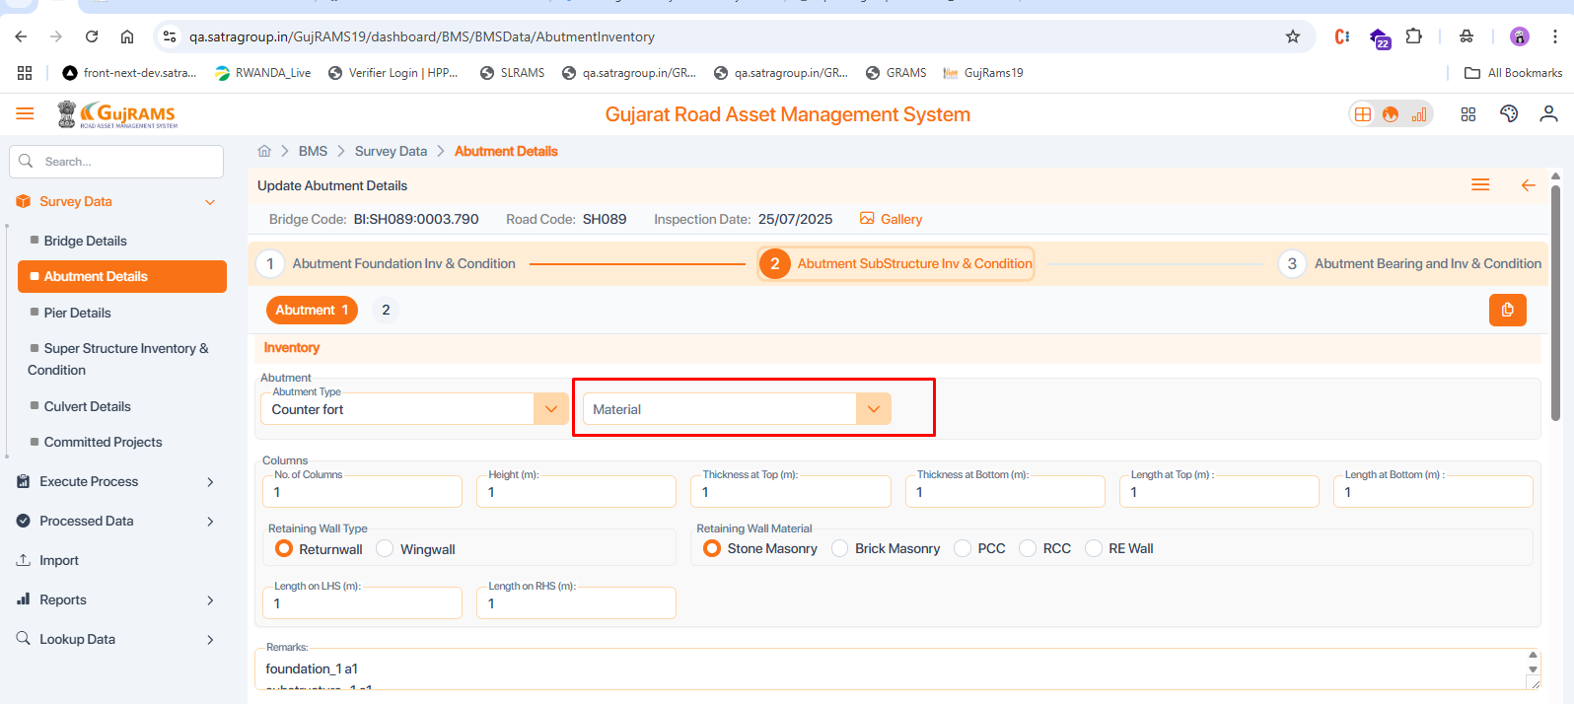  
  
20.Abutment-> super structure-> length on LHS value is displayed as null in exist bridge.  
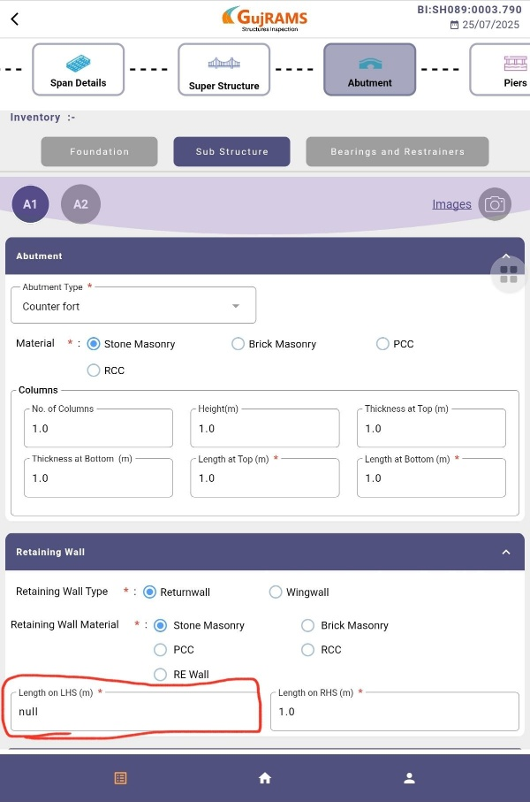

21.Abutment-> return wall/wingwall.->Highlighted field in the tab is missing in web.  
