**Issue 1:**

**Issue**: RIS → Road Inventory → Crud Operations → Add, update functionality not working → Check all the components for all the screens in RIS module.

**Priority**: High  
**Expected Result**:

* Should able to Add, Update the record.
* Alignments should be in proper way.
* User should be able to bind the mandatory field values in the grid.
* Start chainage & End chainage should accept decimal as well as whole numbers.

**Actual Result**:

* Not able to Add & Update the record.
* Improper Alignments observed.
* Mandatory fields are failing to bind in the grid.
* Start chainage & end chainage are only accepting two digits or decimals. If user enter more than two digits it is giving decimal alert.

**Category**: Bug.

**Browser:** Firefox

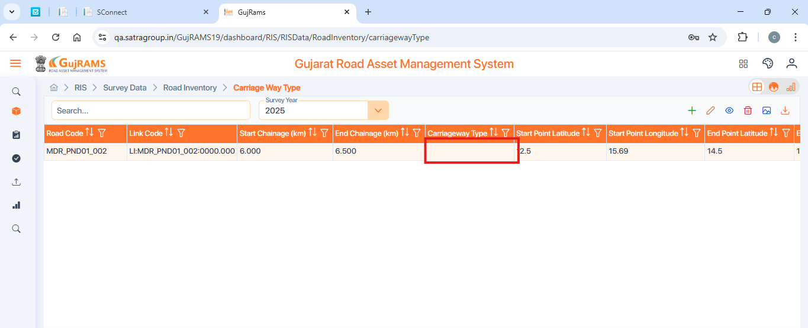

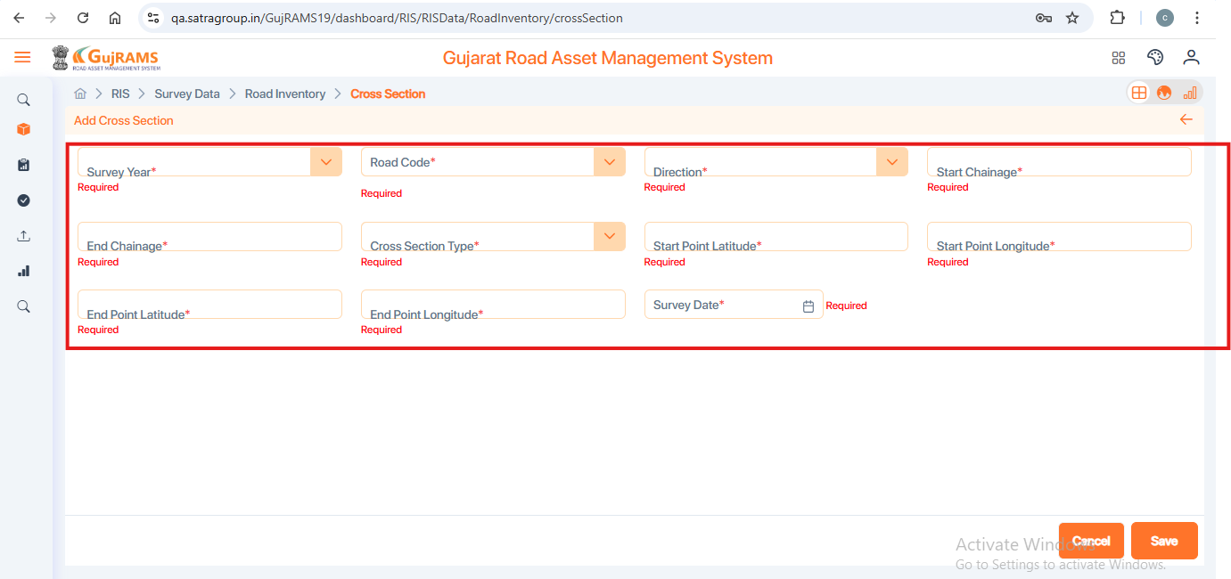

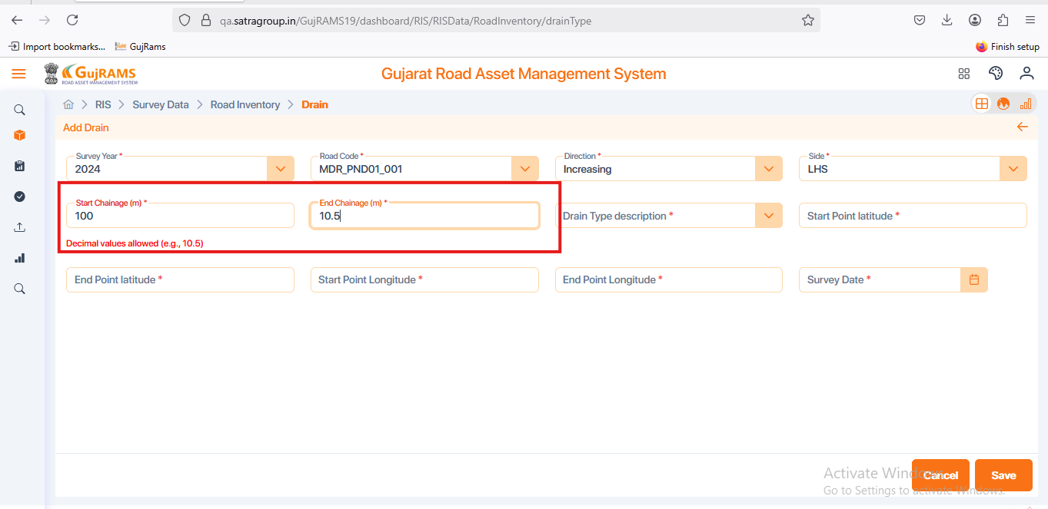

**Issue 2:**

**Issue**: TIS → Survey Data → Traffic Station Details → Select Row to Delete → Click on Delete Button → Click on Delete Confirmation popup YES → Deleted Popup displaying → Still selected record remains in the grid.

**Priority**: High  
**Expected Result**: Selected record should not remain after deleted successful popup displays.

**Actual Result**: After deleting popup displaying the record still present in the grid.

**Category**: Bug.

**Browser:** Firefox

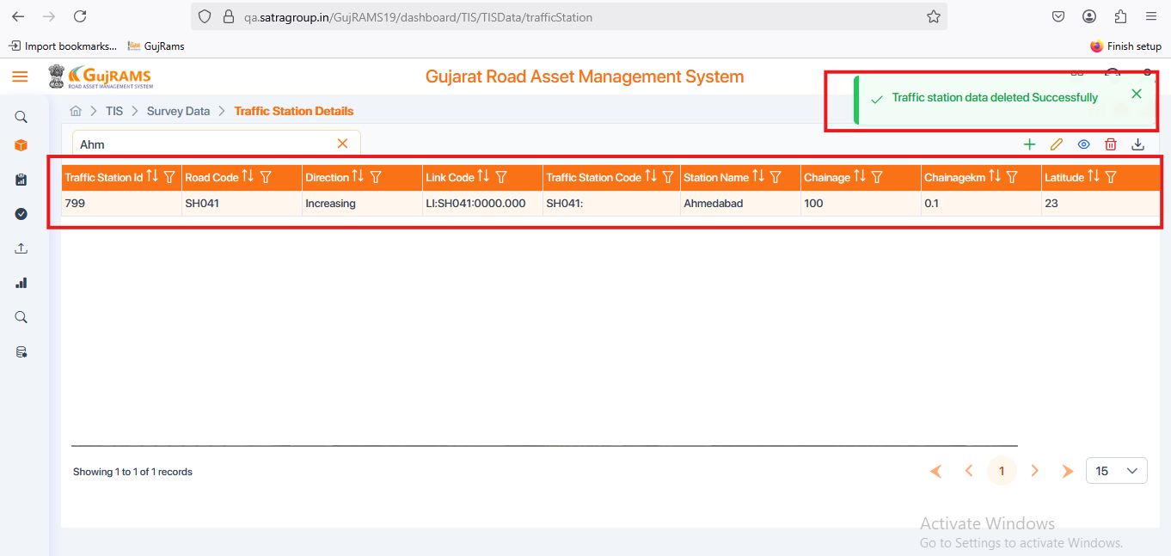

**Issue 3:**

**Issue**: TIS → Survey Data → Traffic Volume Count → Select Row to Delete → Click on Delete Button → Click on Delete Confirmation popup YES → Deleted Popup displaying → Popup Spelling error.

**Priority**: Normal  
**Expected Result**: Popup message spelling should be like Successfully.

**Actual Result**: Popup message is displaying as **Succefully.**

**Category**: UI Issue.

**Browser:** Firefox

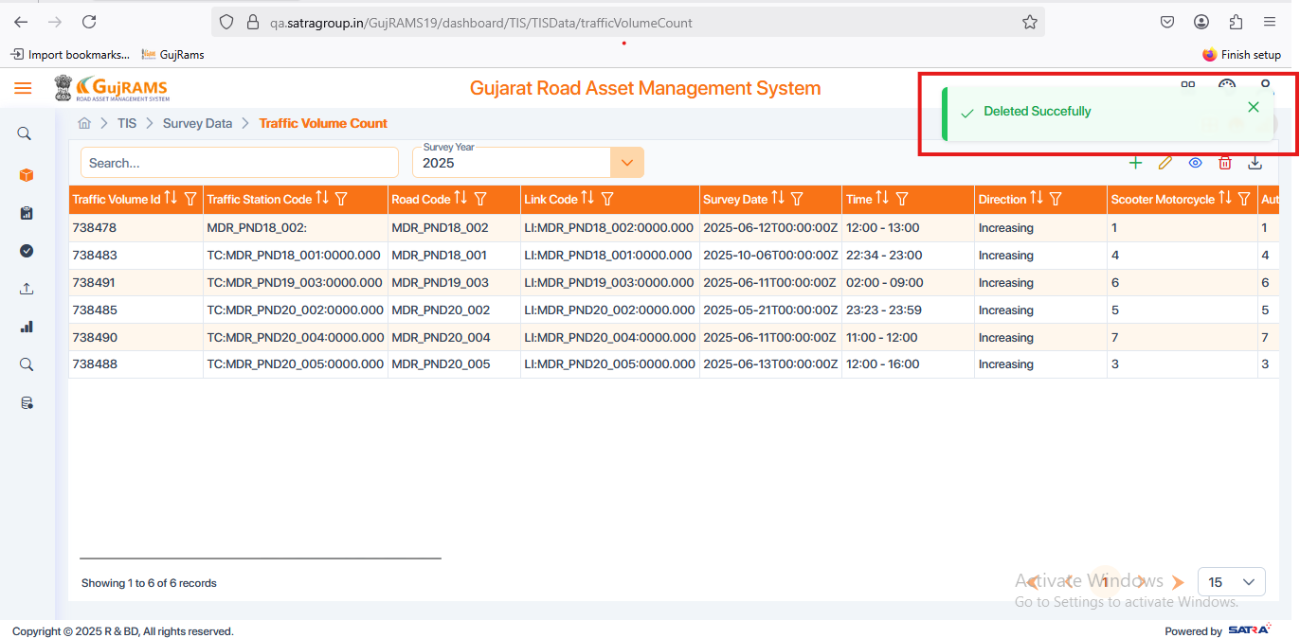

**Issue 4:**

**Issue**: TIS → Survey Data → Axle Load → Add → Fill the Fields → Click on Next Button → Next Button → Save → Wrong popup message is displaying after clicking on save button.

**Priority**: High  
**Expected Result**: User should able save the Axle load data & should redirected to grid after save successfully popup displayed

**Actual Result**: When user click on save button then wrong popup is displaying & data is not saving.

**Category**: Bug.

**Browser:** Firefox

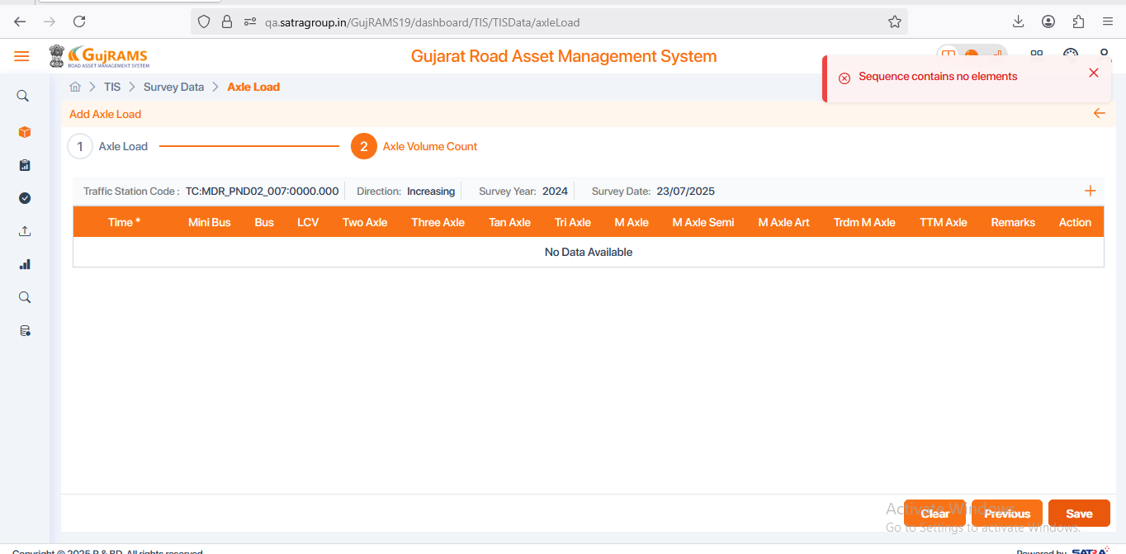

**Issue 5:**

**Issue**: PMS → Lookup Data → HDM Factors, Speed Flow, Decision Tree, Work codes → Add → Fill Data → Save → Wrong popup message is displaying.

**Priority**: High  
**Expected Result**: Data saved successfully popup message should be displayed.

**Actual Result**: Displaying popup message as Data Data saved Successfully**.** In this Data is repeating multiple times

**Category**: Bug.

**Browser:** Firefox

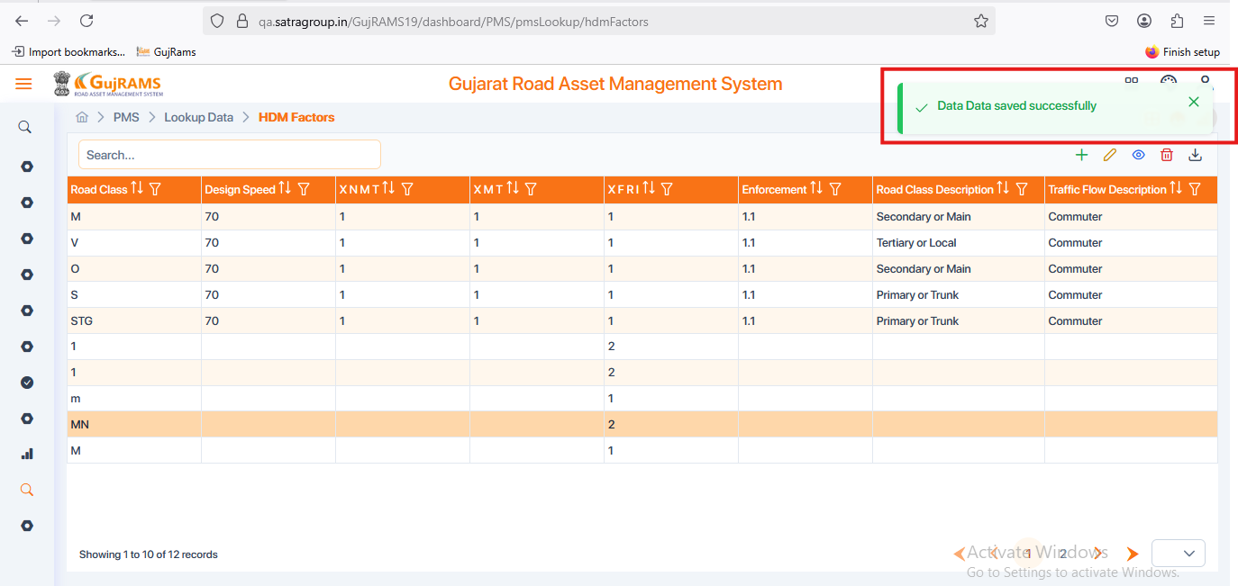

**Issue 6:**

**Issue**: PMS → Lookup Data → Split Merge Ops, Section Criteria → Add → Displaying empty screens.

**Priority**: High  
**Expected Result**: Should display fields to fill the data and save it..

**Actual Result**: Displaying empty page with no fields to fill data.

**Category**: Bug.

**Browser:** Firefox

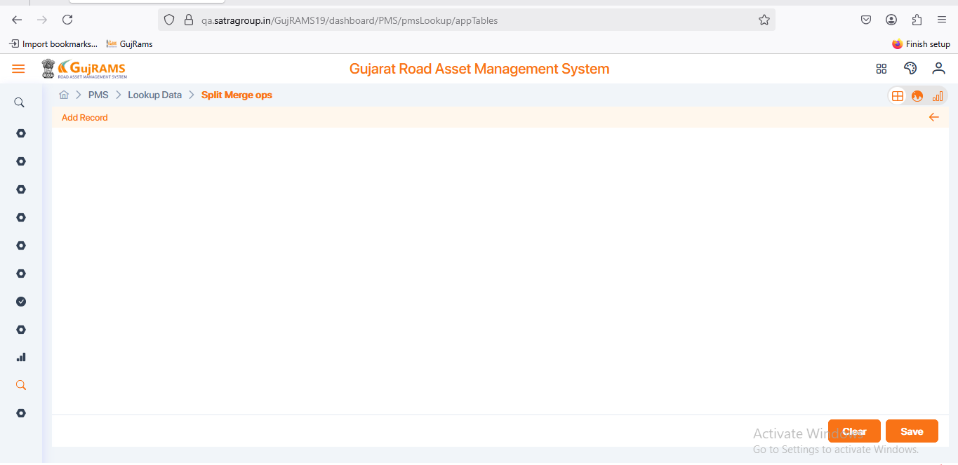

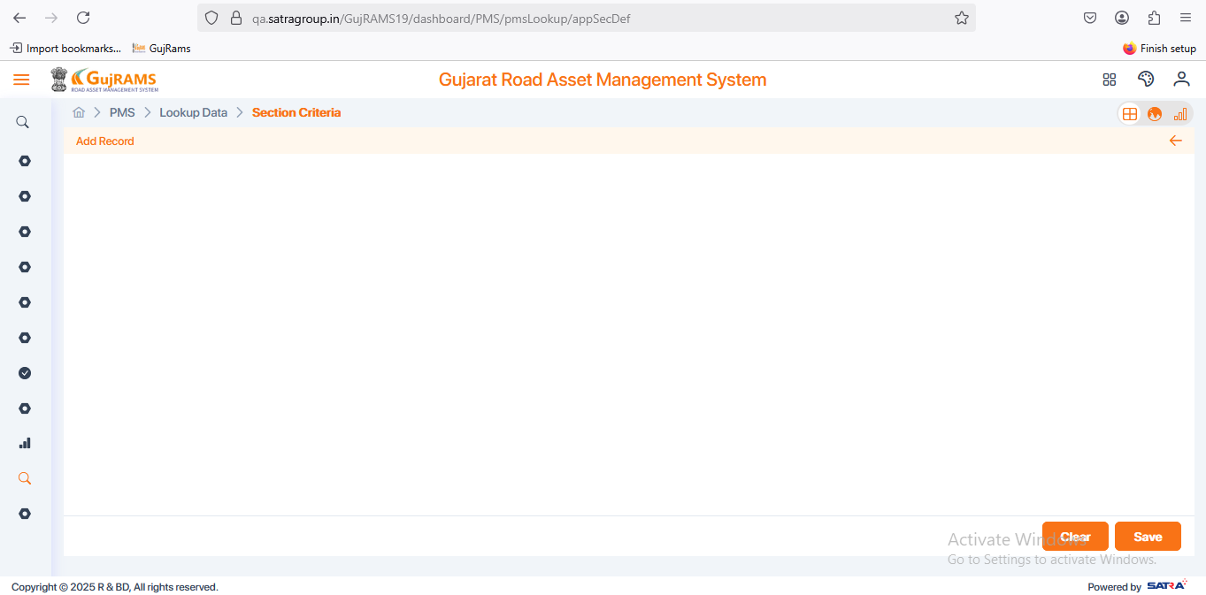

**Issue 7:**

**Issue**: BMS → Missing Mandatory fields

**Priority**: High  
**Expected Result**: Should Add mandatory field mark(*) for all required fields.

**Actual Result**: Missing Mandatory fields for all the components.

**Category**: Bug.

**Browser:** Firefox

**Issue 8:**

**Issue**: EIS → Survey Data → Tree Count → Add → Start chainage & End chainage should accept decimal as well as whole numbers.

**Priority**: High  
**Expected Result**: Start chainage & End chainage should accept decimal as well as whole numbers.

**Actual Result**: Start chainage & End chainage should accept decimal as well as whole numbers.

**Category**: Bug.

**Browser:** Firefox

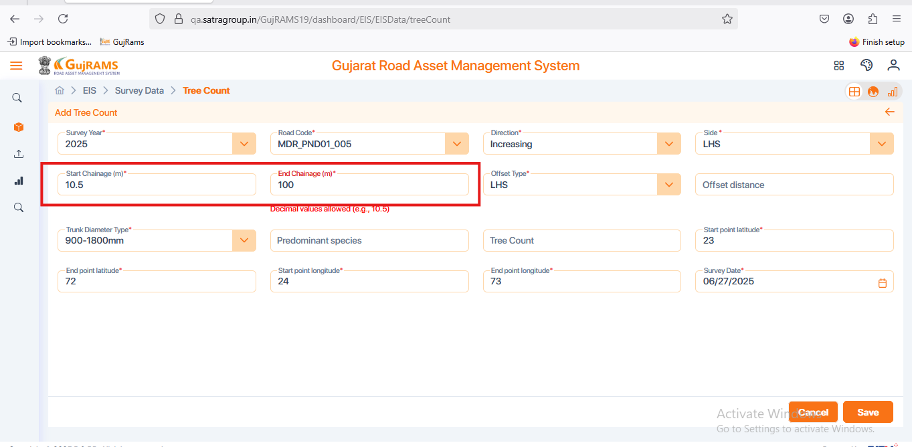

**Issue 9:**

**Issue**: EIS → Survey Data → Noise Level → Add → Fill Details → Save → Displaying wrong popup message & Unable to save data.

**Priority**: High  
**Expected Result**: Should display Data Saved Successfully popup & data should be saved and located in the grid page .

**Actual Result**: Displaying wrong popup message & Unable to save data.

**Category**: Bug.

**Browser:** Firefox

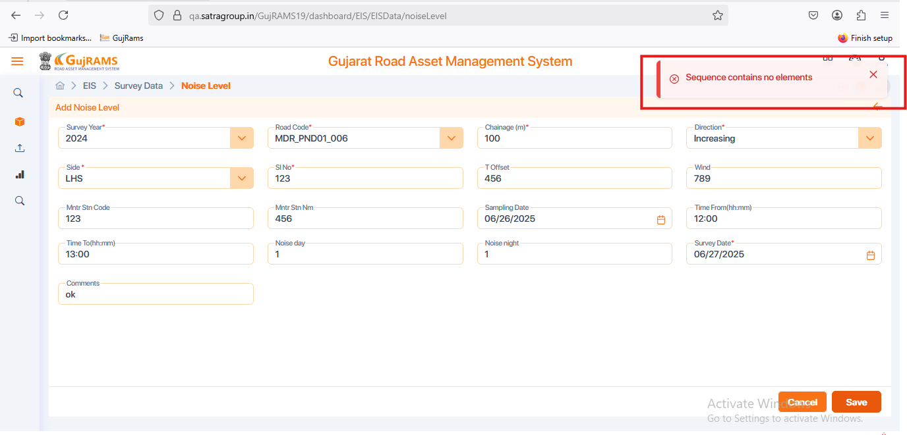

**Issue 10:**

**Issue**: RSAMS → Survey Data → Accident Details → Add → Fill Details → Save → Displaying wrong popup message & Unable to save data.

**Priority**: High  
**Expected Result**: Should display Data Saved Successfully popup & data should be saved and located in the grid page .

**Actual Result**: Displaying wrong popup message & Unable to save data.

**Category**: Bug.

**Browser:** Firefox

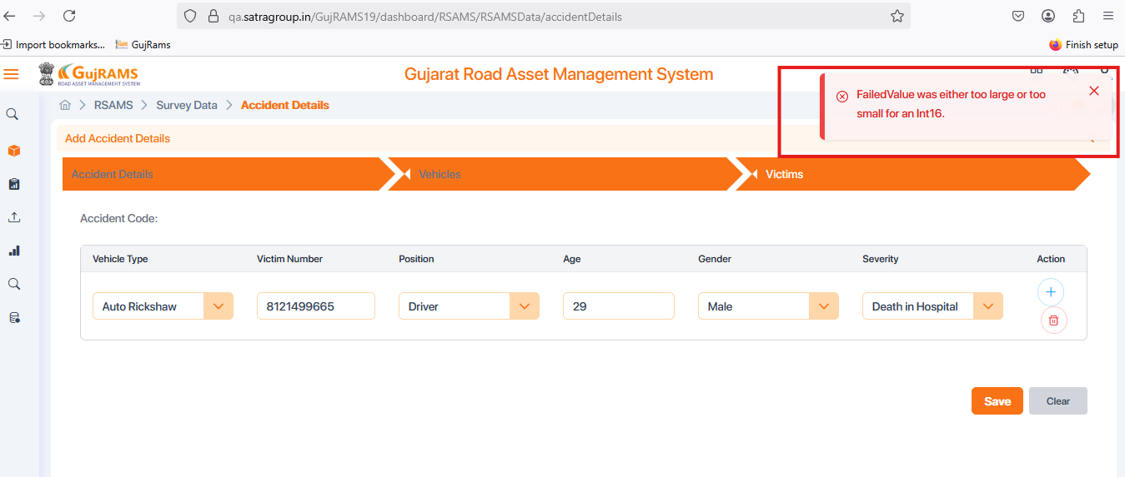

**Issue 11:**

**Issue**: RSAMS → Survey Data → Accident Details → Select Record → Update → Displays wrong heading

**Priority**: High  
**Expected Result**: Update Accident Details heading should be displayed.

**Actual Result**: Displays Edit Accident Details.

**Category**: UI.

**Browser:** Firefox

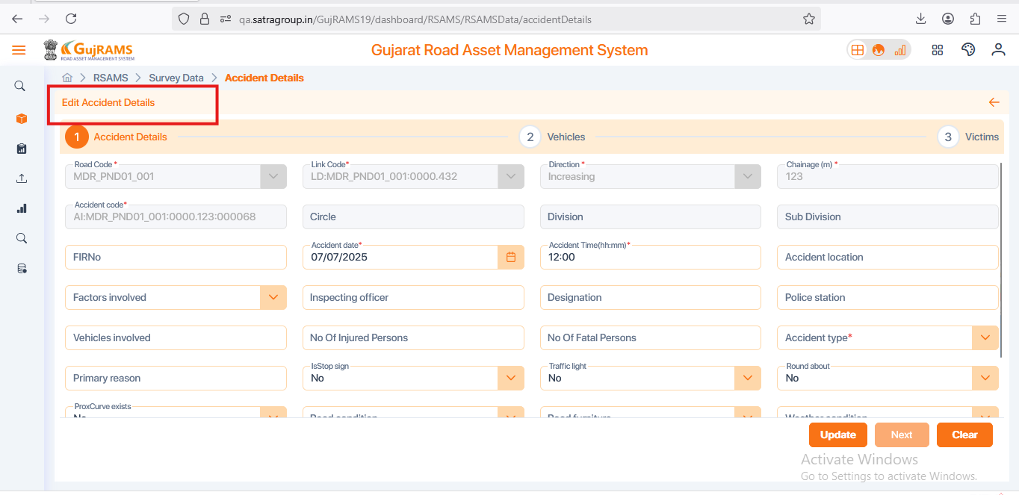

**Issue 12:**

**Issue**: RSAMS → Survey Data → Accident Details → Select Record → Delete → YES → Deleted popup displayed but data is still remaining in the grid.

**Priority**: High  
**Expected Result**: Selected record should be deleted after deleted popup display.

**Actual Result**: Deleted popup displayed but data is still remaining in the grid.

**Category**: Bug.

**Browser:** Firefox

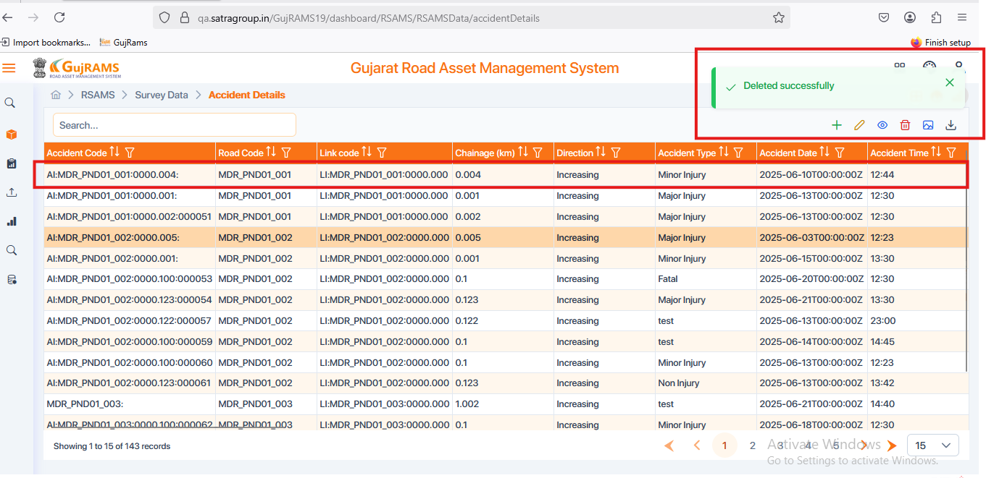

**Issue 13:**

**Issue**: RSAMS → Survey Data → Hazardous Location → Add → Start Chainage, End Chainage & Hazardous Location code fields are disabled to fill data → Check all Crud operations.

**Priority**: High  
**Expected Result**: Able to fill the data .

**Actual Result**: Start Chainage, End Chainage & Hazardous Location code fields are disabled to fill data.

**Category**: Bug.

**Browser:** Firefox

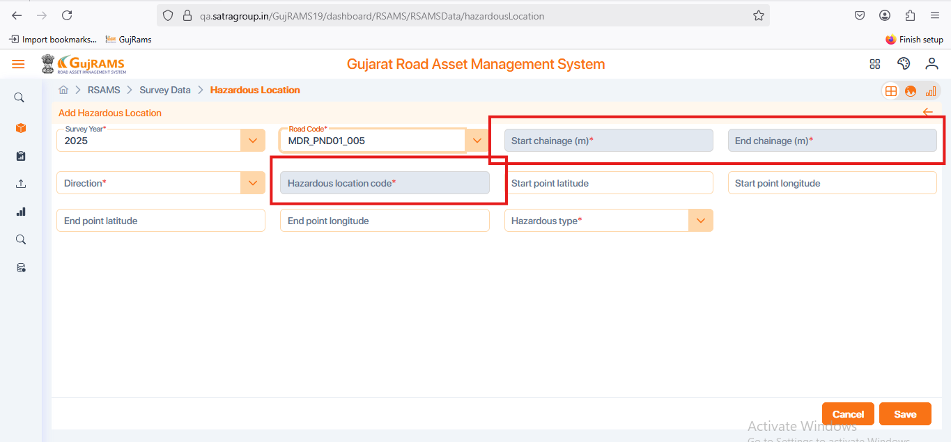

**Issue 14:**

**Issue**: MES → In all components crud operations are not working.

**Priority**: High  
**Expected Result**: Crud operations should be in workable conditions.

**Actual Result**: In this module crud operations are not working properly.

**Category**: Bug.

**Browser:** Firefox