**Dashboard Observations:**

1. NM-> Print not working.  
   After loading for so long, an alert is displayed as the page is unresponsive  
   and later, the print screen is displayed, but in the background, 'Fetching data...' is displayed.  
     
   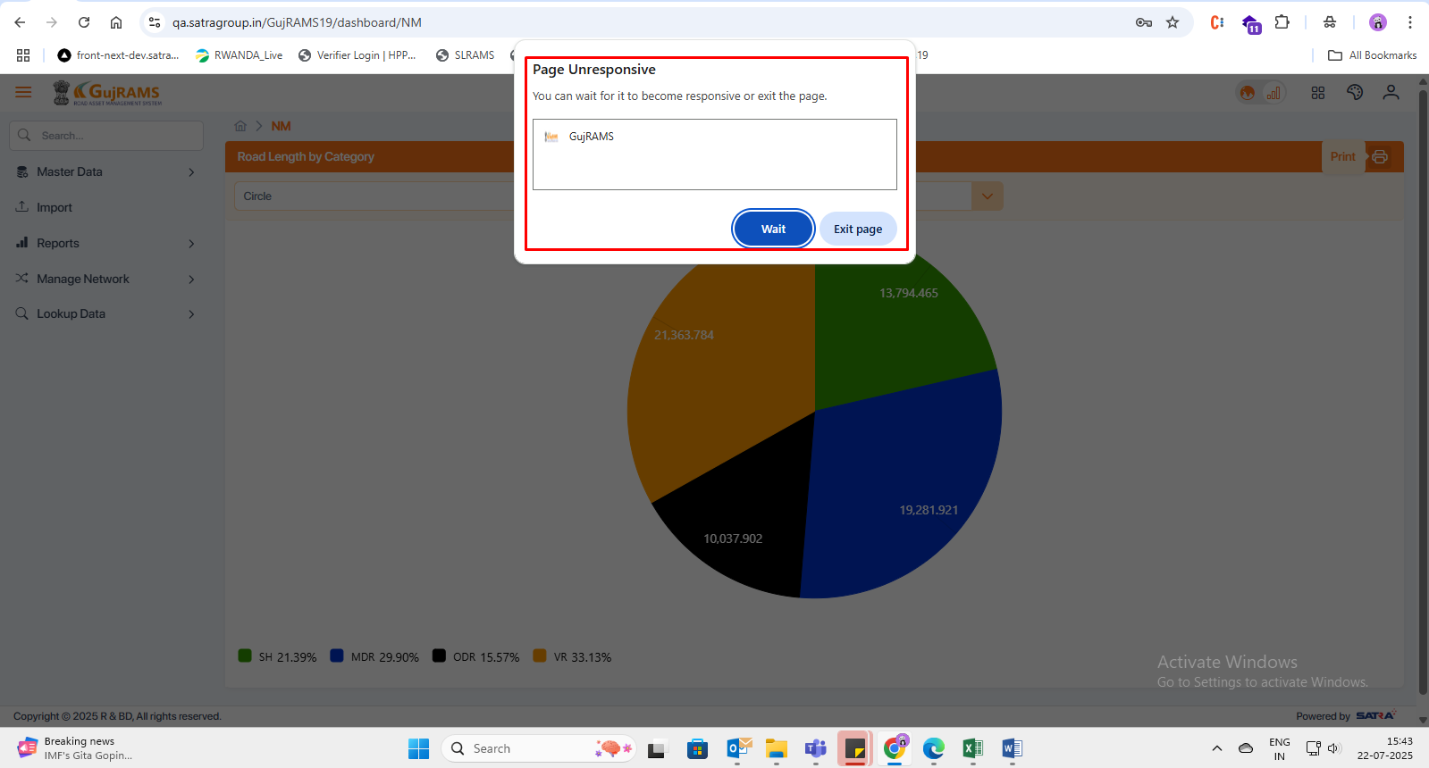  
     
   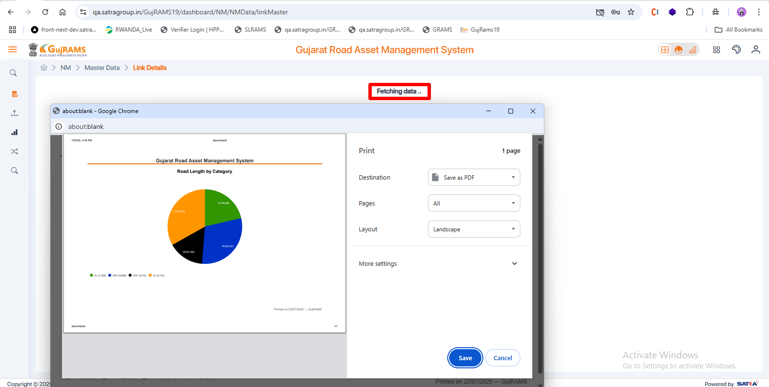
2. **RMMS Dashboard**

In old application charts are binding but in new they are not binding.

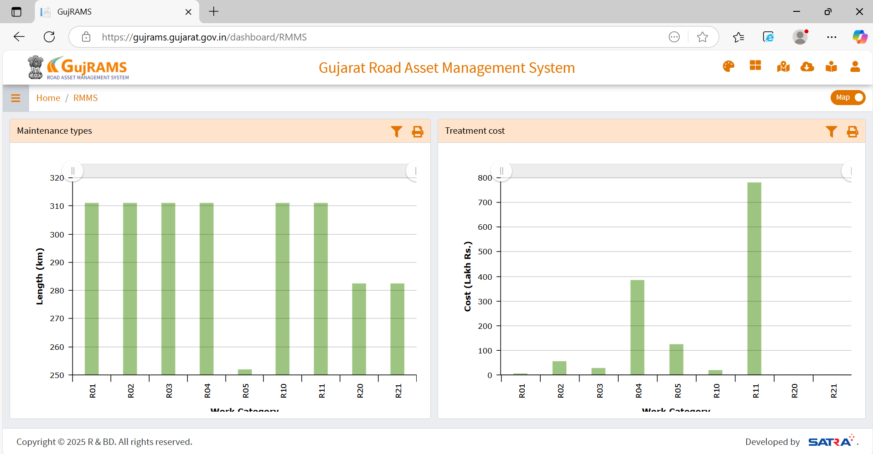

In New application charts are not displaying. It is displaying empty page.

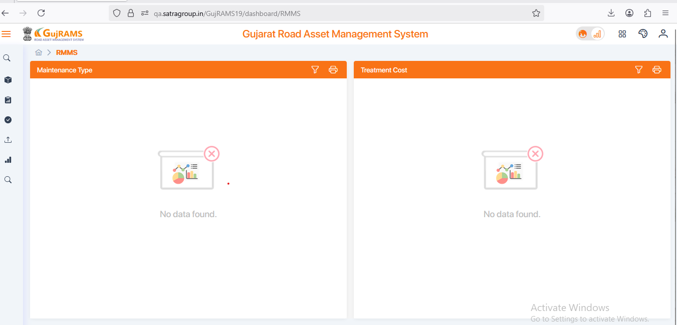

1. Improvement Note: Selection of chart type can also be given here to see both in pie and bar/column chart.

