**Home Dashboard**

In Old system we have 4 charts (1) Network by Width Standard, (2) Network by Roughness, (3) Survey Details, (4) Network by Jurisdiction

In new System also we have 4 charts but first two charts are keep on loading.

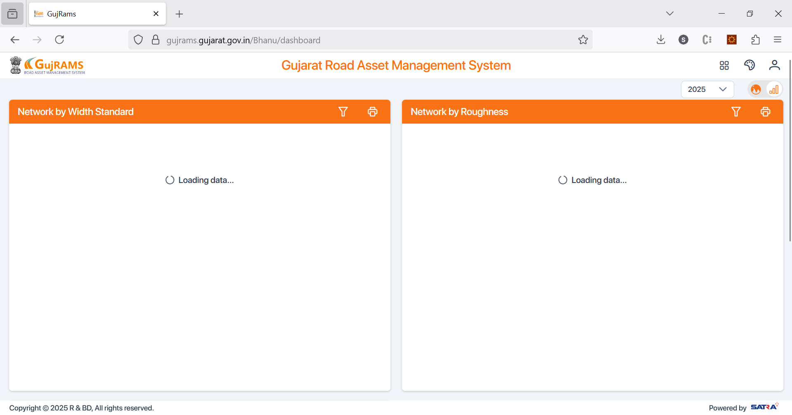

When it was working in old build, roughness chart has issues with old data as links are updated for some roads and not in data.

Total column is doubling the length and for some years its giving NaN values with 2019 year.

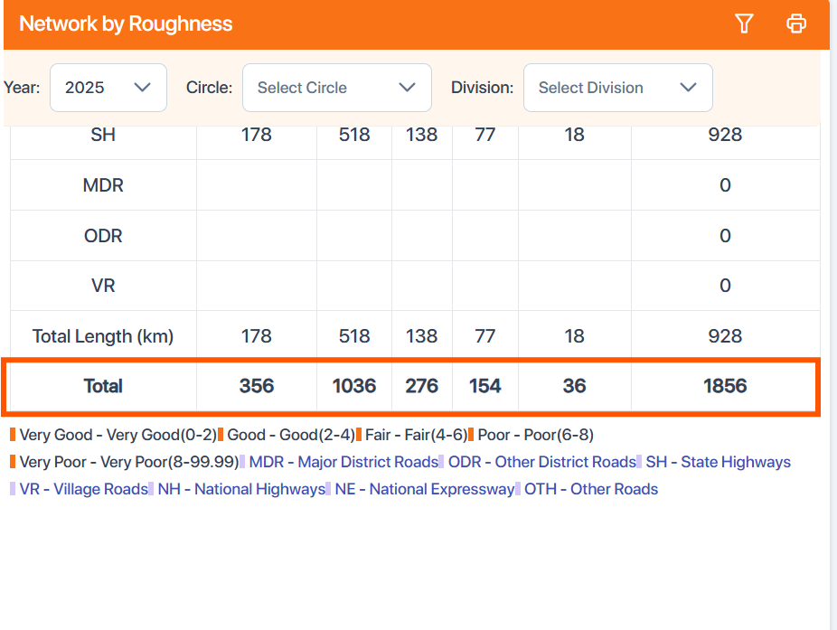

**NM module**

In Old charts Road category by length is given and its data and filters are working properly.

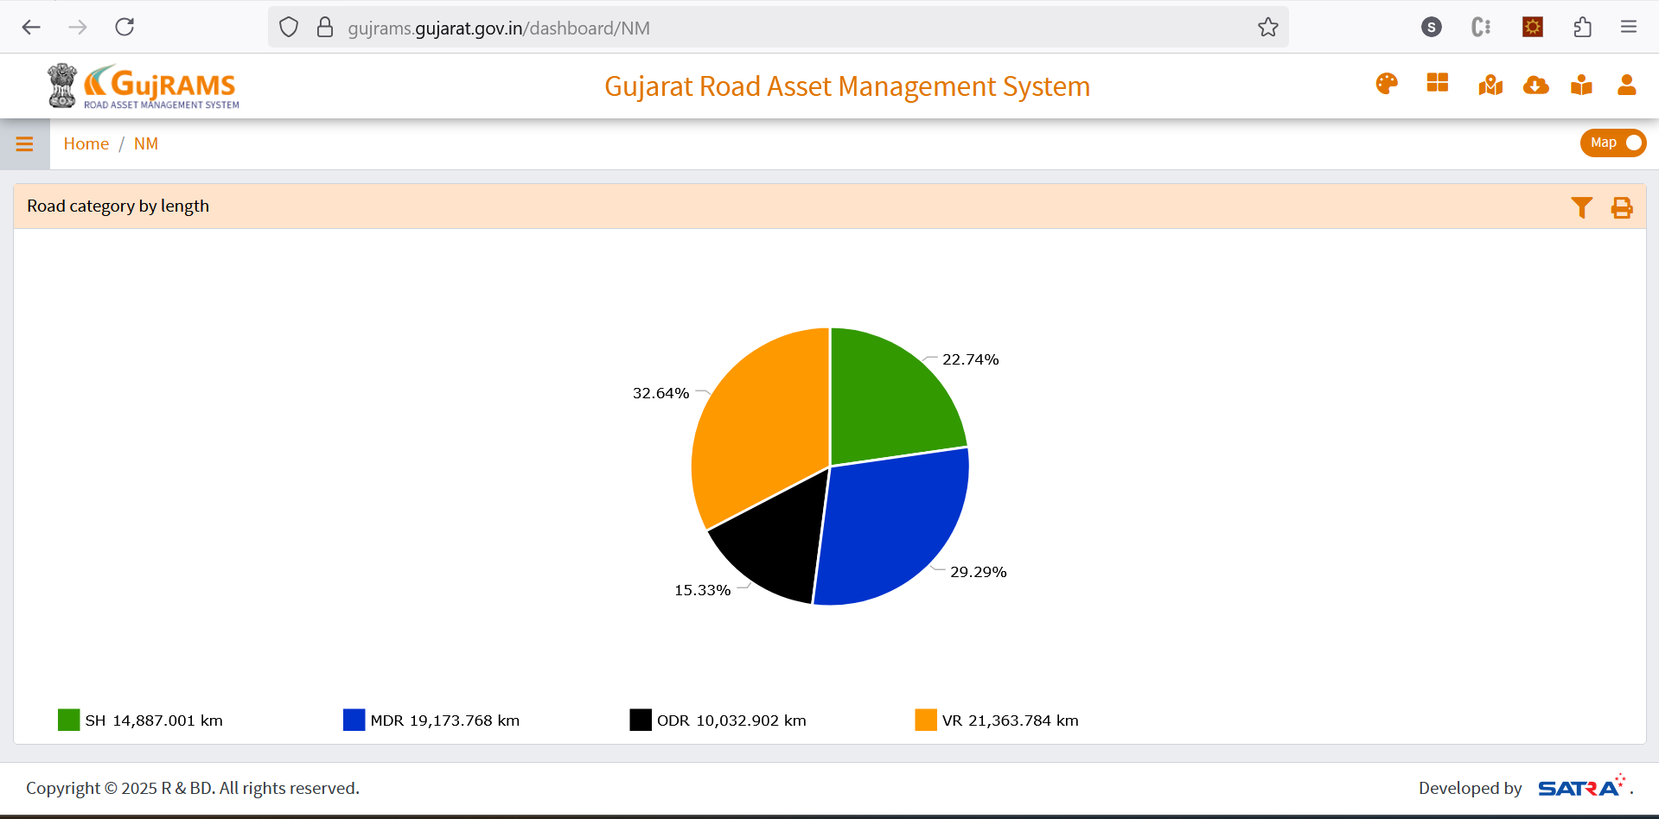

**In new charts**

Division is not filtering as per the selection made in circle in NM module.

After clearing the filter by clicking on x, its not updating the chart.

Print not working.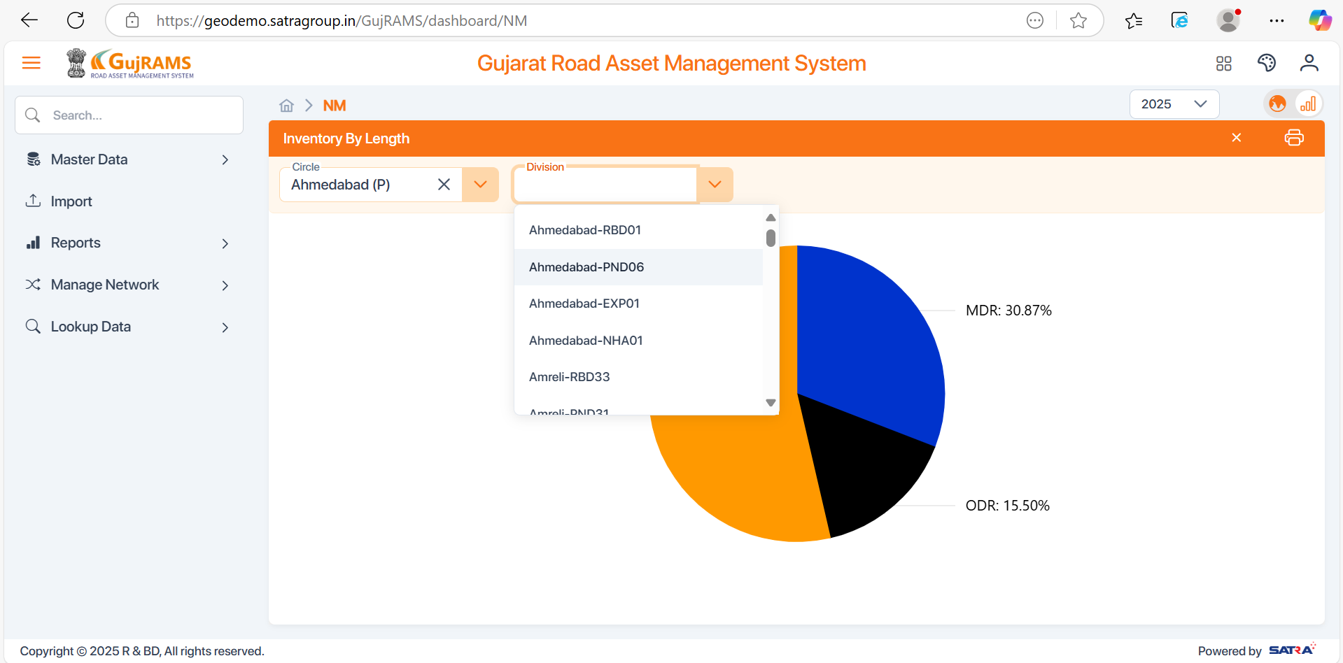

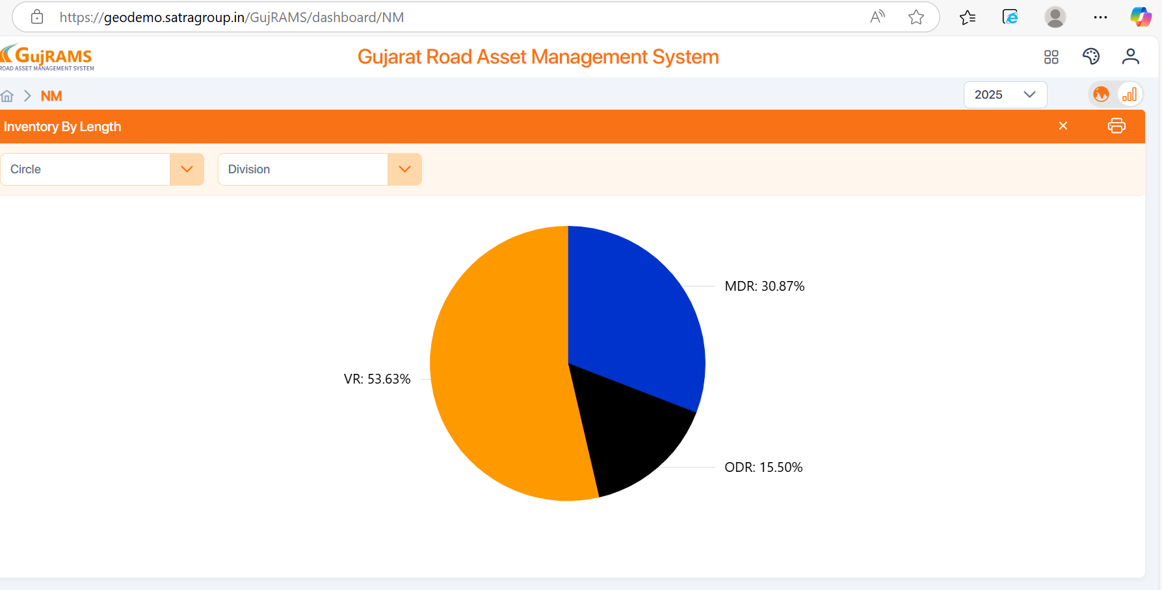

Improvement Note: Selection of chart type can also be given here to see both in pie and bar/column chart.

**RIS Dashboard**

In old charts data is displaying both in percentages and values. Filters working properly and able to revert filter selection.

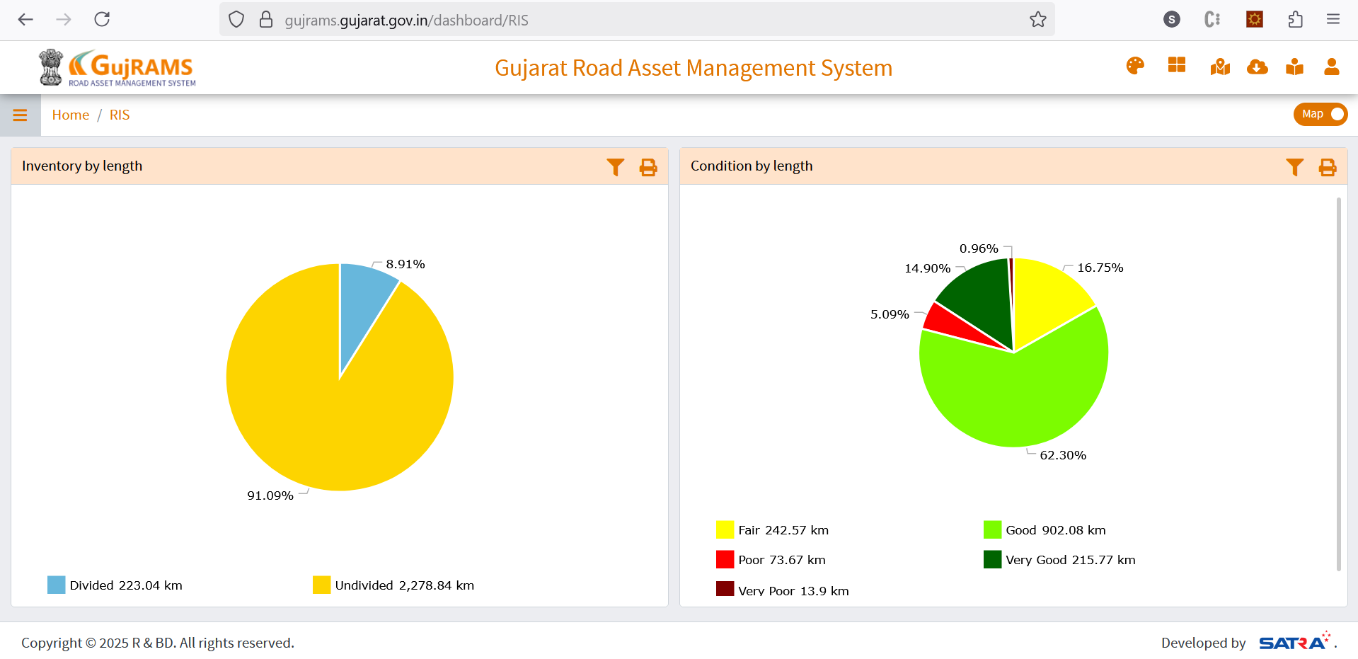

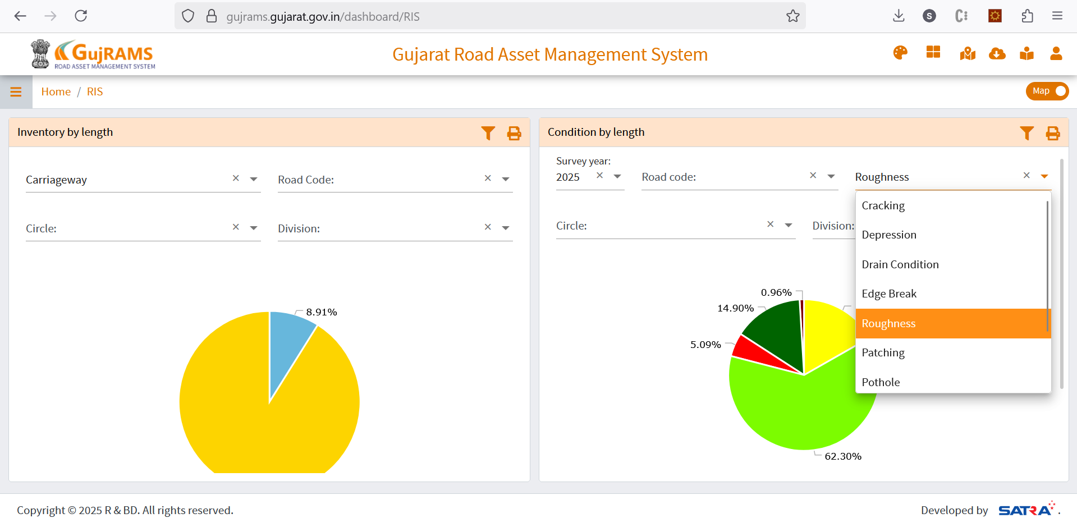

In New app, values are only displayed on mouse hovers and filters are getting applied but not able to revert the selection. For condition chart, there is no parameter selection like in old.

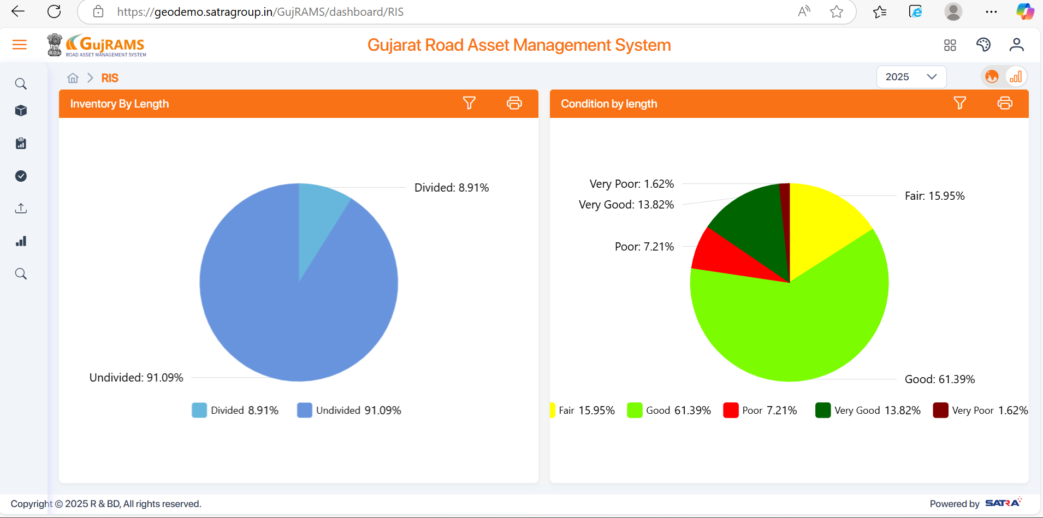

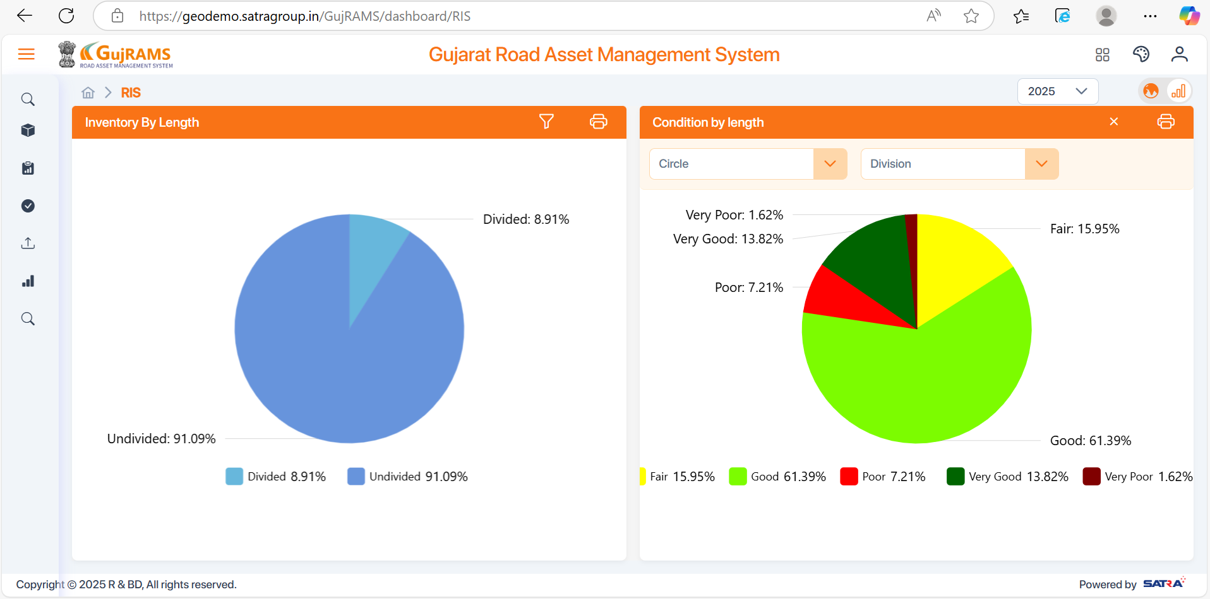

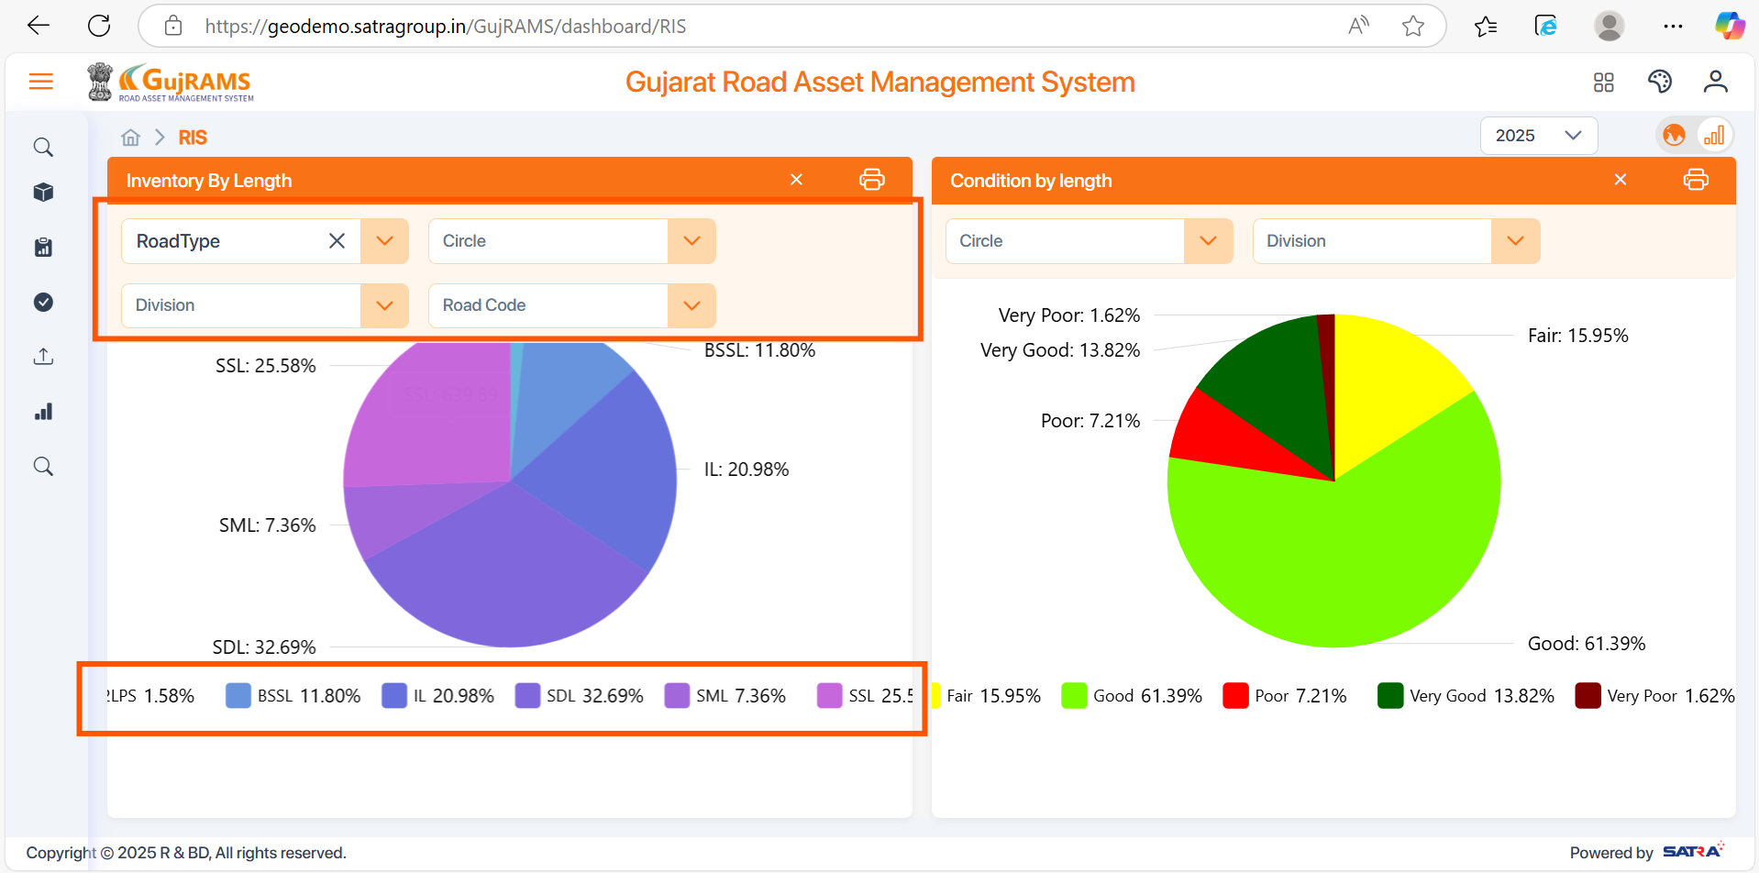

**TIS Dashboard**

In old and new need to identify why AADT distribution (right side) chart is not appearing.

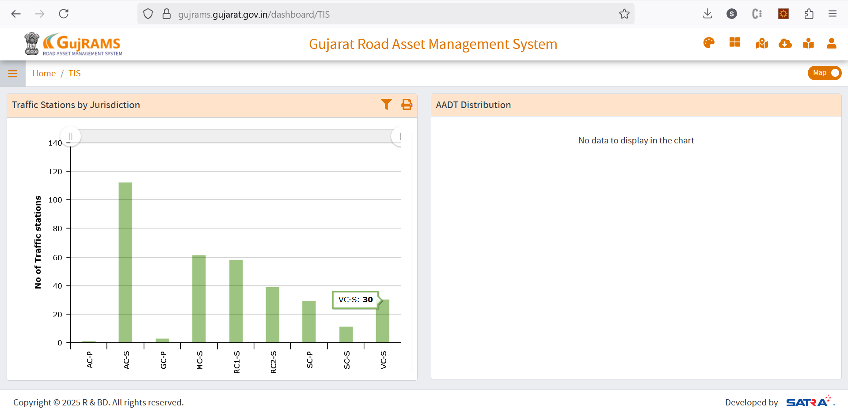

**PMS Dashboard**

In new charts text is overlapping and filter issues of circle and division dependency also not working.

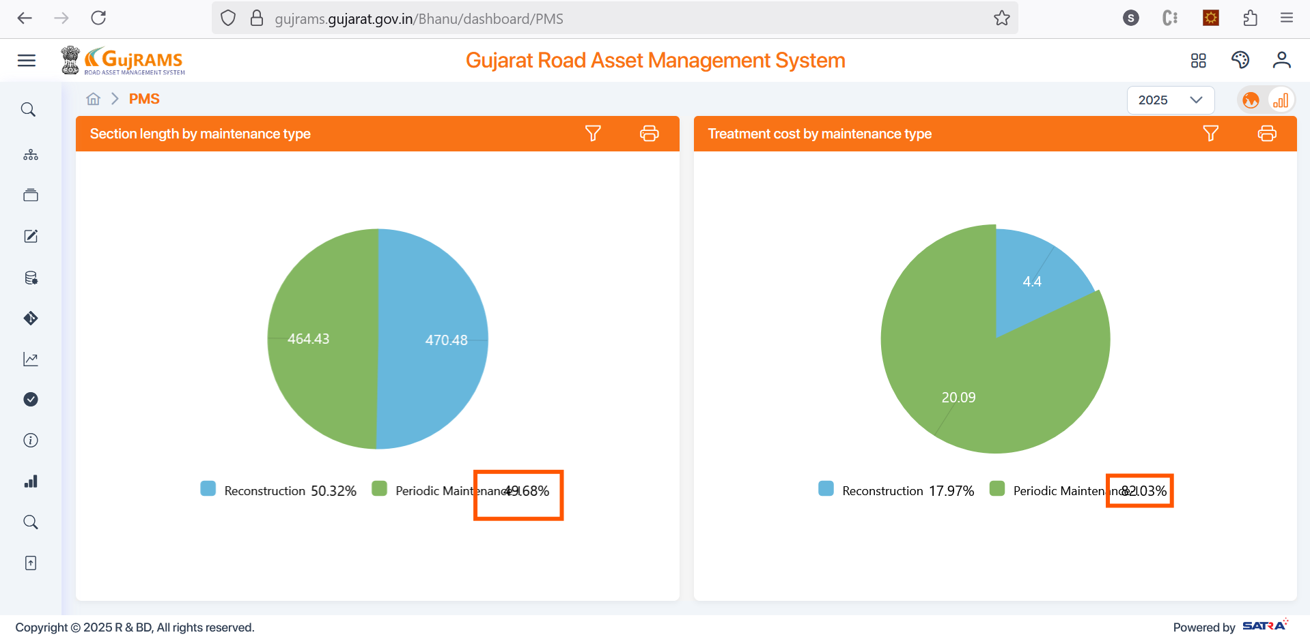

Survey year is coming twice in the screen as shown in below screen.

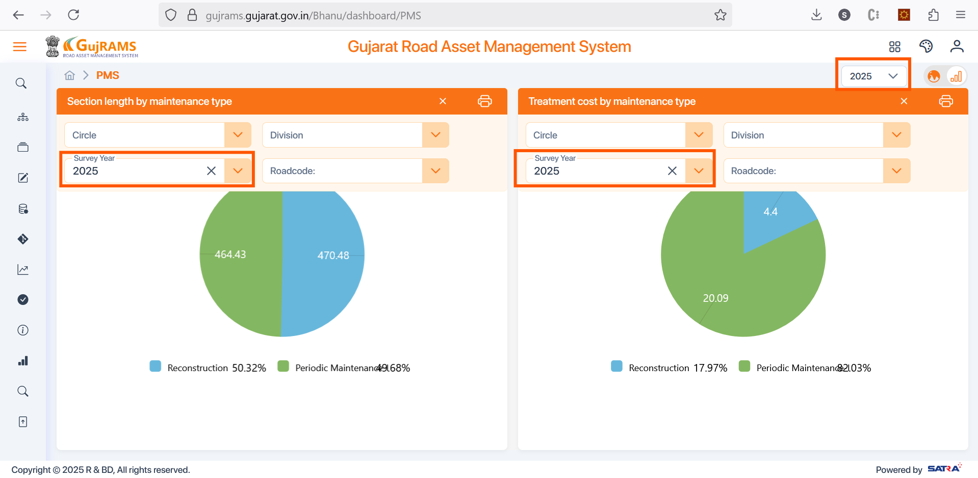

**RMMS Dashboard**

In old application charts are binding but in new they are not binding.

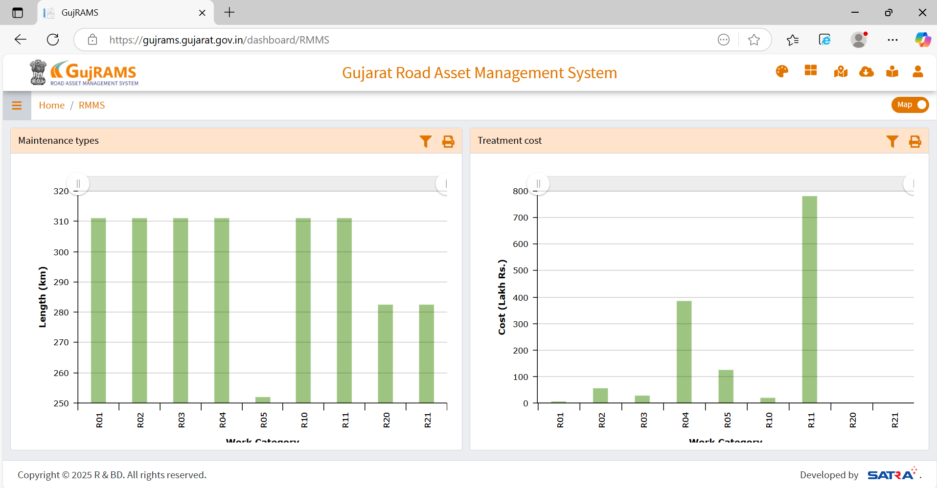

In New application charts are not binding and issues like divisions not filtering based on circle selection and multiple survey year options are existing.

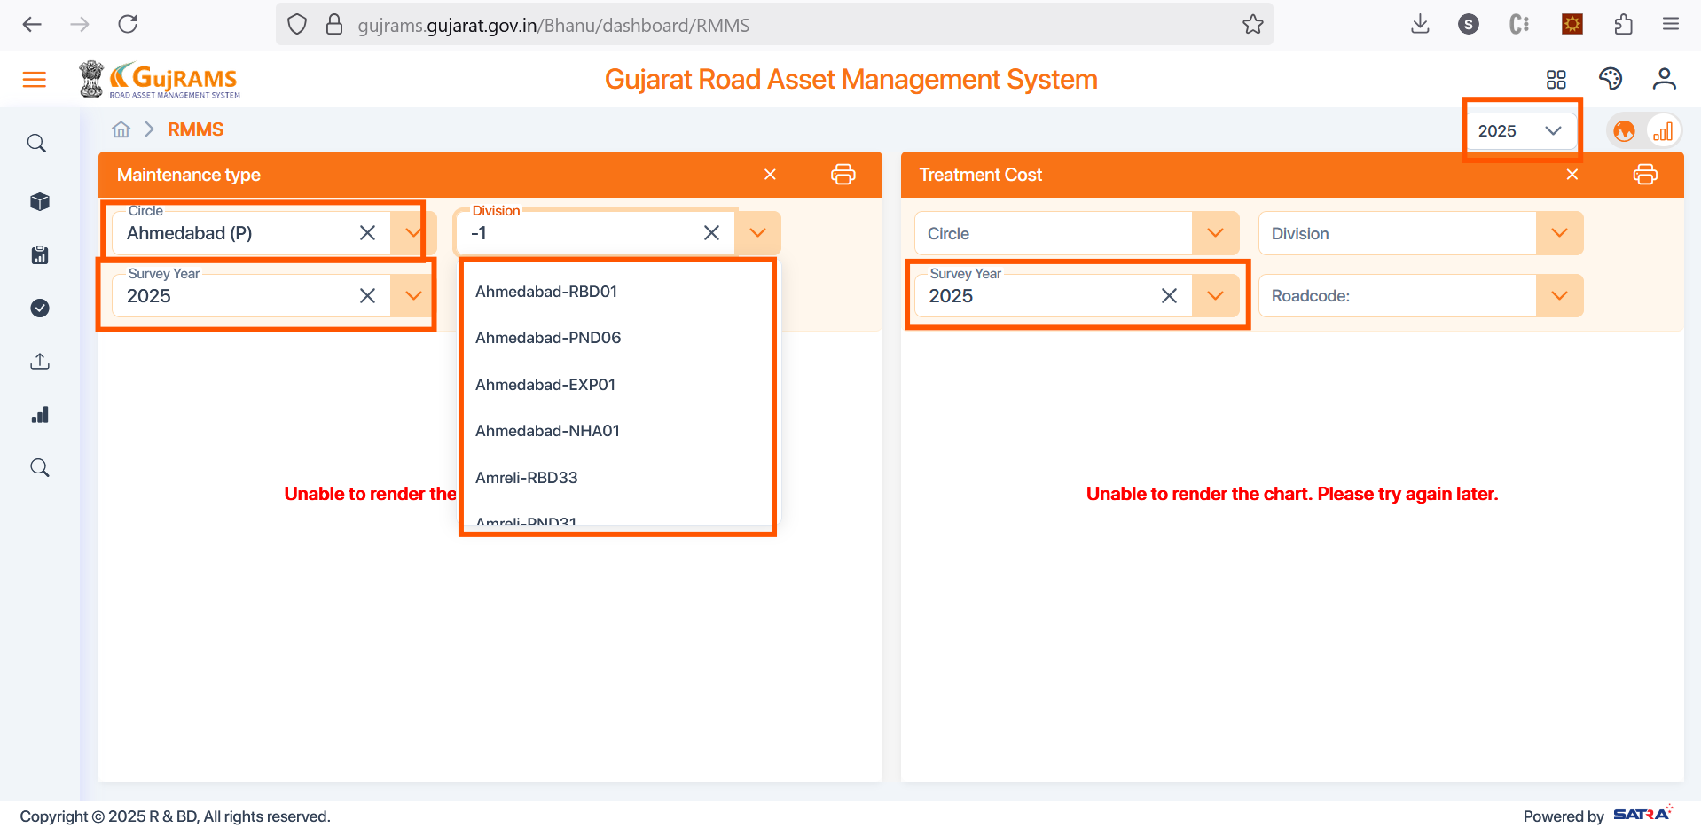

**BMS Dashboard**

In old dashboard charts, upon mouse hover no of culverts and bridges count is displayed.

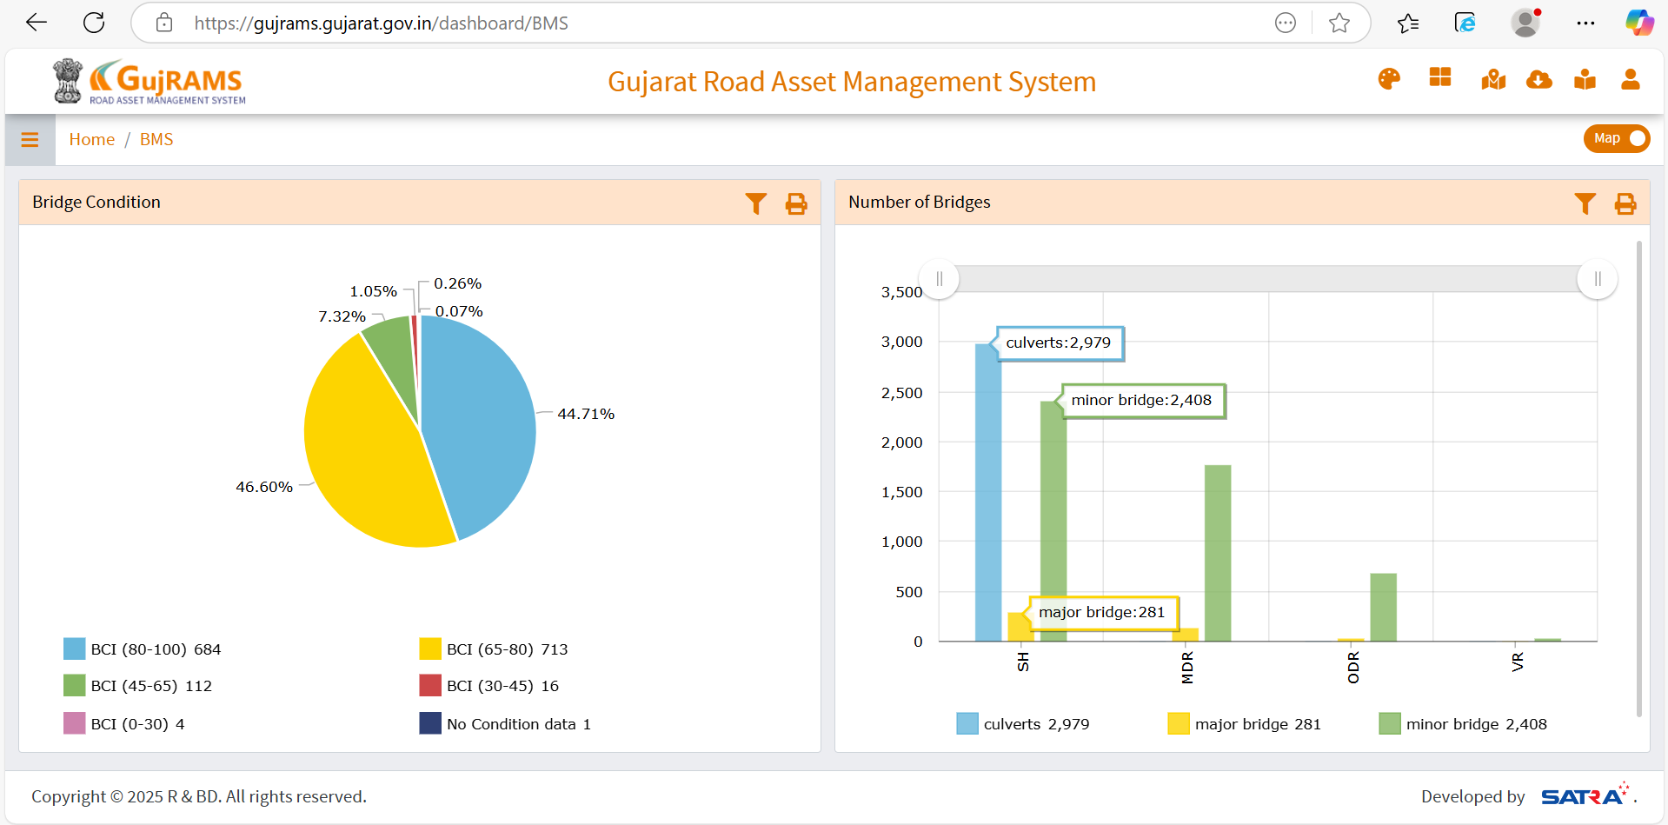

In New charts issues like divisions not filtering based on circle selection and alignment of legends are existing and along with it mouse hover not working.

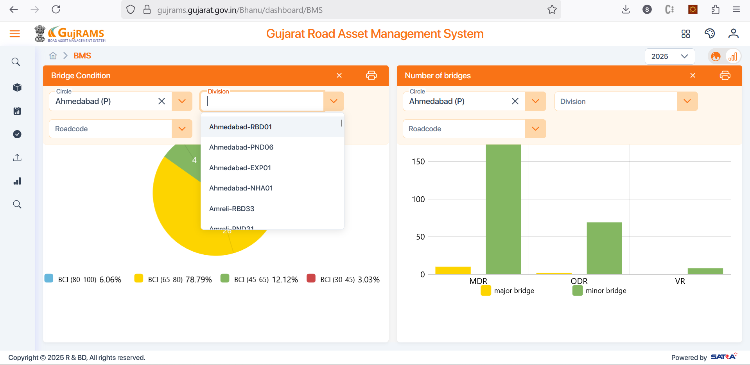

**EIS Dashboard**

Dashboard has no data in both old and new environments.

**RSAMS Dashboard**

In old charts data filters are there as highlighted below and they are working.

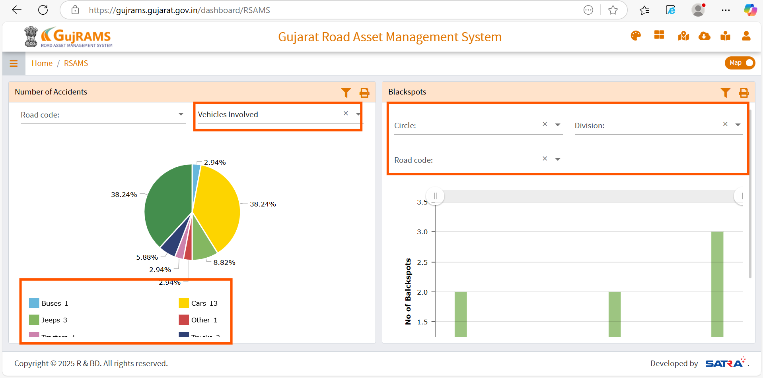

In new app, filters are not working as shown in below screen. Also circle and division dependency, mouse hovers are not working. Also first charts filters are applied to second chart which are different in old app.

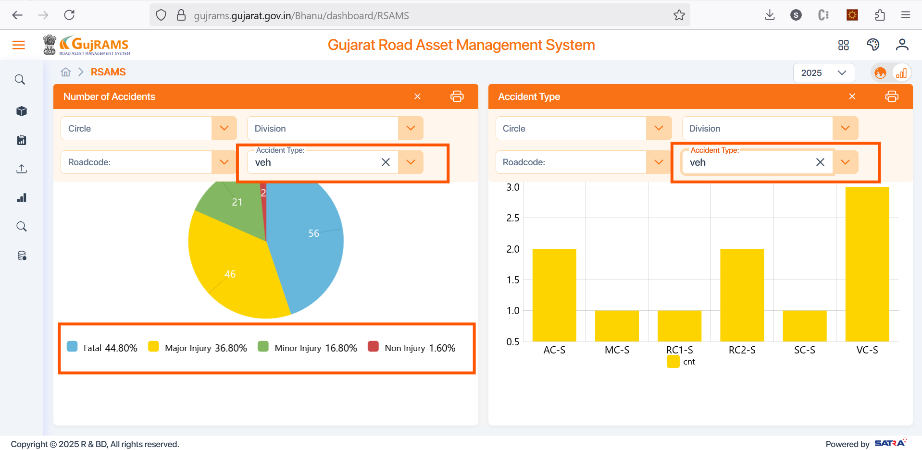

**MES Dashboard**

In old app contractor details look up is given and CRUD operations can be made from dashboard it self.

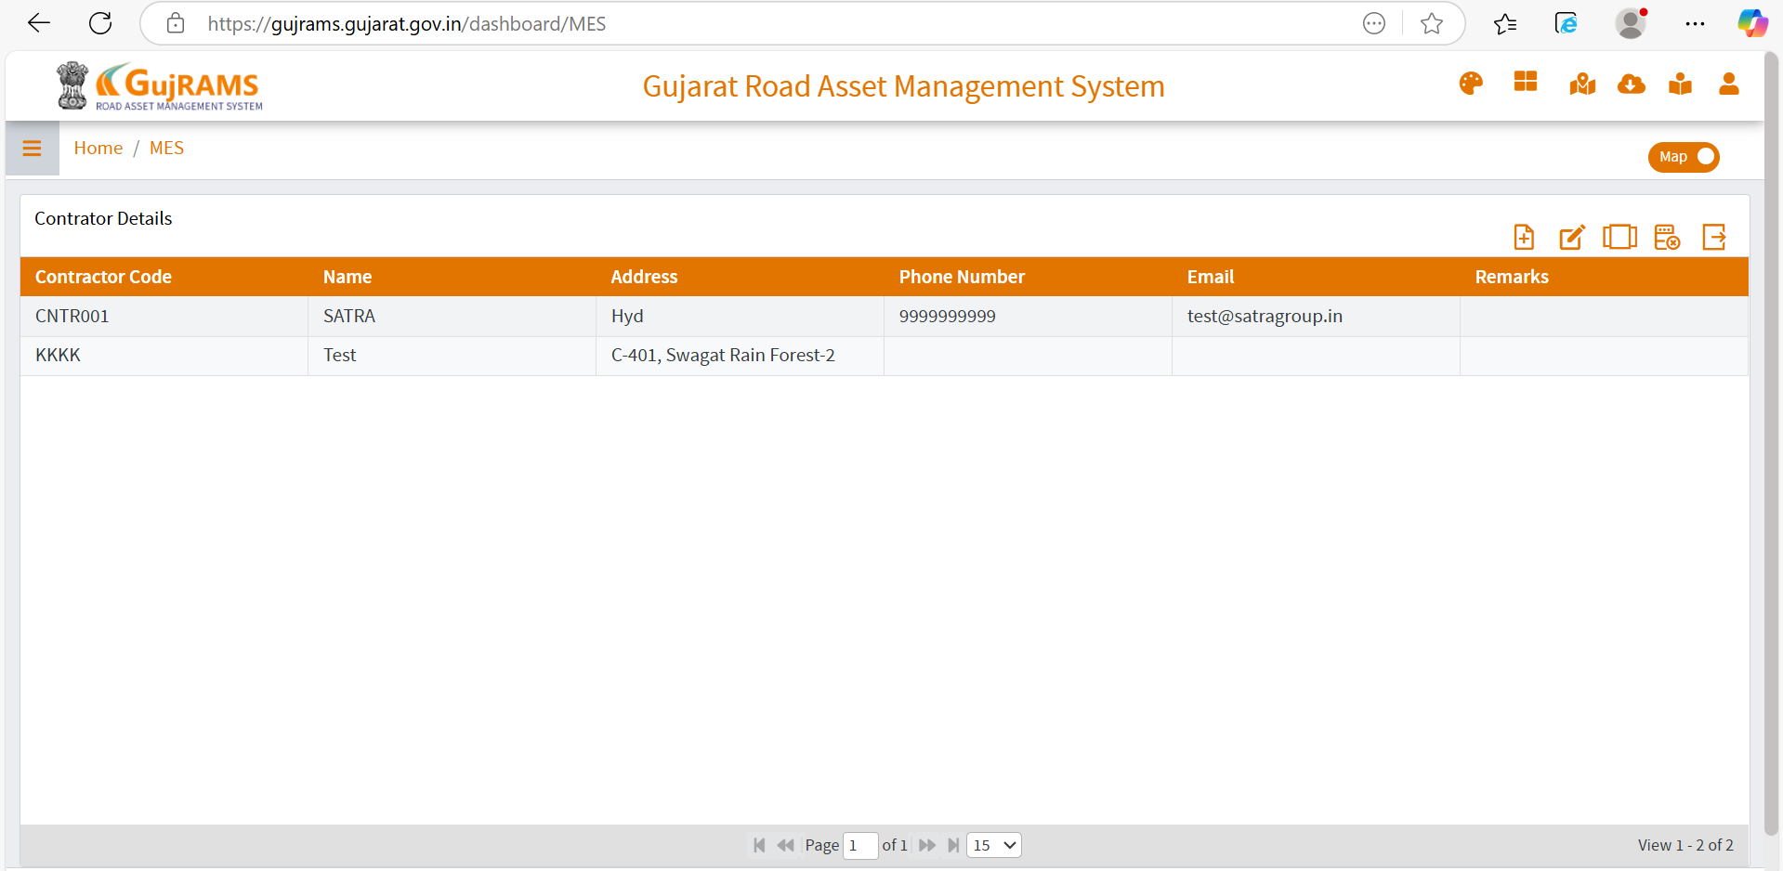

In new app crud operations option is not given as shown in below screen.

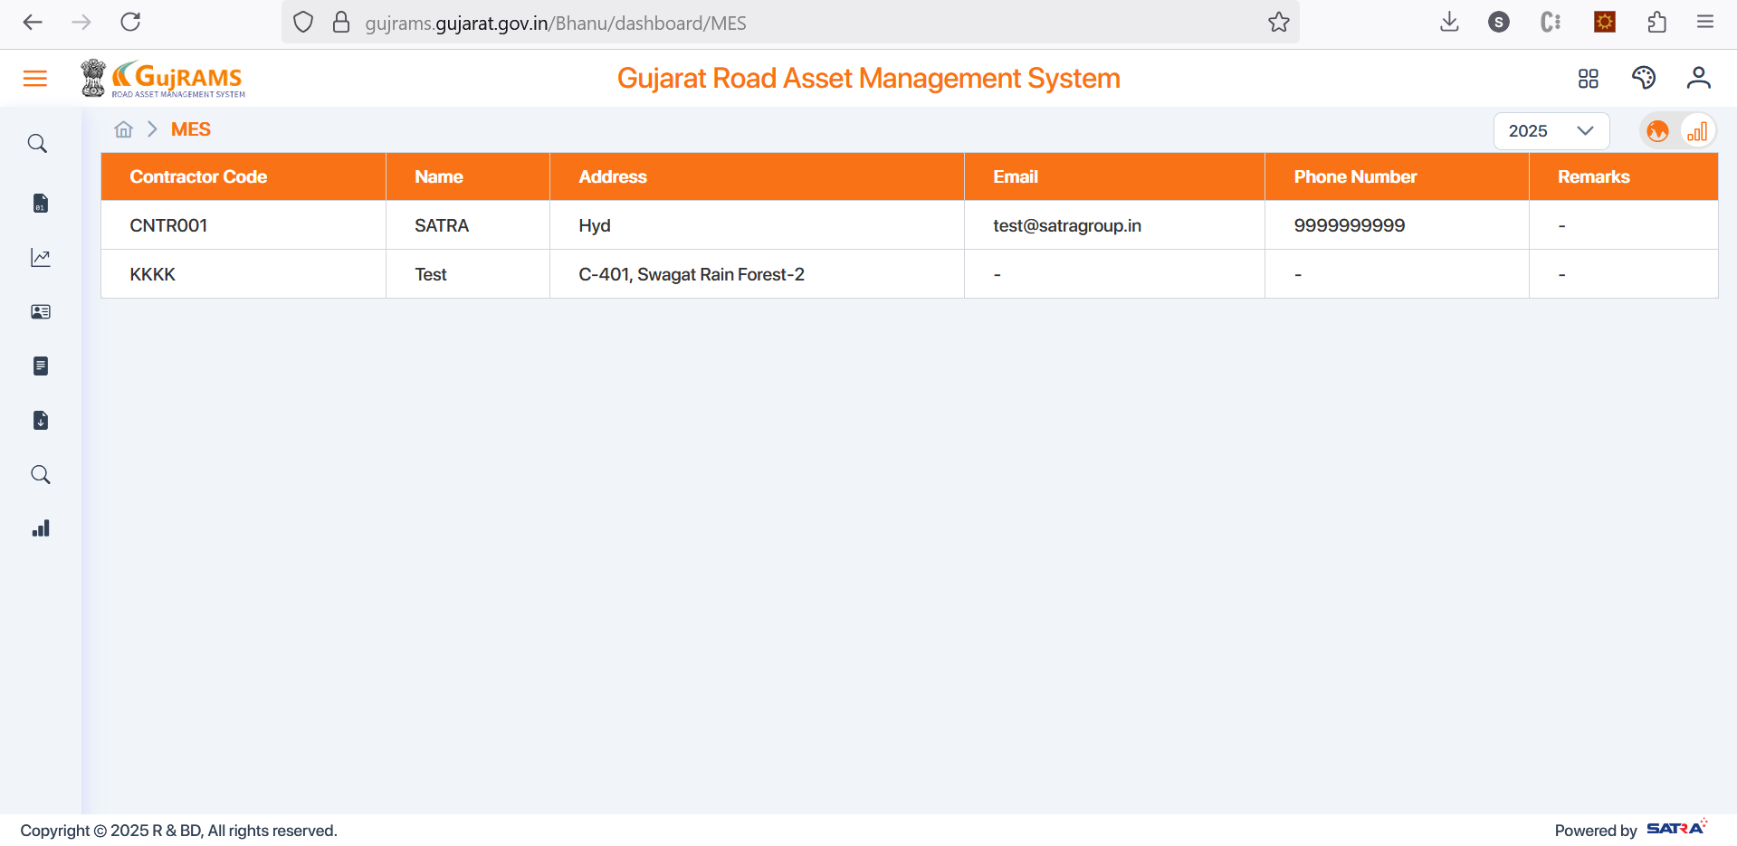

**BAP Dashboard**

In old BAP dashboard budget lookup is given and add , edit and other options are working from here.

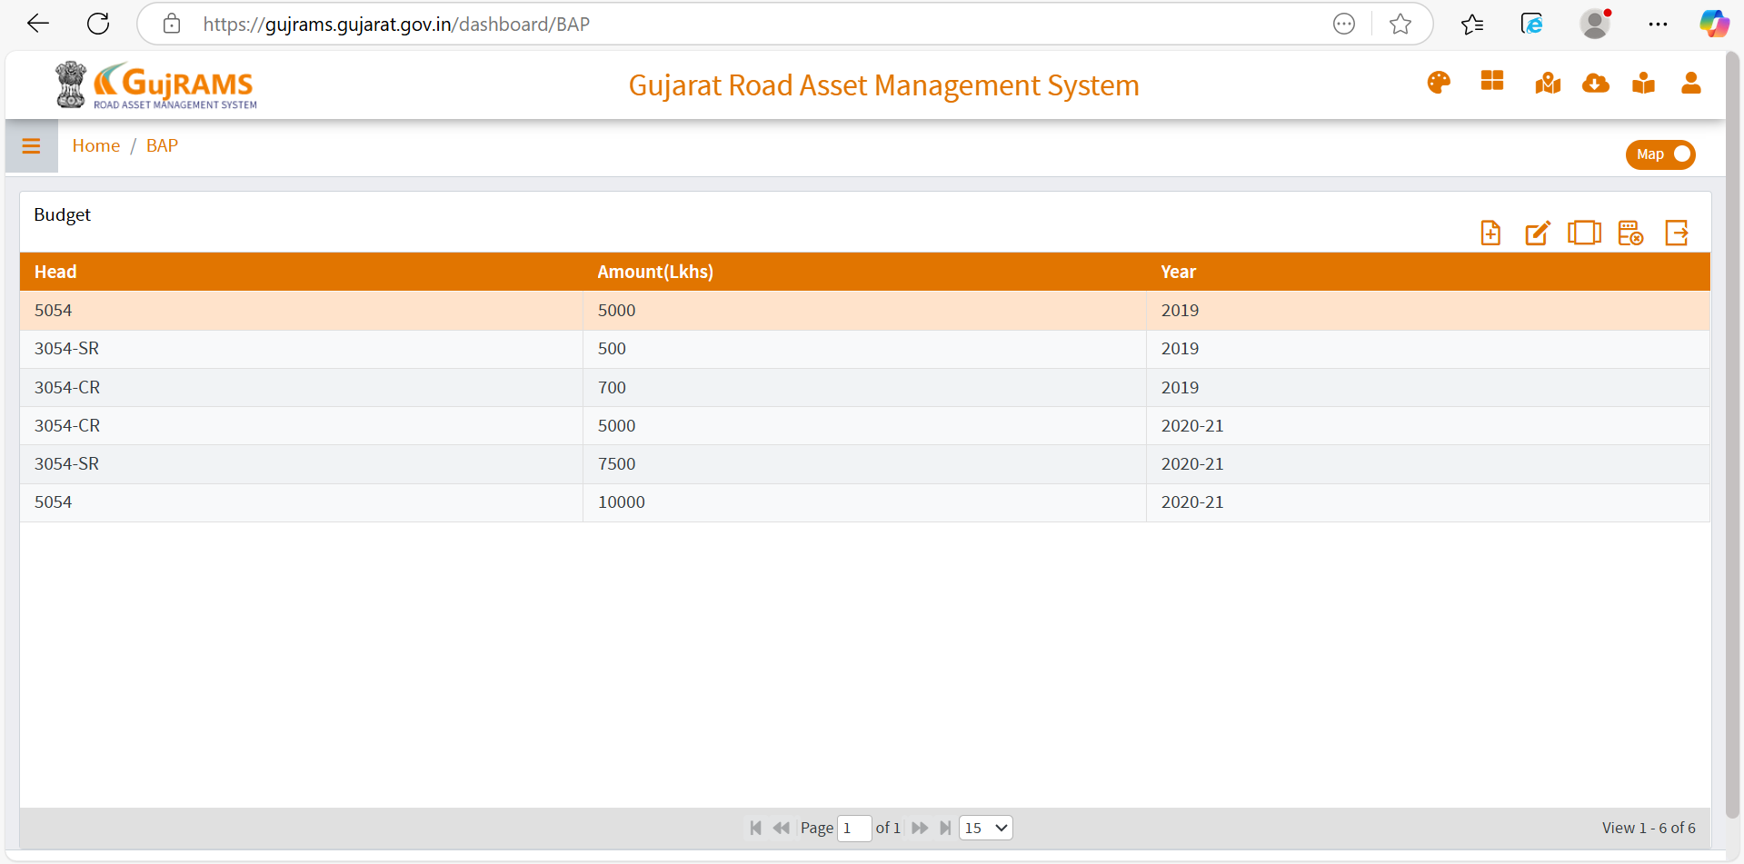

In new app there are no options shown to add/edit/retire etc.

