1. **Ticket Work List Screen for SIAdmin – Needs District-Based Filtering**

In the Ticket Work List Screen. When “**SIAdmin”** user logs in (mapped to multiple specific SI Names), the system is currently displaying tickets from all districts, instead of only the tickets related to the mapped “SI Names” Tickets.

If the logged-in user-role is “**SIAdmin”**, only tickets related to their mapped **“SI Names”** should be fetched and shown  
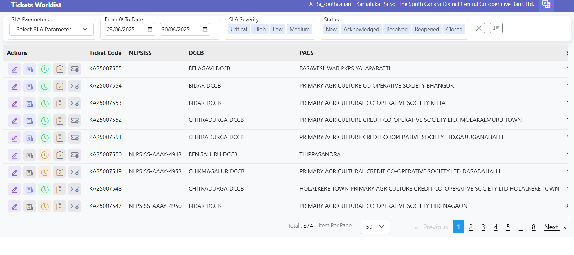  
  
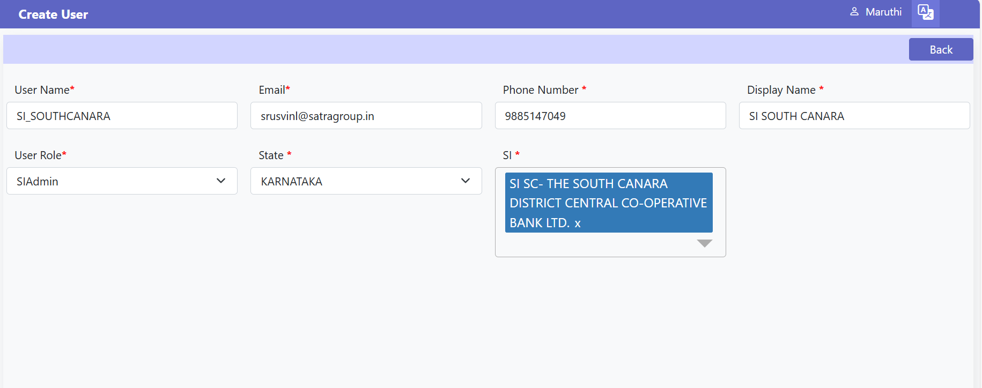

1. **Issue – Attachment Not Updating in NLPSV Tool**  
     
   When a ticket is already pushed to NLPSV and we update it later (due to missing details or a request for additional information from NLPSV), we are able to add comments and attachments in the history . However, only the comments are getting updated in the NLPSV tool — the attachments are not being posted to NLPSV tool.  
    **Both the comments and attachments should be sent to NLPSV during such updates  
     
   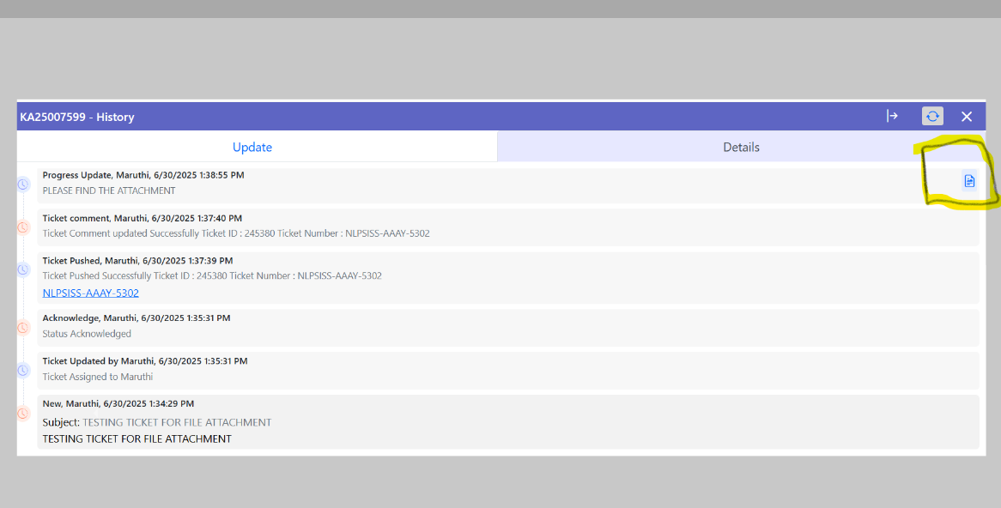**

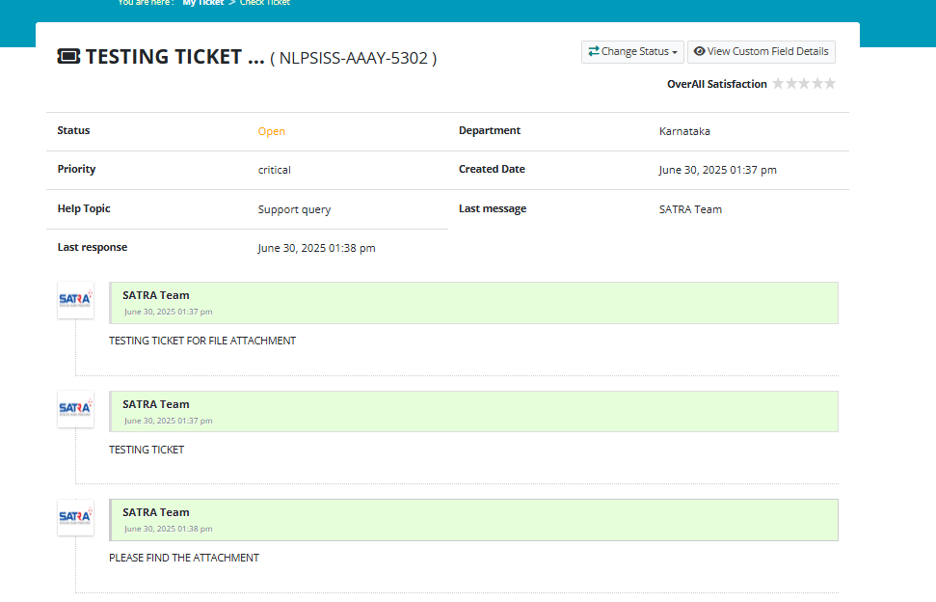

1. **Feature Request – User Deactivation Option**  
   An option should be provided to deactivate users who are inactive or no longer using the Ticketing Id   
     
   In the Create User screen, there should be an option (such as a checkbox or toggle) to deactivate the user. Once deactivated, the user should not be allowed to log in   
   This Should be Implemented

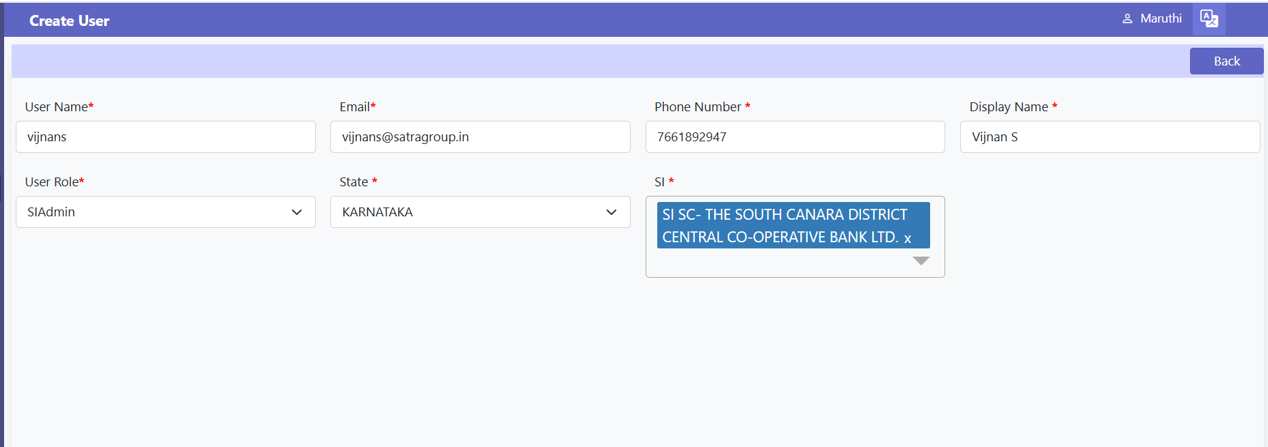

1. **Formatting Issue with Ticket Description and Comments Sent to NLPSV**  
     
   When we raise a new ticket, the issue description is provided in a clear line-by-line format. Similarly, once the ticket is acknowledged, the comments are also added in a Line by line format.  
     
   However, once the ticket is pushed to NLPSV, both the description and the comments appear in a single-line, side-by-side format.

As a result of the formatting change, the NLPSV team is facing difficulty in understanding the issue properly  
  
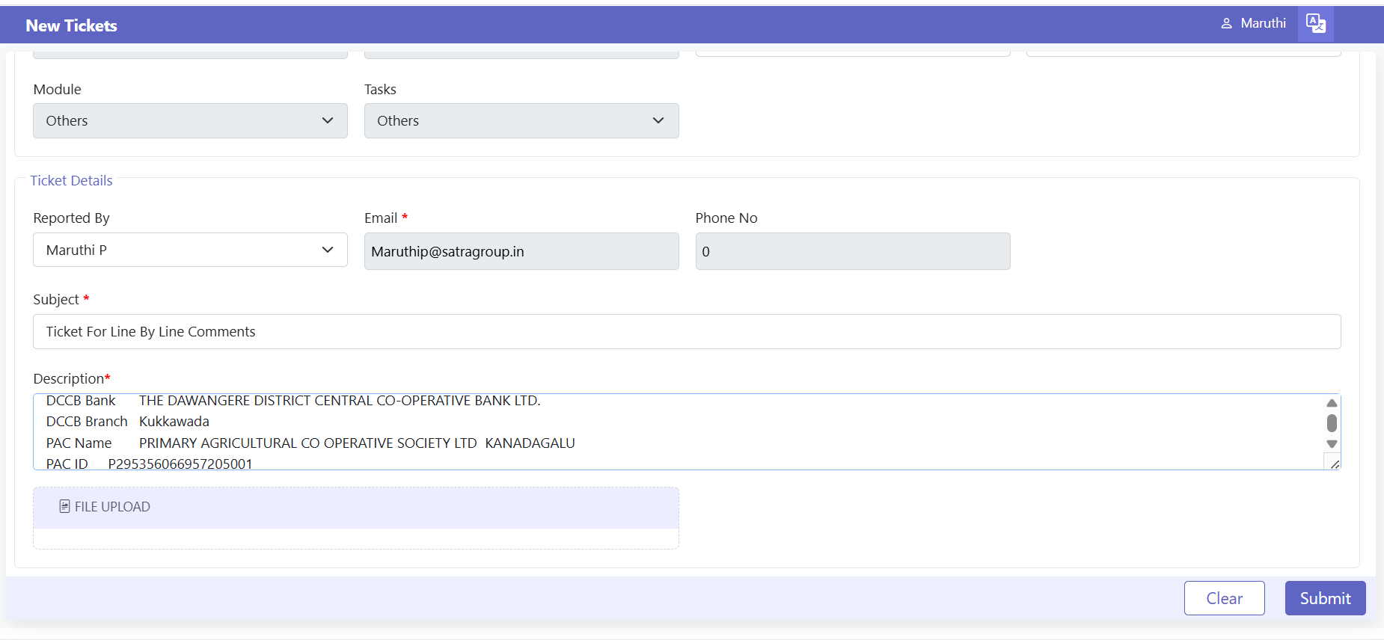  
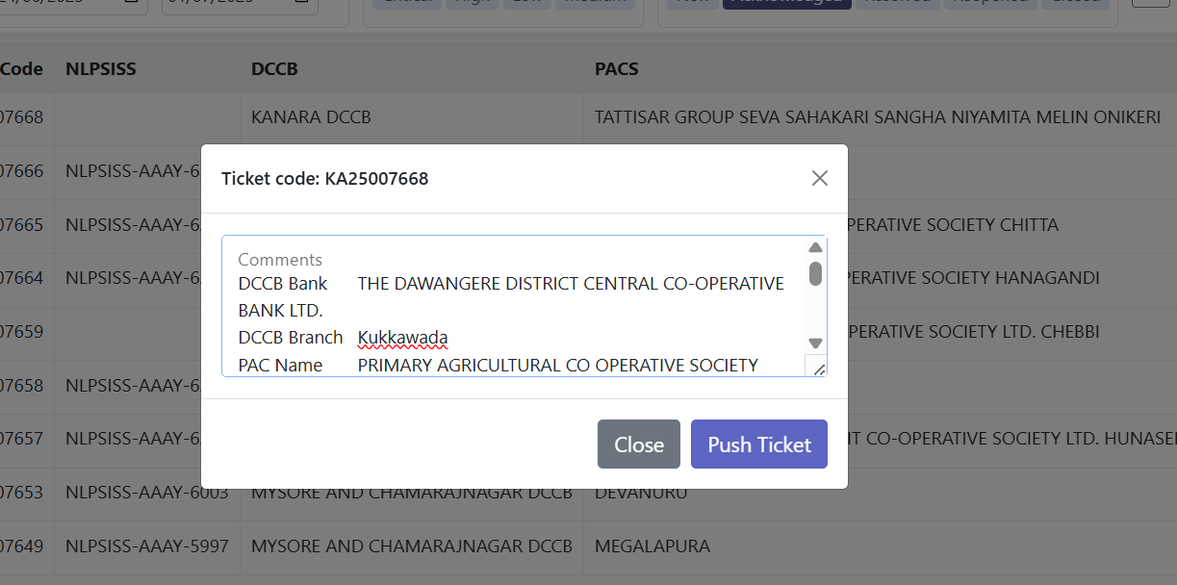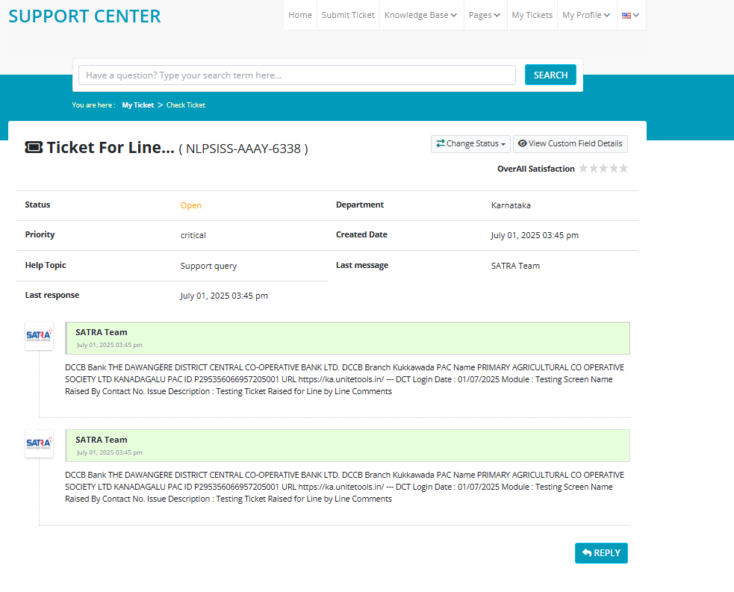  
5 . **Resolved (Not Pushed to NLPSV) Tickets Not Reflected in Reports**  
  
 when downloading the ticket list from the Reports screen, the tickets resolved by us (but not posted to NLPSV) are not appearing in the report