**Bridge** **Details -**

**Bridge** **Code** **:** As per Discussion the Bridge ID was finalized as **“BI”** for Increasing Direction and **“BD”** for Decreasing Direction, however the bridge ID is displayed as **“BR”** for both directions - to be reviewed --

**Review Comments**: **Support Team**: to update for the Existing Bridges.

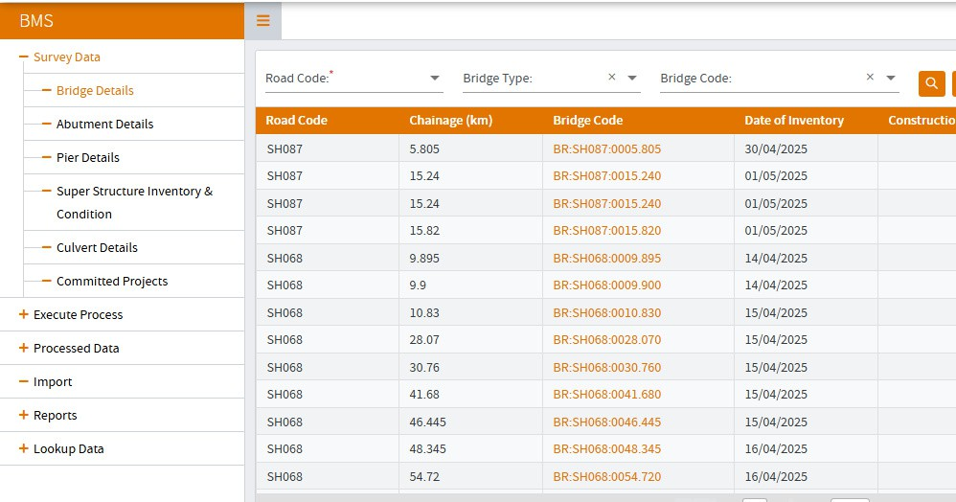

## Bridge Details

Kindly add **“Function** **of** **the** **Bridge”** in the sheet

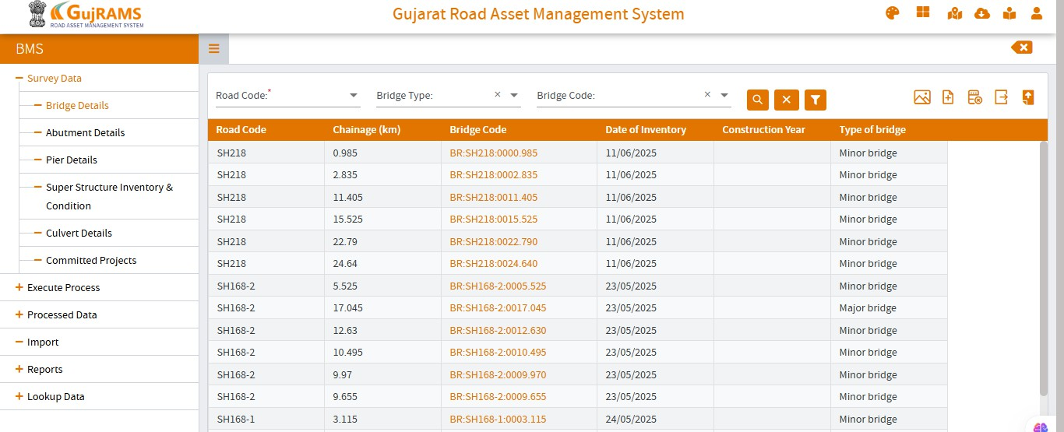

**Function** **of** **Bridge**

**Review Comments** : Dev team : Column to be displayed in UI by the Dev Team.

## Bridge Details –

Kindly check if we can add the Images Link in this sheet – as this is useful while reviewing the data (as of now we need to exit this page to review the photos.

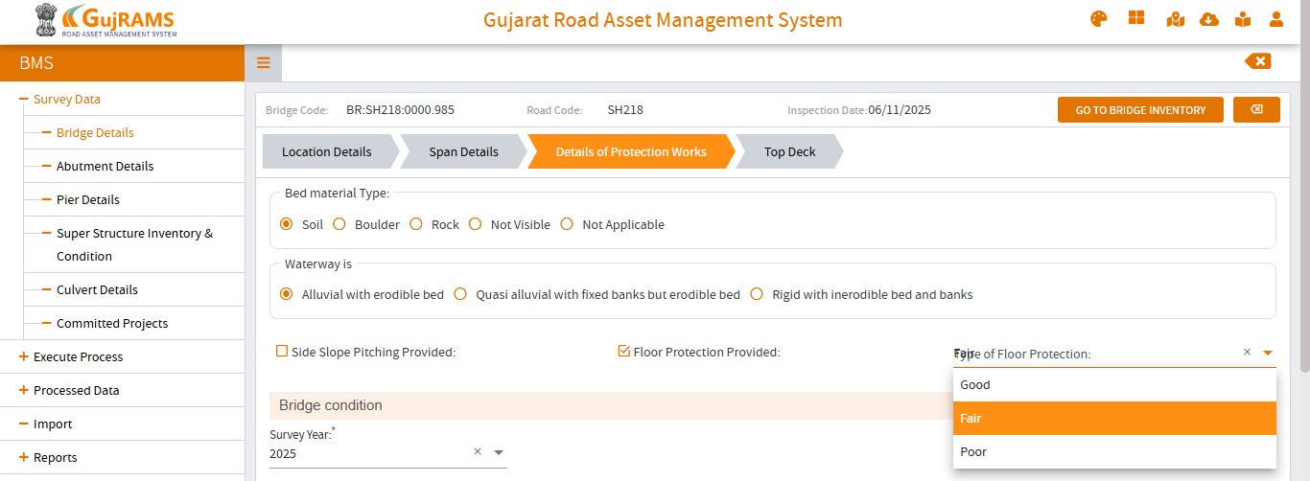

**Images**

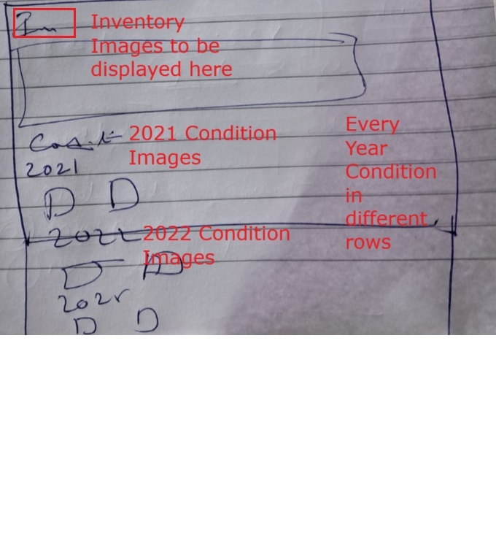

**Review Comments**: Dev Team to provide option to display images in this Screen which is inside the Selected bridge.

Images to be displayed as per Inventory and condition for the Respective Years in this.   
Please refer to the above 2 images.

## Bridge Details –

Kindly check if we can add Link to the following sheets

## Abutment Details Pier Details

**Super** **Structure** **Inventory** **and** **Condition**

Once I click any of the link (Abutment Details / Pier Details / Super Structure Inventory and Condition) it should directly open the detailed sheet as shown

**Review Comments**: Dev team: Need to give 3 buttons to move to other elements like Abutment/Pier/Super structure from Bridge details (for the **selected structure**) and vice versa. Please refer to the complete details in the next Point.



**Images**

|  |  |
| --- | --- |
| **Go** **to** **Abutment** **Details** | |
| **Go** **to** **Pier** **Details** |  |
| **Go** **to** **Superstr** **Details** | |

The Detailed Sheet to open is shown in next page

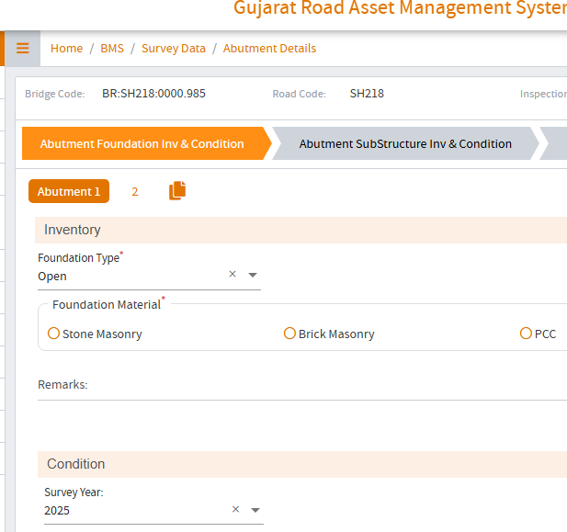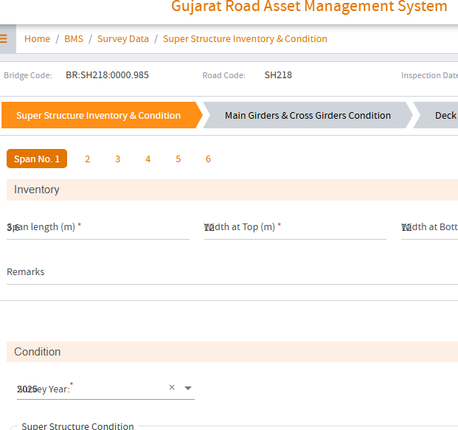

Once I Click “Go to Superstr Details”

This Detailed sheet should open for the particular Chainage



Once I Click “Go to Abutment Details”

This Detailed sheet should open for the particular Chainage



Once I Click “Go to Pier Details” This Detailed sheet should open for the particular Chainage

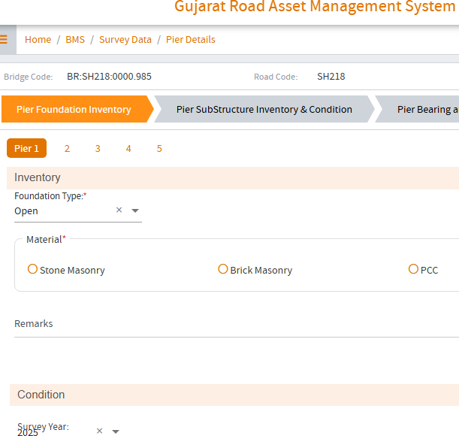

## Bridge Details – Details of Protection Works

Type of Floor Protection works is displayed as “Good / Fair / Poor” – this to be modified as “Stone Pitching / Concrete Block / Gabions”

**Review Comments**: Dev team: **Type of Floor protection** to be displayed as “Stone Pitching, Concrete Block, Gabions”. Please display these dropdown values in **Both** Tab and Web.



**Side** **slope** **pitching**

## Bridge Details – Details of Protection Works

Heading – **“Bridge** **Condition”** to be updated as **“Condition** **of** **Protection** **works”**

The condition for “Side slope pitching to be added” “Severity and Extent” to be removed

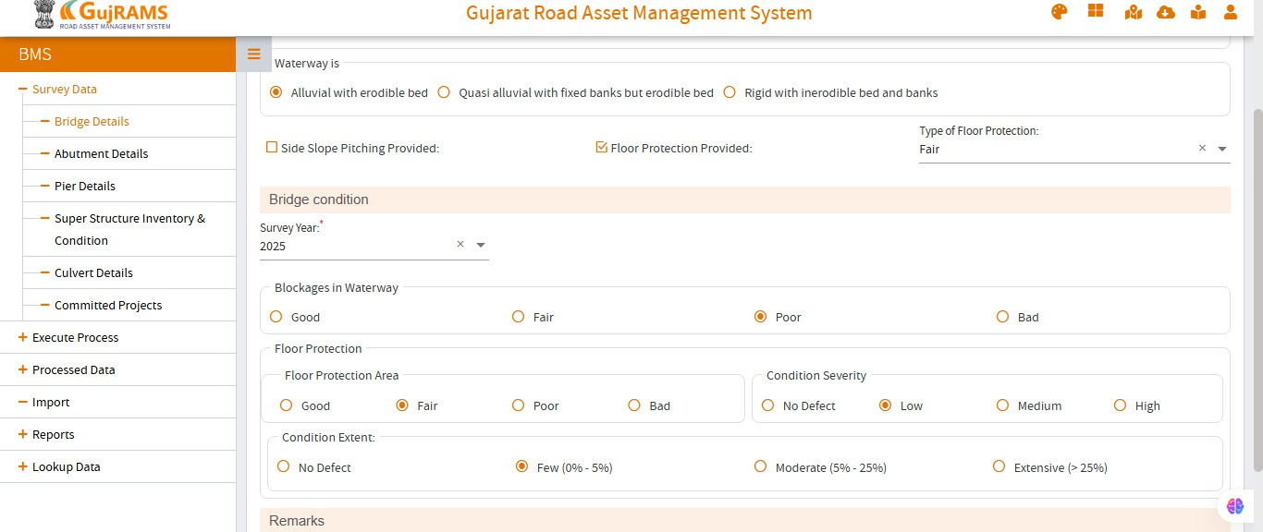

**Remove**

**Remove**

**Review Comments**: Dev Team -- To update the caption name as “**Protection Works Condition**” and to **Remove** the unwanted columns of Condition Severity and Cond extent for both **Floor Protection and the Side Slope Pitching**.  
  
**Side Slope Pitching:** Radio button is already displayed, no action required from Dev Team.

## Abutment Details –

Kindly check if we can add the Images Link in this sheet – as this is useful while reviewing the data (as of now we need to exit this page to review the photos (as explained in Sheet 2)

Kindly check if we can add Link to the following sheets

## Bridge Details Pier Details

**Super** **Structure** **Inventory** **and** **Condition**

Once I click any of the link (Bridge Details / Pier Details / Super Structure Inventory and Condition) it should directly open the detailed sheet as explained in the Above Sheets (Sheet 3 and 4)

**Review Comments**: Dev Team -- Same as Bridge details screen, please provide Images option in this Screen as well. Need to give 3 buttons to move to other elements like Bridge/Pier/Super structure ( for that Selected Structure) from Abutment details .

## Abutment Details – Abutment Substructure Inv & Condition

There is parameter – Deck Surface Condition at the bottom of the sheet – This has to be removed

**Review Comments**: Please do not Remove, heading to be **Renamed** as “**Approach slab/ Expansion Joint** “condition in **both** Tab and Web

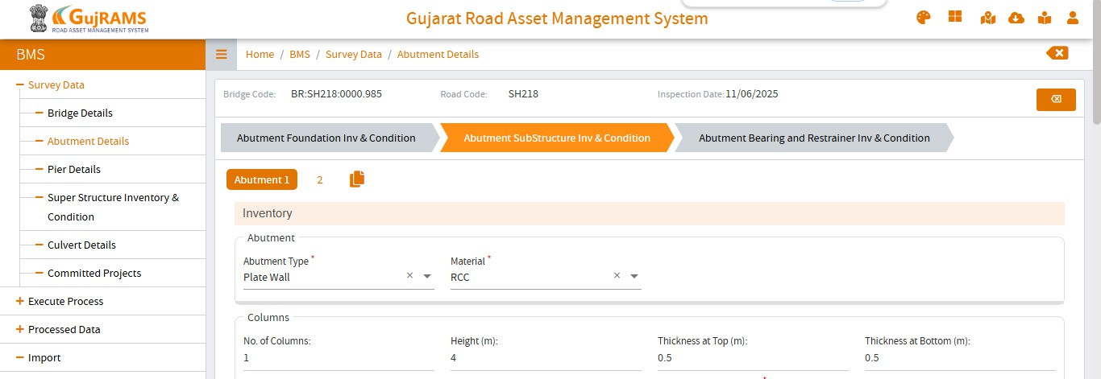

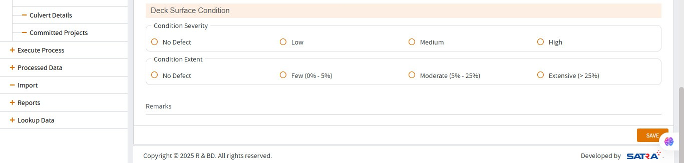

**Remove**

## Abutment Details – Abutment Bearing and Restrainer Inv and Condition

For POT-PTFE, Rocker-Roller, Metallic and plate bearings, the condition “Deformity in the shape of bearing” shall be displayed, as of Now it is displayed only if Metallic bearing is selected

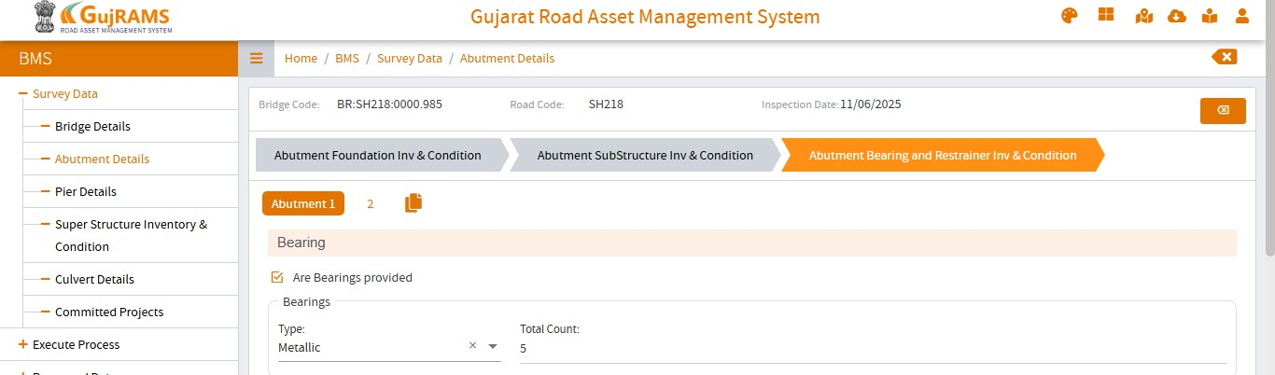

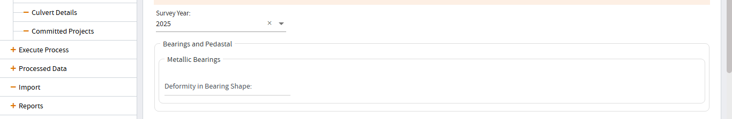

**Review Comments**: Dev team – Please display the deformity in the shape of bearing for the all Bearing types **except** for **Elastomeric** Type of Bearings.(change to be implemented in Tab as well)

## Abutment Details – Abutment Bearing and Restrainer Inv and Condition

In Bearing Pedestals – Cracks is mentioned this to be removed

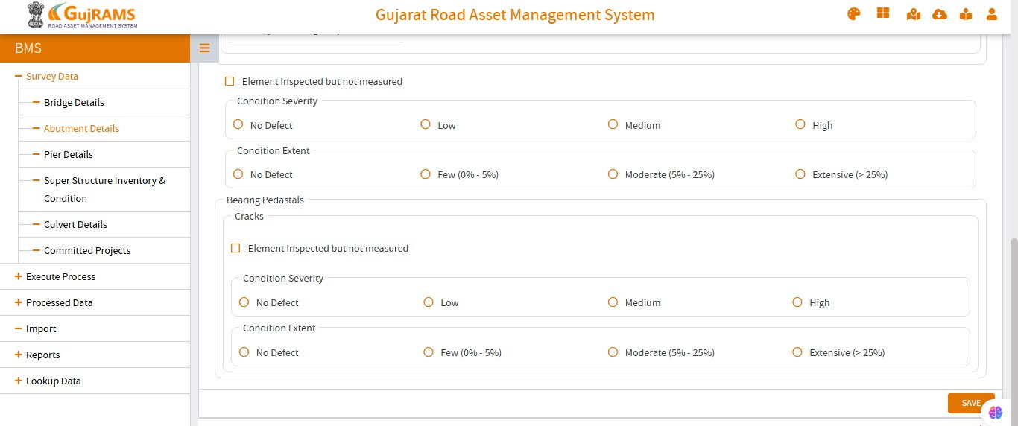

**Review Comments**: Dev Team – Please Remove Cracks as show in the image

**in both** Tab and Web

## Abutment Details – Abutment Bearing and Restrainer Inv and Condition

In the condition, parameter to be mentioned in the Severity and extent condition

**Pier** **Details** **–**

Kindly check if we can add the Images Link in this sheet – as this is useful while reviewing the data (as of now we need to exit this page to review the photos (as explained in Sheet 2)

Kindly check if we can add Link to the following sheets

**Bridge** **Details** **Abutment** **Details**

**Super** **Structure** **Inventory** **and** **Condition**

Once I click any of the link (Bridge Details / Abutment Details / Super Structure Inventory and Condition) it should directly open the detailed sheet as explained in the Above Sheets (Sheet 3 and 4)

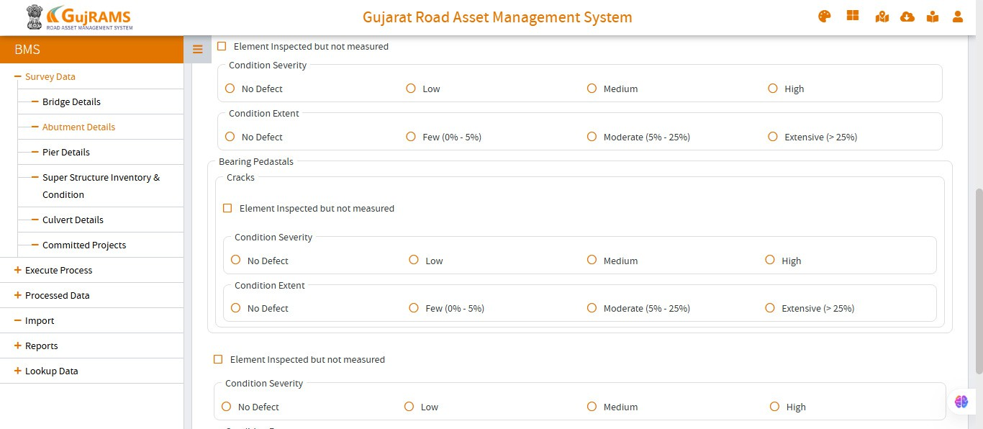

**Bearings**

**Pedestal**

**Seismic** **Restrainer**

**Review Comments** : Please provide headings as 1) Bearings 2) Bearing pedestal 3) Seismic Restrainer in **both** Tab and web

## Pier Details –

Kindly check if we can add the Images Link in this sheet – as this is useful while reviewing the data (as of now we need to exit this page to review the photos (as explained in Sheet 2)

Kindly check if we can add Link to the following sheets

## Bridge Details Abutment Details

**Super** **Structure** **Inventory** **and** **Condition**

Once I click any of the link (Bridge Details / Abutment Details / Super Structure Inventory and Condition) it should directly open the detailed sheet as explained in the Above Sheets (Sheet 3 and 4)

.

**Review Comments**: Dev Team to provide option to display images in this Screen which is inside the Selected bridge.

Images to be displayed as per Inventory and condition for the Respective Years in this. Need to give 3 buttons to move to other elements like Bridge/Pier/Super structure (for that selected structure) from Piers.

## Pier Details – Pier SubStructure Inv & Condition

There is parameter – Deck Surface Condition at the bottom of the sheet – This has to be removed

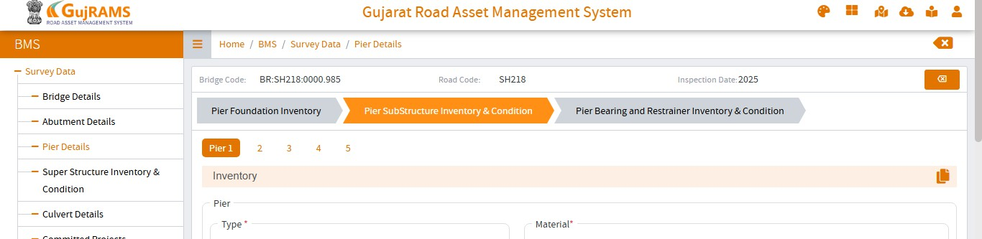



**Remove**

**Review Comments:** Dev team – Please **rename** the Section in UI as **“Expansion Joints Condition**” per the image. To be implemented **Tab/Mobile** as well.

## Pier Details – Pier Bearing and Restrainer Inv and Condition

Once the user selects Are bearing provided, further details are not displayed, this to be looked into

Further for POT-PTFE, Rocker-Roller, Metallic and plate bearings, the condition “Deformity in the shape of bearing” shall be displayed, this shall be checked

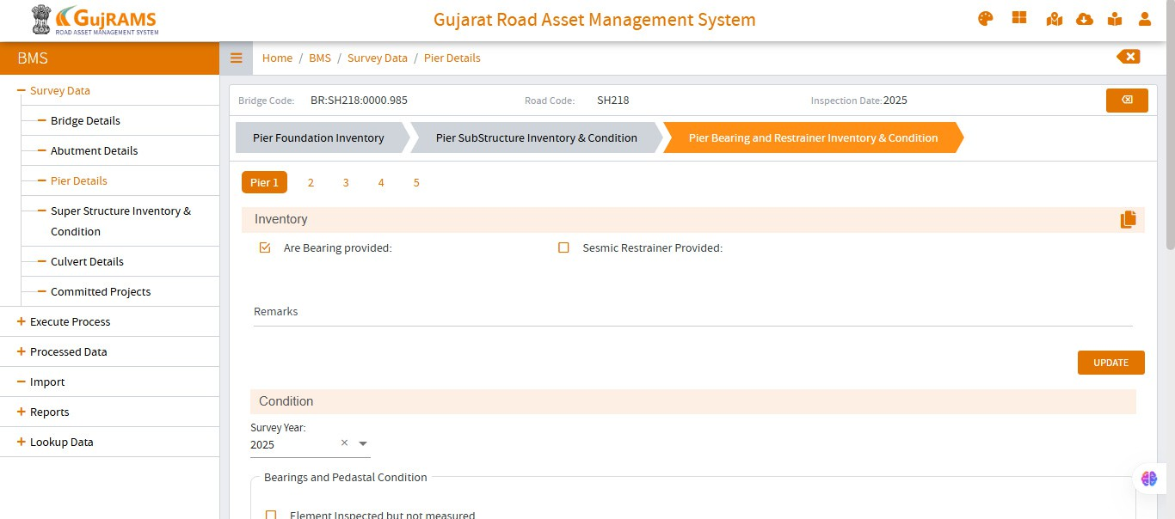

**Review Comments:** Dev team – Type of Bearings field is not displayed in UI. Please implement this change. Please display the deformity in the shape of bearing for the all Bearing types **except** for **Elastomeric** Type of Bearings.(change to be implemented in Tab as well)

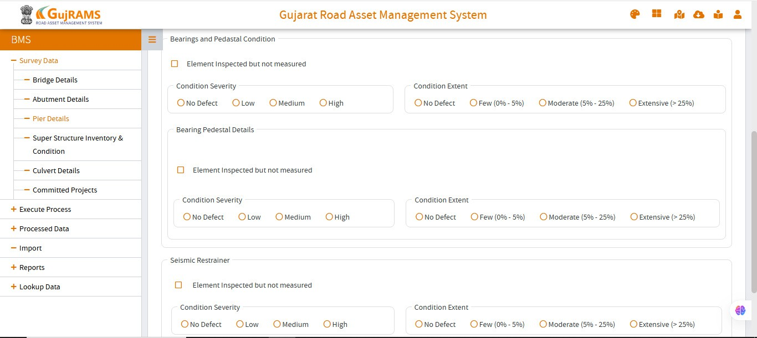

**Review Comments**: Please update the Heading name as “Bearings Condition” shown in the image. Please implement in Tab as well

# Super Structure Inventory and Condition:

These shall be re-arranged as below



**Superstructure** **Details**

**This** **will** **have** **Dimension** **(Inventory)** **Details**

**-** **Details** **of** **Super** **Structure** **(as** **per** **the** **Selected** **Structure)**



**Deck** **Slab** **Condition**

**Main** **Girders** **and** **Cross** **Girder** **Condition**

**This** **will** **have** **Condition** **data** **parameters** **-** **of** **Main** **Girders** **/** **Cross** **Girders** **/** **Steel** **Str** **/** **Arch** **(as** **per** **the** **Selected** **Structure)**

**This** **will** **have** **Condition** **data** **parameters** **-** **of** **Deck** **Slab** **(as** **per** **the** **Selected** **Structure)**



**Deck** **Surface** **Condition**

**This** **will** **have** **Condition** **data** **parameters** **–** **Deck** **Surface**

**Review Comments**: Please update the Heading name of Super Structure Inventory & Condition as “**Super Structure Details**”. Please Create New tab Screen in web with name as **“Deck surface Condition**”. Please Move the Condition details fields from Super Structure Inv & Cond to this new Screen.

# Super Structure Inventory and Condition –

Kindly check if we can add the Images Link in this sheet – as this is useful while reviewing the data (as of now we need to exit this page to review the photos (as explained in Sheet 2)

Kindly check if we can add Link to the following sheets

## Bridge Details Abutment Details Pier Details

Once I click any of the link (Bridge Details / Abutment Details / Pier Details) it should directly open the detailed sheet as explained in the Above Sheets (Sheet 3 and 4)

**Review Comments**: Dev Team to provide option to display images in this Screen which is inside the Selected bridge.

Images to be displayed as per Inventory and condition for the Respective Years in this. Dev Team to provide option to display images in this Screen which is inside the Selected bridge.

Images to be displayed as per Inventory and condition for the Respective Years in this.

Need to give 3 buttons to move to other elements like Abutment/Pier/Bridge details (for that Selected structure) from Super Structure Screen tabs and vice versa.

**Super** **Structure** **Inventory** **and** **Condition** – Shall be renamed as Superstructure Details

All the condition parameters shall be removed from this sheet

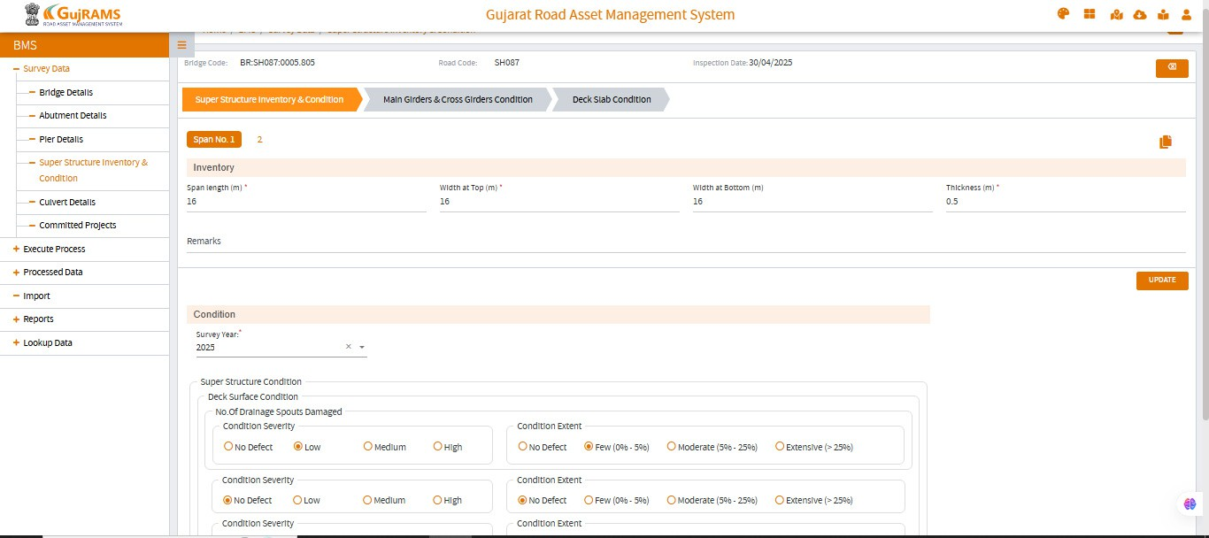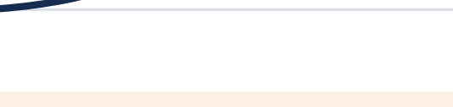

**To** **be** **renamed** **as** **-** **Superstructure** **Details**

**This** **will** **have** **Dimension** **(Inventory)** **Details**

**-** **Details** **of** **Super** **Structure** **(as** **per** **the** **Selected** **Structure)**

**Remove** **these** **Condition** **Parameters**

**Review Comments** : Dev Team : Please change caption name as Super Structure Details. Please move the Condition section fields to new tab screen “Deck Surface Condition” as mentioned in the above point.

**Main** **Girders** **and** **Cross** **Girder** **Condition** **-** This will have Condition data parameters - of Main Girders / Cross Girders / Steel Str / Arch (as per the Selected Structure) **-** this shall be reviewed if the parameters of Arch / Steel Str are displayed if the particular type of structure is selected.

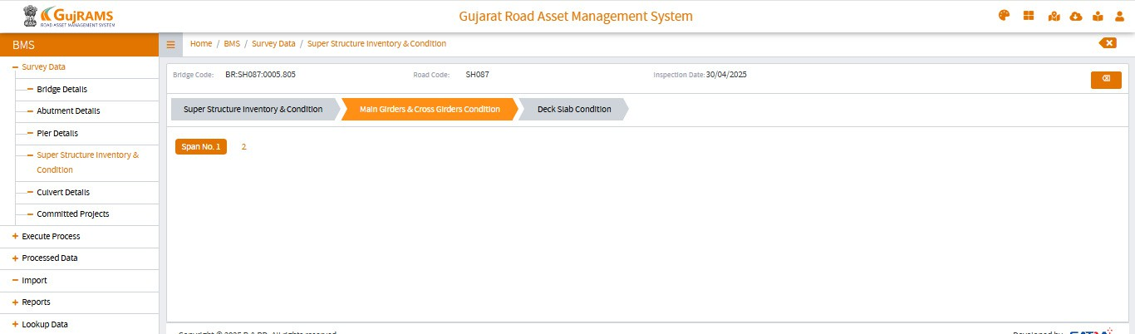

**Review Comments** : Dev Team: Please do not display the Main Girders & Cross girders Tab Screen if the **Main Type of Super Structure** is selected as **Pipe or Slab.**

**Deck** **Slab** **Condition** – this is OK

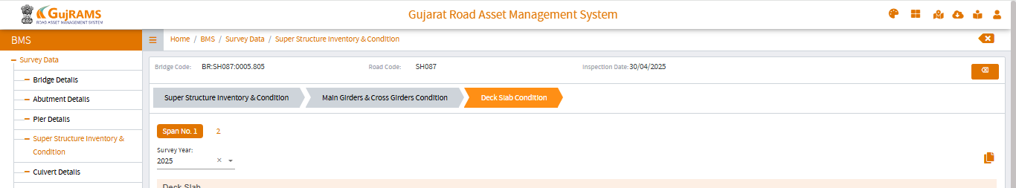

**Review Comments** : No changes in this tab

**Deck** **Surface** **Condition:** these shall have the Severity and Extent for the following parameters.

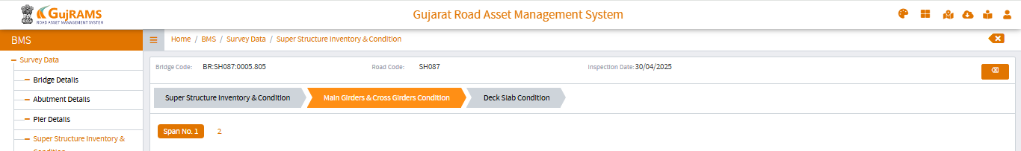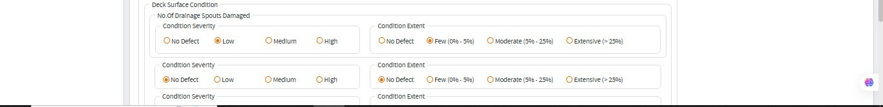

**Deck** **Surface** **Condition**

**Review Comments**: Dev Team: Please place the fields as mentioned below.

Approach Slab Severity / Extent conditions will be only in Abutment Condition Screen

Expansion Joint – Severity / Extent conditions will be in **both** Abutment Condition and Piers Condition. Screen.

The below 5 will be in the Super Structure Details – Deck Surface Condition.

Wearing Coat– Severity / Extent conditions – New fields to be created in the Super Structure Deck Surface Condition Screen.

Drainage Spouts – Severity / Extent conditions

Footpath / Kerb – Severity / Extent conditions--

Railing / Crash Barrier / Parapet – Severity / Extent conditions

Service Lines – Severity / Extent conditions-

Need to give 3 buttons to move to other elements like Abutment/Pier/Bridge (for that structure) from Super structure and vice versa.  
  
  
Need to create the new field in the DB for Wearing Coat Condition Severity and Extent in the Deck Surface Condition Screen.

**Approach Slab – Severity / Extent conditions** – Expansion Joint – Severity / Extent conditions Drainage Spouts – Severity / Extent conditions --Footpath / Kerb – Severity / Extent conditions--

Railing / Crash Barrier / Parapet – Severity / Extent conditions --Wearing Coat – Severity / Extent conditions –

Service Lines – Severity / Extent conditions--

# Culvert

**Review Comments:** Please display the dropdown field values as per the below image.

Please display the Overall Condition of the Structure Field in the UI with 4 dropdown values as   
Retain with Routine Maintenance   
Retain with Repairs   
Retain + Widen   
Propose for Reconstruction.

Super Structure Condition Field to be placed in the Top of Screen.

Overall Condition of the Structure to be placed at the bottom of the Screen. Please refer to the image for complete details.

**Condition** **of** **Super** **Structure** - this shall be moved at the top – Before Abutment/Pier/Headwall Condition

# Condition of Super Structure Condition of Abut. / Pier/Headwall Condition of Return wall / Wing wall Condition of Ppt. / Railing

These parameters are not displayed (to be added / reviewed) The Drop-Down Details should be

**Excellent** **Good** **Fair** **Poor**

The Drop-Down Details should be

**Excellent** **Good** **Fair** **Poor**

**Bad**

**Condition** **-** **Flooring** **/** **Apron** **Condition** **-** **Curtain** **wall** **/** **Cut-off** **Wall** **Condition** **-** **Side** **slope** **Pitching**

**Overall** **Condition** **of** **Structure** **–** This parameter is not displayed (to be added / reviewed) – this will have drop down with the following details (Retain with Routine Maintenance / Retain with Repairs / Retain + Widen / Propose for Reconstruction)

**Condition** **of** **Super** **Structure** **to** **Be** **included** **here**

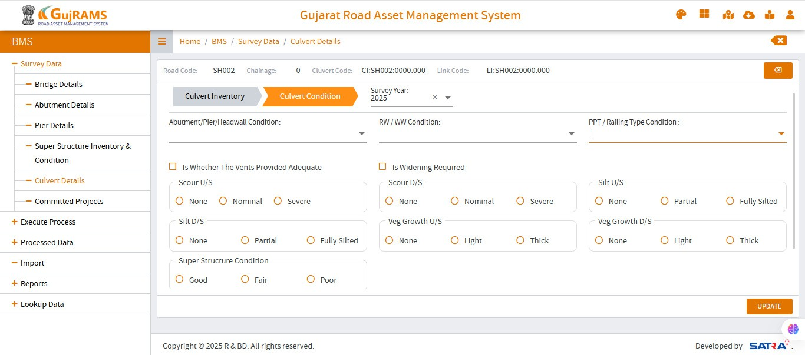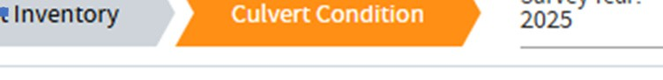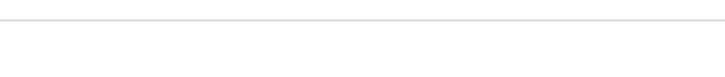

**To** **be** **moved** **to** **top**

**Overall** **condn.** **of** **Str.** **to** **Be** **included** **here**

**Condition** **-** **Flooring** **/** **Apron** **Condition** **-** **Curtain** **wall** **/** **Cut-off** **Wall** **Condition** **-** **Side** **slope** **Pitching**