### Issues observed in Reports: 1. Issue: Uneven Heading Alignment

**Module:** All modules → Reports

**Priority:** Medium

**Category:** UI/UX

**Issue:** The report heading is not aligned properly with the table layout.

**Expected Result:** Heading should be aligned uniformly with the table.

**Actual Result:** Heading appears shifted towards the right corner.

### 2. Issue:Report Split into Multiple Sections

**Module:** All modules → Reports

**Priority:** Medium

**Category:** UI/UX

**Issue:** When the report is generated, it is **not shown in a single PDF format**. Instead, it is split across multiple vertical sections on the screen.

**Expected Result:** The report should be **generated and viewed in a single PDF format** for easy viewing, exporting, and printing.

**Actual Result:** The report is **broken into 2–3 vertical parts on the screen**.

### 3. ****Issue:** Duplicate "No Data to Display" Alert**

**Module:** All modules → Reports

**Priority:** Low

**Category:** Functional

**Issue:** "No data to display" message is shown twice.

**Expected Result:** Only a single alert should be shown.

**Actual Result:** Alert is repeated unnecessarily.

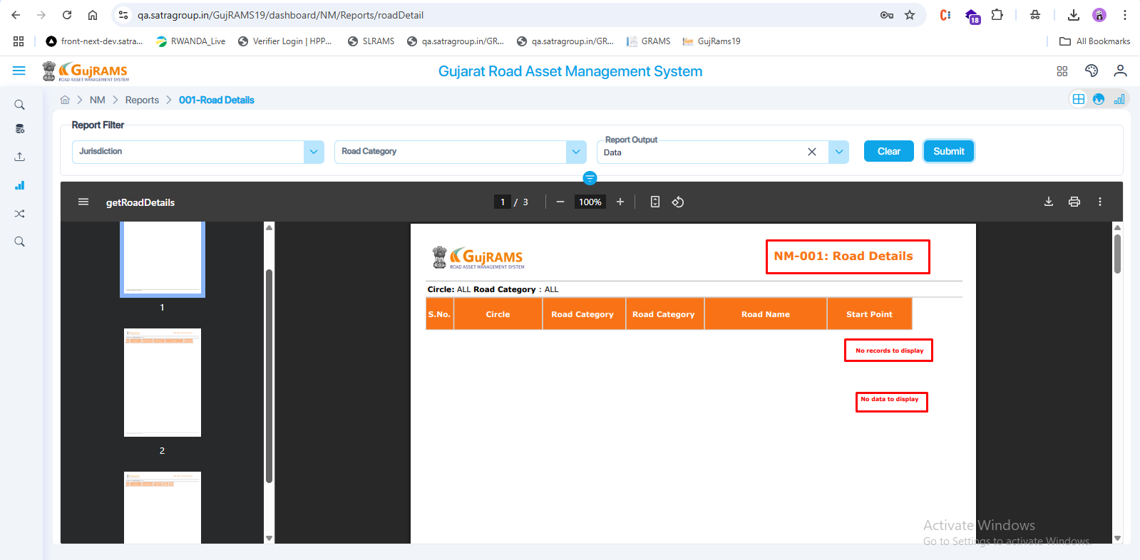

**4. Issue: Inconsistent** Header Naming **Module:** All Modules → Reports  
**Priority:** Low  
**Category:** UI/UX

**Expected Result:** Report headers should follow a consistent format across all modules, displaying either the full description or the submenu name uniformly.

**Actual Result:** In some modules, the full description is shown in the header, while in others, only the submenu name of the report is displayed.  
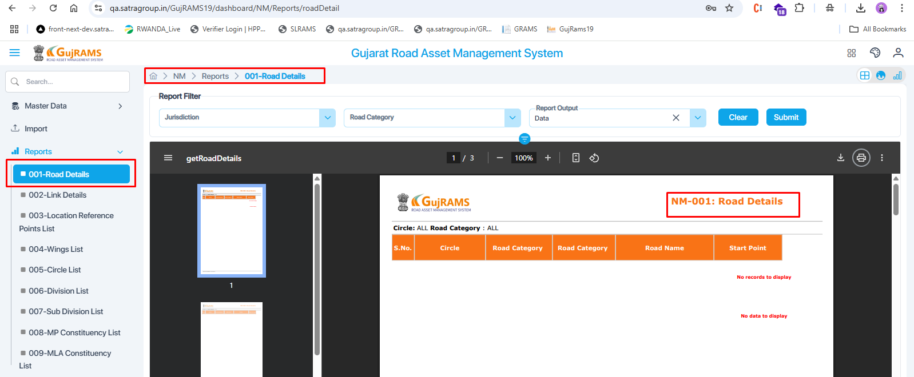  
  
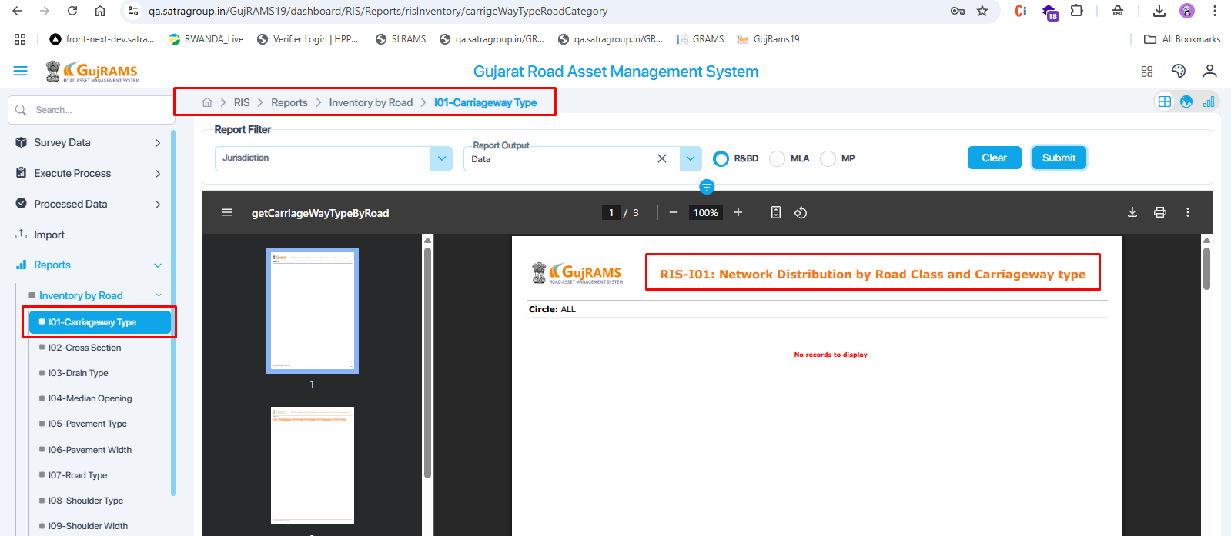

**5**. **Issue: Incomplete Header Name Display**  
**Module:** All Modules → Reports  
**Priority:** Low  
**Category:** UI/UX

**Expected Result:** The full header name of the report should be displayed clearly and completely.

**Actual Result:** The header name is displayed partially (cut off or half visible) in some reports.

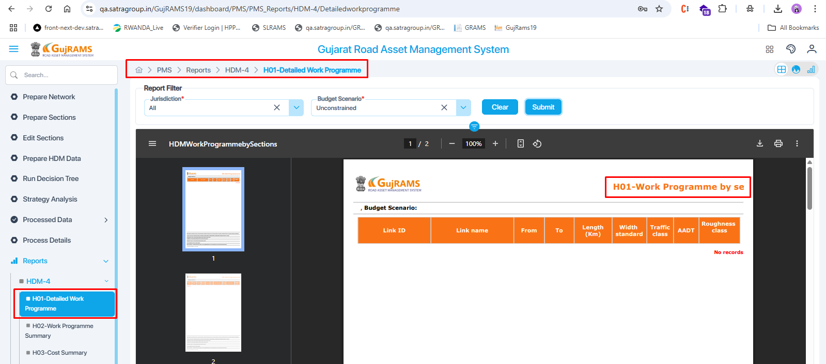

**6. Issue: Header Name Differs from Submenu Name**  
**Module:** PMS Modules → Reports  
**Priority:** Low  
**Category:** UI/UX

**Expected Result:** The header name of the report should match the submenu name.

**Actual Result:** The header name displayed in the report is different from the name shown in the submenu.  


**7.** **Issue : Theme Not Applied to Report Header  
Module:** All Modules → Reports  
**Priority:** Low  
**Category:** UI/UX

**Expected Result:** The theme (fonts, colour, size, and style) should be consistently applied to the report headers.

**Actual Result:** Report headers are missing the applied theme, resulting in a mismatch with the rest of the UI.

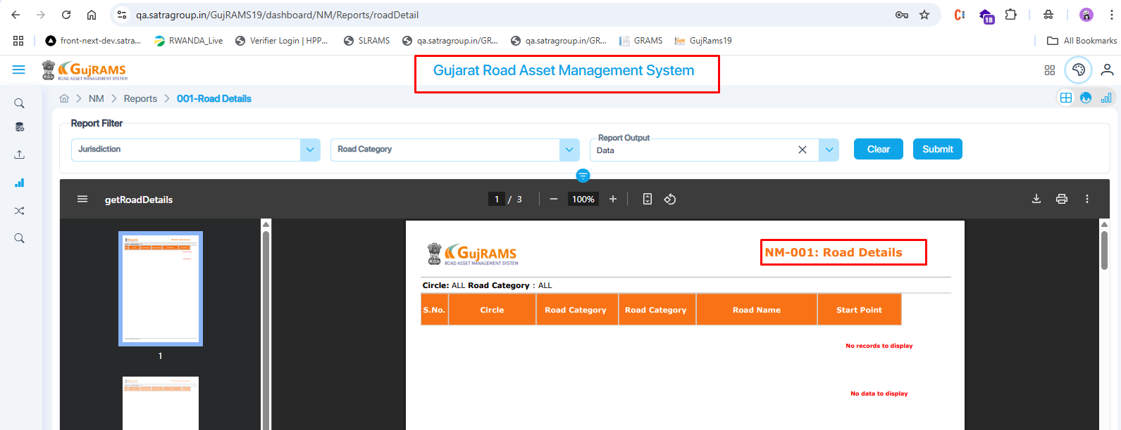

**8.** **Issue: Incorrect Default Text Displayed in Report without Selection**  
**Module:** NM → Reports → 001-Road Details  
**Priority:** Medium  
**Category:** Functional / UI

**Expected Result:** If no circle is selected from the Jurisdiction dropdown, the field should be blank or display a prompt like “ALL”

**Actual Result:** The report shows “**Circle: ALL”** even when no selection is made.

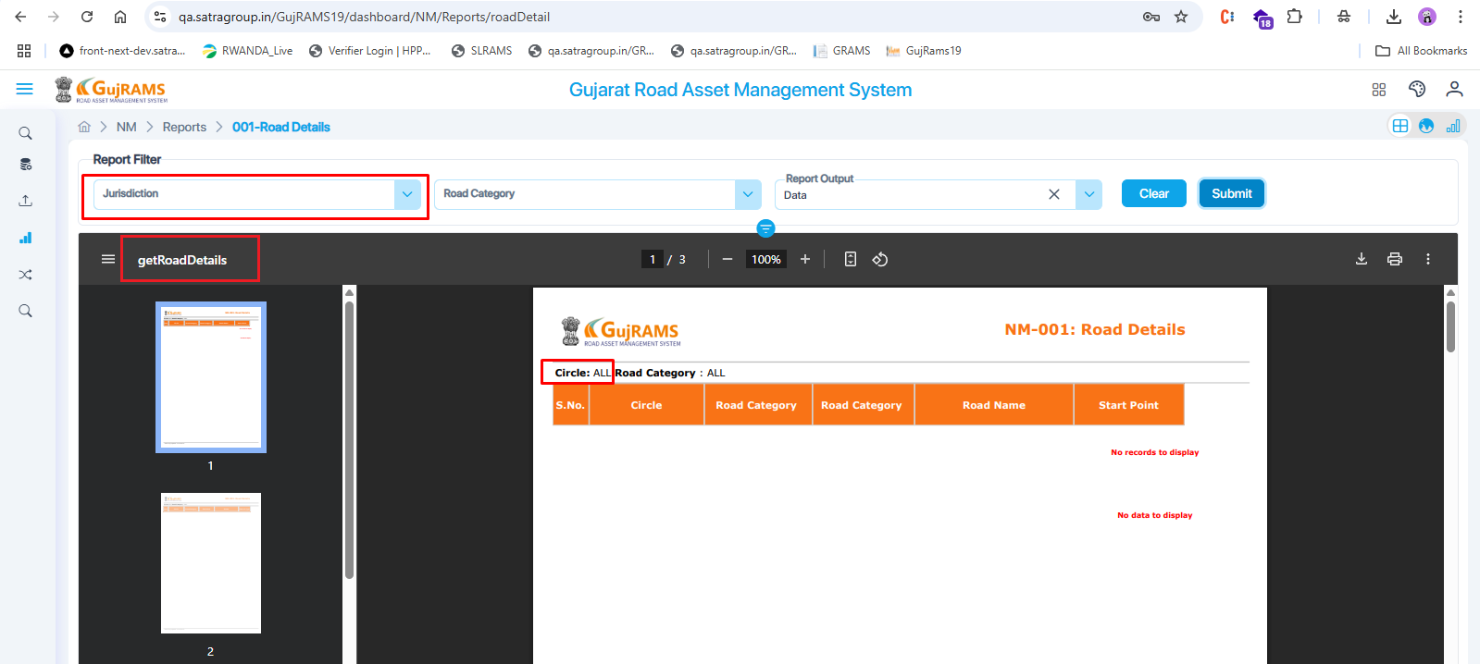

**9.** **Issue: Report Generated Without Selecting Mandatory Field**  
**Module:** NM → Reports → 008-MP Constituency List,009-MLA Constituency List   
**Priority:** High  
**Category:** Validation  
**Expected Result:** The system should restrict report generation and prompt the user to select a mandatory field before proceeding.  
**Actual Result:** Report is generated even when the required field is left unselected.

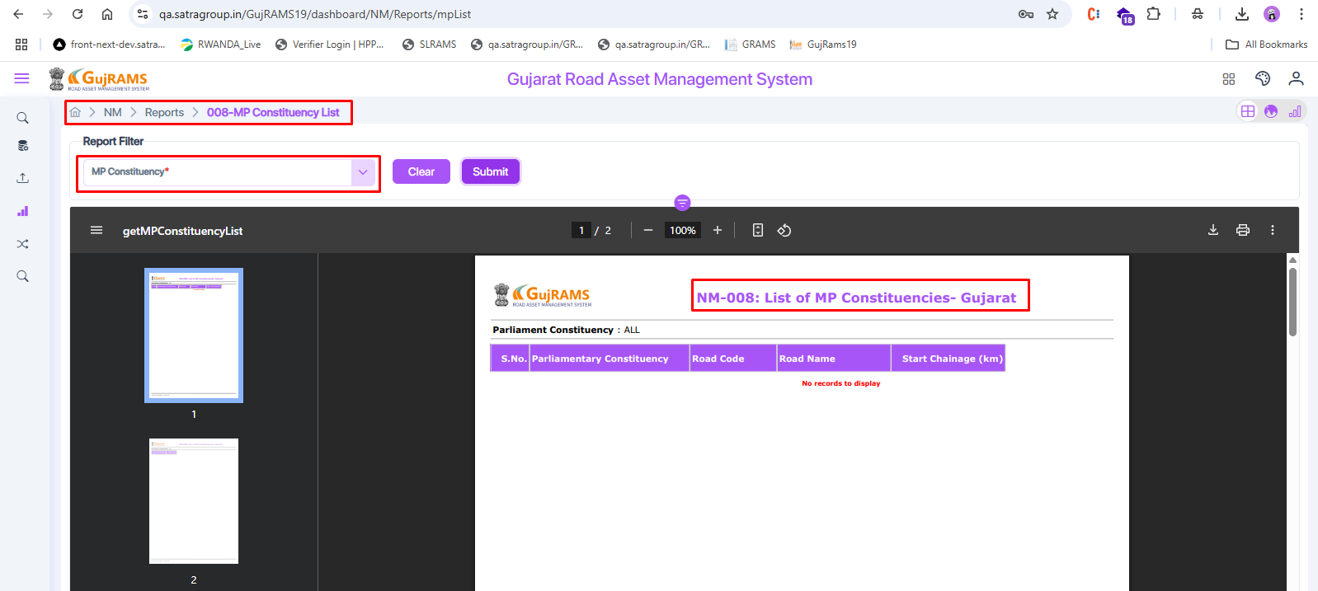

RIS MODULE:   
  
**10.** **Issue:** Theme Missing and Wrong Default dropdown value shown in report  
**Module:** RIS → Reports → Inventory by Road → I01-Carriageway Type **Priority:** Medium  
**Category:** UI/UX

**Issue:** i. The report design doesn’t follow the theme (colours and style are missing).

ii. Even if the user does not select anything in the **Jurisdiction** dropdown, it still shows **Circle: ALL** in the report (in all reports)

**Expected Result:**

* Report should match the app’s theme style.
* "Circle: ALL" should be shown only if the user selects it.

**Actual Result:**

* Report is displayed in the default theme.
* "Circle: ALL" is shown even when not selected.

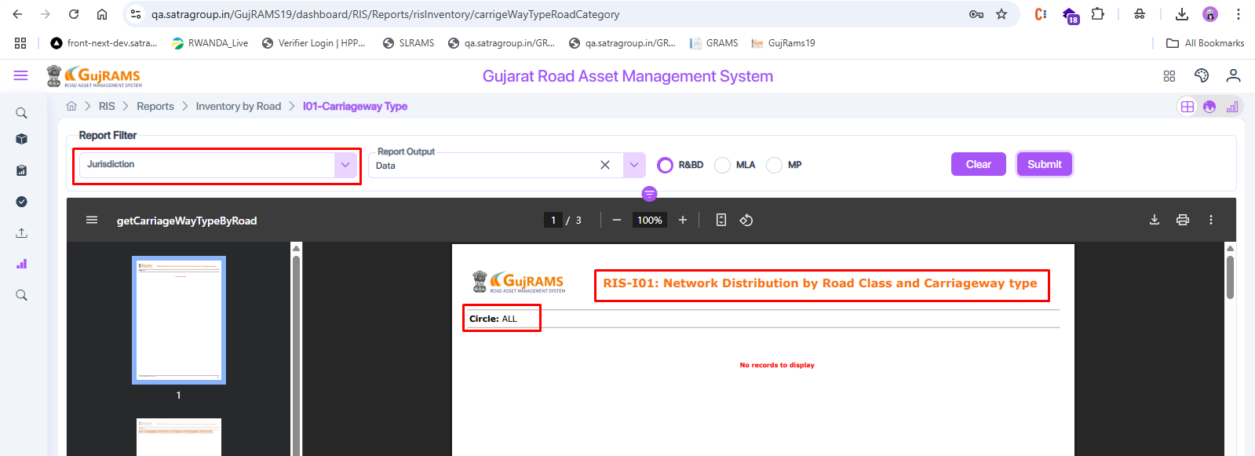  
  
**11**. **Issue: Report Output Dropdown Value Not Bound by Default  
Module:** All applicable modules (Reports section)  
**Priority:** Medium  
**Category:** UI/UX

**Issue:** In some reports, the **Report Output** dropdown is not auto-filled by default like it is in other reports.

**Expected Result:** The Report Output field should have a default value (e.g., "Data") selected automatically, like in the other reports.

**Actual Result:** Report Output dropdown appears empty until the user manually selects a value.  
  
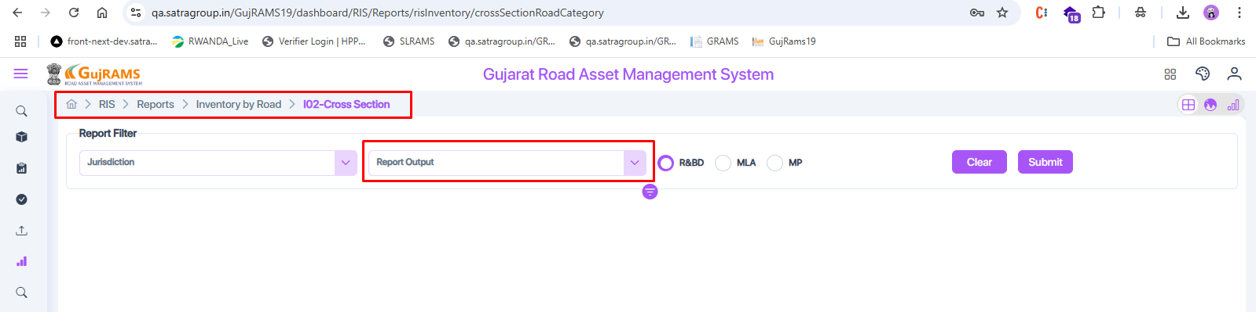  
**12**. **Issue: Report Name Displayed Twice When Output is Chart  
Module:** Reports (All Modules)  
**Priority:** Low  
**Category:** UI/UX

**Issue:** When the **Report Output** dropdown is set to **Chart**, the report name is shown two times on the screen.

**Expected Result:** Report name should appear only once, regardless of the selected output type.

**Actual Result:** Report name is duplicated when chart view is selected.

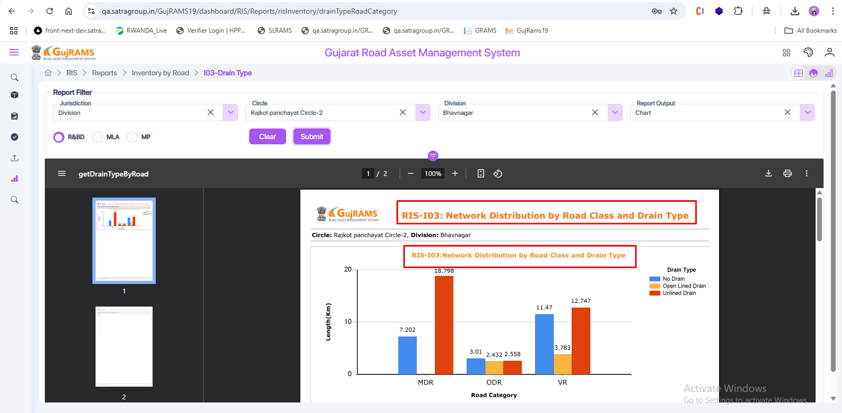

**13.** **Issue: No Alert Displayed When Dropdown Is Left Empty**  
**Module:** Reports (All Modules)   
**Priority:** Medium  
**Category:** Validation

**Issue:** When the user clicks **Submit** without selecting a dropdown value, no response or alert is displayed.

**Expected Result:** An alert should be displayed prompting the user to select a value before submitting or by default, any value should be bound in the dropdown.

**Actual Result:** No message or validation alert is shown, and nothing happens on clicking submit.

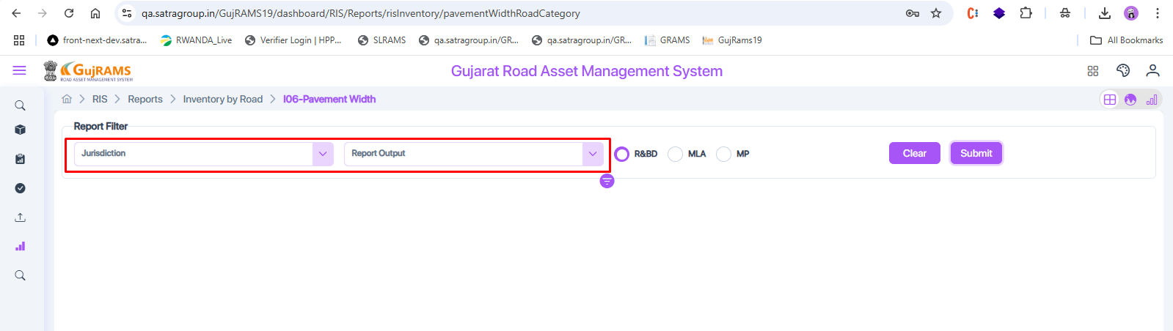

**14**. **Issue: Empty Report and Missing Header When 'All' is Selected in Jurisdiction**  
**Module:** Reports (All Modules)  
**Priority:** Medium  
**Category:** Functional / UI

**Issue:** When the **Jurisdiction** dropdown is set to **All**, the report is generated but shows no data, and the header does not display **Jurisdiction: All**.

**Expected Result:**

The report should display data for all jurisdictions.

The header should show **Jurisdiction: All** clearly.

**Actual Result:**

The report is empty.

The header does not display **Jurisdiction: All**.  
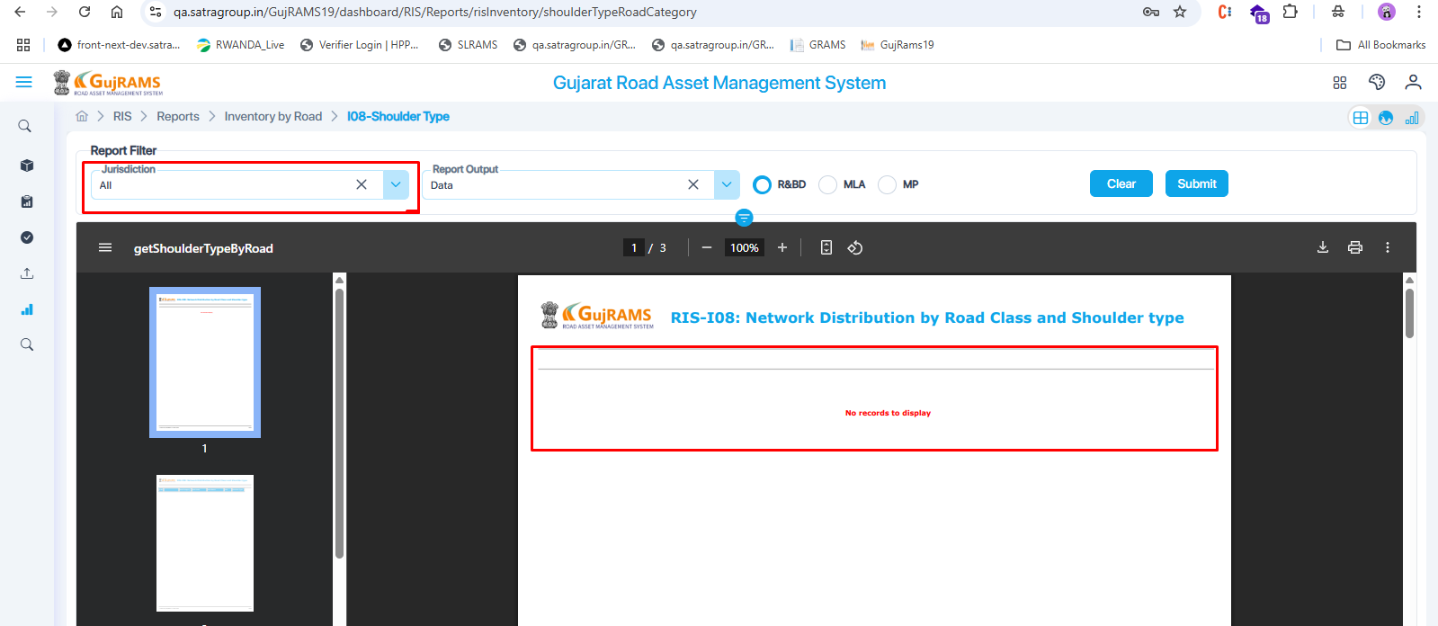  
  
**15.** **Issue: Alert Shown After Clear and Submit Despite No Mandatory Fields  
Module:** Reports   
**Priority:** Medium  
**Category:** Validation

**Issue:** After clicking **Clear** and then **Submit**, an alert is displayed saying, **"Check required fields"**, even though the report does not have any mandatory fields.

**Expected Result:** No alert should be shown if the report has no required fields.

**Actual Result:** An unnecessary alert is shown asking to check the required fields.

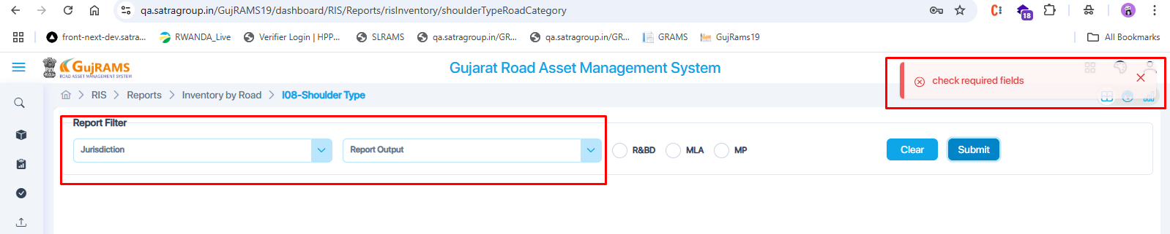

**16**. **Issue: Data Not Displayed When Jurisdiction is Set to 'All' but Displays When Specific Circle is Selected  
Module:** Reports (All Modules)   
**Priority:** High  
**Category:** Functional / Data Handling  
**Issue:** When the Jurisdiction dropdown is set to All, the report shows "No data to display." However, when a specific Circle is selected, data is shown correctly.  
**Expected Result:** Data should be displayed when "All" is selected, if it exists for individual values.  
**Actual Result:** No data is shown when "All" is selected, but data appears for individual Circle selections.  
  
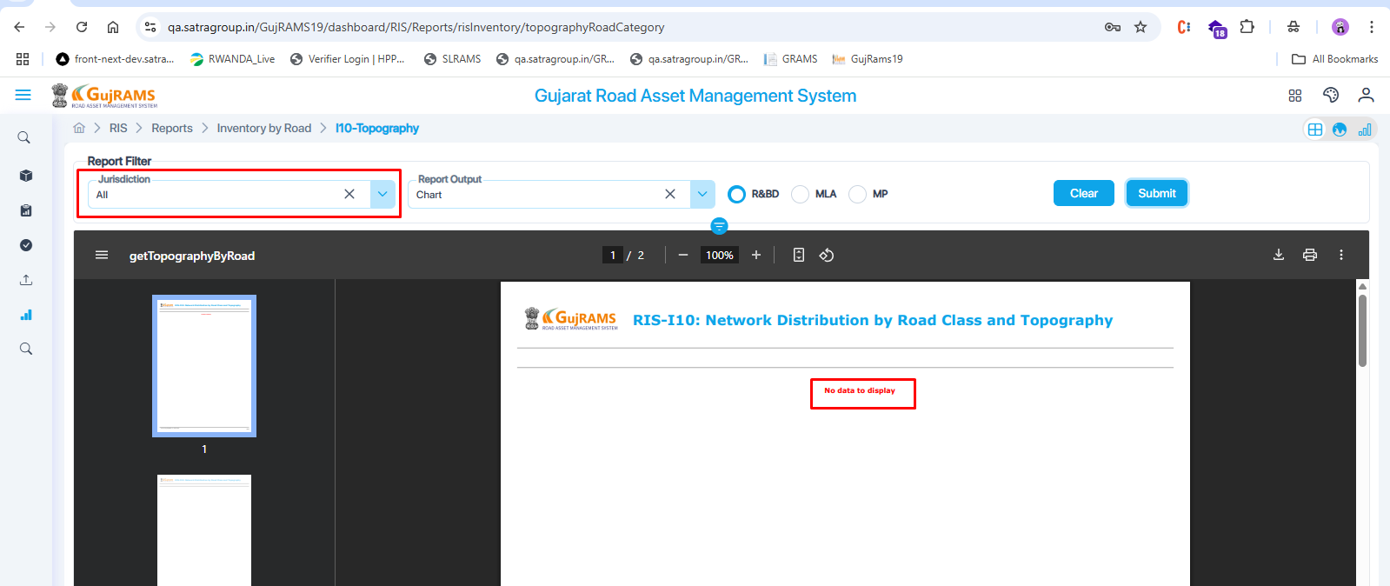  
  
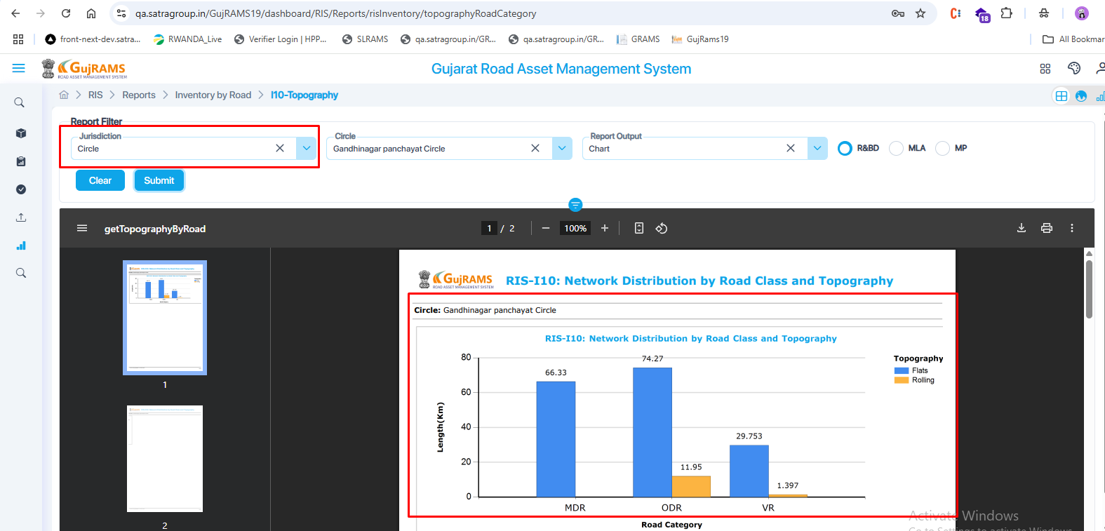  
  
**17**. **Issue: No Response After Using Clear and Re-selecting Jurisdiction  
Module:** RIS → Reports → ITS Reports → ITS01: CC Camera Details (All components in ITS reports)  
**Priority:** Medium  
**Category:** Functional

**Issue:** When the user selects a value in the **Jurisdiction** dropdown and clicks **Submit**, the report is generated as expected. But if the user clicks **Clear**, then selects the **Jurisdiction** again and clicks **Submit**, there is no alert or response, and the report is not generated.

**Expected Result:** The report should be generated properly even after using the Clear option and re-selecting a value.

**Actual Result:** After using Clear, re-selecting a value, and clicking Submit, nothing happens—no alert and no report is displayed.

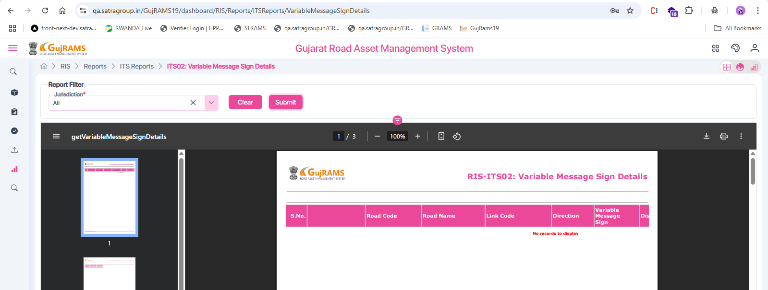  
  
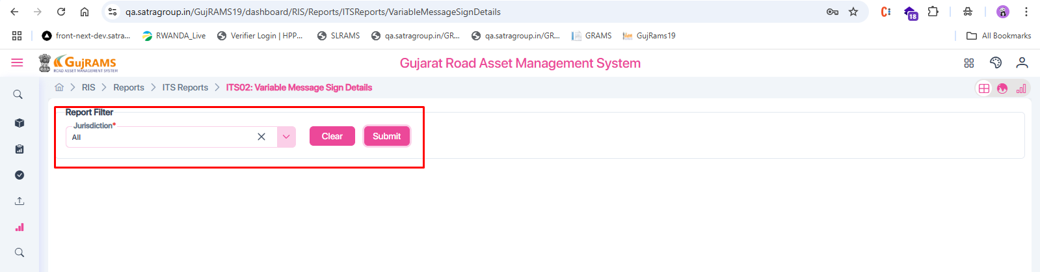

**18**. **Issue: Mandatory Jurisdiction Field Not Validated**  
**Module:** RIS → Reports → Others → O01-(A): Categorywise Road Type Summary  
**Priority:** High  
**Category:** Functional

**Issue:** Report is generated even without selecting the mandatory **Jurisdiction** field.

**Expected Result:** User should receive an alert or validation error when attempting to submit without selecting the mandatory field.

**Actual Result:** Report is displayed with "Circle: ALL" even though no jurisdiction was selected

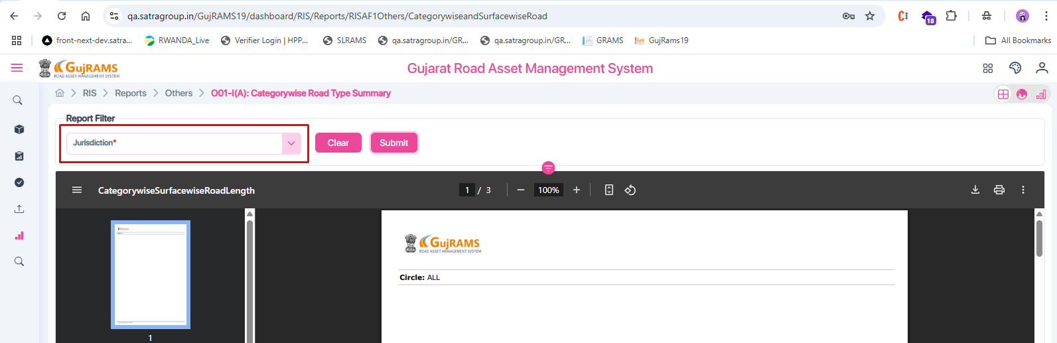  
  
**19.** **Issue:** Incorrect and Mismatched Report Name Displayed  
**Module:** RIS → Reports → Others → O02-F1: Categorywise Road Type Details  
**Priority:** Medium  
**Category:** UI/UX

**Issue:**

1. The report is generated even when the mandatory field "Jurisdiction" is not selected.
2. The report header displays an incorrect name ("For Road Length Information"), which does not match the actual report name shown in the submenu ("O02-F1: Categorywise Road Type Details").

**Expected Result:**

* Report should not be generated unless all mandatory fields are selected.
* Report header should exactly match the submenu name.

**Actual Result:**

* Report is generated without selecting mandatory fields.
* Report header shows a different and incorrect name.

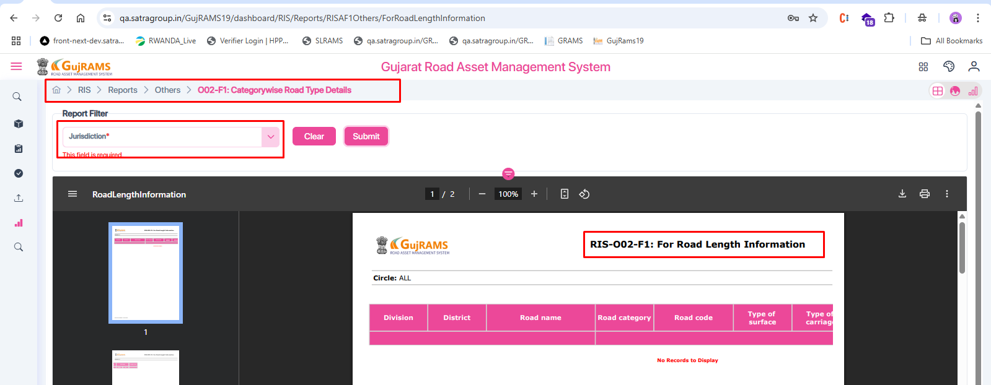  
  
**20.** **Issue: Unmarked Mandatory Fields, No Alerts, and Value Mismatch in Report**  
**Module:** RIS → Reports→ Summary Reports (all components)→ Network Roads  
**Priority:** High  
**Category:** Functional / Validation / UI   
**Issue:**

1. Fields like **CRN** are not marked as mandatory, but the report does not generate unless a value is selected.
2. When the user clicks **Submit** without selecting the required field, no alert or validation message is displayed.
3. In the generated report, the value of **CRN** appears as **0 or 1**, while in the UI screen, it is shown as **True or False**, leading to inconsistency.

**Expected Result:**

* Required fields should be clearly marked as mandatory.
* Alerts should be shown if the user attempts to submit without selecting required fields.
* Values like **CRN** should be displayed consistently across the UI and reports (i.e., **True/False** instead of **0/1**).

**Actual Result:**

* Mandatory fields are not indicated.
* No validation alert is shown when fields are left unselected.
* Reports do not generate unless fields are manually selected.
* CRN displays as **0/1** in reports and **True/False** in the UI.

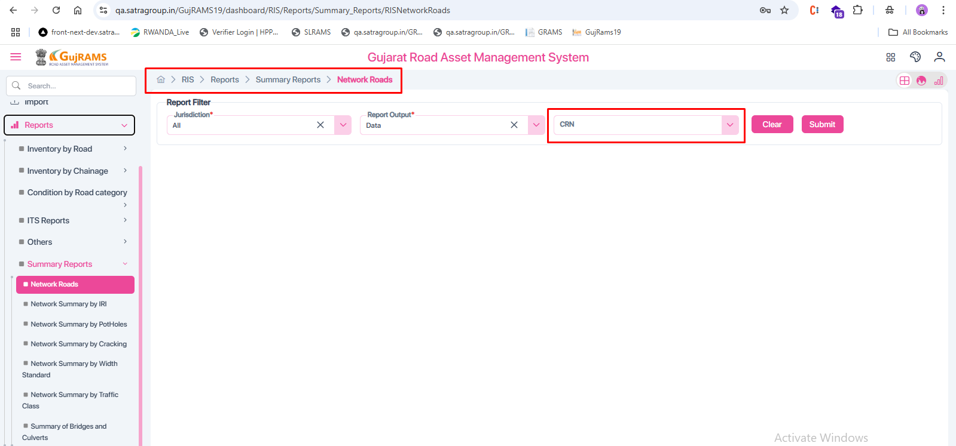  
  
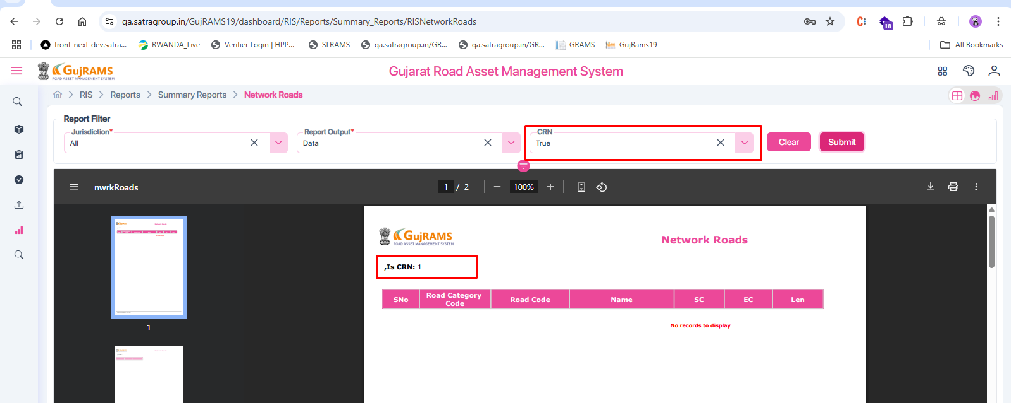

TIS MODULE:   
**21.** **Issue: Jurisdiction Not Shown in Report  
Module:** TIS → Reports (in all reports of TIS) → L01: Average Annual Daily Traffic  
**Priority:** Medium  
**Category:** UI/Report Data  
**Expected:** Jurisdiction value should appear in the report.  
**Actual:** Only Survey Year is shown; Jurisdiction is missing.  
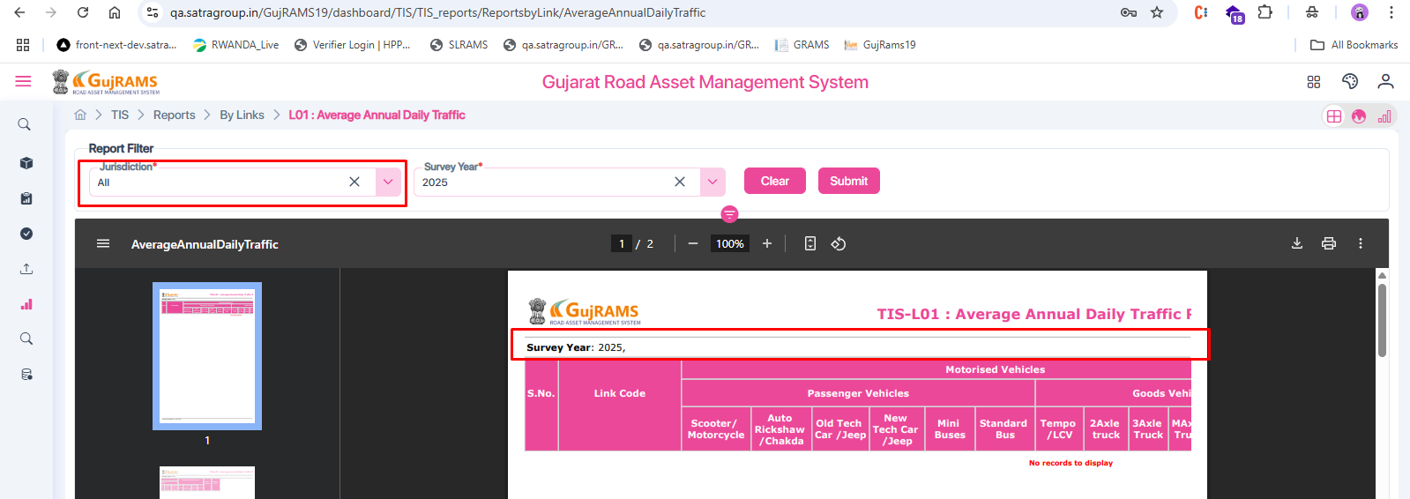

PMS MODULE:   
**22. Issue: Budget Scenario Value Not Displayed in Report Header  
Module:** PMS → Reports → HDM-4 (same issue for all reports in HDM-4) → H01-Detailed Work Programme  
**Priority:** Medium  
**Category:** Report Layout/UI  
**Expected:** The report header should display both the **Budget Scenario label and its selected value** (e.g., "Budget Scenario: Unconstrained").  
**Actual:** The label **"Budget Scenario:"** is shown, but the **value is missing**.  
**Note:** Jurisdiction value is also not displayed in the header.  
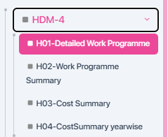  
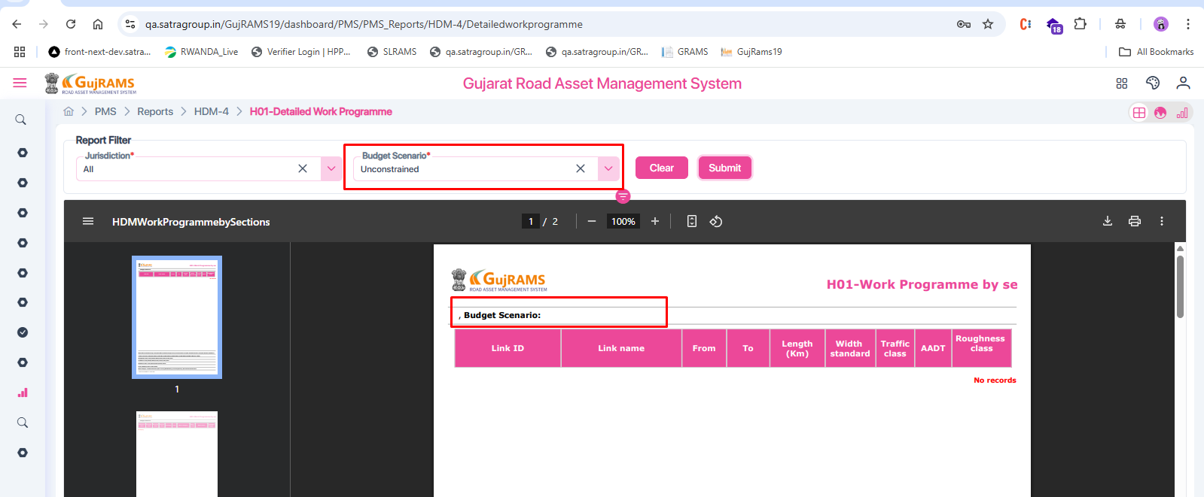  
RMMS MODULE:   
23.**Issue:** Circle and Division Dropdowns Displayed Without Jurisdiction Selection  
**Module:** All applicable modules with Jurisdiction filter  
**Priority:** Medium  
**Category:** UI/Functional

**Expected:** Circle and Division dropdowns should **only appear after a Division is selected** in the Jurisdiction dropdown.

**Actual:**

* After selecting a Division in Jurisdiction and generating the report, Circle and Division dropdowns are shown (✔️ expected).
* But when navigating to another report and returning to the same report **without selecting Jurisdiction again**, the Circle and Division dropdowns are still displayed, even though no Division is selected.

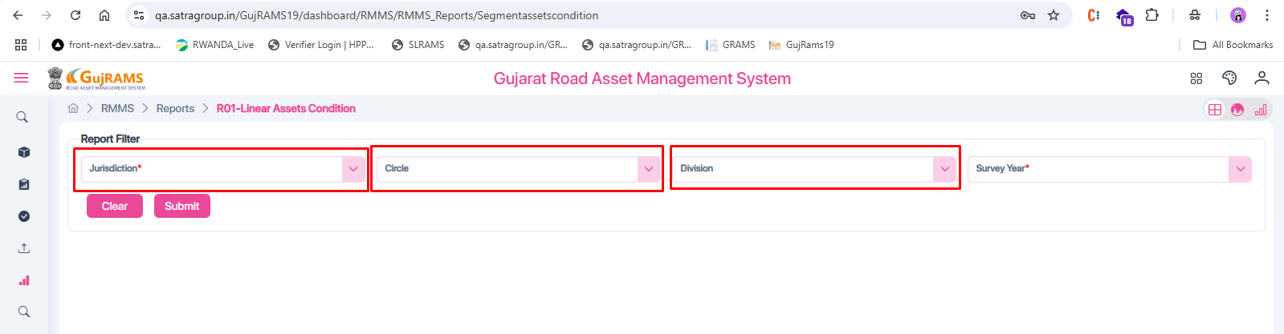  
BMS MODULE:   
24. **Issue:** Bridge Code Dropdown Not Populated  
**Module:** BMS → Reports → Others → BOF2: Categorywise Road Type Structure Details  
**Priority:** High  
**Category:** Functional

**Expected:** Bridge Code dropdown should display available values so the user can select one and generate the report.

**Actual:**

* Bridge Code is marked as a **mandatory field**.
* But the dropdown is **not populated** with any values.
* As a result, the user is **unable to generate the report**

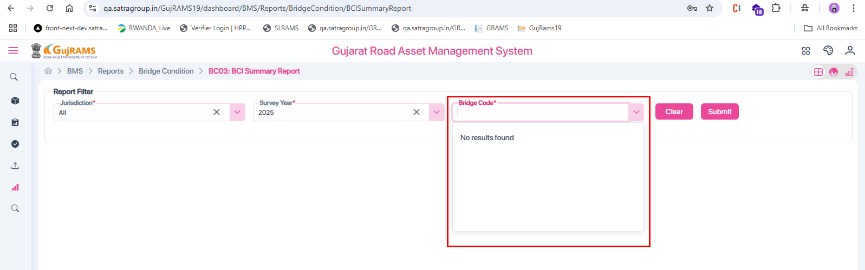

**25.** **Issue:** Jurisdiction Value Not Displayed in Report Header  
**Module:** BMS → Reports → Others → BOF2: Categorywise Road Type Structure Details (observed in all reports)  
**Priority:** Medium  
**Category:** UI / Data Display  
**Expected Result:** The selected **Jurisdiction** (e.g., Division) should be displayed in the report header.  
**Actual Result:** The **Jurisdiction** value is **not displayed** in the report header even though it is selected in the filter.

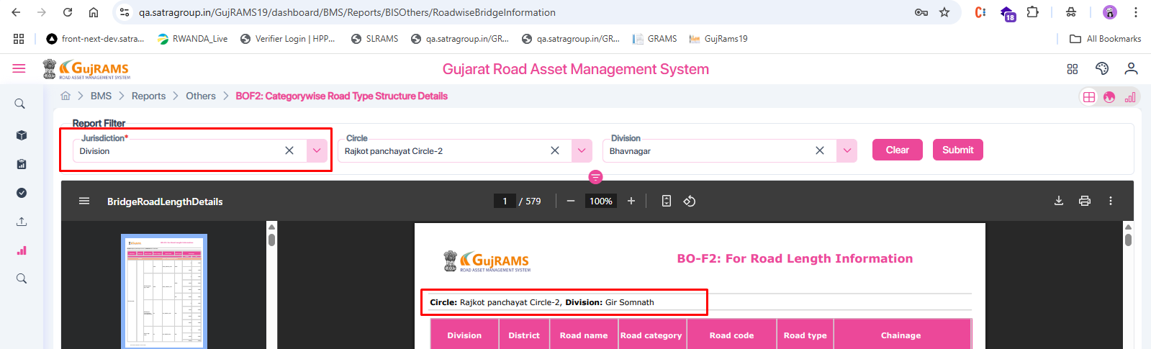  
RSAMS MODULE:

### 26. ****Issue****: Calendar Alignment Problem

**Module**: RSAMS – Accident Details Report  
**Priority**: Low / UI  
**Description**:  
After generating the report, when the user clicks on the **End Date** field again, the calendar popup appears in the **top-left corner of the screen** instead of right below the End Date input field.

**Expected Result**: The calendar should be **aligned properly below the End Date field**, even after the report is generated.

**Actual Result**: Calendar appears in the **left corner**, which is not user-friendly and indicates a UI alignment issue.

### F:\Reports\Screenshot_29.png 27. ****Issue****: Invalid Date Range — No Alert Message Displayed

**Module**: RSAMS – Accident Details Report. (All reports in RSAMS)  
**Priority**: Medium  
**Description**: When an invalid date range is selected (e.g., Start Date: 26/06/2025, End Date: 01/05/2025), **no validation alert** is displayed in the **new portal**, and the report still gets generated.

**Expected Result**: System should **prevent report generation** and display a proper validation message like:

"Start Date should not be greater than or equal to End Date."

**Actual Result**: No alert is shown; the report proceeds with invalid dates.

**Reference**:  
The old portal shows a proper validation message for the same condition (as seen in the first screenshot).  
old portal:  
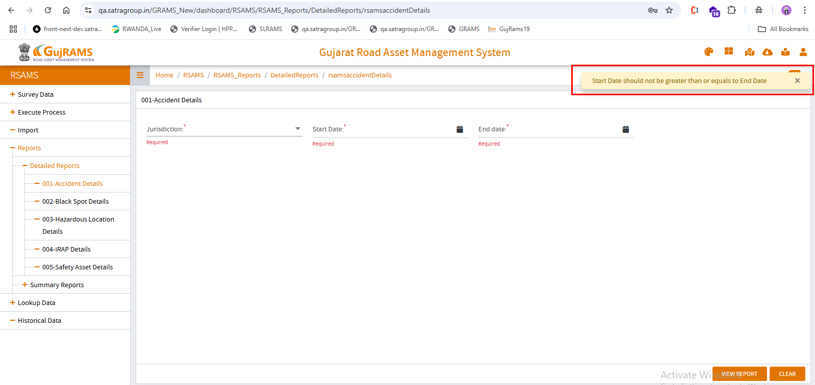  
  
new Portal:  
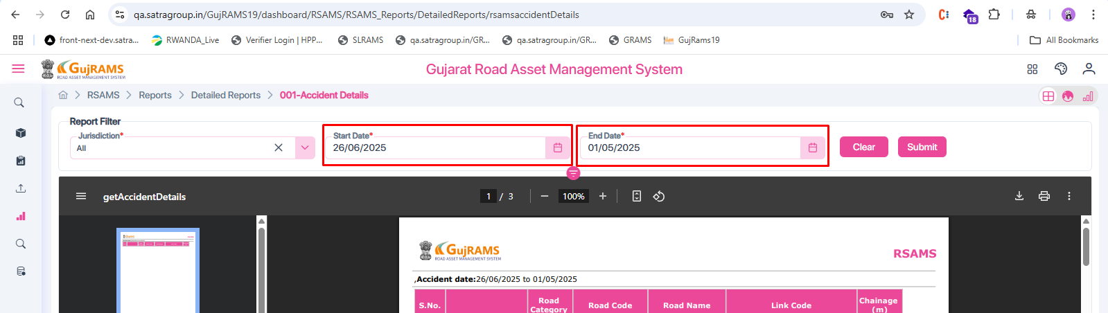

BAP MODULE:   
  
**28. Issue**: In the B02 – Jurisdiction Wise Budget Allocation report, the **Budget Head** field in the header (3054-SR) is misaligned and appears to be entering into the table section.  
**Module:** BAP → Reports → B02 – Jurisdiction Wise Budget Allocation  
**Priority**: Low (UI/Layout)  
**Expected Result**: The Budget Head should be properly aligned in the header and separated from the table content.  
**Actual Result**: The Budget Head (3054-SR) is not fully displayed in the header line and is partially shifted down, overlapping into the first row of the table.  
