1. No need for a mouse-over function in the chart.-> Not done
2. Remove am charts logo below->not done  
   Comments:   
   HOME dashboard -> Charts-> In the Survey Details chart, the AMCharts logo is still visible.”

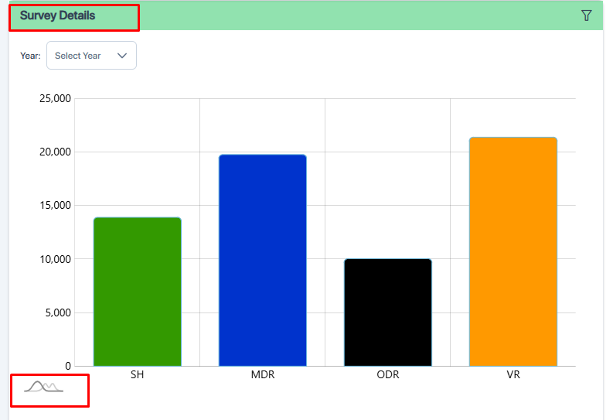

1. 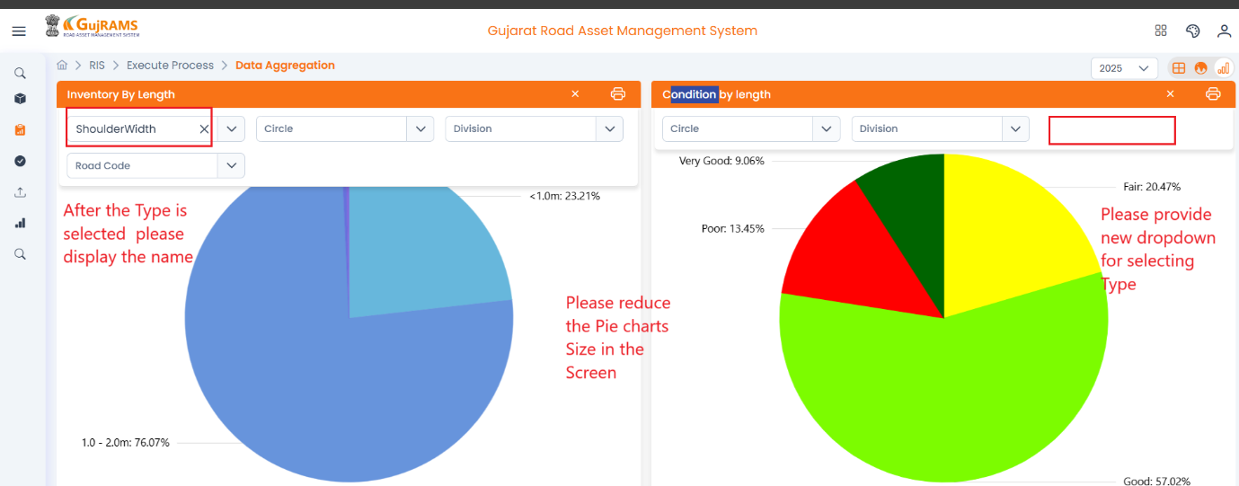Condition Type/ Name is missing. Inventory attribute type should be visible even when the filter is hidden.  
   i. New dropdown for selecting type -> Not implemented.
2. To add another filter, pass for Table list.-> Not implemented
3. 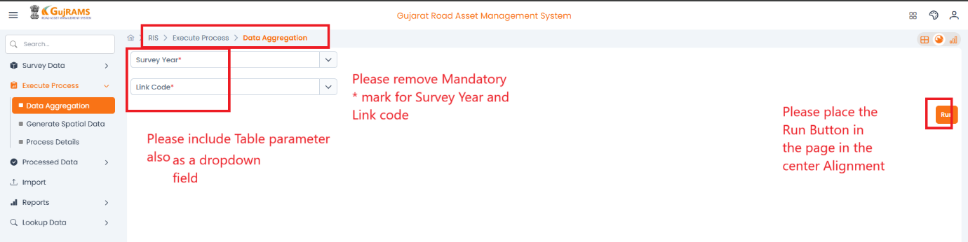To call the “Spatial data updation” in the Data Aggregation Process –Run button, placing to be changed.  
   i. Table parameter dropdown is not included -> Fail
4. Reports – Mandatory symbol is missing.-> Need more info

**Issue:** Print icon is present in the new portal, but the tooltip is missing when hovered over.  
**QA Status:** Fail  
**Screenshot:**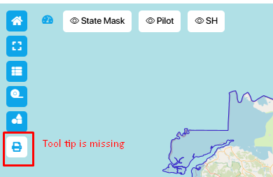

1. Need to check the functionality of ->Not implemented

 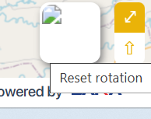

1. When we select a bridge, the legend should pop up, similar to Production portal->Not implemented
2. Print is not working in RIS modules graph -> Not implemented

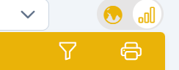

1. After removing filters, the graph is showing error RIS only tested. Also need filter reset-> Not implemented

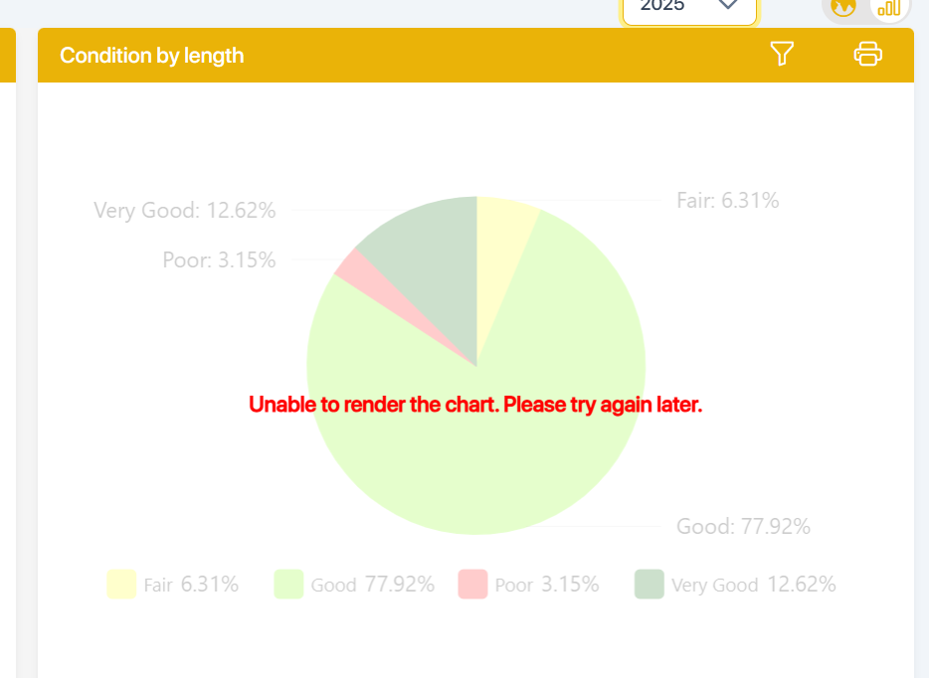

**Support Team:**

1. Data should be verified in the dashboard and Reports.
2. In Reports colour should be changed according to the given Parameter.-> Done
3. To prepare manual for Generate Spatial data.
4. GPS Process (Spatial Data updation) to be put in the data Aggregation Process.