**GujRAMS – R & B App Modifications:**

1. 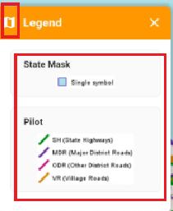After Placing the icon for the Legend. Please reduce the space for the State mask and the Pilot Section. Please reduce the height of the Orange Strip Legend.

After the legend is displayed and the User clicks anywhere else on the Screen the legend popup should not be displayed.

**Comments:**

* **Reduced the spaces in the legend section.**
* **Reduced the size and height on the orange strip in the legend section.**
* **Unable to close the legend popup by clicking anywhere on the screen**

**QA Status: Fail**

1. When jurisdiction is selected as “All” the reports are generating “No Records” as output. Only when either Circle / Division is selected, then the report output is generated.

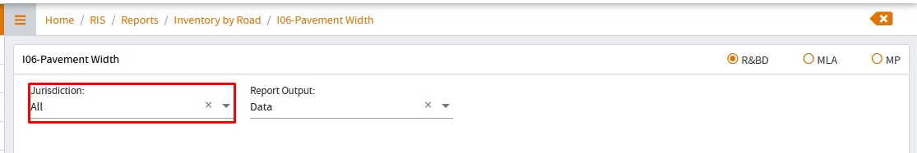

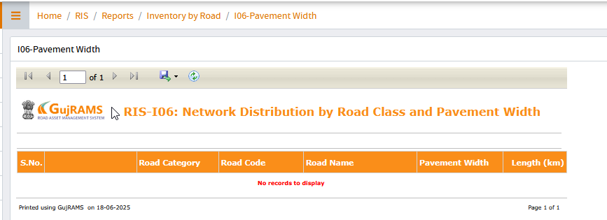

**Comments: By selecting jurisdiction as All no recording are displaying whereas for circle & division records are displaying.**

**QA Status: Fail**