**NEW OBSERVATIONS IN GUJRAMS FOR RMMS MODULE:**

**Issue 1: (Done)**

**Issue**: RMMS → Survey Data → Vegetation → Add record → Unable to save and different popup message is displaying.

**Priority**: High  
**Expected Result**: “Data Saved Successfully” popup message should be displayed.  
**Actual Result**: It is displaying different message popup as the screen shot attached below.  
**Category**: Bug

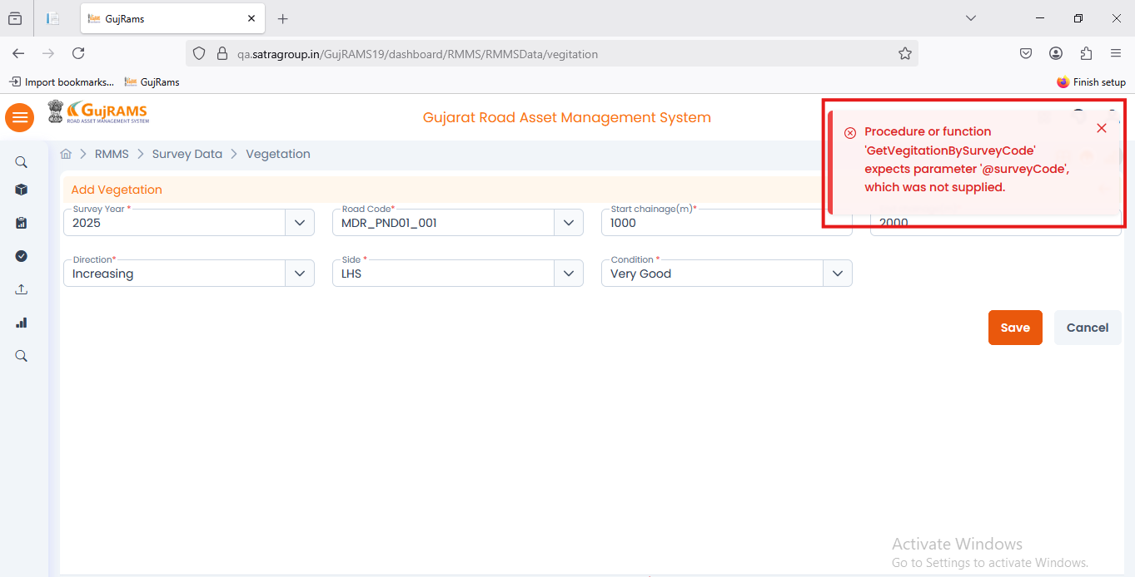

**Comment**: **Data saved and popup displayed as per the expected.  
QA Status: Pass**

**Issue 2: (Done)**

**Issue**: RMMS → Survey Data → Vegetation → Select row →Update record → Unable to update record and different popup message is displaying.

**Priority**: High  
**Expected Result**: “Data Updated Successfully” popup message should be displayed.  
**Actual Result**: It is displaying different message popup as the screen shot attached below.  
**Category**: Bug

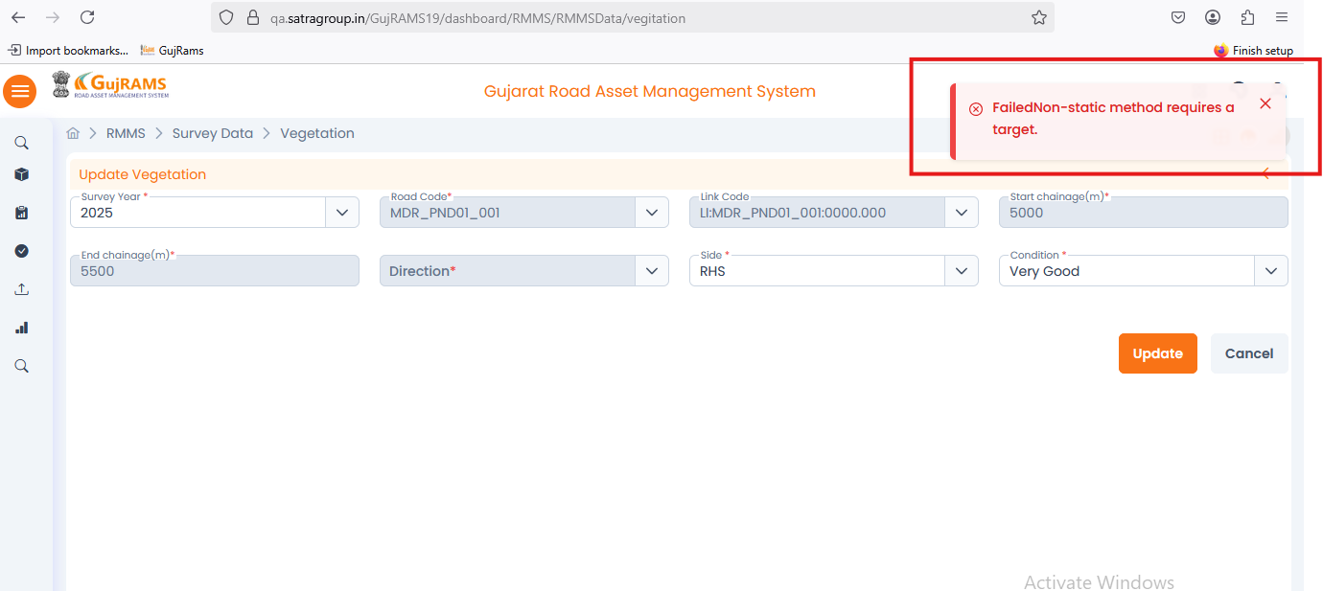**Comment**: **Update popup displayed as per expected.  
QA Status: Pass**

**Issue 3: (Done)**

**Issue**: RMMS → Survey Data → Vegetation →View record → different popup message is displaying.

**Priority**: High  
**Expected Result**: “Please select a row to view” popup message should be displayed.  
**Actual Result**: It is displaying message popup “Please select a row to update” screen shot attached below.  
**Category**: Bug

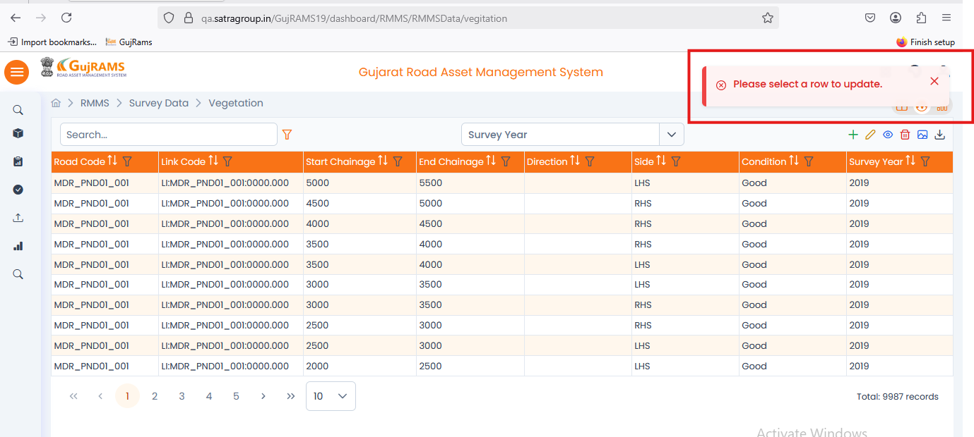**Comment**: **View related popup displayed as per the expected.  
QA Status: Pass**

**Issue 4: (Done)**

**Issue**: RMMS → Survey Data → Vegetation → Select row →Delete record → different popup message is displaying.

**Priority**: High  
**Expected Result**: “Data Retired Successfully” popup message should be displayed.  
**Actual Result**: It is displaying message popup “Data” screen shot attached below.  
**Category**: Bug

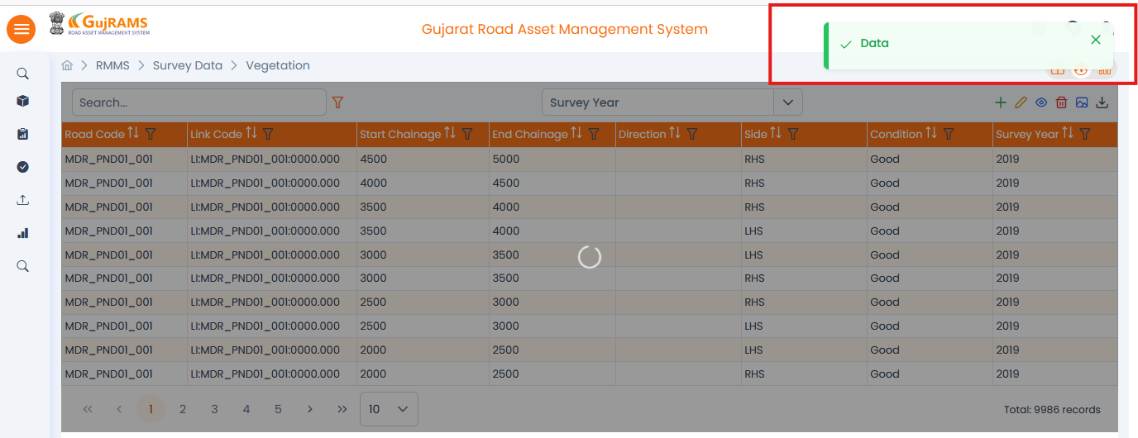**Comment**: **Delete popup is displayed as per expected.  
QA Status: Pass**

**Issue 5: (Done)**

**Issue**: RMMS → Execute Process → Candidate Sections → fill all the fields and run it then different popup message is displaying.

**Priority**: High  
**Expected Result**: “Candidate section process completed ” popup message should be displayed. Screenshot attached for your reference

**Actual Result**: It is displaying different popup message screen shot attached below.  
**Category**: Bug

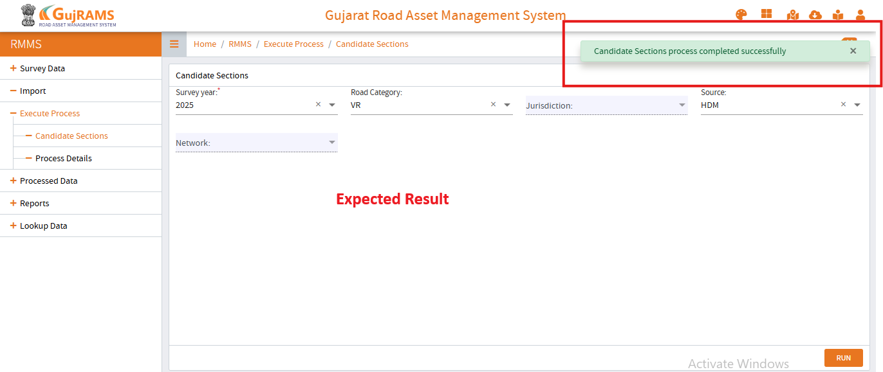 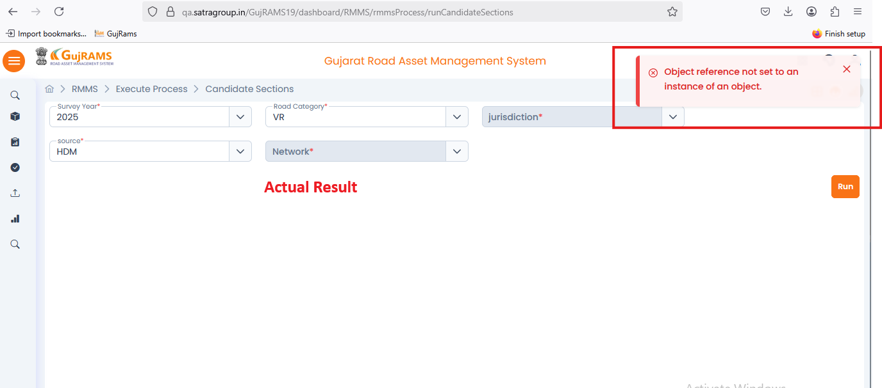**Comment**: **Run button is not working.  
QA Status: Fail**

**Issue 6: (Done)**

**Issue**: RMMS → Execute Process → Candidate Sections → All fields are mandatory fields.

**Priority**: High  
**Expected Result**: For only survey year mandatory field should be displayed.  
**Actual Result**: It is displaying for all the fields  
**Category**: Bug

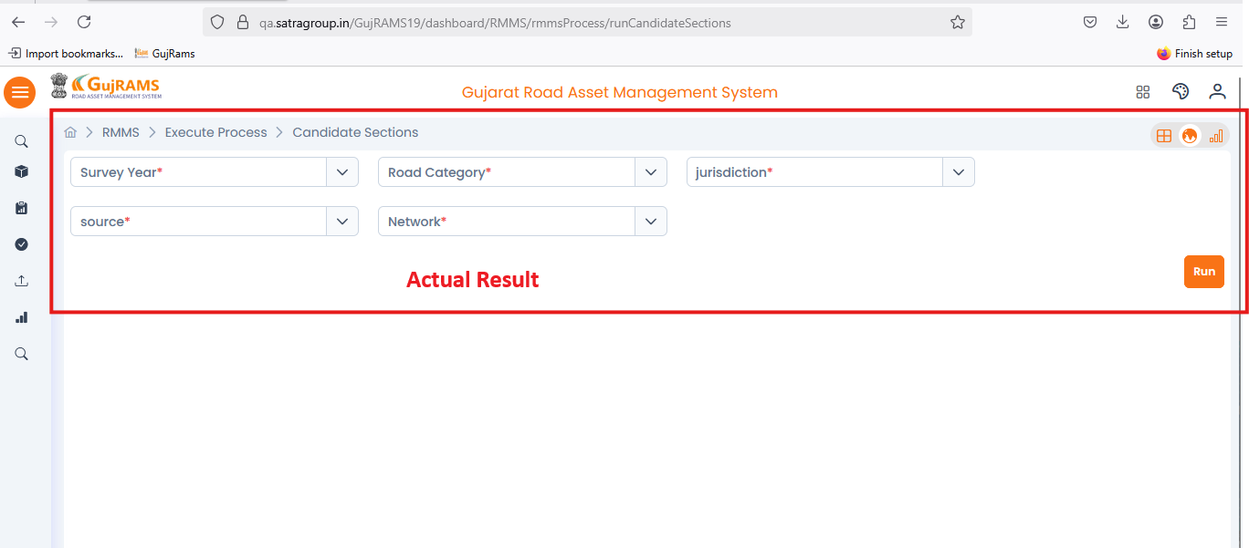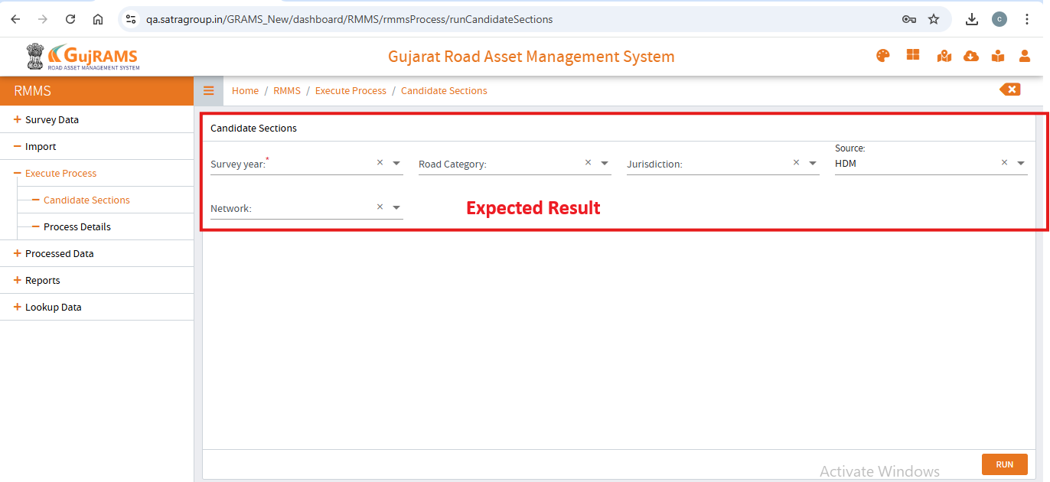**Comment**: **Done as per expected.  
QA Status: Pass**

**Issue 7: (On Hold)**

**Issue**: Profile Icon → Data Template→ Select RMMS template → Try to download required template

**Priority**: High  
**Expected Result**: RMMS Template should be downloaded in excel.  
**Actual Result**: It is directing to login screen.  
**Category**: Bug

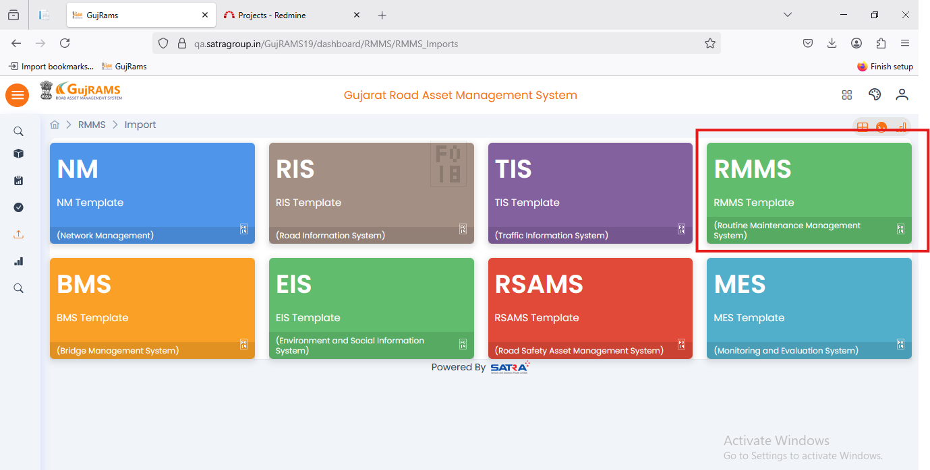**Comment**: **Still facing same issue.  
QA Status: Fail**

**Issue 8: (Done)**

**Issue**: RMMS → Lookup data → Quantity Standard → Add record → Mandatory fields not shown.  
**Priority**: High  
**Expected Result**: Mandatory fields should be indicated.  
**Actual Result**: Mandatory field indicator is missing.  
**Category**: Bug

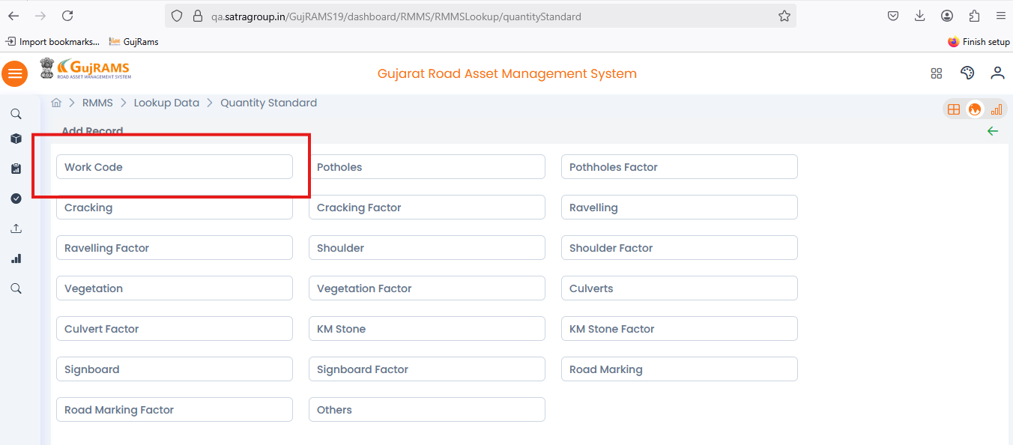**Comment**: **Added mandatory field as per expected.  
QA Status: Pass**

**Issue 9: (Working Fine)**

**Issue**: RMMS → Lookup data → Quantity Standard → Select Row → Edit/View Record → Clicking 'View Record' shows heading as 'Edit Record'  
**Priority**: Low  
**Expected Result**: The heading should match the action being performed (i.e., 'View Record').  
**Actual Result**: Heading incorrectly says 'Edit Record'.  
**Category**: UI Issue

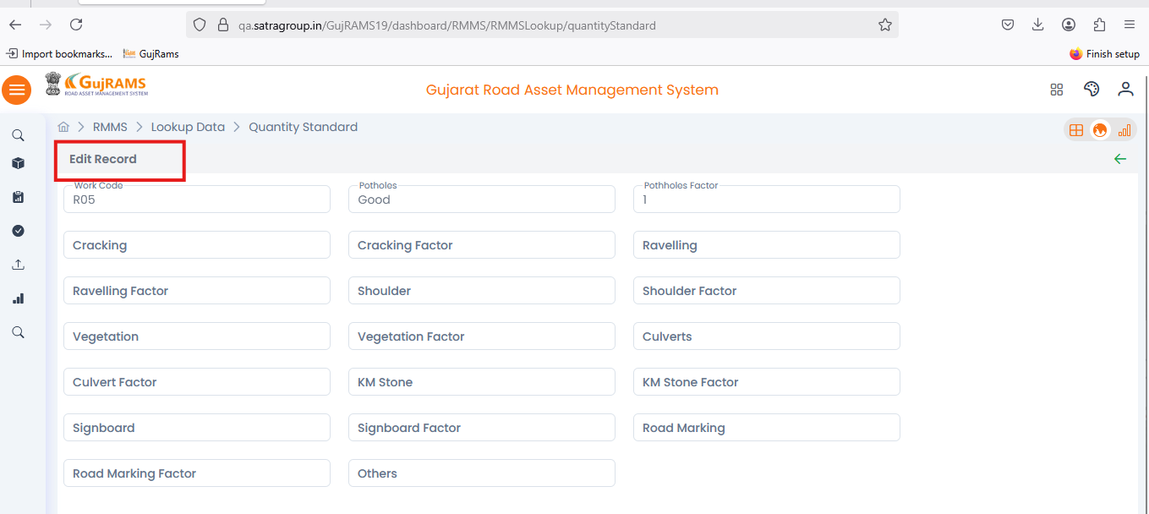**Comment**: **Heading changed as per expected.  
QA Status: Pass**

**Issue 10: (Done)**

**Issue**: RMMS → Lookup data → Work Codes → Add record → Mandatory fields not shown.  
**Priority**: High  
**Expected Result**: Mandatory fields should be indicated.  
**Actual Result**: Mandatory field indicators are missing.  
**Category**: Bug

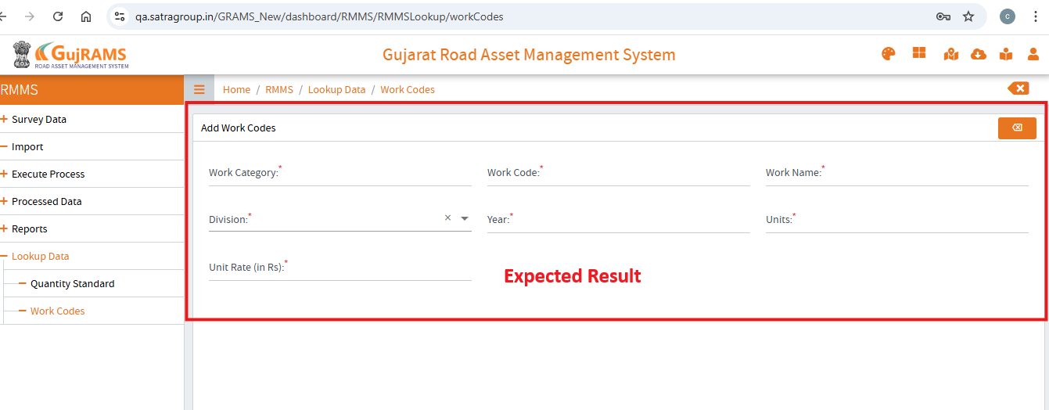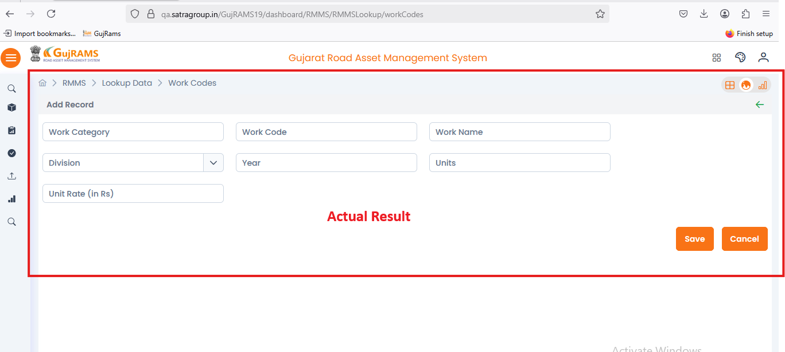**Comment**: **Added mandatory fields as per expected.  
QA Status: Pass**

**Issue 11: (Done)**

**Issue**: RMMS → Lookup data → Work Codes → Update, View, Delete Records → No records shown.

**Priority**: High  
**Expected Result**: Records should be displayed and able to select the record.  
**Actual Result**: In Total it is showing count but no record is displaying to select.  
**Category**: Bug

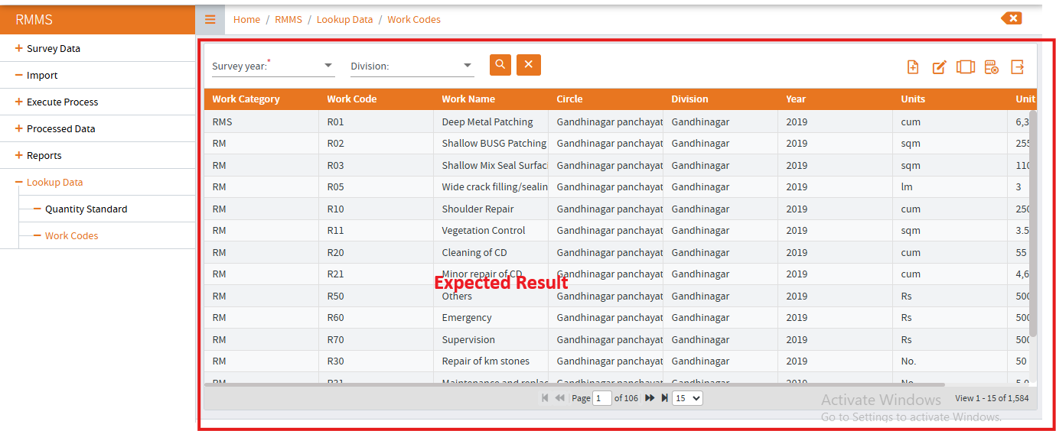

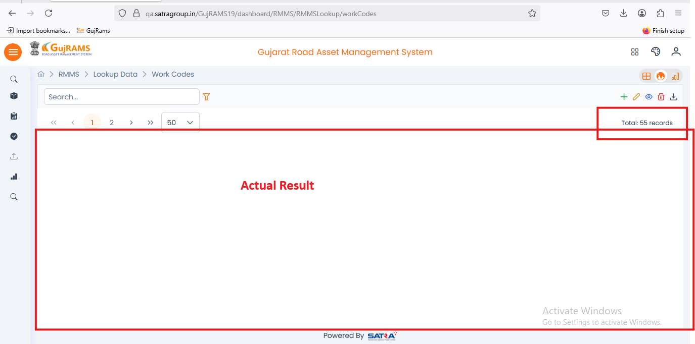

**Comment**: **Records displayed and showing correct count & Add, Update, View, Delete are working as expected.  
QA Status: Pass**