**NEW OBSERVATIONS IN GUJRAMS FOR BAP MODULE:**

**Issue 1:(Done)**

**Issue**: BAP → [Finalise Projects](https://qa.satragroup.in/GujRAMS19/dashboard/BAP/BAPFinaliseprojects) → Search Box → Unable to fetch the existing data. Check for all modules.

**Priority**: High  
**Expected Result**: Data should be fetched according to search data.  
**Actual Result**: Unable to fetch the data even we are searching a existing. It is displaying “No data found.”  
**Category**: Bug

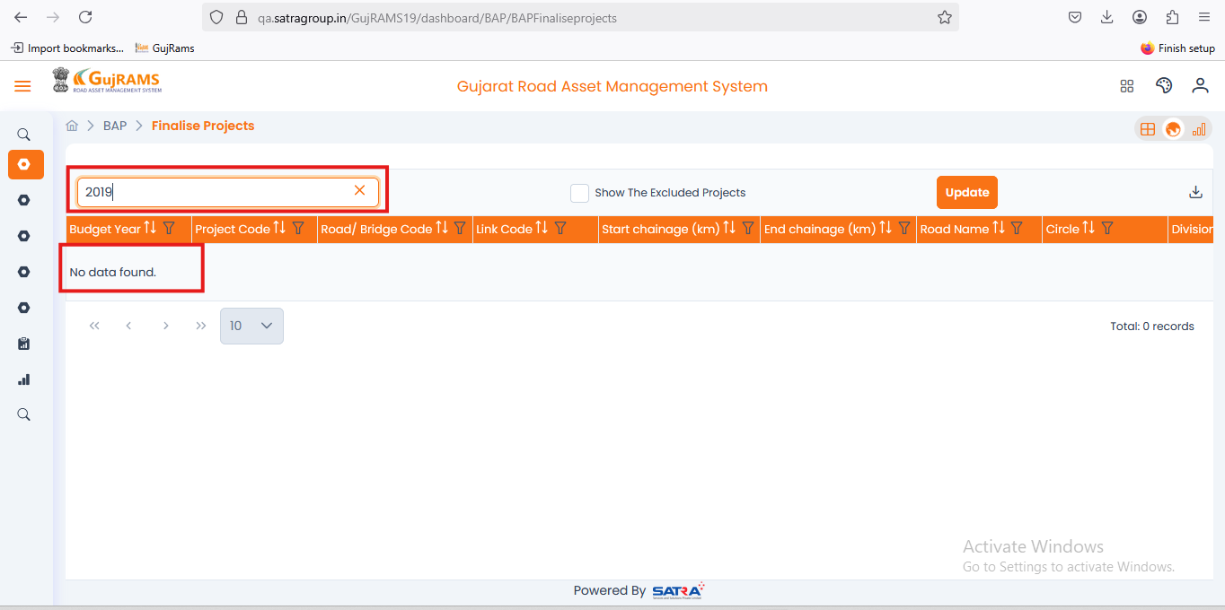**Comment**: **Data fetching as per the expected.  
QA Status: Pass**

**Issue 2:(Done)**

**Issue**: BAP → [Finalise Projects](https://qa.satragroup.in/GujRAMS19/dashboard/BAP/BAPFinaliseprojects) → Update Button → Functionality is not working. Check for all modules.

**Priority**: High  
**Expected Result**: If user clicks on update it should update all the data & it should display a popup that “Finalise project updated successfully.”  
**Actual Result**: Update button is not clickable.  
**Category**: Bug.

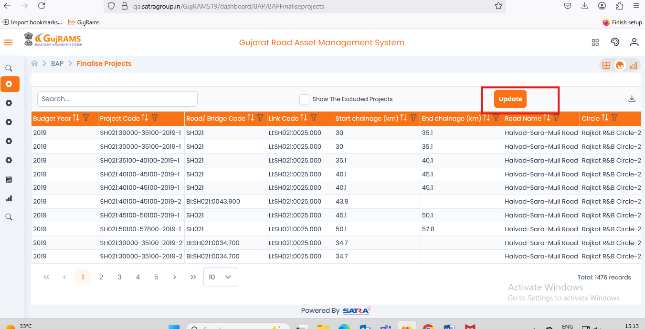**Comment**: **Data fetching as per the expected.  
QA Status: Pass**

**Issue 3: (Done)**

**Issue**: BAP → Reports → [B01- Approved Projects](https://qa.satragroup.in/GujRAMS19/dashboard/BAP/BAP_Reports/Approvedprojects) → Generate Report → After generating the report back button functionality is not working. Check for all modules.

**Priority**: High  
**Expected Result**: Clicking on back button should be directed to the previous page.  
**Actual Result**: It is clickable but it stays in the same page.  
**Category**: Bug.

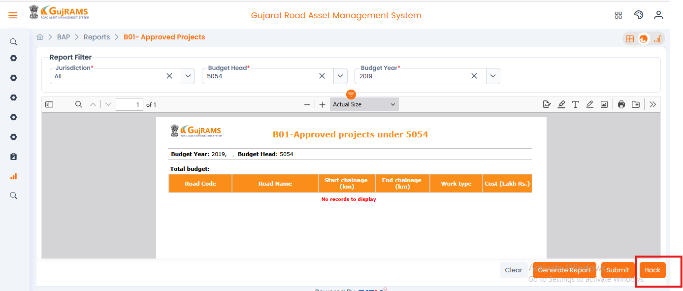**Comment**: **Back button removed.  
QA Status: Pass**

**Issue 4: (Done)**

**Issue**: BAP → Lookup data → Budget → Add record → User filled all the fields and save data.

**Priority**: High  
**Expected Result**: Data should be added to the record section.  
**Actual Result**: After filling the fields and clicked on save button different popup message displayed as shown in the screenshot  
**Category**: Bug.

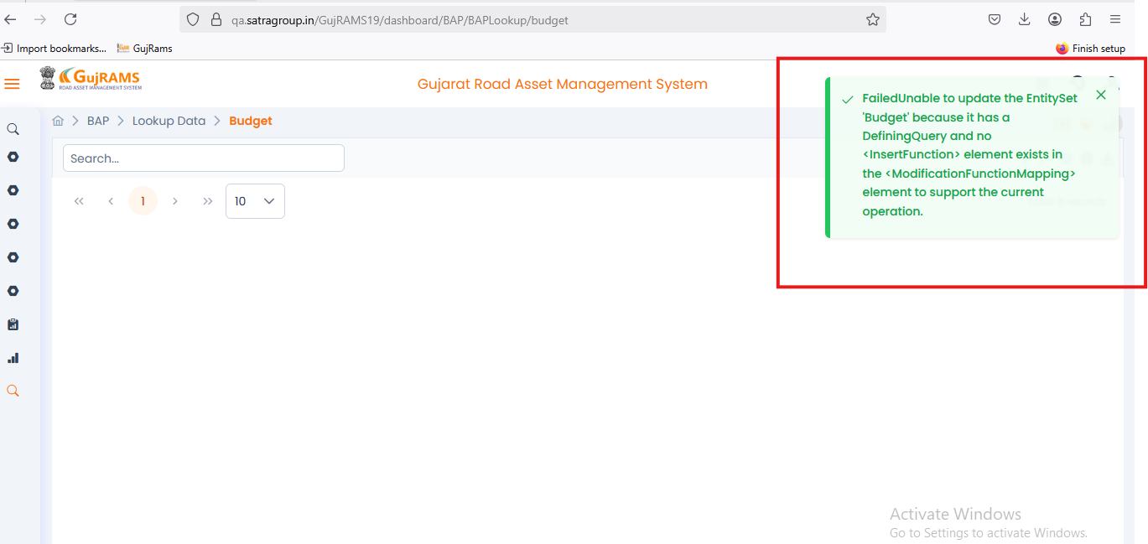**Comment**: **Still Same error is displaying when user try to add data.  
QA Status: Fail**

NEW OBSERVATIONS IN GUJRAMS FOR SSUM MODULE:  
  
Issue 1: Unnecessary Map in SSUM Module(Done)  
Issue: Map is displayed in the SSUM module, but it is not needed.  
Priority: Medium  
Category: UI/UX  
Expected Result: The SSUM module should not display the map.  
Actual Result: The map is unnecessarily shown in the SSUM module.  
  
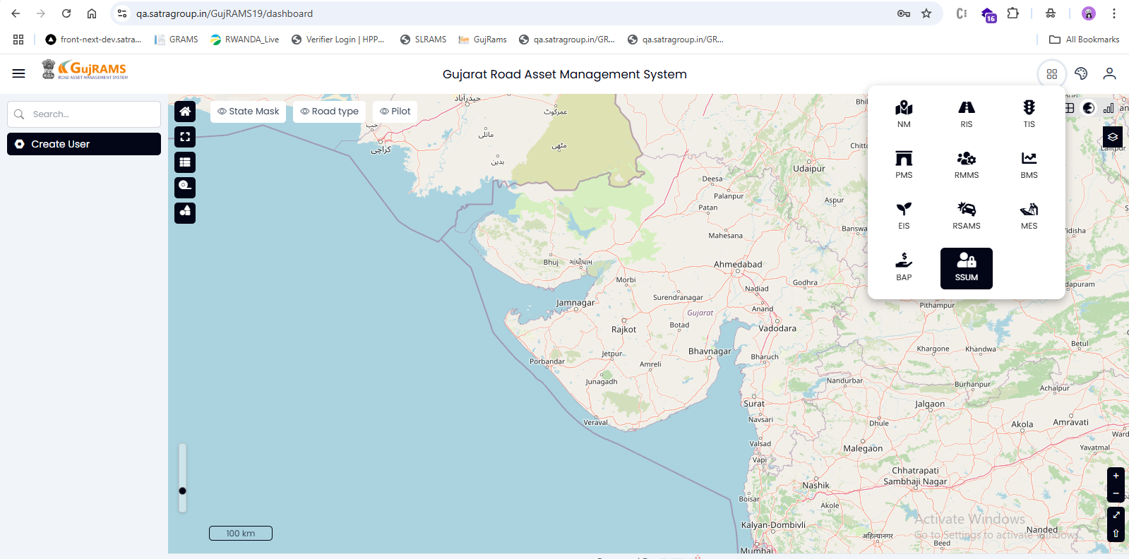  
**Comment**: **Map removed as per the expected.  
QA Status: Pass**

**Issue 2: Missing Phone Number Validation(Done)**  
**Issue:** The system allows submission without validating the phone number field.  
**Priority:** High  
**Category:** Validation  
**Expected Result:** The phone number field should accept only valid formats and should not allow empty or incorrect entries.  
**Actual Result:** The user can submit the form without entering a valid phone number.

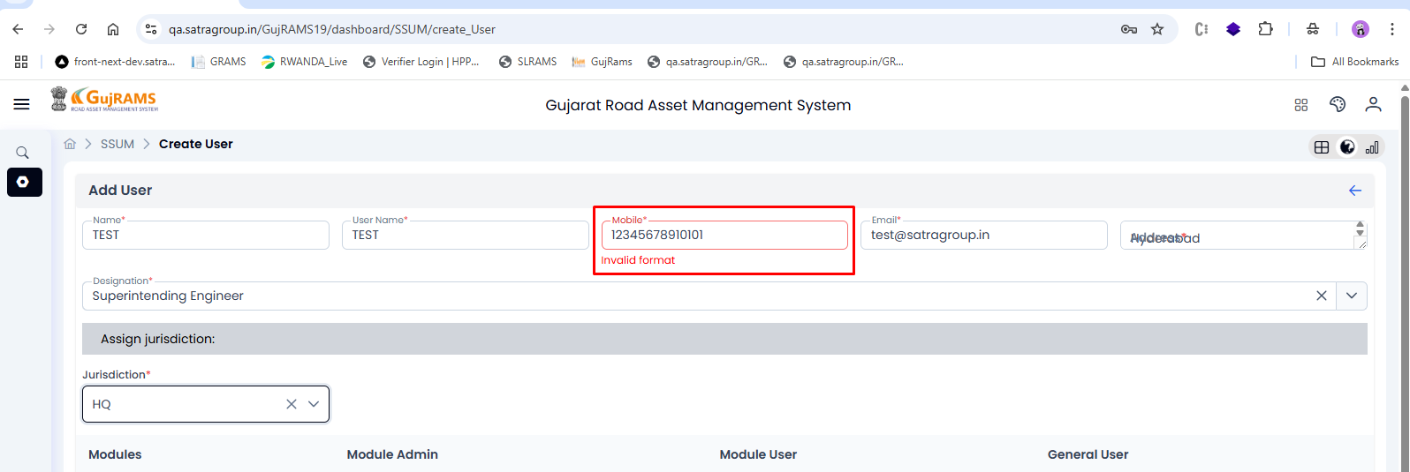**Comment**: **Done as per the expected.  
QA Status: Pass**

**Issue 3: Alignment Issue near Address Field**  
**Issue:** Address field looks uneven.  
**Priority:** Low  
**Category:** UI/UX  
**Expected Result:** Address field should be properly aligned.  
**Actual Result:** Address field is not aligned properly.

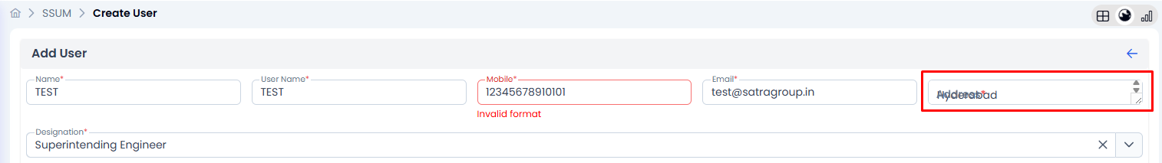**Comment**: **Done fetching as per the expected.  
QA Status: Pass**

**Issue 4: No Response after Clicking Save(Done)**  
**Issue:** After clicking the Save button, the record should be saved and the user should be created, but nothing happens on the page.  
**Priority:** High  
**Category:** Functionality  
**Expected Result:** After clicking Save, the record should be saved and a user should be created, with a success message or navigation.  
**Actual Result:** After clicking Save, there is no response or movement on the page.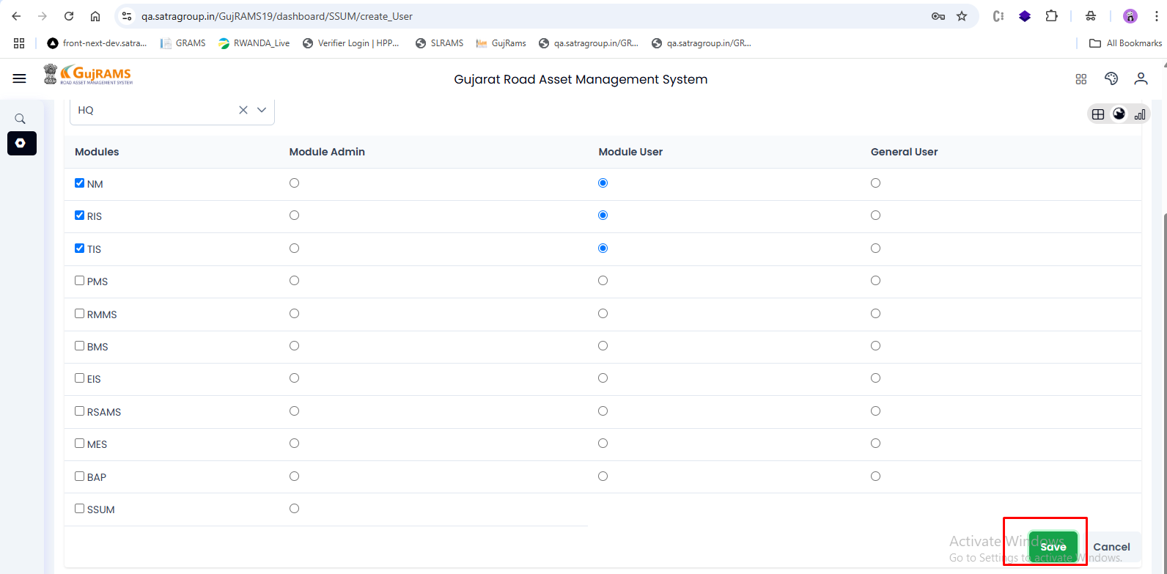**Comment**: **Save button is working & record is saved as per the expected.  
QA Status: Pass**