**NEW OBSERVATIONS IN GUJRAMS FOR EIS MODULE:**

**Issue 1:**

**Issue**: EIS → Survey Data → Air Quality → Add, Update record → No mandatory fields are mentioned. Check for all modules

**Priority**: High  
**Expected Result**: Mandatory must be displayed for text fields.  
**Actual Result**: Mandatory field indicators are missing.  
**Category**: Bug (Done)

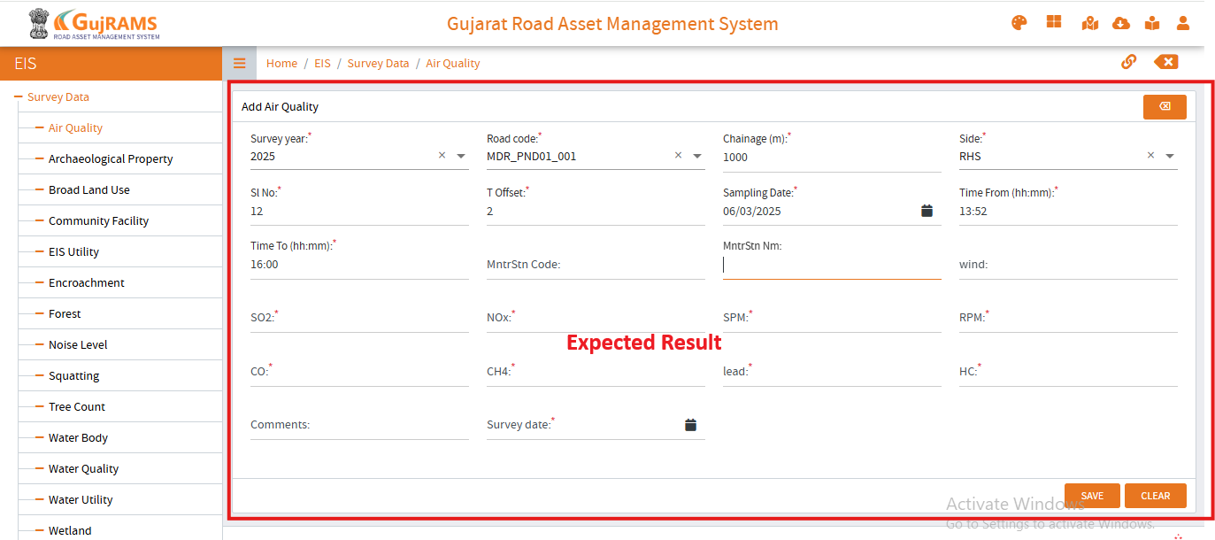 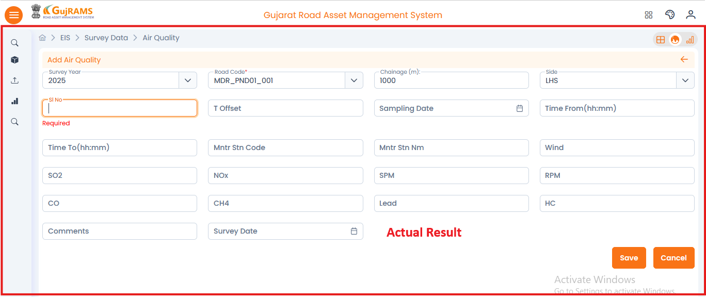

**Comment**: **Mandatory fields added as per the expected.  
QA Status: Pass**

**Issue 2:**

**Issue**: EIS → Survey Data → Archaeological Property → Select Row → View record → Data record is editable. Check for all modules

**Priority**: High  
**Expected Result**: View feature is only just to view the record and It is non editable.  
**Actual Result**: In this text fields are editable.  
**Category**: Bug (Done)

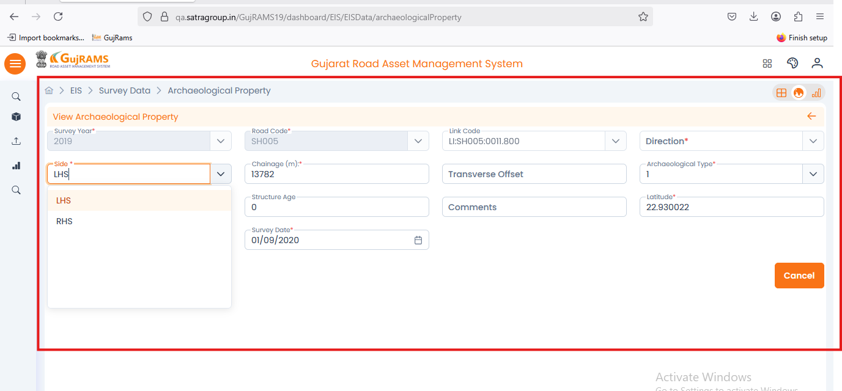**Comment**: **Working as per the expected.  
QA Status: Pass**

**Issue 3:**

**Issue**: EIS → Survey Data → Archaeological Property → Add record → Alignments & Some of text boxes are not satisfying their criteria (Accepting all values). Check for all modules

**Priority**: Normal  
**Expected Result**: Text values should match to their criteria, & Alignments of required fields and calendar should in viewed properly  
**Actual Result**: Text fields accepting all alphabetical values & calendar is also unable to view properly.  
**Category**: UI Issue(Done)

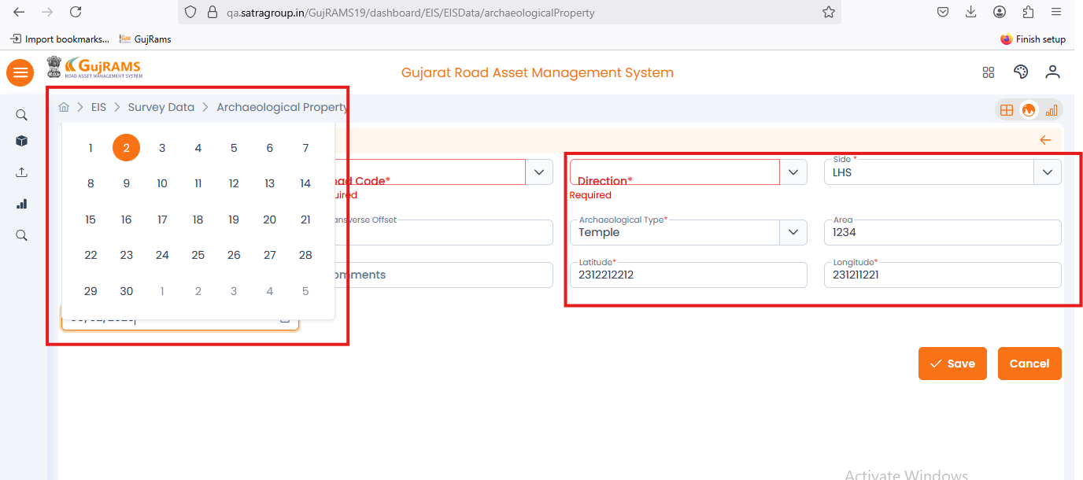**Comment**: **Working as per the expected.  
QA Status: Pass**

**Issue 4:**

**Issue**: EIS → Survey Data → Broad Land Use → Add record → Filling the data but unable to save. Check for all modules

**Priority**: High  
**Expected Result**: Data must be added and redirected to records page.  
**Actual Result**: Unable to save the data because after clicking on save button it is not performing any action.  
**Category**: Bug (Done)

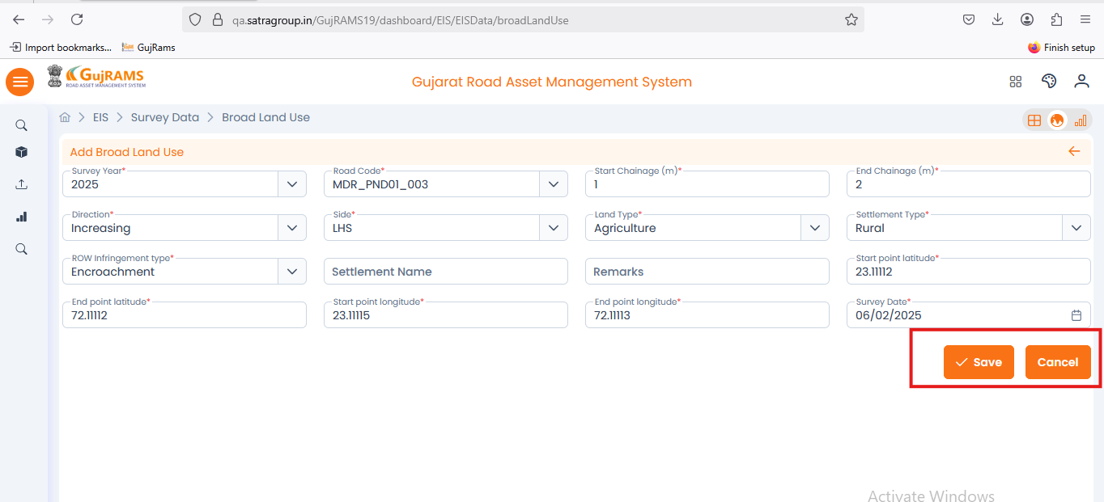

**Comment**: **Working as per the expected.  
QA Status: Pass**

**Issue 5:**

**Issue**: EIS → Survey Data → Broad Land Use → Update record → updated popup message is displaying but not redirecting to record page. Check for all modules

**Priority**: High  
**Expected Result**: Data must be updated and redirected to records page.  
**Actual Result**: Popup got displayed and stayed in the same page.  
**Category**: Bug (Done)

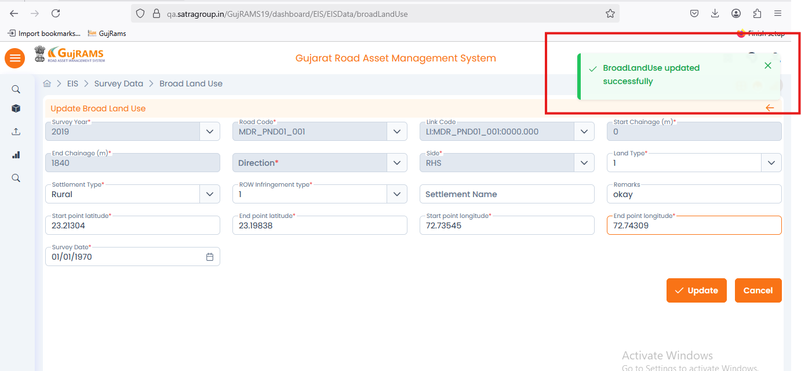**Comment**: **Working as per the expected.  
QA Status: Pass**

**Issue 6:**

**Issue**: EIS → Survey Data → Broad Land Use → Gallery Button → Not clickable. Check for all modules. Check for all modules

**Priority**: High  
**Expected Result**: Displays Image or else it will display No Images Found ...   
**Actual Result**: Gallery icon is not clickable.  
**Category**: Bug (Done)

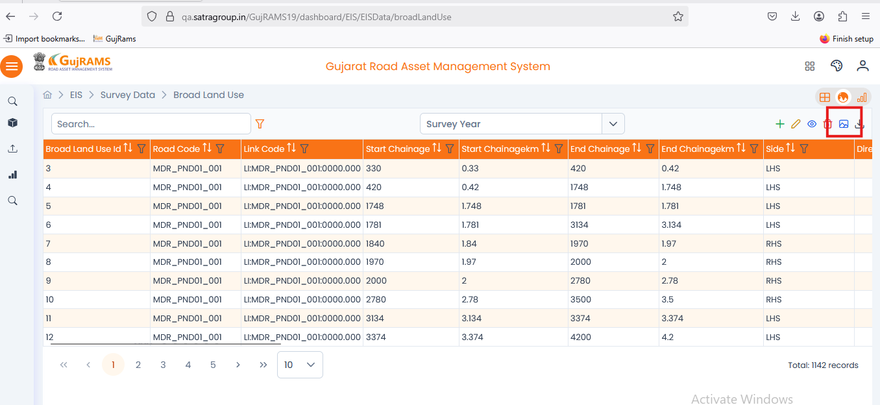**Comment**: **Working as per the expected.  
QA Status: Pass**

**Issue 6:**

**Issue**: EIS → Table Missing

**Priority**: High  
**Expected Result**: Approve Data table must be displayed in Hamburgers menu  
**Actual Result**: Missing Table.  
**Category**: UI Issue ( It is Not required )

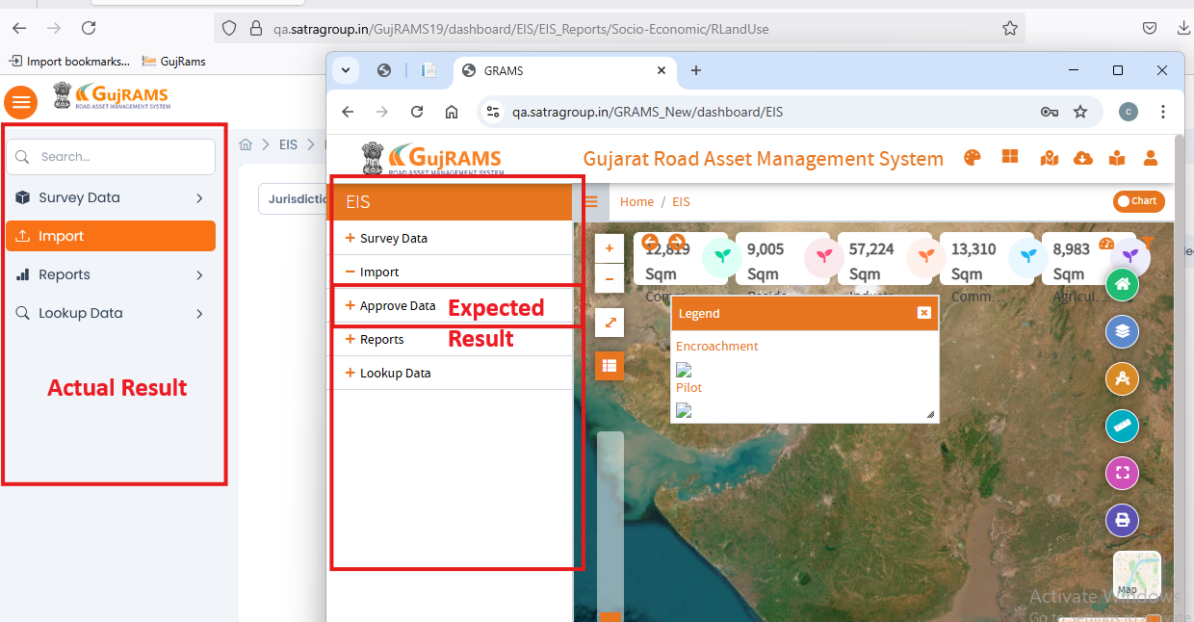**Comment**: **Removed From the table.  
QA Status: Pass**