**GujRAMS Map observations  
  
1**. **Module:** Maps

**Issue:** When a **layer is activated**, the **same alert is displayed twice**.

**Priority:** Medium  
**Category:** Functional/Validation

**Expected Result:** Alert should be shown **only once** when a layer is activated.

**Actual Result: Alert appears two times**.  
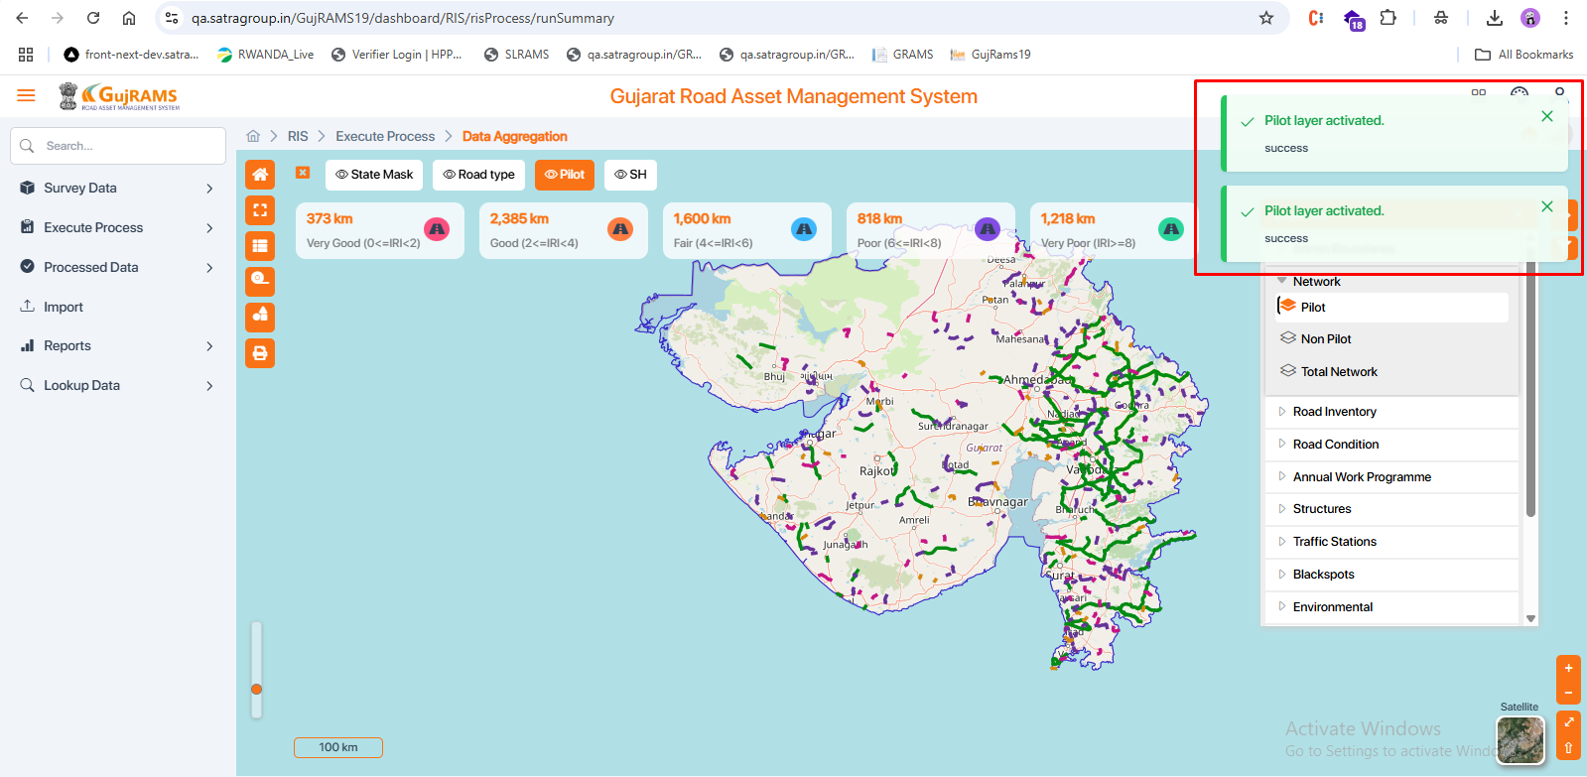

2. **Module:** Maps

**Issue:** When a **layer is deselected**, a **wrong alert is displayed** saying the **"layer is active"**, which is incorrect.

**Priority:** Medium  
**Category:** Functional/Validation

**Expected Result:** On **deselecting** a layer, the system should display an alert like **"Layer is deactivated"**.

**Actual Result:** An **incorrect alert** appears as **"Layer is active"**, even when the layer is deselected.

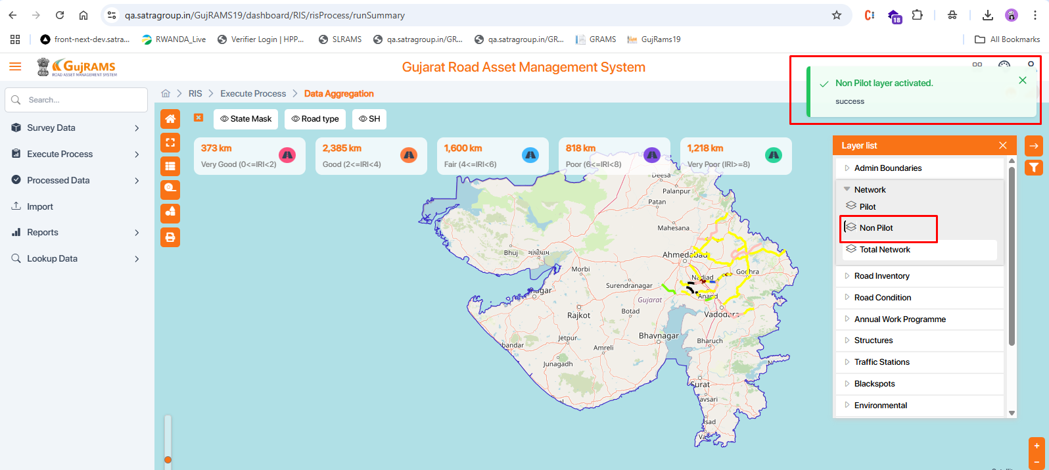

3. **Module:** Map Screen

**Issue:** In **Print preview**, the **Properties panel** is displayed in the **middle** of the map, while on the actual screen, it stays at the **right corner**.

**Expected Result:** The **Properties panel** should stay at the **right corner** in both screen and print view.

**Actual Result:** It appears in the **middle of the print screen**, causing layout issues.

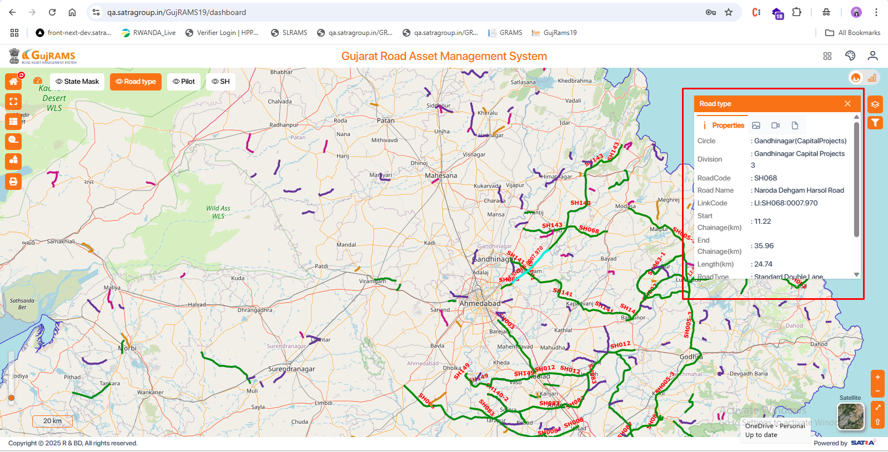  
  
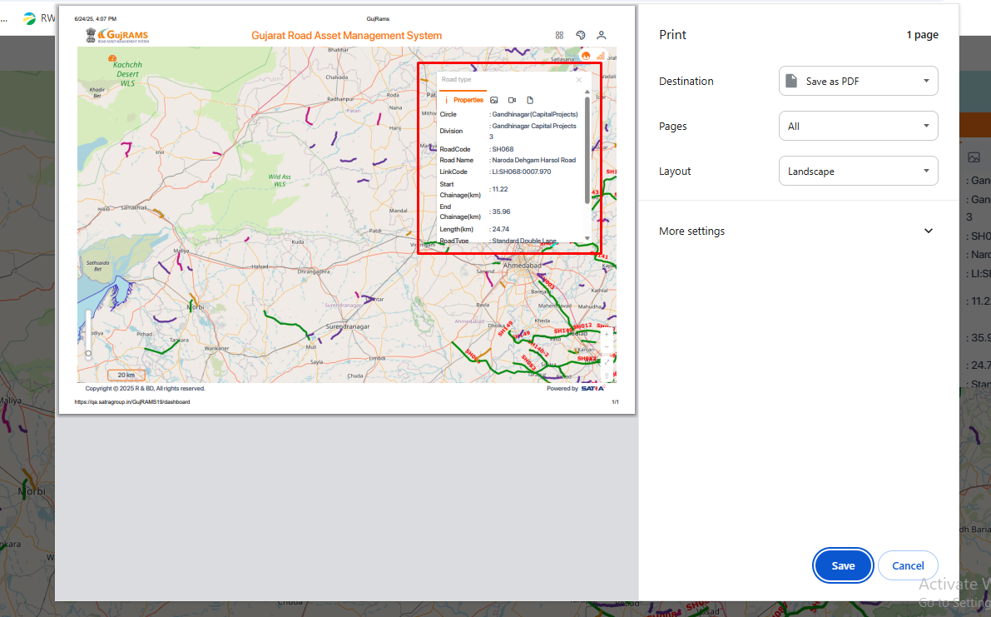

4. **Module:** Map Legend

**Issue:** SH (State Highways) symbol is not loading — instead, a broken image icon is displayed.

**Expected Result:** SH, icon should load properly in the legend panel.

**Actual Result:** Broken image icon is shown under SH, indicating the symbol is missing or not loading.

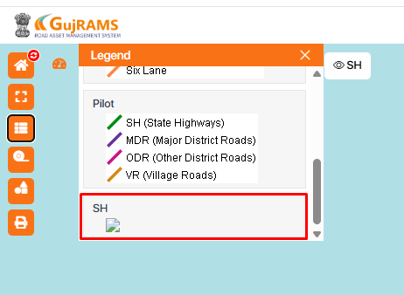  
5. **Issue:** Only half of the map is displayed in the print screen.

**Expected:** Full map should be visible.

**Actual:** Print preview shows only half of the map.

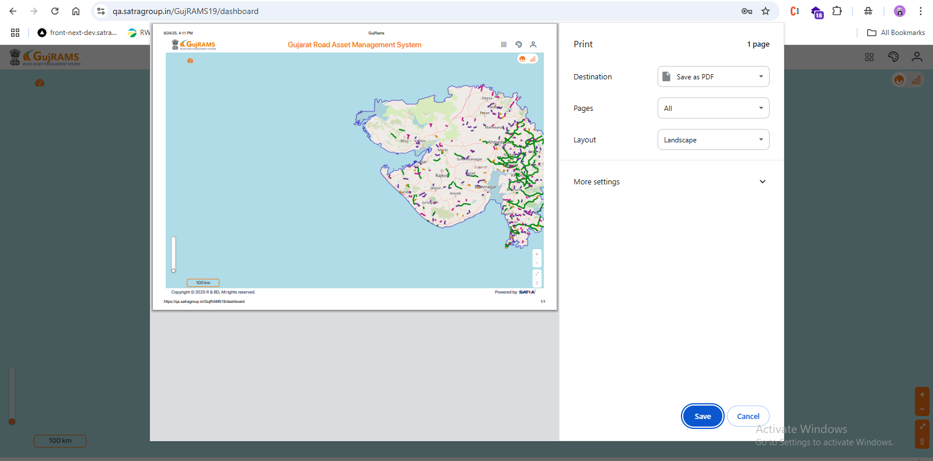  
Observation:

6. **Issue:** Schema Name is displayed in the Blackspots properties pop-up.

**Expected:** Schema Name should not be shown in the properties.

**Actual:** Schema Name (e.g., "RSAMS") is visible in the popup.

