1. 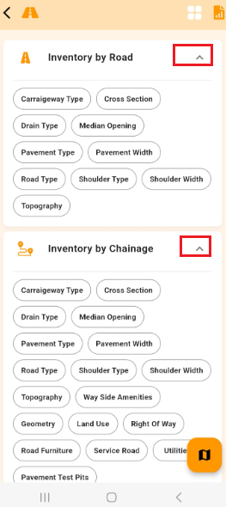Please display only one category items at a time.  
   Example: After Inventory by Chainage type is clicked please auto hide Inventory by Road.
2. In Reports page**,** after preview is Successfully displayed of the selected Filter on click of the below highlighted (eye) image, the screen displayed in the right image is showing in UI.  
    In this right image it is allowing to set the Filters but preview option is not provided before only download or Share are provided.  
   Please check to provide Preview button or please remove the option to change filter in this page.

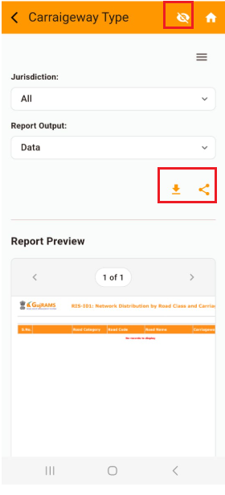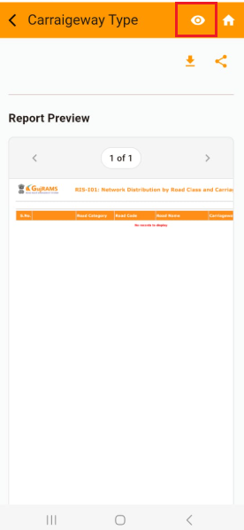kindly proceed with **any** **one** of the above options as per Dev team feasibility.

1. Please align all the Heading in the Application in the **Left** Alignment in **iOS** in all screens**.**in Android it is fine.

Example: the below image is in Android which is fine