**GujRAMS Mobile app Issues**

1. Home dashboard – Network by Jurisdiction chart (Title and chart data are not relevant to each other)

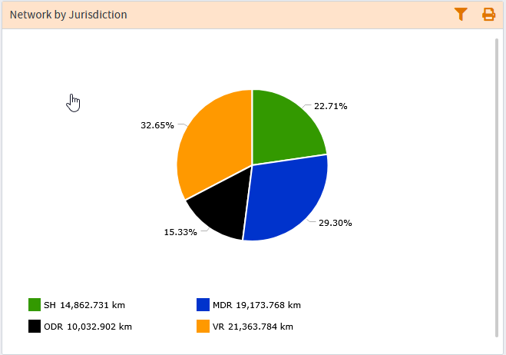

**Comments: Title & Chart are displaying relevant data.**

**QA Status: Pass**

1. In mobile app when properties are displayed for a layer Schema name is visible in the properties list.

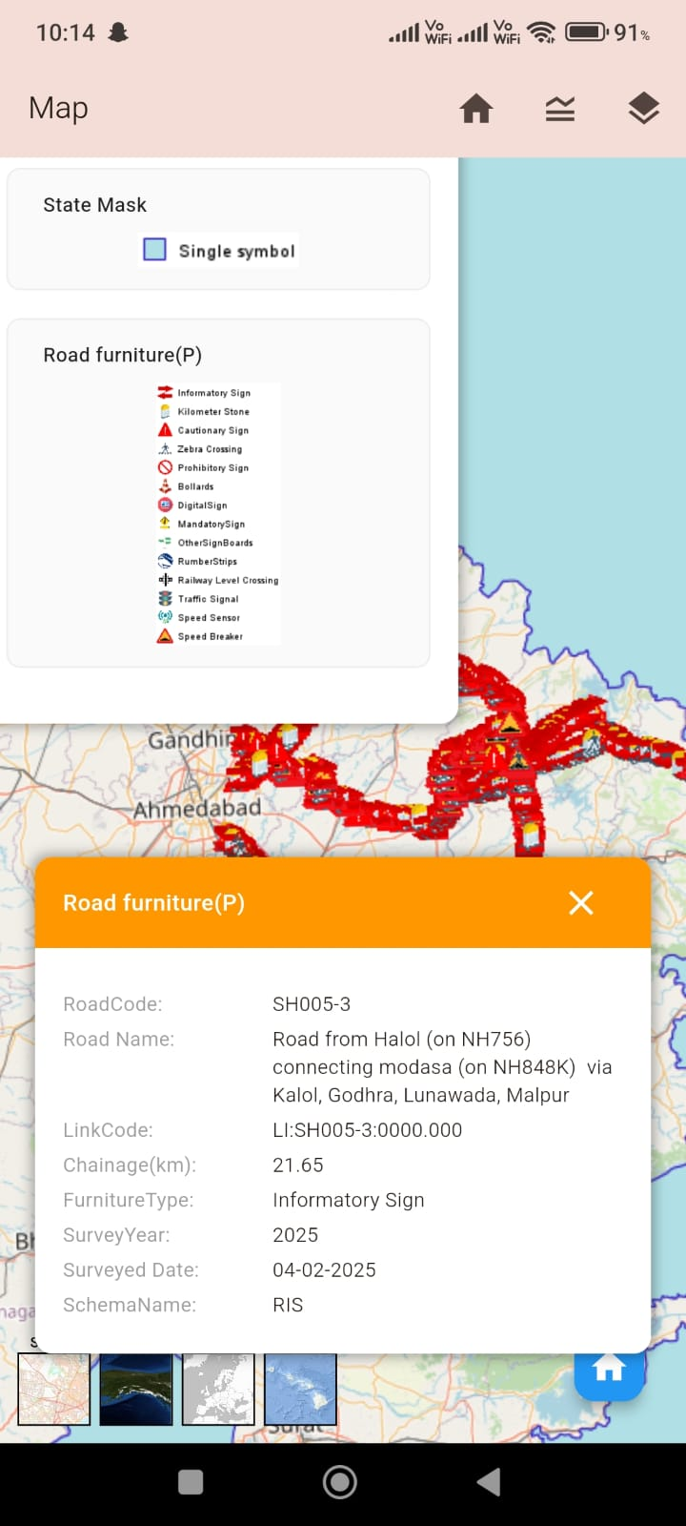

**Comments: Schema name is removed in properties.**

**QA Status: Pass**

1. Title change in NM dashboard. (Road Length by Category)

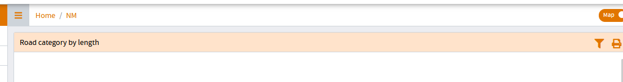

**Comments: In NM dashboard title changed to Road Length by Category.**

**QA Status: Pass**

1. Chart title in RIS dashboard (Carriageway type by Length)

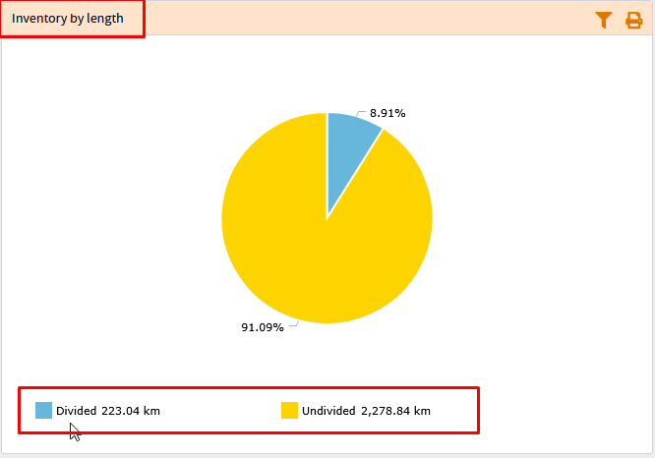

**Comments: In RIS dashboard title changed to Carriageway type by Length.**

**QA Status: Pass**

1. When jurisdiction is selected as “All” the reports are generating “No Records” as output. Only when either Circle / Division is selected, then the report output is generated.

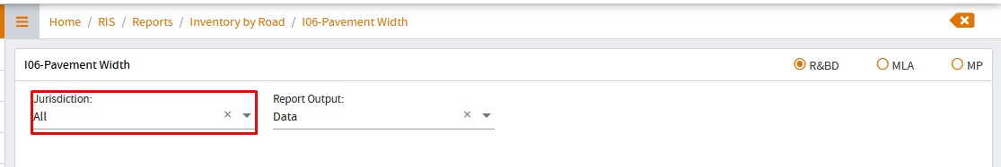

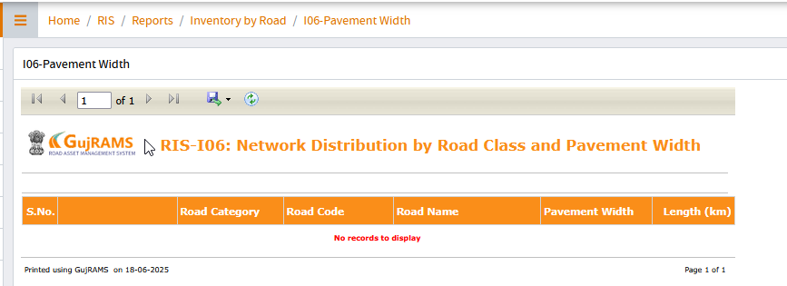

**Comments: By selecting jurisdiction as All no recording are displaying whereas for circle & division records are displaying.**

**QA Status: Fail**

1. In RMMS module dashboard – No option to reset the selected filters (Check in all modules)

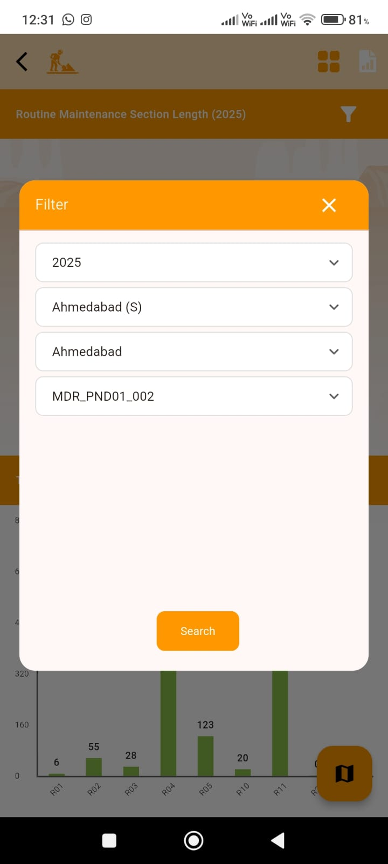

**Comments: Added clear button for all the modules.**

**QA Status: Pass**