## GujRAMS\_RIS\_WebApplication\_Changes

1. 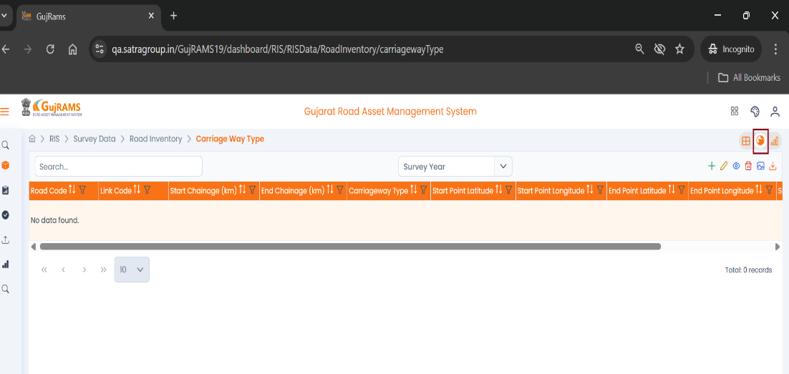Please do not rotate the Globe Icon on the webpage.  
   QA Status: Done  
   Screenshot :

F:\GUJRAMS\Grams_19\A.png

1. 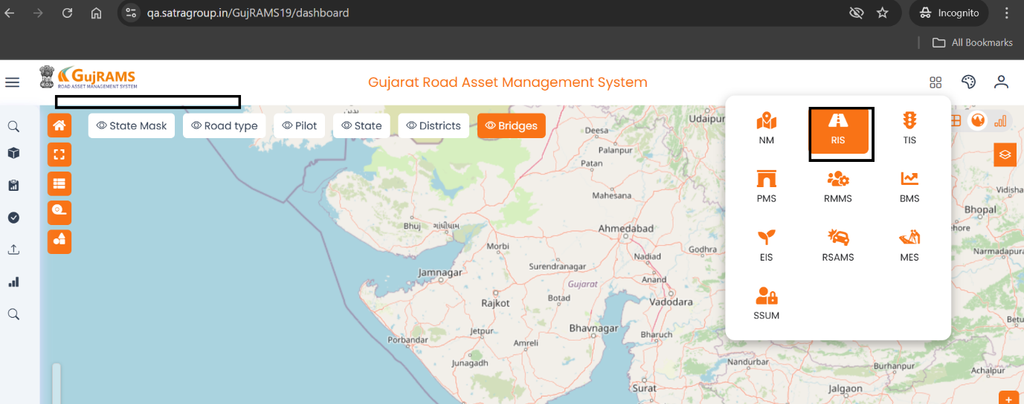Module name is not Visible when first entered into Module. I clicked on the RIS, but it is not displayed. Please review

QA Status: Done  
Screenshot:   
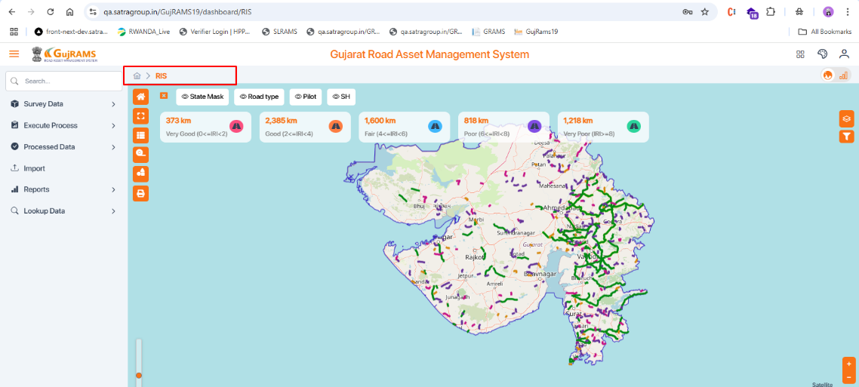

1. **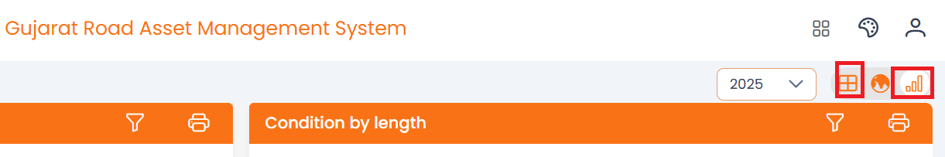**Please display the Name as mouse Over

QA Status: Done  
Screenshot:

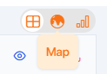 F:\GUJRAMS\Grams_19\C.png F:\GUJRAMS\Grams_19\E.png

1. Dashboard – Headings and spelling mistakes.-> Done
2. Colour should be changed for Inventory by length Chart.-> Done
3. No need for a mouse-over function in the chart.-> Not done
4. Remove am charts logo below->Done
5. Chart size should be reduced.
6. Values should be shown in the chart itself – (Percentage, value ex: 63.66 %, 504 km).-> Done

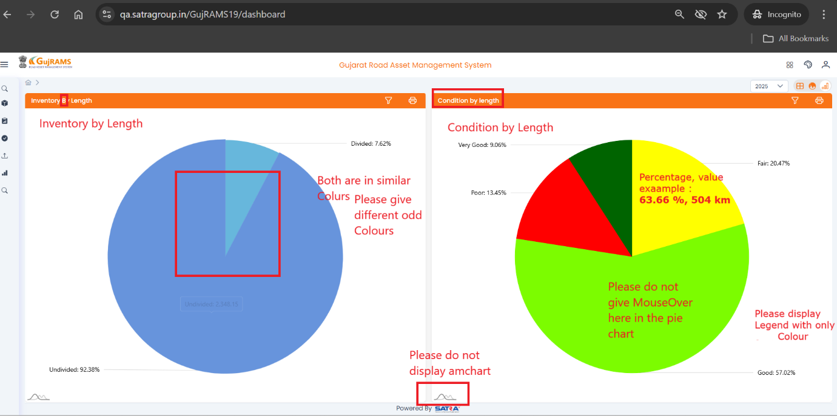

Please refer above image for 4- 9 points

1. Condition Type/ Name is missing. Inventory attribute type should be visible even when the filter is hidden.  
   QA comments: i. after the type is selected name is displayed -> Done  
   ii. Reduced the pie chart's size on the screen -> Done  
   iii. New dropdown for selecting type -> Not implemented.

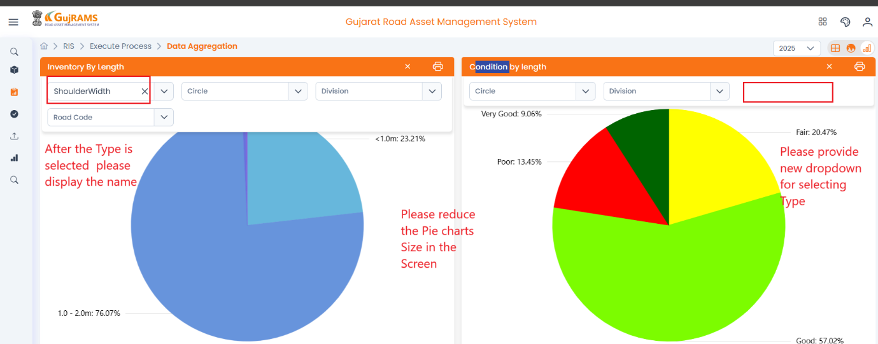

1. Execute process- Data aggregation – remove mandatory symbol.  
   QA status: Done  
   Screenshot:   
   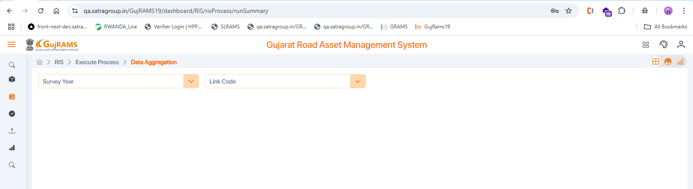
2. To add another filter, pass for Table list.-> Not implemented
3. 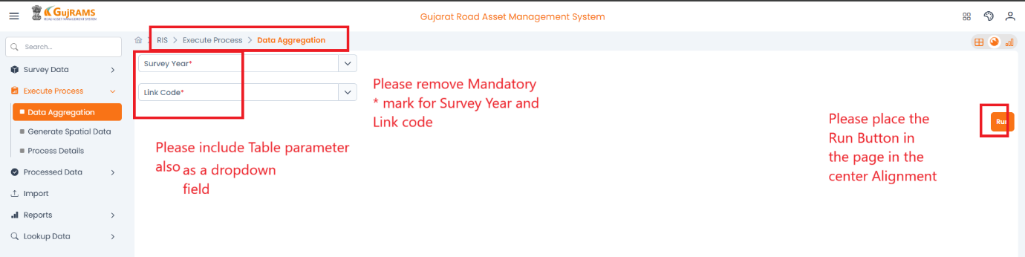To call the “Spatial data updation” in the Data Aggregation Process –Run button, placing to be changed.  
   QA comments: removed mandatory fields for survey year and link code -> Done  
   ii. Run button alignment is changed -> Done  
   iii. Table parameter dropdown is not included -> Fail
4. 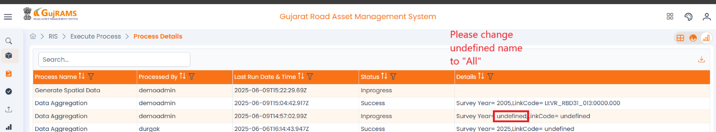Process Details – change text “Undefined to ALL” when no link is selected.

QA status: Done  
Screenshot: 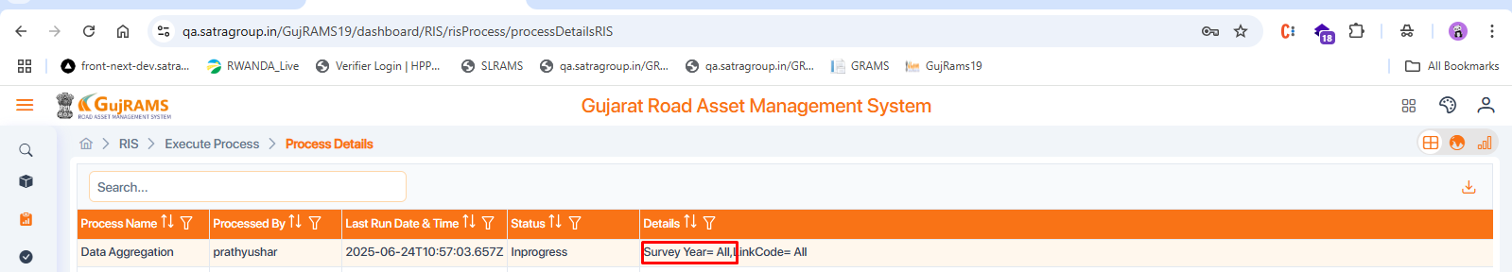

1. Reports – Mandatory symbol is missing.-> Need more info
2. Need to remove Submit Button from the reports.-> done  
   QA comments : Generate report button is removed

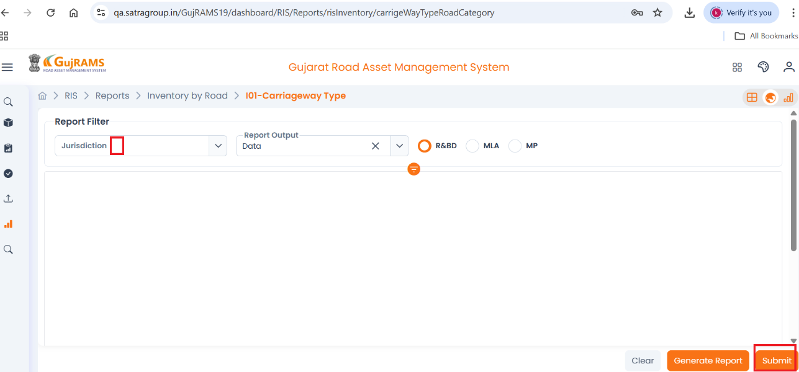

**Support Team:**

1. Data should be verified in the dashboard and Reports.
2. In Reports colour should be changed according to the given Parameter.-> Done
3. To Prepare manual for Generate Spatial data.
4. GPS Process (Spatial Data updation) to be put in the data Aggregation Process.