1. Satellite view is missing in the new portal

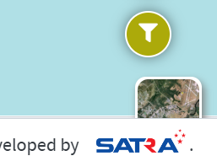

1. Provide a drop down to change the measuring unit with Kilo meters and Miles , need it in both old and new portal

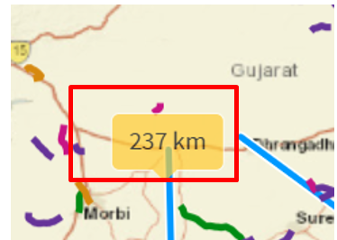 **comments: In the new portal drop down to change the measuring unit with Kilo meters and Miles is provided  
QA Status:** Pass  
**Screenshot:** New portal : https://qa.satragroup.in/GujRAMS19/

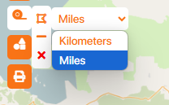   
Old portal: https://qa.satragroup.in/GRAMS_New/  
Comment: In the old portal, only Length and Area are visible; the dropdown is not available.  
 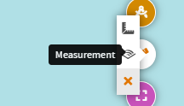

1. When we add measurement or draw, the Theme need to be changed ( whichever colour is personalized, that colour needs to be drawn

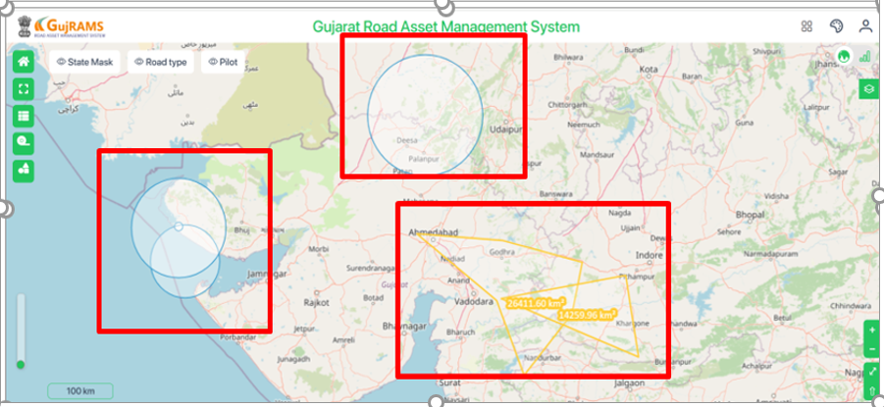  
**Comments:** When drawing shapes, the personalized theme colour is not applied. However, it works correctly for measurements. After performing other functionalities, when selecting measurements again, it displays a different colour instead of the personalized theme colour.  
**QA Status:** Fail  
**Screenshot:**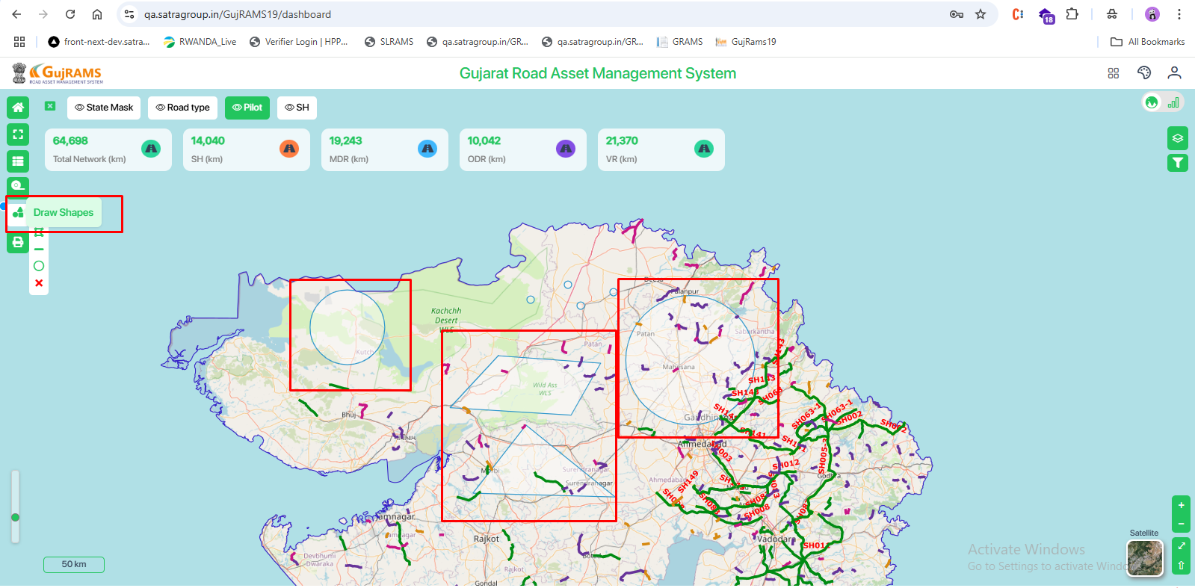  
  
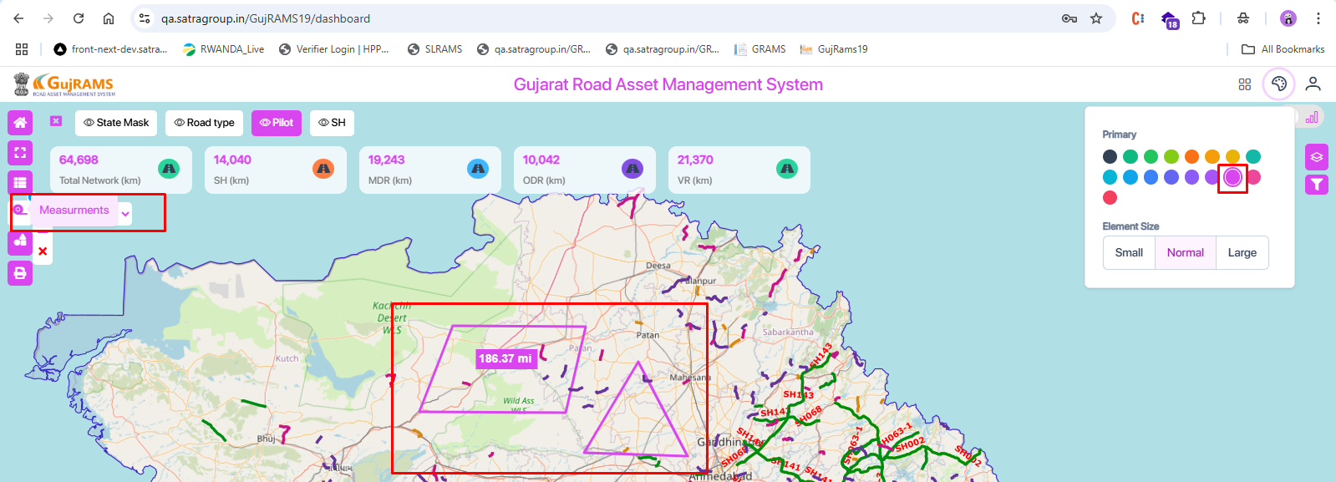  
  
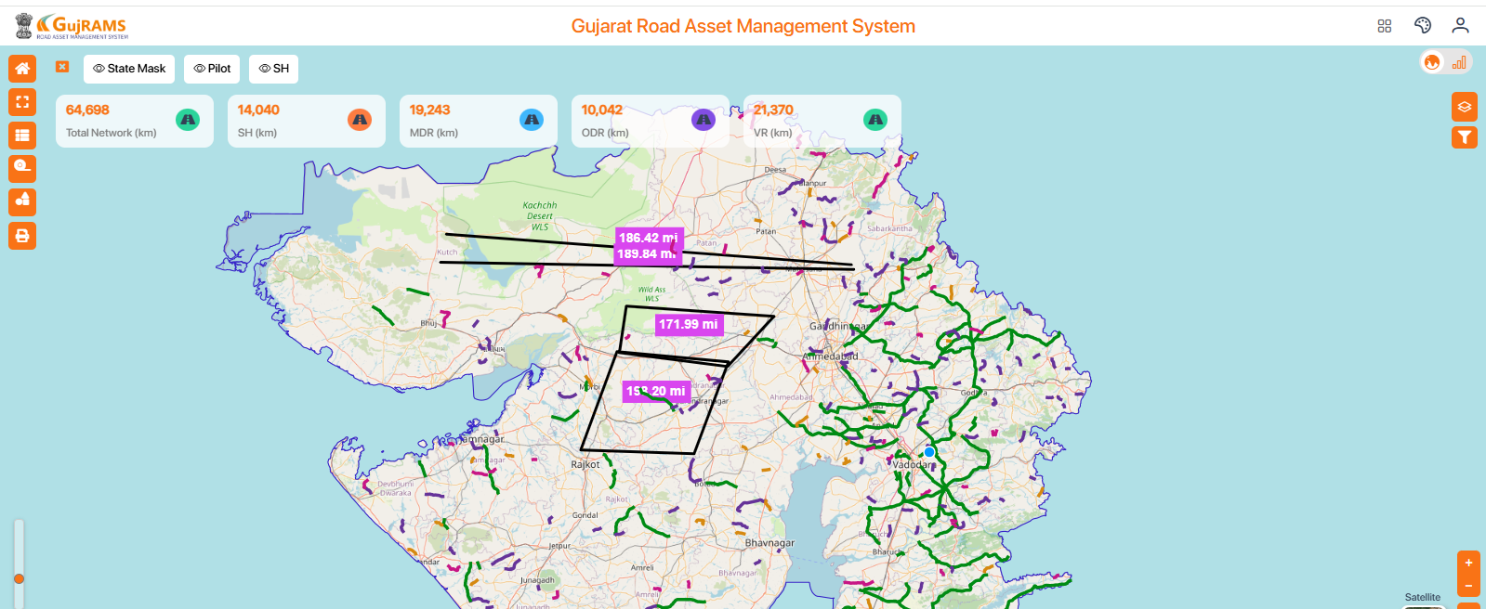

1. Need to add the below strip in the new portal

  
**Comments:** Successfully added the required strip in the new portal.  
**QA Status:** Pass  
**Screenshot:**  
  
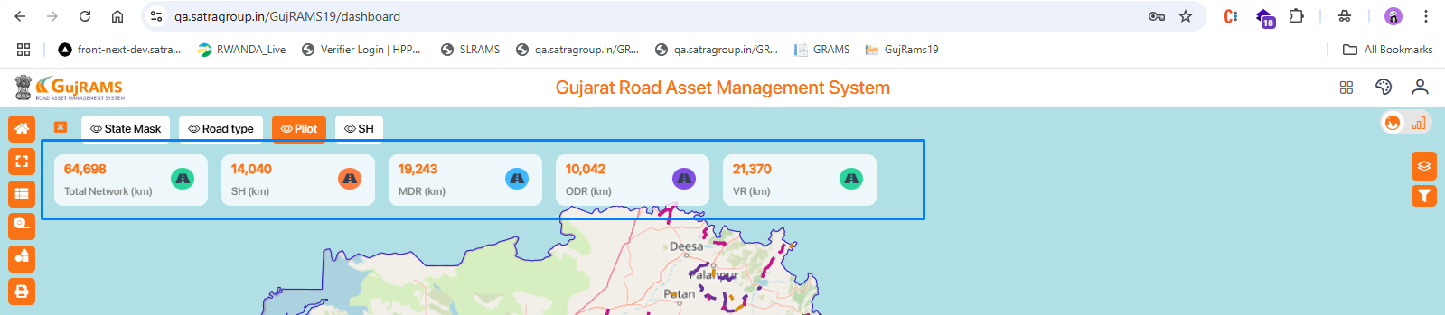

1. When click on the strip anywhere (Click on Pavement type) action need to take place, its working only when we click on the icon. This is same in old and new portal

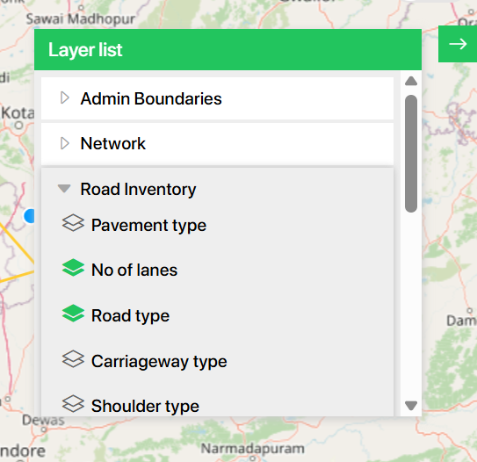

**Comments:** In the new portal, clicking anywhere on the strip (e.g., Pavement Type) triggers the action as expected.  
**QA Status:** Pass  
**Screenshot:**

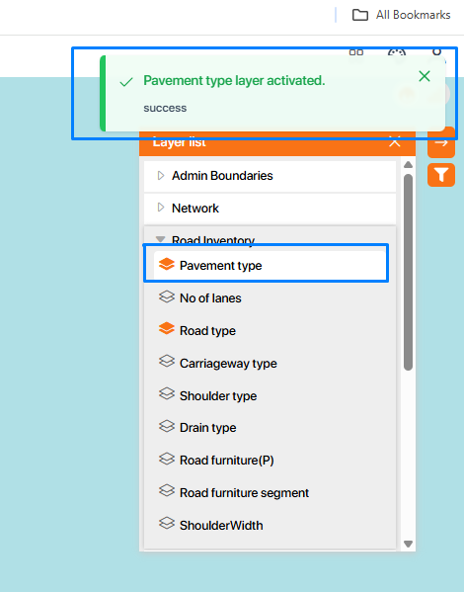

1. After drawing, there is no button to clear the drawing; “Clear graphics “button is missing in both. In old When we click on close, it clears. But in new we are unable to clear at all.

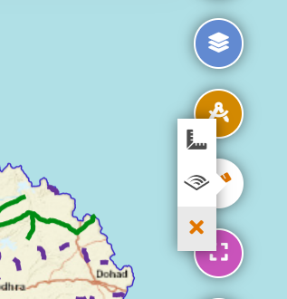  
  
**Comments:** "Clear Graphics" button is available in both the old and new portals, and it is working as expected to clear the drawing.  
**QA Status:** Pass  
**Screenshot:**  
old portal: https://qa.satragroup.in/GRAMS_New/  
  
  
 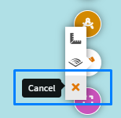 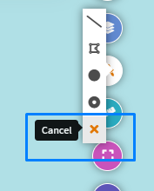  
  
new portal: https://qa.satragroup.in/GujRAMS19/  
  
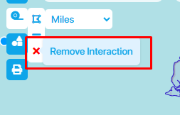 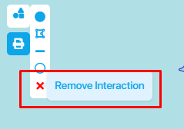

1. Print icon is missing in the new portal



**Comments:** Print icon is present in the new portal, but the tooltip is missing when hovered over.  
**QA Status:** Fail  
**Screenshot:**

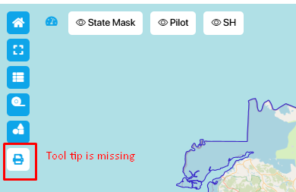  
  
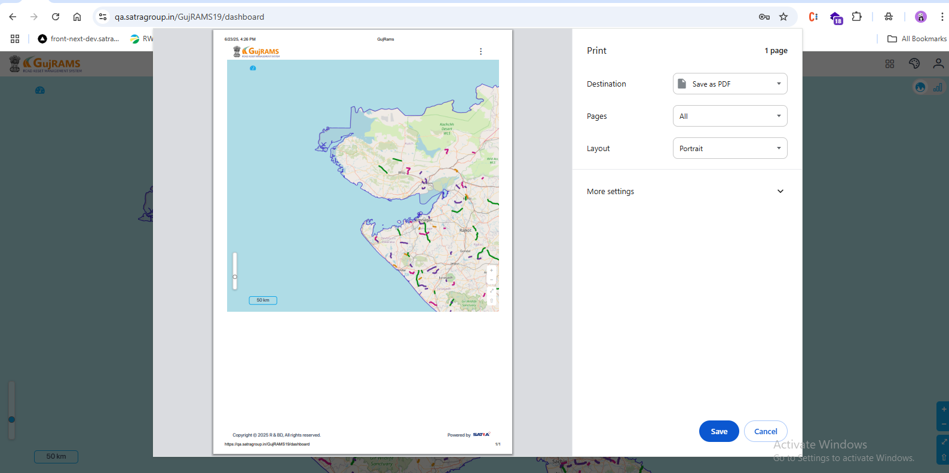

1. In New portal we have Layer scroll, not required, it should be like old screen without scroll complete right alignment, but in the same new design as it is now.

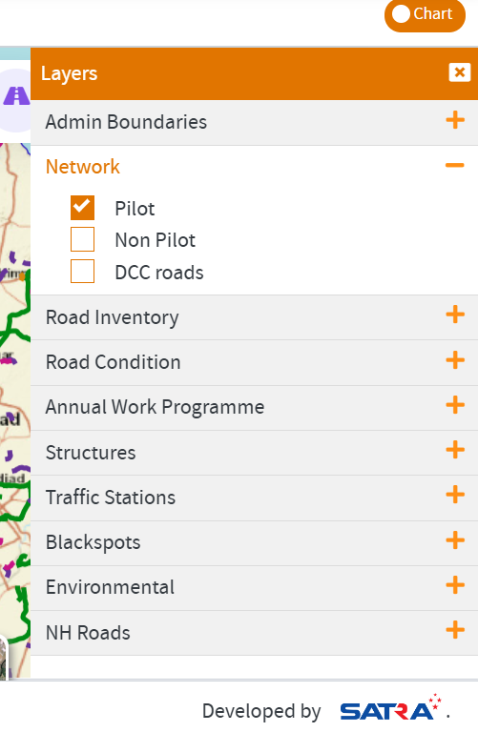  
  
**Comments:** Layer scroll is present in the new portal. Not found in the old version, so can be considered as an enhancement.  
**QA Status:** Enhancement  
**Screenshot:**

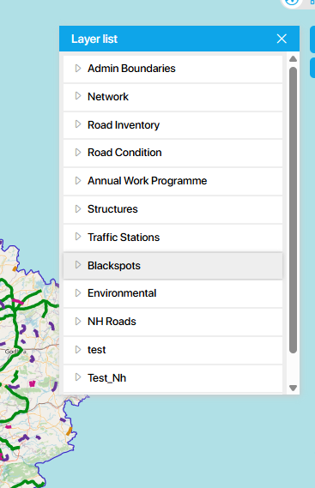

1. Remove the full stop and need to be right-aligned in the new portal

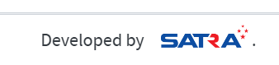

**Comments:** Full stop removed and text is right-aligned in the new portal.  
**QA Status:** Pass  
**Screenshot:**



1. Image rotation is working in the sample, but not in full screen

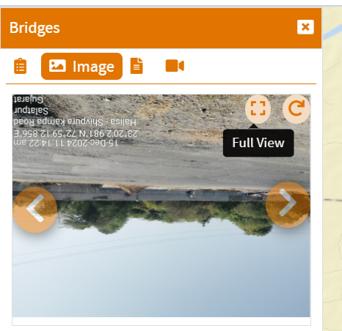  
**Comments:** Image rotation is working in both sample view and full screen.  
**QA Status:** Pass  
**Screenshot:**  
  
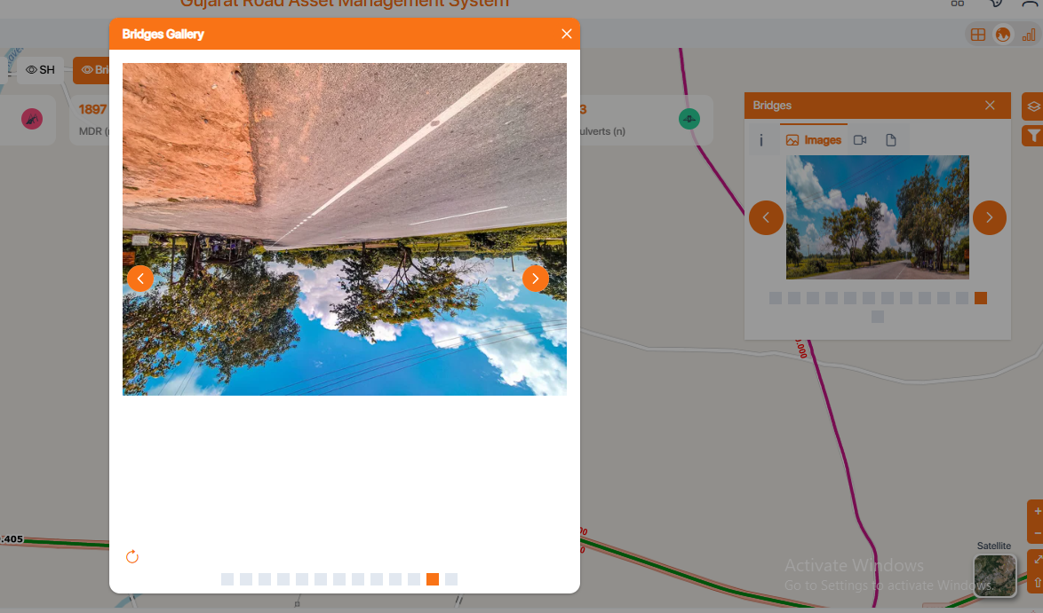

1. Remove the ID column, and Pilot is displaying twice. When we click on any data record in the grid, it should highlight the data on the map and show properties.

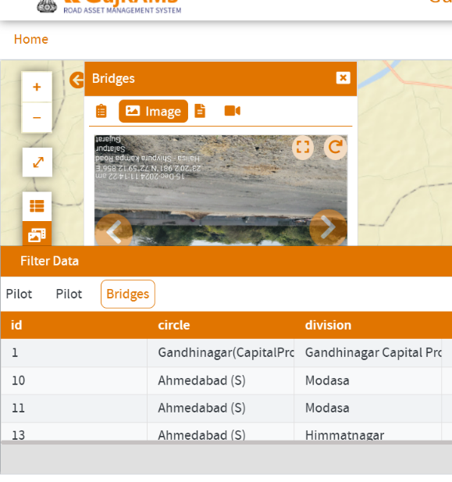  
**Comments:** ID column has been removed, and Pilot is no longer displayed twice.  
**QA Status:** Pass  
**Screenshot:**  
  
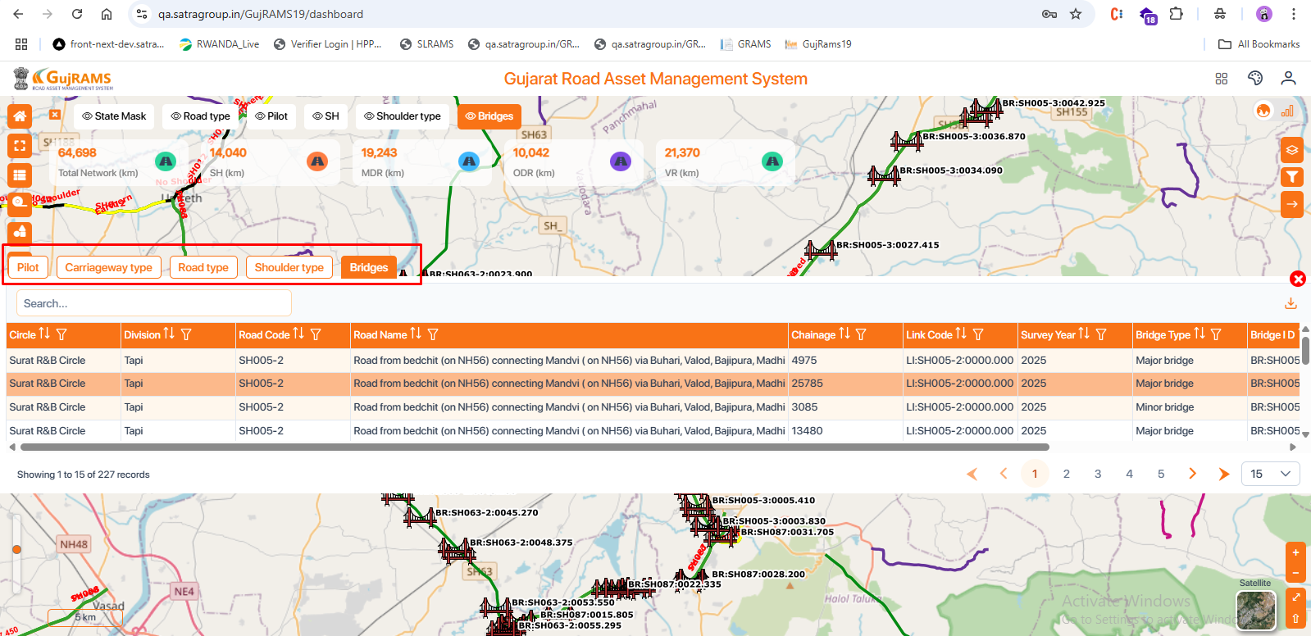

1. Filter is missing in the new web, and Grid icon is also missing

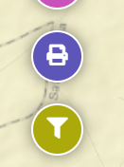  
  
**Comments:** Filter icon and Grid icon are visible in the new portal.  
**QA Status:** Pass  
**Screenshot:**  
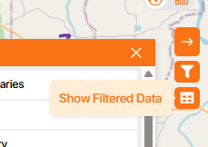

1. The below screen filter is missing

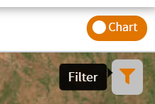



**Comments:** Filter is available on the screen in the new portal.  
**QA Status:** Pass  
**Screenshot:**

