1. **Module:** Home Screen Dashboard  
**Issue:**

1. The **amChart logo** is unnecessarily displayed on the dashboard.
2. There is a **spelling mistake near "Survey Details"**.

**Priority:** Low  
**Category:** UI/UX

**Expected Result:**

The **amChart logo** should be removed from the dashboard.

The **spelling near "Survey Details"** should be correct   
**Actual Result:**

The **amChart logo is shown** on the dashboard.

A **spelling error appears** near the "Survey Details" section.

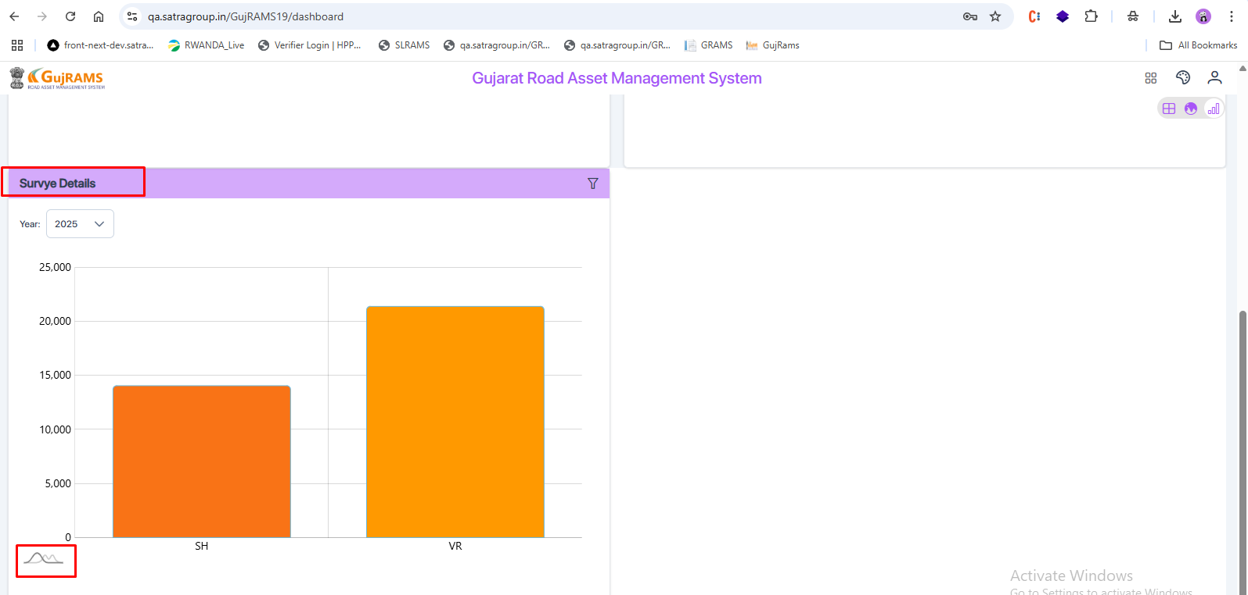  
  
2. **Module:** In all modules in the charts screen.

**Issue:** When no data is available, the chart displays an empty screen with no message.

**Priority:** Medium  
**Category:** UI/UX

**Expected Result:** When no data is available, an **alert or message**, such as “No data to display the chart,” should be displayed in place of the chart.

**Actual Result:** An **empty screen** is displayed, and **no alert/message** is shown.

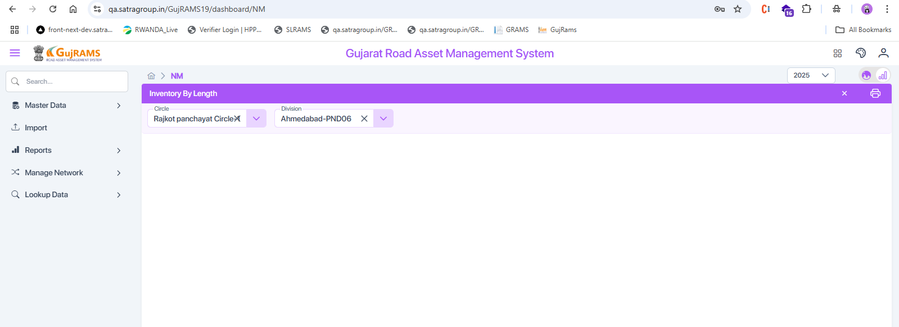  
  
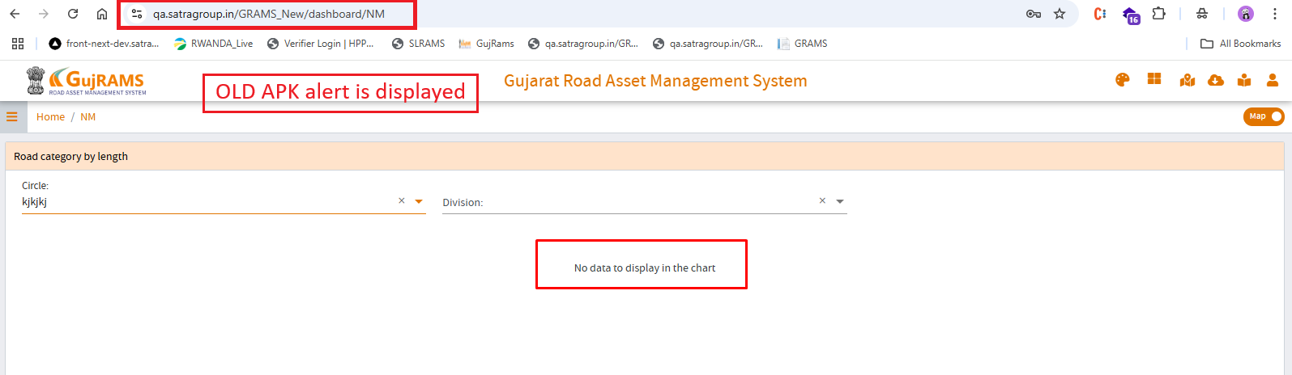  
  
3. **Module:** In all modules in the charts section

**Issue:** When the user clicks on the **Clear** button in filters, the **default chart is not displayed**.

**Priority:** Medium  
**Category:** Functional/UX

**Expected Result:** On clicking **Clear**, the system should **reset filters and display the default chart** view.

**Actual Result:** On clicking **Clear**, the chart **does not reset to default,** and the view remains empty or unchanged.

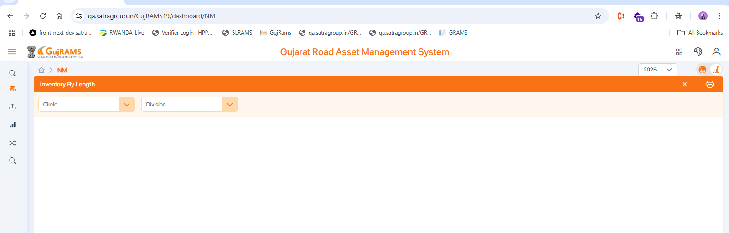  
  
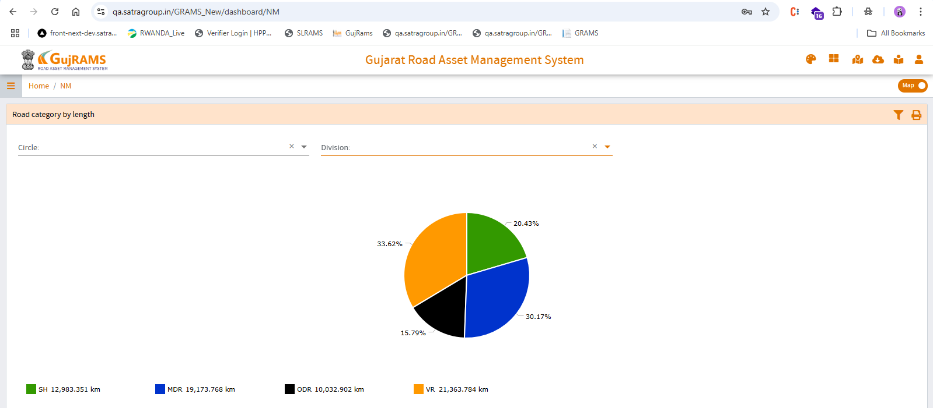

4. **Module:** RSAMS→ Charts Screen   
**Issue:** When the user selects a value in the **Accident Type dropdown** of the **Number of Accidents chart**, the **same value is reflected** in the **Accident Type dropdown** of the **Accident Type chart**, which should function independently.

**Priority:** Medium  
**Category:** Functional/UX

**Expected Result:** Each **Accident Type dropdown** should function **independently** for its respective chart. Selecting a value in one should **not affect** the other.

**Actual Result:** Selecting a value in one **Accident Type dropdown auto-updates the other dropdown**, causing confusion and inaccurate filtering.

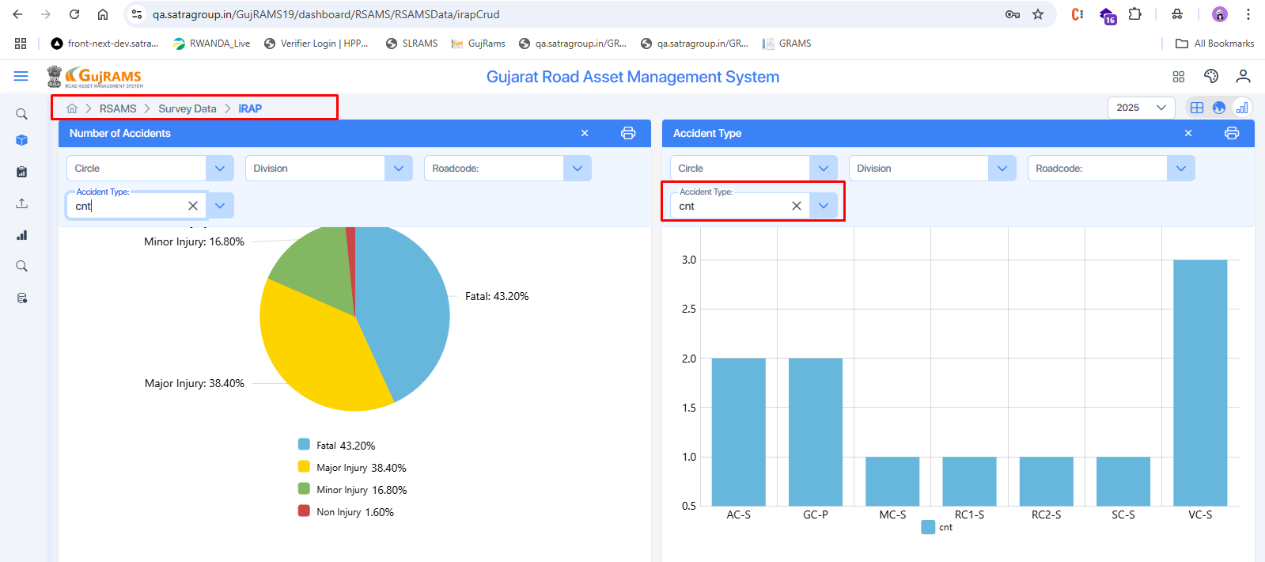  
  
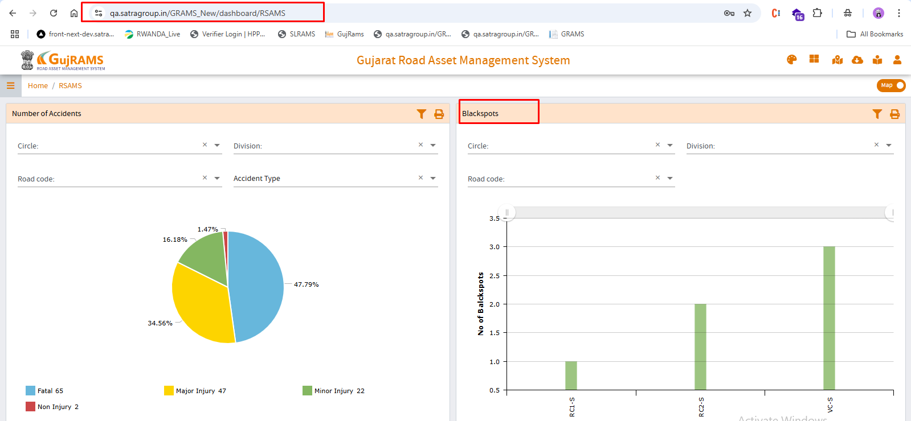

5. **Module**: RIS   
**Issue: Road code dropdown alignment** is **misaligned** compared to other filter fields.  
**Priority:** Low  
**Category:** UI/UX  
**Expected Result:** **Roadcode dropdown** should be **properly aligned** in line with other filter fields for a consistent UI layout.  
**Actual Result: Roadcode dropdown** appears **misaligned** or **positioned unevenly** compared to other dropdowns.

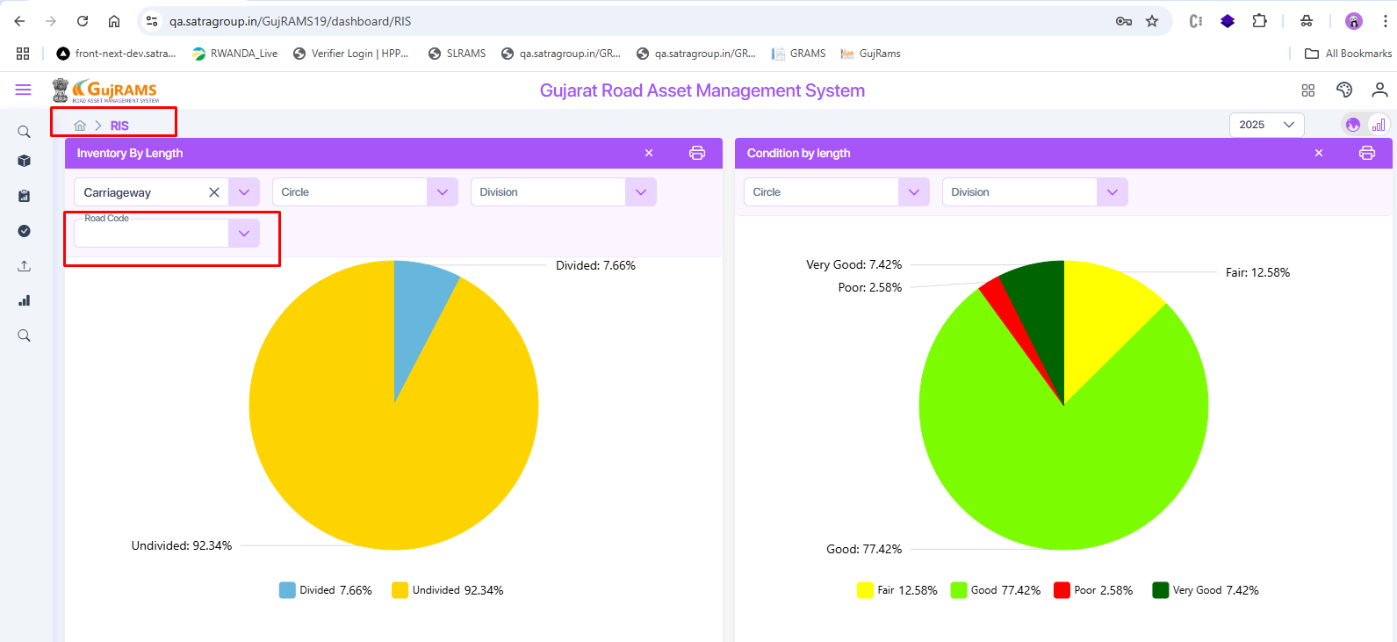

6.**Module:** MES → Charts Screen

**Issue:** Screen layout is different from the old APK.

**Expected Result:** Chart screen should match the old APK design.

**Actual Result:** Layout is completely different and inconsistent.

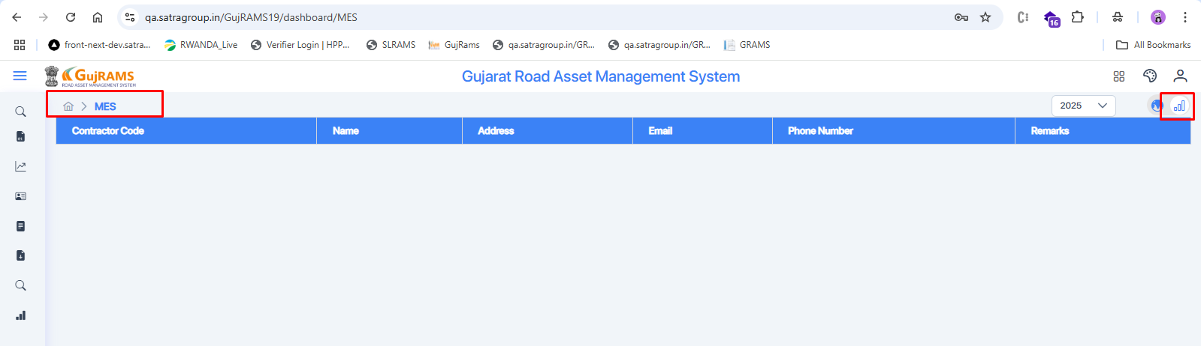  
  
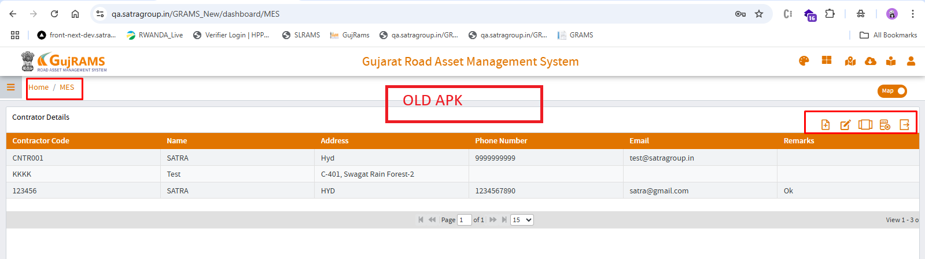

7.**Module:** BAP → Charts Screen

**Issue:** Screen layout is different from the old APK.

**Expected Result:** Chart screen should follow the same layout as in the old APK.

**Actual Result:** Layout and design are completely different from the old version.

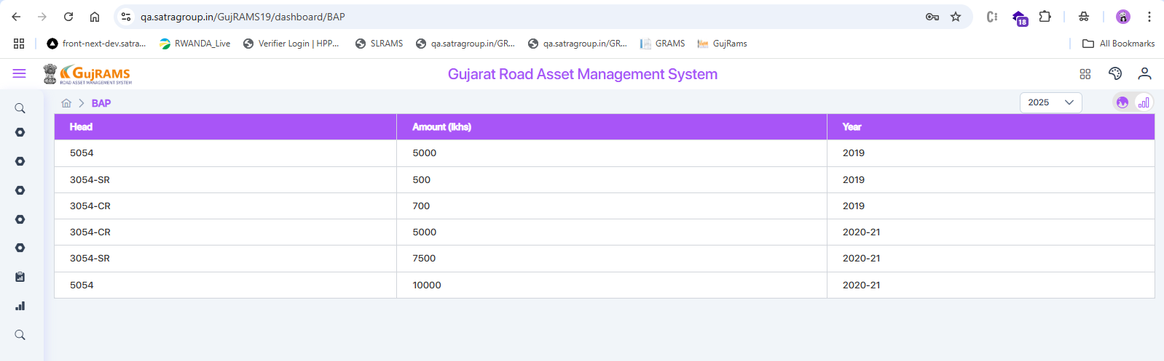  
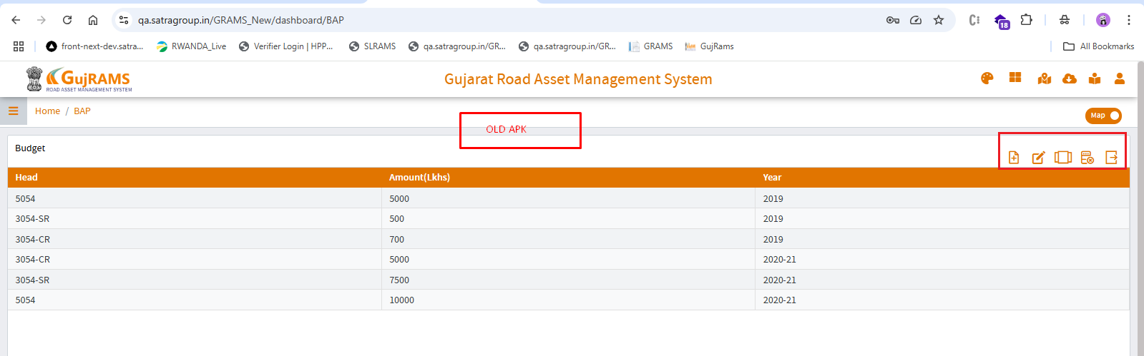  
8. **Module:** PMS → Charts Screen

**Issue:** Charts are **not displayed** in the new APK, while they are **visible with data** in the old APK.

**Expected Result:** Charts should be displayed with relevant data like in the old APK.

**Actual Result:** Charts are missing or not loading in the new APK.  
