**GujRAMS Mobile app Issues**

1. Home dashboard – Network by Jurisdiction chart (Title and chart data are not relevant to each other)

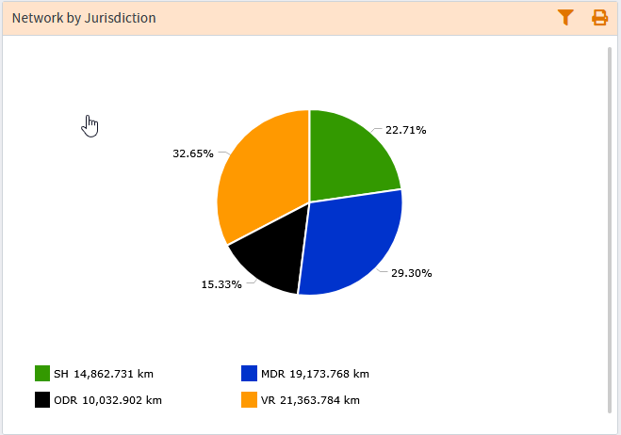

1. In mobile app when properties are displayed for a layer Schema name is visible in the properties list.

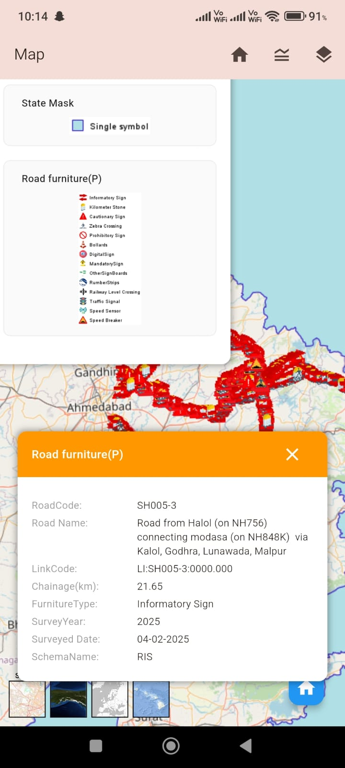

1. Title change in NM dashboard. (Road Length by Category)

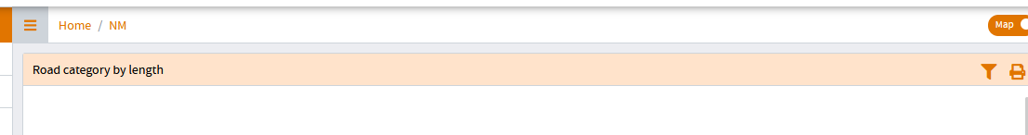

1. Chart title in RIS dashboard (Carriageway type by Length)

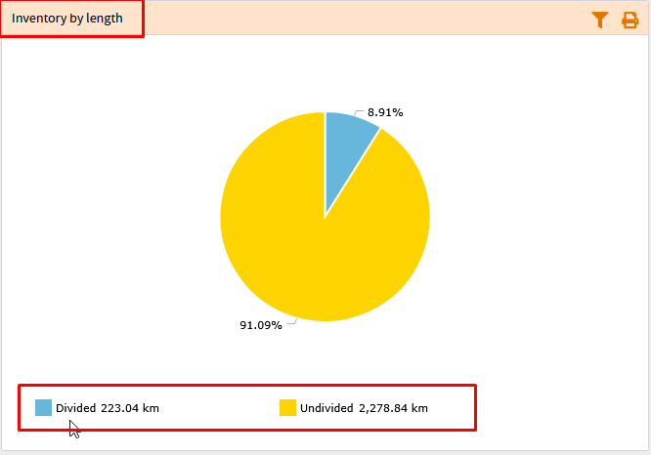

1. When jurisdiction is selected as “All” the reports are generating “No Records” as output. Only when either Circle / Division is selected, then the report output is generated.

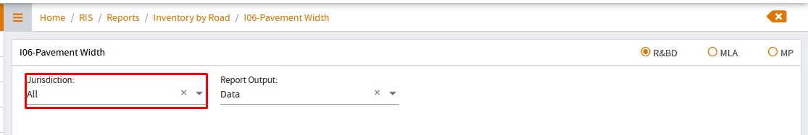

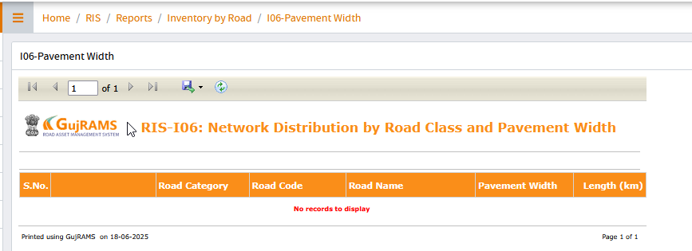

1. In RMMS module dashboard – No option to reset the selected filters (Check in all modules)

