**RRAMS PWD Mobile App Observations**

1. Landing page of the Mobile App,   
   Please do not display the bottom strip

Dashboard, Reports and Survey in the home/ Landing) page.

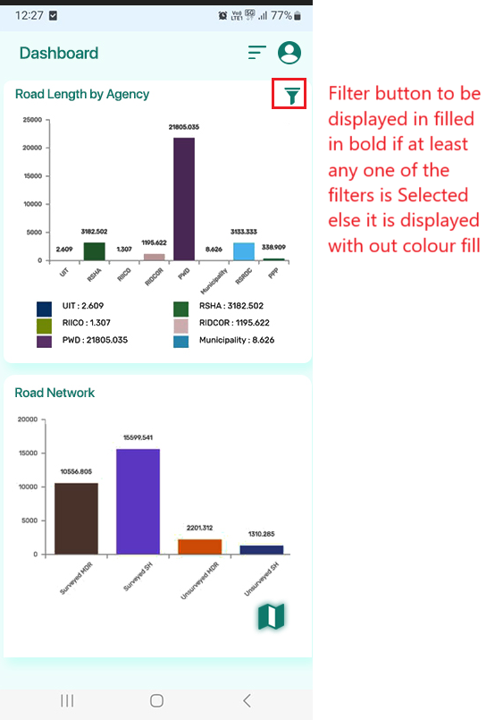

1. 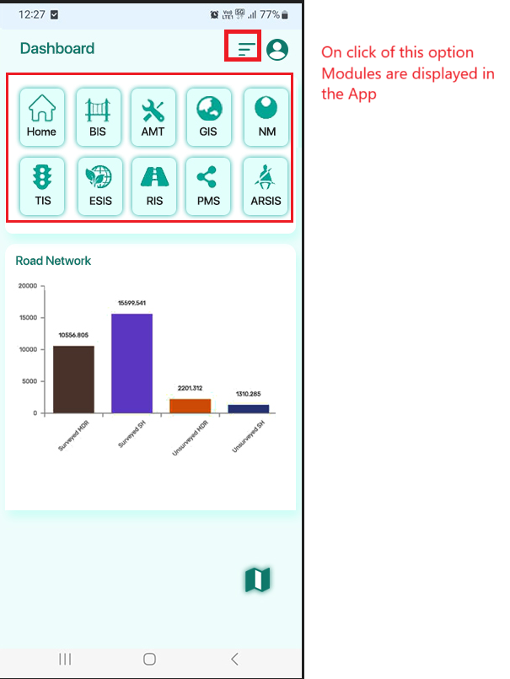Modules page – Refer to 6 point
2. 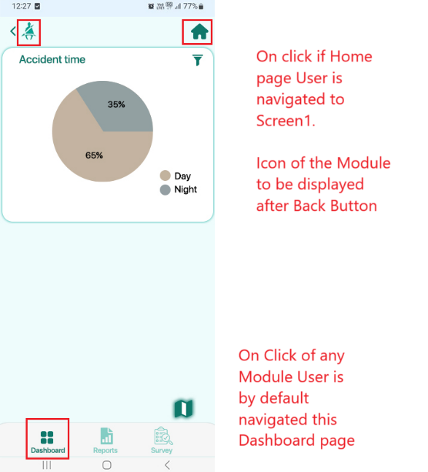Module Dashboard page

1. 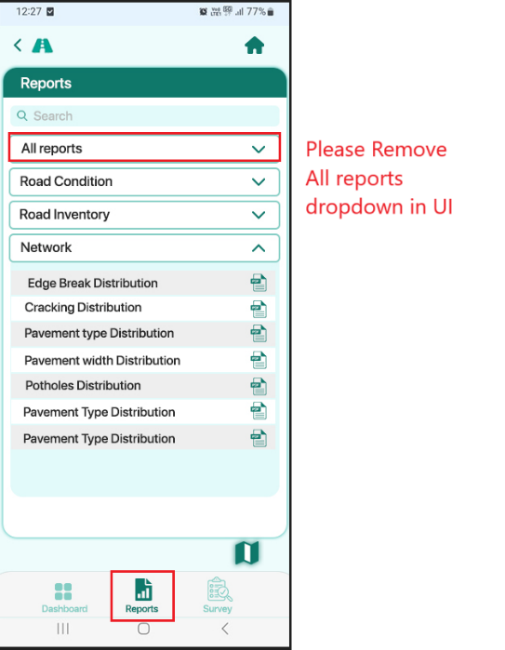Module Reports Page

1. 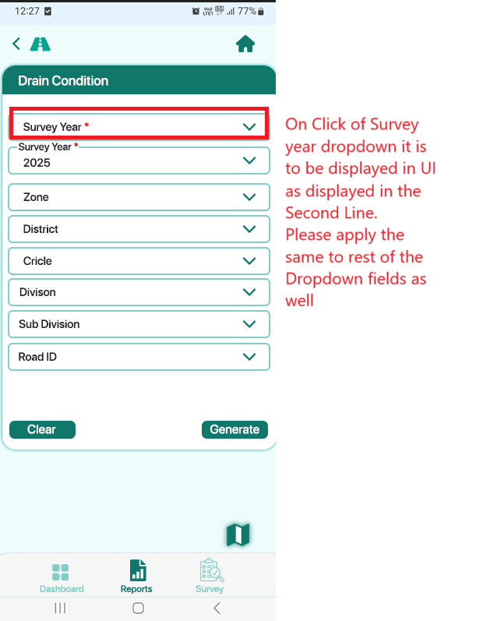Module sub page Reports dropdown
2. Please increase the fonts and icons size as displayed in this image.  
   Please Remove GIS Icon in this list.   
   The Map Icon at the bottom of the Screen to replace with this GIS Image.

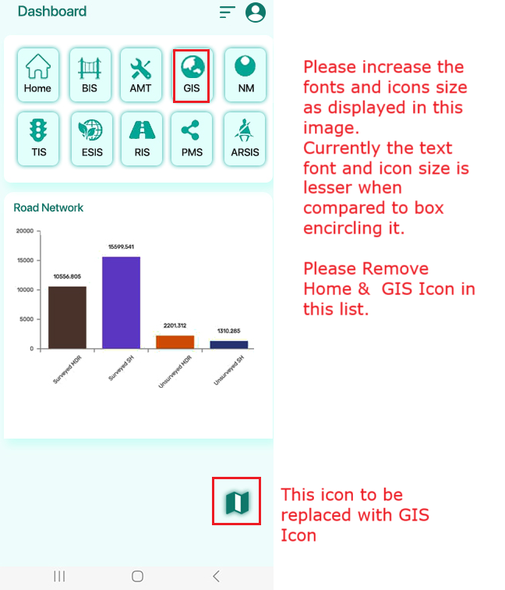

1. The session is getting Expired in a lesser time. It displays to log in again even though User is Active in the App.