GRAMS Web

1. Success notification not required

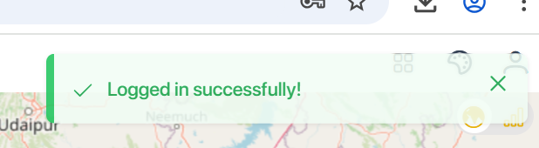

1. Satellite view image need to check

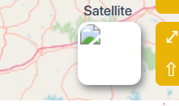 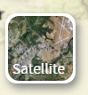

1. Unable to move the property window of layers like .. bridges and when expanded need to be in center

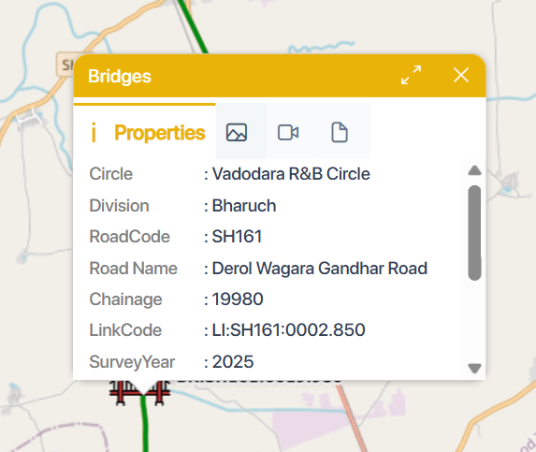

1. When select that bridge need to be circled (selected)
2. Pilot and Road Type when select in layer list the top strip pilot is missing and when we deselect in layer list the top strip we see the icon pilot … its working in reverse

Bridge is working fine

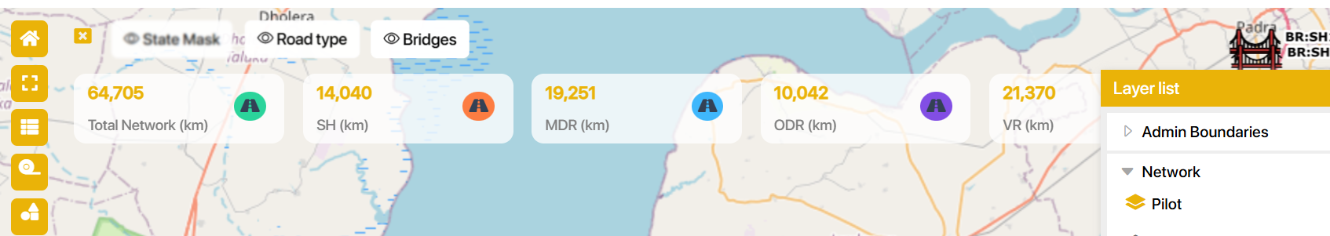

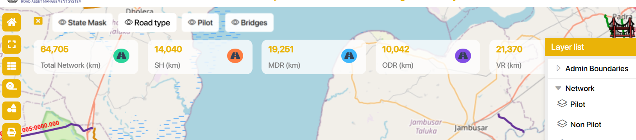

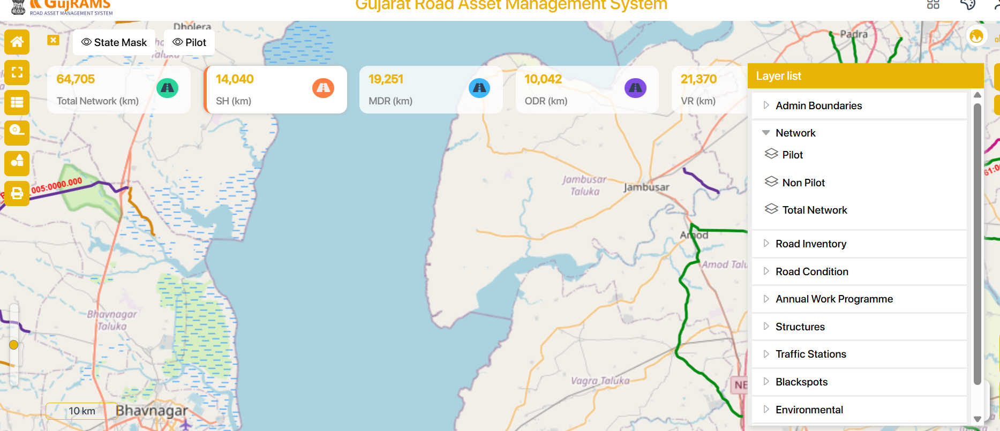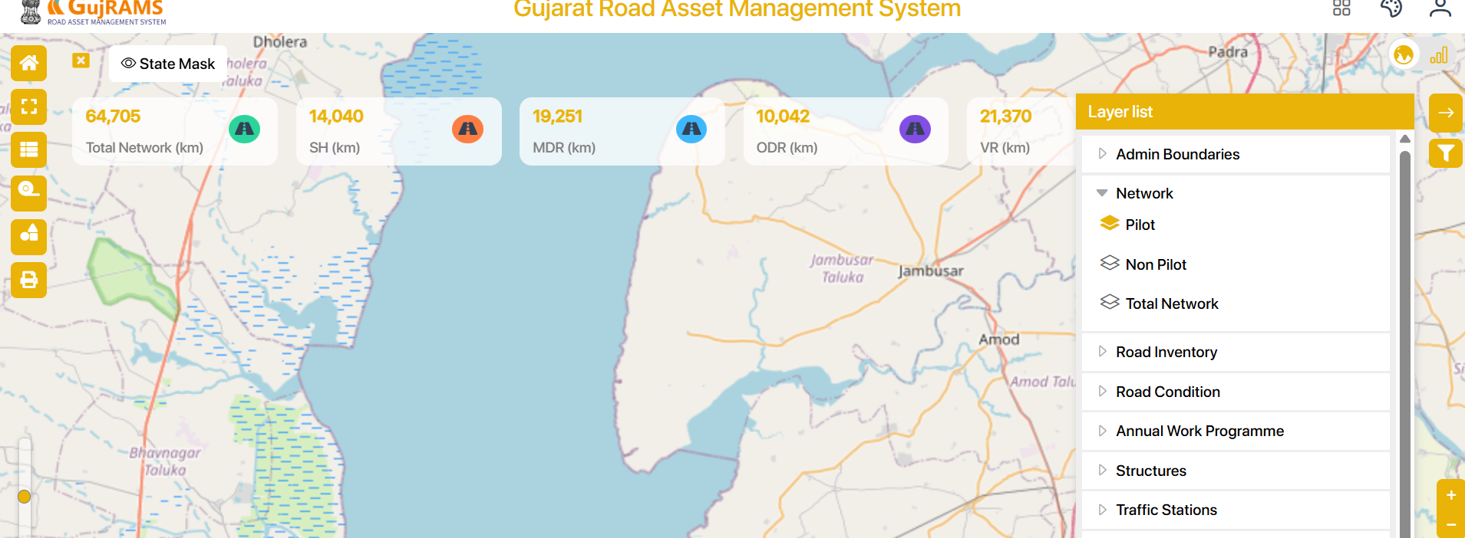

1. Filter for data icon missing

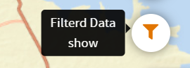

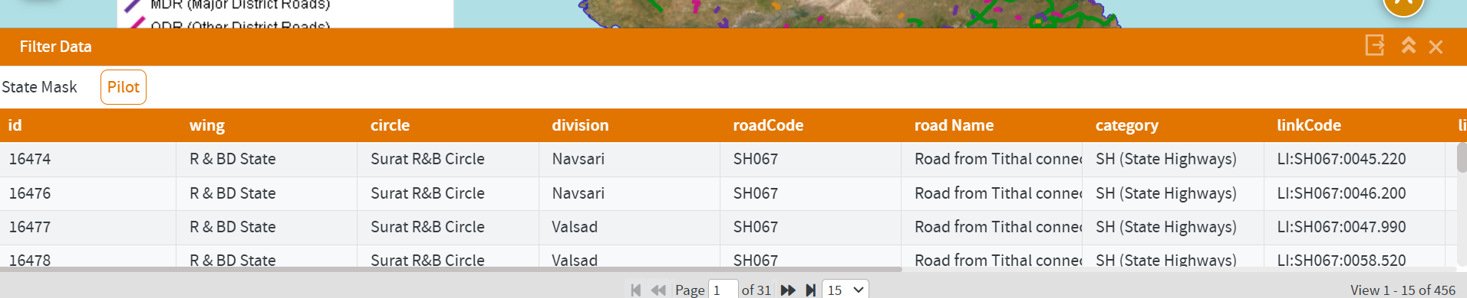

1. Need to check the functionality of 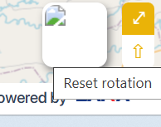
2. When we select a bridge, the legend should pop up, similar to Production portal
3. Print is not working in RIS modules graph



1. After removing filters, the graph is showing error RIS only tested. Also need filter reset

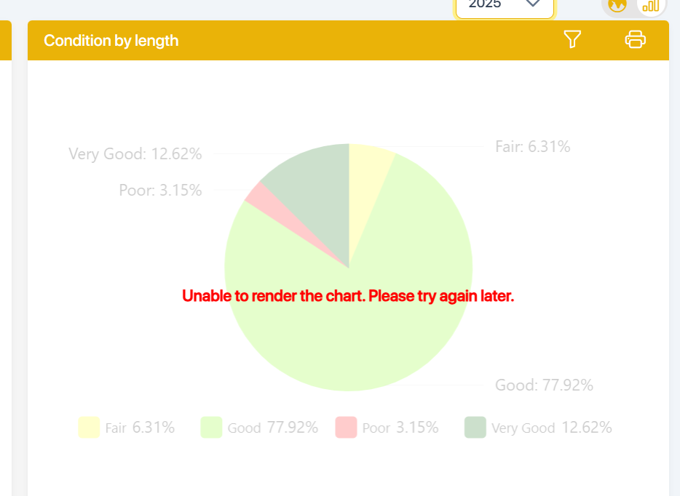

1. Please remove 2026 and 2027

