**Issue 1:**

**Issue**: After logging out, refreshing the page shows a 404 error.  
**Priority**: High

**Category**: Bug  
**Expected Result**: User should be redirected to the login page or shown a proper logout confirmation screen.  
**Actual Result**: 404 error page is displayed. (Working Fine)  
  
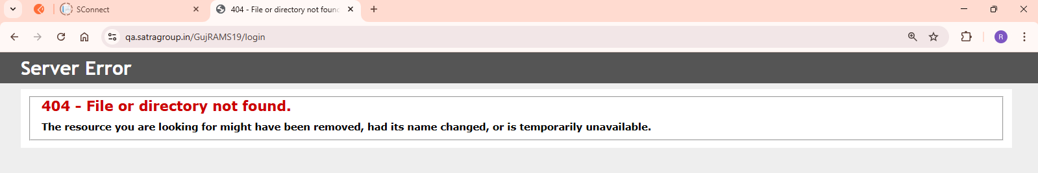

**Issue 2:**

**Issue**: Captcha spelling is incorrect.  
**Priority**: Low  
**Category**: UI Issue  
**Expected Result**: Captcha label should be spelt correctly.  
**Actual Result**: Incorrect spelling is shown in the CAPTCHA label. (Working Fine)  
  
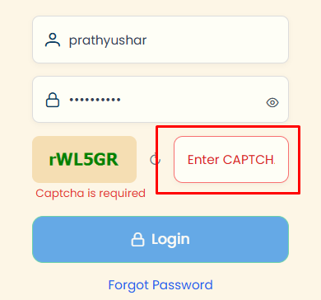

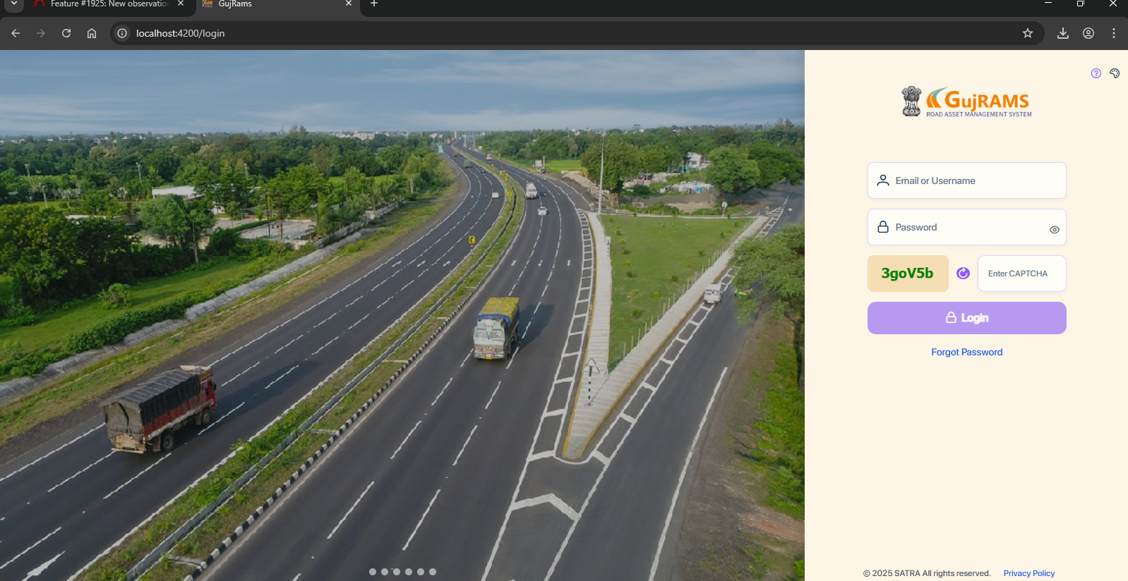

**Issue 3:  
Issue**: Dark mode and test menu are missing in the old application.  
**Priority**: Low  
**Category**: Enhancement  
**Expected Result**: Dark mode and test menu are new enhancements not available in the previous URL.   
**Actual Result**: Features are not available in the old version.(not an Issue)  
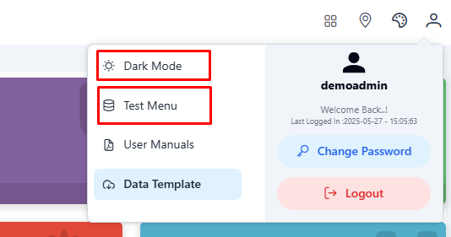

**Issue 4:**

**Issue**: Search functionality is not required on the home dashboard.  
**Priority**: Medium  
**Category**: Enhancement  
**Expected Result**: Search functionality should be removed from the dashboard if not required.  
**Actual Result**: Search bar is present in the dashboard.

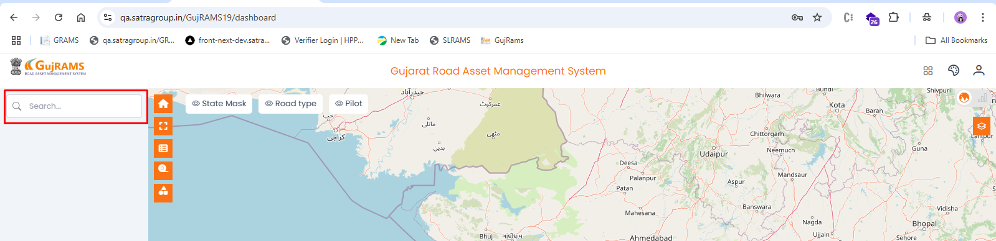

**Issue 5: (Not an Issue)**

**Issue**: Header is not displayed on login in the latest app.  
**Priority**: Medium  
**Category**: Bug  
**Expected Result**: Header showing current module should appear after login.  
**Actual Result**: Header is missing in the latest build.

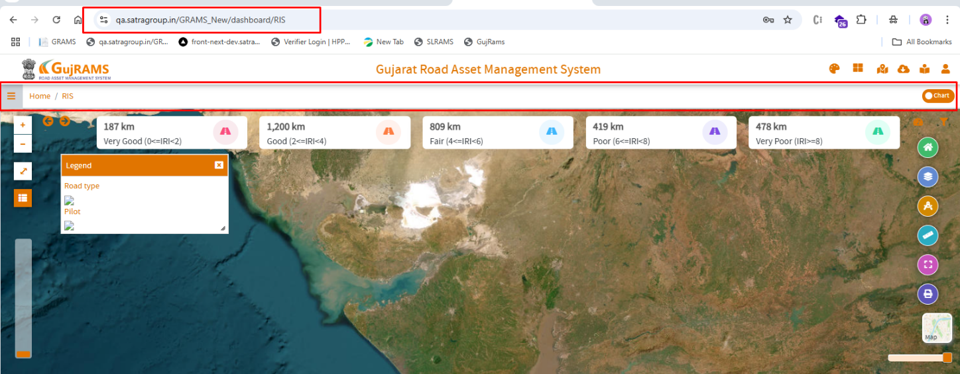

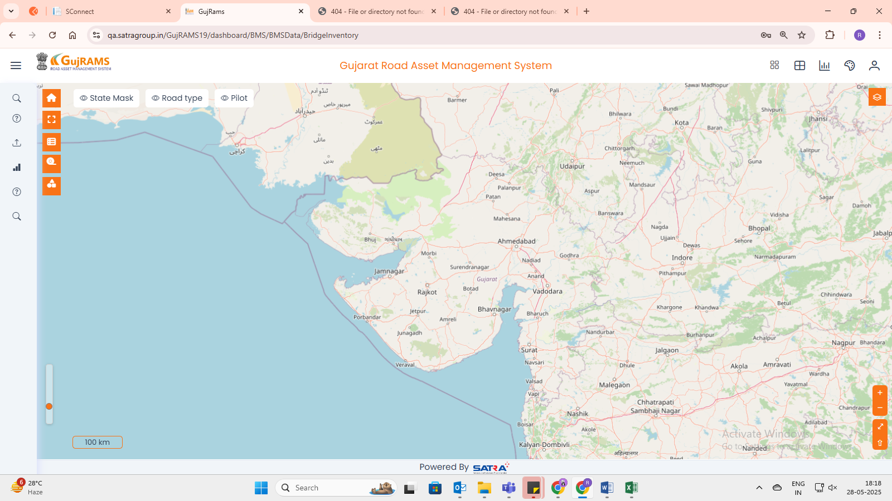

**Issue 6: (Working fine)  
Issue**: Clicking charts redirects to a different module dashboard.  
**Priority**: High  
**Category**: Bug  
**Expected Result**: Chart click should stay within the same module dashboard.  
**Actual Result**: Redirects to other unrelated module dashboards.  
  
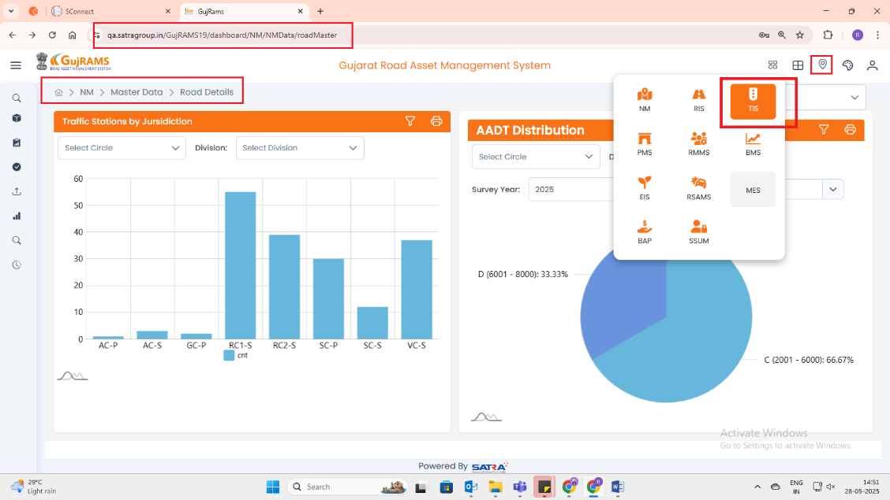  
  
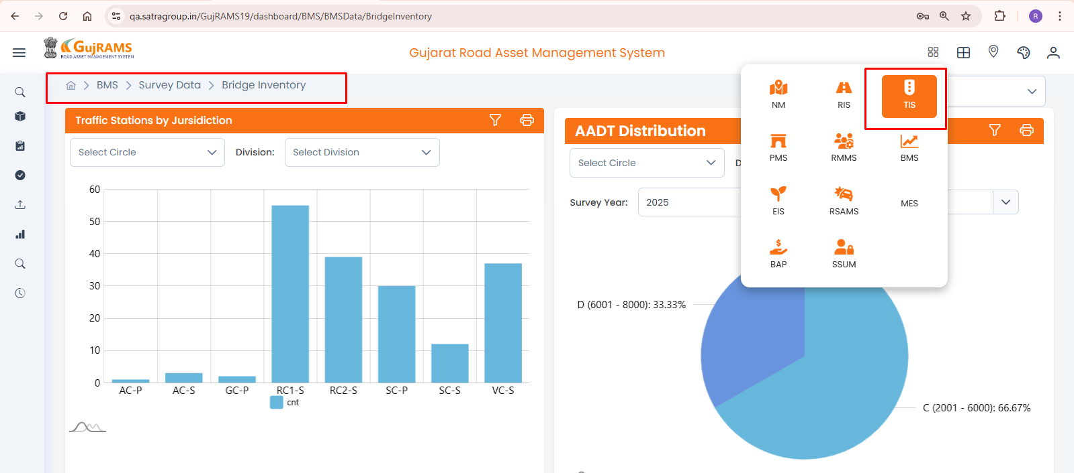

(Working Fine)

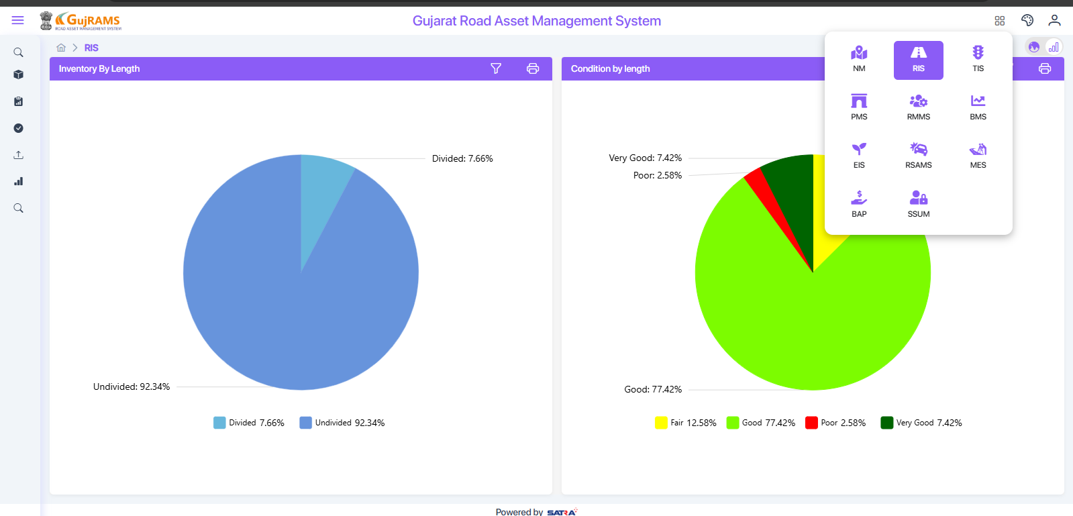

**Issue 7:  
Issue**: Search functionality is not needed in user manuals.  
**Priority**: Low  
**Category**: Enhancement  
**Expected Result**: Search bar should be removed from the user manuals section.  
**Actual Result**: Search field is shown unnecessarily.   
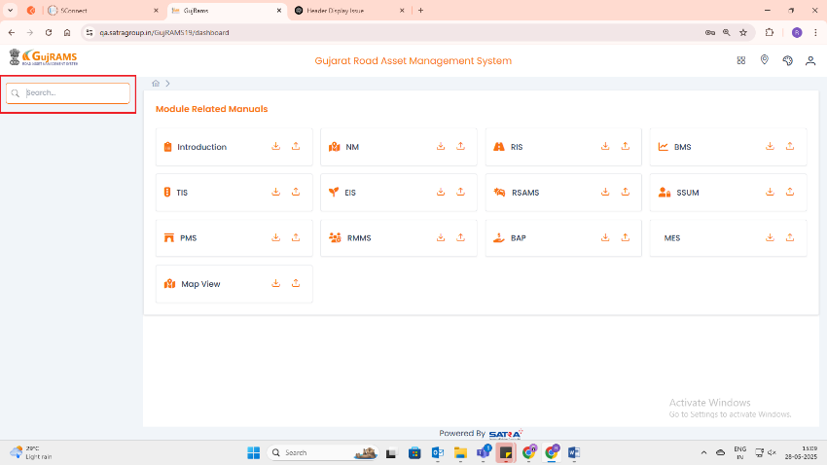

(Working Fine)

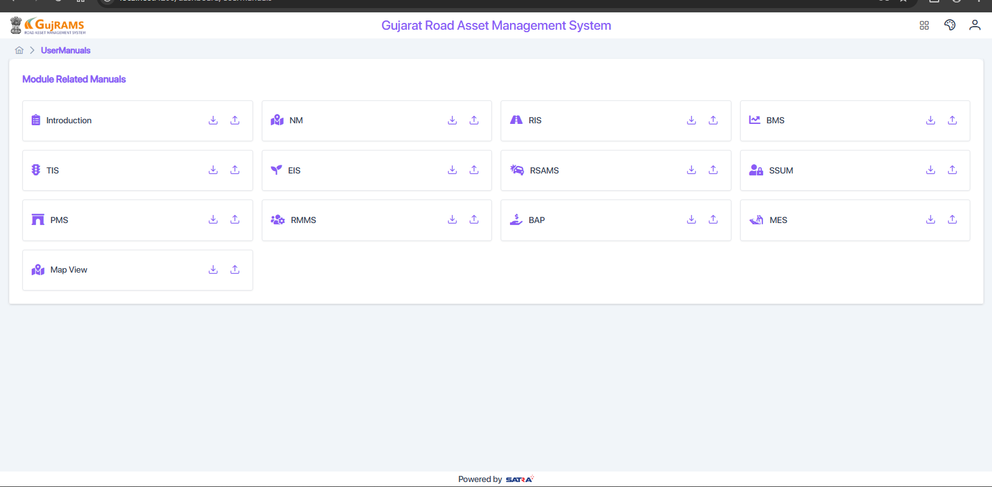

**Issue 8:**

**Issue**: In the old APK, there is no upload button near the user manuals.  
**Priority**: Low  
**Category**: Enhancement  
**Expected Result**:   
**Actual Result**: Upload button is missing in the old APK and only available in the new one.

(new Implementation)

**Issue 9:**

**Issue**: MES module logo is not displayed in the New APK.  
**Priority**: Low  
**Expected Result**: MES module should display its logo.  
**Actual Result**: MES module logo is missing in the New APK.  
**Category**: UI Issue (Working Fine)

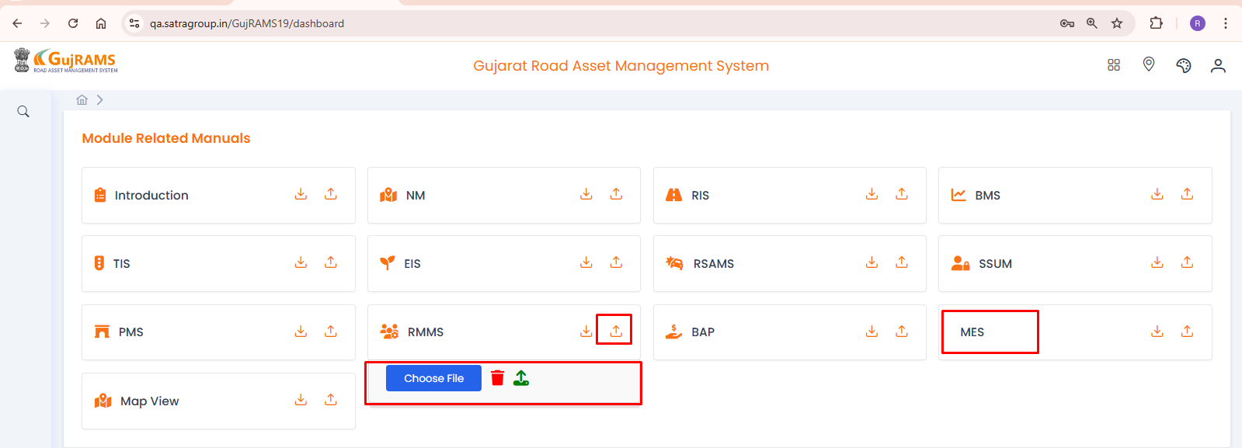

**BMS Module**

**Issue 10:  
Issue**: In BMS Module → Import, failed → clicking on error count shows a 404-error page.  
**Priority**: High  
**Category**: Bug  
**Expected Result**: Clicking on error count should show relevant error logs or a meaningful message.  
**Actual Result**: 404-error page is displayed.(Working Fine)

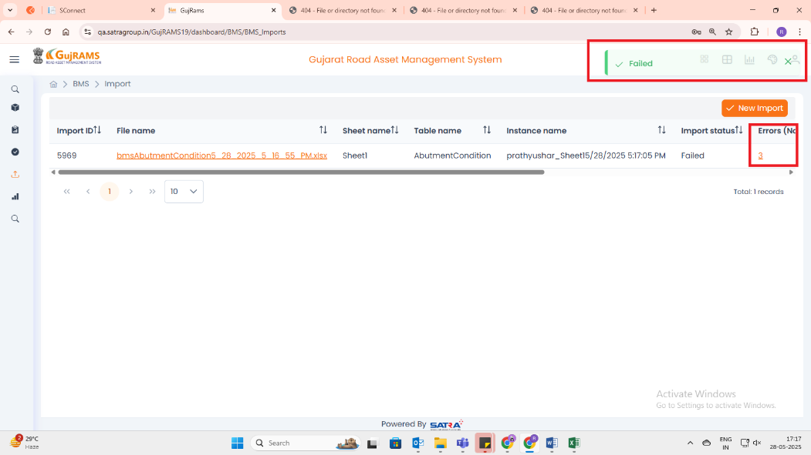

**Issue 11: (Working Fine)**

**Issue**: In BMS → Survey Data → some tables are missing.  
**Priority**: High  
**Category**: Bug  
**Expected Result**: All necessary survey data tables should be present.  
**Actual Result**: Some tables are missing from the display.

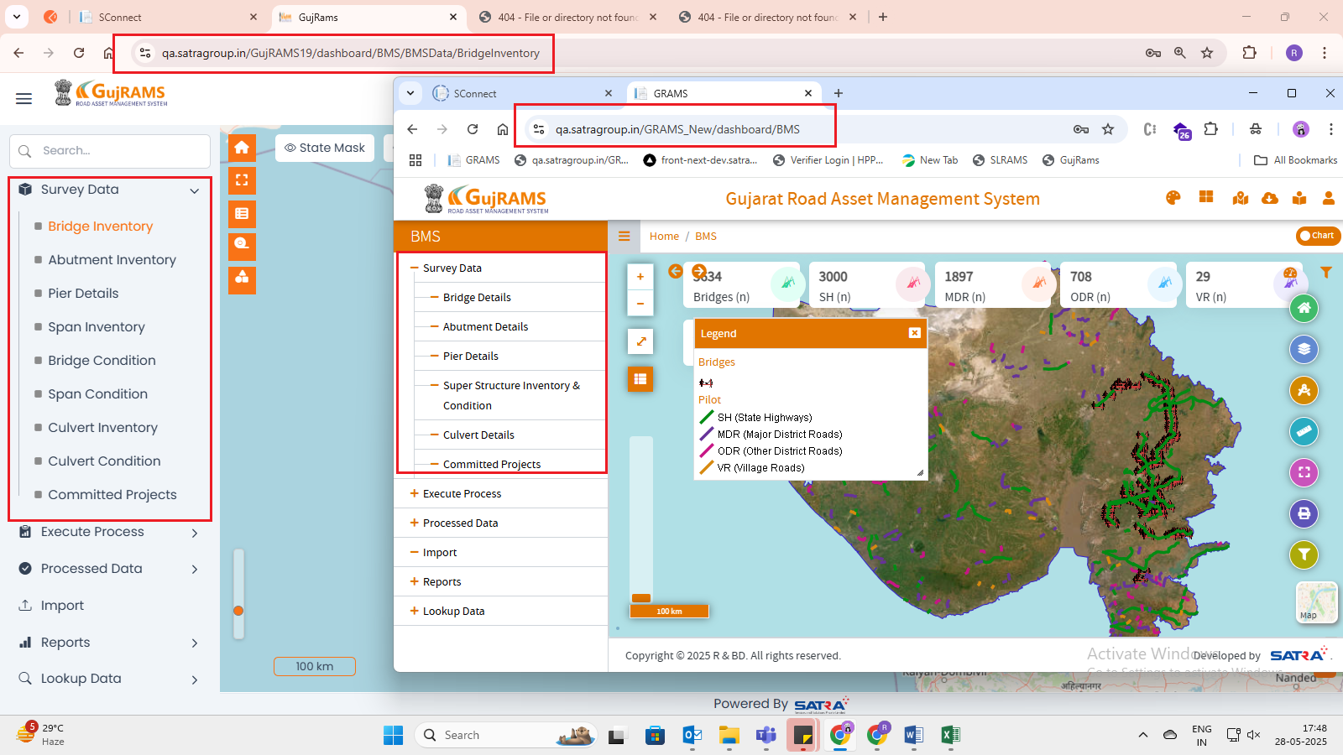

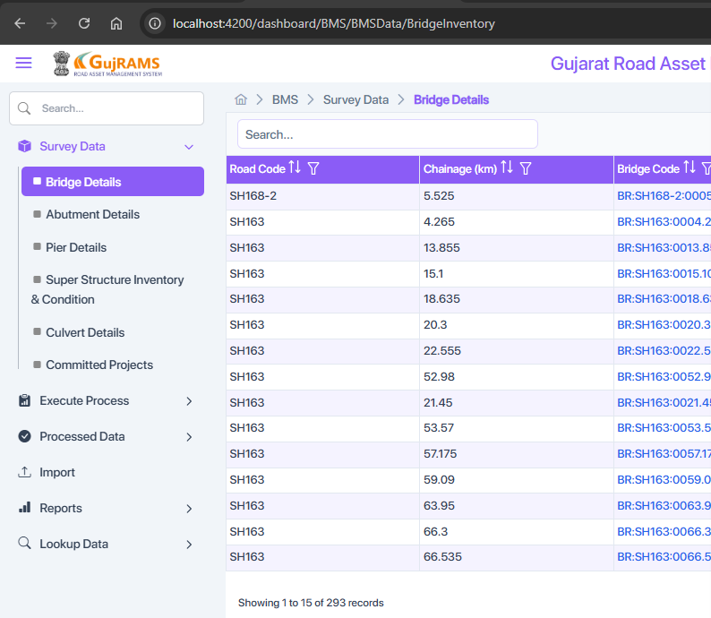

**TIS Module**

**Issue 12:**

**Issue**: In TIS Module → Survey year dropdown not fully visible in 'Execute Process'.  
**Priority**: Medium  
**Category**: UI Issue  
**Expected Result**: Survey year dropdown should be fully visible for proper selection.  
**Actual Result**: Dropdown is not fully visible.(working Fine)

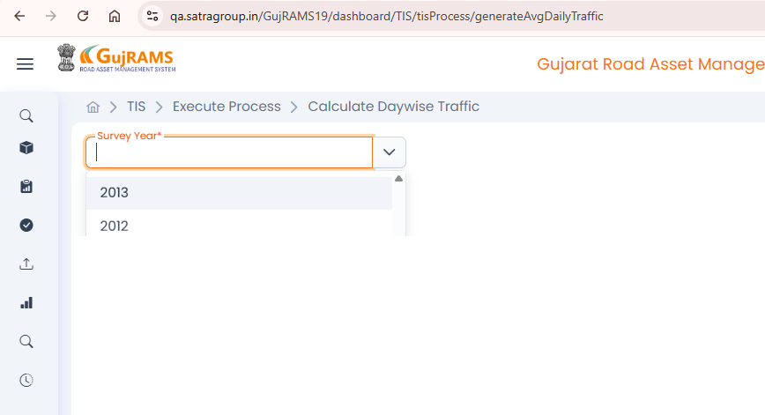

**Issue 13:**

**Issue**: Executing the process in TIS Module throws an unknown error.  
**Priority**: High  
**Category**: Bug  
**Expected Result**: Process should execute successfully or provide a clear error message.  
**Actual Result**: An unknown error is displayed during execution.(Working Fine)

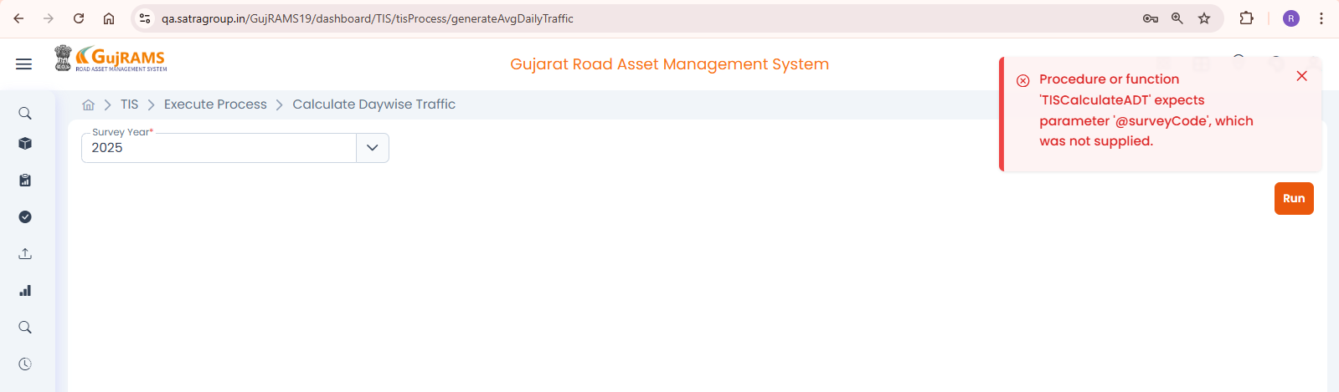

**Issue 14:**

**Issue**: TIS → Historical data screen layout is completely different.  
**Priority**: Medium  
**Category**: UI Issue  
**Expected Result**: Screen layout should match the expected design or documentation.  
**Actual Result**: The entire screen appears different from the OLD apk.(Working Fine)  
  
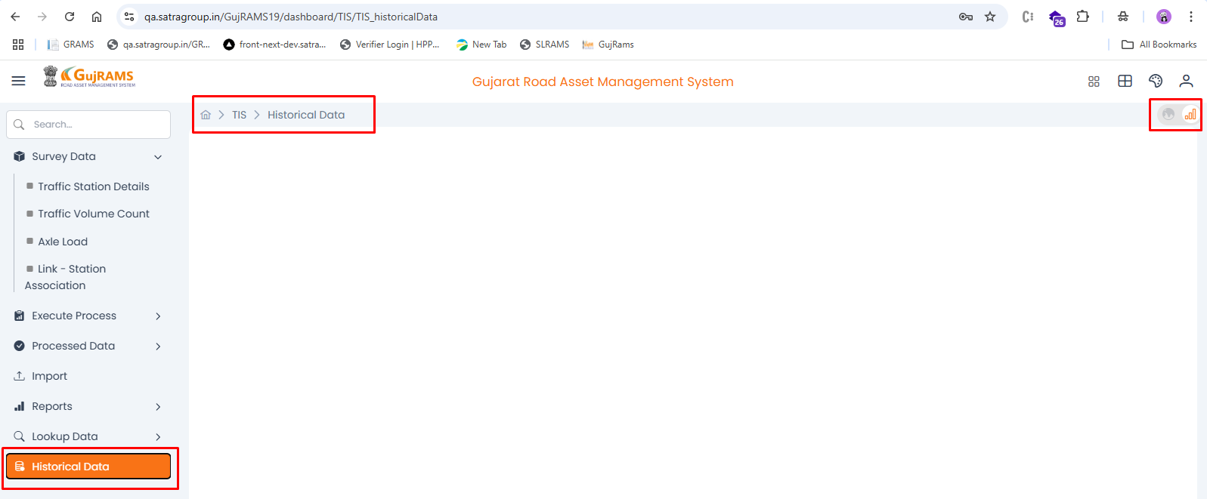

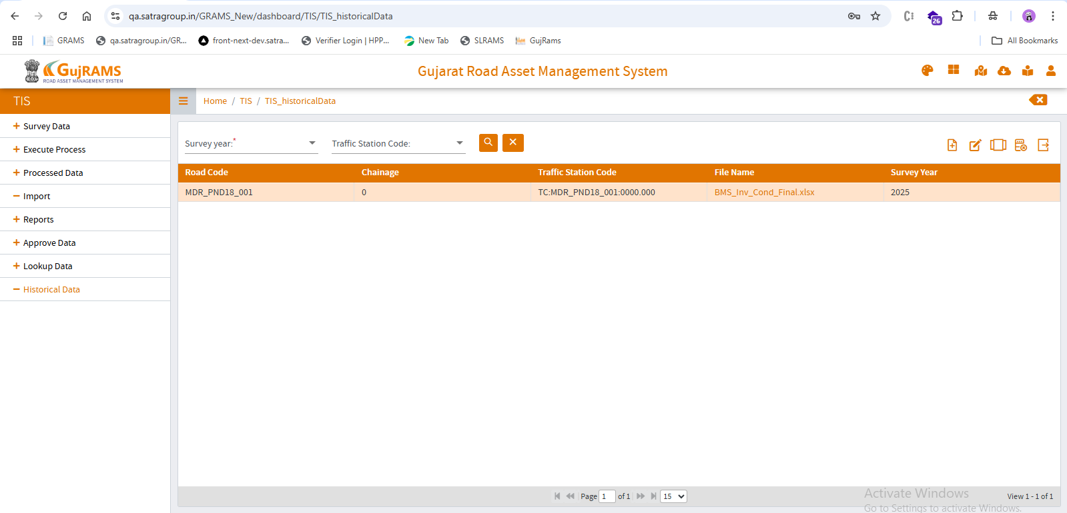

**Issue 15:**

**Issue**: Clicking 'View Record' shows heading as 'Edit Record'.  
**Priority**: Low  
**Category**: UI Issue  
**Expected Result**: The heading should match the action being performed (i.e., 'View Record').  
**Actual Result**: Heading incorrectly says 'Edit Record'. (Working Fine)

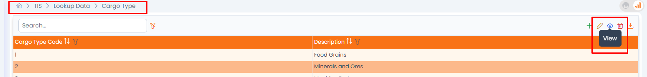

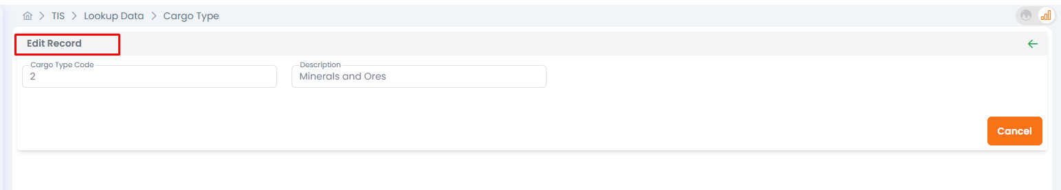

**Issue 16:**

**Issue**: TIS → Lookup data → Traffic growth rates → Add record → Mandatory fields not shown.  
**Priority**: High  
**Category**: Bug  
**Expected Result**: Mandatory fields should be indicated while adding a new record.  
**Actual Result**: Mandatory field indicators are missing.(Done)

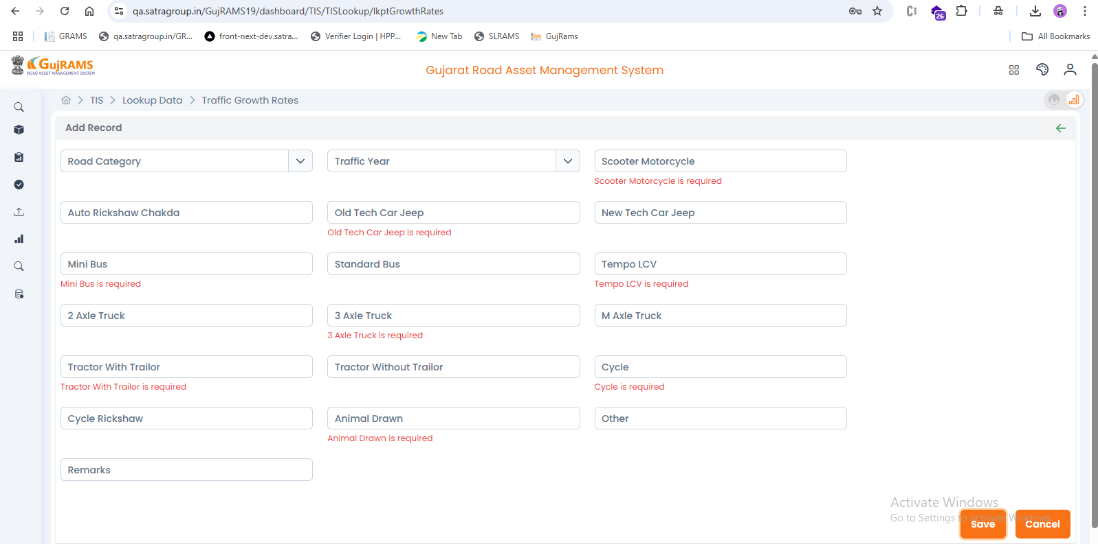

**Issue 17:  
Issue**: TIS → Lookup Data → Edit/View Record shows empty form fields.  
**Priority**: High  
**Category**: Bug  
**Expected Result**: Form fields should be pre-filled with record data for edit/view.  
**Actual Result**: All fields appear empty.(Working Fine)

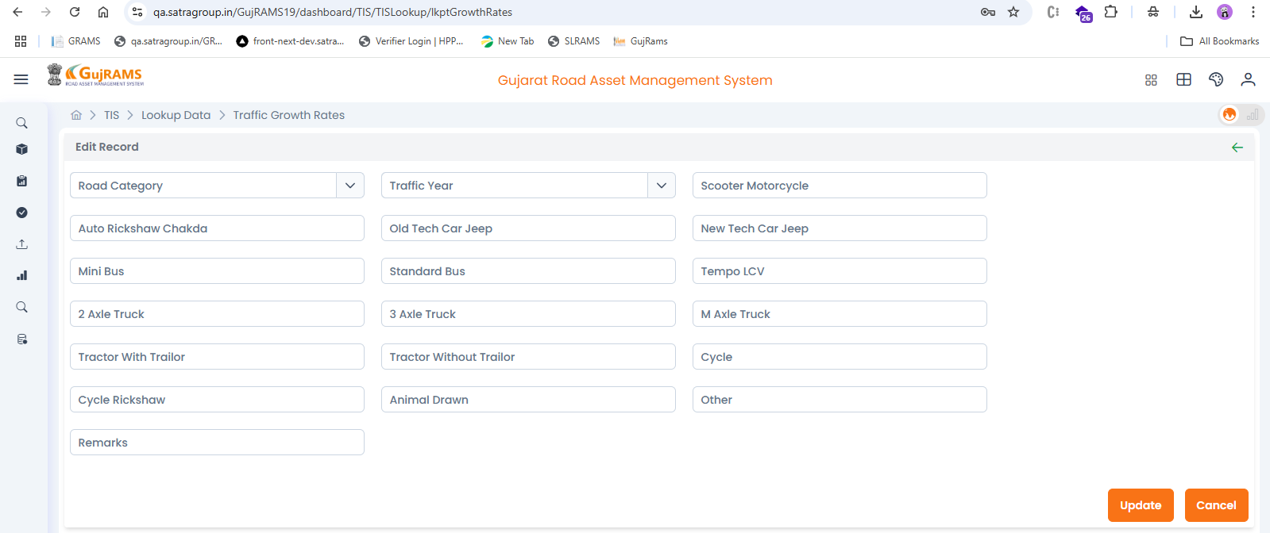

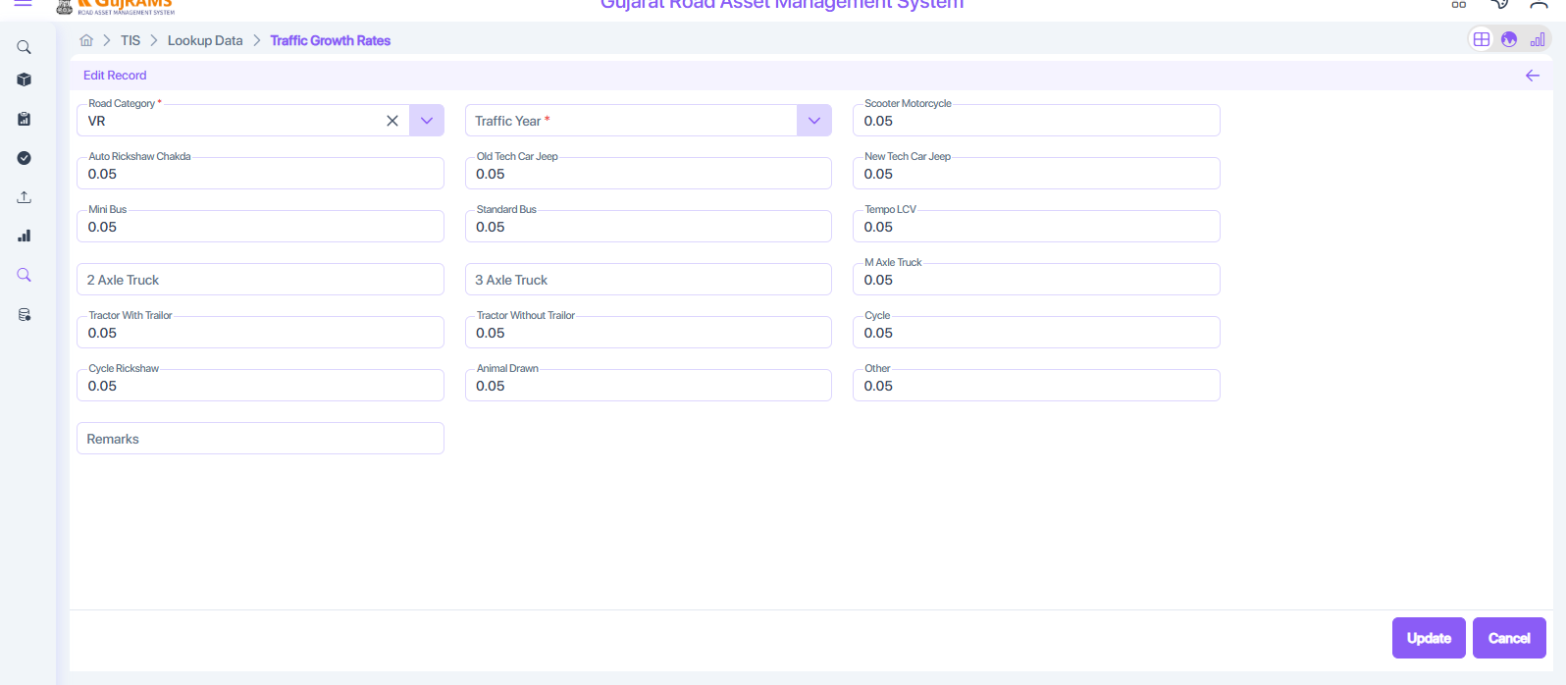

**Issue 18:  
Issue**: TIS → Reports → Unable to select survey date; report generation fails.  
**Priority**: High  
**Category**: Bug  
**Expected Result**: User should be able to select a survey date and generate the report.  
**Actual Result**: Survey date cannot be selected, and report generation is blocked, as it is a mandatory field.

(dependency base on dropdown)  
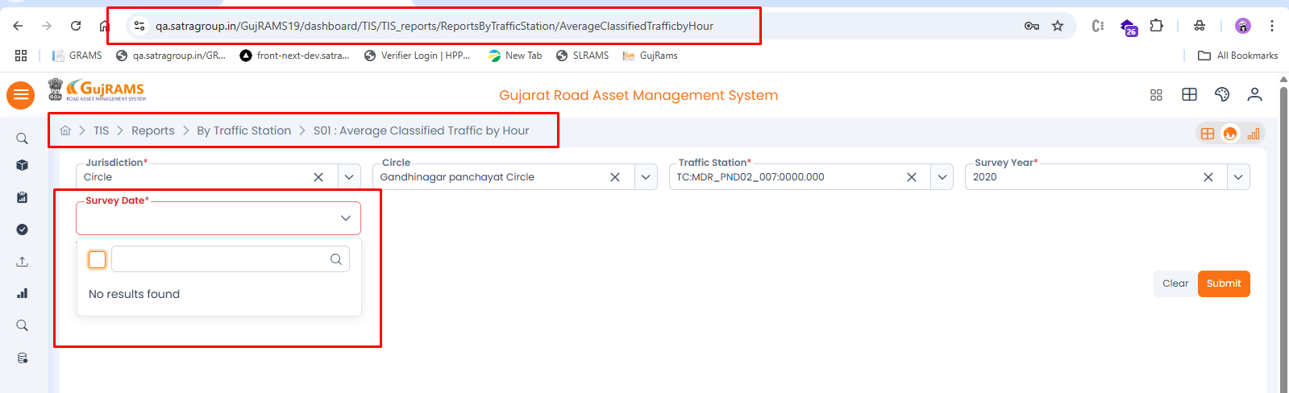

**Issue 19:**

**Issue**: TIS → Survey Data → Unable to add record; Save button does nothing.  
**Priority**: High  
**Category**: Bug  
**Expected Result**: Clicking 'Save' should add the record and provide confirmation.  
**Actual Result**: No response when 'Save' is clicked. (Done)

