## GujRAMS_RIS_WebApplication_Changes

1. 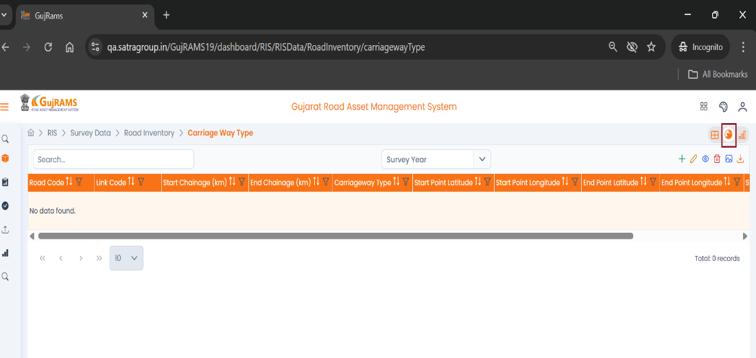Please do not Rotate the Globe Icon in the webpage.
2. 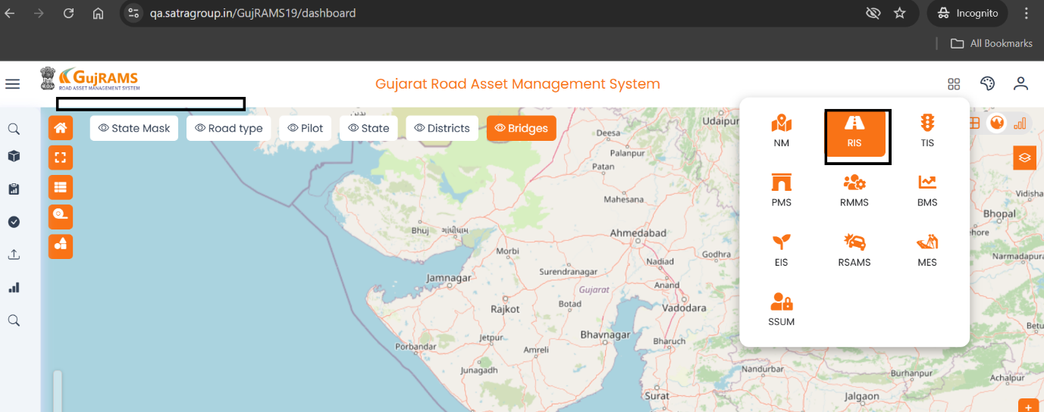Module name is not Visible when first entered in to Module. I clicked in the RIS but it is not displayed. Please review
3. 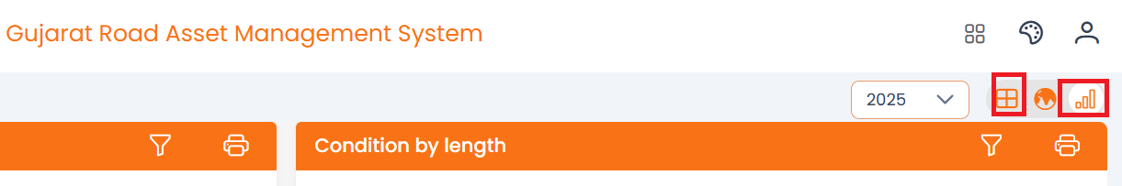Please display the Name as mouse Over

1. Dashboard – Headings and Spellings mistakes.
2. Colour should be changed for Inventory by length Chart.
3. No need of Mouse over function in chart.
4. Remove am charts logo below
5. Chart size should be reduced.
6. Values should be shown in the chart itself – (Percentage, value ex : 63.66 %, 504 km).

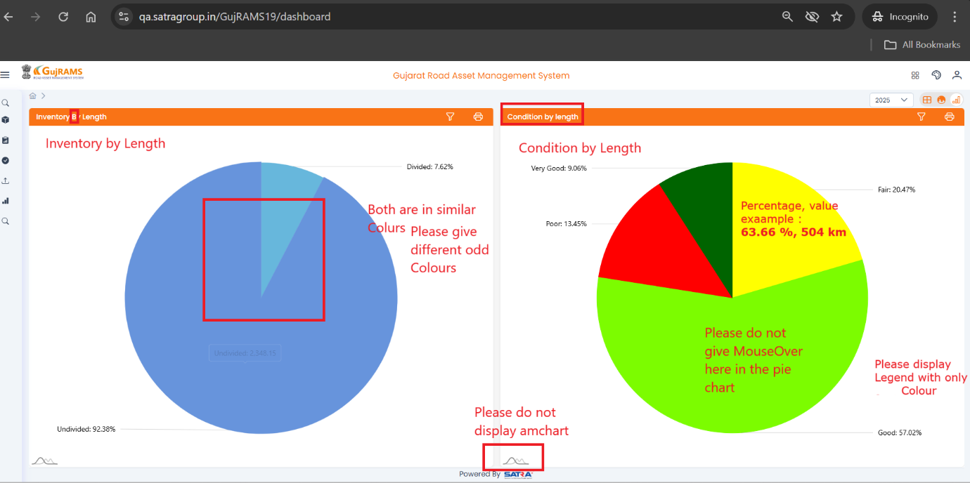

Please Refer above image for 4- 9 points

1. Condition Type/ Name is missing. Inventory attribute type should be visible even when the filter is hidden.

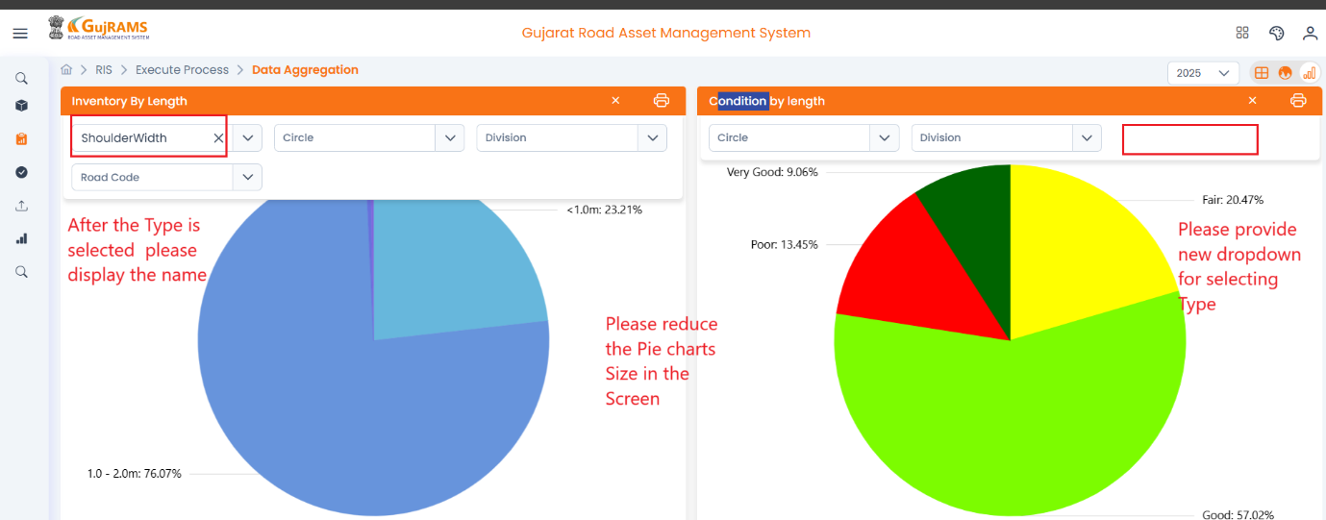

1. Execute process- Data aggregation – remove mandatory symbol.
2. To Add another filter, pass for Table list.
3. 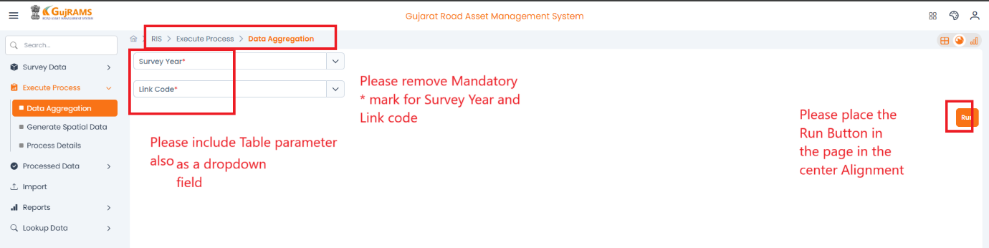To call the “Spatial data updation” in the Data Aggregation Process –Run button placing to be changed.
4. 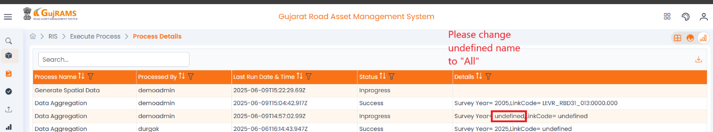Process Details – change text “Undefined to ALL ” when no link is selected.

1. Reports – Mandatory symbol is missing.
2. 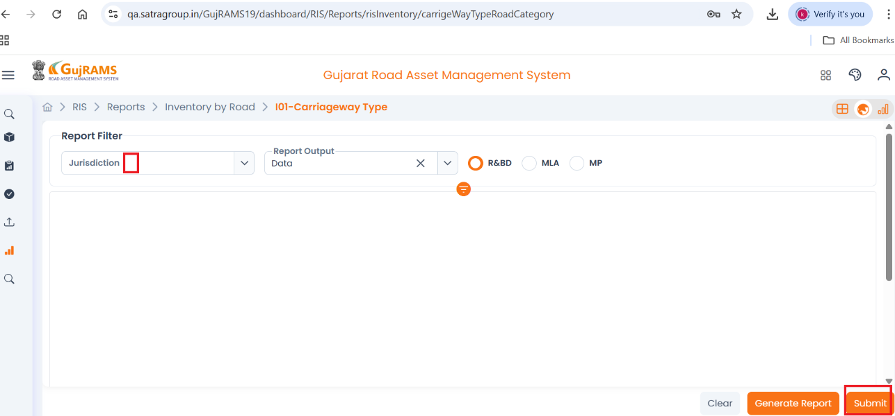Need to Remove Submit Button at the reports.

**Support Team:**

1. Data should be verified in the dashboard and Reports.
2. In Reports colour should be changed according to given Parameter.
3. To Prepare manual for Generate Spatial data.
4. GPS Process (Spatial Data updation) to be put in the data Aggregation Process.