1. Satellite view is missing in the new portal

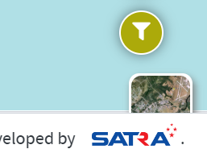

1. Provide a drop down to change the measuring unit with Kilo meters and Miles , need it in both old and new portal

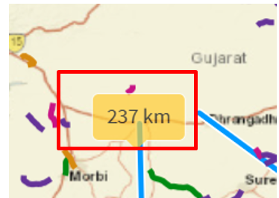

1. When we add measurement or draw , the Theme need to changed ( whichever colour is personalized that colour it needs to draw

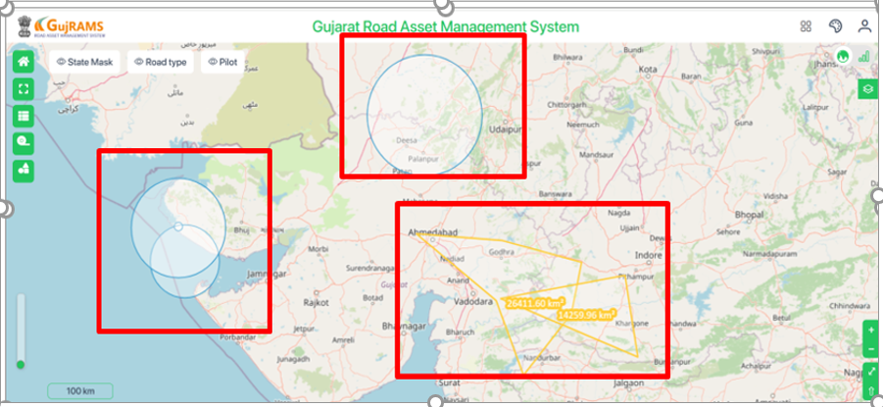

1. Need to add the below strip in the new portal



1. When click on the strip anywhere (Click on Pavement type) action need to take place, its working only when we click on the icon. This is same in old and new portal

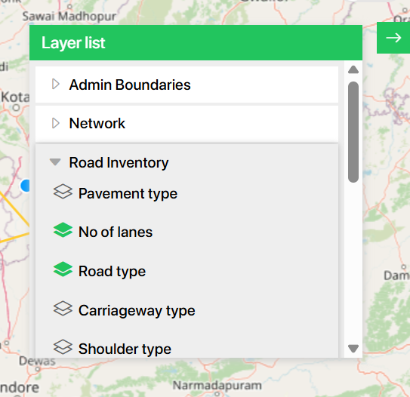

1. After drawing , there is no button to clear the drawing, “Clear graphics “ button is missing in both. In old When we click on close, it clears. But in new we are unable to clear at all.

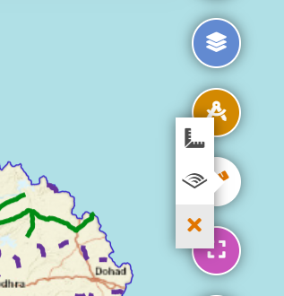

1. Print icon is missing in the new portal



1. In New portal we have Layer scroll, not required, it should be like old screen without scroll complete right alignment, but in the same new design as it is now.

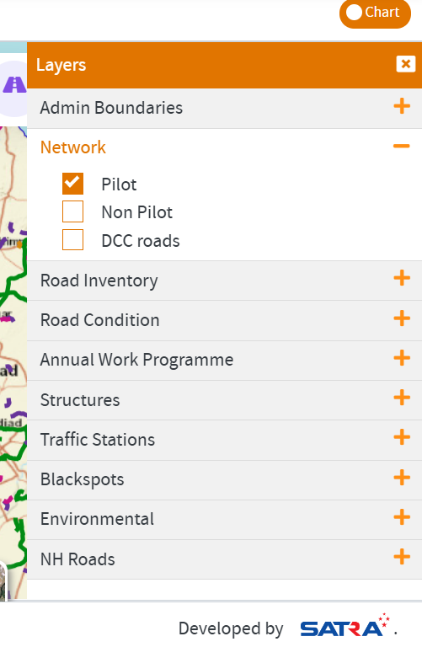

1. Remove the full stop and need to be right aligned in the new portal



1. Image rotation is working in the sample , but not in full screen

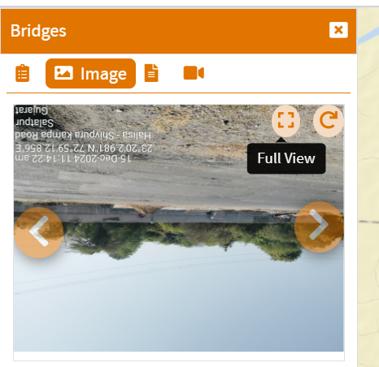

1. Remove ID column and Pilot is displaying twice . When we click on any data record in the grid, it should highlight the data on the map and show properties .

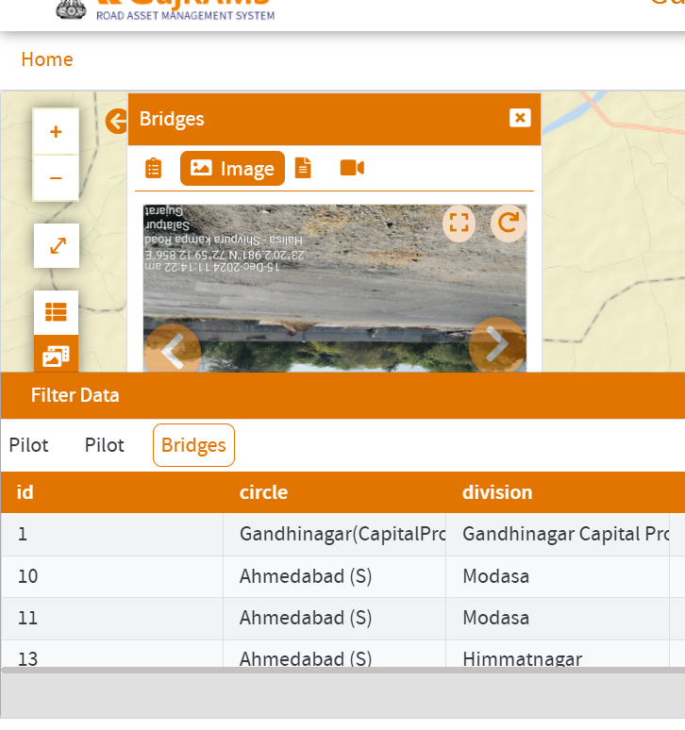

1. Filter is missing in the new web and Grid icon is also missing

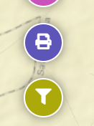

1. The below screen filter is missing

