**GujRAMS – R & B App Modifications:**

1. 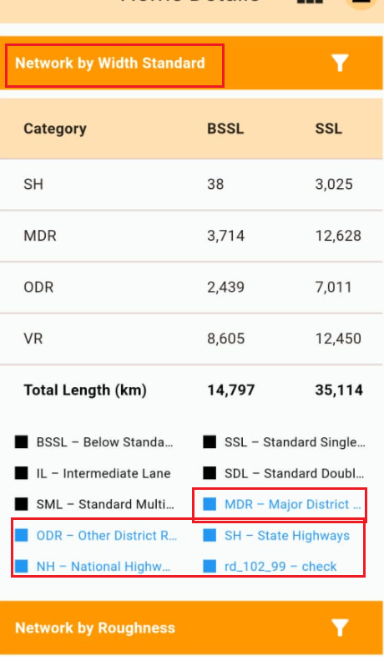Please display the data as Horizontal Stacked bars for “Network by Width Standard” and Network by Roughness. Please Remove Highlighted MDR, ODR etc from the Legend. Please decrease the Box width for the Network by Standard.
2. 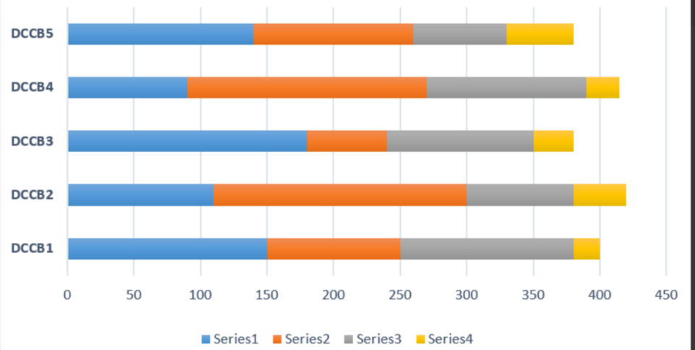Please find the Sample Example below for display of horizontal Stacked bars.   
   on the X axis Please display these 5 BSSL, SSL, IL, SDL, SML (each with different Colour Code and only abbreviation to be displayed, please do not expand BSSL etc).   
   Legend to be displayed mapping the Colour code to the Value  
   On the Y Axis Please display SH,MDR,VR Etc. Please display (Km) for Y Axis

1. 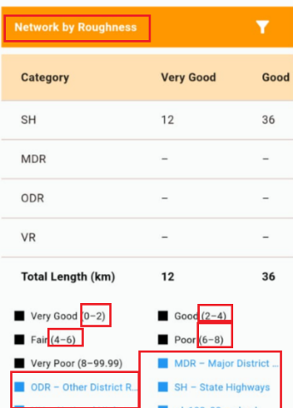For Network by Roughness, please display in the horizontal Stack Board Format, with Very poor, Good etc in the X axis and Road category in Y Axis. Please remove the Bracket values like (0-2) for the x Axis and do not display in legend the values in blue highlighted in the below image. Please display year beside the Name and by default data to be displayed. The year to be changed dynamically on selecting rom the filter. Please decrease Box width for the Network by Roughness.
2. Please do not display in App “Total length”, once the data is represented in Horizontal stacked bar.
3. 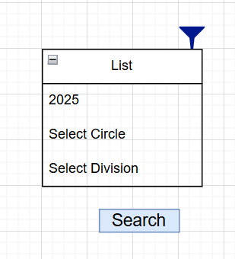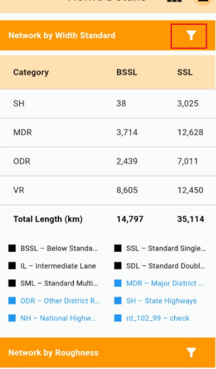On click of Filter button, please do not navigate to the New page. It is to be displayed as a popup in the same Home Screen.

If the Year need to be selected in Filter, please display the year beside the name.

Ex: Network by Roughness- 2025.

1. By default please display data for the year 2025 data (wherever year filter is Applicable).
2. 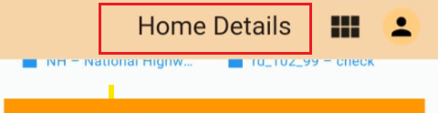Please Change the Name as “Network Survey” and place in the left Alignment.
3. Please display Modules as popup in the same Home Screen on click of menu Button.(Icons same as Web Application).

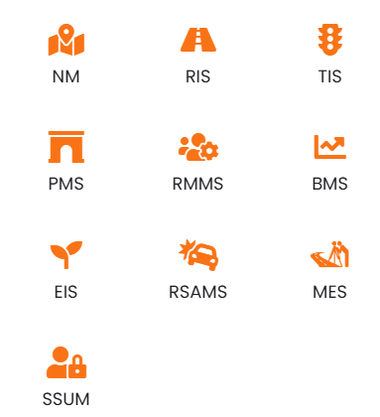

1. In Pie charts, please display the Percentage in the first line and the Round off Value (no Decimals) in the Second line.
2. 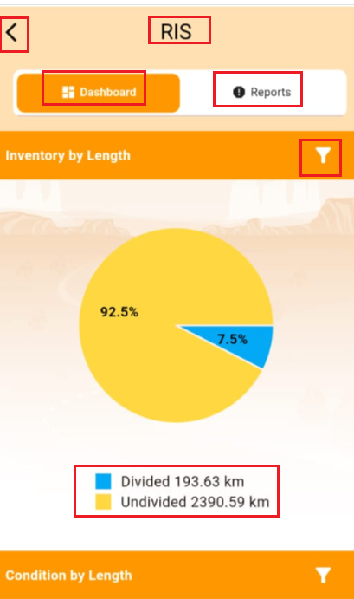On Click of any module by default User is landed in the below dashboard page.

Please implement the following changes across all the modules.

Please place the Back button and the Module icon(ex :RIS Icon) in the Left Alignment, Please display only Module Icon(do not display name).  
Dashboard and Reports to be displayed in the form of Suitable Icons (no Names) in the Right Alignment.(Kindly refer point 11 for the Dashboard, Reports icons).

The pie chart to display percentage values in the first line and the Actual number in the Second line.

Legend Divided, Undivided to be placed in the Same line (Font and size same as Reports Word). In the Legend only Colour and name to displayed(ex : Divided).  
  
Name change For Condition by length as “Condition by length -2025 “and by default to display 2025 condition data. Year to be changed dynamically after selecting from filter.

On Click of Filter please display in UI as shown in the image for point 5.   
Please display filter in the above defined format across all the Screens in the Applications.

1. 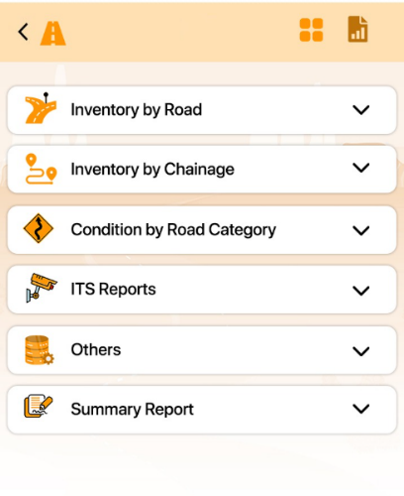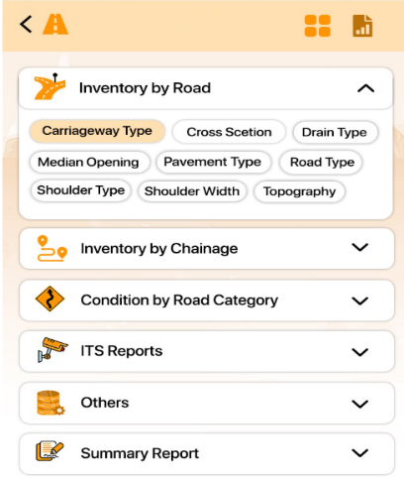Please do not display the Numerical values in Categories or Reports (ex: 101: carriage way report). Please display the Categories and reports as per below image.  
   In the above image RIS is the Selected Module. Please implement the same UI alignments for all other modules also.
2. On Click of any report (carriage way tab,) it is to be displayed as below screen

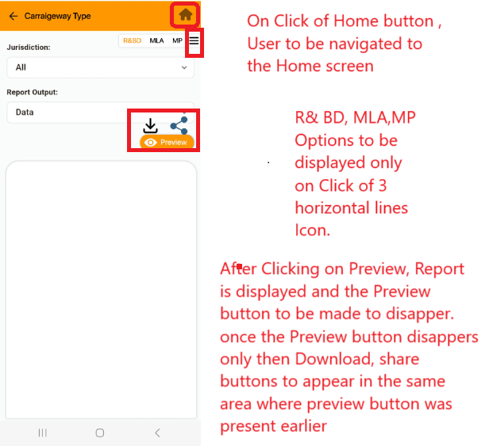In the below Screen Please remove the number before Carriageway Type and display name (Colour Black, Style same as Report Word) in the left Alignment..  
Generate Report to be Renamed as “Preview”.

1. 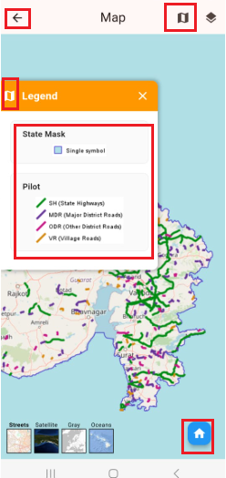In the Maps, Please Remove the Back button and the Functionality of that button to be given to the Home button.  
   Please display the heading Map in the Left Alignment.  
   Please Provide the new Icon for legend, currently Same Map Icon is displayed for Legend.
2. 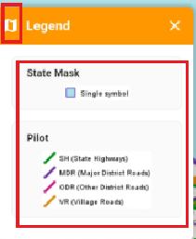After Placing the icon for the Legend. Please reduce the space for the State mask and the Pilot Section. Please reduce the height of the Orange Strip Legend.

After the legend is displayed and the User clicks anywhere else on the Screen the legend popup should not be displayed.

1. The below highlighted filter “State Mask” message is getting auto displayed on the Screen whenever zoom out or Zoom In in the Screen, Please do not display it.   
   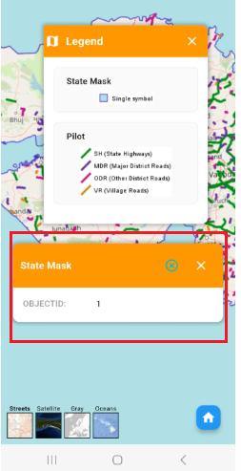
2. Whenever a Filter is Applied please make it Bold, if No filters are applied then make it normal Colour (Orange Colur)
3. 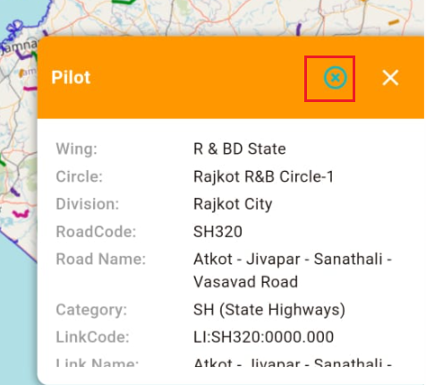When the details are displayed, Close button in Green colour is displayed, please Remove this Green Close button.