# New Observations in GujRams for RSAMS Module

### ****Issue 1: Circle Dropdown Not Displayed Properly**** Issue: Circle dropdown values are not displayed when the jurisdiction is set to "Circle". Priority: High Category: Bug Expected Result: Circle dropdown should list all available circles based on the selected jurisdiction. Actual Result: Dropdown appears blank and does not show any values. ****Screenshot:**** F:\GUJRAMS\Screenshot_RSAMS_1.png ****Issue 2: Division Dropdown Shows No Results****

### Issue: Division dropdown does not show any values when jurisdiction is set to "Division". Priority: High Category: Bug Expected Result: Division dropdown should display a list of available divisions based on the selected road code and jurisdiction. Actual Result: Dropdown displays "No results found" even when the inputs are valid. Screenshot****:****

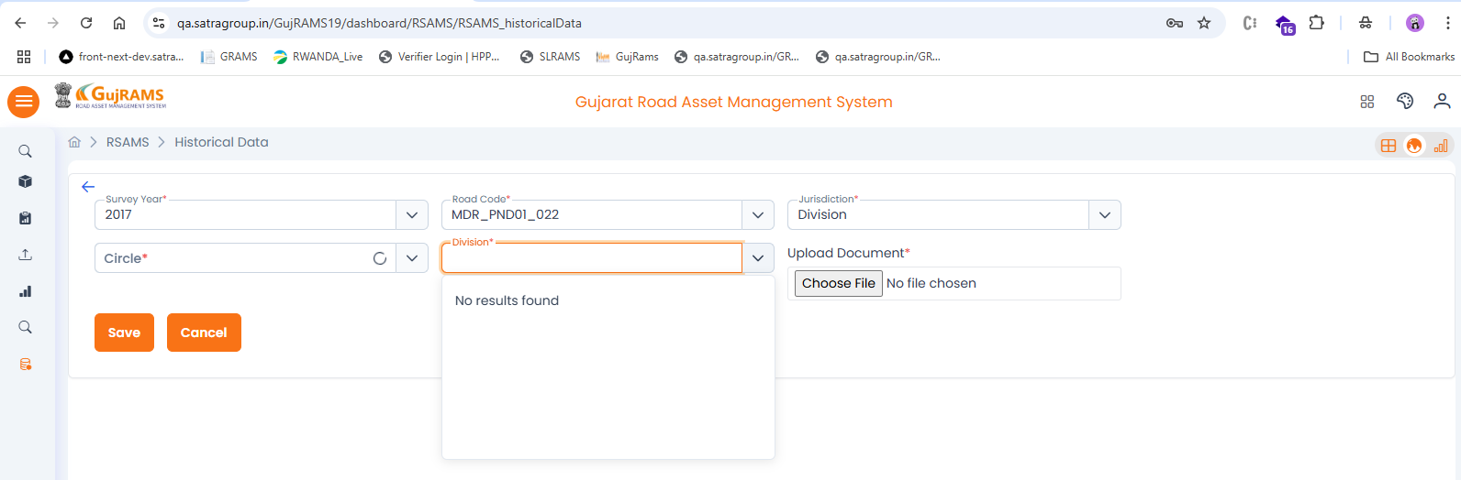

## Issue 3

### Issue: Alignment issue in Add column screen.

### Priority: Medium

### Category: UI

### Expected Result: All fields and labels should be properly aligned.

### Actual Result: Fields are not aligned properly in Add screen. Screenshot: F:\GUJRAMS\Screenshot_RSAMS_3.png

## Issue 4

### Issue: Survey and Coding dates not displayed.

### Priority: High

### Category: Bug

### Expected Result: Survey and Coding dates should be shown.

### Actual Result: Dates are missing in the iRAP view screen. Screenshot: F:\GUJRAMS\Screenshot_RSAMS_4.png

## Issue 5

Issue: Unknown error occurs while saving Accident Details. (The same error appears across all tables in the Survey Data section.)  
Priority: High  
Category: Bug  
Expected Result: Accident details should be saved without errors.

Actual Result: Unknown error appears on clicking Save.  
**Screenshot:**  
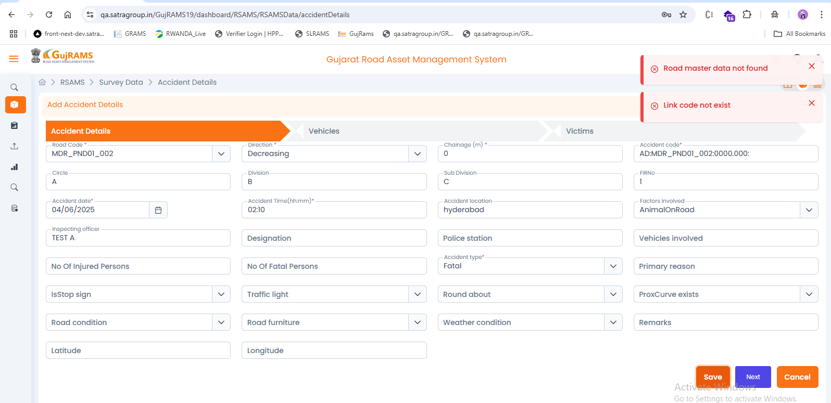

## Issue 6

Issue: Navigation and saving errors in Accident Details - Vehicles section.  
Priority: High  
Category: Bug  
Expected Result: Next button should navigate, Save should work.  
Actual Result: Next does nothing, save throws unknown error.  
**Screenshot:**  
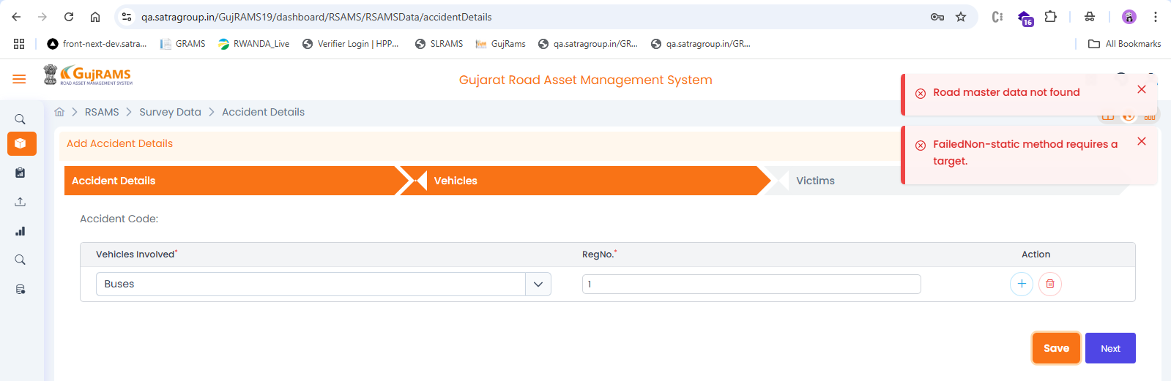

## Issue 7

Issue: Unknown error on saving in Victims section.  
Priority: High  
Category: Bug  
Expected Result: Victim data should be saved properly.

Actual Result: Unknown error on clicking Save in Victims add screen.  
**Screenshot:**  
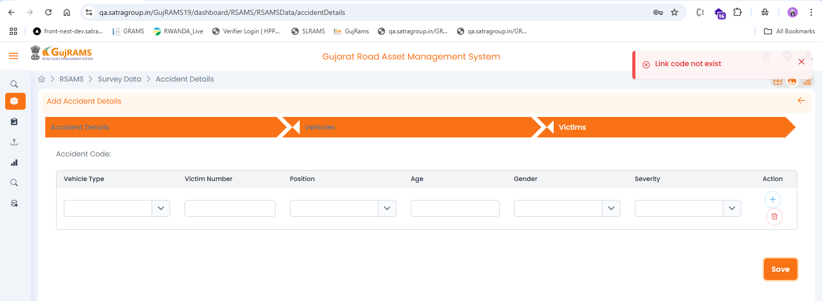

## Issue 8

Issue: Alignment differs from the old APK.  
Priority: Low  
Category: UI  
Expected Result: UI should match old APK alignment.  
Actual Result: Alignment is inconsistent with old APK.  
**Screenshot:**  
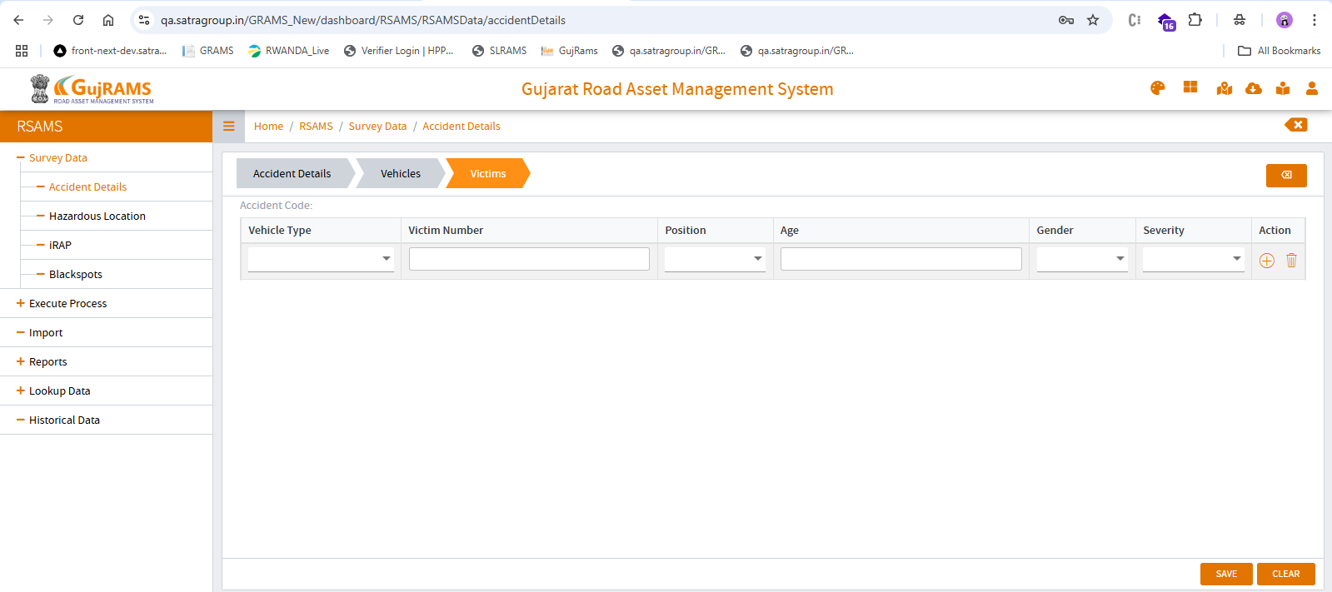  
  
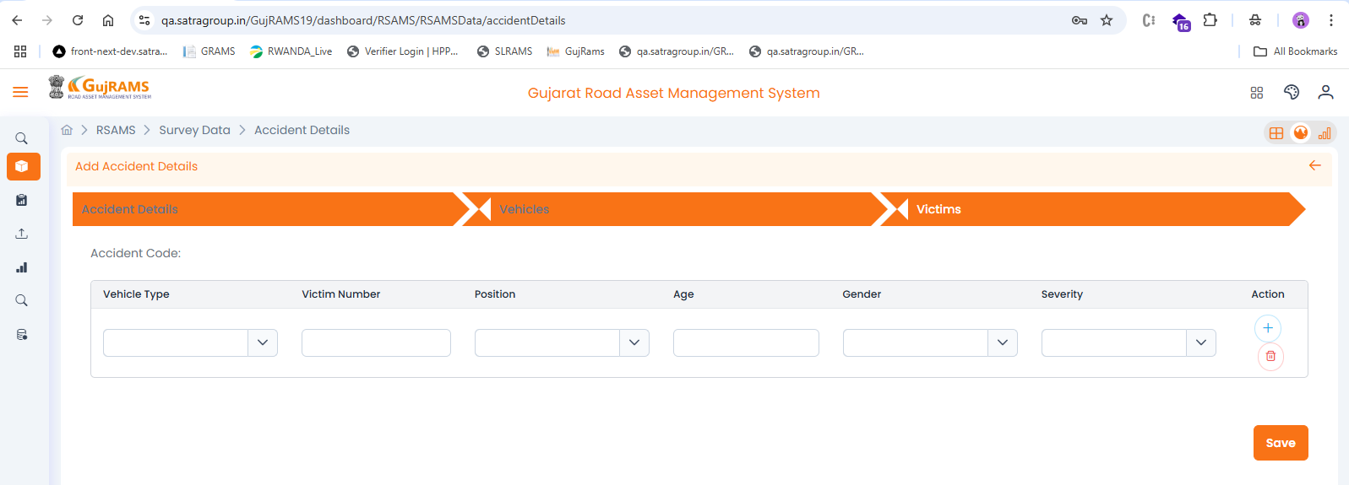

## Issue 9

Issue: No Clear button, and Cancel closes the whole page.  
Priority: Medium  
Category: UI/UX  
Expected Result: A Clear button should be present; Cancel should not close the page.  
Actual Result: Clear button missing; Cancel closes entire page.  
**Screenshot:**  
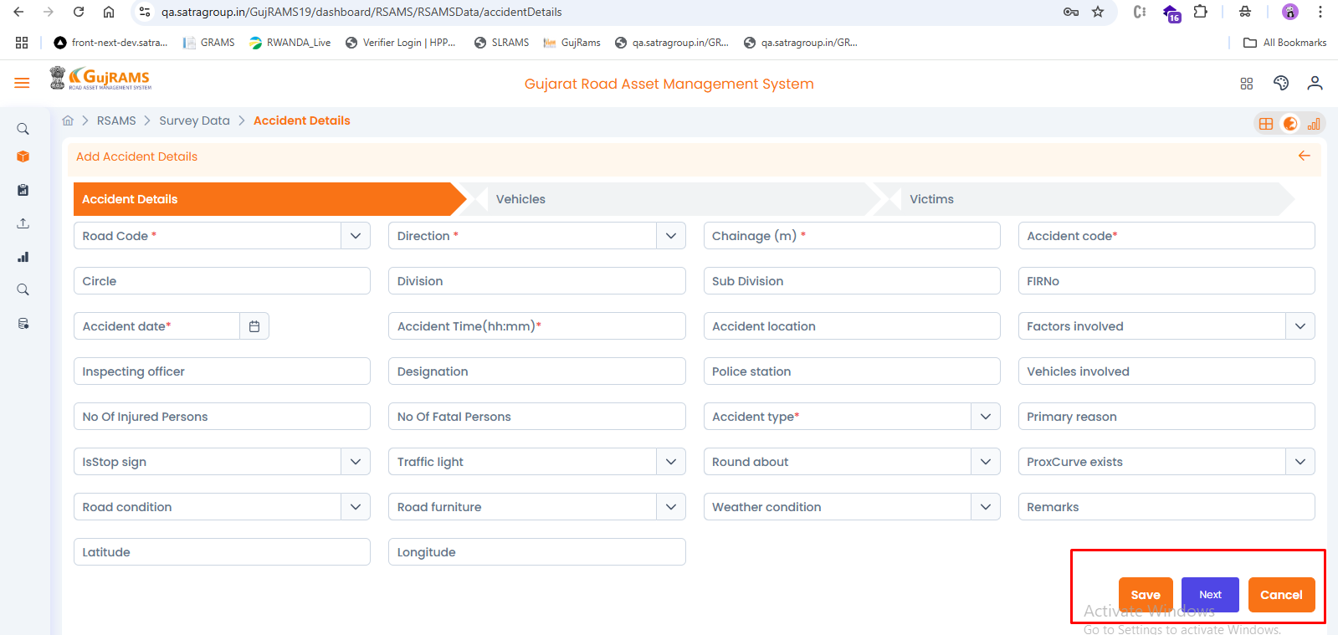

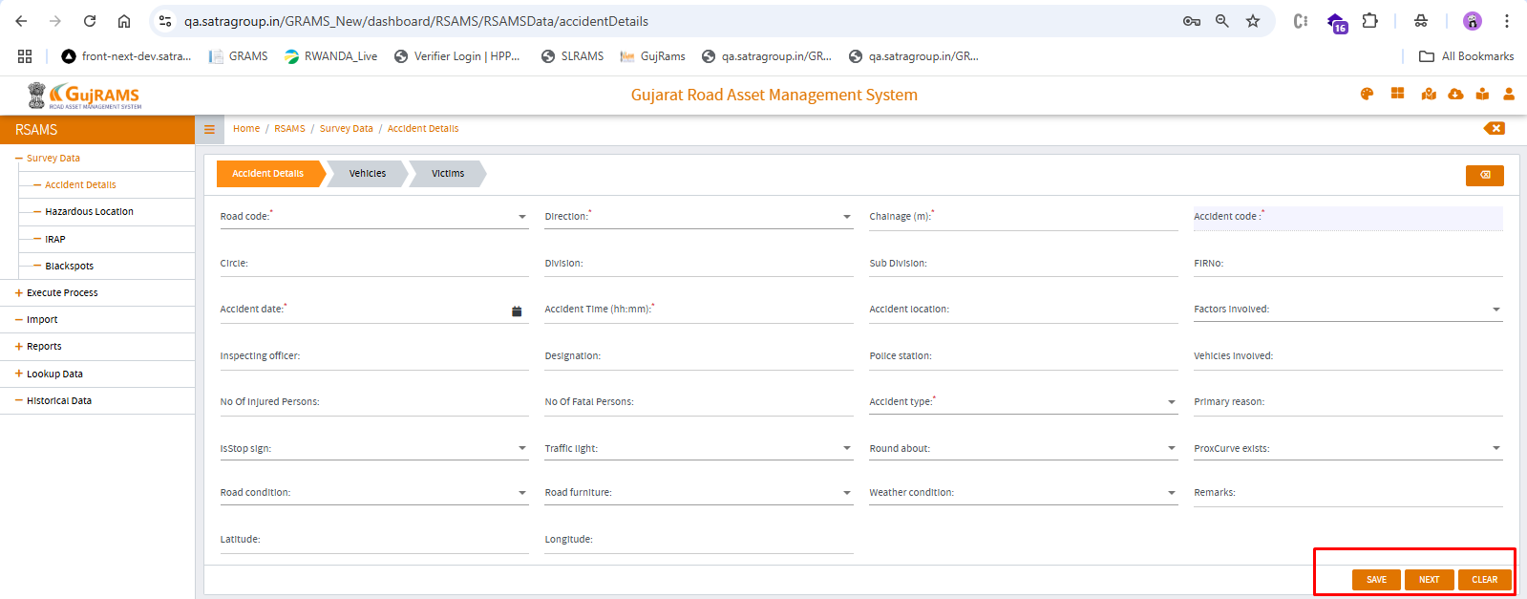

## Issue 10

Issue: Next button in Accident Details does not work.  
Priority: High  
Category: Bug  
Expected Result: Clicking Next should navigate to the next screen.

Actual Result: No action occurs on clicking Next.  
**Screenshot:**  
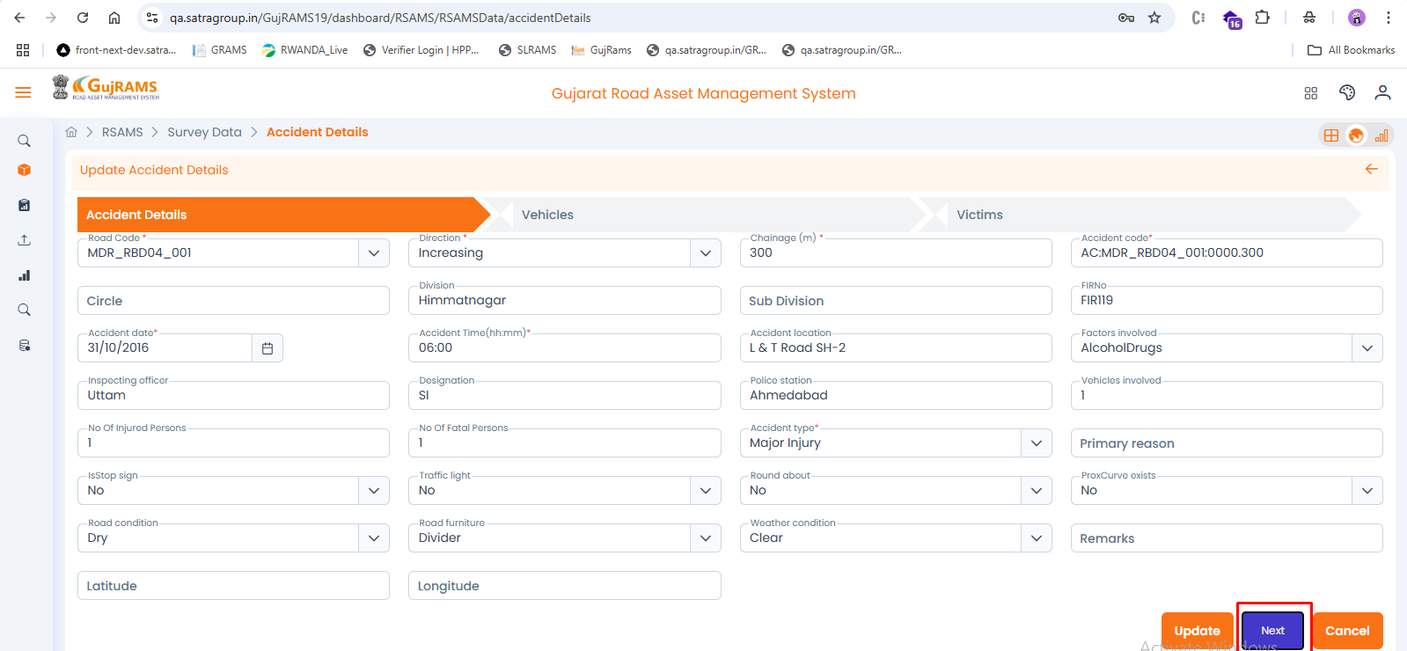

## Issue 11

Issue: Wrong alert message shown when no row is selected.  
Priority: Medium  
Category: Bug  
Expected Result: Alert should say: 'Please select a row to view'.  
Actual Result: Alert wrongly says: 'Please select a row to update'.  
**Screenshot:**  
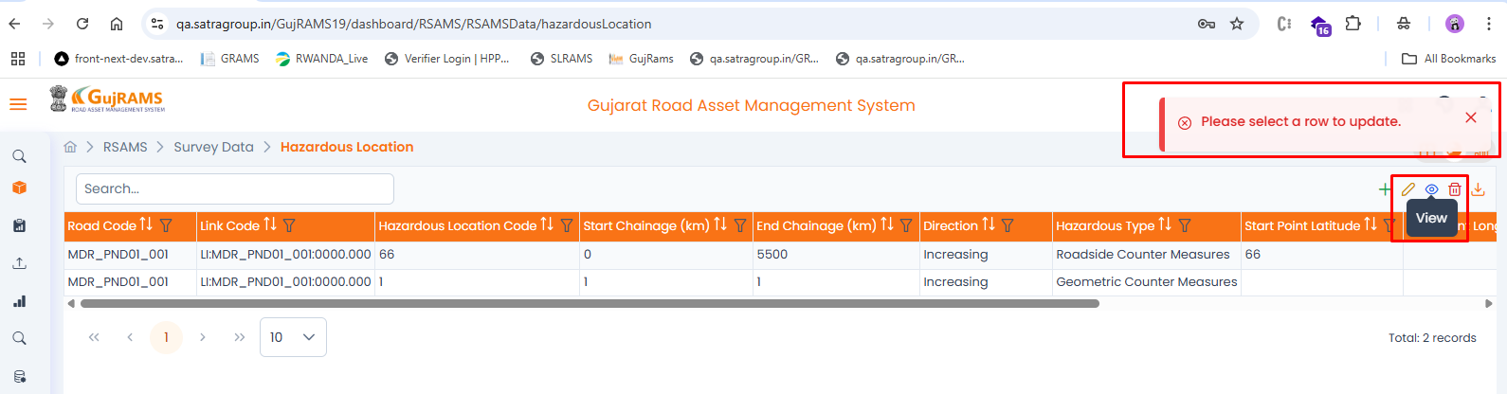

## Issue 12

Issue: Gallery icon is missing.  
Priority: Low  
Category: UI  
Expected Result: Gallery icon should be present.  
Actual Result: Gallery icon is missing from Survey Data screen.  
**Screenshot:**  
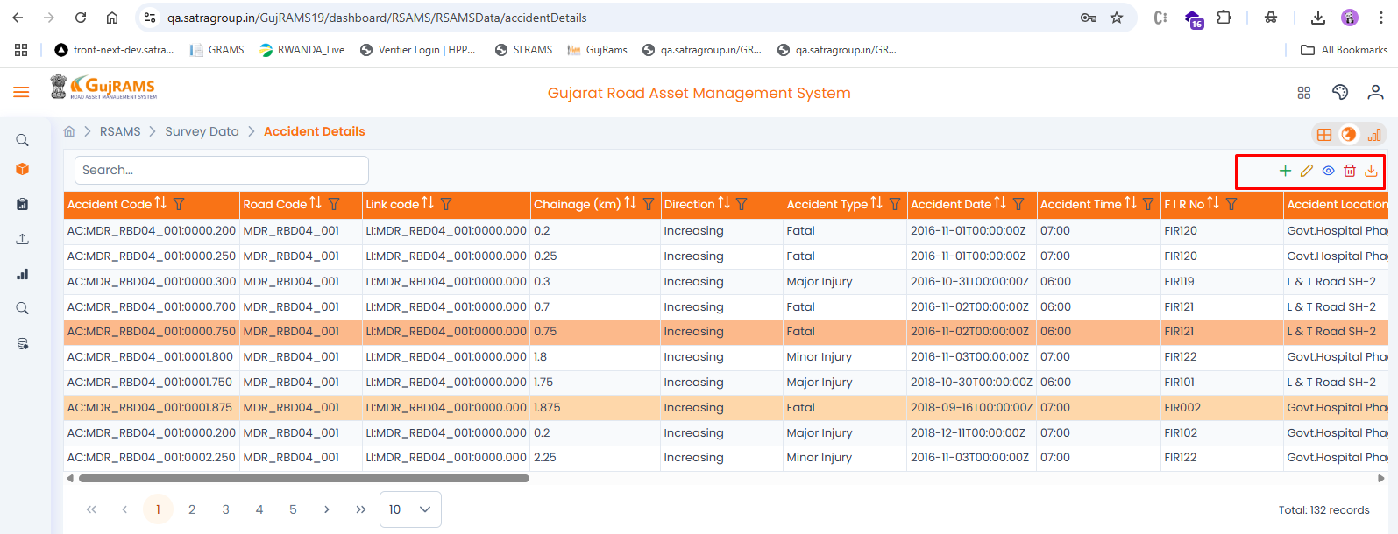

## Issue 13

Issue: Unknown error when clicking Run in Execute Process.

Priority: High

Category: Bug

Expected Result: Execute process should run without errors.

Actual Result: Unknown error is shown on clicking Run.  
**Screenshot:**  
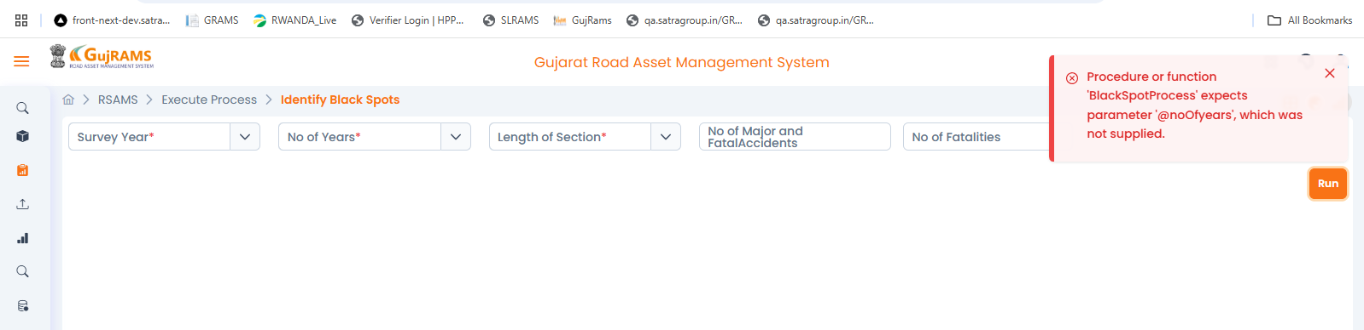

## Issue 14

Issue: Detailed report not refreshed on generating new report.  
Priority: Medium  
Category: Bug  
Expected Result: New report should be displayed on generation.  
Actual Result: Old report remains visible; page is not refreshed.  
**Screenshot:**  
