**NEW OBSERVATIONS IN GUJRAMS FOR MES MODULE:**

**Issue 1:**

**Issue**: MES → Package Details → Add Record → Mandatory fields are not highlighted with specific colour. Check for all modules

**Priority**: Low  
**Expected Result**: Mandatory Symbols must be highlighted and displayed in red colour.  
**Actual Result**: Mandatory field symbols are not highlighted as shown  
**Category**: UI Issue

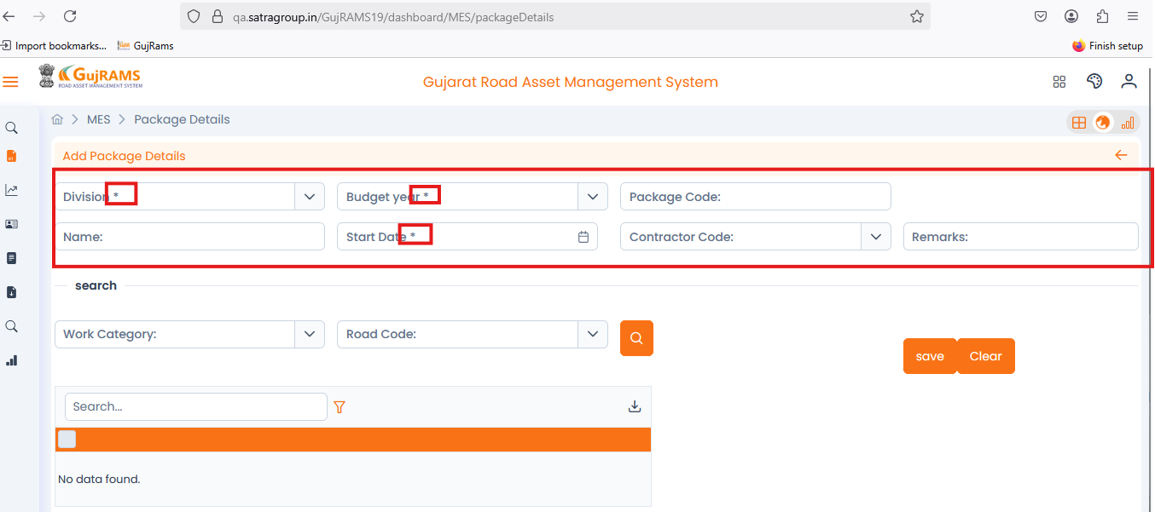

**Issue 2:**

**Issue**: MES → Package Details → Add Record → Alignments of text boxes are not good. Check for all modules.

**Priority**: Medium  
**Expected Result**: Alignments must be in right way  
**Actual Result**: Text boxes and alignments are not good and looking some awkward as attached the screenshot for your reference.  
**Category**: UI Issue.

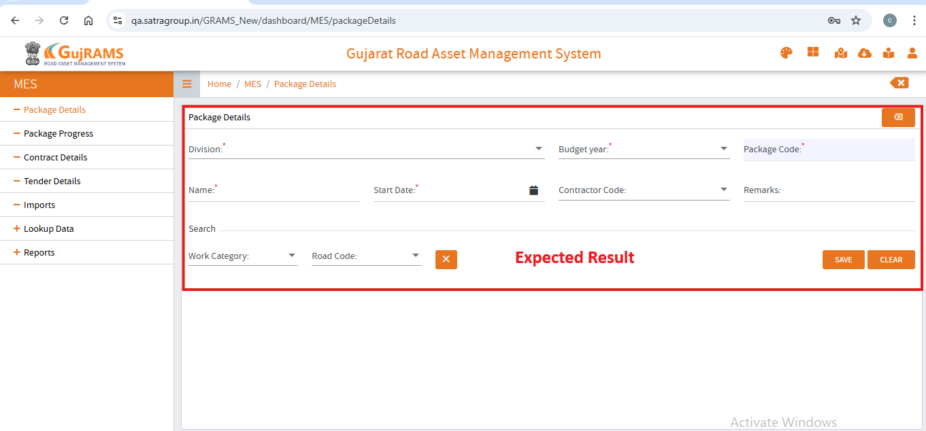

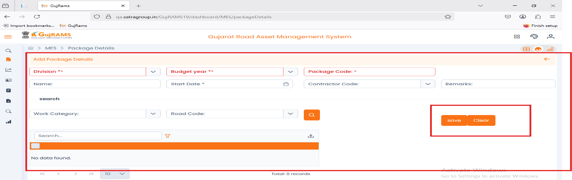

**Issue 3:**

**Issue**: MES → Package Details → Update Record → Without selecting a row to update it is redirecting to update package details screen directly.

**Priority**: High  
**Expected Result**: Only popup must be displayed “Please select a row.”  
**Actual Result**: It is redirecting to the next screen and at the same time it is also displaying popup message.  
**Category**: Bug.

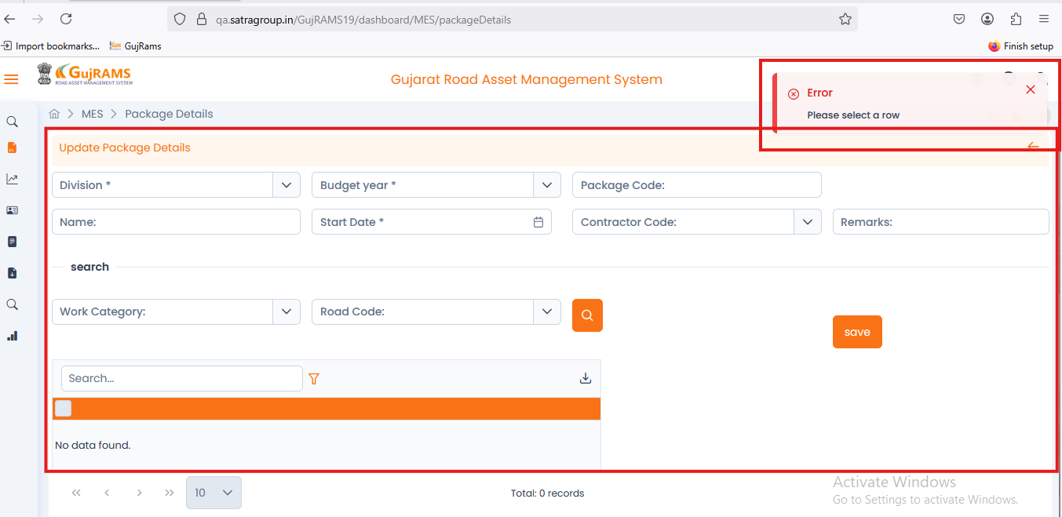

**Issue 4:**

**Issue**: MES → Package Details → Select Row → Update Record → After updating the record it is directing to package details screen but it is displaying no records found.

**Priority**: High  
**Expected Result**: Along with records updated record should be displayed.  
**Actual Result**: No records displaying after updating the record. Please find the screen shot for your reference.  
**Category**: Bug.

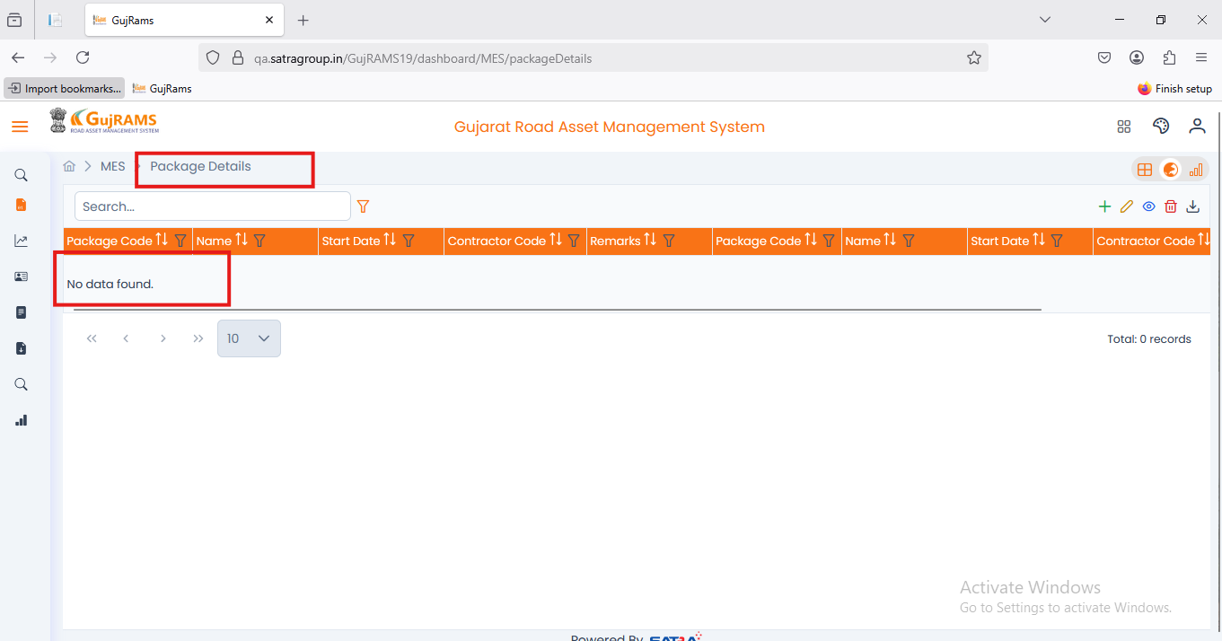

**Issue 5:**

**Issue**: MES → Package Details → Select Row → View Record → Add Package Details heading is displaying.

**Priority**: High  
**Expected Result**: View Package details Heading should be displayed in the particular screen.  
**Actual Result**: Displaying wrong heading for the particular screen screenshot attached for your reference.  
**Category**: UI Issue.

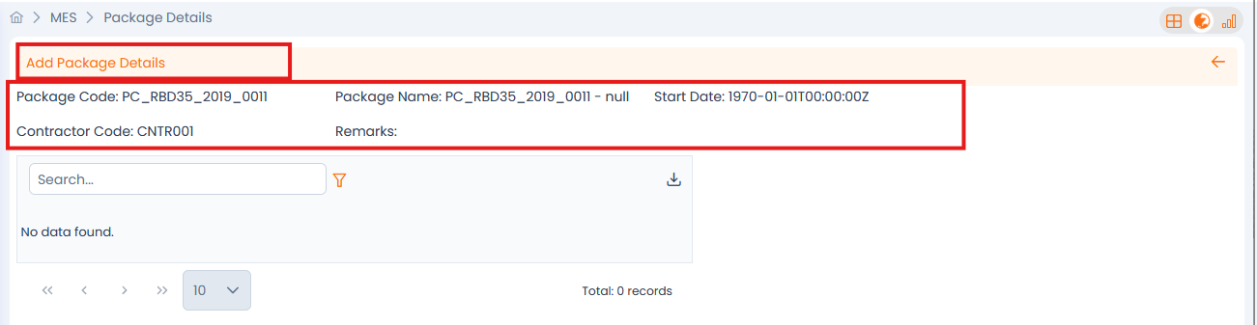

**Issue 6:**

**Issue**: MES → Package Progress → Add Record → After adding all the data in fields unable to click on update button & Update button must be highlighted. Check for all modules.

**Priority**: High  
**Expected Result**: Able to click on update button and data which user user is trying to add must be displayed in records screen.  
**Actual Result**: After clicking on update button the wrong popup is displaying as shown in the screen shot attached for your reference.  
**Category**: Bug.

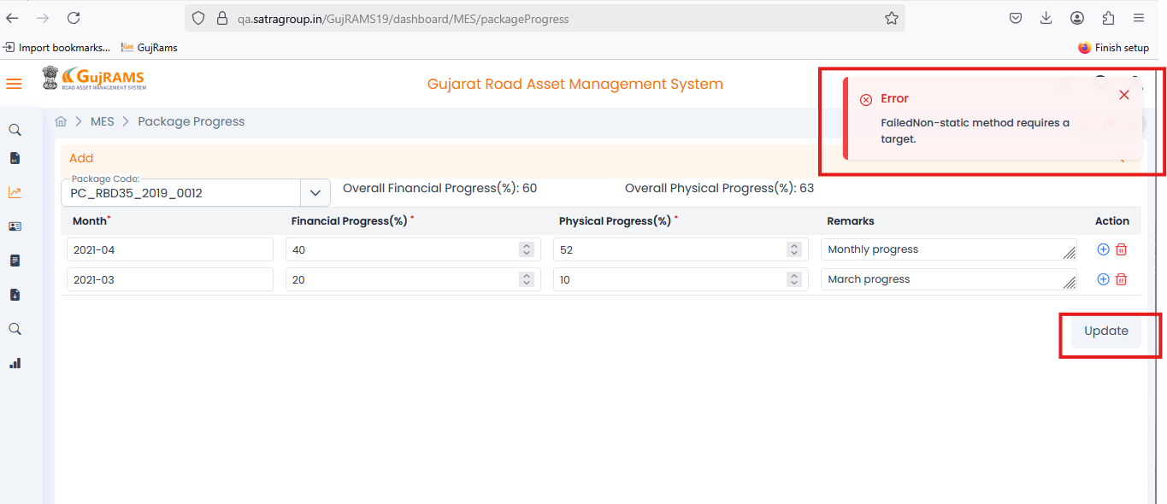

**Issue 7:**

**Issue**: MES → Contract Details → Add Record → Mandatory fields are not highlighted with specific colour. Check for all modules

**Priority**: Low  
**Expected Result**: Mandatory Symbols must be highlighted and displayed in red colour.  
**Actual Result**: Mandatory field symbols are not highlighted as shown  
**Category**: UI Issue

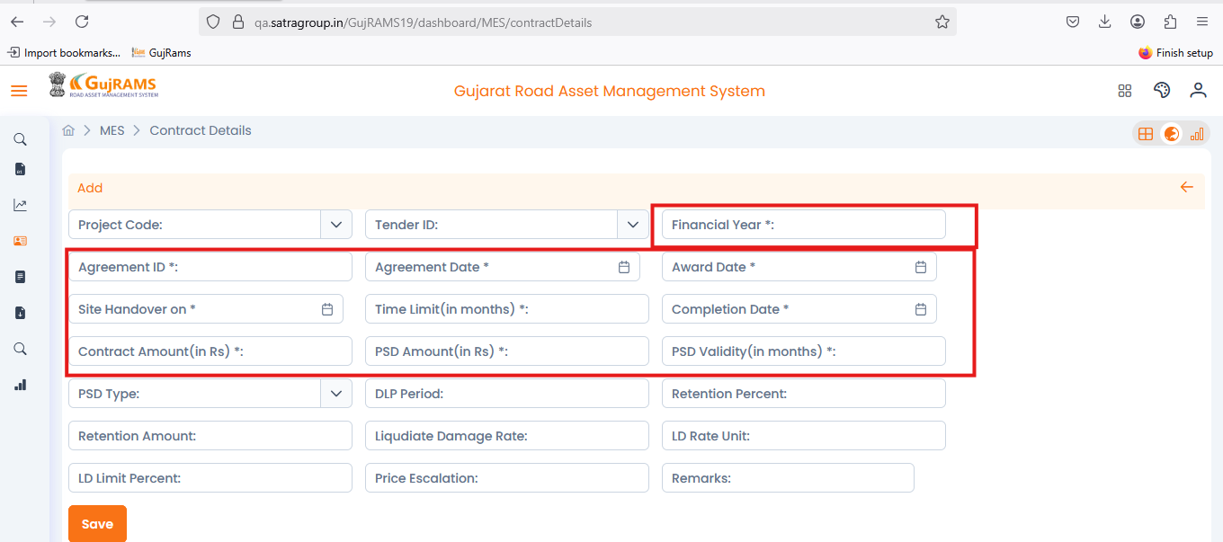

**Issue 8:**

**Issue**: MES → Contract Details → Add Record → Given data but save is not clickable. Check for all modules

**Priority**: High  
**Expected Result**: Save Button should be clickable & page must redirected to records page.  
**Actual Result**: Not able to add the record because save button is not clickable.  
**Category**: Bug

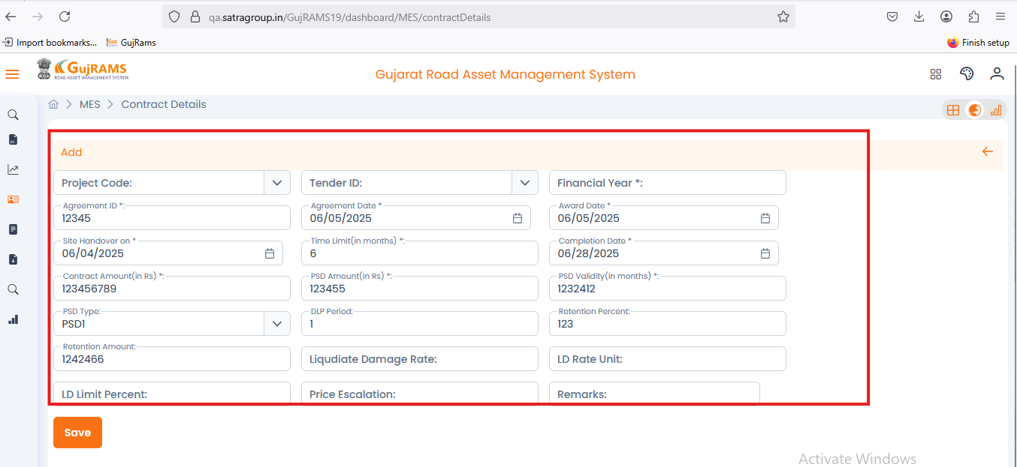

**Issue 9:**

**Issue**: MES → Lookup Data → Contractor Details → Select Row → Update → When user update data it is displaying wrong popup and updated data not reflecting in the record section. Check for all modules

**Priority**: High  
**Expected Result**: It should display “Contractor Details updated Successfully” and updated data should reflect in record section.  
**Actual Result**: It is displaying wrong popup message.  
**Category**: Bug

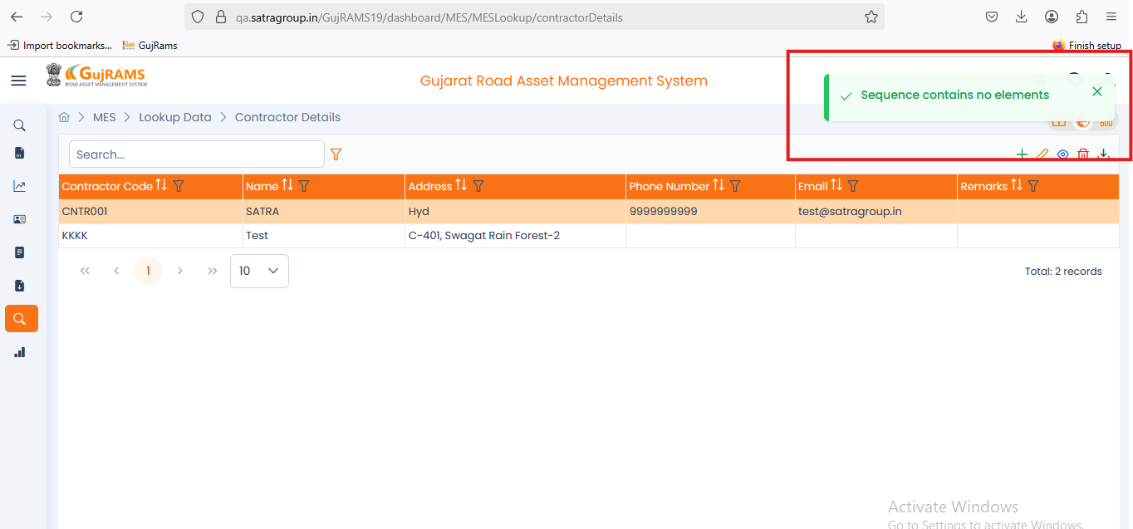

**Issue 10:**

**Issue**: MES → Lookup Data → Contractor Details → Select Row → View → When user try to view data the heading of the page is not matching. Check for all modules

**Priority**: High  
**Expected Result**: Page heading should be like view contractor details  
**Actual Result**: It is displaying as edit record.  
**Category**: UI Issue

