**NEW OBSERVATIONS IN GUJRAMS FOR NM MODULE:**

1. User clicked on **NM**.

**Priority-** Medium

**Category** – Improvement

**Result -**

**Actual** - No indication that user is in NM module page

**Expected** - NM indication must be there.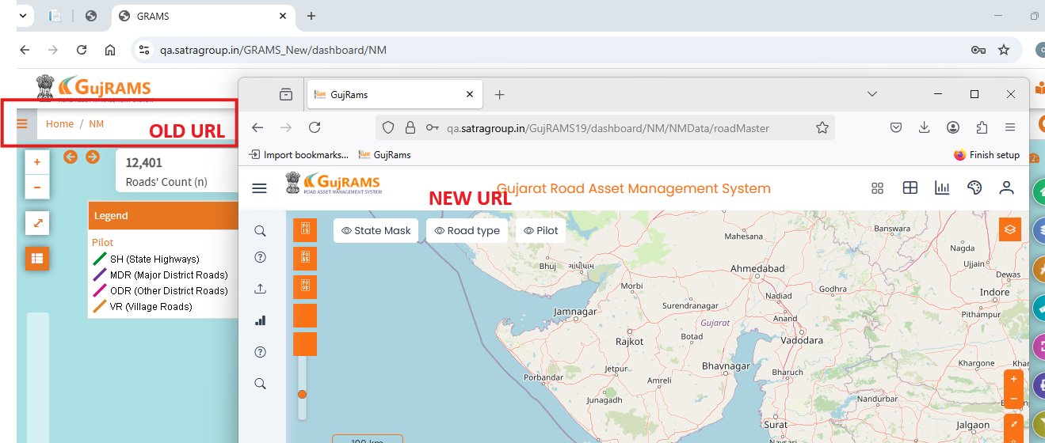

1. User clicking on Add Button in Road Details ->Lands on Add Road Details Page.

**Priority-** Medium

**Category** - Improvement

**Result-**

**Actual** – Text alignments are changing for required fields by editing the text box without filling data and user moving cursor to another text box.

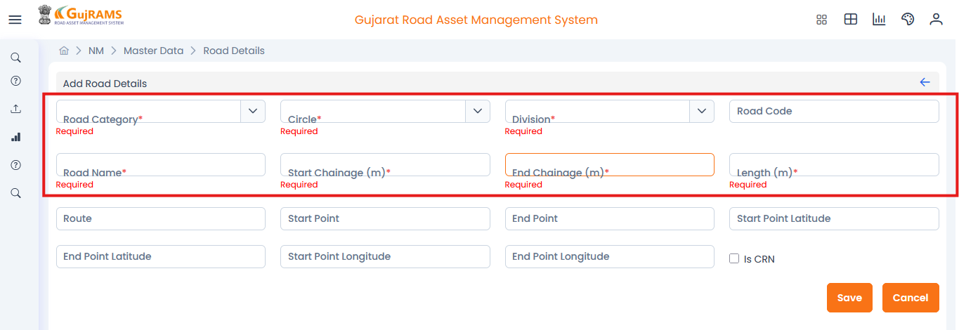

**Expected** – Text Alignments should be same by default.

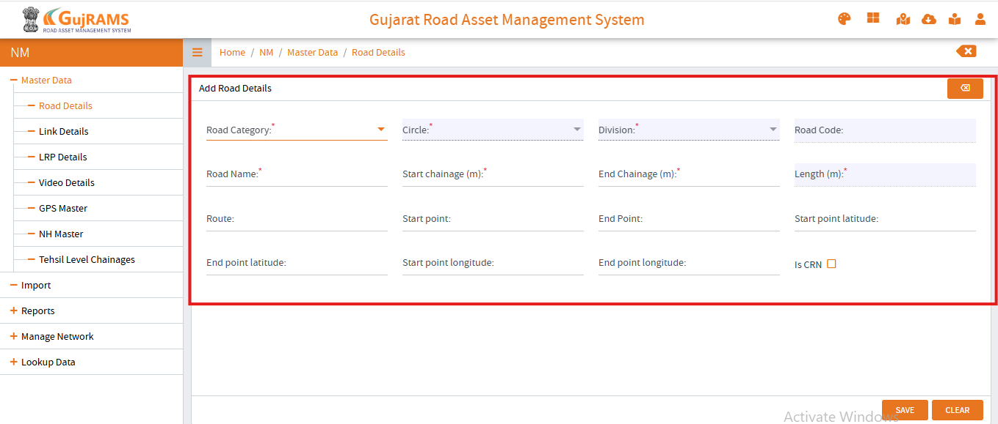

1. User clicking on Add Button in Road Details ->Lands on Add Road Details Page.

**Priority-** Medium

**Category** - Improvement

**Result-**

**Actual -** Text colour is changing in red colour for required fields by editing the text box and filling the data and deleting that filled data and moving cursor to another text box.

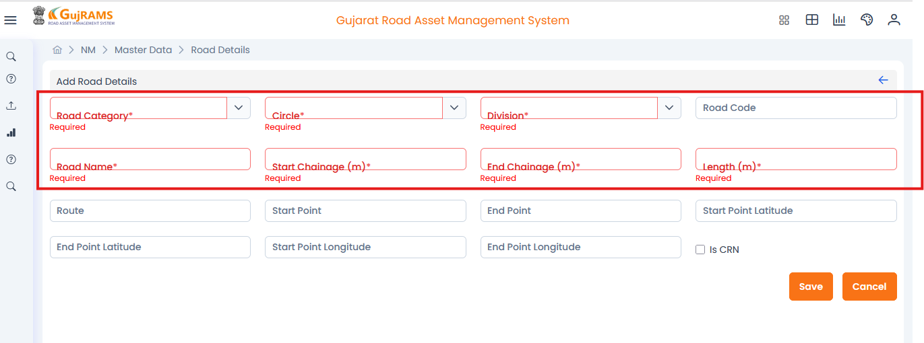

**Expected –** Text colour should be same by default for all fields.



1. User clicking on Add Button in Road Details ->Lands on Add Road Details Page.

**Priority-** High

**Category** - Bug

**Result-**

**Actual-** Filled all the data and saved it-> Getting some failed validation **popup** as shown below.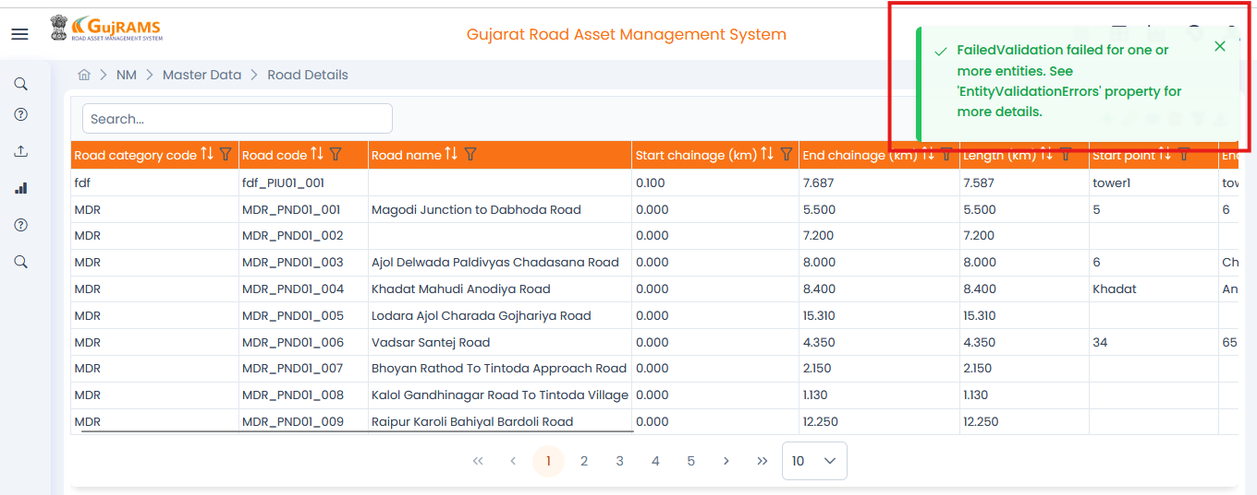**Expected-** popup message must be **Roadcode saved successfully** as shown below.

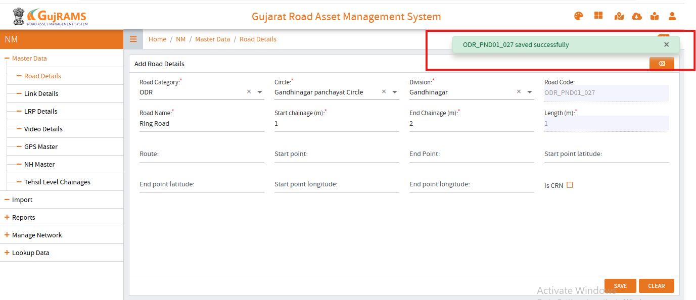

1. User clicking on **Update Button** in Road Details ->Lands on Update Road Details Page.

**Priority-** High

**Category** – Improvement

**Actual** – Road updated successfully popup message is displaying.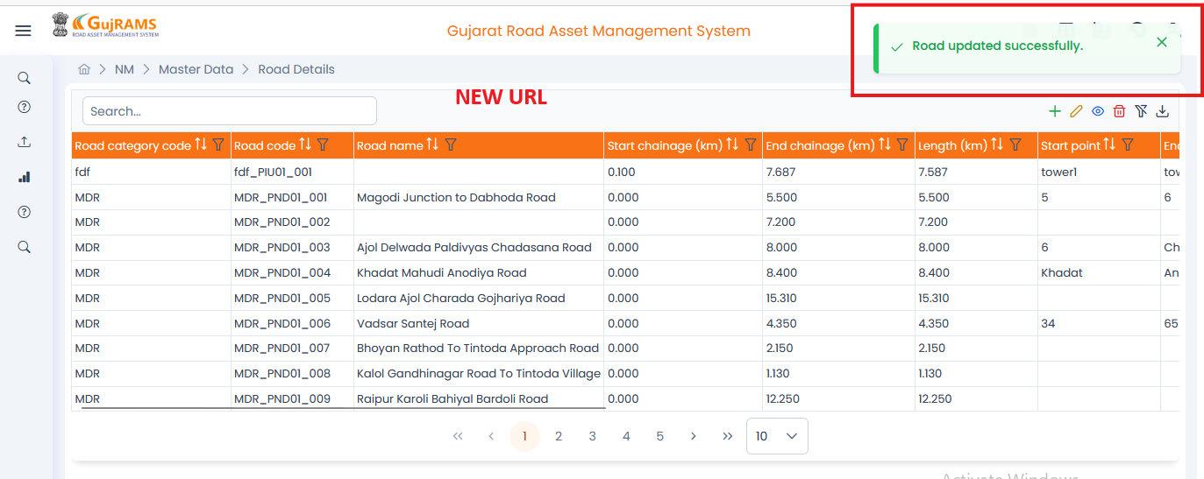

**Expected**- Better to Display Successful popup message with particular road name or road code, which we have selected previously to update as below attached screen shot.

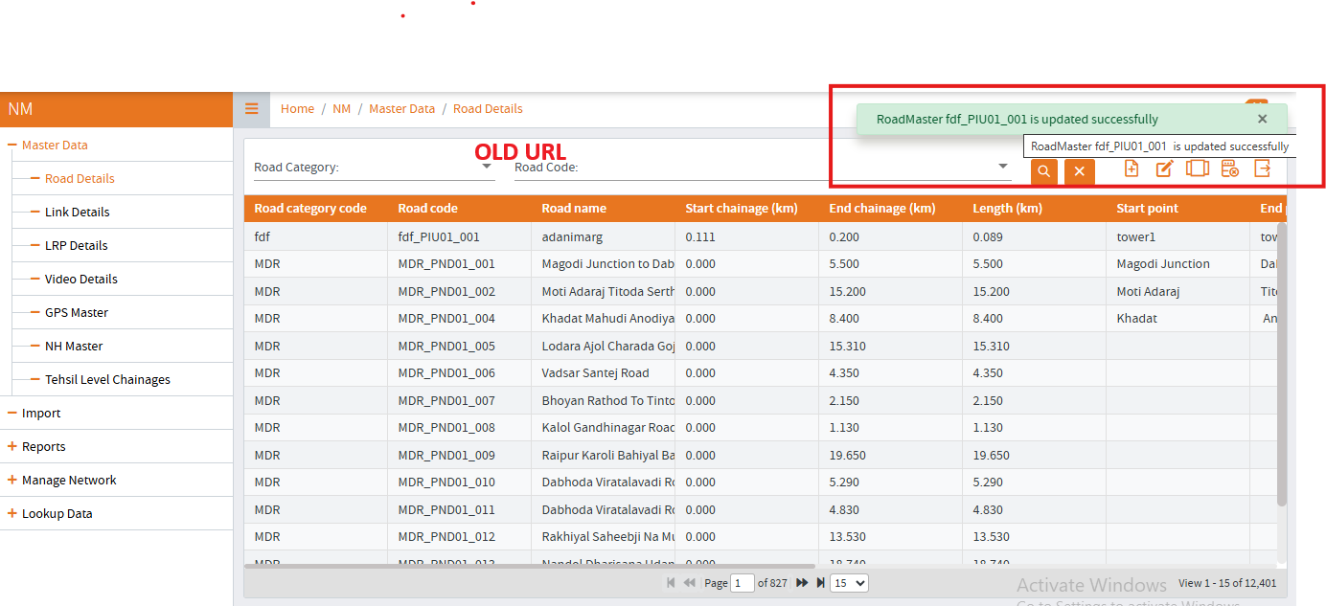

1. User clicking on **View Button** in Master Data ->Lands on **View Road Details Page**.

**Category** – Bug

**Priority-** High

**Actual** –Unable to view the selected data.

**Expected**- For the first only data must be viewed.

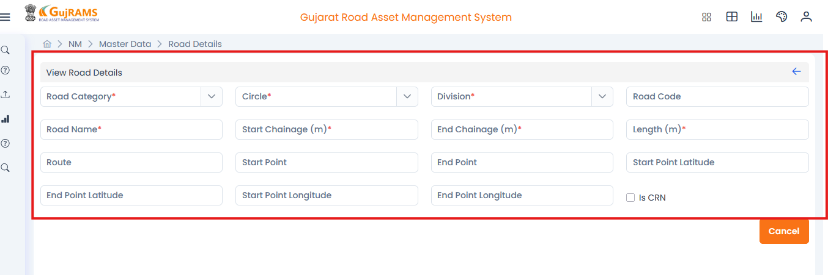

1. When User clicks on Hamburgers menu in Nm Module

**Category** – Bug

**Priority-** High

**Actual-** When compared some tables are missing.

**Expected-** Tables must be added as per the previous build.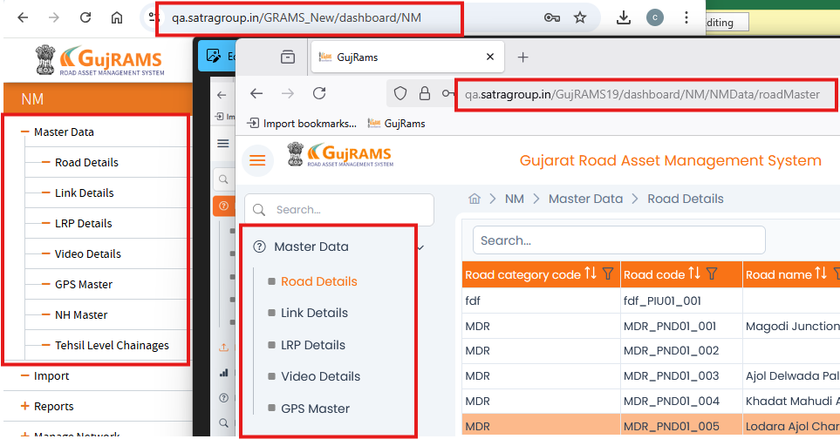

1. User clicking on Add Button in Road Details ->Lands on Add Road Details Page

**Category** – Bug

**Priority-** High

**Actual-** When user trying to give alphabets in the start end points latitude and longitude it is accepting and not displaying any error message.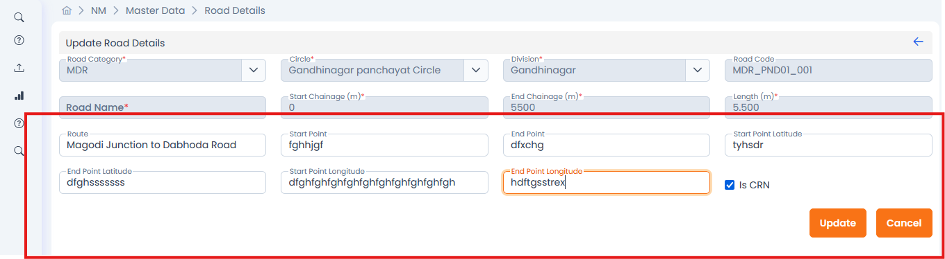

**Expected-** Must only accept decimal numbers if not it should display error message(Check for all modules).

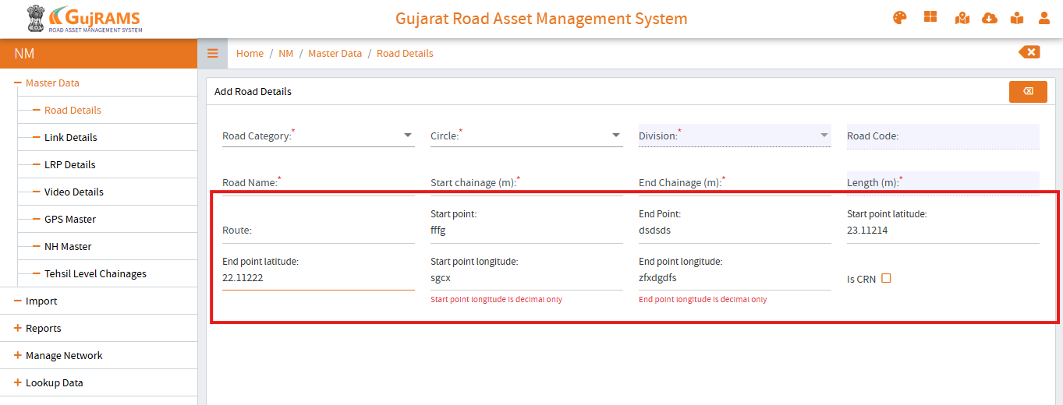

1. User clicking on Add Button in Link Details->Lands on Link Details Page.

**Category** – Bug

**Priority-** High

**Actual-** Filled details and try to save the data but the save is not clickable.

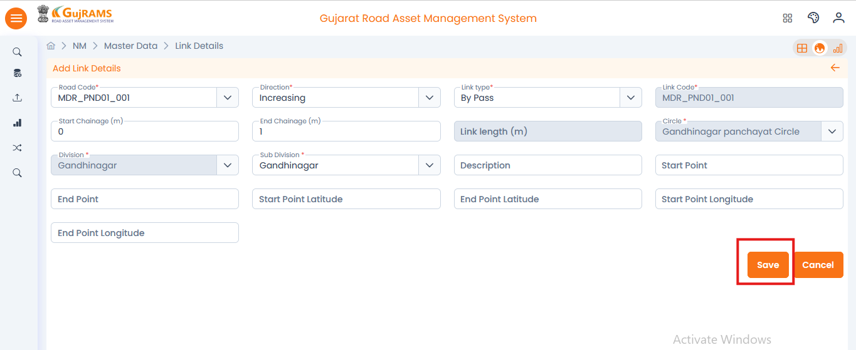

**Expected-** After filling the data the save must be clickable to save it and page redirects and lands on Link Details Page.

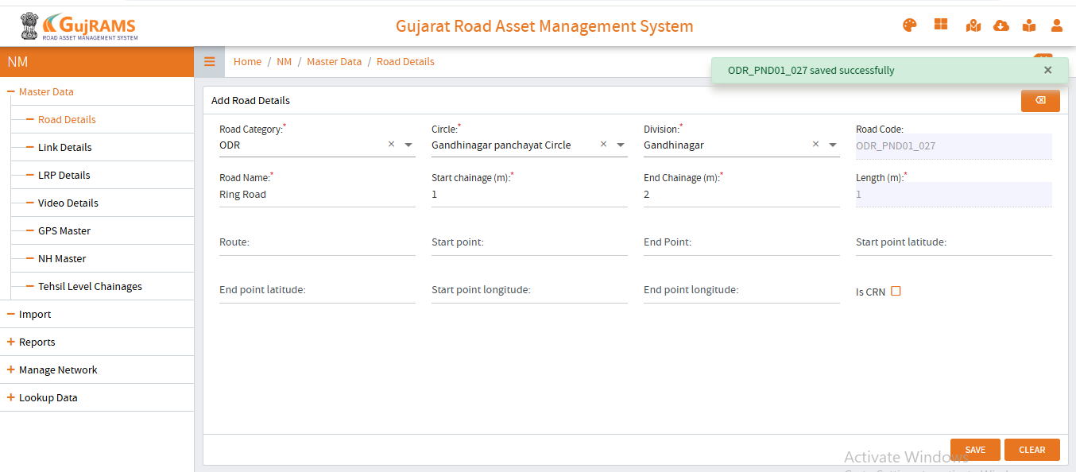

1. User clicking on Add Button in LRP Details->Lands on LRP Details Page.

**Category** – Bug

**Priority-** High

**Actual-** Chainage field accepting the alphabets.

**Expected-** It should accept only integer values.

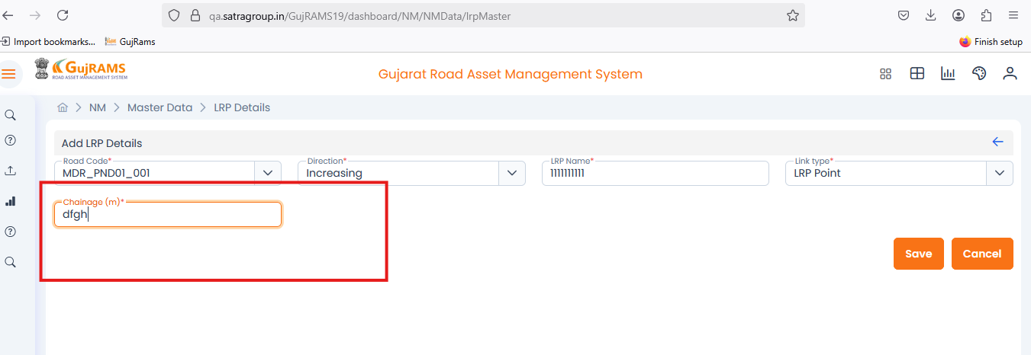

1. User clicking on Update Button in LRP Details->Lands on Update Link Details Page.

**Category** – Bug

**Priority-** High

**Actual-** Updated details and tried to click on update button but it is not clickable.

**Expected-** After updating data the button must be clickable and popup is displayed on screen.

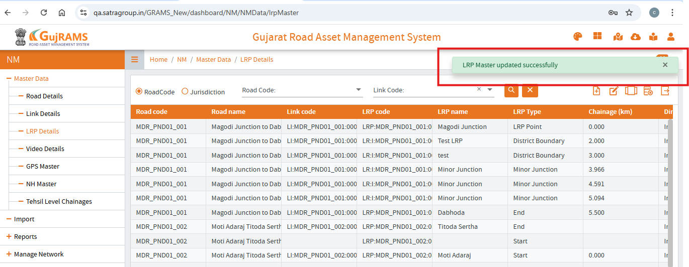

1. User clicking on Delete Button in LRP Details

**Category** – Bug

**Priority-** High

**Actual-** When user click on delete icon without selecting a row then the error popup is displaying as “**Please select a row to update**”

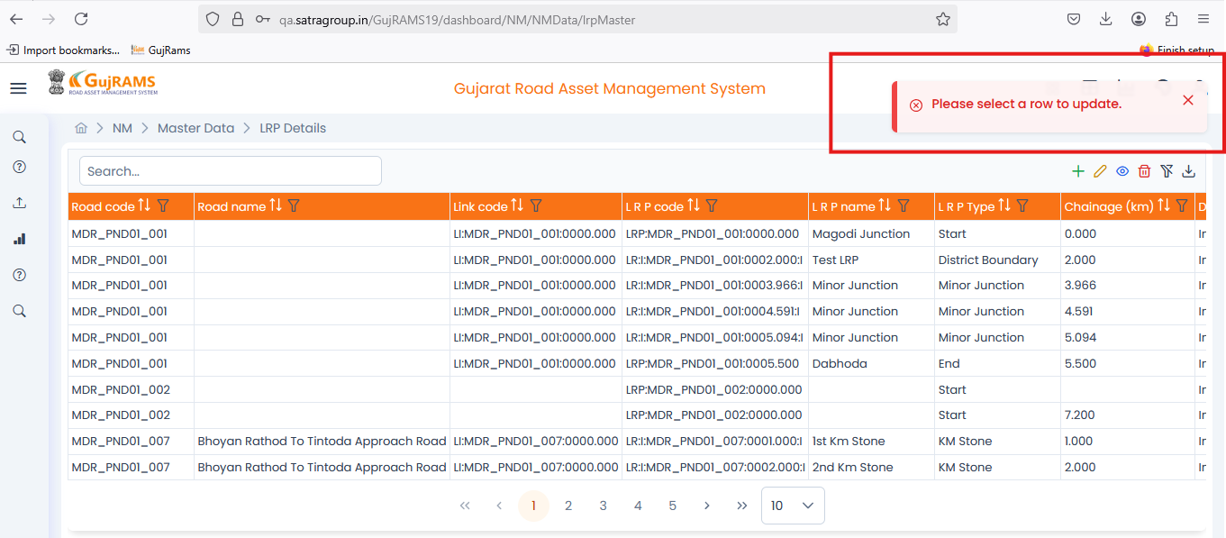

**Expected-** When user click on delete icon without selecting a row then the error popup is displaying as “**Please select a row to delete.”**

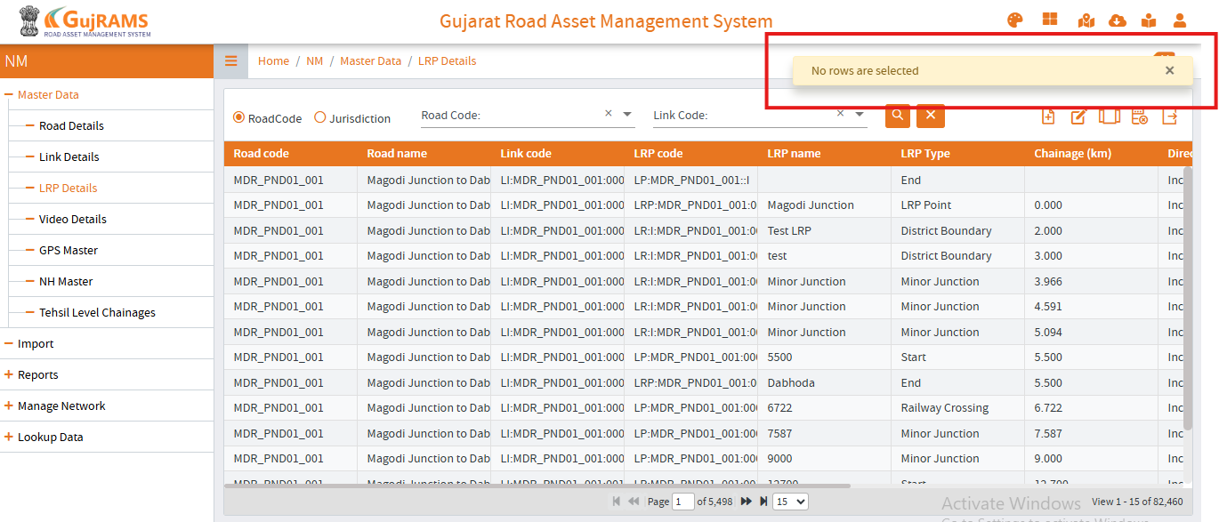

1. User clicking on Delete Button in Video Details->Lands on Video Details Page.

**Category** – Bug

**Priority-** High

**Actual-** When user click on delete icon with selecting a row then the error popup is displaying as “**Data**” Check for all modules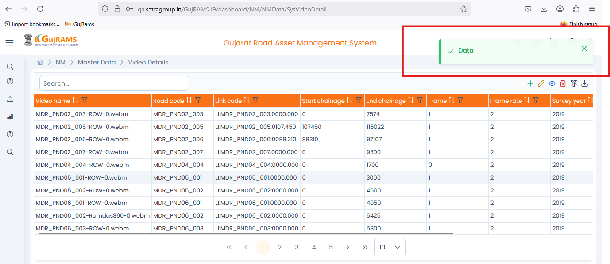

**Expected-** The popup message must be like data deleted successfully and remains in Video details page.

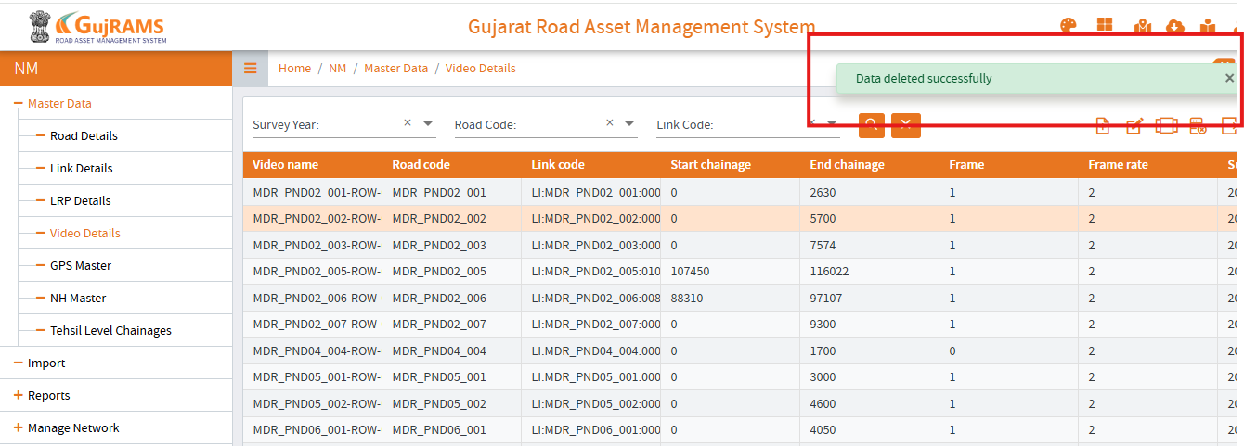

1. User clicking on Add Button in GPS Master ->Lands on GPS Master Page.

**Category** – Bug

**Priority-** High

**Actual-** Text boxes alignments are changing basing on user cursor actions.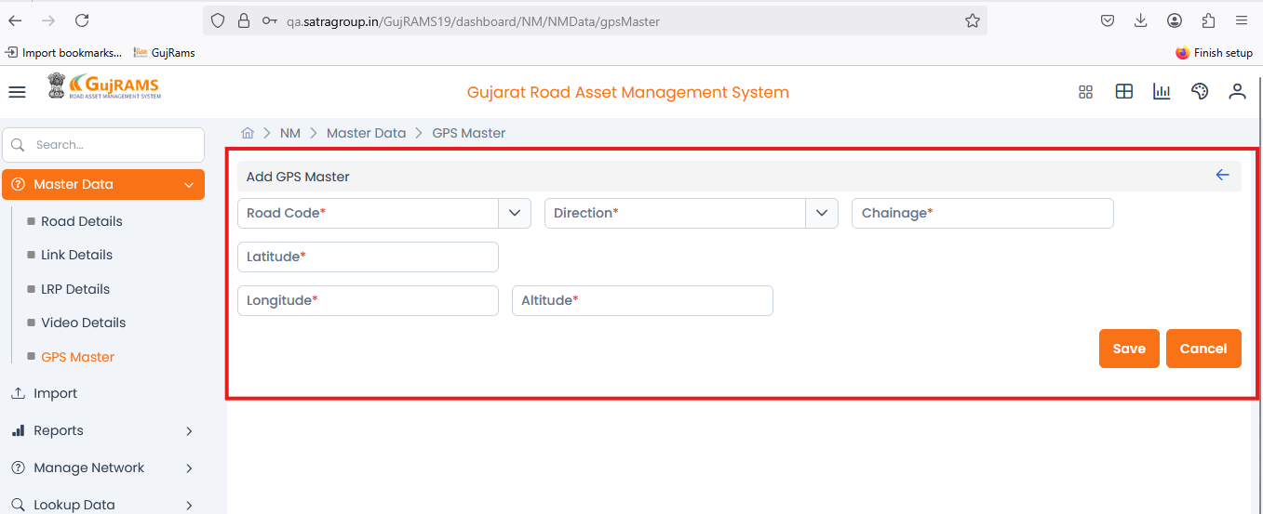**Expected-** Text boxes alignments should not change and they should remains constant as per the screenshot attached below.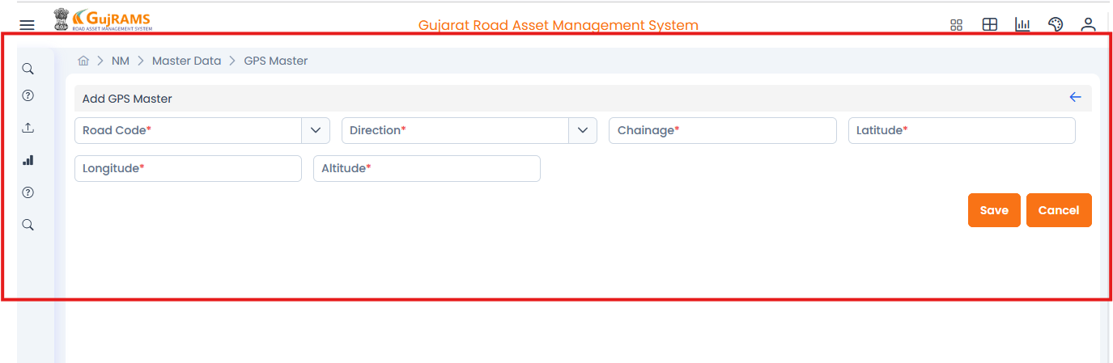

1. User clicking on Add Button in GPS Master ->Lands on GPS Master Page.

**Category** – Bug

**Priority-** High

**Actual-** After adding the data we unable see the saved popup message.

**Expected-** It should display the popup message like data is saved.

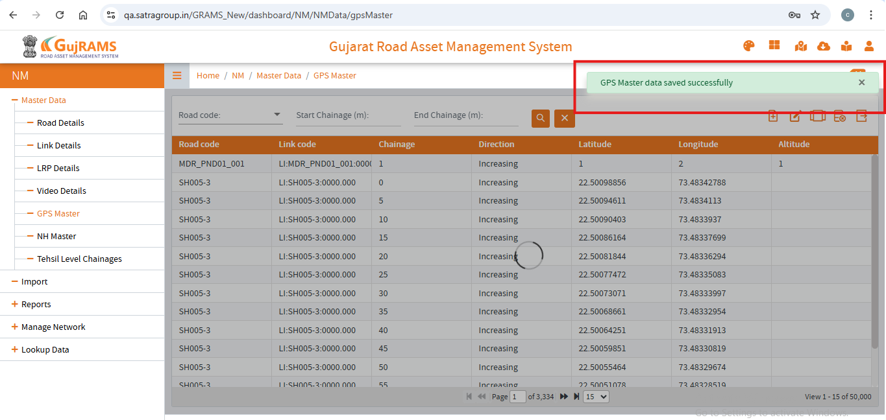

1. User clicks on import in Hamburger’s menu-> page lands on Import Page

**Category** – Bug

**Priority-** High

**Actual-** User trying to open the data by clicking on link in the table it is redirection to new tab with error page.

**Expected-** It should download the data in excel format.

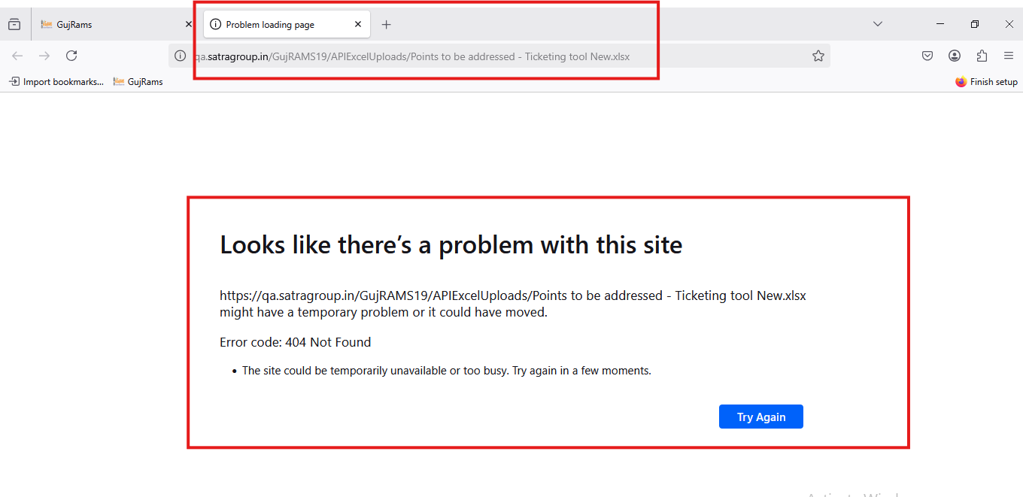

1. User clicks profile icon-> Click on Data Template-> Multiple modules seen then select and click on that (automatically downloads).

**Category** – Bug

**Priority-** High

**Actual-** Templates miss match with the tables in the modules.

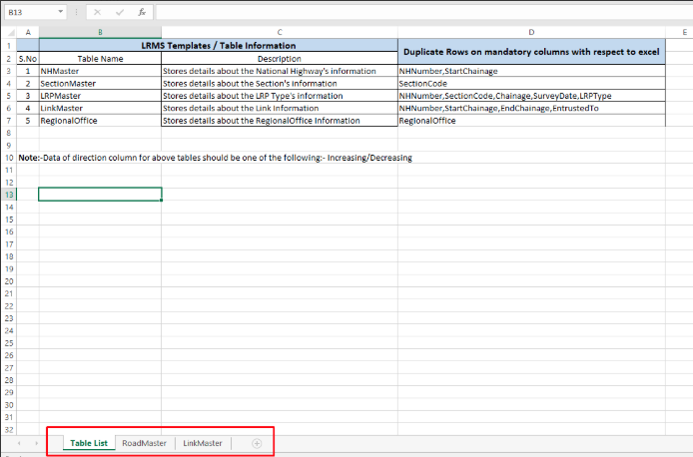

**Expected-** Template should match with the tables count in the modules.

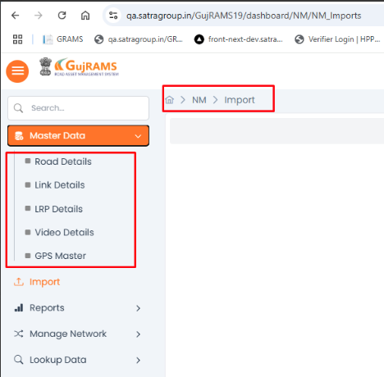

1. User clicks on import in Hamburger’s menu-> page lands on Import Page

**Category** – Bug

**Priority-** Medium

**Actual-** After importing data->it directs to Import page-> When user click on New Import then the mandatory fields directly displaying in red colour.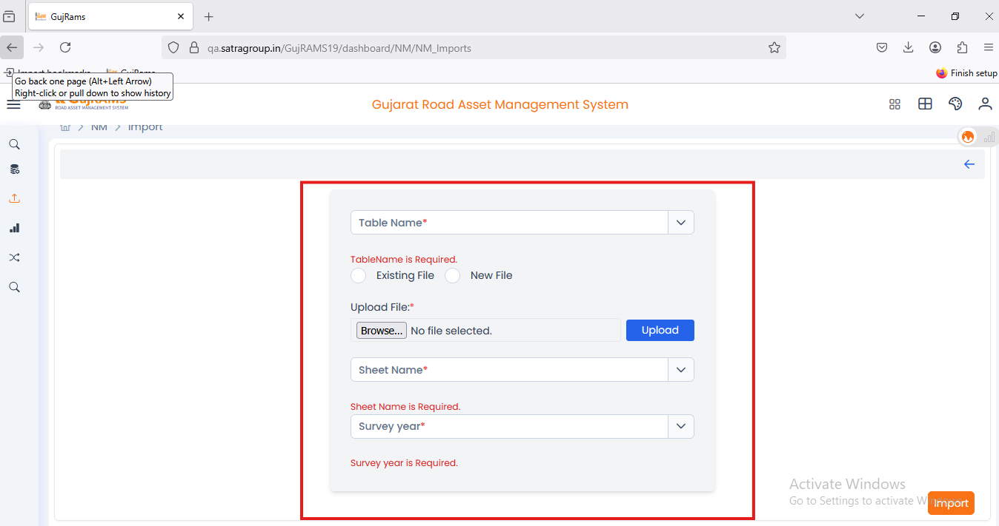

**Expected-** No mandatory alerts should be displayed below is the screen shot for reference.

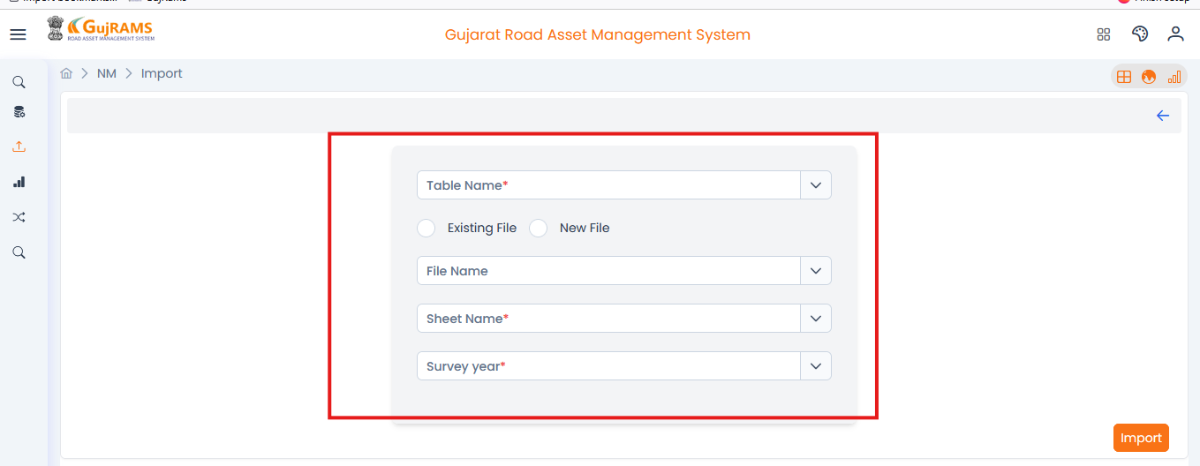

1. In the Circle List screen, Submit and Clear buttons are present despite no fields being available to enter data.

**Category**: UI issue  
**Priority**: Medium

**Actual**: Buttons are displayed without any associated input fields.  
**Expected**: Submit and Clear buttons should only be shown if there are fields present for the user to input data..  
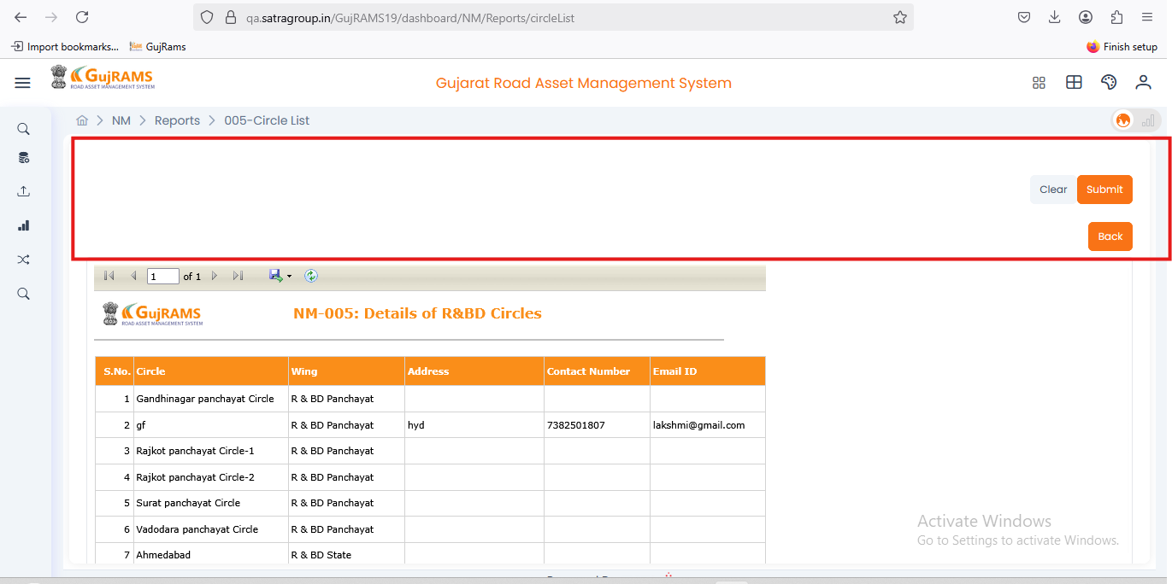

1. In [NM](https://qa.satragroup.in/GujRAMS19/dashboard/NM)->[Manage Network](https://qa.satragroup.in/GujRAMS19/dashboard/NM/manage_Network)s->Click on [Split Links](https://qa.satragroup.in/GujRAMS19/dashboard/NM/manage_Network/split_Road), Merge Links

**Category**: UI issue  
**Priority**: Medium

**Actual**: No data is displaying and it remains empty as shown

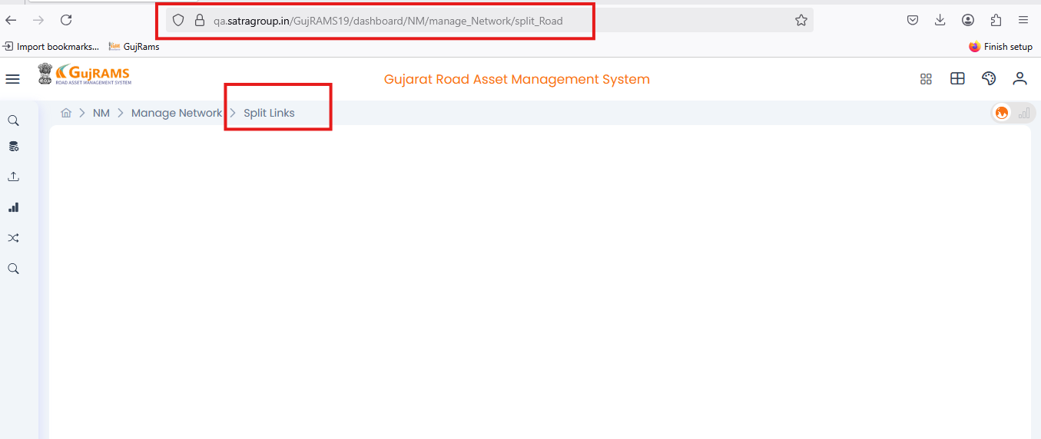

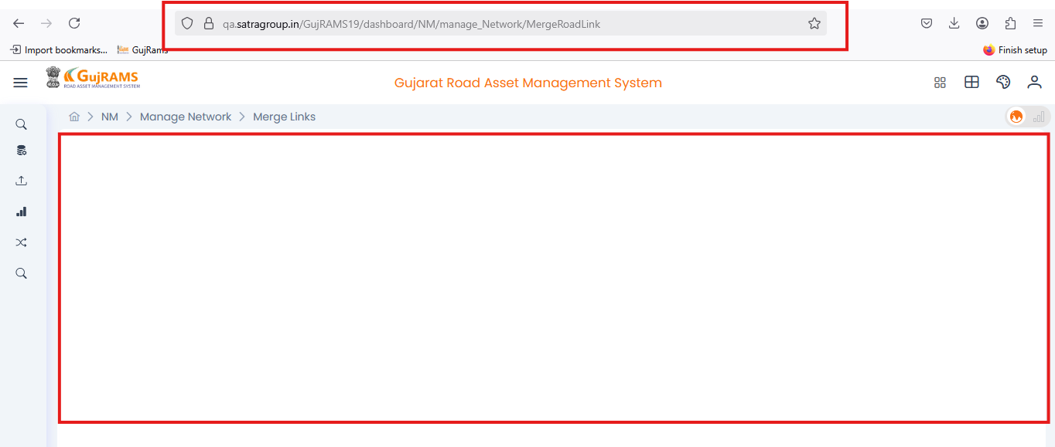

1. When user viewing the data it is showing edit record (Check for all modules)

**Category**: UI issue  
**Priority**: Medium

**Actual**: Displaying Edit Record page.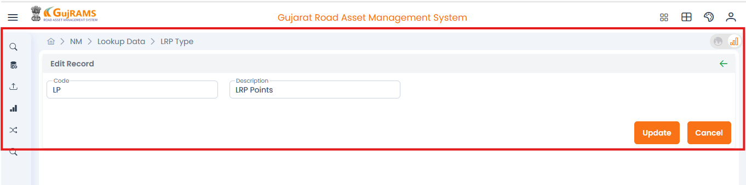**Expected-** It should display view details page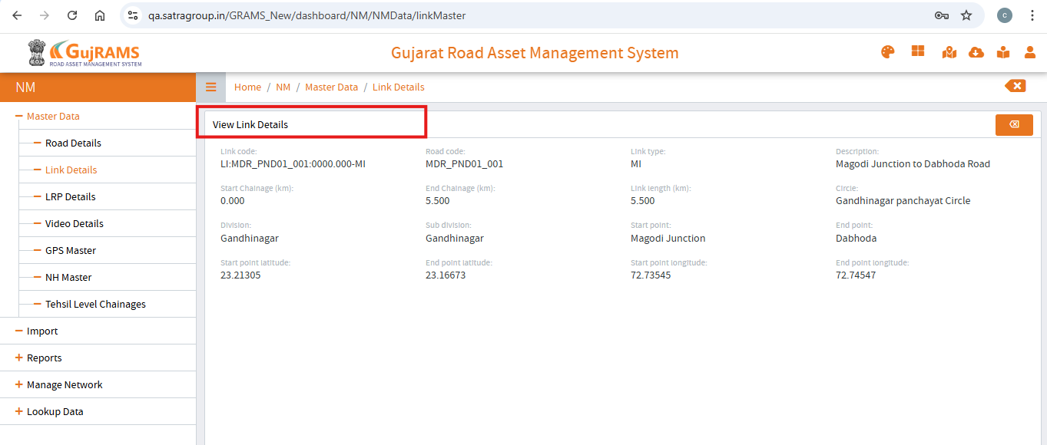

**NEW OBSERVATIONS IN GUJRAMS FOR PMS MODULE:**

1. In PMS ->User click Hamburger’s menu-> clicks on Prepare Network

**Category**: Bug  
**Priority**: High

**Actual-** Fill the data in required fields, and runs it, then a pop-up appears, but it loads and stays on the same page.

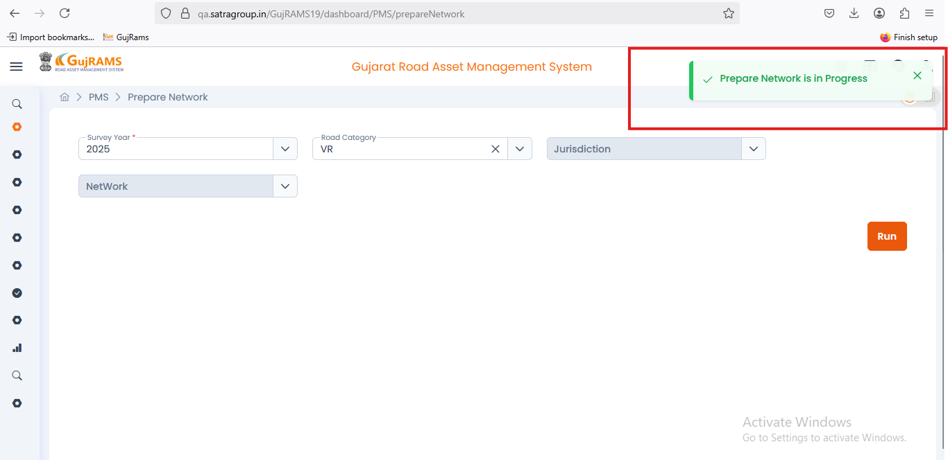

**Expected-** After popup it should redirects to process details page.

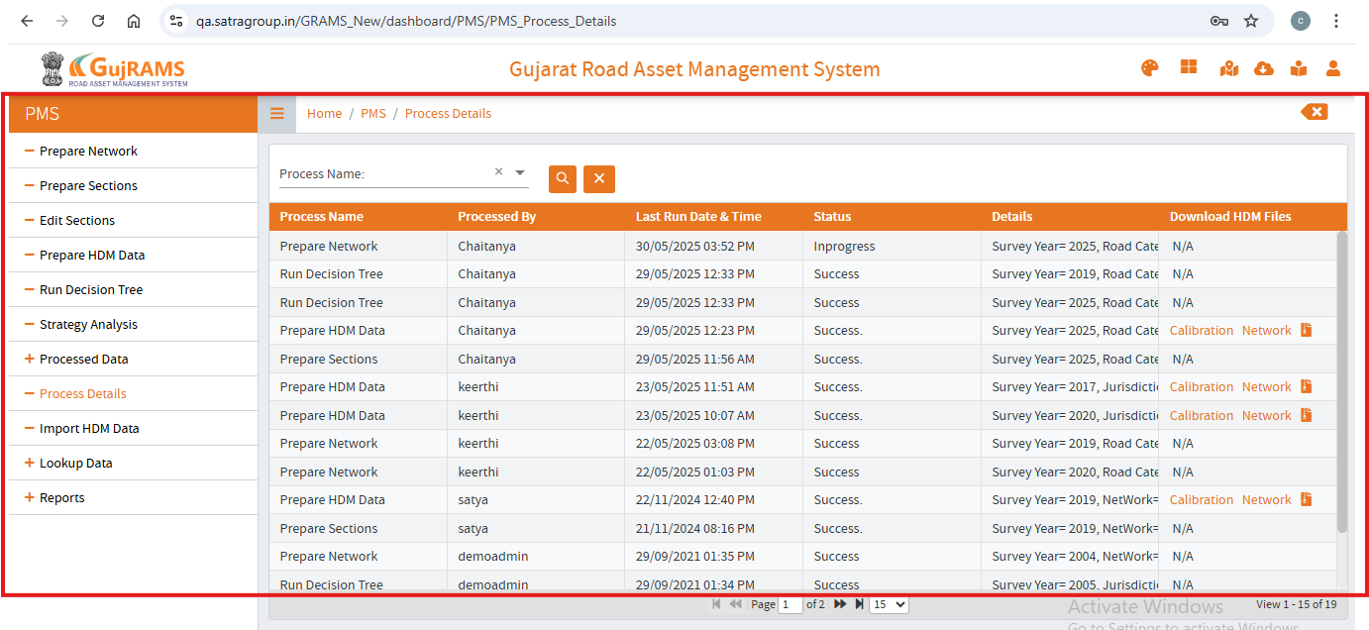

1. In PMS -> click Hamburger’s menu -> User clicks on Prepare section ->Lands on prepare section page.

**Category**: UI Issue  
**Priority**: High

**Actual- Repeated input field is displayed.**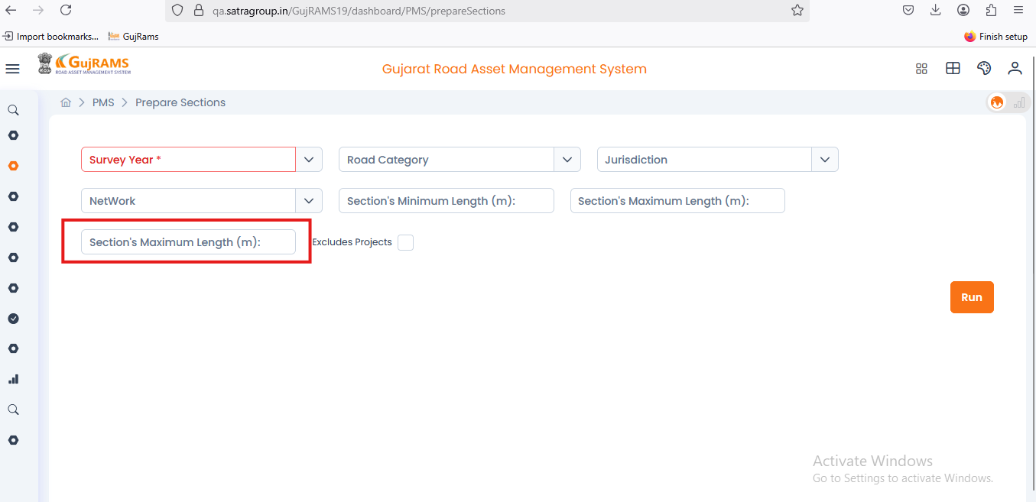

**Expected-** Input fields should not be repeated as shown.

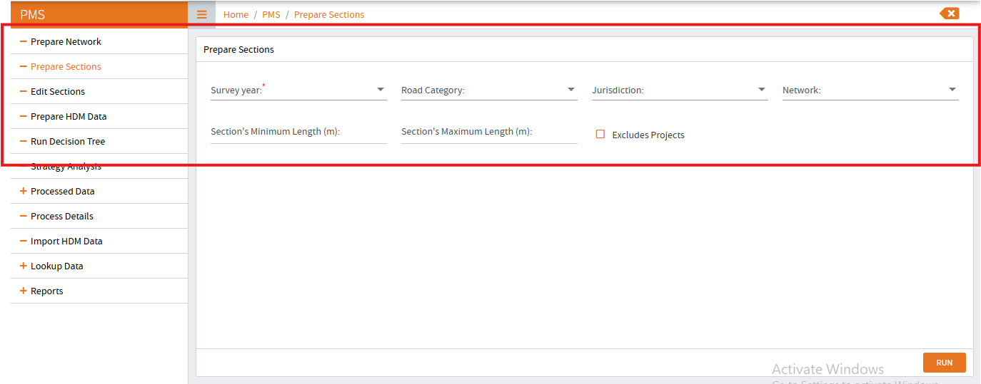

1. In PMS -> click Hamburger’s menu -> User clicks on Prepare section (Check for all modules)

**Category**: Bug  
**Priority**: High

**Actual- After filling all the data when we click on run it is not working and remains in same page.**

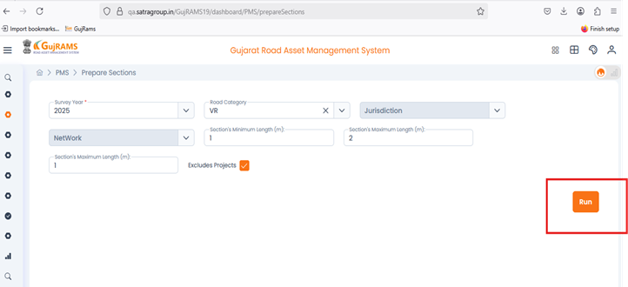**Expected**- Run action should be able to perform and user redirected to process details page and displays the data. (Check for all sections in PMS module).

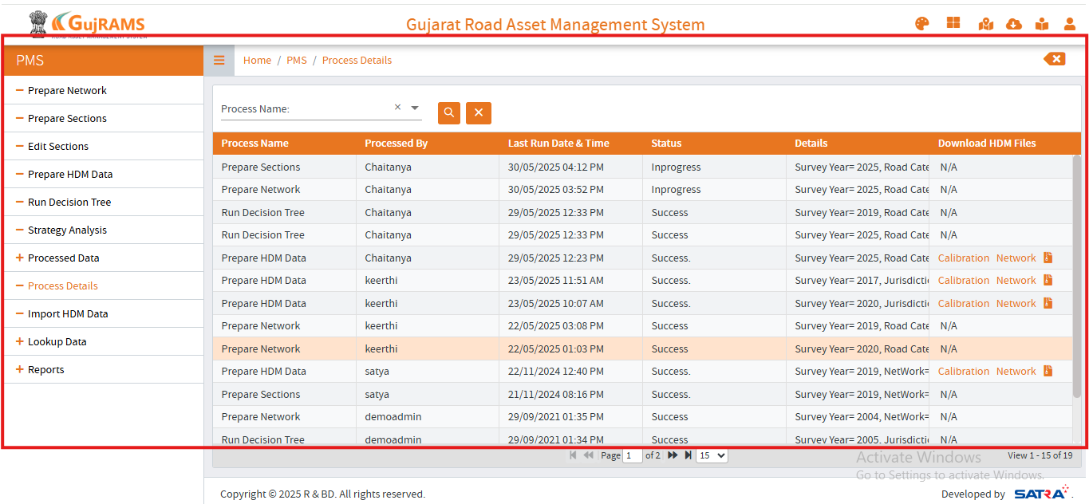

1. In PMS -> click Hamburger’s menu -> User clicks on Edit Section.

**Category**: UI Issue  
**Priority**: High

**Actual-** When user click on the edit section it is loading & redirecting to empty page

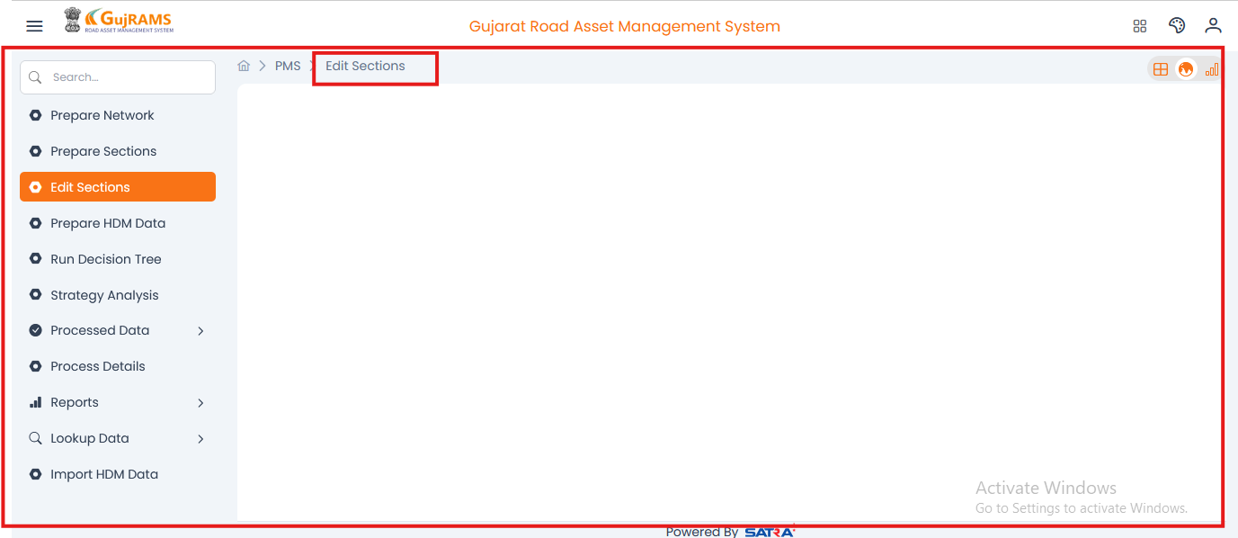

**Expected-** Redirects to edit section page and data must be displayed.

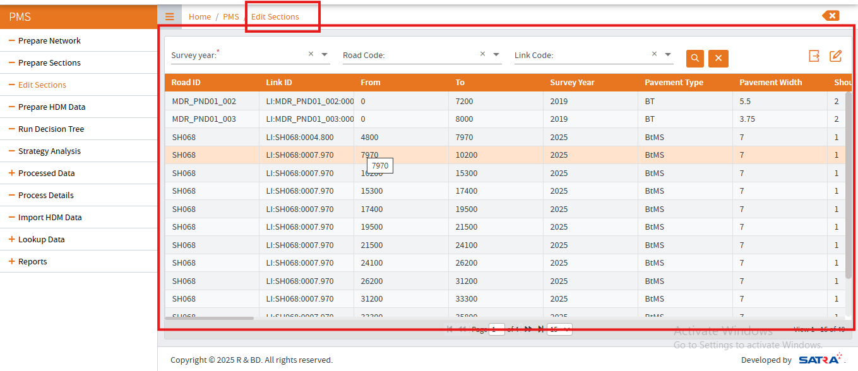

1. In PMS -> click Hamburger’s menu -> User clicks on the Run Decission.

**Category**: UI Issue  
**Priority**: Low

**Actual-** Filling the data in fields and click on run then two popups are displaying at a time as shown.

**Expected-** Popup’s are displayed one after one.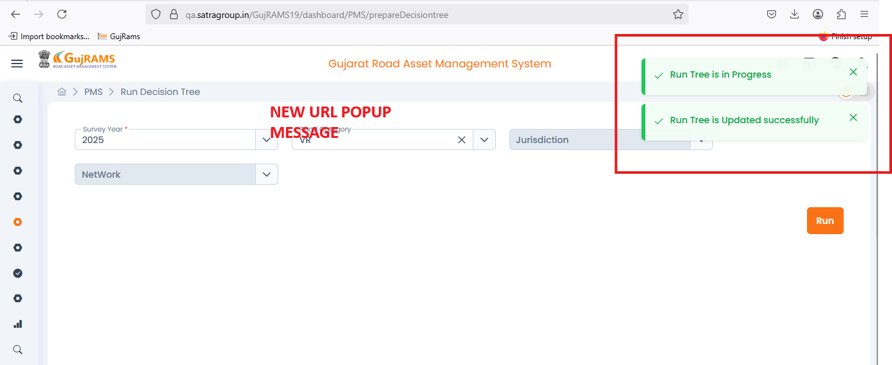

1. In PMS-> click Hamburger’s menu ->Click on Lookup ->Select HDM factors

**Category**: UI Issue  
**Priority**: Medium

**Actual-** Click on add button user lands on add details page then we can see that mandatory fields missing when user clicks on save button, then only required field alerts are displayed. 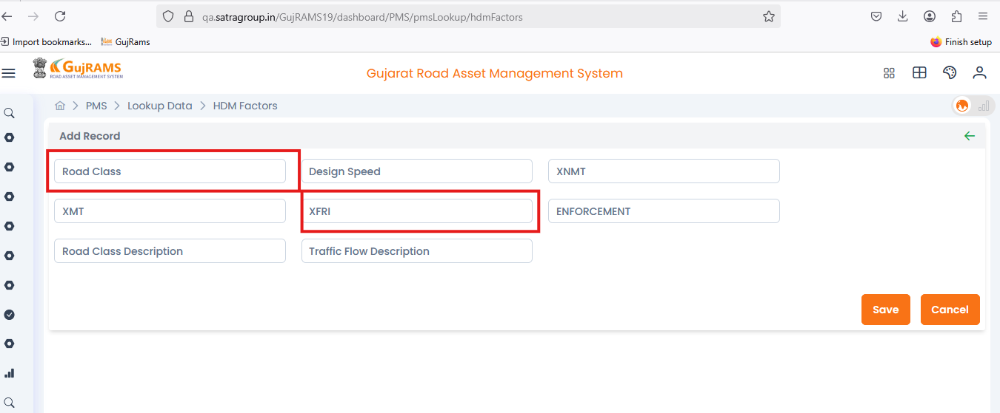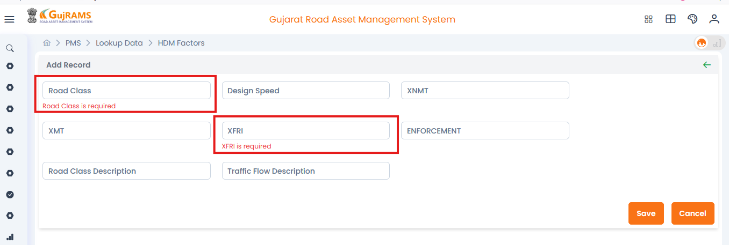**Expected-** By defaultly the should be displayed with (*) indication.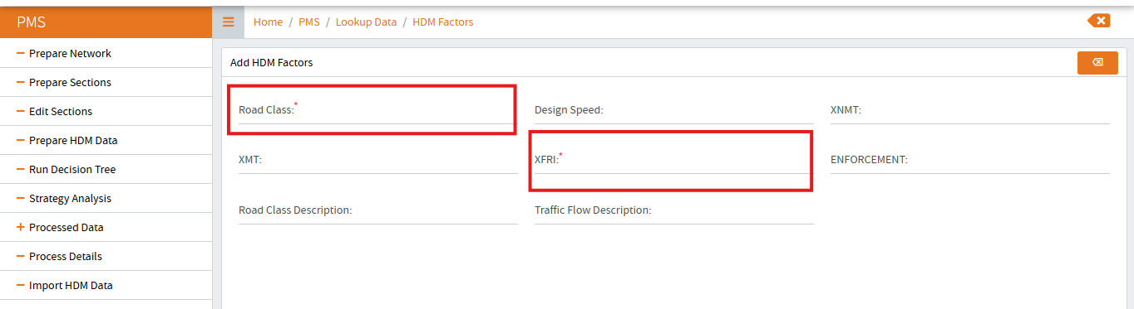

1. When user click delete icon->data not deleting and user getting a popup message as below.  
   **Category**: Bug  
   **Priority**: High

**Actual-** Click on delete with no row selection different popup message is displaying.

**Expected-** The popup message must be displayed as like Selected data is deleted

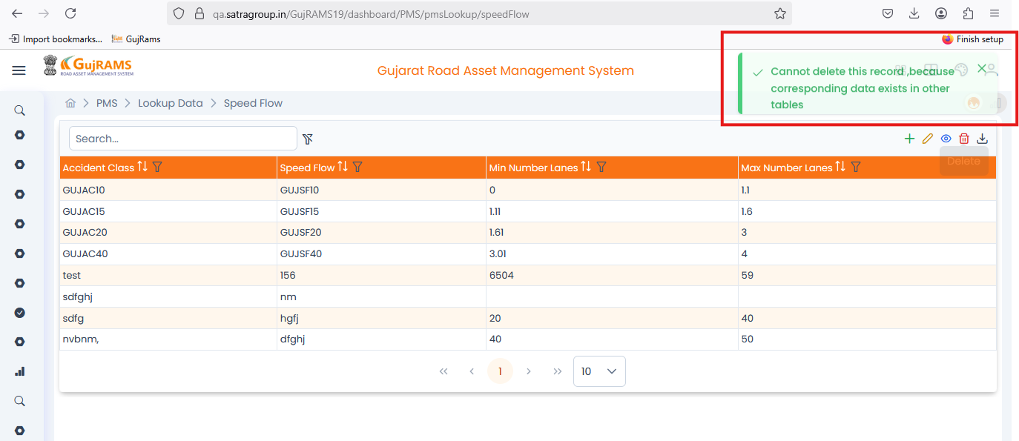

**NEW OBSERVATIONS IN GUJRAMS FOR RIS MODULE:**

1. Unknown text is displayed on bottom of the screen as below

**Category**: UI Issue  
**Priority**: Low

**Actual-** Unknown text is displayed as shown in screenshot.

**Expected-** Text Shouldnot be displayed.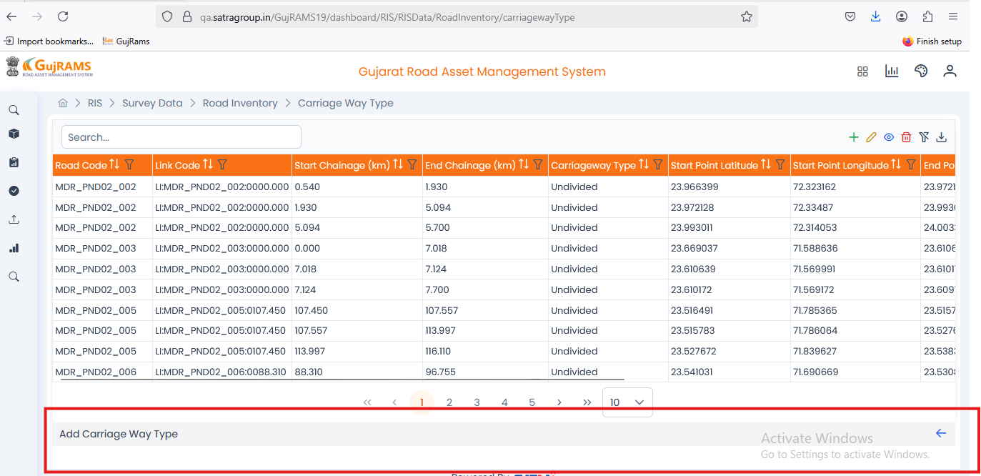

1. User clicked on add button directly it is showing required alert as shown below

**Category**: UI Issue  
**Priority**: Medium

**Actual-** Directly displaying the required field alerts.

**Expected-** User misses to fill the data and save it then only the required alerts should be displayed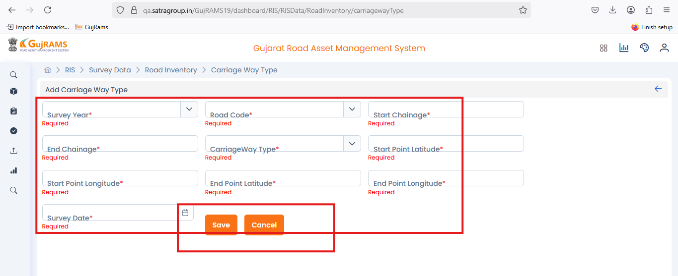

1. For start latitude and start longitude, end latitude and end longitude

**Category**: Bug  
**Priority**: High

**Actual-** Only allowing two numbers after decimal point

**Expected-** Allow up to nine numbers after decimal.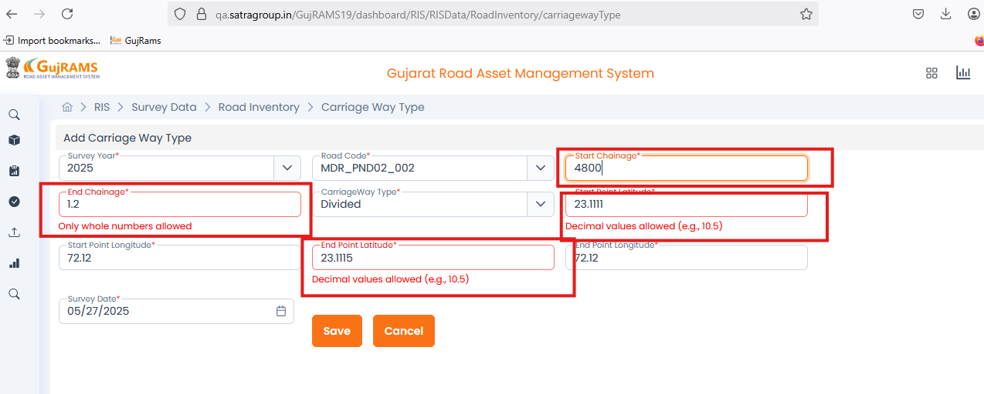

1. Issue with calendar in survey data->Road Inventory->Carriage way type

**Category**: UI Issue  
**Priority**: High

**Actual-** Calendar alignment is not correct

**Expected-** Calendar alignment must be correct and display properly.

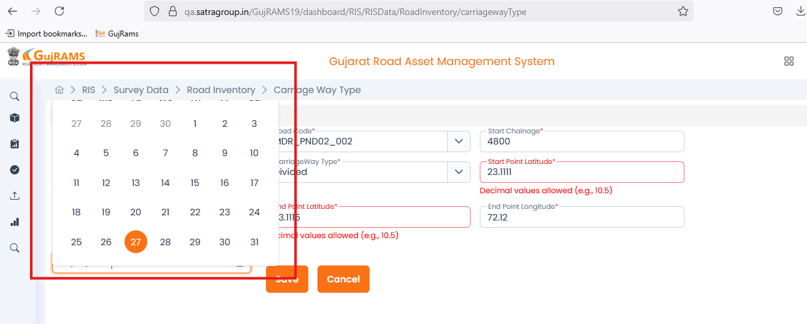

1. survey data->Road Inventory->Carriage way type

**Actual-** When user clicking on the update icon, delete icon without selecting any row user getting a popup alert with extra text like info as shown below

**Expected-** No extra text displayed in popup message.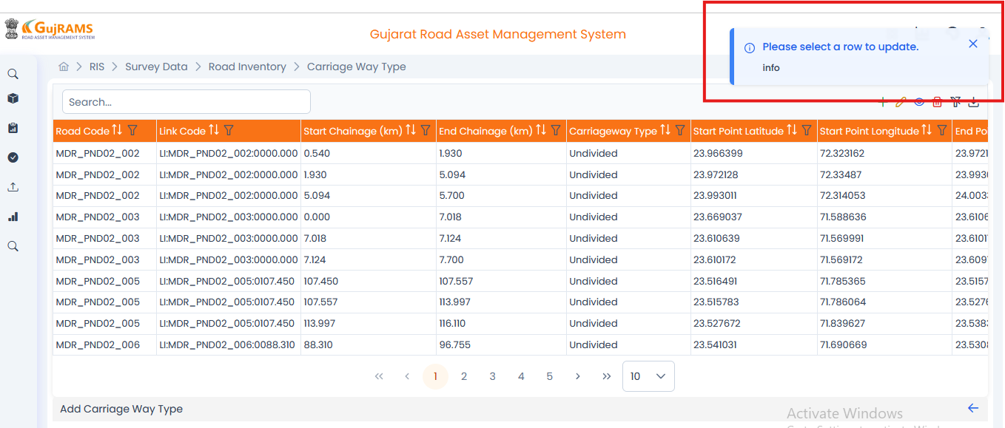

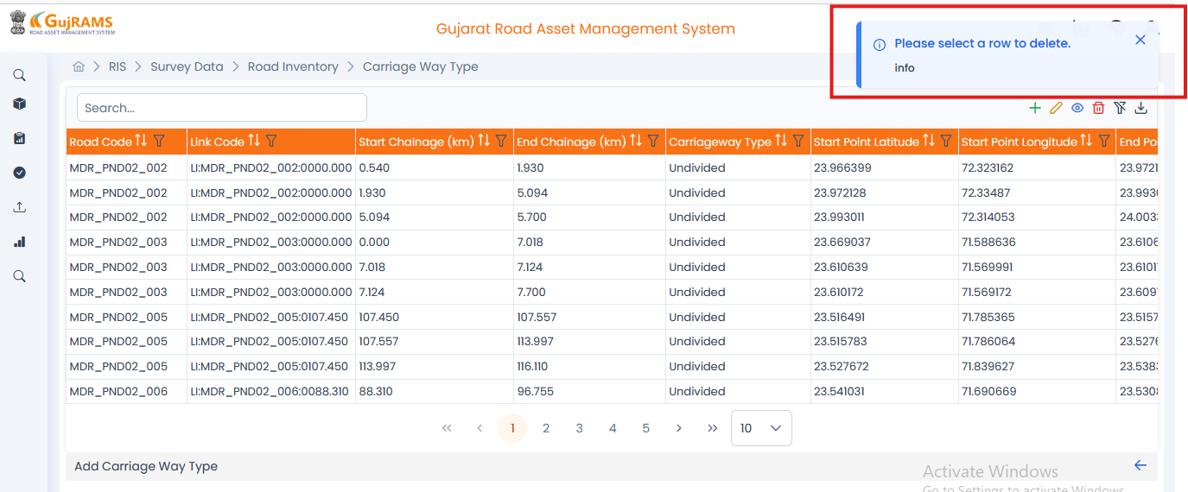

1. "Clicking on RMMS & MES   
   **Actual-** Template Download redirects the user to the login screen.

**Expected-** Templates must be downloaded in excel.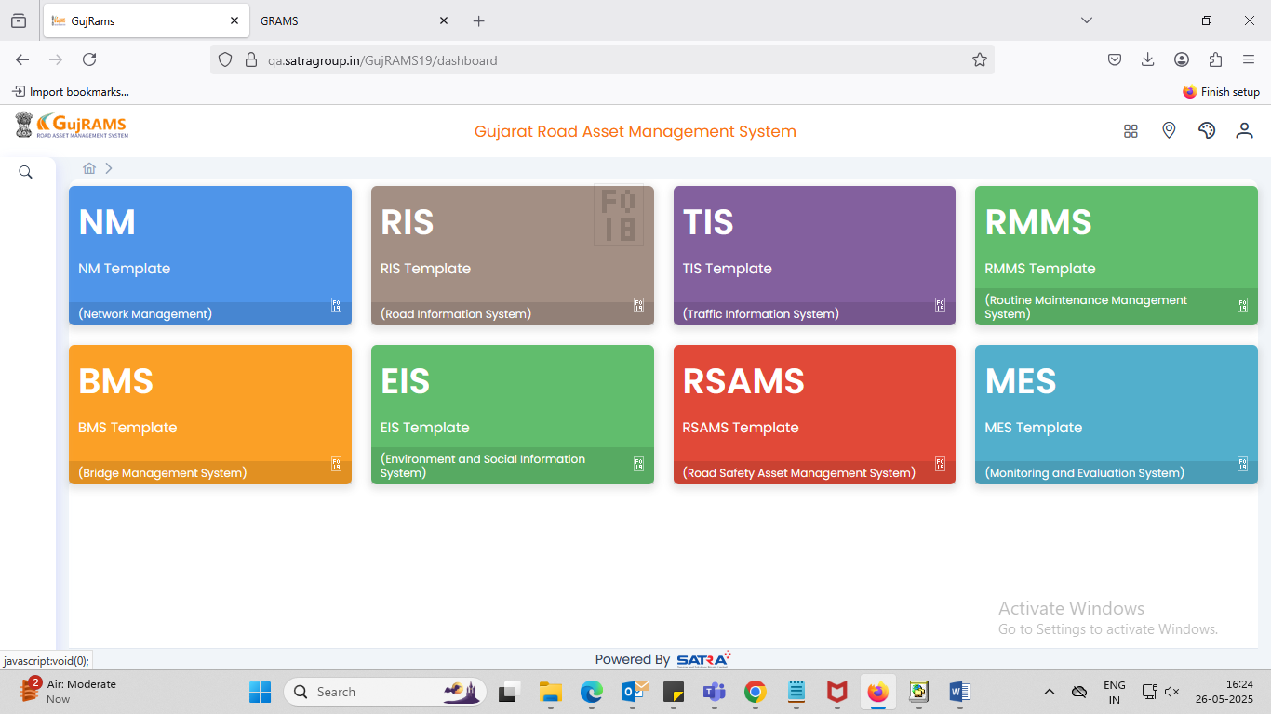

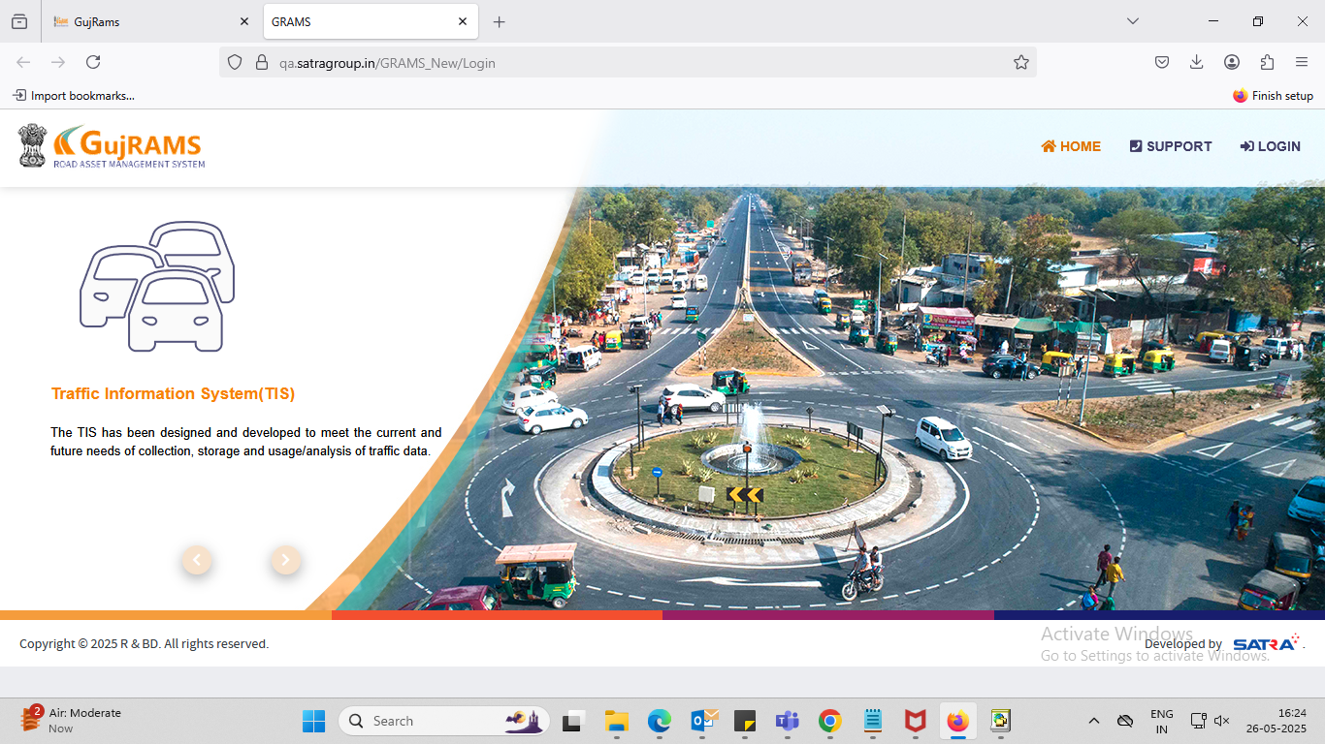

1. User Import Data

**Actual-**"After filling in all the required fields and clicking the Import button, a popup appears displaying 'res.caption'. Please refer to the screenshot below."

**Expected-** It should display successfully imported message