1. 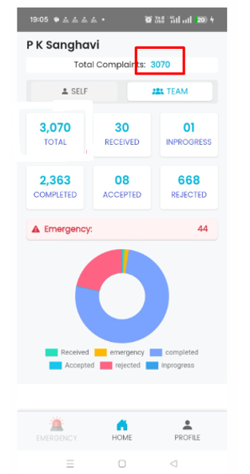Please Remove the highlighted Total Complaints Field and display the Officers name in that place (Example: P K sanghavi). Officers name to be displayed with Centre Alignment.
2. 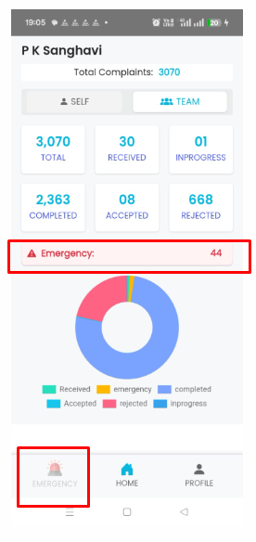Please Remove **Emergency 44** 1st highlighted box  
   If there are Emergency Tickets , the Emergency button at the left bottom to be Highlighted (Enabled). The User should be allowed to click and it should display the list of Emergency Tickets.
3. The Complaints to be displayed in the Screen in the following Sequence.

Accepted, Received, InProgress, Completed, Rejected and Total

