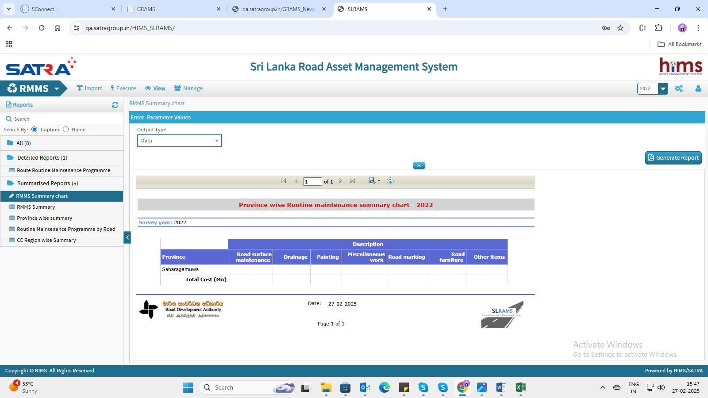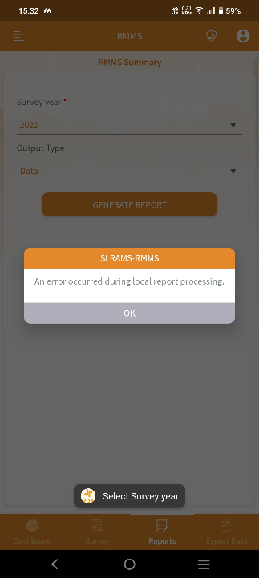1. Reports cannot be generated in the mobile application, but they can be generated on the web.

2.Filter is not working, but it displays the selected values above the table.

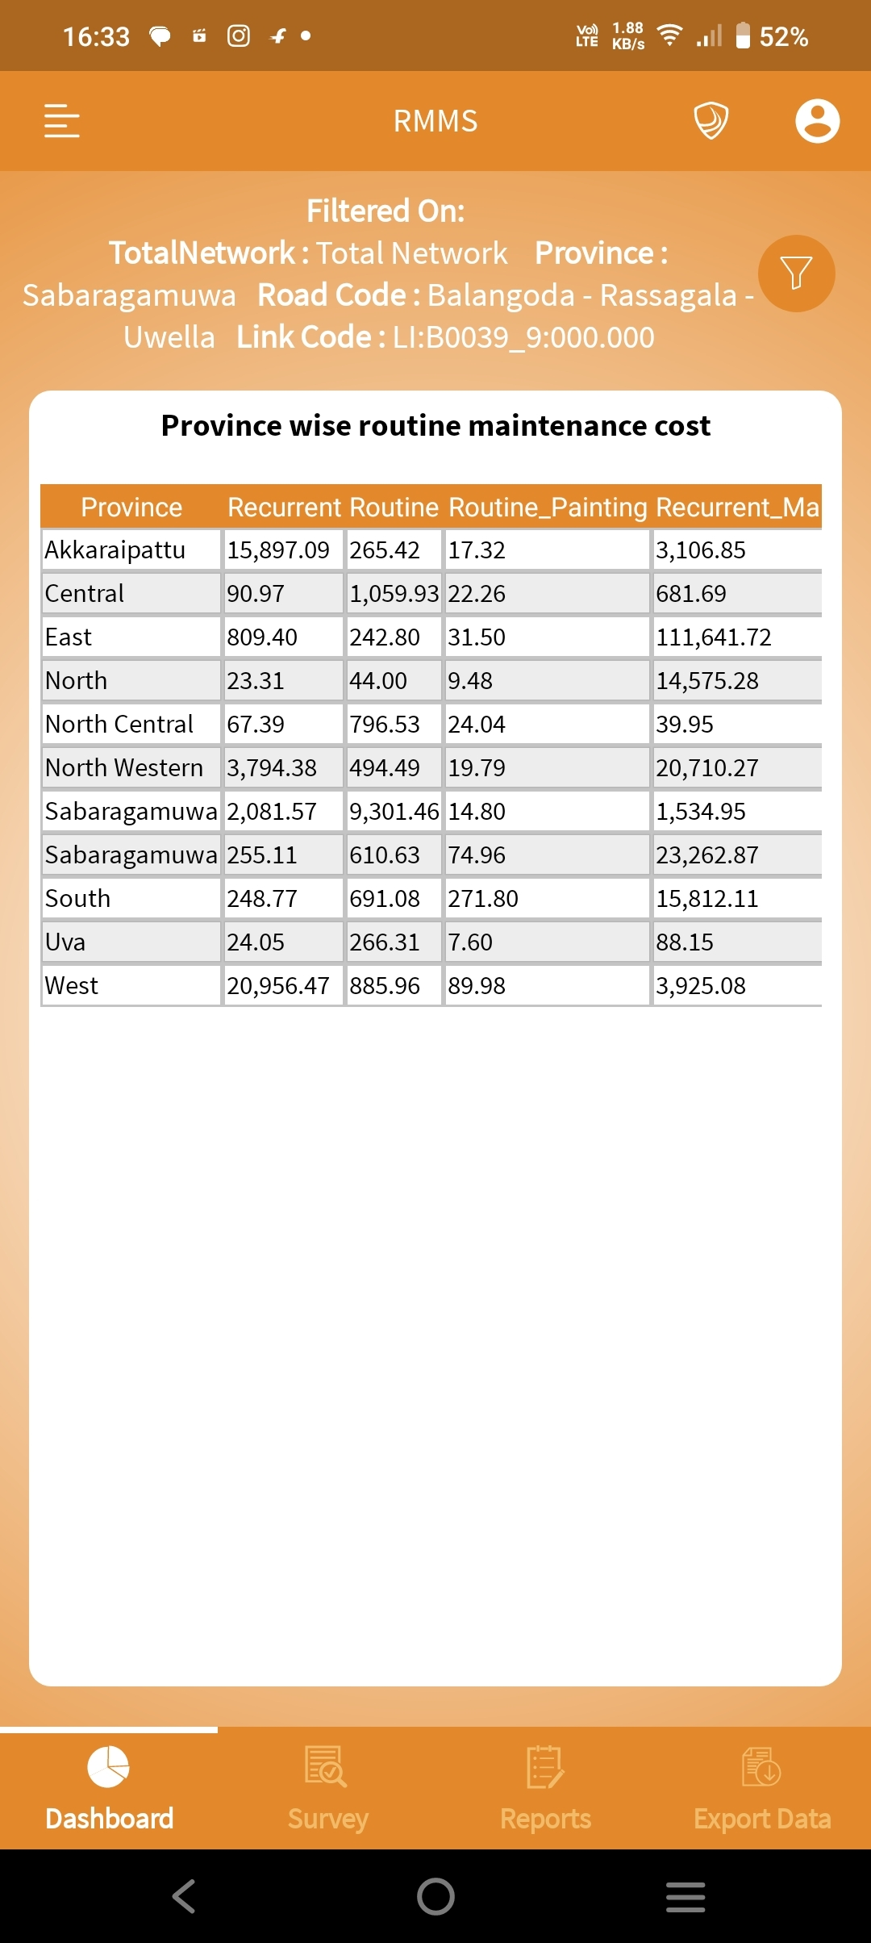

3. Observation: values are overlapping

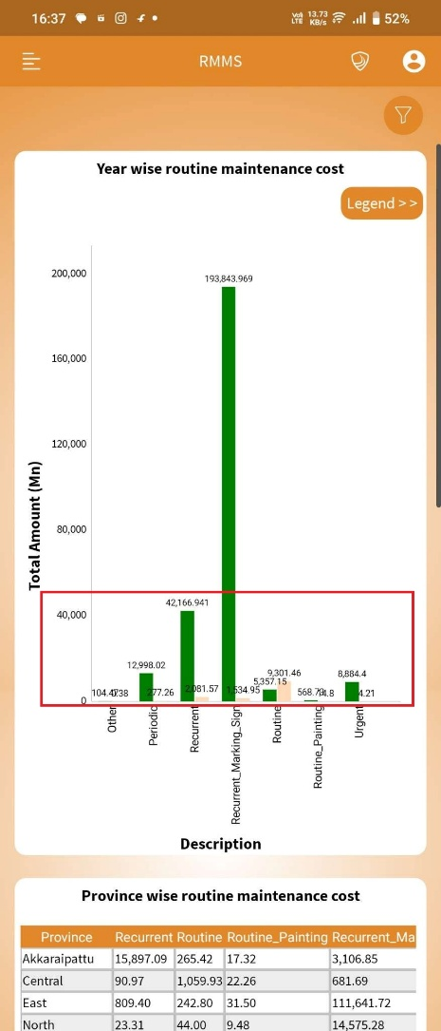

4.Material -> unable to enter text.

